Quantum 1/f Noise and Quantum 1/f Phase Noise Related to the Uncertainty Relations

Adam G. Tournier and Peter H. Handel

Department of Physics and Astronomy, Univ. of Missouri St. Louis

Abstract
Quantum 1/f noise is the manifestation of the coherent and conventional quantum 1/f effects (Q1/fE). The conventional Q1/fE is a fundamental quantum fluctuation of physical cross sections σ and process rates Γ, caused by the bremsstrahlung (recoil) energy and momentum losses of charged particles, when they are scattered, or accelerated in any way. The closely related coherent Q1/fE is present in any current carried by many particles. It is caused by the energy spread characterizing any coherent state of the electromagnetic field oscillators. According to the Heisenberg’s uncertainty principle, because t is known, exact knowledge of the energy is precluded. This energy spread results in nonstationary energy values, or fluctuations in the energy of the oscillators. To find the spectral density of these inescapable basic fluctuations, which are known to characterize any quantum state, which is not an energy eigenstate, we use an elementary physical derivation based on Schrödinger’s definition of coherent states, which can be supplemented by a rigorous derivation from a well-known quantum-electrodynamical branch-point propagator. The example of a simple harmonic oscillator is also useful for illustrating the uncertainty that arises due to Q 1/f Noise. Clearly illustrating the relation between the uncertainty principle and Q 1/f noise.

1. Introduction

Quantum 1/f noise is the manifestation of the coherent and conventional quantum 1/f effects (Q1/fE) [1].
The conventional Q1/fE is a fundamental quantum fluctuation of physical cross sections σ and process rates Γ, caused by the bremsstrahlung (recoil) energy and momentum losses of charged particles, when they are scattered, or accelerated in any way. Q1/f Noise is given by the spectral density of fractional fluctuations. [1]

(1)

Where α=e²/hc=1/137 is the fine structure constant, Δv is the vector velocity change in the scattering process considered, and N is the number of particles used to define both the notion of current, and the cross section σ.
The closely related coherent Q1/fE is present in any current carried by many particles. This effect arises in a beam of electrons (or other charged particles propagating freely in vacuum) from the definition of the physical electron as a bare particle plus a coherent state of the electromagnetic field. It is caused by the energy spread characterizing any coherent state of the electromagnetic field oscillators, according to the uncertainty principle, because the phase of the harmonic oscillators is known. This knowledge precludes exact knowledge of the energy, according to Heisenberg’s uncertainty relation. The energy spread spells non-stationarity, i.e., fluctuations. To find the spectral density of these inescapable basic fluctuations, which are known to characterize any quantum state, which is not an energy eigenstate, we use an elementary physical derivation based on Schrödinger's definition of coherent states, which was verified later by a rigorous derivation from a well-known quantum-electrodynamical branch-point propagator. [2]
The coherent quantum 1/f effect will be derived in three steps: first we consider a hypothetical world with just a single mode of the electromagnetic field coupled to a beam of charged particles; considering the mode to be in a coherent state, we calculate the autocorrelation function of the quantum fluctuations in the particle-density (or concentration) which arise from the nonstationarity of the coherent state. Then we calculate the amplitude with which this one mode is represented in the field of an electron, according to Coulomb’s law. Finally, we take the product of the autocorrelation functions calculated for all modes with the amplitudes found in the previous step. [3]
The example of an oscillatory circuit modeled as a simple harmonic oscillator is an effective method for demonstrating how the Q 1/f E arises from the uncertainty relation inherent in the coherent frequency state of the simple oscillator model. [4]

2. Derivation of the Coherent Q 1/f Effect

Let a mode of the electromagnetic field be characterized by the wave vector q, the angular frequency ω = cq and the polarization λ, in short by “q”. The coherent state of amplitude |zq| and phase arg zq then has the form

(2)

Here aq+ is the creation operator which adds one energy quantum to the energy of the mode, and all sums go up to ∞. Let us use a representation of the energy eigenstates in terms of Hermite polynomials Hn(x)

(3)

This yields for the coherent state |zq> the representation

(4)

In the last form the generating function of the Hermite polynomials was used. The corresponding autocorrelation function of the probability density function, obtained by averaging over the time t or the phase of zq, is, for |zq|<<1,

(5)

Integrating over x from -∞ to ∞, we find the autocorrelation function

(6)

This result shows that the probability distribution contains a constant background with small-superposed oscillations of frequency ω. Physically, the small oscillations in the total probability describe self-organization or bunching of the particles in the beam. They are thus more likely to be found in a measurement at a certain time and place than at other times and places relative to each other along the beam. Note that for zq = 0 the coherent state becomes the ground state of the oscillator which is also an energy eigenstate, and therefore stationary and free of oscillations. We now determine the amplitude zq with which the field mode q is represented in the physical electron. One way to do this is to let a bare particle dress itself through its interaction with the electromagnetic field, i.e. by performing first order perturbation theory with the interaction Hamiltonian

(7)

Where A is the vector potential and φ the scalar electric potential. Another way is to Fourier expand the electric potential e/r of a charged particle in a box of volume V. In both ways we obtain

(8)

Considering now all modes of the electromagnetic field, we obtain from the single - mode result of Eq. (6)

(9)

Here we have again used the smallness of zq and we have introduced a constant C. Using the |zq|2 expression,
(10)

The autocorrelation and spectrum Sδj/j(f) of the relative density or current j=e(k/m)|ψ|2 fluctuations is the second term in curly brackets divided by the first term [5]

(11)
This coherent quantum 1/f Effect is observed in large devices in which a thin salami slice perpendicular to the flow of the current contains at least one current carrier. The thickness of the slice is 2.8 10⁻¹³ cm., the classical radius e²/mc² of the electron. As an example we can provide the results of Wu and van der Ziel [6] in Fig. 1 below. The measured values of the 2 devices considered are both roughly consistent with the coherent Q1/fE prediction of Eq. (11), with no adjustable parameters.

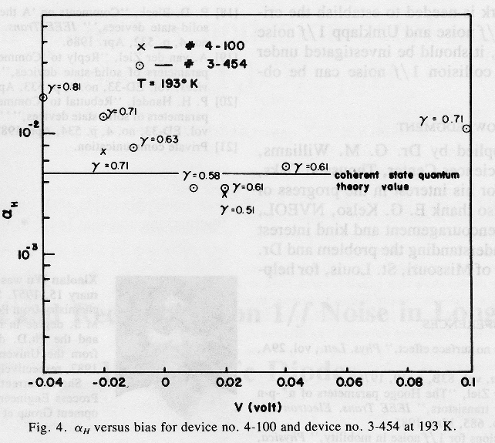
Fig. 1: The Quantum 1/f (Hooge) parameter for GaAs device No. 4-100 and device 3-454 at 193 K.

3. Phase Noise in an Oscillator from the Q 1/f Effect

Phase noise is generated both classically and quantum mechanically. The quantum mechanical noise source is quantum 1/f noise in the cross sections and process rates determining the elementary act of dissipation. In an oscillator phase noise can be modeled in a first approximation as an oscillating circuit described by a harmonic oscillator equation

(12)

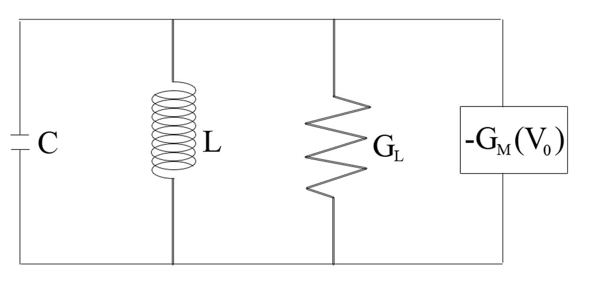
Fig 2. An oscillating circuit with negative conductance active element (-G_{m})

In the circuit a negative conductance represents the active element, the force F₀exp(iωt), causing the oscillations. This force, or emf is assumed to be free of fluctuations. The fluctuations are present in the dissipative element γ that may be present in the active device and in the resonator. The solution for x, which can be the current or the voltage in the oscillating circuit, is

(13)

The variable x represents the vector potential is the case of a beam of charged particles. From the probability density of Eq. (5) the vector potential fluctuates with respect to time and these fluctuations lead to energy uncertainty. These quantum 1/f fluctuations are present in the loss coefficient γ.

The resonance condition d|x₀|²/dω=0 yields.

(14)

Conventional quantum 1/f noise is a fundamental quantum fluctuation present in quantum mechanical cross sections and process rates. The latter determine the dissipation in quartz crystals and in general in resonant systems of any kind. Considering therefore fluctuations of the dissipative constant γ, we obtain for the resulting frequency fluctuations of the arbitrary resonant system

(15)

With y≡δω_{r}/ω_{r} and with 2γ/ω being the quality factor Q, we obtain the frequency fluctuations power spectrum
(16)

This defines the phase noise that is to be expected in first approximation. The oscillator can be based on either FETs/HFETs or BJTs/HBTs. In the case of FETs/HFETs the dissipation described by γ contains contributions from the source and drain series resistances, and from the gate leakage current. All of these noise sources are likely to be of Q1/f nature in high quality devices. Together with the channel noise, they define the total quantum 1/f frequency fluctuation noise S_{y}^{Q1/f}, and the corresponding phase noise L(f). given by. [7]
_{L(f)} (17)
4. Conclusions

The derivation of coherent Q1/f noise from the uncertainty relation yields insight into the fundamental nature of the Q1/fE. Even in a beam of charged particles the Q1/fE is present. It has been measured down to 10⁻⁸ Hz and it’s prevalent in all high tech applications. This ubiquitous presence requires that devices be optimized utilizing Q1/f theory to limit possible sources of noise. The coherent Q1/fE, when derived using the coherent nature of the electromagnetic field oscillators, shows how the energy uncertainty of the current is due to the bunching of the individual particles in the stream.
The probability density of the vector potential also has uncertainty. The vector potential has a distribution of values that oscillate in time. The median value of the vector potential oscillates around the value expected if no fluctuations were present in the beam of charged particles. The autocorrelation function being the relation of the probability density at a time t and some later time t + τ, is a representation of the memory of the system. As τ increases the autocorrelation functions value decreases. The autocorrelation function, which is used to calculate the spectral frequency fluctuations of the current, shows a non-exponential decay an exponent to a very small power roughly equal with the Q1/f coefficient. The Q1/f autocorrelation function’s value is a power law close to a constant decaying very slowly at large values of τ, unlike a standard autocorrelation function, which has a lorentzian distribution.
The resultant phase noise of an oscillator usually arises from the Q1/fE in the dissipative elements present in the circuit, as shown in Fig 1. Often there is one dissipative element, which contributes the most to the phase noise in which case we can neglect the other elements thereby simplifying the final engineering formulas. This is illustrated in detail in the “Blue Sky” special issue of IEEE Proceedings.
The derivation of the coherent Q1/fE is developed in more depth utilizing information theory in the second paper in this volume by Handel and George, and more information on Q1/f theory can be found on the website at www.umsl.edu/~handel in the Q1/f bibliography.

References

[1] P.H. Handel: “Noise, Low Frequency”, Wiley Encyclopedia of Electrical and Electronics Engineering, John Wiley & Sons, Inc., vol. 14, 428-449, 1999.
[2] P.H. Handel “The Nature of Fundamental 1/f Noise”, XII International. Conf. on Noise in Physical Systems and 1/f Fluctuations AIP Conf. Proc., 162-71, 1993.
[3] P.H. Handel, "Any Particle Represented by a Coherent State Exhibits 1/f Noise" in "Noise in Physical Systems and 1/f Noise", Proceedings of the VIIth International Conference on Noise in Physical Systems and 1/f Noise), 97, 1983
[4] P.H. Handel: “1/f Noise Universality in High-Technology Applications”, Proc. 1994 IEEE International. Frequency Control Symp., 8-21, 1994.
[5] P.H. Handel, C. Fazi, A.G. Tournier: “Nanoscale Engineering for Reducing Phase Noise in Electronic Devices”, IEEE Trans. on UFFC, accepted April 2005
[6] X. Wu, A Van der Ziel, “Diffusion and Recombination 1/f Noise in Long n+-p Hg1-xCdxTe Diodes”, IEEE Transactions on Electron Devices,1971-77,1987
[7] P.H. Handel, "Analysis of quantum 1/f effects in frequency standards". Proc. 48th Ann. Freq. Contr. Symp., 539-540, 1994.

