Comparison of various gate dielectrics on the performance of AlGaN/GaN HFETs

Qian Fan, Jacob H. Leach, Mo Wu, Bo Xiao, Xing Gu, Hadis Morkoç
Department of Electrical and Computer Engineering
Virginia Commonwealth Univ.
Richmond, VA, 23284
Peter H. Handel
Department of Physics and Astronomy
University of Missouri
St. Louis, MO, 63121

Abstracts

We report a comparison of various gate dielectrics including SiO₂, Si₃N₄, ZrO₂ and Pb(Zr, Ti)O₃ (PZT) on AlGaN/GaN heterojunction field-effect transistors, deposited by PECVD, MBE, and sputtering respectively. In terms of I-V characteristics, maximum drain-source current could be enhanced under positive gate voltage and the reverse leakage current level decreases by orders of magnitude. In terms of DC measurements, very thin SiO₂ layers can improve performance, which may be due to the passivation effect to remove surface states. No significant difference exists between control and the Si₃N₄ and ZrO₂ samples. Slightly reduction in transconduction is observed on the sample with PZT probably because of the much thicker layer was utilized. The thickness of insulator layers examined from C-V measurements reveals a better crystal quality can be obtained by PECVD deposition. While the RF S-parameters measurements shows the PZT gate dielectric brings the highest cut-off frequency or the lowest gate capacitance confirmed also by C-V data, which makes it a better candidate for microwave applications.

- Introduction

The GaN-based metal-insulator-semiconductor heterojunction field-effect transistor (MISHFET) is a promising device with significantly decreased gate leakage current and increased break down voltage over the conventional metal-on-semiconductor HFET, making the device suitable for high power applications. Different insulator materials such as SiO₂, Si₃N₄, Al₂O₃, ZrO₂, AlN and HfO₂ have been examined and discussed respectively in [1] – [6]. The dielectric layer under the gate will affect the DC performance of the transistor by reducing the transconductance as well as the gate capacitance. On the other hand, some insulators can serve as surface passivation layers to reduce the density of surface states, leading to smaller current collapse effect^{[6],[7]}. The RF performance of MISHFET is often reported to exceed that of normal AlGaN/GaN HFET^{[1],[8]}. The state-of-the-art MISHFET has demonstrated current gain cut-off frequency (f_{T}) of 181 GHz and maximum oscillation frequency (f_{max}) of 186 GHz by using an ultra-thin Si₃N₄ gate dielectric layer^{[9]}. The improvement of RF performance might be ascribed to the screening of the Coulomb scattering from the charged surface defects by the dielectric layer^{[10]}. However, the question of which insulator is the best material still stands. High dielectric constant (κ) materials such as ZrO₂ and PZT have more potential by providing less gate capacitance and the ability to use thicker layers to further reduce leakage current. But the imperfection of the material quality due to different crystalline structure and large lattice mismatch between the high-κ insulators and GaN, and the difficulty of integrating them into nitride device fabrication processes are the major obstacles to be overcome.

In this report, we made a systematic comparison between MISHFETs with different insulator layers, namely SiO₂, Si₃N₄, ZrO₂ and PZT. All the MISHFETs utilize the identical heterojunction layer structures and fabrication technology. The electrical prosperities of the MISHFETs are characterized in terms of Hall, C-V, I-V and RF S-parameters measurements.

- Material Growth and Device Fabrication

The Al_{0.25}Ga_{0.75}N/GaN heterojunction layer structure was grown on c-sapphire by low-pressure metal-organic chemical vapor deposition (MOCVD). A 200 nm insulating AlN buffer layer was grown first at 1050 ºC, followed by a 3 µm un-doped GaN buffer and a thin AlN spacer with thickness ~1- 2 nm. Next the 20 nm Al_{0.25}Ga_{0.75}N barrier layer was grown, intentionally doped with Si to 8×10¹⁷ cm⁻³, followed by a 2 nm un-doped GaN cap layer. The buffer layer crystal quality characterized by x-ray diffraction (XRD) showed a FWHM of 5 arcmin and 9 arcmin on the (0 0 2) and (1 0 2) planes. Hall measurement using Van der Pauw configured Ti/Al/Ti/Au ohmic metal contacts on the epilayer were performed. This resulted in an electron sheet concentration of 9.0×10¹² cm⁻² and mobility of 1100 cm²/Vs at room temperature.

The transistor device was then fabricated, starting with Ti/Al/Ti/Au (30/100/30/50 nm) metallization for source/drain pads. Devices were rapid thermal annealed at 850 ºC for 1 minute in N₂ ambient to form ohmic contacts, followed by a 200 nm mesa isolation by using BCl₃ RIE. During the conventional MISHFET fabrication^{[10],[11]}, very thin SiO₂ or Si₃N₄ gate dielectrics could then be deposited in a low temperature CVD system before gate metallization. The short deposition time, low growth temperature and low power will not degrade the ohmic metal of the devices. However, the deposition of high-κ dielectric materials such as ZrO₂ and PZT requires active oxygen plasma source and much higher growth temperatures (~600 ºC), which will ruin the devices by quickly oxidizing the ohmic contacts. To address this problem, we proposed and optimized a fabrication procedure shown in Figure 1. Prior to the dielectric growth, a thick (~200 nm) amorphous SiO₂ layer was selectively deposited on the top of source and drain contacts by e-beam evaporation. This protects the metal during the insulator deposition. The 3 nm SiO₂ and Si₃N₄ were deposited by plasma enhanced chemical vapor deposition (PECVD) at 300 ºC; the 2 nm ZrO₂ was grown by molecular beam epitaxial (MBE); the 50 nm PZT was grown in RF magnetron sputtering system. The growth details can be found in [12]-[14]. Then, the samples were re-patterned so that the channel area was covered by photoresist, and etched in CF₄ RIE system to remove the SiO₂ protection layer. After cleaning, at last gate pattern was defined and a Ni/Au (30/50 nm) gate was deposited.
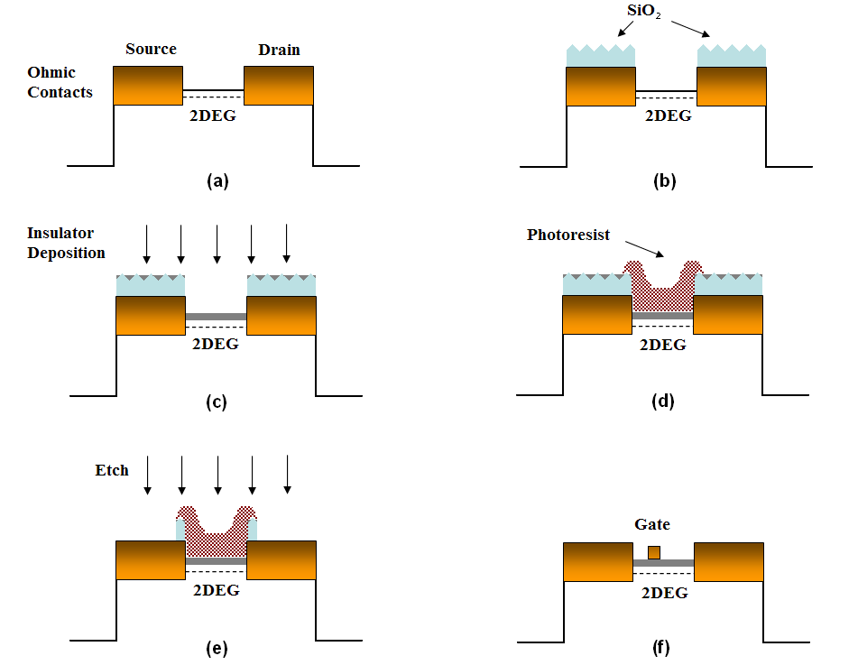

Figure 1. Fabrication procedures for MISHFETs

- Characterization and Discussion

As examined by the transmission line measurement (TLM), the ohmic contact property does not degrade after the insulator deposition – the average ohmic contact resistance before and after the fabrication processes remained the same at about 3 Ω∙mm. Therefore it proved that the SiO₂ protection layer works effectively. Also, a test sample that followed these procedures but removed the gate dielectric before gate metallization showed the same saturation current and pinch-off voltage, compared with conventional fabricated HFET control sample, so the deposition of gate insulator does not damage the channel notably.

Figure 2 shows the typical I_{ds}-V_{ds} and gate leakage current characteristics on all control and MISHFET samples at room temperature. The data are all from devices with gate length/width of 2/40 μm and source-drain spacing of 6 μm. For the control sample, positive gate bias will induce significant leakage current that limits the input signal’s dynamic range, while all MISHFETs shows orders of magnitude in decrease of leakage current. Si₃N₄ and PZT samples show similar leakage current range as low as 10 pA at -8 V gate bias, but it is worth mentioning that the uniformity of Si₃N₄ sample is better than PZT sample, showing a higher crystal quality achieved by the PECVD system.

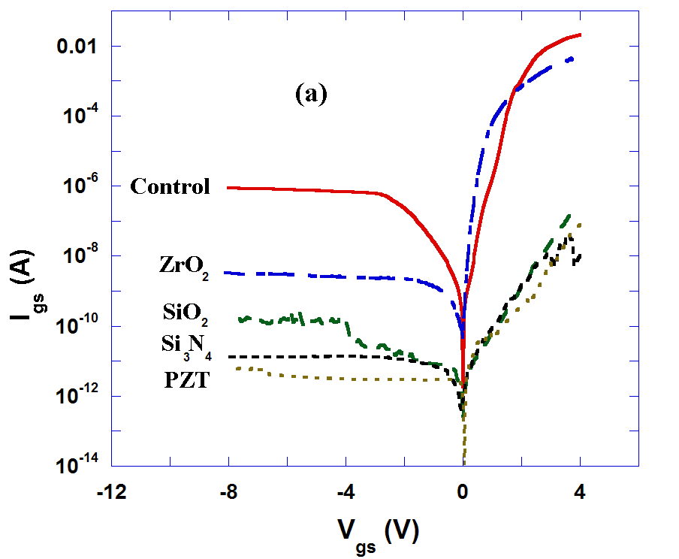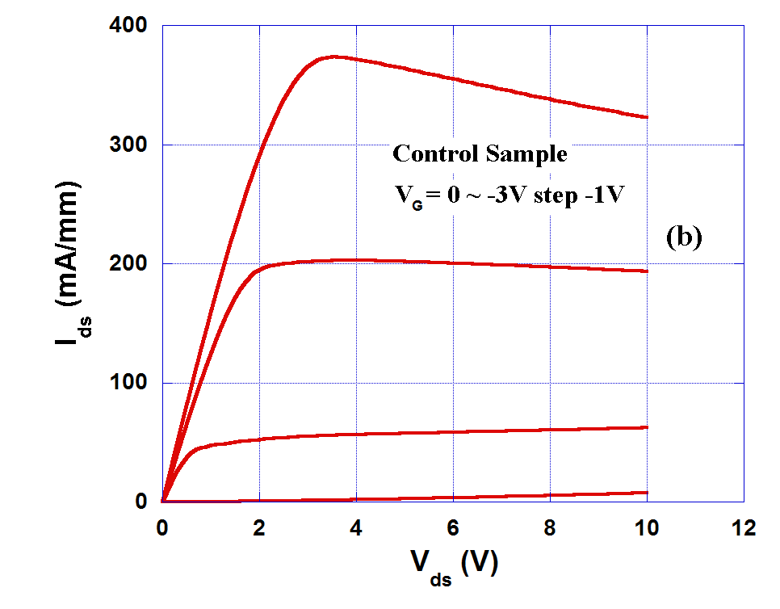
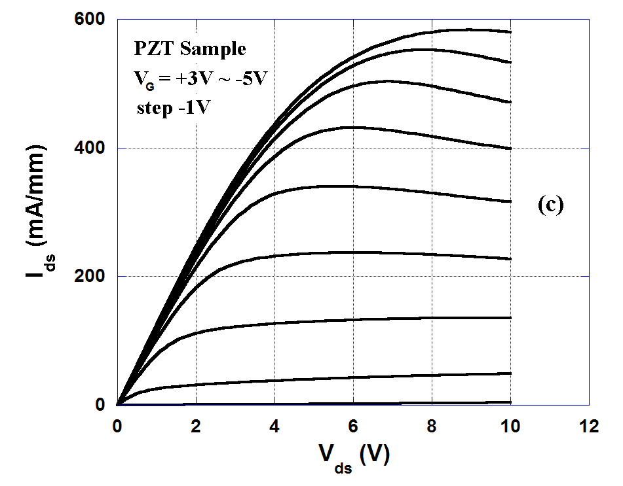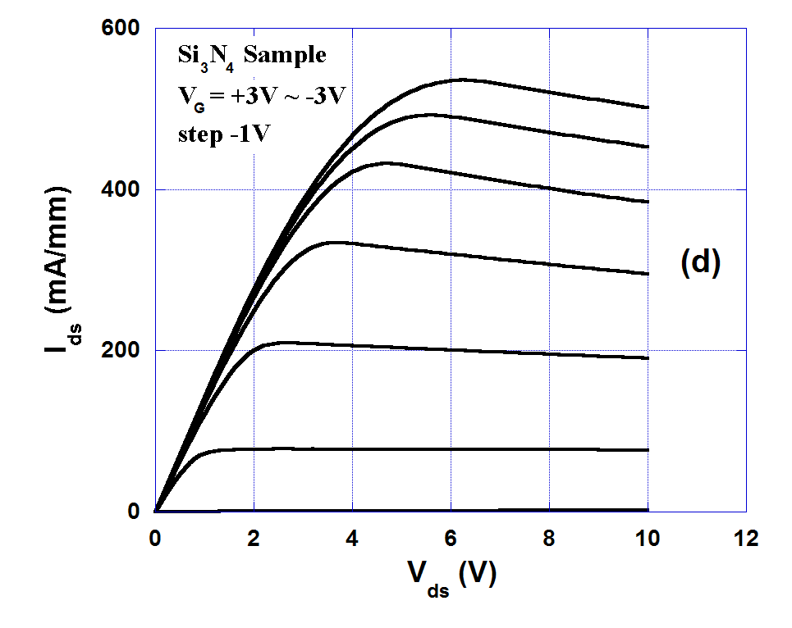
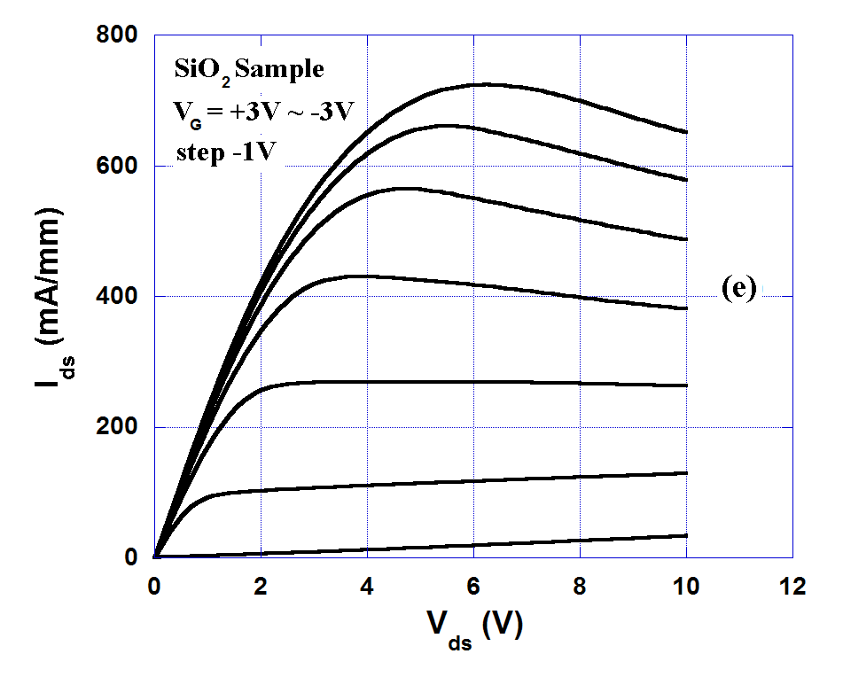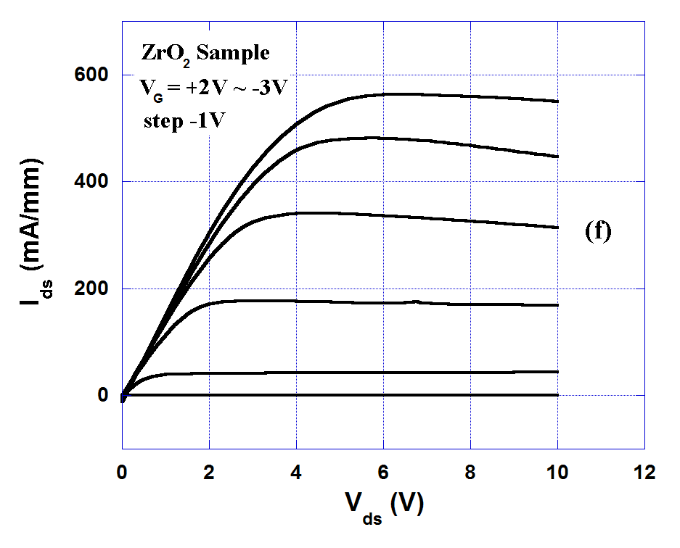

Figure 2. Typical leakage current and IV characteristics on control and all MISHFETs samples

The control sample shows good pinch-off and saturation properties. The reduction of the drain-source current is due to the self-heating. All MISHFETs can be applied up to +5 V gate bias without notable leakage current except the ZrO₂ sample. Under +3 V gate bias, the maximum current level can be enhanced, with the best reaching 700 mA/mm on the SiO₂ sample. Compared with the control sample, some of the MISHFETs also show higher saturation current at the zero bias, probably because of the passivation effect. No increase, except the PZT sample, in pinch-off voltage is observed for the MISHFETs due to the use of very thin dielectrics layers.

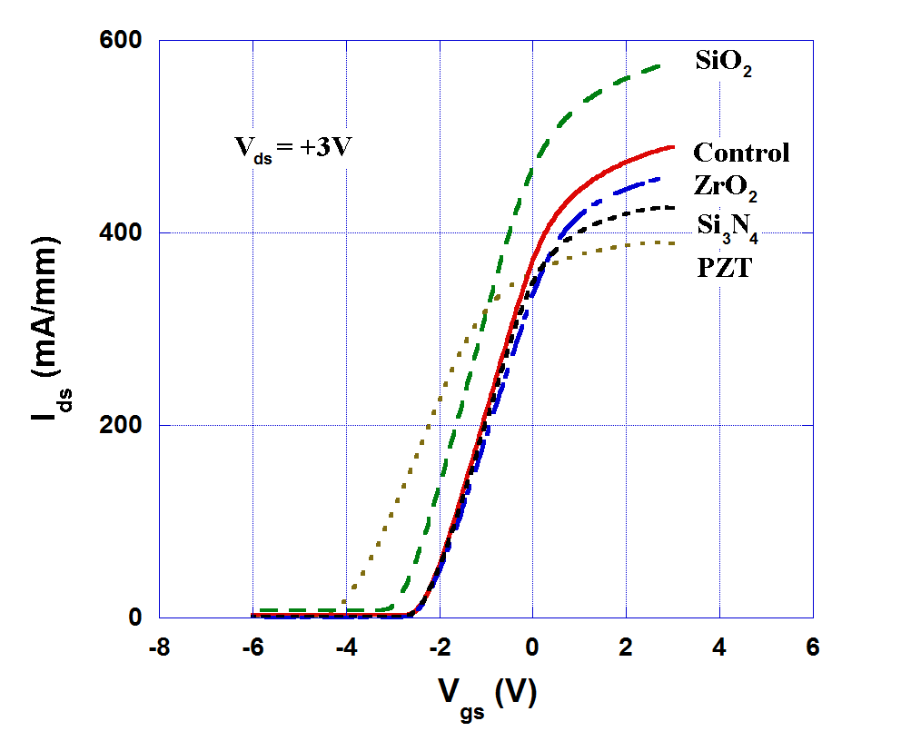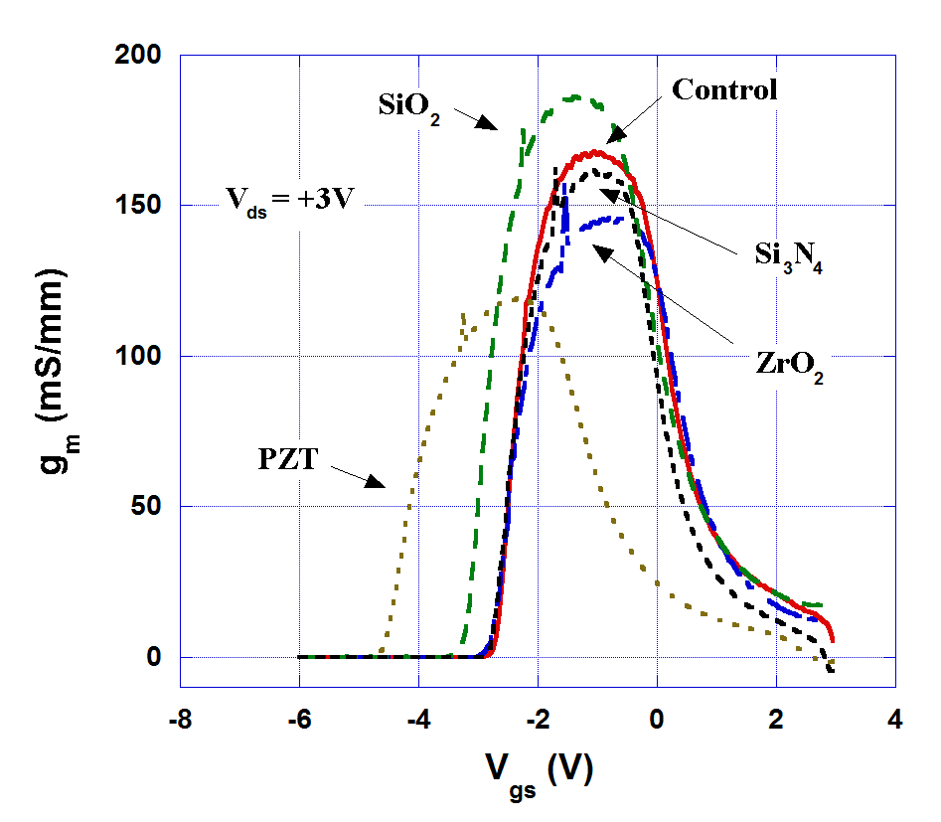

Figure 3. Drain current and transconductance at Vds = 3V on control and all MISHFETs samples

Under the fix drain bias (+3V), the dependence of drain-source current on the gate bias and the transconductance properties of all FETs are shown in Figure 3. It is found that the thin Si₃N₄ and ZrO₂ gate dielectrics samples have a slightly reduction in transconductance, while the threshold voltage is unaffected as compared with control sample. The SiO₂ gate dielectric improves both the transconductance and the saturation current by around 10~15 %, probably caused by the effectively removing of surface states. On the other hand, transconductance drops from 170 mS/mm to 120 mS/mm on PZT sample, which is considered as the result of the larger separation between the gate and the 2DEG channel with the presence of dielectrics. However, considering that the thickness of PZT is much larger than the other insulators, the decrease in transconductance is less significant due to the high- κ nature of PZT.

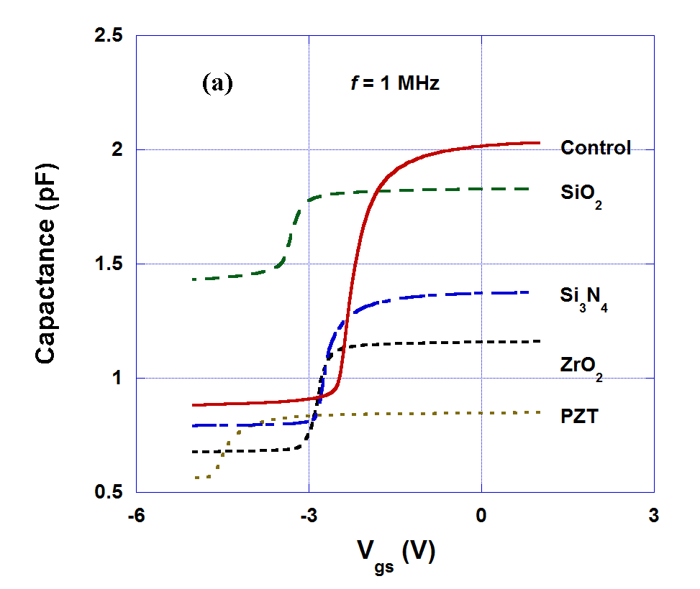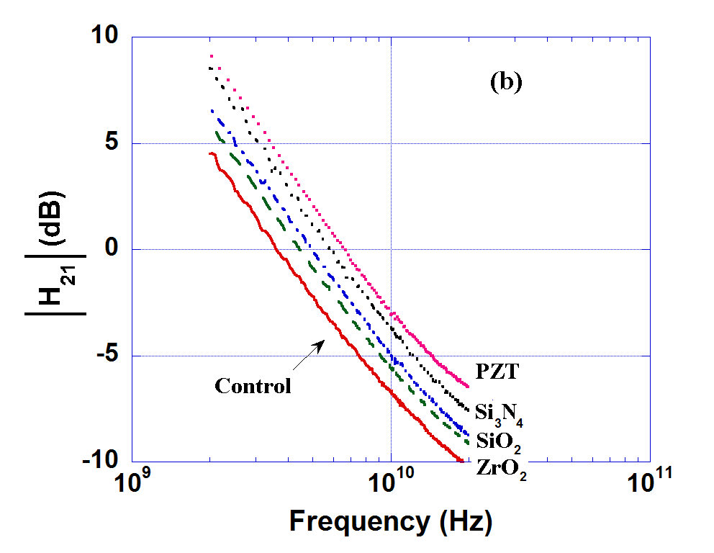
Figure 4. (a) C-V measurements at 1 MHz; (b) current cut-off frequency obtained from RF S-parameter measured at 2GHz ~ 20 GHz

Figure 4 (a) shows the C-V measurements at 1 MHz on control and MISHFETs samples with the same dimension. A sharp transition could be observed at the threshold voltage consistent with the values obtained from I-V measurements. For MISHFETs, at the 2DEG accumulation stage, the total capacitance can be expressed as:
(1)
Under the zero gate bias condition, the thickness of insulators and the total capacitance are related by:
(2)
The dielectric constant for AlGaN and the insulators used in this study are listed in Table 1, along with the calculated and experimental (estimated from the calibration growth) thicknesses of each material. Note that the dielectric constant of PZT is strongly dependant on the growth conditions^{[15]}, hereby we took a estimated average value of 200. The SiO₂ and Si₃N₄ thicknesses show agreement between calculated and experimental data, while the calculated PZT and ZrO₂ thicknesses are much larger. This may be accounted by the reduction of the actual dielectric constant, due to the different crystallization conditions of those high- κ materials on GaN. The on-wafer S-parameters of the devices were measured with HP 8510B network analyzer system up to 20 GHz. The drain bias was set around 6~7 V and gate bias used 2~3 V on different samples. As seen form Figure 4 (b), the cut-off frequency (f_{T}), corresponding to the zero gain value of h₂₁, of all MISHFETs are enhanced with the highest one achieved by PZT sample. Notice that the transconductance of PZT sample is lower, therefore the gate capacitance of it needs to be even smaller to increase f_{T}, which is consistently observed from C-V data shown in Figure 4 (a).

 | ε | Experimental (nm) | Calculated(nm)
AlGaN | 8.9 | 30 | -
SiO₂ | 3.9 | 3 | 2
Si₃N₄ | 7.5 | 3 | 9
ZrO₂ | 20 | 2 | 32
PZT | 200 | 50 | 700

Table 1. Dielectric constant, experimental and calculated thickness of all insulators

- Summary

AlGaN/GaN heterojunction field-effect transistors with different gate insulators layers were successfully grown and fabricated. The obstacle of ohmic contact degradation during high temperature deposition in order to get high quality insulator layers was overcome by utilizing SiO₂ protection layers. TLM measurements confirmed that good ohmic contacts were maintained despites the processes. With the help of gate insulators, the reverse-bias leakage current could be dramatically reduced as compared with the normal devices, reaching 10 pA for Si₃N₄ and PZT samples. The drain-source saturation current increases when applying forward gate bias, and almost doubles on the SiO₂ sample, which also shows slightly higher transconductance probably due to the passivation and removal of the surface states. PECVD deposition can provide better insulator material quality, proved by thickness calculation from C-V measurements. Large variations between calculated and experimental thicknesses on ZrO₂ and PZT layers indicated their imperfection of crystallization conditions on GaN surface. RF measurements showed a higher cut-off frequency can be obtained on PZT MISHFET, consistent with the lowest capacitance as measured. With a much thicker layer that can be applied as gate dielectric, high-κ PZT material is a good candidate for MISHFET on microwave applications.

Reference:

[1] P. Kordoš, G. Heidelberger, J. Bernát, A. Fox, M. Marso, and H. Lüth, “High-power SiO₂/AlGaN/GaN metal-oxide-semiconductor heterostructure field-effect transistors” Appl. Phys. Lett., 87 (14), 143501 (2005).
[2] P. D. Ye, B. Yang, K. K. Ng, J. Bude, G. D. Wilk, S. Halder and J. C. M. Hwang, "GaN metal-oxide-semiconductor high-electron-mobility-transistor with atomic layer deposited Al₂O₃ as gate dielectric", Appl. Phys. Lett., 86 (6), 063501 (2005).
[3] Ruonan Wang, Yong Cai, Chi-Wai Tang, Kei May Lau, "Enhancement-Mode Si₃N₄/AlGaN/GaN MISHFETs", IEEE Electron Device Lett., 27 (10), 793-795 (2006)
[4] S. Lawrence Selvaraj, Tsuneo Ito, Yutaka Terada, and Takashi Egawa, "AlN/AlGaN/GaN metal-insulator-semiconductor high-electron-mobility transistor on 4 in. silicon substrate for high breakdown characteristics", Appl. Phys. Lett., 90 (17), 173506 (2007).
[5] Chang Liu, Eng Fong Chor, and Leng Seow Tan, "Investigations of HfO₂/AlGaN/GaN metal-oxide-semiconductor high electron mobility transistors", Appl. Phys. Lett., 88 (17), 173504 (2006).
[6] G. Simin, A. Koudymov, H. Fatima, J. P. Zhang, J. Yang, M. A. Khan, X. Hu, A. Tarakji, R. Gaska, and M. S. Shur, "SiO₂/AlGaN/InGaN/GaN MOSDHFETs", IEEE Electron Device Lett., 23 (8), 458-460 2002
[7] J. W. Johnson, B. Luo, F. Ren, B. P. Gila, W. Krishnamoorthy, C. R. Abernathy, S. J. Pearton, J. I. Chyi, T. E. Nee, C. M. Lee, and C. C. Chuo, "Gd₂O₃/GaN metal-oxide-semiconductor field-effect transistor", Appl. Phys. Lett., 77 (20), 3230 (2000).
[8] Y. Cai, Y. G. Zhou, K. J. Chen, and K. M. Lau, "III-nitride metal-insulator-semiconductor heterojunction field-effect transistors using sputtered AlON thin films", Appl. Phys. Lett., 86 (3), 032109 (2005).
[9] Masataka Higashiwaki, Takashi Mimura and Toshiaki Matsui, "30-nm-Gate AlGaN/GaN Heterostructure Field-Effect Transistors with a Current-Gain Cutoff Frequency of 181 GHz", Jpn. J. Appl. Phys., 45 (42), L1111–L1113 (2006).
[10] Michel Marso, Gero Heidelberger, Klaus Michael Indlekofer, Juraj Bernát, Alfred Fox, P. Kordoš, and Hans Lüth, "Origin of improved RF performance of AlGaN/GaN MOSHFETs compared to HFETs", IEEE Trans. Electron Devices, 53 (7), 1517-1523 (2006).
[11] M. Asif Khan, X. Hu, A. Tarakji, G. Simin, J. Yang, R. Gaska, and M. S. Shur, "AlGaN/GaN metal–oxide–semiconductor heterostructure field-effect transistors on SiC substrates", Appl. Phys. Lett., 77 (9), 1339 (2000).
[12] Bo Xiao, Xing Gu, Natalia Izyumskaya, Vitaliy Avrutin, Jinqiao Xie, Huiyong Liu, and Hadis Morkoç, "Structural and electrical properties of Pb(Zr,Ti)O₃ grown on (0001) GaN using a double PbTiO₃/PbO bridge layer", Appl. Phys. Lett., 91 (18), 182908 (2007).
[13] Xing Gu, Natalia Izyumskaya, Vitaly Avrutin, Bo Xiao, and Hadis Morkoç, "Epitaxial growth of ZrO₂ on GaN templates by oxide molecular beam epitaxy", Appl. Phys. Lett., 91 (2), 022916 (2007).
[14] Youn-Seon Kang, Qian Fan, Bo Xiao, Ya. I. Alivov, Jinqiao Xie, Norio Onojima, Sang-Jun Cho, Yong-Tae Moon, Hosun Lee, D. Johnstone, and Hadis Morkoç, Young-Soo Park, "Fabrication and current-voltage characterization of a ferroelectric lead zirconate titanate/AlGaN/GaN field effect transistor", Appl. Phys. Lett., 88 (12), 123508 (2006).
[15] Andrei T. Bartic, Dirk J. Wouters, Jin Sing, Gerd Norga, Hugo Bender, Herman E. Maes, "Quantitative Determination of the Dielectric Constant of the Interfacial Layer in PZT Ferroelectric Capacitors", Proceedings of the Eleventh IEEE International Symposium on Applications of Ferroelectrics, 24, 73-76 (1998).

Email: fanq@vcu.edu

