1/f Noise Inside a Faraday Cage
Peter H. Handelª and Thomas F. George^{b}
ªDepartment of Physics & Astronomy and Center for Nanoscience
University of Missouri-St. Louis, 1 University Boulevard, St. Louis, MO 63121, USA
^{b}Office of the Chancellor and Center for Nanoscience, Department of Physics & Astronomy and Department of Chemistry & Biochemistry, Univ. of MO-St. Louis, St. Louis, MO 63121, USA
Abstract. We show that quantum 1/f noise does not have a lower frequency limit given by the lowest free electromagnetic field mode in a Faraday cage, even in an ideal cage. Indeed, quantum 1/f noise comes from the infrared-divergent coupling of the field with the charges, in their joint nonlinear system, where the charges cause the field that reacts back on the charges, and so on. This low-frequency limitation is thus not applicable for the nonlinear system of matter and field in interaction. Indeed, this nonlinear system is governed by Newton’s laws, Maxwell’s equations, in general also by the diffusion equations for particles and heat, or reaction kinetics given by quantum matrix elements. Nevertheless, all the other quantities can be eliminated in principle, resulting in highly nonlinear integro-differential equations for the electromagnetic field only, which no longer yield a fundamental frequency. Alternatively, we may describe this through the presence of an infinite system of subharmonics. We show how this was proven early in the classical and quantum domains, adding new insight.
Keywords: 1/f Noise, Quantum 1/f Noise, Turbulence, Faraday Cage, Screening.
PACS: 05.40.-a, 05.45.-a, 47.27.-e

Introduction
We explain here the existence of quantum 1/f noise at frequencies below the lower frequency cutoff of the electromagnetic field in the Faraday cage. One could argue against this, based on the solution of Maxwell's equations for the free electromagnetic field with the usual homogeneous boundary conditions applicable to electromagnetic Helmholtz resonators. However, both the coherent and conventional quantum 1/f effects, which together represent the observed fundamental quantum 1/f noise, are caused by the nonlinearity of the system of particle and field, e.g., of an electron (or many electrons) and the electromagnetic field. The eigenstates of the free electromagnetic field are quite different from those of the nonlinear “system of matter and field in interaction.” Like any nonlinear system, this particle-field system also has an infinite system of sub-harmonics, extending down to the frequency zero.
It is true that any free electromagnetic field in an ideal (lossless, perfectly uncoupled from the external world) cavity can be expanded in terms of the cavity modes and can have only frequencies larger than the fundamental mode, which represents the lower cutoff of the frequency spectrum of the free field. However, a simple example can illustrate the magnitude of the error connected with claiming that in all cases the actual electromagnetic field, describing the system of matter in interaction with the electromagnetic field in an ideal cavity, can only have frequencies that are eigenfrequencies of the free-field (empty) cavity modes. Consider a cavity with an inner diameter of the order of 1m, which would have a lowest frequency of the order of the order of 100 MHz for the free electromagnetic field. A battery connected to capacitor plates encompassing most of the space in the cavity, with very small conduction between the plates, can produce an electric (and magnetic) field that slowly dies out during a year while the battery discharges. It can be completely enclosed, with the whole circuit, in that resonant cavity. This is a field that contains Fourier frequencies down to 10⁻⁷ Hz, but it is not a free field. It proves that the restriction to high frequencies rigorously applies only for the free field, with no electric charges coupled in, and with no matter included.
All this may seem difficult to understand for some critics of the quantum theory of 1/f noise, because for them (1) the direct calculation that displays the nonlinearity of the system of matter and field may not be clear, or (2) the direct connection between nonlinearity and 1/f noise may not be clear, or (3) because the generation of sub-harmonics in the nonlinear system, and their ability to extend the 1/f law to arbitrarily low frequencies may not be obvious. These subjects are considered in Sec. 2 in simple, directly accessible, classical physics language, where the system of equations of motion and diffusion for electrons and holes in a semiconductor is solved together with Maxwell's equations and with the heat diffusion equation by reducing it all to a closed, third-order nonlinear equation for the components of the magnetic field at low frequencies. A similar treatment is also referred to Sec. 2 for the case of metals. In both cases, the infinite system of coupled nonlinear integro-differential equations resulting for the correlation functions of any order, describing homogeneous isotropic turbulence, is truncated. This is done by using the method introduced by Heisenberg [1] in 1946 to construct the first dynamical theory of hydrodynamic turbulence: the fourth-order correlation function is approximated in terms of the second order correlation function with a quasi-normality hypothesis. For homogeneous isotropic turbulence, this was shown by Handel to yield a universal 1/f power spectrum [2]-[6] for the field components and for the turbulent currents. Later, after many attempts to find zero-threshold instabilities that could feed the turbulence [7], Handel quantized the turbulence theory [8]-[18], noticing that the universal 1/f noise result was in fact a part of quantum electrodynamics (QED), allowing calculation of the noise magnitude.
Indeed, all these classical considerations have a quantum mechanical (QM) equivalent, where the quantum theory of 1/f noise is in fact a new aspect of QM and QED [19]-[22], and is known as quantum 1/f noise [8]-[18]. It is in essence the quantized form of the Handel's turbulence theory of 1/f noise [2]-[6]. The coherent quantum 1/f effect is derived elsewhere [12]-[15]. A generalization of Handel's turbulence theories developed for semiconductors, metals, and traffic on highways, has been obtained [12], which derives a universal sufficient criterion [12] for 1/f spectra from arbitrary nonlinear systems. There the criterion is also successfully applied to electrodynamics [12]. This provides the epistemological and mathematical basis for expecting 1/f noise at low frequency for QED.
Furthermore, quantum 1/f noise is not caused or even affected by the quantum interactions of charge carriers with the thermal radiation background or with any photons causing induced emission and absorption processes, so it is not affected by their energetic width. The photon modes are strongly attenuated and acquire very large width in conducting media in a wide frequency interval, but this does not affect the quantum 1/f noise that is shown to be caused only by the electromagnetic vacuum state. This thermal radiation background independence of quantum 1/f noise was rigorously derived earlier [9]-[11], by first proving the statistical independence of spontaneous and induced radiation processes. The vacuum state does not acquire any width. This is another way through which we can understand why the quantum 1/f noise (a) is unaffected by the presence of a thermal radiation background, that was proven only contribute a small white noise term, and (b) is unaffected by the presence of a Faraday cage, a resonator, or even copper walls of infinite thickness: all these affect just the width or lifetime of the photons, not of the vacuum.

2. Nonlinearity of the System of Matter and Field
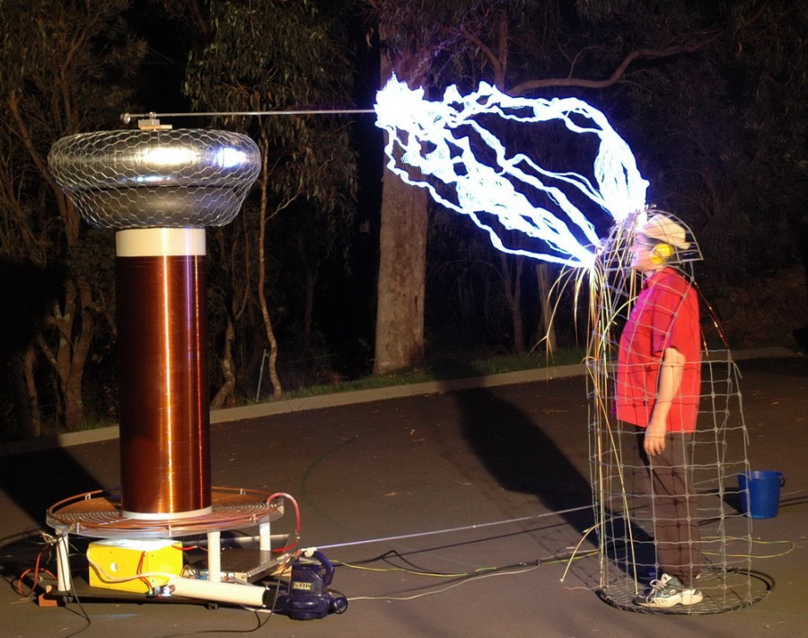
Maxwell's equations are linear, as long as the sources are not functions of the field. However, in reality, the field caused by the electrons acts back on them, and modifies their motion. This is seen directly, considering the electric current density j = nev of the electrons in the Ampere-Maxwell equation, and the momentum density nmv as the time integral of the force j×B per unit volume from Newton's equation. Then,

Fig. 1: Gas discharges also display the fundamental particle-field system nonlinearity, and many more.

∇×H = (∂/∂t)D+j = (∂/∂t)D+(e/m)∫[ ∇×H-(∂/∂t)D] ×Bdt ≈ (e/m)∫[∇×H]×Bdt (2.1)

The last form is for low-frequency processes, important for 1/f noise, in which the displacement current can be neglected. Considering B = μH, this is a closed nonlinear equation for the magnetic field, that reflects Newton's equation as well as the Ampere-Maxwell equation, and proves our point (Fig. 1). For an electrically-charged particle, or even an electron, quasi-elastically bound to a position of equilibrium inside an ideal cavity, with a soft elastic constant k resulting in a very long period of oscillation (m/k)^{1/2} of the particle and of its field inside the cavity, we obtain in the same way

∇×H ≈ (e/m)∫[∇×H]×Bdt -(k/m)∫∫dt dt'∇×H (2.2)

It is thus also described by a closed nonlinear integro-differential equation for B as in Eq. (2.1), but with a double time-integration in the last term. Equations (2.1) and (2.2) are nonlinear, and their solutions are fundamentally different from the free electromagnetic field. The closed equations for the examples with the battery and with the capacitor are even more complicated. The best example is found in our turbulence theory [2]-[6], where a large system of plasma equations for electrons and holes in semiconductors is reduced to a single closed, third-order nonlinear, equation for each of the three magnetic field components b_{α}. For simplicity, we consider the electron-hole plasma in an unlimited volume of a symmetrical intrinsic semiconductor with equal mobilities ≡ e/ν and concentrations n_{n}=n_{p}=n of the holes and electrons. Let us denote by P_{n},P_{p} the partial pressures of electrons and holes, and by P the total pressure of the current carriers. Adding and subtracting the momentum transport equations for electrons and holes, and neglecting the inertial terms at low frequencies, we obtain

νv+ = (e/2c)v-×B - (1/2n)∇P; νv- = 2e[E + v+×B/c] - (1/n)∇(Pp - Pn), (2.3)

∇⋅v+= 0 (n = const); ∇ ×E = -(1/c)∂B/∂t, ∇ ×B = 4πenv-/c, ∇⋅B = 0. (2.4)

Here v- and v⁺ are the difference and half the sum of the hole and electron drift velocities, and ν is a friction coefficient defining the conductivity σ = 2e²n/ν. Fourier integral expansion and elimination all other quantities, yields [2]-[6], with s=κ/k,
. 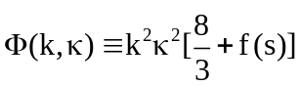 (2.5)
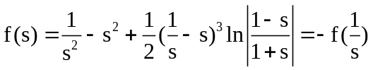; u(k,x) = (h/k3-ε) e-|x|m, wαβ(k,τ) ≡ (L/2π)3<bα*(k,t-τ)bβ(k,t)>; wαβ(ω) = (1/π)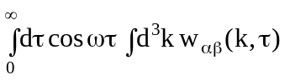 = δαβ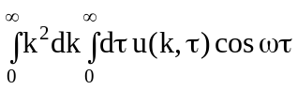 = hδαβ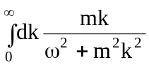 = 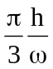δαβ, (2.6)

Which is a universal 1/f spectrum in the ε=0 limit [2]-[6]. Q1/f theory determines h&ε.

References
1. W. Heisenberg: Z. Physik 124, 628 (1948); Proc. Roy. Soc. London A 195, 1042 (1948).
2 P.H. Handel, Phys. Rev. A 3, 2066 (1971);.
3. P.H. Handel, in Proceedings of the XVIIIth International Symposium on Turbulence of Fluids and Plasmas (Brooklyn Polytechnic Institute. Press, New York, 1969), pp. 381-395.
4. P.H. Handel. Physica Stat. Sol. 29, 299 (1968).
5. P.H. Handel, Z. Naturforschung 21a, 579 (1966).
6. P.H. Handel, "Theory of 1/f Noise in Semiconductors," Stud. Cerc. Fiz. Roum. 18, 993-1055 (1966).
7. J.O. Hinze, Turbulence (McGraw Hill, New York, 1959).
8. Search in Quantum 1/f Bibliography, and Integral List of Papers in Vita at www.umsl.edu/~handel.
9. P.H. Handel, in Proceedings of the IInd International Symposium on 1/f Noise, edited by C.M. Van Vliet and E.R. Chenette (University of Florida Press, Gainesville, 1980), pp. 96-110.
10. P.H. Handel, Phys. Rev. A 38, 3082 (1988).
11. P.H. Handel and J. Xu, in Proc. of the 5th van der Ziel Symposium on Quantum 1/f Noise and Other Low Frequency Fluctuations in Electronic Devices, edited by P.H. Handel and A.L. Chung (St. Louis, 1992), AIP Conference Proceedings 282, 14-20 (1993) ISBN 1-56396-252-7.
12. P.H. Handel, in Proc. XIIth Int. Conf. on Noise in Physical Systems and 1/f Fluctuations, P.H. Handel and A.L. Chung Eds., AIP Conf. Proceedings 285, 162-171 (1993) ISBN 1-56386-270-5.
13. P.H. Handel, Physica Status Solidi b 194, 393 (1996).
14. P.H. Handel, IEEE Trans. Electronic Devices 41, 2023 (1994).
15. P.H. Handel, in Wiley Encyclopedia of Electrical and Electronics Engineering, Vol. 14, edited by J. G. Webster (Wiley, New York, 1999), pp. 428-449.
16. P. H. Handel, Phys. Rev. Lett. 34, 1492 (1975).
17. P. H. Handel, Phys. Rev. A 22, 745 (1980).
18. P.H. Handel and A.G. Tournier, “Nanoscale Engineering for Reducing Phase Noise in Electronic Devices,” invited paper, Proc. IEEE 93, 1784-1814 (2005).
19. T.W.B. Kibble, Phys. Rev. 173, 1527; 174, 1882; 175,1624 (1968);
20. T.W.B. Kibble, J. Math. Phys. 9, 315 (1968).
21. D. Zwanziger, Phys. Rev. D 7, 1082 (1973); Phys. Rev. Lett. 30, 934 (1973); Phys.
Rev. D 11, 3481, 3504 (1975); J.D. Dollard, J. Math. Phys. 5, 729 (1965).
22. J. M. Jauch and F. Rohrlich, The Theory of Photons and Electrons (Springer, Heidelbg, 1976).

