Noise in Quartz Crystal Microbalance

Petr Sedlak, Josef Sikula, Jiri Majzner
Dept. of physics, FEEC,
Brno University of Technology
Brno, Czech Republic
sedlakp@feec.vutbr.cz
Martin Vrnata, Filip Vyslouzil
Premysl Fitl, Dusan Kopecky
Dept. of Physics and Measurement,
Institute of Chemical Technology,
Prague, Czech Republic
Peter H. Handel
Dept. of Physics and Astronomy, University of Missouri,
St. Louis, USA

Abstract—There are several mechanisms that are related to fluctuation phenomena in QCM. The aim of our research is oriented to study the sensitivity and influence of different kind of noises on sensor resolution. Our experiments are provided on sensor with sorption layer of polypyrrole which is suitable for detection of water vapor. Based on these experiments, we suppose that 1/f noise caused by quartz internal friction and adoption-desorption (generation-recombination) noise from analyzed gas create the main components of measured noise spectral density. The value of the adoption-desorption noise depends on the physical and chemical parameters of analyzed gas and it is proportional to gas density. Adsorption-desorption kinetics is described by Kolmogorov equation and compared with Wolkenstein and Langmuir equations.
This research has been supported by the Czech Ministry of Education in the frame of MSM 0021630503 Research Intention MIKROSYN New Trends in Microelectronic System and Nanotechnologies and MSM 604 613 7306 as well as by the Grant Agency of Czech Republic No. 102/09/1920.
Keywords-quartz crystal microbalance; Kolmogorov equations; adsorption-desorption noise; noise spectroscopy

Introduction
Quartz crystal microbalance (QCM) belongs to a group of high-sensitive sensors for detection of chemical substances dissolved in gas or liquid. This type of sensor is applied routinely by biologists and chemists to obtain information about chemical processes. The core of QCM is the AT-cut quartz crystal that oscillates at a resonant frequency which is determined by mass and geometry of the crystal mass as well as several other factors (temperature, applied voltage etc.). The section for the cut is chosen specially for the shear oscillations to possess the first-order zero temperature coefficient, which is necessary to provide thermal stability to the devices. The quartz electrodes are covered by sorption layers with affinity to the molecules of the detected matter. Sorbed matter (molecules of the detected mass) represents mass increment and the change of the viscoelastic properties of the layer, which leads to the change of resonant frequency. Thus, selectivity is given by the choice of the material of the sorption layer. At a resonance frequency of 10-15 MHz, the sensitivity may reach 1 ng/cm² which corresponds to the monolayer of adsorbed substance [1]. The sensitivity depends on the stability of the oscillator and the accuracy and stability of the devices measuring the parameters of the quartz resonator.
Noise measurement and its evaluation represent a new approach of extracting more selective response from resistive [2-6] and surface acoustic wave [7] sensors. Experimental results revealed that exposure to different gases causes modification in the noise spectral density of sensor’s resistance fluctuations. Thus, noise spectroscopy might be highly useful for improving gas sensors selectivity if both theoretical models and adequate sensing devices can be developed [3]. Gomri et al [4] proposed a model of adsorption-desorption noise in metal oxide gas sensors, based on the free electron density fluctuation produced by the gas adsorption. Using this model for simulating the oxygen chemisorption – induced noise, they found that the contribution of oxygen adsorption-desorption noise to the noise spectra is a Lorentzian component having a corner frequency and low frequency magnitude which are specifics of the adsorbed gas.
The paper shows experimental results how absorption of detected gas molecules affects frequency fluctuations, and presents the model of adsorption-desorption noise, which is devoted on the basis of Kolmogorov equation for interaction between two reservoirs.

Measurement Setup
In QCM measurement, standard approach uses frequency and quartz crystal is a part of wideband oscillator circuit, whose frequency is controlled by the crystal properties (active method) [11]. A counter measures actual frequency in resolution 0.1 Hz or 1 Hz. Since this method is not enough sensitive to small frequency fluctuations, the measurement method was modified.
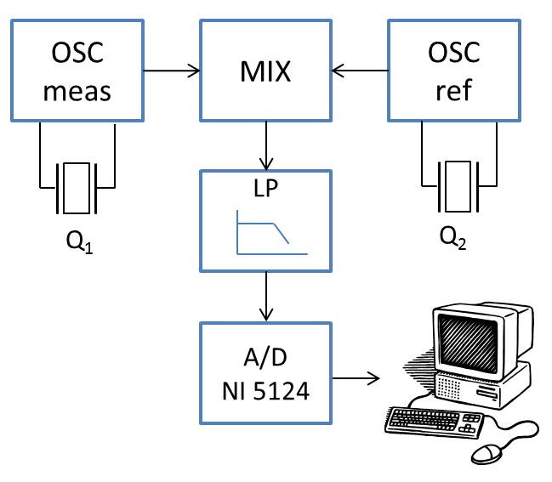
- Noise measurement setup for quartz crystal microbalance
The scheme of our measurement setup is shown in Fig. 1. The mixing principle is used for frequency Δf measurements of two independent (measuring and referencing) oscillators. Signal to noise ratio is improved by low-pass (LP) filter after mixer procedure. This one allows us separating of useful component of frequency Δf from both input signals and other parasitic components. Further, a data-acquisition card (NI 5124) triggers on the rise-edges of the output signal and stores these corresponding times on which the instantaneous frequency is estimated. Such a technique can acquire even a very small change of a resonant frequency.
The experimental study was carried out on two sensors with thin and thick sorption layer of polypyrrole (PPY) which is a material suitable for construction of QCM humidity sensors. The change of relative humidity from 0 % RH to 25 % RH causes the change of resonant frequency (-∆f) in the range 50-150 Hz. Sensor parameters (e.g. sensitivity, dynamic properties, time stability of response) depend not only on composition but even on the way of deposition of the sorption layer. Thus, PPY was deposited using Matrix Assisted Pulsed Laser Evaporation. The MAPLE technology [10] is a laser deposition method providing gentle mechanism for organic layer deposition. In MAPLE, a frozen phase consisting of a dilute solution of a high-molecular weight compound (basic material) in a low- molecular-weight solvent (matrix) is used as the laser target. Deposition takes place after the impact of a laser pulse with the surface of the frozen target. In an optimal case, the energy of the laser pulse is completely absorbed by the matrix, resulting in a strong local increase of temperature. The matrix molecules transfer their kinetic energy of thermal motion to the molecules of basic material. Hence the molecules of basic material are transferred to the substrate “mechanically”, with neither photolytic nor pyrolytic damage. The depositions were carried out using Nd:YAG laser (Quantel), operating at fourth harmonic frequency (wavelength 266 nm). Nd:AYG laser was used in a pulse mode with a 10 Hz repetition rate. The fluence F of the laser radiation was set by an attenuator to be F = 0.4 J cm⁻². The substrate - quartz crystal was placed at a distance of 30 mm. The deposited PPY layers have thicknesses ranging from 80 to 400 nm.

Fluctuation Mechanisms in QCM and Results
There are several mechanisms that are related to fluctuation phenomena. The fundamental noise include thermal noise, 1/f noise due to the quantum fluctuation and phonon scattering by defects, adoption-desorption noise from analyzed gas, thermo-mechanical noise, temperature fluctuation noise, electronic oscillator noise. The fluctuation mechanisms can be separated into two groups; the first one is related to quartz crystal and its electrical circuit, while the second one is related to adsorption desorption processes on the sorbent layer. Based on our experiments thermal noise, 1/f noise and generation-recombination (adsorption desorption) noise are supposed to be the main components of measured noise spectral density as shown in Fig.2. Thermal noise is given by interaction of phonons with electrons or holes and electric dipoles. Thermal fluctuations creates also component of 1/f noise due to frequency dependent conductivity [8]. The 1/f noise includes the quantum 1/f noise [10]. Both components were investigated in previous papers [8-10]. Absorption of detected matter affects frequency fluctuations by two ways in dependence on a thickness of deposited sorbent layer. Fig. 3 shows noise spectral density of QCM with thin active layer for different values of relative humidity. When relative humidity increases, the 1/f noise remains same while generation-recombination (GR) component corresponds to RH concentration. It is caused in increased flux density between sorbent layer of QCM and ambient environment.
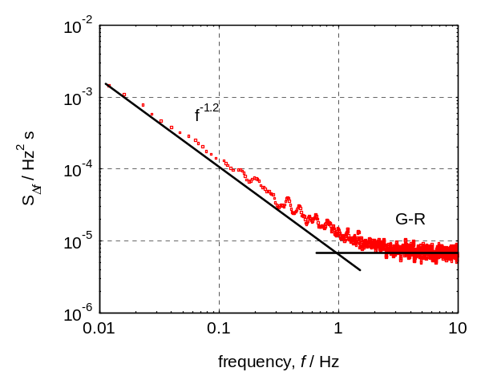
- Noise spectral density of QCM for relative humidity 30%, where S(Δf) is spectral density of frequency fluctuation
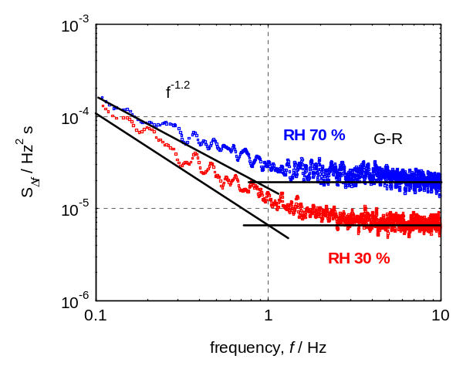
- Noise spectral density of QCM with thin sorbent layer for relative humidity 30% and 70%
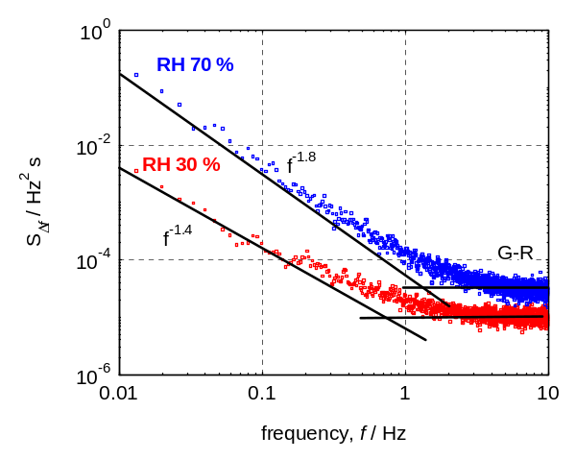
- Noise spectral density of QCM with thick sorbent layer for relative humidity 30% and 70%
In the case of quartz crystal microbalance with thick sorbent layer (see Fig. 4.), relative humidity increase represents shift of G-R component as well as 1/f noise component. We suppose that this change of 1/f noise component represents another generation-recombination process with long time constant. This process is probably caused by diffusion, which is connected to a potential barrier change due to ion adsorption of detected matter. In the paper our focus concentrates on formulating the model of adsorption-desorption noise without consideration of diffusion process in active layer.

Adsorption-desorption Noise
In previous section, two cases are presented how humidity increase affects noise spectral density. This section presents model when adsorption desorption noise reflects only to RH concentration. The value of the adoption-desorption noise depends on the physical and chemical parameters of analyzed gas.

Kolmogorov equation
A proposed model of adsorption-desorption noise is based on interaction between two reservoirs:
- analyzed gas with concentration n, temperature T and partial pressure p,
- sensor sorbent surface with total surface density of sites for adsorption of analyzed gas N₀, with surface density of sites occupied by analyzed gas molecules N_{t}

Transition probability intensities
The model supposes that the system is: (i) Markowian, (ii) near equilibrium, and (iii) generation-recombination processes may take place between these two reservoirs. The random process of the surface site is assumed to have two states and to be stationary with a constant transition probability intensity μ_{ij} defined by
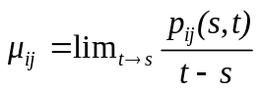 
where p_{ij} is the transition probability at time s from the i-state to the j-state at time t.
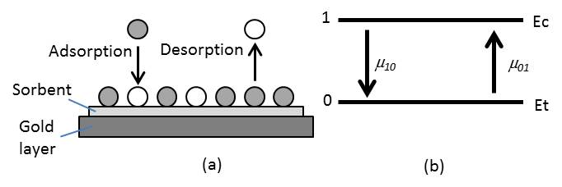
- (a) model of the adsorption-desorption processes on the quartz crystal layer, (b) the transition probability intensity for emission and capture
Fig. 5a shows the model of adsorption-desorption process on the quartz crystal sorbent layer. Desorption corresponds to molecule emission from sorbent, i.e. generation of free particle, and process of adsorption corresponds to recombination. Thus, the process is similar to generation-recombination in semiconductors. The transition probability intensity for emission and capture is schematically shown in Fig. 5b, where μ₀₁ is the transition probability intensity for the molecule emission and μ₁₀ - for capture. There are two physical quantities: the time τ_{c} for molecule captured on surface site, which is inversely proportional to the transition probability intensities μ₁₀
 =1_{c} 
and the time τ_{e} for molecule emission from the surface site, which is inversely proportional to the transition probability intensities μ₀₁
 =1_{e} 
The probabilities p_{ij} (t) of the transition from the state i into the state j are found by solving the Kolmogorov differential equations
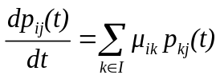  
for i, j = 0, 1, with the conditions p_{ii}(0)=1, p_{ij}(0)=0, for i≠j. In thermodynamic equilibrium the statistics that surface site is free or occupied by molecule is described by the absolute probability distributions Π₀ and Π₁. These ones are given by solving Kolmogorov equation in the form
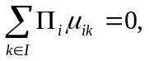  
where 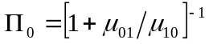 (6)
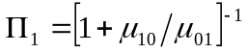 
The absolute probabilities distributions Π₀ and Π₁ are similar to Fermi – Dirac statistics.

Kinetic equation
Kinetic equation describing surface density of adsorbed molecules follows from (5) in the form
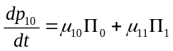 
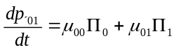 
where μ₀₀, μ₁₁ - intensity that system is persisting in the state 0 or 1 respectively, μ₀₁ = σ v_{T} n₁ - generation, μ₁₀ = σ v_{T} n - recombination
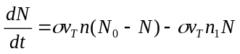  
Surface density of adsorbed molecules is proportion surface site cross section σ, adsorbed molecule thermal velocity v_{T}, concentration of adsorbed molecules n, sensor surface density of sites N₀ and effective concentration of occupied sites n₁.

Langmuir adsorption kinetics
Rate of formation of the monolayers can be express by
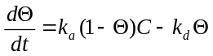 
where Θ = N/N₀ , C denotes concentration of analyzed gas molecules, k_{a} and k_{d} are the rate constants for adsorption and desorption processes, respectively. Integration of (11) and substitutions k_{obs} = k_{a} + k_{b} and k’ = C /(C + k_{d}/k_{a}) lead to
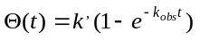 
If the fractional coverage Θ is measured as a function of time t, coefficients k_{obs} and k’ can be determined by fitting of (11) on experimental data.

Wolkenstein adsorption kinetics
Rate of formation of the monolayers can be express by
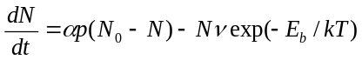  
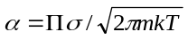  
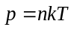 
Where Π is probability that the molecule approaching an adsorption centre will be fixed on the sensor surfaces, p - pressure of adsorbed gas, m - adsorbed molecule mass, σ - sensor site adsorption cross section, E_{b} binding energy of the adsorbed molecule and ν is oscillation frequencies of the corresponding particle (typically ν = 10¹² Hz).

Modelling of the adsorption-desorption noise
In order to calculate the expression of the fluctuation δN(t) around its value N₀ at the adsorption-desorption equilibrium on the thickness d of the sensing layer, small fluctuations of N around the value N₀ are considered as done in [3] and [4]. After some calculation procedures, the following differential equation is obtained [4]:
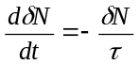 
where 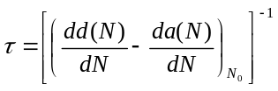 
Hence, using (16) and (17) the power density spectrum of the adsorbed molecules density fluctuation writes:
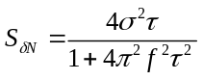 
where σ² denotes the mean square value of δN.

Conclusions
Experimental results showed that absorption of detected matter affects frequency fluctuations by two ways in dependence on a thickness of deposited sorbent layer. The paper focuses on adsorption-desorption noise without consideration of diffusion process in active layer, and presents its model, which is devoted on the basis of Kolmogorov equation for interaction between two reservoirs. The probability, that molecule will be captured on active layer of sensor, is proportional to adsorbed molecule thermal velocity and surface site cross section. The probabilities, that surface sites are free or occupied by molecules, are implied by Kolmogorov equation in the case of thermodynamic equilibrium when flow of emitted particles is same as flow of captured particles on active layer of sensor. The devoted probabilities distributions are similar to Fermi – Dirac statistics for semiconductors. Surface density of adsorbed molecules is proportion surface site cross section, adsorbed molecule thermal velocity, concentration of adsorbed molecules and sensor surface density of sites. Adsorption-desorption kinetics described by Kolmogorov equation is compared with Wolkenstein and Langmuir equations. On the basis of our model, the time τ_{c} for molecule capture can be estimated.

References
- F. N. Dultsev, E. A. Kolovsky, “QCM Operating in Threshold Mode as a Gas Sensor”, Langmuir 25 (20), 2009, pp 12195–12200
- L.B. Kish, R. Vajtai, C.G. Granqvist, “Extracting information from noise spectra of chemical sensors: single sensor electronic noses and tongues”, Sens. Actuators B 71, 2000, pp 55–59.
- S. Gomri, J.-L. Seguin, K. Aguir, “Modelling on oxygen chemisorption induced noise in metallic oxide gas sensors”, Sens. Actuators B, 107 (2), 2005, pp 722–729.
- S. Gomri, J.-L. Seguin, J. Guerin and K. Aguir, “Adsorption–desorption noise in gas sensors: modelling using Langmuir and Wolkenstein models for adsorption”, Sensors Actuators B 114, 2006, pp 451–9
- J. Smulko, J. Ederth, Y. Li, L. B. Kish, M. K. Kennedy, Frank E. Kruis, “Gas sensing by thermoelectric voltage fluctuations in SnO2 nanoparticle films”, Sensors and Actuators B 106, 2005, pp 708-712
- A.K. Vidybida, “Adsorption-desorption noise can be used for improving selectivity,” Sensors and Actuators A, vol. 107, pp. 233–237, 2003.
- G. Schmera, L.B. Kish, “Fluctuation-enhanced gas sensing by surface acoustic wave devices”, Fluctuations Noise Lett. 2 (2), 2002, pp 117–3.
- J. Majzner, P. Sedlak, J. Sikula, M. Strunc, “Noise in piezoceramics” AIP Conf. Proc. 922 (ICNF), Tokyo (Japan), 2007, pp 347-350
- J. Sikula, P. H. Handel and A. M. Truong, “Quantum 1/f Noise in Bio-Chemical Resonant ZnO Sensors”, AIP Conf. Proc. 922 (ICNF), Tokyo (Japan), 2007, pp 339-342
- P. Sedlak, J. Majzner, J. Sikula, “Mathematical model of electrical noise of piezoelectric sensor”, AIP Conf. Proc. 922 (ICNF), Tokyo (Japan), 2007, pp 335-338
- S. Kurosawa et al, "Gas sensor using high-frequency quartz crystal microbalance," Frequency Control Symposium and PDA Exhibition, 2001. Proceedings of the 2001 IEEE International, 2001, pp 462-464
- P.K.Wu et al, "The deposition, structure, pattern deposition and activity of biomaterial thin films by matrix-assisted pulsed-laser evaporation (MAPLE) and MAPLE direct write" Thin Solid Films 398–399, 2001, pp 607-614.

