Dependence of 1/f Noise on the Distance Between Wires
Quantum 1/f Proximity Effect

Peter H. Handel
Department of Physics and Astronomy & Center for Nanoscience
University of Missouri -Saint Louis
St. Louis, MO 63121, USA
handel@umsl.edu
Kobra Nasiri Avanaki
Department of Chemistry
University of Kansas
Lawrence, Kansas 66045, USA
l

Abstract— This paper shows that in certain conditions fundamental 1/f noise in a semiconductor sample is increased by the presence of another similar current-carrying sample located in the close vicinity. This proximity effect is described by simple formulas derived here. The paper displays the connection between coherent and conventional quantum 1/f effect in terms of the s-parameter, i.e., the ratio between magnetic and kinetic energy of the carriers. On this basis the proximity effect is introduced for the first time. It is shown to be important in the transition region between coherent and conventional quantum 1/f effect. This is just the region corresponding to nano-scale structures and devices. Therefore, the new effect will be important in nanotechnology allowing for lower 1/f noise by splitting up the nano-wire into several thinner wires, or wells, with the same total cross section.

Keywords— Current fluctuations in nanostructures, 1/f noise, Quantum 1/f Effect, Quantum 1/f noise, Quantum Wires.

Introduction
The transition region between the coherent and conventional quantum 1/f effects is given by
αH = αconv/(1+s) + αcohers/(1+s)
=(4α/3π)(Δv/c)2/(1+s) +(2α/π)s/(1+s),

for the quantum 1/f coefficient, or Hooge constant, αH, where s is a parameter that governs the transition. Here αconv and αcoher are the coefficients present before the weights 1/(1+s) and s/(1+s). Also, α =e2/ch=1/137 is the fine structure constant and αA = 2e2(Δv)2/3c3hin the conventional (first) term. We denoted by Δv the velocity change of the current carriers in the scattering process whose rate fluctuations we are describing. The coherence parameter s depends on the concentration n of carriers and on the transversal cross section area A of the quantum wire, conductor, semiconductor, sample or device. A is perpendicular to the direction of the current. Specifically, s = 2nAr0.

Here r0 = e2/mc2 is the classical radius of the electron, r0= 2.84 10-13cm. Therefore, s is twice the number of carriers in a salami slice of thickness equal to the classical diameter of the electron, normal to the direction of current flow. The resulting spectral density of fractional quantum 1/f current fluctuations δj/j is then given by the quantum 1/f coefficient αH through the relation Sδj/j(f)= αH/fN.
Consider two very long straight conductors of length L, of almost equal circular cross sections A₁ and A₁ ≈ A₂, both with approximate radius of the cross section a, carrying currents and and separated by a distance r between their axes. Then the magnetic energy, per unit length, becomes
(1)
As we explain after equation (3) below, ignoring the work done on the battery that keeps the currents I₁ and I₂ constant when we increase the distance between the wires, causes the usual energy considerations, which are based on the definition of energy as the work done by us on the system, to yield a wrong sign of the second term here. Substituting
(2)
into equation (1), we obtain
(3)
Here R is a large cutoff of the order of the radius of the circuits that contains the long straight conductors of length L. This parameter enters only logarithmically so it is not very important and can be determined experimentally, e.g. by measuring the resonance frequency of the circuit with a capacitor and tunable A.C. generators. Notice that for r=2a, when the two conductors fuse, the second term in equation (1) is practically zero and the magnetic energy is the well-known energy of a single cylindrical conductor of circular cross section A = A₁ + A₂. This is four times the energy of a single conductor of cross section A₁, in the case A₁ = A₂.
On the other hand, for r = R the second term can be combined with the first term in equation (1) as shown in equation (3), to yield simply the sum of the energies of the two infinitely separated parallel conductors. This is only two times the energy of a single conductor of cross section A₁, in the case A₁ = A₂. The approximation indicated in equation (1) uses the same effective radius a in the argument of the slowly varying logarithm present in the first term, as is used for each of the conductors separately. Note, however, that even using 2a or we are ignoring the additional magnetic energy caused by currents present inside the conductors i.e., inside
r =2a or r = radius. That would underestimate the magnetic energy by a constant term independent of r, which does not affect our calculation of the proximity effect. Indeed, It is known that the uniform current distribution inside the circular cross section of conductors just adds a term of 0.25 to the logarithm.
The second term in equation (1) is the interaction energy of the two conductors, is given by minus the work W_{m} done by us in the separation process against the electrodynamical attraction force between the conductors,
(4)
When the distance is increased from 2a to r. The integral is from 2a to r in equation (3), and yields the second term in equation (1) with opposite sign. The negative sign appears because in the separation process, the induced-Faraday-emf work WB done by the system of energy
(5)
on the agency (e.g. a battery) to keep the currents constant is twice as large as W_{m}, and of opposite sign. In fact, while we are doing the separation work W_{m} on the system of two conductors, the system, in turn, must do on the battery twice the work W_{m} performed by us on it, for the benefit of the agency that keeps the current constant in the two conductors. Indeed, denoting the fluxes through the circuits to which the two parallel conductors are belonging with Φ₁ and Φ₂ respectively.
(6)
Here the sum Σ runs over i =1 and 2. We obtain for the differential dW of the energy W of the system of two conductors in the form
(7)
This explains the minus sign in equation (1). Based on symmetry and A₁ ≈ A₂, we use equation (4) to write the magnetic energy corresponding to the first conductor
(8)
To generalize the definition of the parameter s we divide the magnetic energy of Eq. (8) by the kinetic energy of the drift component present in the motion vd of current carriers in the first conductor, per unit length
(9)
This yields
(10)
or

(11)
This form clearly displays the proximity effect in the second term of the expression obtained for the s-parameter of a wire, in the presence of a similar wire located at the distance r. Indeed, when we bring in A2 from infinity, (i.e., from r ≈ R), to the point of outright fusion with A1, (r ≈ a), s₁ increases by an amount equal to s₂. Fig. 1 (a), (b), and (c) show the overall s parameter as a function of the distance between the wires r. We consider two equal nanowires of radius (A1 = A2 = πa²) and circuit radius R = 10 m, n = 10¹⁷ cm⁻³, |Δv| = 10⁴ m/s, with different sizes of the common radius a of cross section of the wires. It shows that s can vary over a large interval as we see in Fig. 2, which contains both a, r, and the s parameter with R=10m, the size of circuit. The variation in this case is shown to be from s = 0 to s = 140.

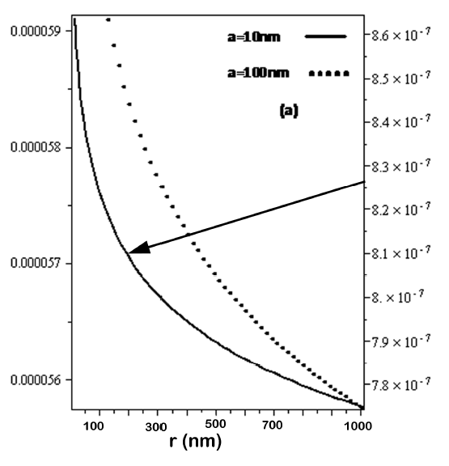
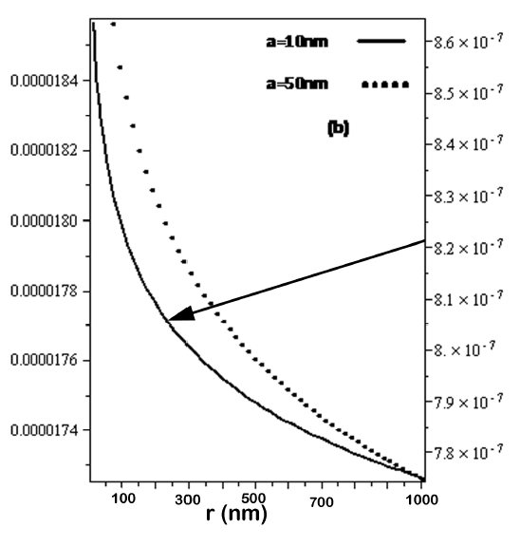

We can visualize the overall trend of the spectral density of fluctuations when we increase the distance between wires. Figs. 1. (a), (b), and (c) show the spectral density of fluctuation decreasing as a function of distance between wires, r, considering two equal nanowires (A1 = A2) and R = 10 m, n = 10¹⁷ cm⁻³, |Δv| = 10⁴ m/s, for different wire radius values.

DISCUSSION
As we see from Fig. 1, due to the smallness of (≈ 10⁻⁸ in our Example in Fig. 1) the 1/f noise spectral density is practically proportional to s in the interval
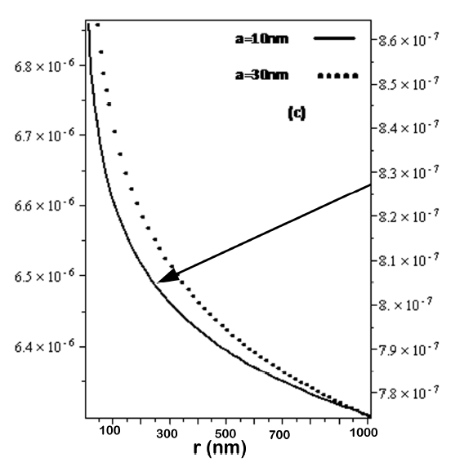
Fig. 1. (a), (b), and (c) The overall s parameter as a functionof the distance r between wires (r = 10nm - 1000nm). For R = 10 m, n = 10¹⁷ cm⁻³, |Δv| = 10⁴ m/s

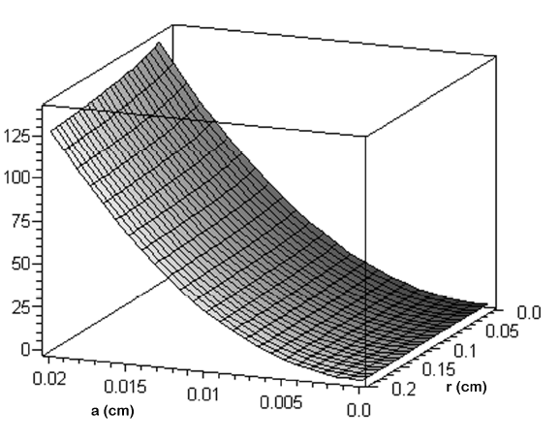
Fig. 2. The overall s parameter as a function of the distance r between wires (r =10nm - 1000nm). For R = 10 m, n = 10¹⁷ cm⁻³,
|Δv| = 10⁴ m/s

10⁻⁵ < s < 1. This corresponds to the transition to coherence. What we have proven in equation (11) is that anywhere in this transition region of small to ultra-small device sizes, the 1/f noise power doubles when we simply bring 2 wires or nano-devices closer to each other. When we separate them again, a 50% noise reduction can be achieved, by avoiding the proximity effect.
Our result can be easily generalized to arbitrary ratios between the parameters of the two wires, wells or devices, such as cross section, carrier concentration, drift velocities, etc by using equation (39). For instance, if you start from a nanowire and bring another wire which is macroscopic
(a = 1 mm) from a distance r ≈ R to where r ≈ a, then the s
parameter of the nanowire will vary from a very small number, e.g. s = 10⁻⁶ to a value s = s₁ + s₂ where s₂ is about 3.6 x 10⁹ for a copper wire with a =1 mm radius. This is a change by 12 orders of magnitude, as seen from the
prospective of the nanowire. From the prospective of the copper wire, it's s parameter did not change: it was 10⁹ before and remained 10⁹ after it fused with the nanowire. Both are considered to be very long, which means of the order of R.
In general, the proximity effect in the thinner of the two wires or devices will represent an increase by a percentage larger than 100%, and smaller than 100% in the thicker of the two wires. The generalization to any number of conductors is also trivial. This effect, based on the quantum theory of 1/f noise, will negatively affect the efforts of nanoscale integration, if it is not avoided by quantum 1/f optimization of the layout.
In conclusion, we expect the induced 1/f noise caused by the proximity effect to vary with the distance r between two parallel elements of current as shown in Equation (11) and Figs. 1 and 2. This result shows, e.g., for bundles of N identical doped strands of DNA, used as conductors, that the 1/f noise will be reduced about N times in each strand (of thickness 2a), if the distance between them is increased to values r ≈ R ≫ a. However, we remind here again, that this unusual effect will be observed only for wires (or strands, or ultra-small devices) in the transition region between the coherent and conventional regimes, corresponding to the central flat region on a versus N, or wire cross section, graph. This places restrictions on the thickness and concentration of carriers of the wires, strands, or devices.
As was shown in the paper of Handel and Tournier [16] the results obtained for wires here cannot be applied to the case of modern FETs and HFETs which have a width that can be two orders of magnitudes larger than the length of the gate or the channel.
In that case the magnetic energy only grows proportionally to the logarithm of the width of the device, therefore the width of such devices can be increased to several orders of magnitude above the length without increasing the s parameter and without increasing the resulting 1/f noise. This possibility of increasing width with impunity has been exploited in practice by device builders for the last five decades. The extreme width of these devices leads to incoherent-like, i.e., conventional, values of the s parameter and of the resulting Q1/f parameter, α_{H}, since the magnetic field lines will close over the distance of order of the device length, in spite of the big device width, which is orders of magnitude larger. In conclusion, for FETs and HFETs the s parameter can be approximated by replacing the width with the much smaller device length.
The coherent and conventional terms in the Q1/f noise expression are calculated using the full width of the device in calculating the number of the carriers. It is only the s parameter that must be calculated by replacing the width with the device length.

Acknowledgment
The authors acknowledges the support of AFOSR, ONR and the Ultra Low Phase Noise MURI.

References

- J.B. Johnson” The Schottky Effect in Low Frequency Circuits,” Phys. Rev. 26, 71-85 (1925).
- W.H. Press, “Flicker Noises in Astronomy and Elsewhere,” Comments Astrophys, Space Phys. 7, 103 (1978).
- P.H. Handel, "The Nature of Fundamental 1/f Noise," XII. Internatl. Conf. on Noise in Physical Systems and 1/f Fluctuations, St. Louis, MO, Aug. 16-20, 1993, AIP Conf. Proceedings No. 285, P.H. Handel and A.L. Chung, Editors, pp. 162-171 (1993).
- P.H. Handel, "1/f Noise-an “Infrared' Phenomenon,", Phys. Rev. Letters 34, 1492 - 1494 (1975); "Nature of 1/f Phase Noise,", Phys. Rev. Letters 34, 1495-1498 (1975).
- P.H. Handel, "Quantum Approach to 1/f Noise", Phys.Rev. 22A, p. 745 (1980).
- P.H. Handel and D. Wolf, "Characteristic Functional of Quantum 1/f Noise,", Phys. Rev. A26, 3727-30 (1982).
- P.H. Handel, "The Quantum 1/f Effect and the General Nature of 1/f Noise,", Archiv für Elektronik und Übertragungstechnik (AEÜ) 43, 261-270 (1989).
- T.S. Sherif and P.H. Handel, "Unified Treatment of Diffraction and 1/f Noise,", Phys. Rev. A26, p.596- 602, (1982).
- A. van der Ziel, , Proc. IEEE 76, 233-258 (1988 reviewpaper); Solid-State Electronics 31, 1205-1209 (1988)
- P.H. Handel, "Any Particle Represented by a Coherent State Exhibits 1/f Noise" in "Noise in Physical Systems and 1/f Noise", Ed. M. Savelli, G. Lecoy and J.P. Nougier (North - Holland, Amsterdam, p. 97, (1983).
- P.H. Handel, "Coherent States Quantum 1/f Noise and the Quantum 1/f Effect" in "Noise in Physical Systems and 1/f Noise" (Proceedings of the VIIIth International Conference on Noise in Physical Systems and 1/f Noise) Ed. A. D'Amico and P. Mazzetti, Elsevier, New York, p. 469, (1986).
- P.H. Handel, "Instabilities, Turbulence and Flicker-Noise in Semiconductors I, Instabilities without Considering Magnetic Fields,", Zeitschrift für Naturforschung 21a, 561-593 (1966).
- P.H. Handel, "Turbulence Theory for the Current Carriers in Solids and a Theory of 1/f Noise,", Phys. Rev. A3, 2066 (1971).
- P.H. Handel, “Noise, Low Frequency”, Wiley Encyclopedia of Electrical and Electronics Engineering, vol. 14, pp. 428-449, John Wiley & Sons, Inc., John G. Webster, Editor, (1999).
- P.H. Handel, "Coherent and Conventional Quantum 1/f Effect,", Physica Status Solidi b194, pp. 393-409 (1996).
- P.H. Handel, "Fundamental Quantum 1/f Noise in Small Semiconductor Devices,", IEEE Trans. on Electr. Devices 41, 2023-2033 (1994).
- P.H. Handel, A.G. Tournier, “Nanoscale Engineering forReducing Phase Noise in Electronic Devices,”, Proceedings of the IEEE Vol. 93, No. 10, October 2005, pp.1784-1814, invited paper.
- F. Sthal, J. Imbaud, M. Devel, P. Salzenstein, R. Bourquin and G. Cibiel: “Some considerations on acoustic resonator phase noise modeling and recent short-term stability experimental results” Proc. 65th Annual Symposium on Frequency Control, San Francisco 5/2011, (978-1-61284-110-6/11/$26.00 ©2011 IEEE 178), pp. 178-182; Aee Also Tans IEEE-UFFC 2013 to be publ.

