
Test Date: May 29, 2024
Jack Parent | jack.parent@transpak.com
Annie Schaubel | annie.schaubel@transpak.com


Camera Pack
ISTA 2A-2011
Rev A

TransPak
20415 Corsair Blvd.
Hayward, CA 94545

Table of Contents

Table of Contents 2
Objective 3
Key Takeaways 3
Test Protocol 4
Test Equipment 5
Test Sample Description 6
Pre-test Photos 6
Test Sequence 1 – Ambient Atmospheric Preconditioning 8
Test Sequence 2 – Controlled Atmospheric Preconditioning 8
Test Sequence 3 – Compression 8
Test Sequence 4 – Random Vibration 10
Test Sequence 5 – Shock 12
Test Sequence 6 – Random Vibration 14
Post-Test Photos 16
Appendix A – Test Sequence 4 Vibration Data 17
Appendix B – Test Sequence 6 Vibration Data 21

Certification

TransPak is an ISTA certified testing facility – Member ID: 10149
International Safe Transit Association
1400 Abbott Road, Suite 160
East Lansing, MI 48823- 1900
Email: ista@ista.org

Objective

To validate the ability of the packaging and product to withstand shipping environment hazards utilizing ISTA 2A-2011, Partial Simulation Performance Test Procedure, Packaged-Products 150 lb or Less. Using one (1) package system, TransPak performed a series of tests that simulate hazards which may be present in a standard shipping environment.

Key Takeaways

- One (1) Camera Pack package system provided by Cavnue was tested using ISTA 2A-2011 test procedure.
- No visible critical damage to the packaging was observed upon pre-test inspection.
- Product inspection required by the customer to determine if any damage to the product has occurred, whether functional or cosmetic.

Test Protocol

Sequence No. | Test Category | Test Type | Test Level
1 | Atmospheric Preconditioning | Temperature and Humidity | Ambient
2 | Atmospheric Preconditioning | Controlled Temperature and Humidity | 72 hours at Controlled Conditions - 23°C and 50% RH +/- 5%
3 | Compression | Machine Apply and Release | 1,739.5 lbs
4 | Vibration | Random | 1 hour at 1.15 G_{rms}
5 | Shock | Drop | 10 drops at 32”
6 | Vibration | Random | 1 hour at 1.15 G_{rms}

Test Equipment

Equipment Used
Equipment | Make | Model | S/N | Calibration Due Date
Swingarm Drop Tester | Lansmont | ODT-56ED | M-11233 | 03/28/2025
Vibration Test System | Lansmont | 10000 | 18163 | 03/28/2025
Vibration Controller | Lansmont | TTV4 | 74538 | 03/28/2025
Compression Test Machine | Haida International Equipment Co., Ltd. | HD-A502S-1500 | N/A | N/A
Triaxial Accelerometer | PCB Piezotronics | 356A24 | 346135 | 5/08/2025

Test Sample Description

Packaged-Product Materials | Total Weight | Outside Dimensions  (L x W x H) | Quantity
350# BC-flute double-wall Kraft corrugated RSC | 24.85 lbs | 24” x 19.75” x 18” | 1
1.7# PE Laminated Foam - Black |  | N/A | 1
Customer Product Sample |  | N/A | 1

Pre-test Photos

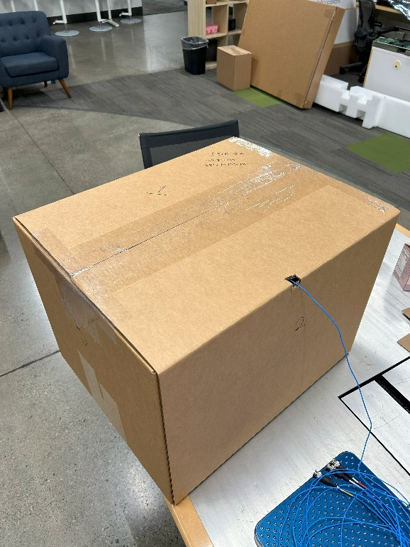 | 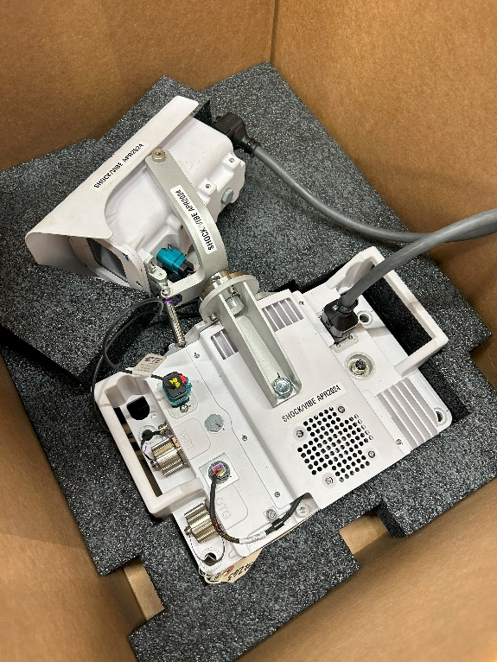
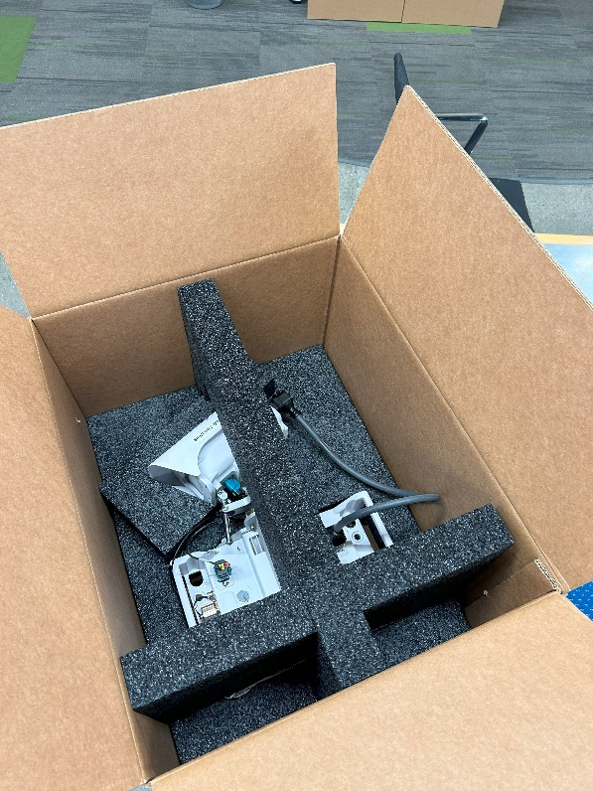 | 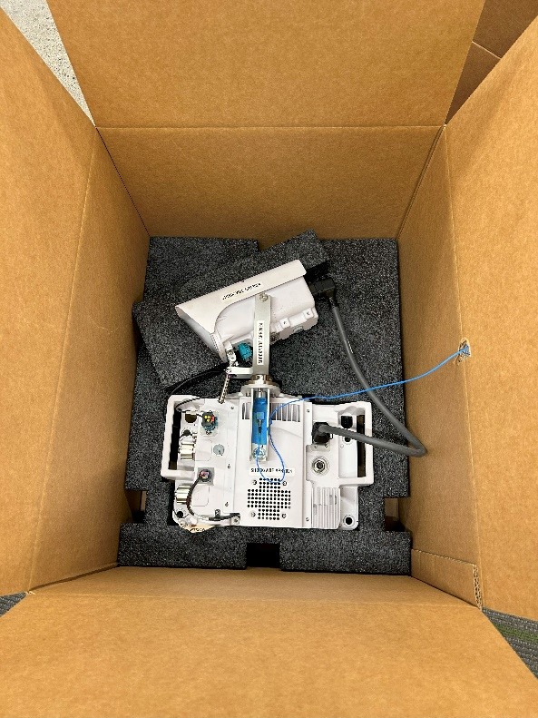
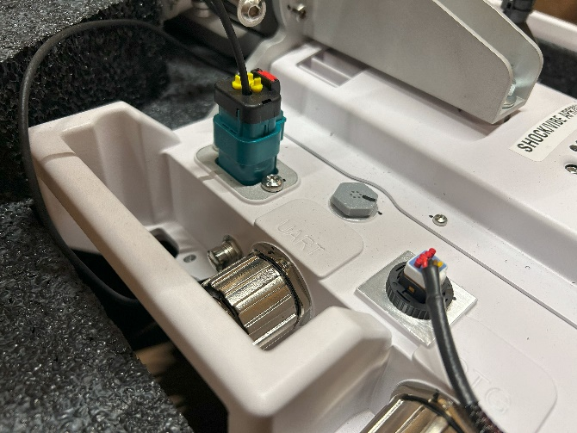 |  | 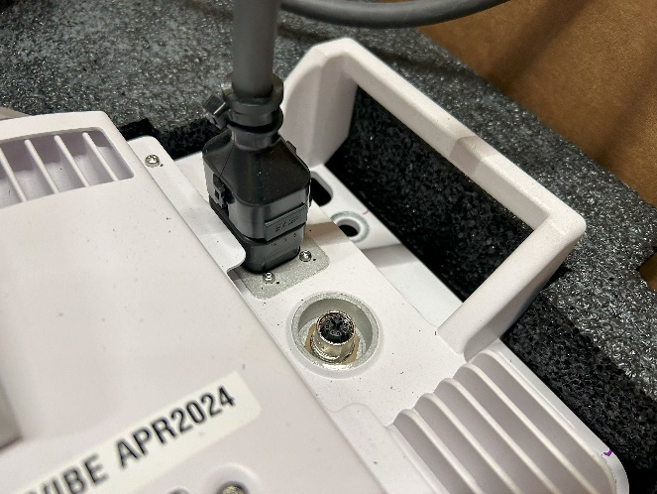

Test Sequence 1 – Ambient Atmospheric Preconditioning

The package system was exposed to ambient atmospheric conditions for a minimum duration of twelve (12) hours.

Test Sequence 2 – Controlled Atmospheric Preconditioning

The package system was conditioned to the appropriate Anticipated Conditions as defined in ISTA 2A-2011, page 6. The “Controlled Conditions” profile was selected as this profile is the most similar to typical conditions experienced in Northern California.
Anticipated Conditions | Time in Hours | Temperature in °C +/- 2°C | Humidity in %
Controlled Conditions | 72 | 23°C | 50% RH +/- 5%

Test Sequence 3 – Compression

Immediately following Test Sequence 2, Compression (Machine Apply and Release) was performed according to the defined test procedure in ISTA 2A-2011. A compression force of 1,739.5 lbs was determined using the following equation:
$$[W_{t}×(S-1)×F]×1.4$$
W_{t} – Total weight of the packaged-product – 24.85 lbs
S – Total number of packaged-products in a stack – 11 (calculated using guidance provided in ISTA 2A)
F – Compensating factor – 5 (ISTA recommends a minimum of 5 if the packaged-product may be warehoused during distribution)

The compression test procedure was performed using a compression testing machine; see report below of results:
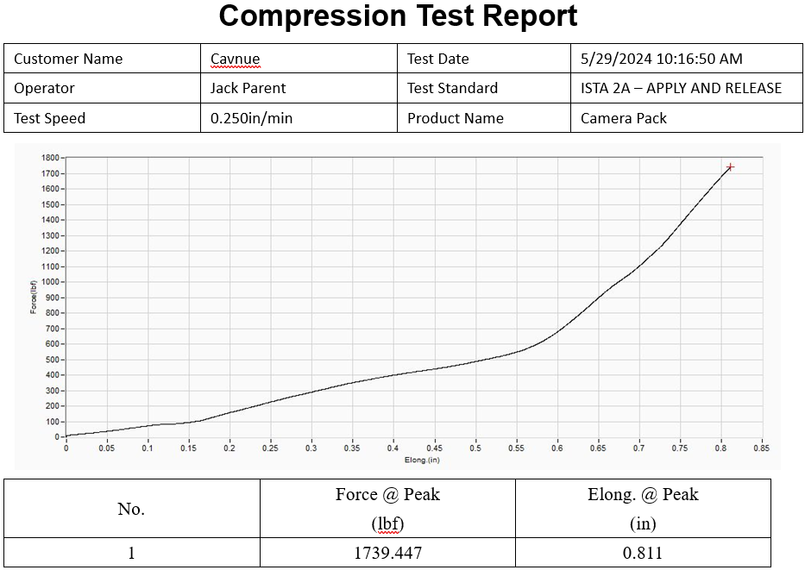

Conclusion | Pass / Fail
Packaged-product achieved the calculated compression force. | Pass

Test Sequence 4 – Random Vibration

Random vibration was performed for 1 hour following Test Sequence 3 - Compression. See table below:
Random Vibration
Test No. | Orientation | Vibration Profile | Vibration Intensity (G_{rms}) | Duration (min) | Resonant Frequency (Hz) | Transmissibility (Q)
1 | Face 3 | ISTA 2A-2011 | 1.15 | 30 | 14.75 | 3.08
2 | Face 1 |  |  | 10 | 13.75 | 2.88
3 | Face 4 |  |  | 10 | 11.5 | 3.06
4 | Face 6 |  |  | 10 | 13.5 | 3.12
Graph data of frequency response and transmissibility is located in Appendix A

The ISTA 2A-2011 acceleration versus frequency vibration profile spectrum is shown below:
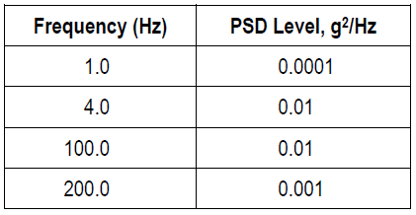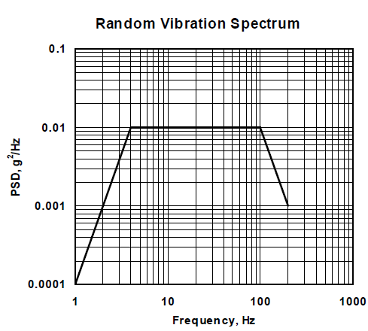

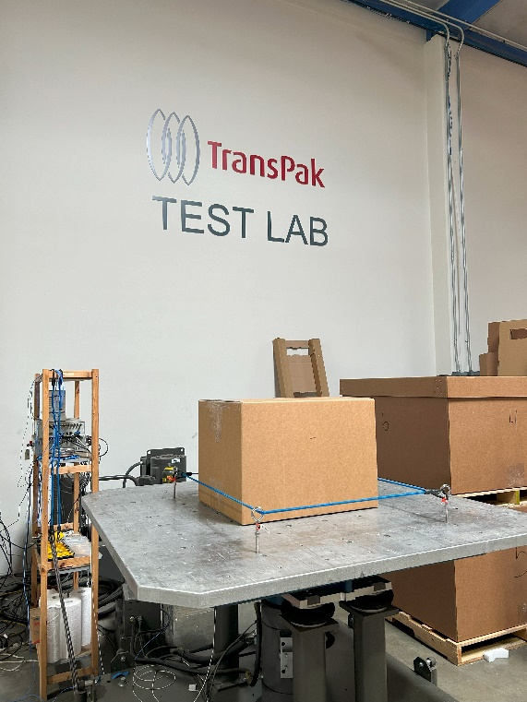 | 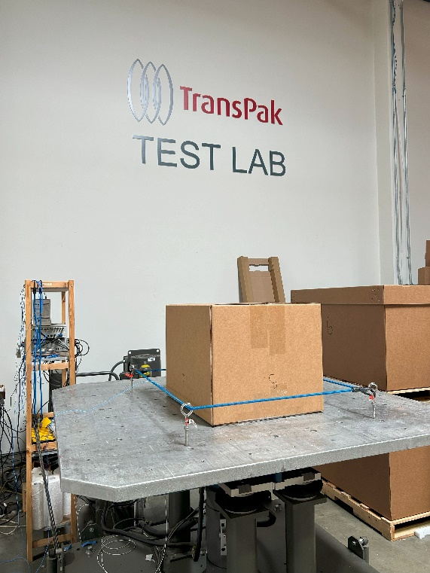
Face 3 | Face 1
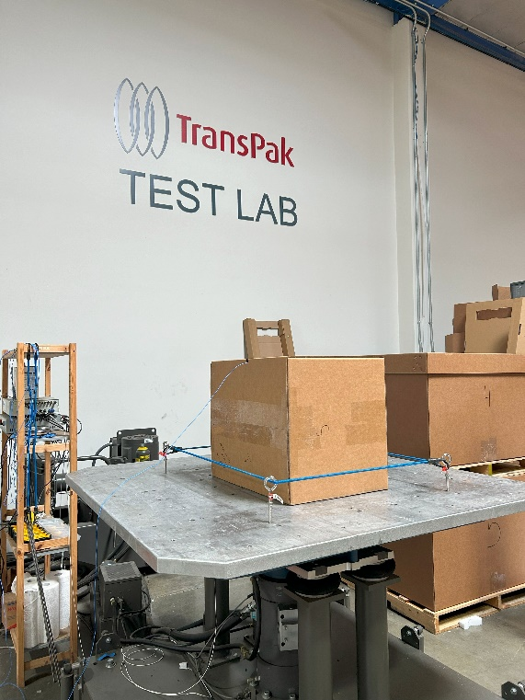 | 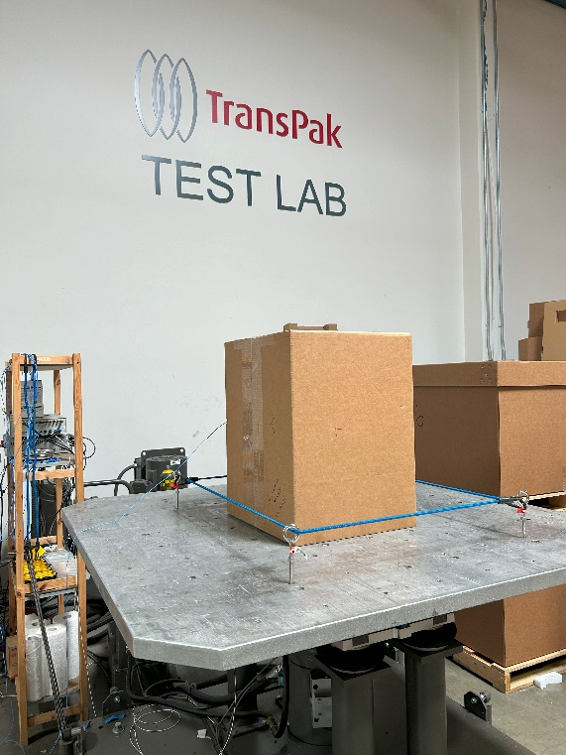
Face 4 | Face 6

Conclusion | Pass / Fail
No critical damage or conditions were observed post random vibration testing. | Pass

Test Sequence 5 – Shock

Packaged-product was subjected to 10 free fall drops at 32”. Drop height was determined according to the following chart provided in ISTA 2A-2011, Page 9 below:
Packaged-Product Weight (pounds) |  | Drop Height (inches)
Equal to or greater than | But Less than | Free Fall
0 | 21 | 38
21 | 41 | 32
41 | 61 | 26
61 | 100 | 20
100 | 150 | 12

The drop sequence was performed according to the table below:
Drop # | Drop Height (in.) | Face | Peak G’s (axis)
1 | 32 | Corner 2-3-5 | 13.48 (X)
2 |  | Edge 2-5 | 17.25 (Y)
3 |  | Edge 3-5 | 23.13 (X)
4 |  | Edge 2-3 | 15.57 (Y)
5 |  | Face 6 | 26.06 (X)
6 |  | Face 5 | 37.78 (X)
7 |  | Face 2 | 39.69 (Y)
8 |  | Face 4 | 28.19 (Y)
9 |  | Face 3 | 38.94 (Z)
10 |  | Face 1 | 24.23 (Z)
Waveform data available upon request.

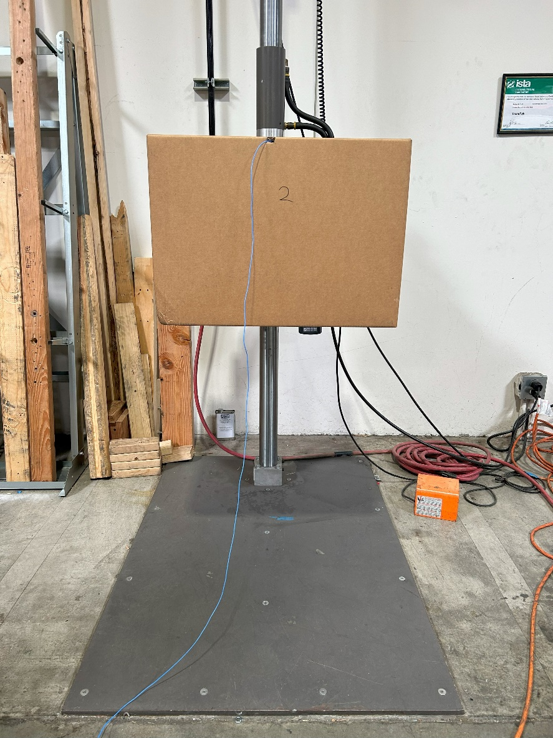
32” Drop Height

Conclusion | Pass / Fail
No critical damage or conditions were observed post free fall drop testing. | Pass

Test Sequence 6 – Random Vibration

Random vibration was performed for 1 hour following Test Sequence 5 - Shock. See table below:
Random Vibration
Test No. | Orientation | Vibration Profile | Vibration Intensity (G_{rms}) | Duration (min) | Resonant Frequency (Hz) | Transmissibility (Q)
1 | Face 3 | ISTA 2A-2011 | 1.15 | 30 | 15.5 | 2.65
2 | Face 1 |  |  | 10 | 10 | 2.98
3 | Face 4 |  |  | 10 | 10.5 | 2.96
4 | Face 6 |  |  | 10 | 11.75 | 3.13
Graph data of frequency response and transmissibility is located in Appendix B

The ISTA 2A-2011 acceleration versus frequency vibration profile spectrum is shown below:


 | 
Face 3 | Face 1
 | 
Face 4 | Face 6

Conclusion | Pass / Fail
No critical damage or conditions were observed post random vibration testing. | Pass

Post-Test Photos

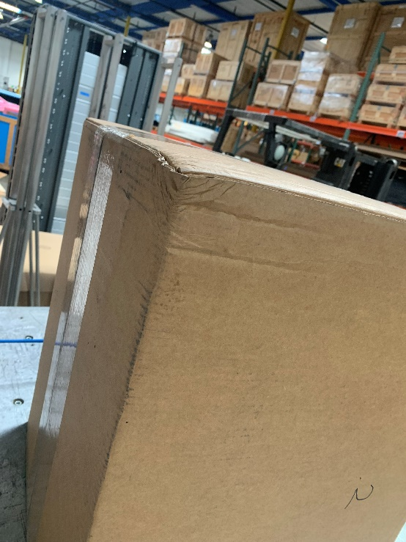 | 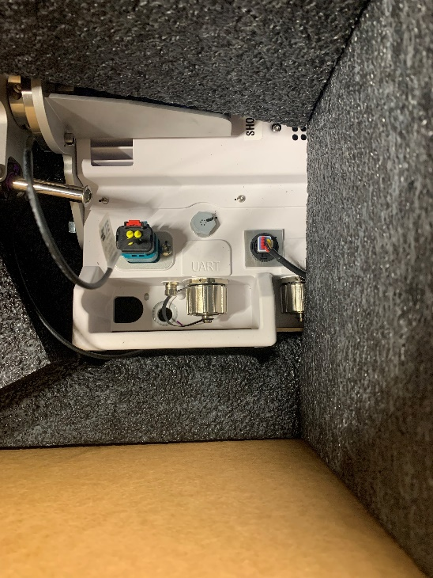
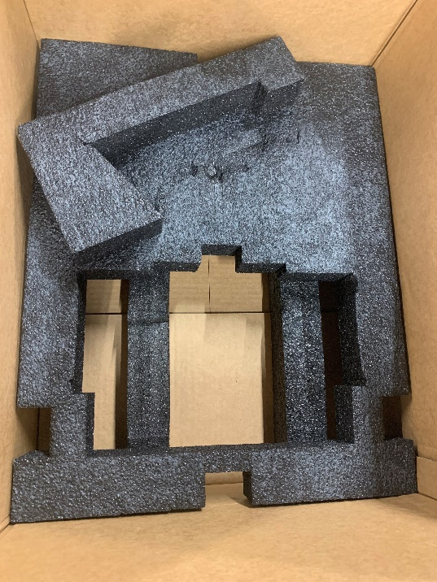 | 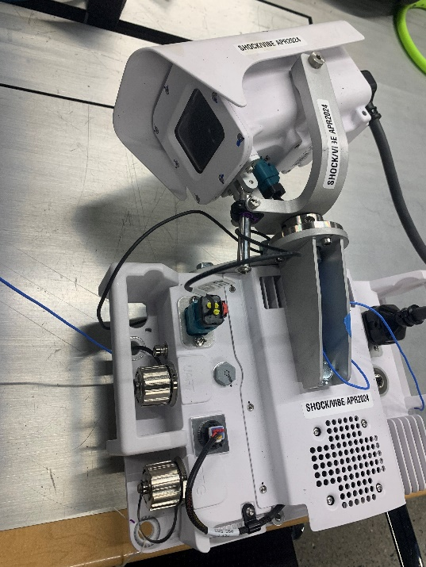

Appendix A – Test Sequence 4 Vibration Data
Face 3 Transmissibility Report
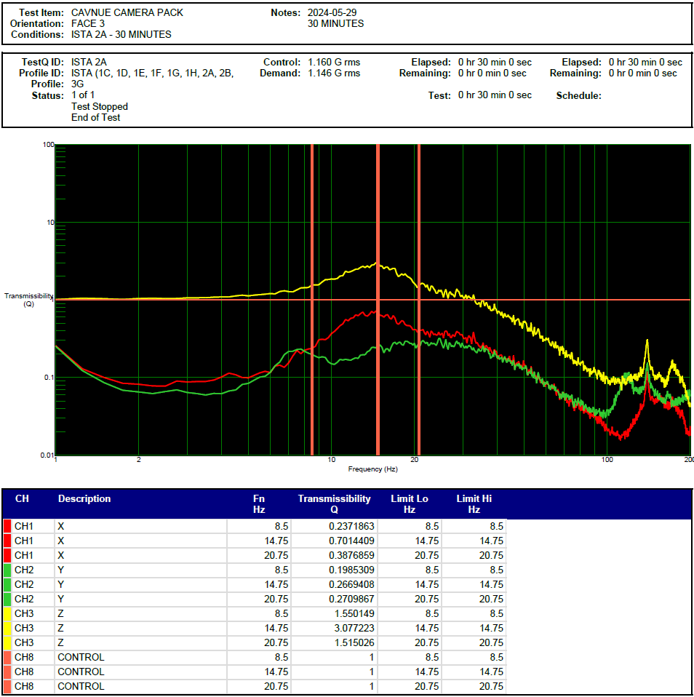

Face 1 Transmissibility Report
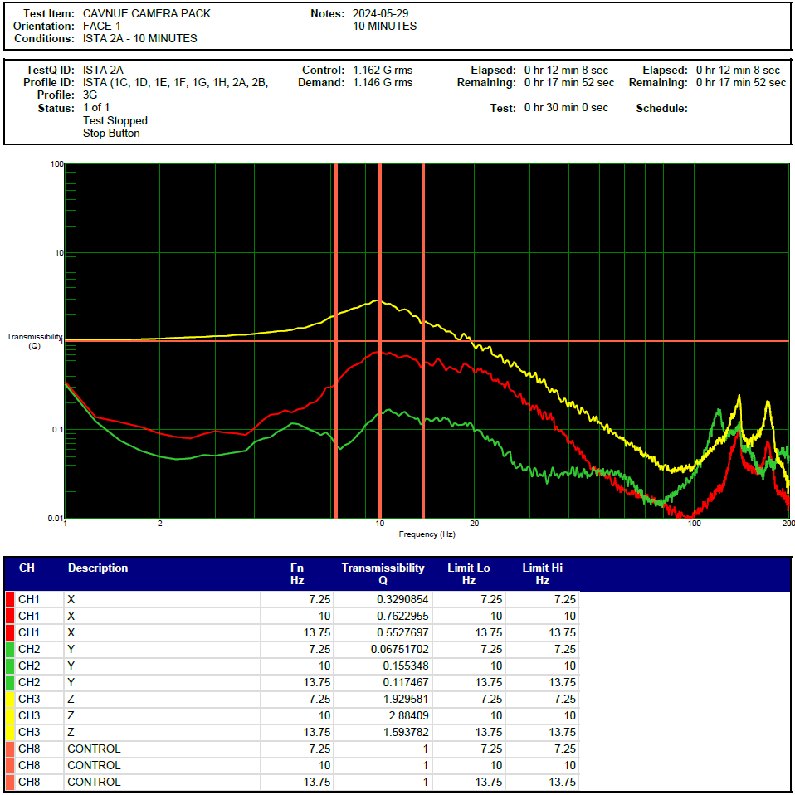

Face 4 Transmissibility Report
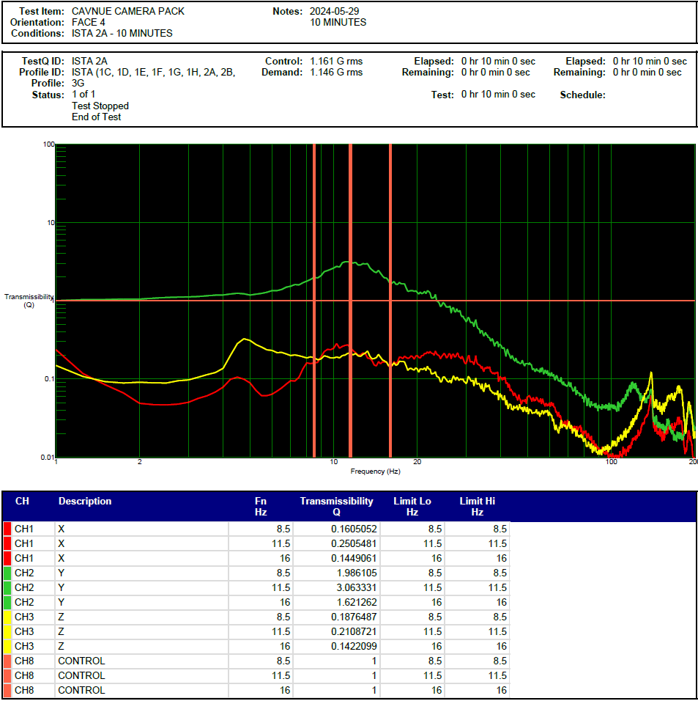

Face 6 Transmissibility Report
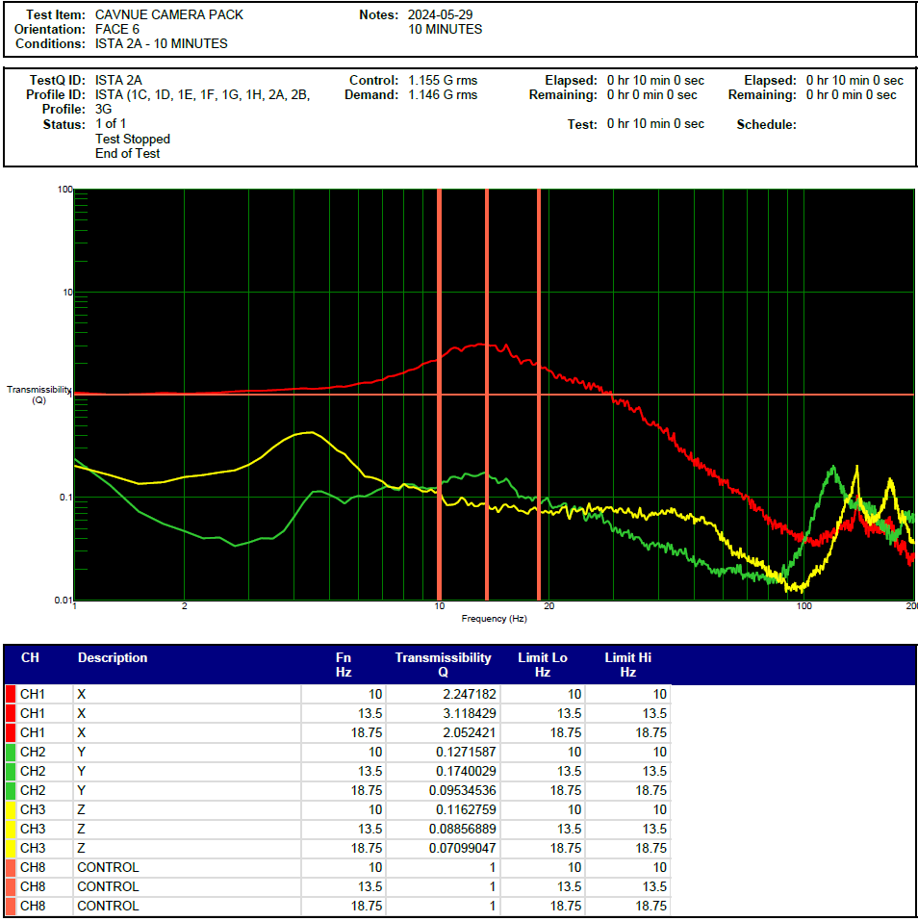

Appendix B – Test Sequence 6 Vibration Data
Face 3 Transmissibility Report
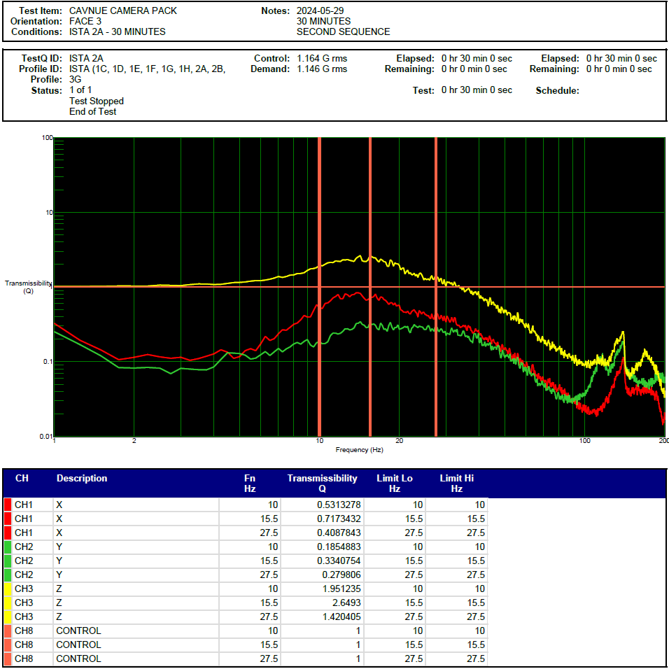

Face 1 Transmissibility Report
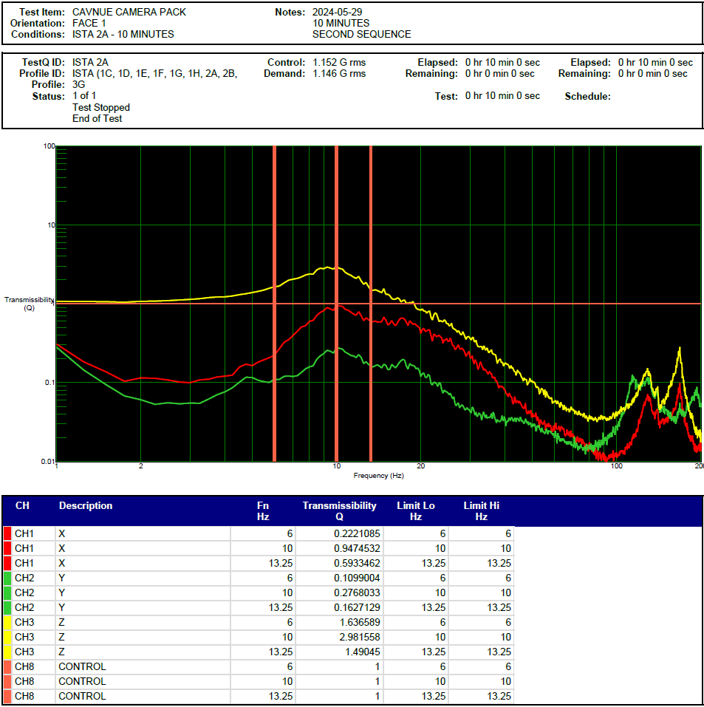

Face 4 Transmissibility Report
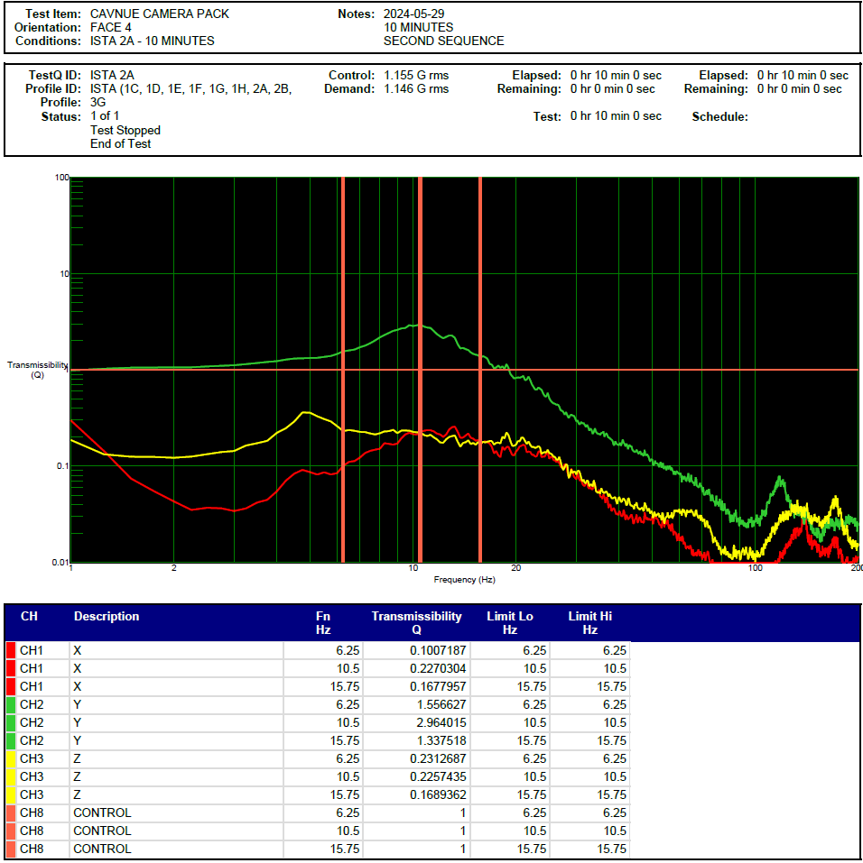

Face 6 Transmissibility Report
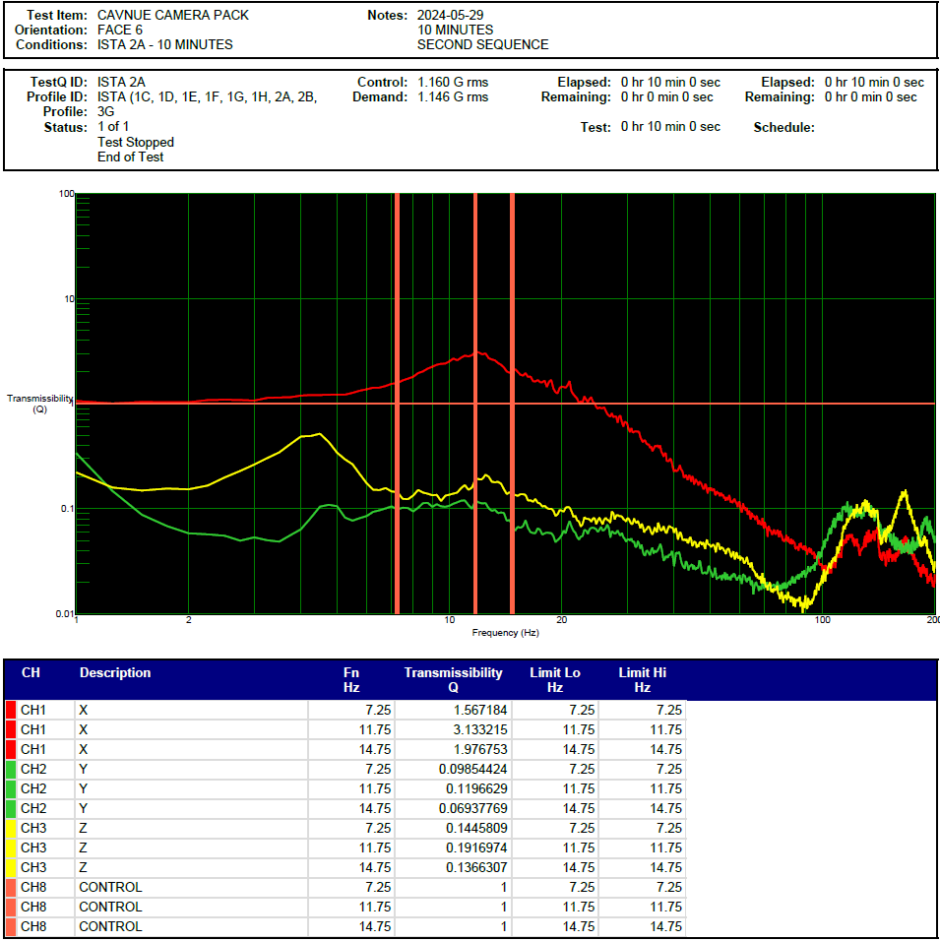

End of Report

