
Test Date: August 2, 2023
Test Operator #1 Name | Email
Test Operator #2 Name | Email


Product
Modified ISTA 3A Test Protocol
Rev A

TransPak
20415 Corsair Blvd.
Hayward, CA 94545

Table of Contents

Table of Contents 2
Objective 3
Key Takeaways 3
Test Protocol 4
Test Equipment 5
Test Sample Description 6
Pre-test Photos 6
Test Sequence 1 8
Test Sequence 2 8
Test Sequence 3 9
Test Sequence 4 16
Post-Test Photos 17

Certification

TransPak is an ISTA certified testing facility – Member ID: 10149
International Safe Transit Association
1400 Abbott Road, Suite 160
East Lansing, MI 48823- 1900
Email: ista@ista.org

Objective

To validate the ability of the packaging and product to withstand shipping environment hazards utilizing a Modified ISTA 3A-2018 General Simulation Performance Test Procedure. Using one (1) package system, TransPak performed a series of tests that simulate hazards which may be present in a standard shipping environment.

Key Takeaways

- One (1) Product Name package system provided by Company Name was tested using a modified ISTA 3A test procedure (no top load vibration).
- No visible critical damage to the packaging was observed upon pre-test inspection.
- Internal inspection required by the customer to determine if any damage to the product has occurred.

Test Protocol

Sequence No. | Test Category | Test Type | Test Level
1 | Atmospheric | Preconditioning | Ambient lab conditions for >12 hours
2 | Shock | Free-Fall Drop | 9 Drops
3 | Vibration | Random (without topload) | Overall G_{rms} levels of 0.53 and 0.46
4 | Shock | Free-Fall Drop | 8 Drops

Test Equipment

Equipment Used
Equipment | Make | Model | S/N | Calibration Due Date
Swingarm Drop Tester | Lansmont | ODT-56ED | M-11233 | 03/28/2025
Vibration Test System | Lansmont | 10000 | 18163 | 03/28/2025
Vibration Controller | Lansmont | TTV4 | 74538 | 03/28/2025
Triaxial Accelerometer | PCB | 356A24 | 241279 | 5/08/2025

Test Sample Description

External Packaging | Weight | Outside Dimensions  (L x W x H) | Quantity
3mm Wgile | 4.1 lbs | 21.75 X 21 X 7.375 | 1

Pre-test Photos

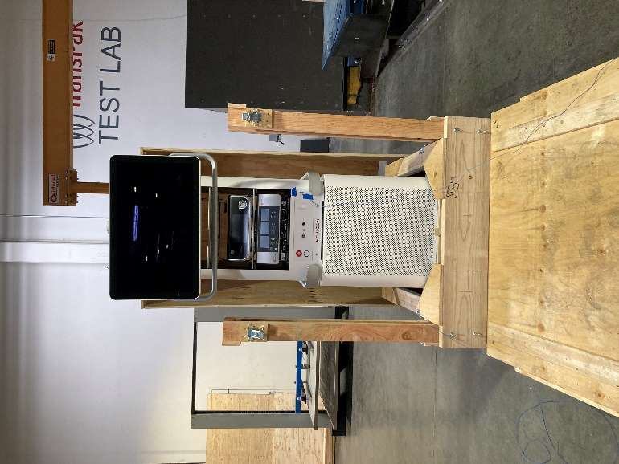 | 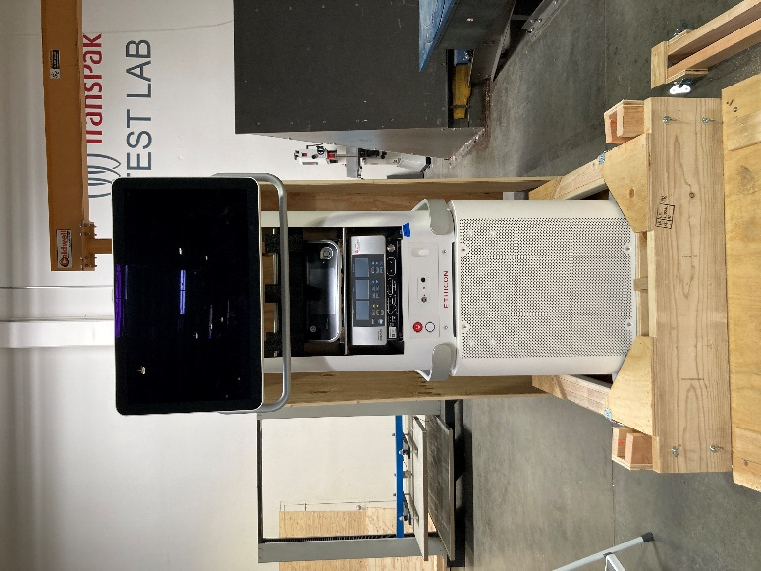
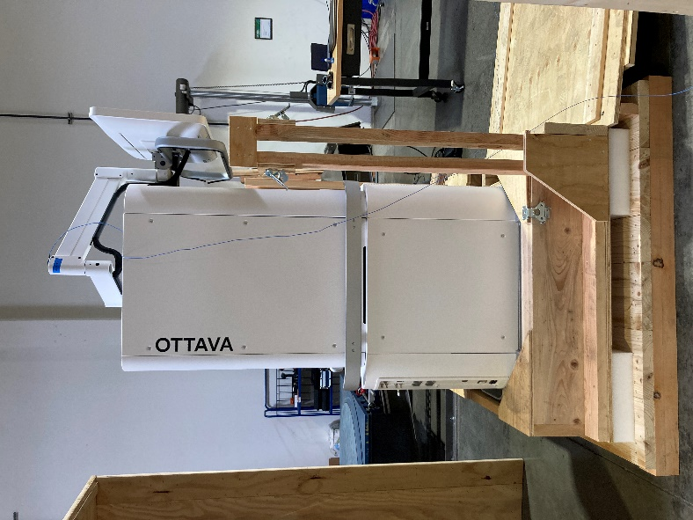 | 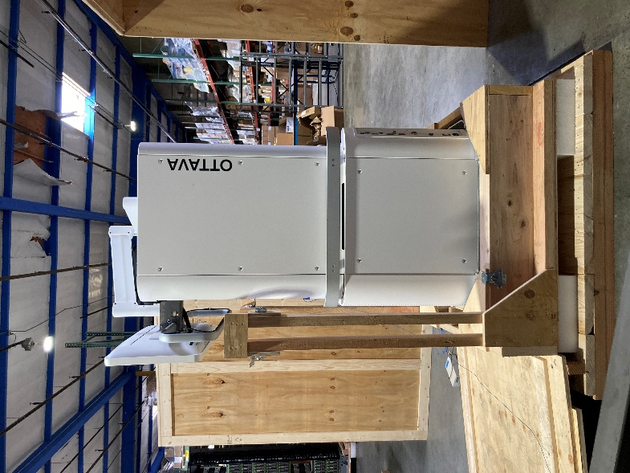
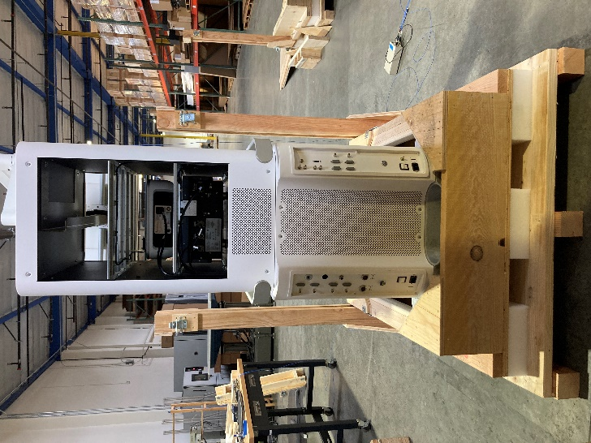 |  | 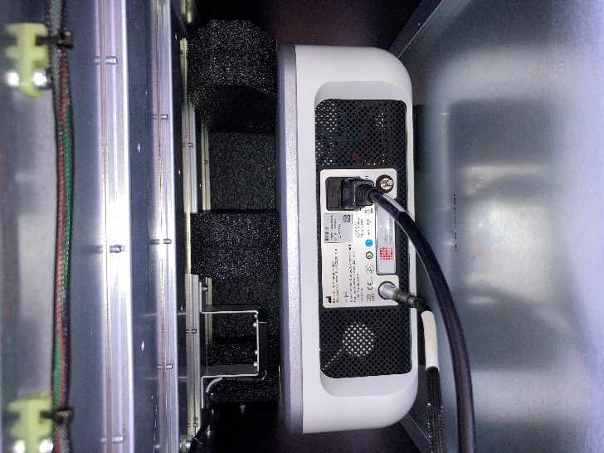

Test Sequence 1

The package system was exposed to ambient laboratory conditions for a minimum duration of twelve (12) hours.

Test Sequence 2

Free Fall Drop (First Sequence)
Drop # | Drop Height (in.) | Face | Peak G’s
1 | 18 | Edge 3-4
2 |  | Edge 3-6
3 |  | Edge 4-6
4 |  | Corner 3-4-6
5 |  | Corner 2-3-5
6 |  | Edge 2-3
7 |  | Edge 1-2
8 | 36 | Face 3
9 | 18 | Face 3
Waveform data available upon request.

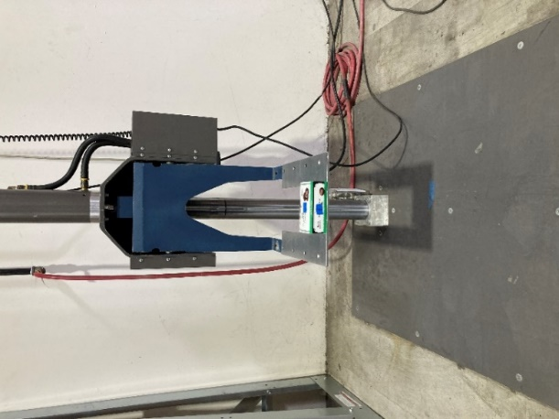 | 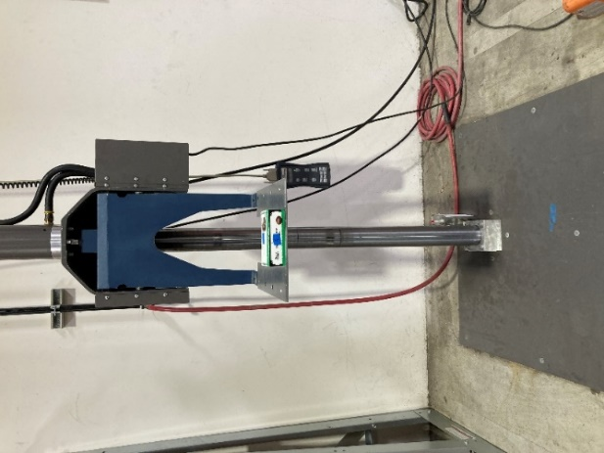
18” Drop Height | 36” Drop Height

Conclusion | Pass / Fail
No critical damage or conditions were observed post free fall drop testing. | Pass

Test Sequence 3

Random Vibration
Test No. | Orientation | Vibration Profile | Vibration Intensity (G_{rms}) | Duration (min) | Resonant Frequency (Hz) | Transmissibility (Q)
1 | Face 3 | Over the Road Spectrum | 0.53 | 60
2 | Face 4 |  |  | 30
3 | Face 6 |  |  | 30
4 | Face 3 | Pick Up and Delivery Vehicle Spectrum | 0.46 | 30
No topload was applied during testing.

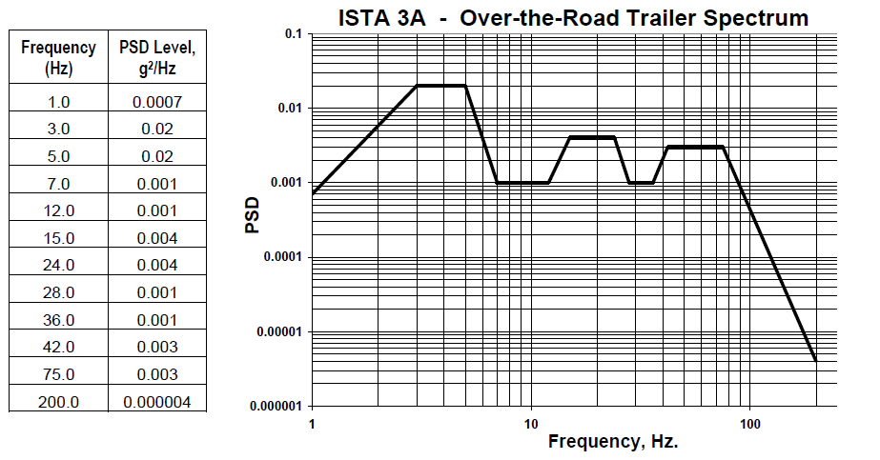

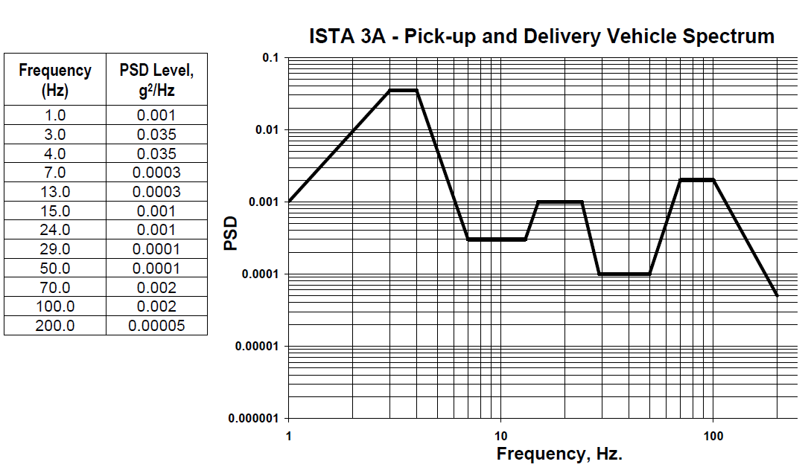

Face 3 Over-The-Road Spectrum Transmissibility Report
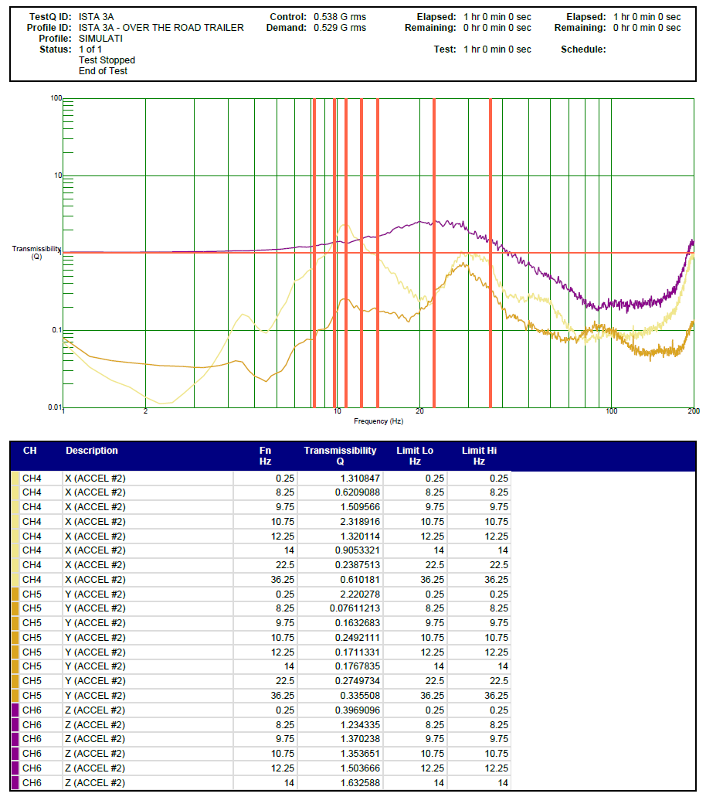
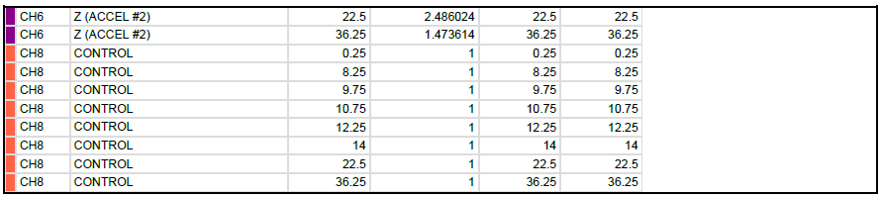

Face 4 Over-The-Road Spectrum Transmissibility Report
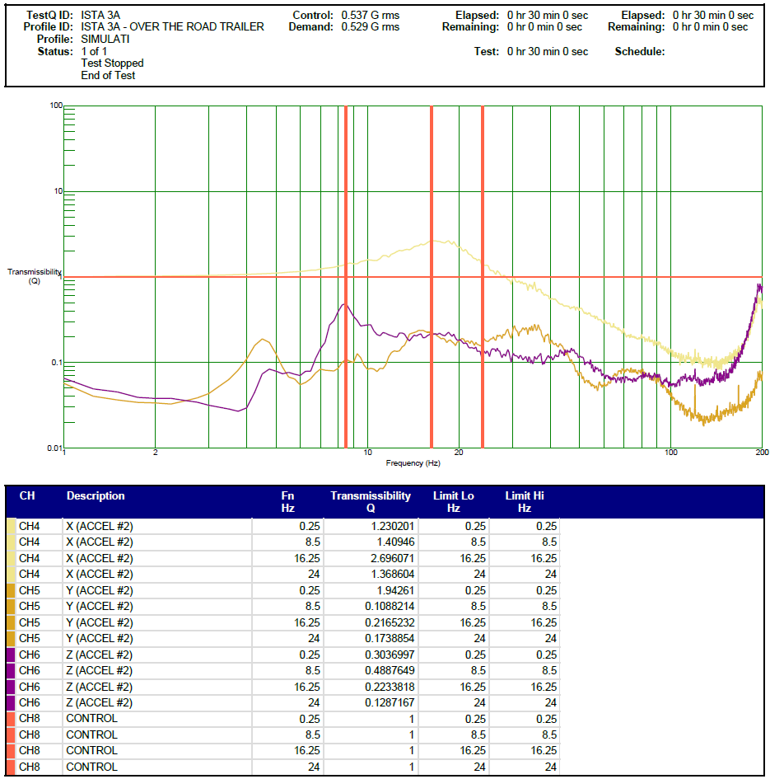

Face 6 Over-The-Road Spectrum Transmissibility Report
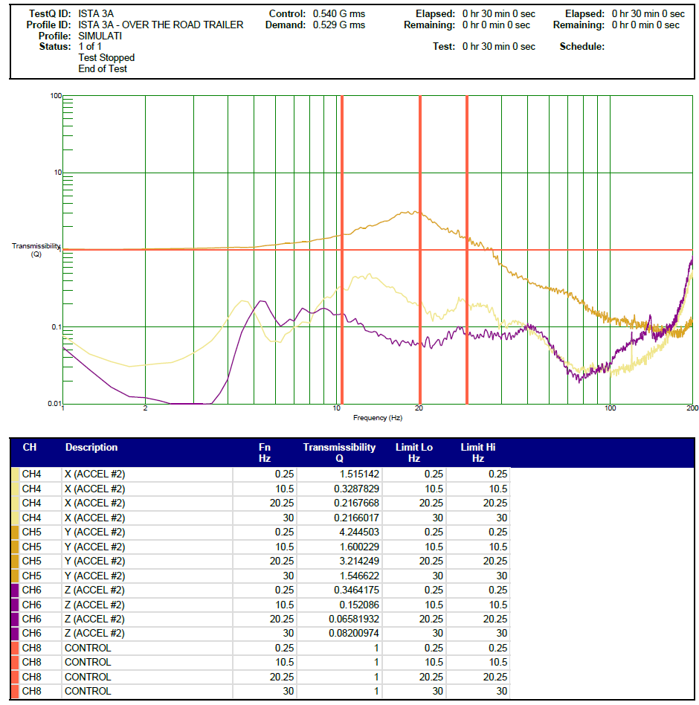

Face 3 Pick Up & Delivery Transmissibility Report
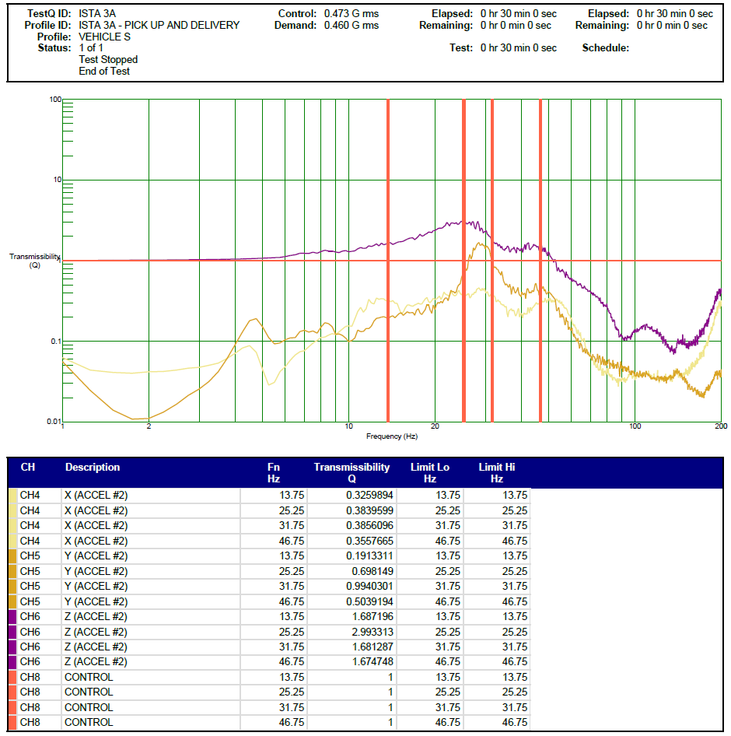

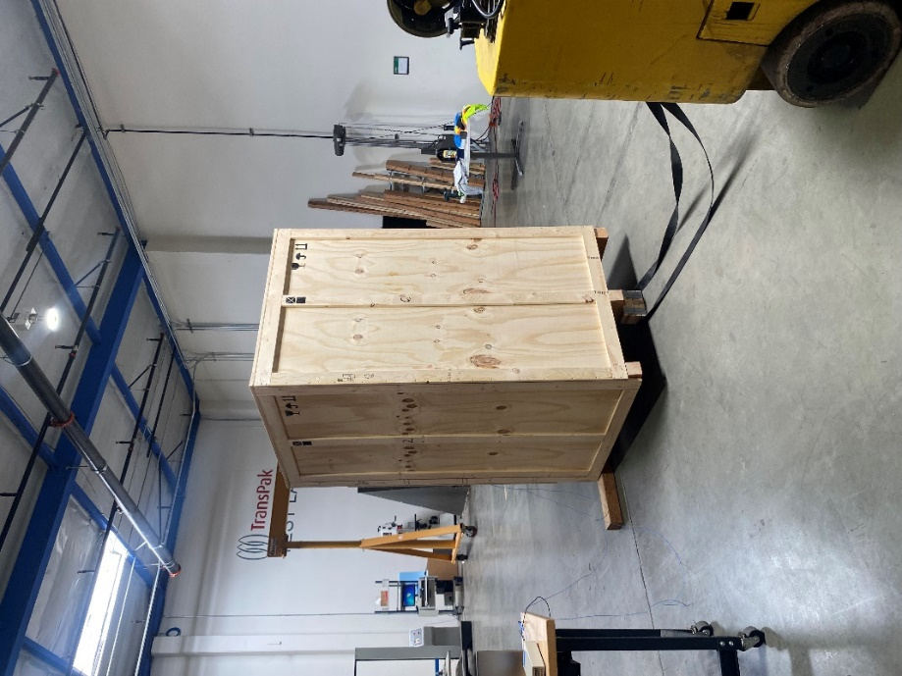 | 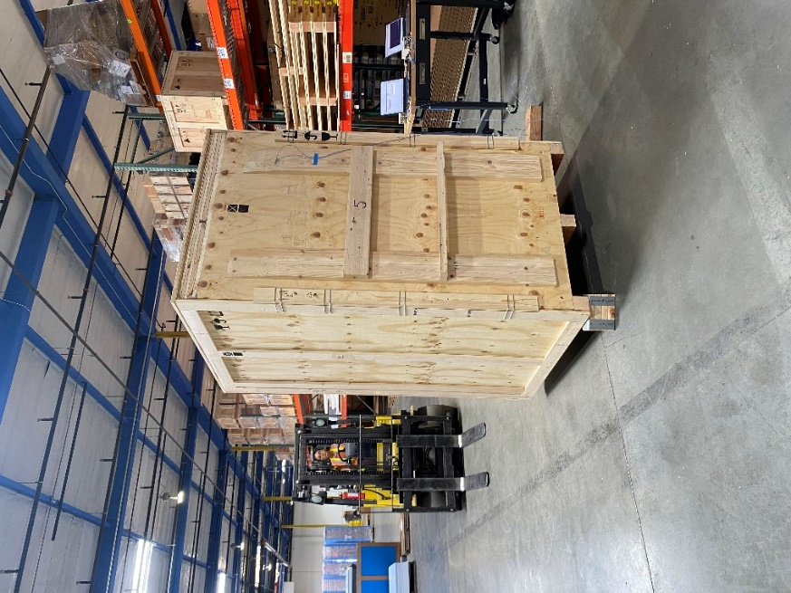
Image | Image

Conclusion | Pass / Fail
No critical damage or conditions were observed post random vibration testing. | Pass

Test Sequence 4

Free Fall Drop (Second Sequence)
Drop # | Drop Height (in.) | Face | Peak G’s
10 | 18 | Edge 3-4
11 |  | Edge 3-6
12 |  | Edge 1-5
13 |  | Corner 3-4-6
14 |  | Corner 1-2-6
15 |  | Corner 1-4-5
16 | 36 | Most critical or damage-prone flat orientation  Face 3
17 | 18 | Face 3 on hazard
Waveform data available upon request.

 | 
Drop #16 | Drop #17

Conclusion | Pass / Fail
No critical damage or conditions were observed post free fall drop testing. | Pass

Post-Test Photos

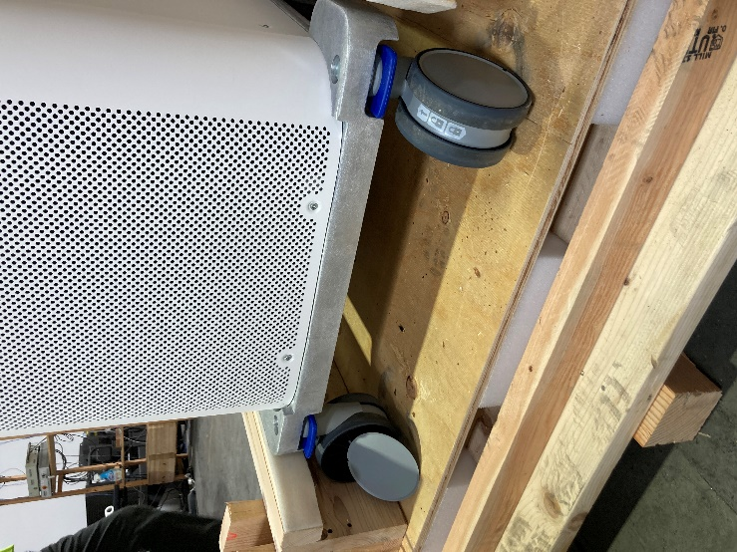 | 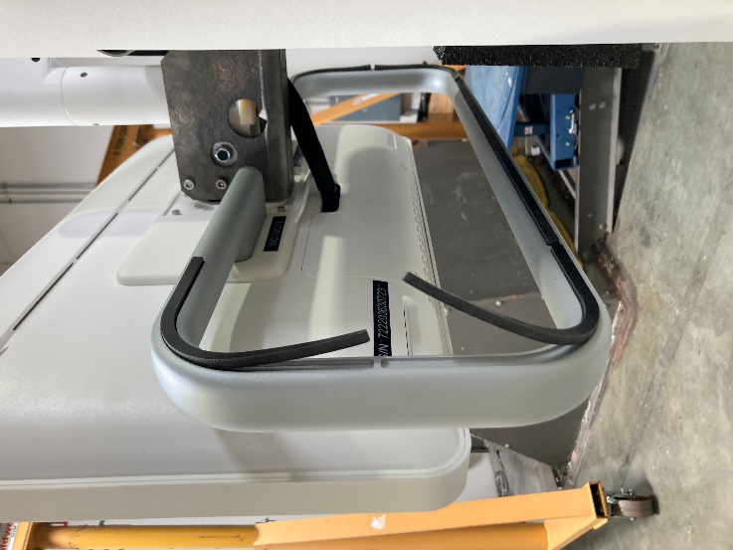
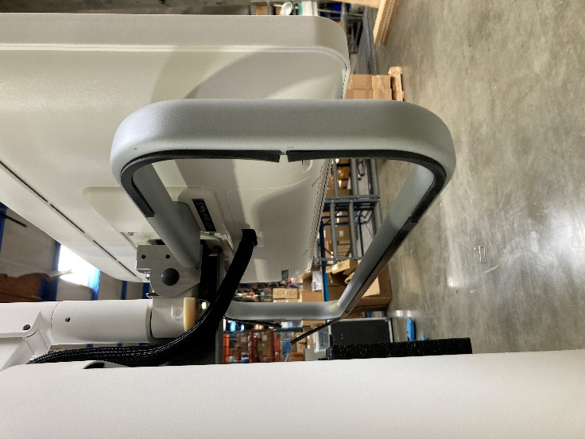 | 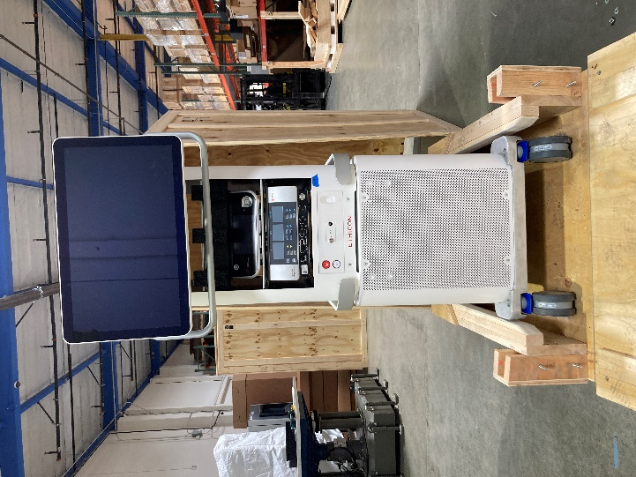

End of Report

