
Test Date: June 22, 2023
Test Operator #1 Name | Email
Test Operator #2 Name | Email



Product Name
ISTA 3B Test Method
Rev # (A, B, C, etc)

TransPak
20415 Corsair Blvd.
Hayward, CA 94545

Table of Contents

Table of Contents 2
Objective 3
Key Takeaways 3
Test Protocol 4
Test Equipment 5
Test Sample Description 6
Pretest Preparation 8
Test Sequence 1 11
Test Sequence 2 11
Test Sequence 3 12
Test Sequence 4 13
Test Sequence 5 15
Test Sequence 6 19
Test Sequence 7 21
Test Sequence 8 22
Test Sequence 9 24
Test Sequence 10 25
Test Sequence 11 26
Post-Test Photos 27

Certification
TransPak is an ISTA certified testing facility – Member ID: 10149
International Safe Transit Association
1400 Abbott Road, Suite 160
East Lansing, MI 48823- 1900
Email: ista@ista.org


Objective

To validate the ability of the packaging and product to withstand shipping environment hazards utilizing a ISTA 3B-2021 General Simulation Performance Test Procedure. Using one (1) package system, TransPak performed a series of tests that simulate hazards which may be present in a standard shipping environment.

Key Takeaways

- Two (2) front (Face 5) wooden posts attached to pallet base were removed prior to testing.
- Front panel (Face 5) of crate was exchanged after the first set of incline impact tests (Sequence #3)
- Nails were dislodged on the top lid of the crate sleeve during elevated rotate fork lift handling (Corner 2-3-5 and Corner 3-4-5 from Sequence #7).
- Nine (9) lugs were fastened around the perimeter of the base to secure the crate sleeve to the pallet post vibration testing (Sequence #4). Prior to Sequence #4, crate sleeve and pallet were held in place solely with eight (8) metal crate clips (four (4) on each side of Face 5).
- Front left caster lid was found detached post-test.
- Internal rack components remained in position with no critically loosened parts post vibration tests.
- Scuffing and indents to the crate is considered normal for test level.

Test Protocol

Sequence No. | Test Category | Test Type | Test Level
1 | Atmospheric | Preconditioning | Ambient lab conditions for >12 hours
2 | Shock | Tip/Tip Over | 22 Degree Tip Angle
3 |  | Rotational Drop | 6” on Edge 3-6  6” on Corner 3-4-5
4 |  | Incline Impact | 48 in/sec on Face 5  48 in/sec on Face 6
5 | Vibration | * Random | Overall G_{rms} level of 0.54
6 | Shock | Fork Lift Handling | Flat Push 40”  Rotate 90°
7 |  |  | Elevated Push & Pull 40”
8 |  |  | Elevated Rotate 90°
9 |  |  | Handling Course
10 | Shock | Rotational Drop | 6” on Edge 3-4  6” on Corner 3-4-6
11 |  | Incline Impact | 48 in/sec on Face 2  48 in/sec on Face 4
* No top load was required as the product is greater than 72” in height.

Test Equipment

Equipment Used
Equipment | Make | Model | S/N | Calibration Date
Vibration Test System | Lansmont | 10000 | 18163 | 4/24/23
Vibration Controller | Lansmont | TTV4 | 74538 | 4/24/23
Incline Impact | Lansmont | IT 152-4K | 17374-3 | 4/24/23
Accelerometer – Tri Axis #1 | PCB Piezotronics | 356A24 | 346135 | 9/12/22
Accelerometer – Tri Axis #2 | PCB Piezotronics | 356A24 | 241279 | 5/24/23

Test Sample Description

External Packaging | Weight | Outside Dimensions  (L x W x H) | Quantity
Wood crate sleeve and wood pallet | 1,170.00 lbs. | 56” x 50” x 89.50” | 1

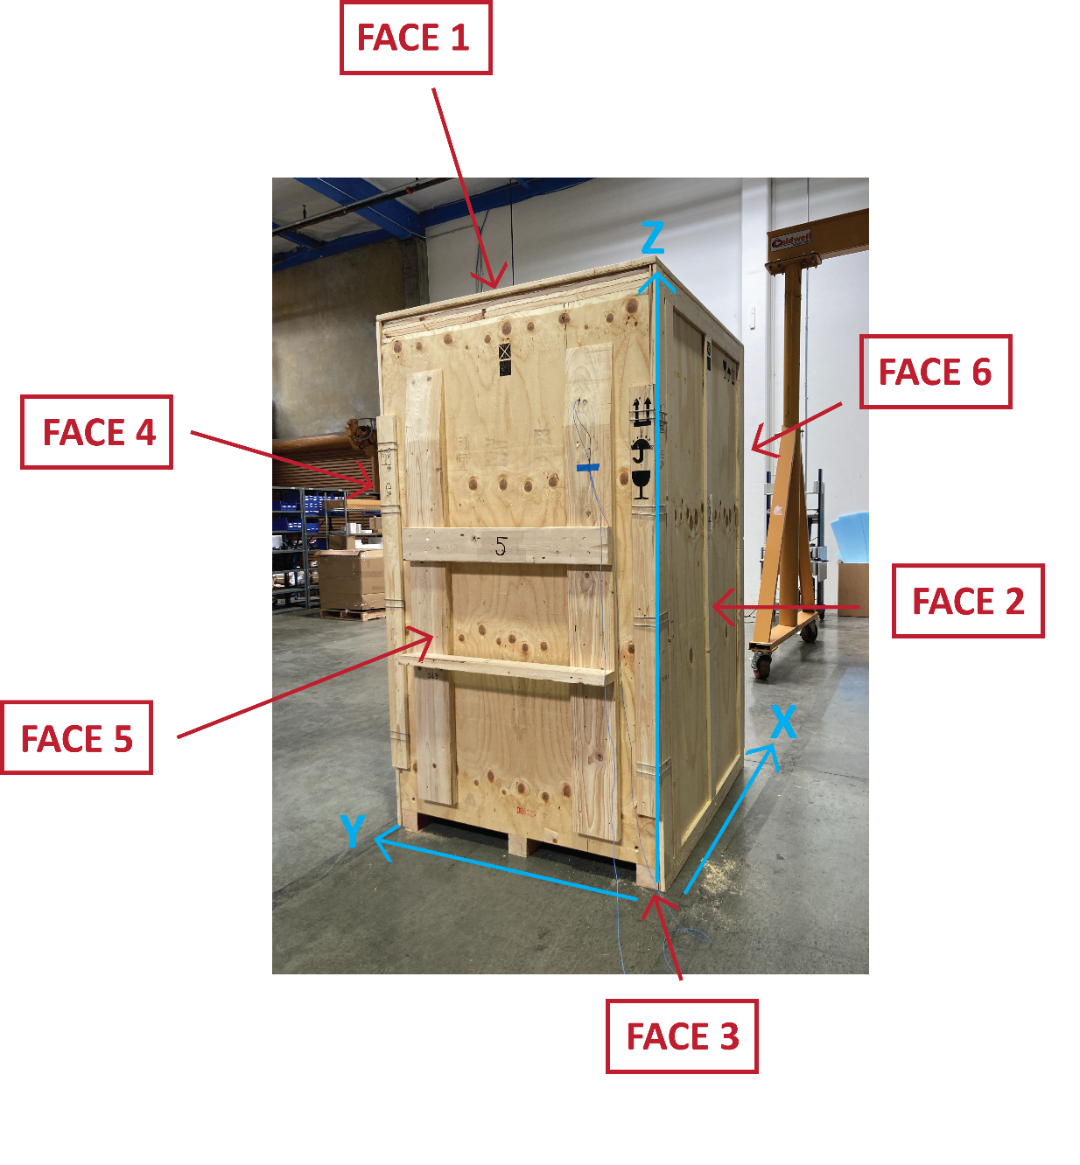
See above image for notations of X, Y, Z axes.

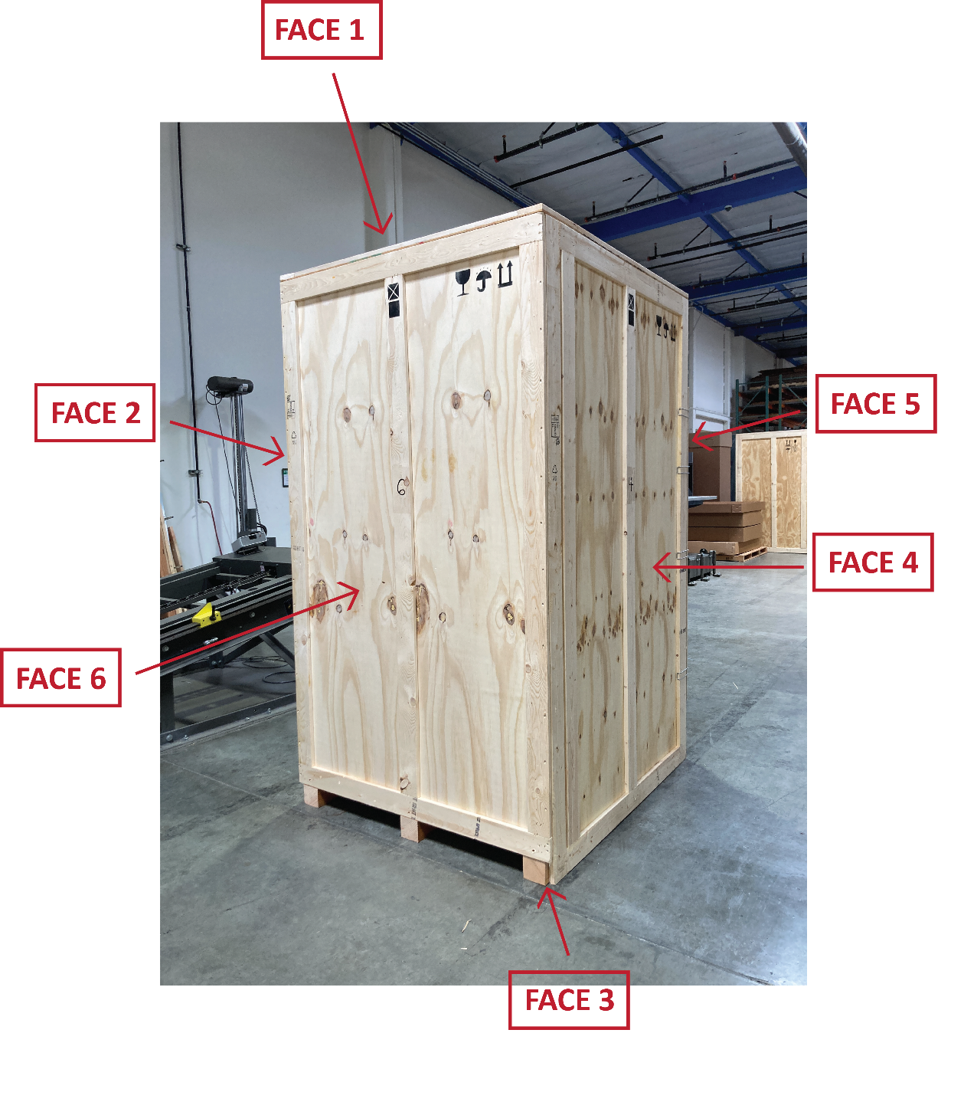

Pretest Preparation

Accelerometer #1
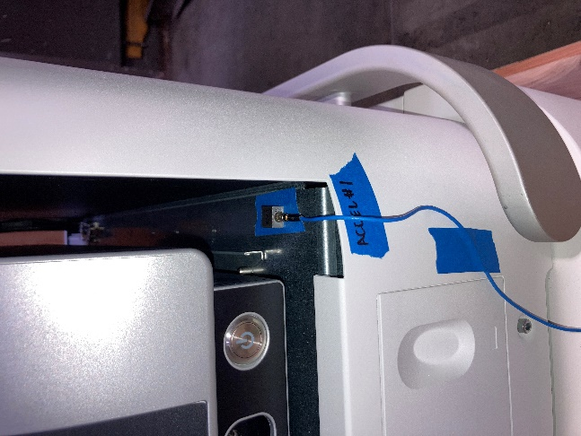 | 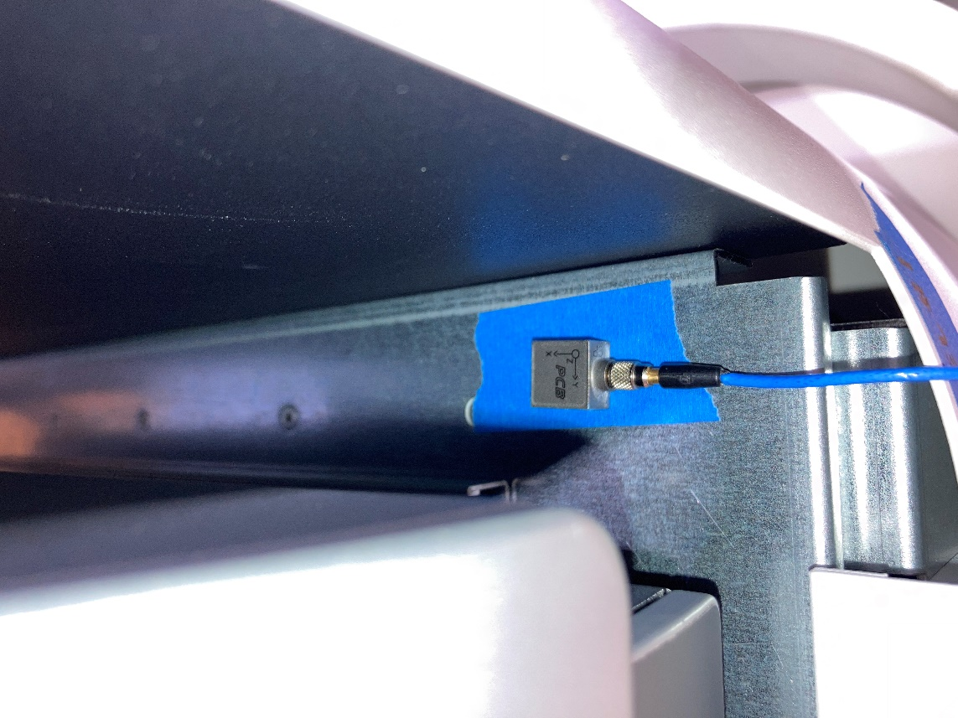

Accelerometer #2
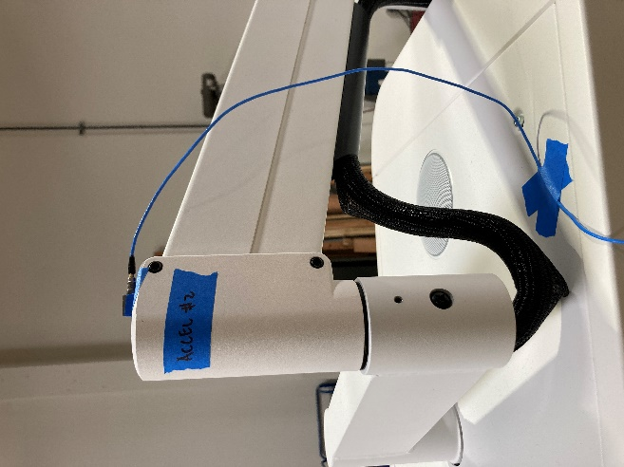 | 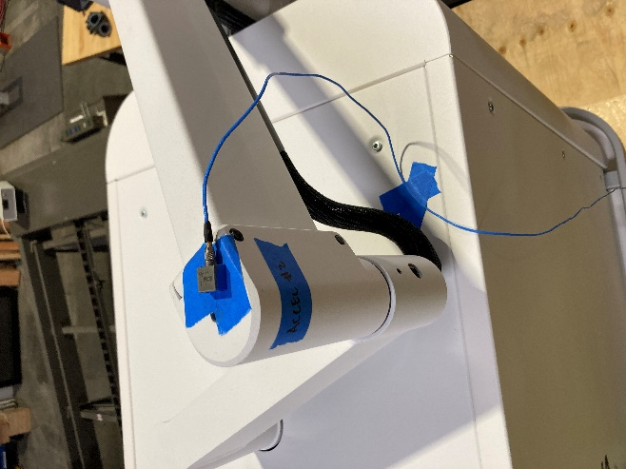

Pretest Photos
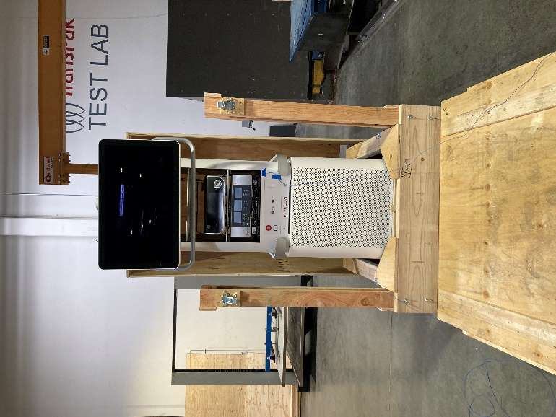 | 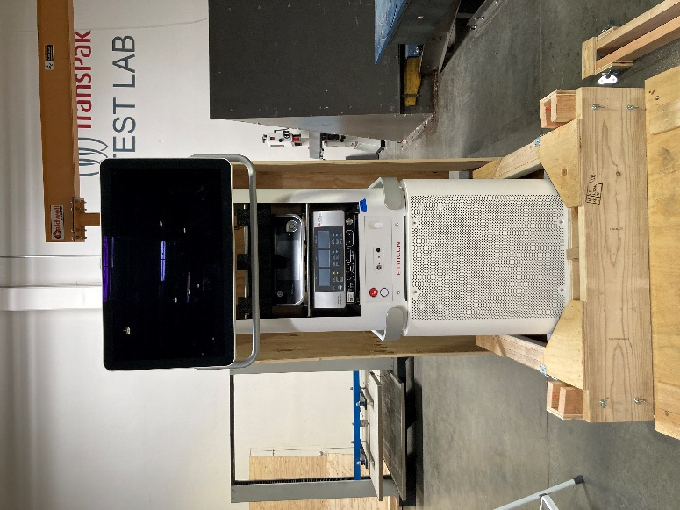
Two front wooden posts attached to the crate frame was removed (Face 5).
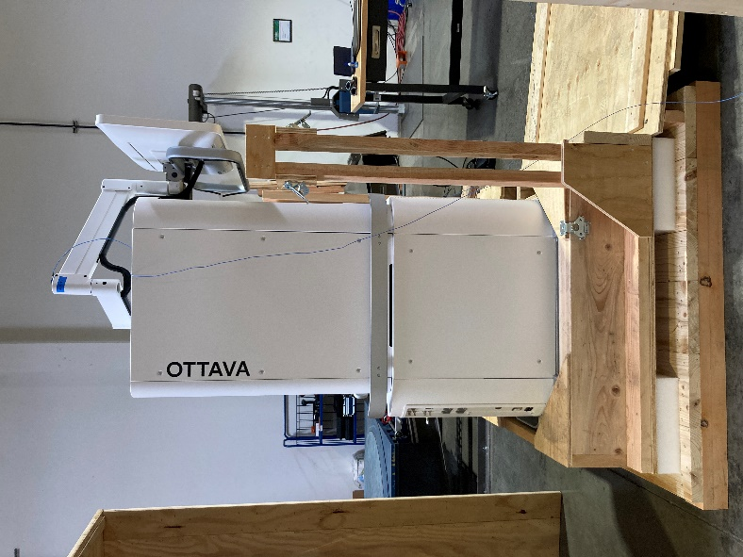 | 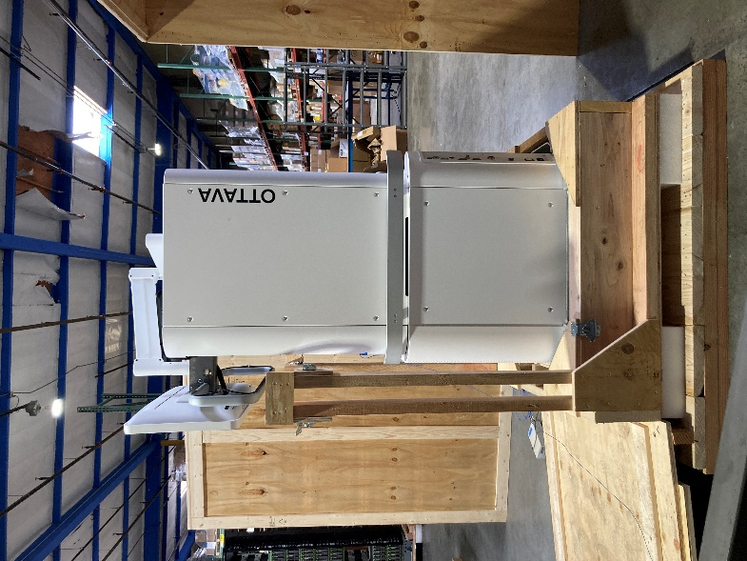
Face 4 | Face 2
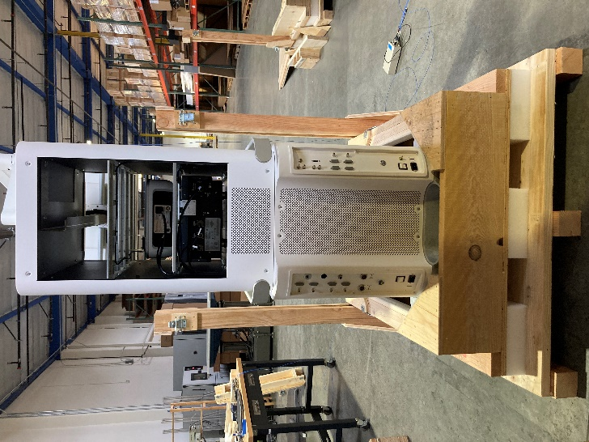 |  | 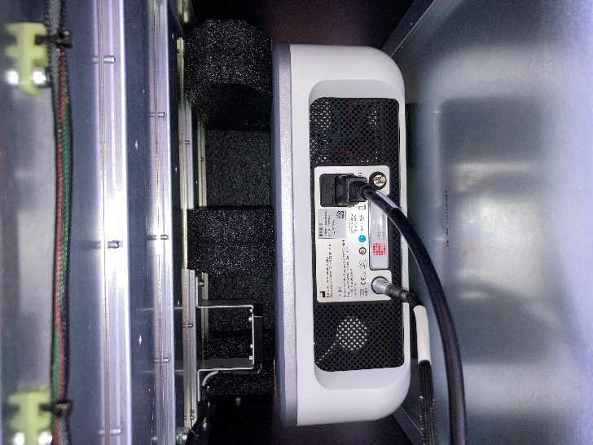
Face 6 |  | Close up of foam insert from Face 6 view
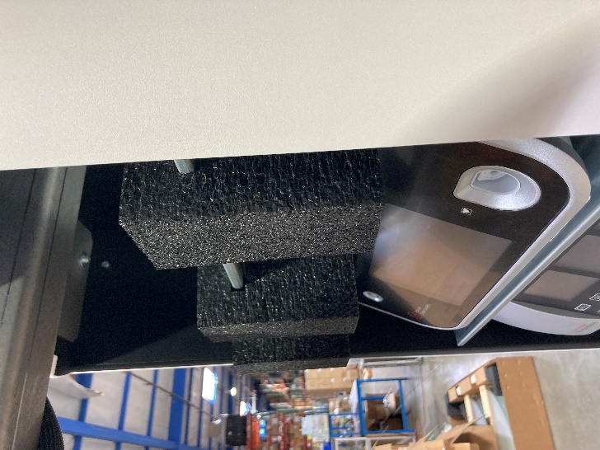
Close up of foam insert from Face 5 view

Additional Notes
Wood crate sleeve and pallet were held in place solely with eight (8) metal crate clips (four (4) on each side of Face 5). Lugs were not used in the first few tests until Sequence #4 (by mistake, not by intention).

Test Sequence 1

The package system was exposed to ambient laboratory conditions for a minimum duration of twelve (12) hours.

Test Sequence 2

Tip/Tip Over
Test No. | Orientation | Angle (°)
1 | Edge 2-3 | 22

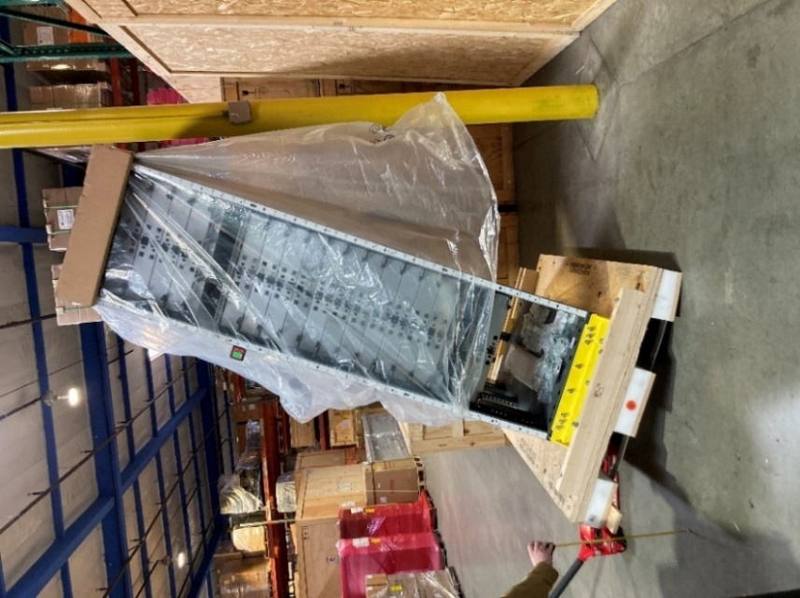

Conclusion | Pass / Fail
No critical damage or conditions were observed post tip/tip over test. | Pass

Test Sequence 3

Rotational Drop
Test No. | Orientation | Drop Height (in.) | Accelerometer #1  Peak G’s | Accelerometer #2  Peak G’s
1 | Edge 3-6 | 6 | No trigger  (<10 G’s) | No trigger  (<10 G’s)
2 | Corner 3-4-5 | 6
Note: The opposite impacted edge/corner was supported with a 4.0” block.

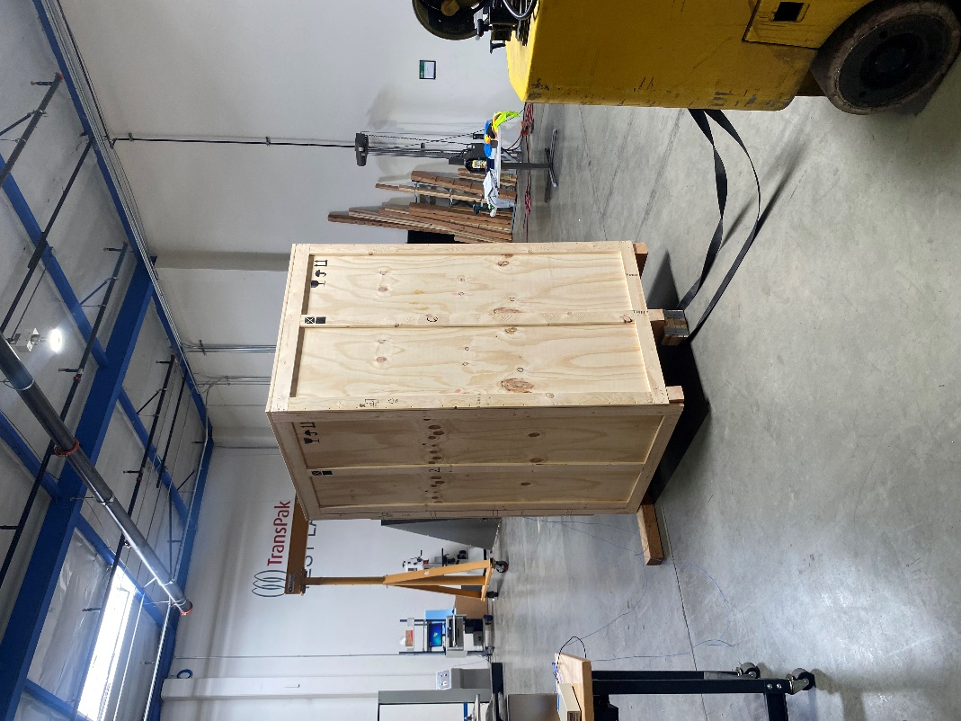 | 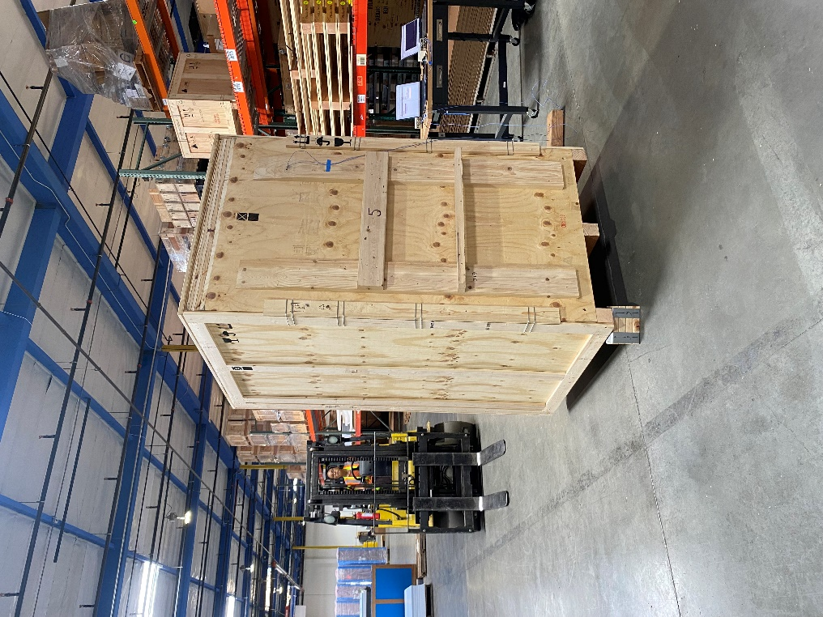
Edge 3-6 | Corner 3-4-5

Conclusion | Pass / Fail
No critical damage or conditions were observed post rotational edge drop and rotational corner drop. | Pass

Test Sequence 4

Incline Impact
Test No. | Face | Velocity | Accelerometer #1  Peak G’s | Accelerometer #2  Peak G’s
1 | Face 5 | 48 in/sec | No trigger  (<10 G’s) | 14.06 G’s
2 | Face 6 | 48 in/sec | No trigger  (<10 G’s) | No trigger  (<10 G’s)

Face 5
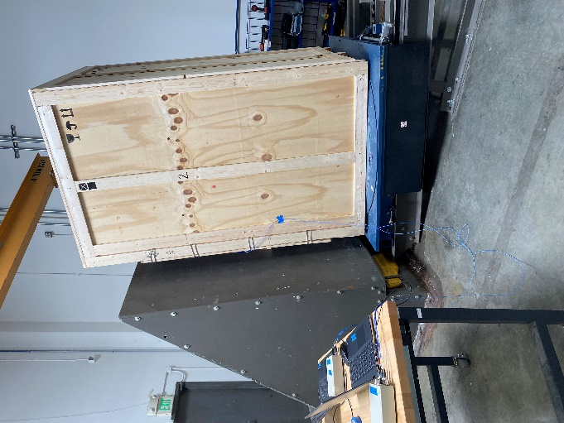 | 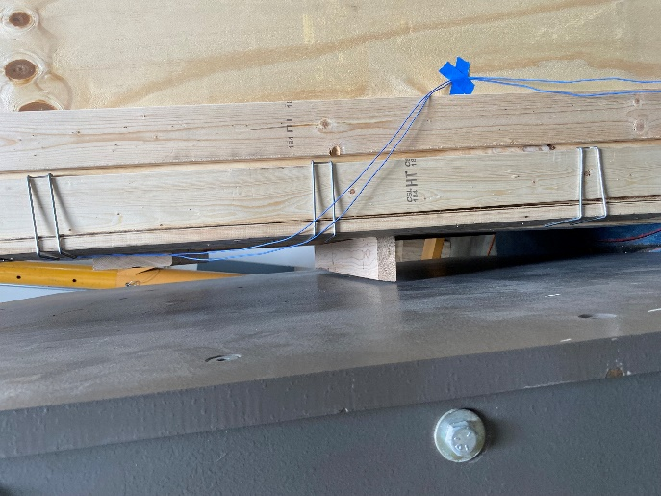

Face 6
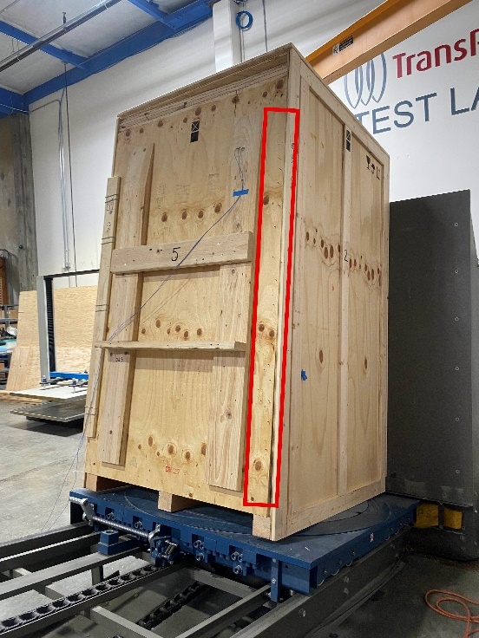 | 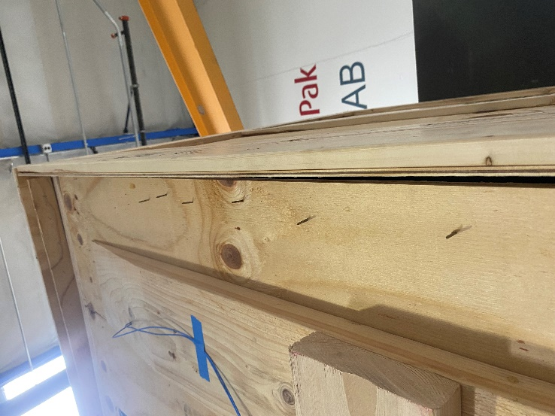
Front panel of crate (Face 5) was damaged post Face 6 incline impact testing. Wood component on the right side of Face 5 was dislodged along with four (4) crate clips.
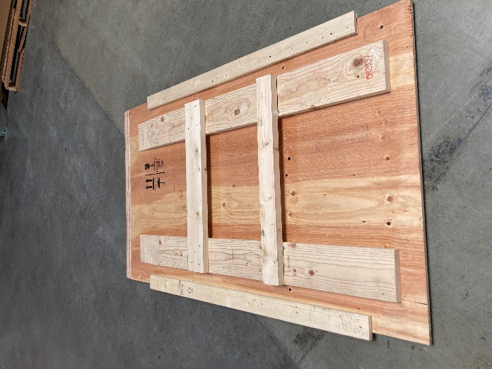 | 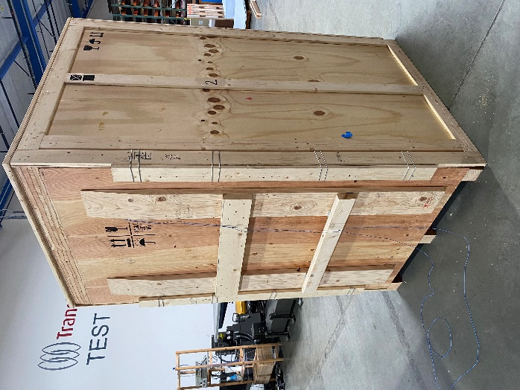
Face 5 panel was replaced for the remainder of tests. Pictured is the new panel.

Conclusion | Pass / Fail
No critical damage or conditions were observed post incline impact testing for Face 5. Face 6 incline impact testing caused damage to Face 5 panel and was replaced for the remaining tests. | N/A

Test Sequence 5

Random Vibration
Orientation | Frequency Range | Vibration Intensity (G_{rms}) | Duration (min)
Face 3 Bottom | 1 – 200 Hz | 0.54 | 240
Note: No top load was required as the rack system is greater than 72” in height.

Random Vibration Spectrum
Frequency (Hz) | PSD (g²/ Hz)
1 | 0.00072
3 | 0.018
4 | 0.018
6 | 0.00072
12 | 0.00072
16 | 0.0036
25 | 0.0036
30 | 0.00072
40 | 0.0036
80 | 0.0036
100 | 0.00036
200 | 0.000018

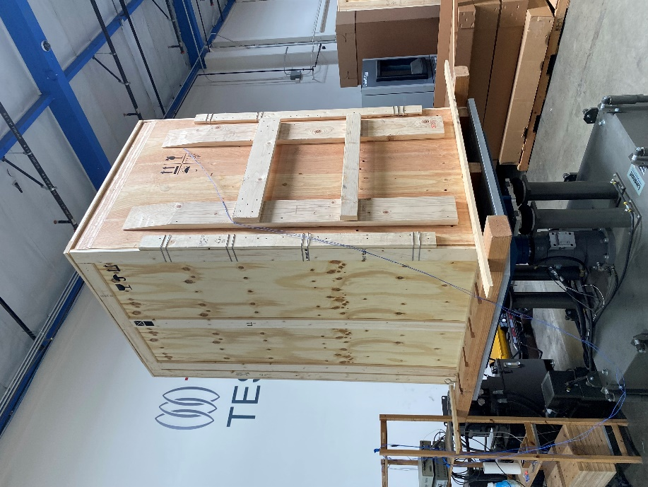

Accelerometer #1 Results |  | Accelerometer #2 Results
Resonant Frequency  Z Axis | Transmissibility (Q)  Z Axis | Resonant Frequency  Z Axis | Transmissibility (Q)  Z Axis
13.25 Hz | 5.74 | 11.5 Hz | 5.77

Accelerometer #1 Transmissibility Report
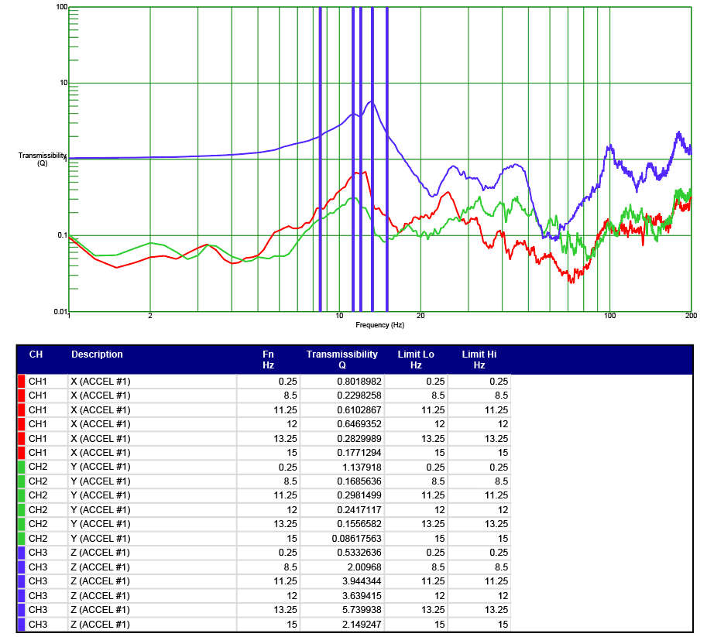

Accelerometer #2 Transmissibility Report
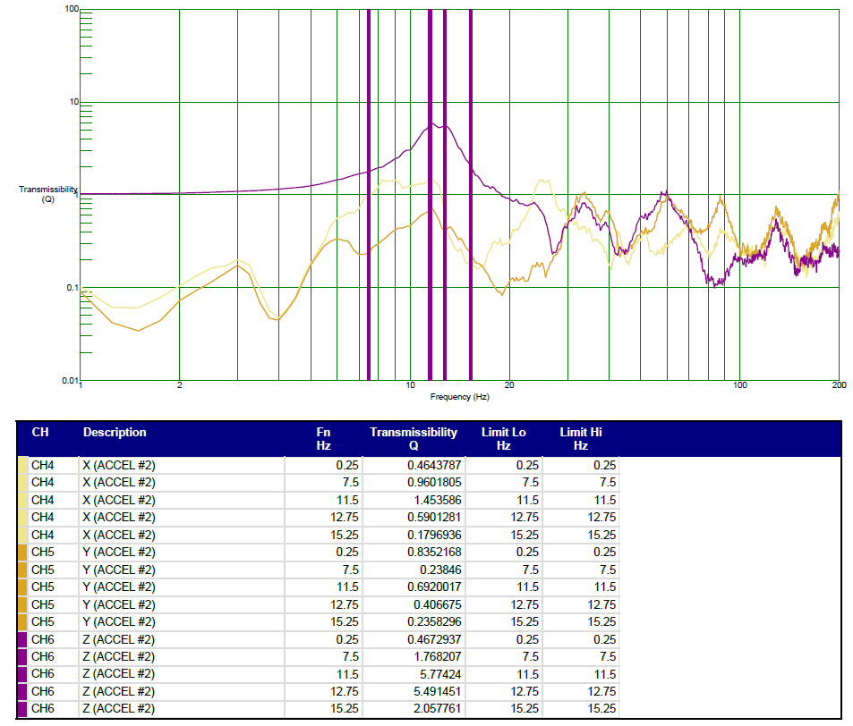

Conclusion | Pass / Fail
No critical damage or conditions were observed post random vibration testing. | Pass

Additional Notes
Nine (9) lugs were fastened around the perimeter of the base to secure the crate sleeve to the pallet. This is the condition of the crate for the remainder of tests.
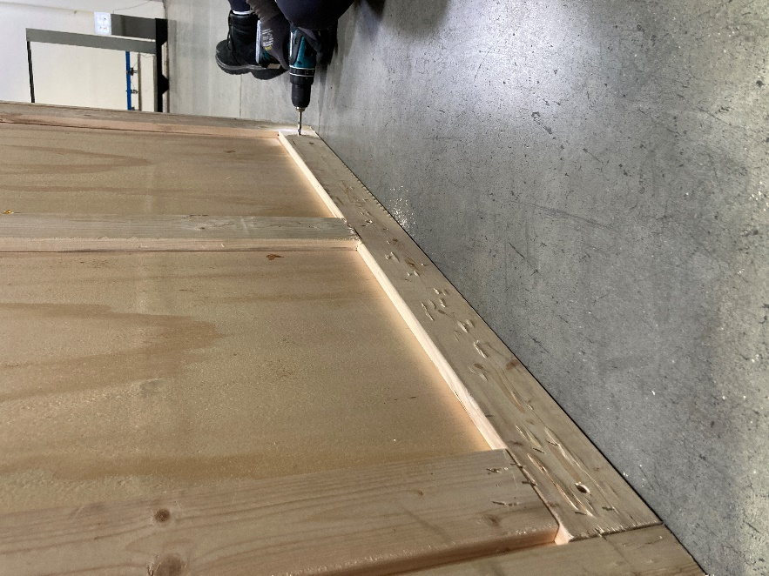 | 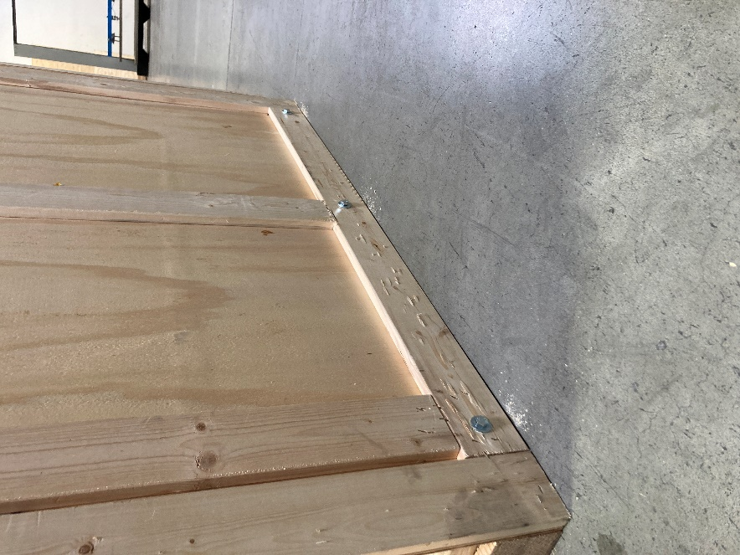
Holes were drilled to the pallet to align with pre-drilled holes on the crate sleeve. | Three (3) lugs were each fastened to Face 2, 4, and 6.

Test Sequence 6

Fork Lift Handling - Flat Push & Rotate
Test No. | Orientation | Test Procedure
1 | Face 5 | Using the tips of the forklift tines to touch the center of the stringer halfway up its height, push the pallet forward 40 inches in 2-3 seconds.
2 | Corner 3-4-5 | Contact the corner with a forklift tine and rotate the pallet 90°.
3 | Face 4 | Using the tips of the forklift tines to touch the center of the stringer halfway up its height, push the pallet forward 40 inches in 2-3 seconds.
4 | Corner 3-4-6 | Contact the corner with a forklift tine and rotate the pallet 90°.
5 | Face 6 | Using the tips of the forklift tines to touch the center of the stringer halfway up its height, push the pallet forward 40 inches in 2-3 seconds.
6 | Corner 2-3-6 | Contact the corner with a forklift tine and rotate the pallet 90°.
7 | Face 2 | Using the tips of the forklift tines to touch the center of the stringer halfway up its height, push the pallet forward 40 inches in 2-3 seconds.
8 | Corner 2-3-5 | Contact the corner with a forklift tine and rotate the pallet 90°.

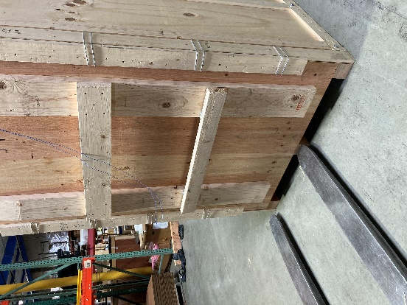 | 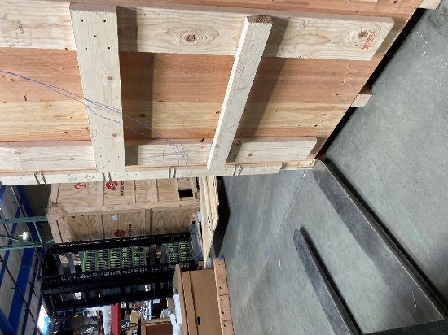 | 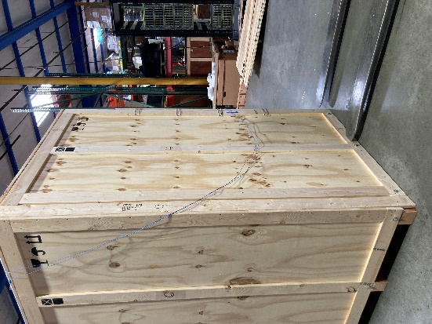
Face 5 | Corner 3-4-5 | Face 4
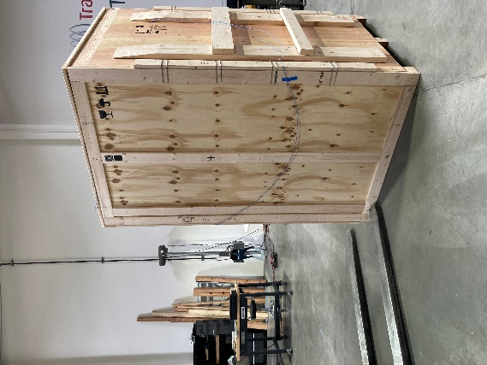 | 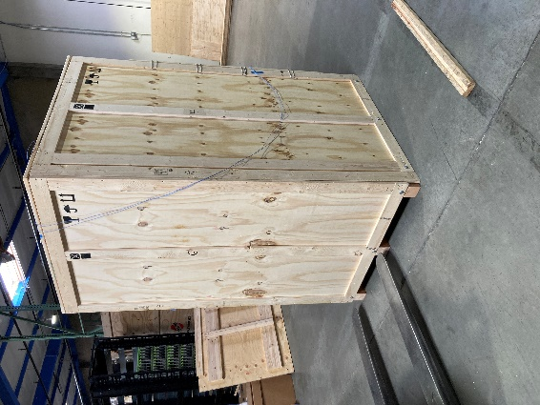 | 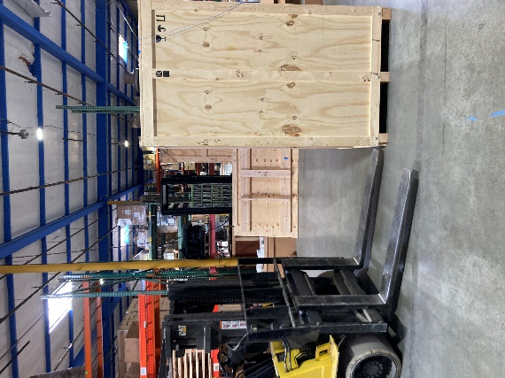
Corner 3-4-6 | Face 6 | Corner 2-3-6
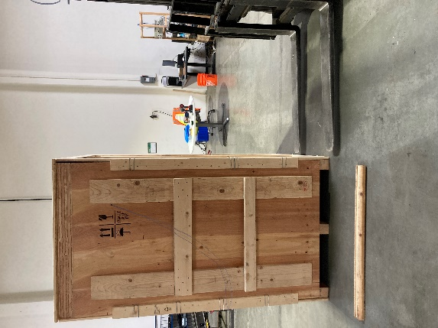 | 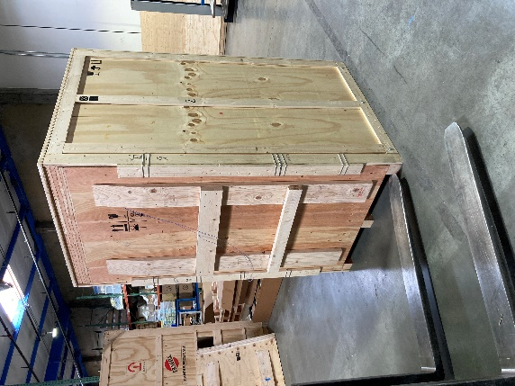
Face 2 | Corner 2-3-5

Conclusion | Pass / Fail
No critical damage or conditions were observed post fork lift handling flat push & rotate tests. All damage to the pallet is considered normal for test level. | Pass

Test Sequence 7

Fork Lift Handling - Elevated Push & Pull
Test No. | Orientation | Test Procedure
1 | Face 5 | Lift the edge 4 inches and push the pallet forward 40 inches, then pull backwards 40 inches.
2 | Face 6

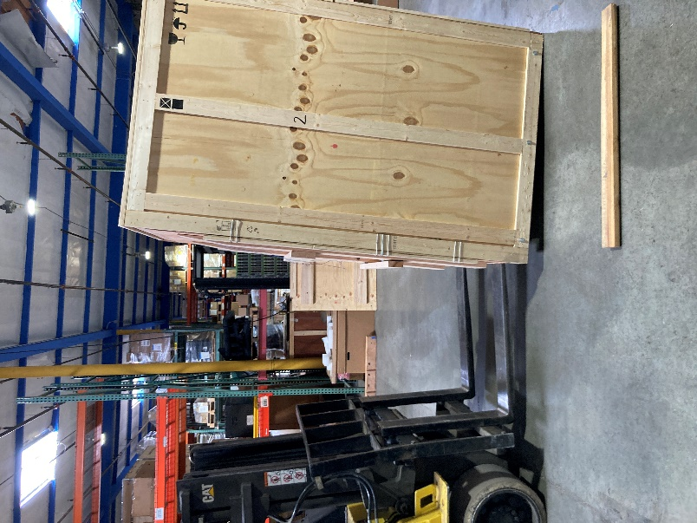 | 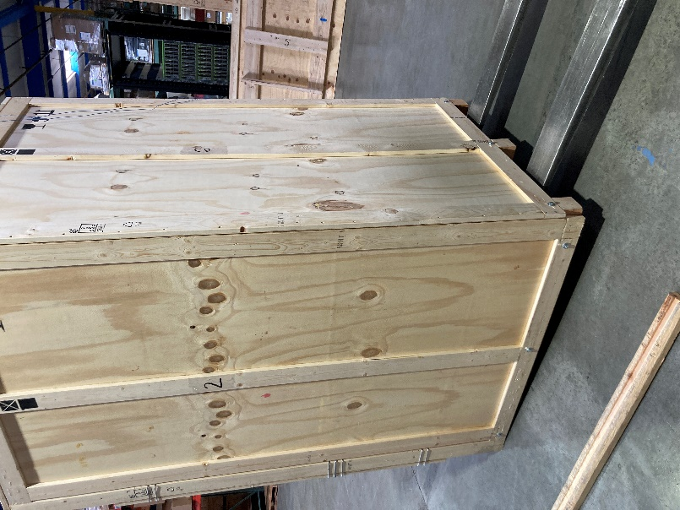
Face 5 | Face 6

Conclusion | Pass / Fail
No critical damage or conditions were observed post fork lift handling elevated push & pull tests. All damage to the pallet is considered normal for test level. | Pass

Test Sequence 8

Fork Lift Handling - Elevated Rotate
Test No. | Orientation | Test Procedure
1 | Corner 3-4-6 | Lift the corner a minimum of 4 in. leaving the opposite corner on the floor and rotate the pallet 90°.
2 | Corner 2-3-6
3 | Corner 2-3-5
4 | Corner 3-4-5

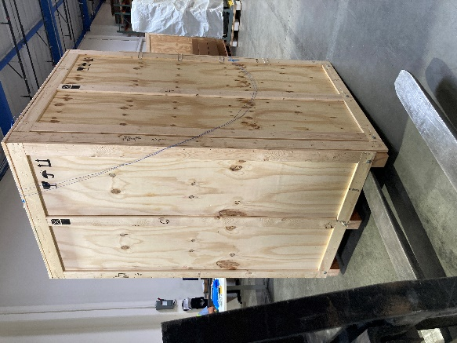 | 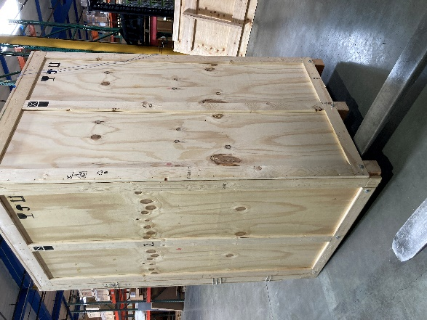
Corner 3-4-6 | Corner 2-3-6
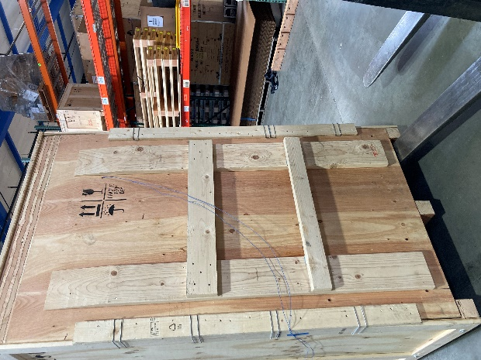 | 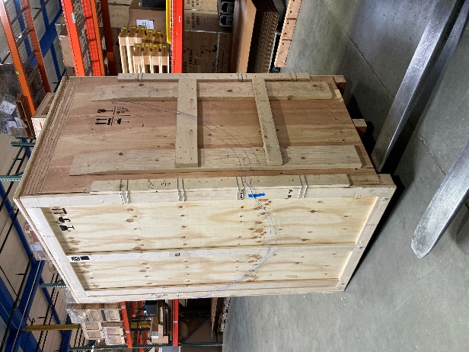
Corner 2-3-5 | Corner 3-4-5

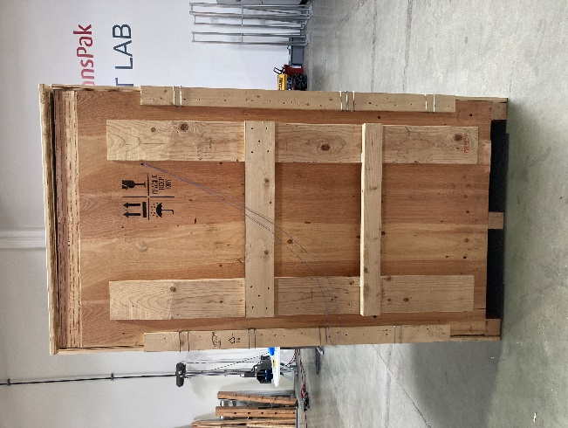 | 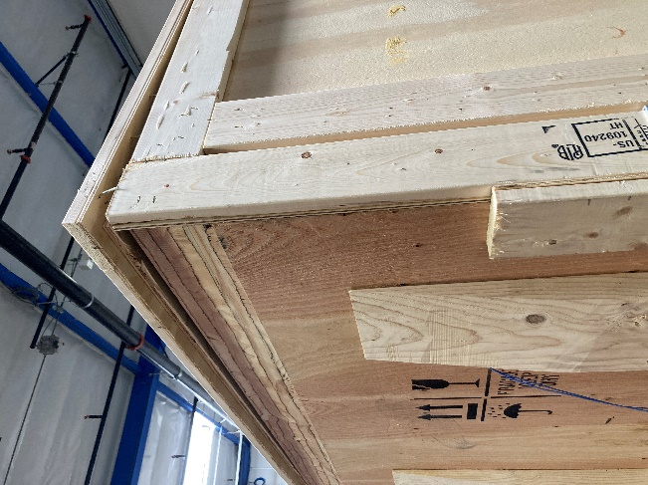
Post-test Corner 2-3-5

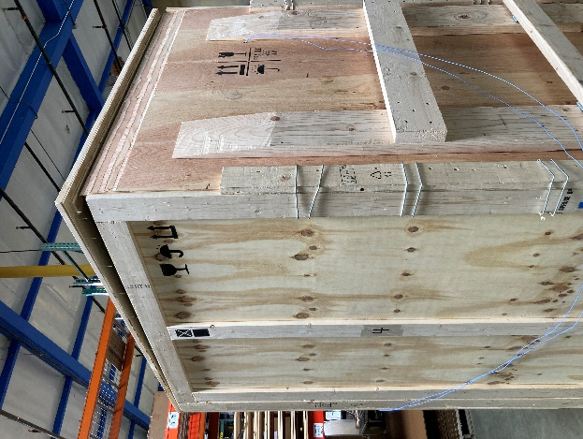 | 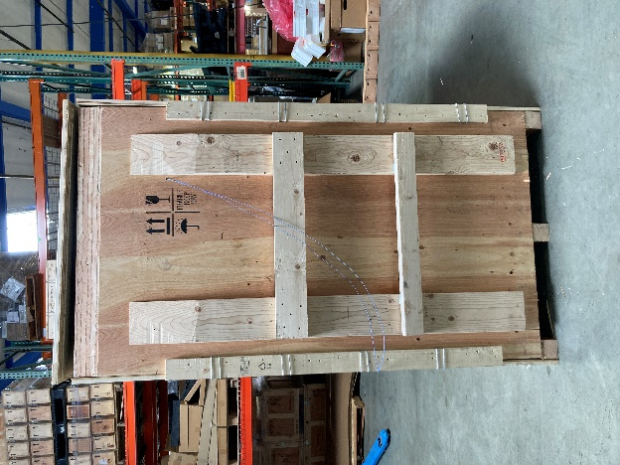
Post-test Corner 3-4-5

Conclusion | Pass / Fail
No critical damage or conditions were observed post fork lift handling elevated rotate tests for Corner 3-4-6 and Corner 2-3-6. Testing on Corner 2-3-5 and Corner 3-4-5 caused damage to the top lid of the crate sleeve. | Design review recommended

Test Sequence 9

Fork Lift Handling – Handling Course
No. of Roundtrips | Test Procedure
2 | The unitized load was picked up with a forklift and transported through a course consisting of eleven rigid plates bolted to a concrete floor.

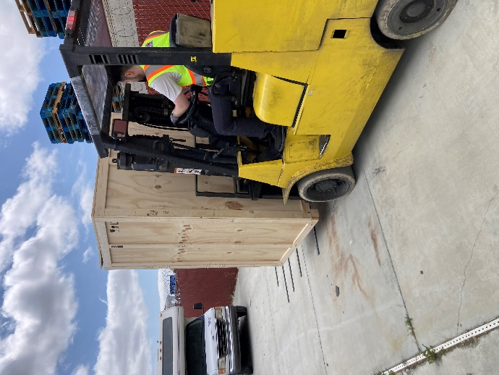 | 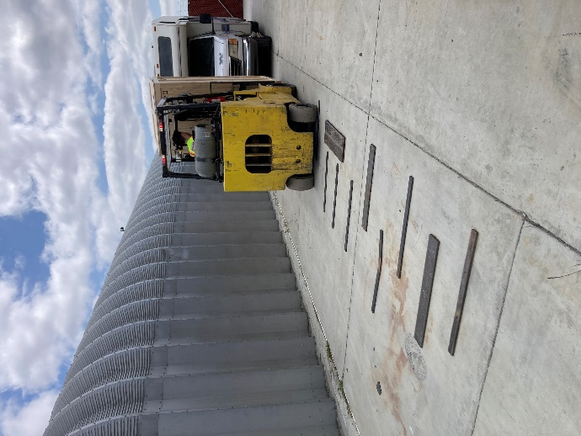

Conclusion | Pass / Fail
No critical damage or conditions were observed post fork lift handling course tests. All damage to the pallet is considered normal for test level. | Pass

Test Sequence 10

Rotational Drop
Test No. | Orientation | Drop Height (in.) | Accelerometer #1  Peak G’s | Accelerometer #2  Peak G’s
1 | Edge 2-3 | 6 | No trigger (<10 G’s) | No trigger (<10 G’s)
2 | Corner 3-4-6 | 6 | No trigger (<10 G’s) | No trigger (<10 G’s)
Note: The opposite impacted edge/corner was supported with a 4.0” block.

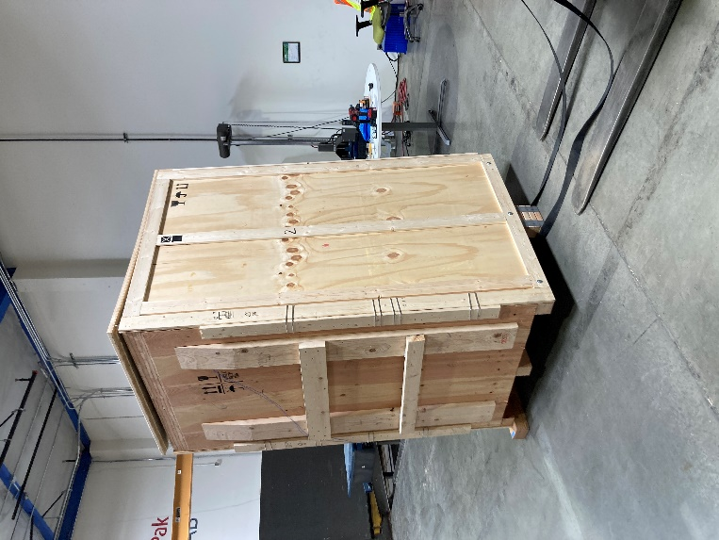 | 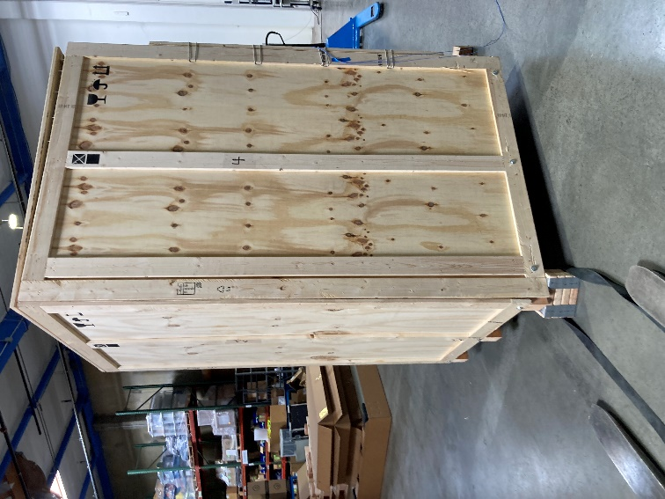
Edge 3-6 | Corner 3-4-5

Conclusion | Pass / Fail
No critical damage or conditions were observed post rotational edge drop and rotational corner drop. | Pass

Test Sequence 11

Incline Impact
Test No. | Face | Velocity | Accelerometer #1  Peak G’s | Accelerometer #2  Peak G’s
1 | Face 2 | 48 in/sec | 6.28 | No trigger (<10 G’s)
2 | Face 4 | 48 in/sec | 5.57 | No trigger (<10 G’s)

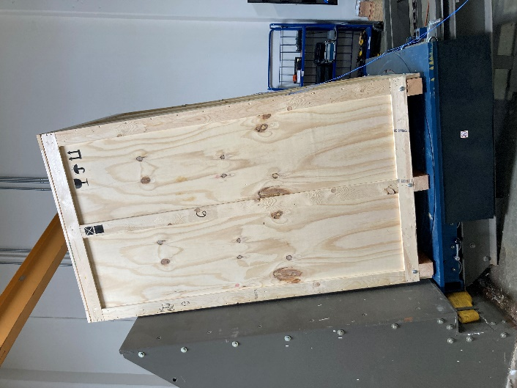 | 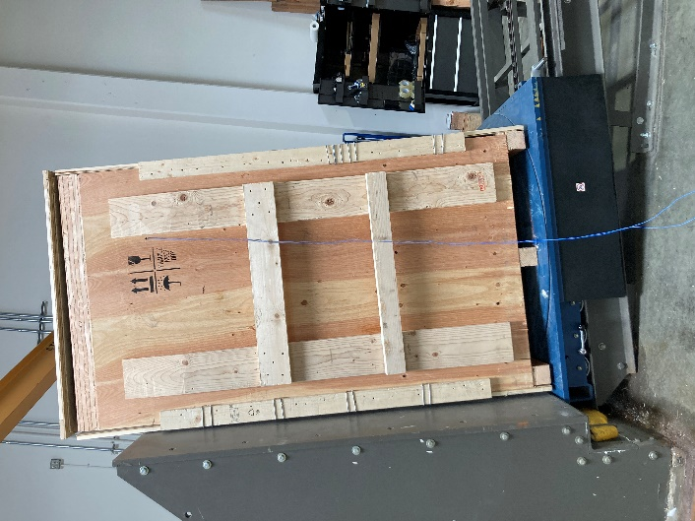
Face 2 | Face 4

Conclusion | Pass / Fail
No critical damage or conditions were observed post incline impact testing. | Pass

Post-Test Photos

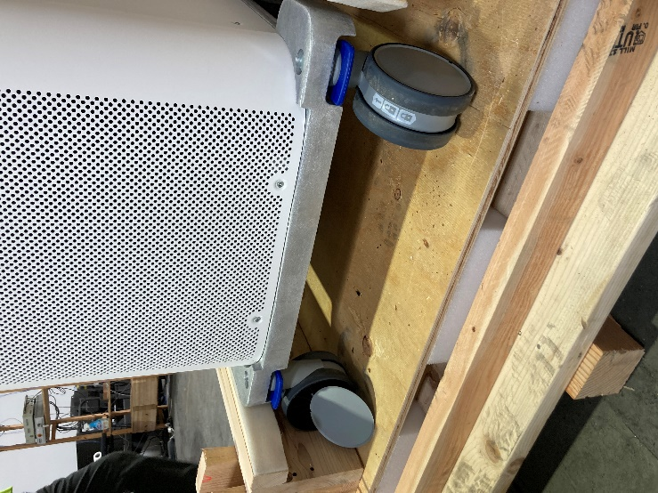 | 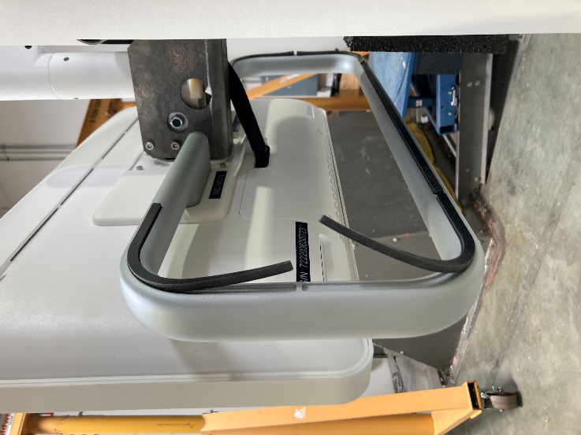
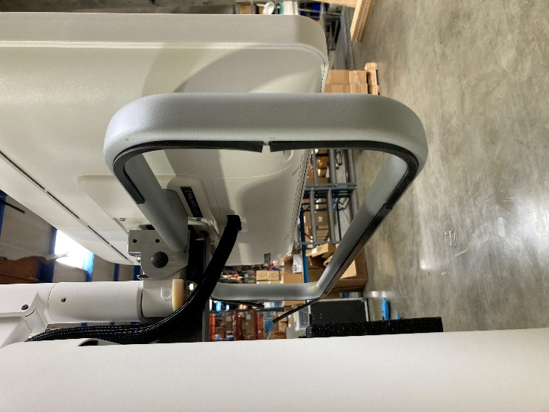 | 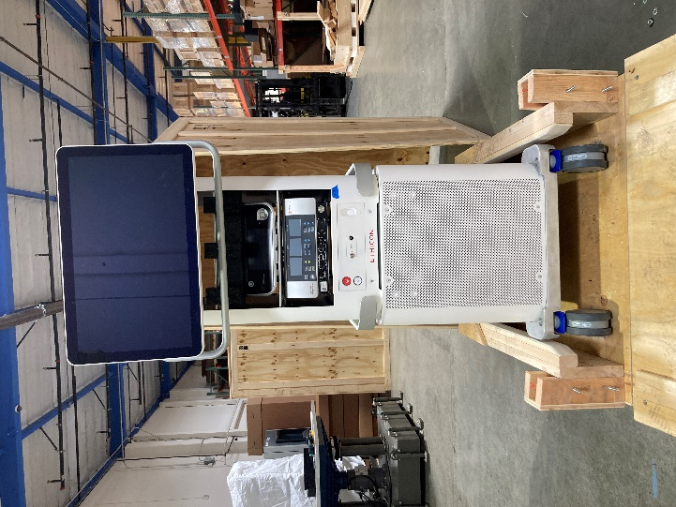

End of Report

