
Test Date: June 22, 2023
Test Operator #1 Name | Email

Product Name
ISTA 3B Test Method
Rev (A, B, C, etc)

TransPak
20415 Corsair Blvd.
Hayward, CA 94545

Table of Contents

Table of Contents 2
Objective 3
Key Takeaways 3
Test Protocol 4
Test Equipment 5
Test Sample Description 6
Pretest Preparation 8
Test Sequence 1 11
Test Sequence 2 11
Test Sequence 3 12
Test Sequence 4 13
Test Sequence 5 15
Test Sequence 6 19
Test Sequence 7 21
Test Sequence 8 22
Test Sequence 9 24
Test Sequence 10 25
Test Sequence 11 26
Post-Test Photos 27

Certification
TransPak is an ISTA certified testing facility – Member ID: 10149
International Safe Transit Association
1400 Abbott Road, Suite 160
East Lansing, MI 48823- 1900
Email: ista@ista.org

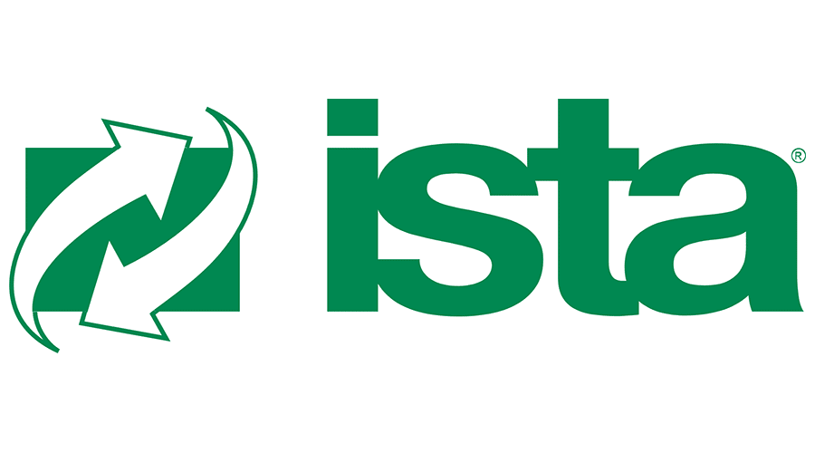

Objective

Key Takeaways

Test Protocol

Sequence No. | Test Category | Test Type | Test Level
1
2
3
4

Test Equipment

Equipment Used
Equipment | Make | Model

Test Sample Descriptions

External Packaging | Weight | Outside Dimensions  (L x W x H) | Quantity

Pretest Preparation

Pretest Photos

Additional Notes

\
\

Test Sequence 1

Test Sequence 2

