Ics第二次作业

吴欣怡 PB21051111

T1.

1. 最小规格化浮点数为1.0 $×2^{-126}$
2. 最大非规格化浮点数为0.11111111111111111111111 $×2^{-127}$

T2

$2^{31}$

T3

T4

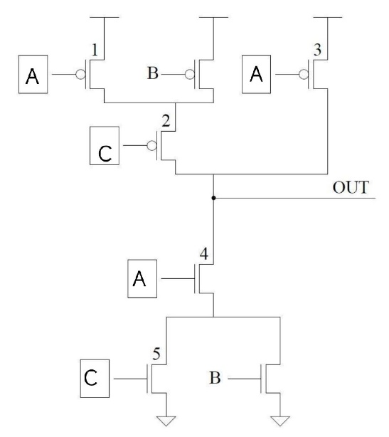

|  |  |  |  |
| --- | --- | --- | --- |
| A | B | C | OUT |
| 0 | 0 | 0 | 1 |
| 0 | 0 | 1 | 1 |
| 0 | 1 | 0 | 1 |
| 0 | 1 | 1 | 1 |
| 1 | 0 | 0 | 1 |
| 1 | 0 | 1 | 0 |
| 1 | 1 | 0 | 0 |
| 1 | 1 | 1 | 0 |

T5

X，1，0，1，0

T6

T7

(1) $2^{5}=32$

(2)1，4

T8

(1)2

(2)

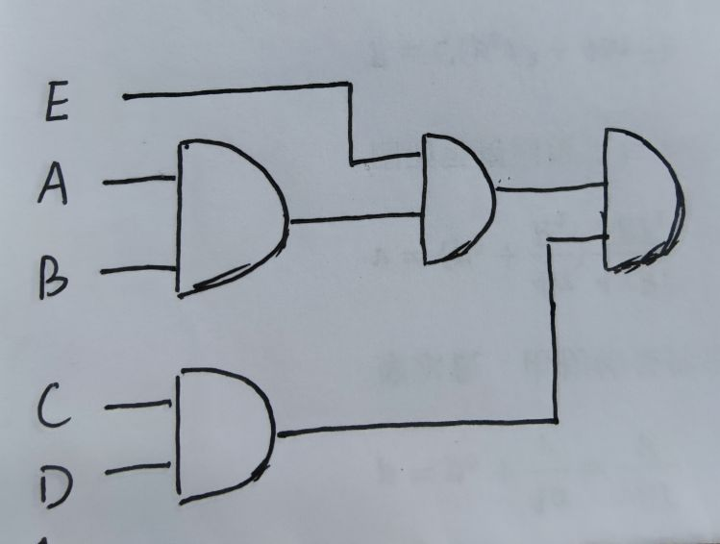

T9

100000

12

T10

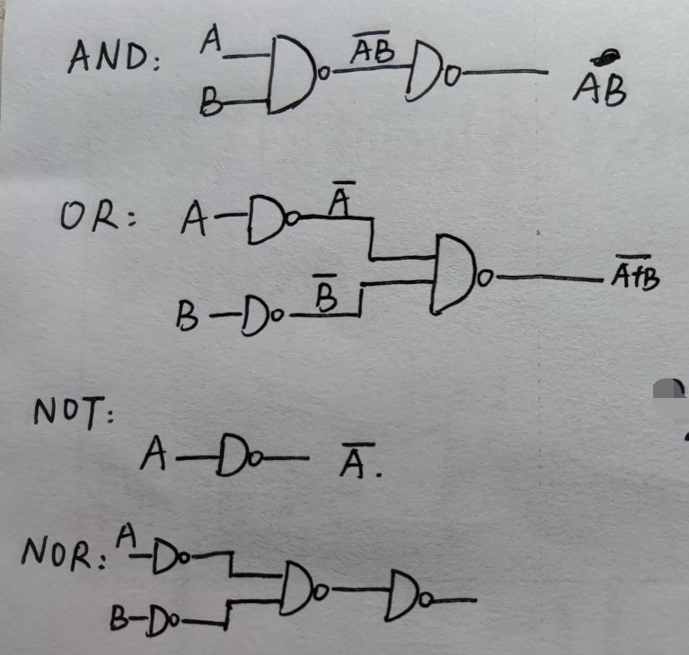

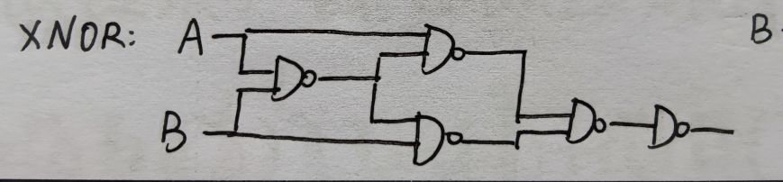

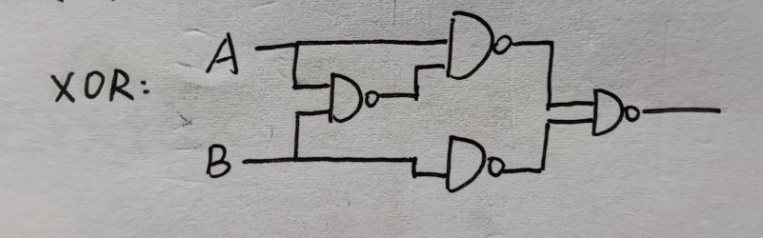

T11

a) 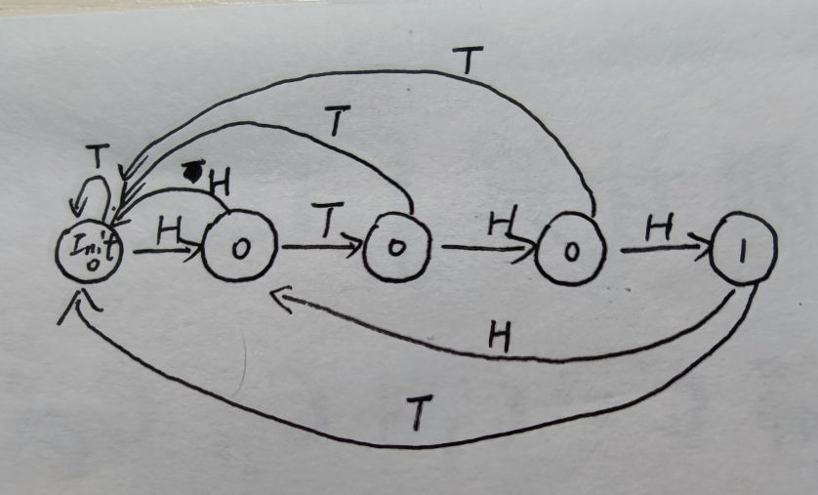

b)3

T12

没做出来

T13

256byte