**T1**

|  |  |  |  |  |  |
| --- | --- | --- | --- | --- | --- |
| S1 | S2 | X | Z | S1' | S2' |
| 0 | 0 | 0 | 1 | 0 | 0 |
| 0 | 0 | 1 | 1 | 0 | 1 |
| 0 | 1 | 0 | 0 | 1 | 0 |
| 0 | 1 | 1 | 0 | 0 | 0 |
| 1 | 0 | 0 | 0 | 0 | 1 |
| 1 | 0 | 1 | 0 | 1 | 0 |
| 1 | 1 | 0 | 0 | 0 | 0 |
| 1 | 1 | 0 | 0 | 0 | 0 |

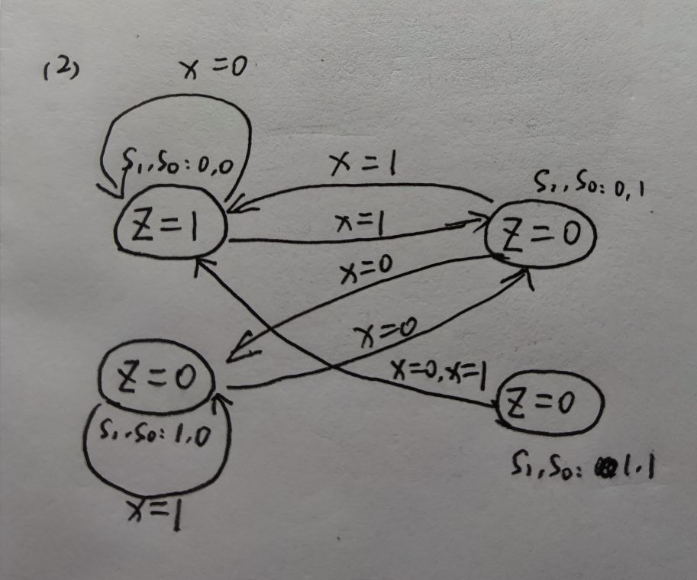

**T2**

当在x3030处执行的指令结果不为0时

**T3**

1. 操作码（即该字段最多可表达 $2^{4}$ 个操作类型）
2. 操作数的表示（目的寄存器，源寄存器，偏移寄存器，基地址等等）

**T4**

104

**T5**

56 opcodes = 6 bits

64 registers = 6 bits

IMM = 32 - 6 - 6 - 6 = 14

range ：- $2^{13}$ ~（$2^{13}$-1）

**T6**

不会

**T7**

|  |  |  |  |  |  |  |
| --- | --- | --- | --- | --- | --- | --- |
|  | **Fetch Instruction** | **Decode** | **Evaluate Address** | **Fetch Data** | **Execute** | **Store Result** |
| **PC** | **JMP** |  |  |  | **JMP** |  |
| **IR** |  |  |  |  |  |  |
| **MAR** |  |  | **ADD** |  |  |  |
| **MDR** | **STR** |  |  |  |  | **ADD、STR** |

**T8**

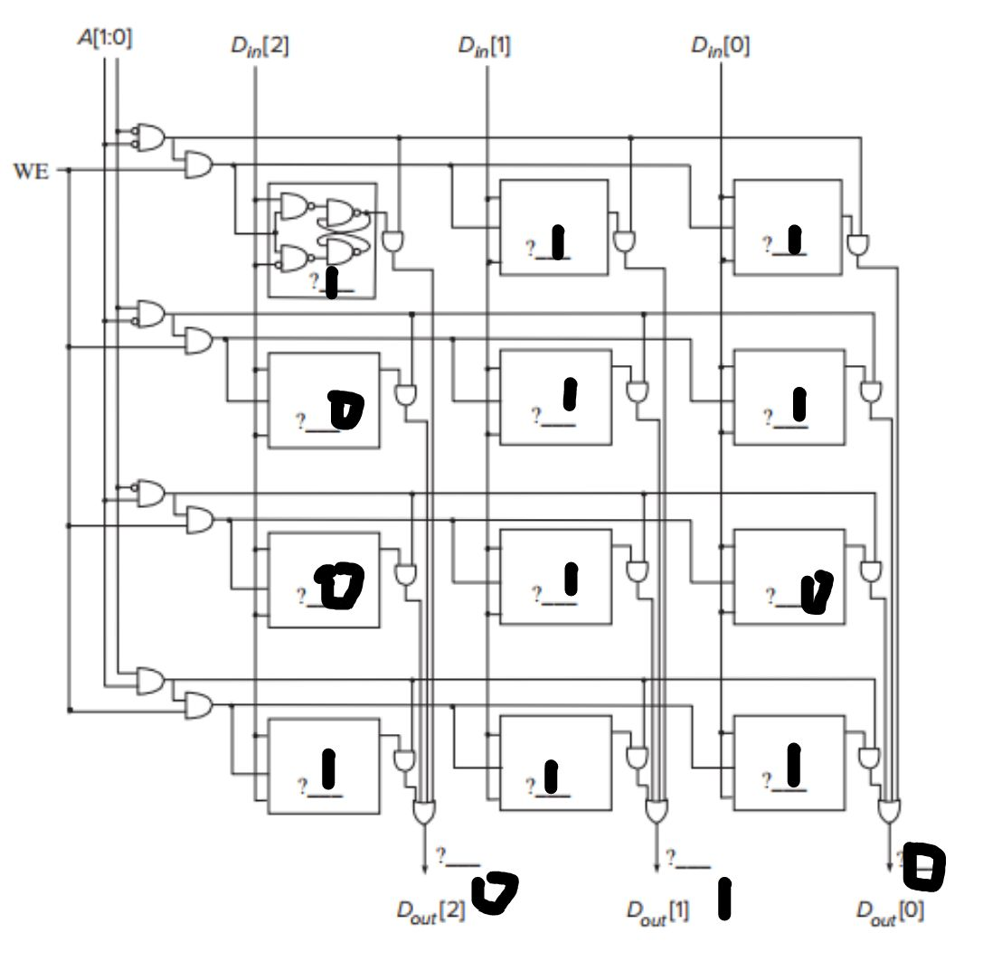

**T9**

（a）000，00010110

（b）00011011

**T10**

|  |  |  |  |
| --- | --- | --- | --- |
|  | **R/W** | **MAR** | **MDR** |
| **Operation 1** | W | x4000 | 1 1 1 1 0 |
| **Operation 2** | R | x4003 | 1 0 1 1 0 |
| **Operation 3** | W | x4001 | 1 0 1 1 0 |
| **Operation 4** | R | x4002 | 0 1 1 0 1 |
| **Operation 5** | W | x4003 | 0 1 1 0 1 |

|  |  |
| --- | --- |
| X4000 | 0 1 1 0 1 |
| X4001 | 1 1 0 1 0 |
| X4002 | 0 1 1 0 1 |
| X4003 | 1 0 1 1 0 |
| X4004 | 1 1 1 1 0 |

|  |  |
| --- | --- |
| X4000 | 1 1 1 1 0 |
| X4001 | 1 1 0 1 0 |
| X4002 | 0 1 1 0 1 |
| X4003 | 1 0 1 1 0 |
| X4004 | 1 1 1 1 0 |

|  |  |
| --- | --- |
| X4000 | 0 1 1 0 1 |
| X4001 | 1 1 0 1 0 |
| X4002 | 0 1 1 0 1 |
| X4003 | 0 1 1 0 1 |
| X4004 | 1 1 1 1 0 |

**T11**

（1）8

（2）7

（3）3

**T12**

（1）5 ${10}^{8}$

*

（2）6.25 ${10}^{7}$

*

（3）取决于工作负载和整体架构的核心

**T13**

(a) Fetch: Get instruction from memory. Load address of next instruction in the Program Counter.

(b) Decode: Find out what the instruction does.

(c) Evaluate Address: Calculate address of the memory location that is needed to process the instruction.

(d) Fetch Operands: Get the source operands (either from memory or register file).

(e) Execute: Perform the execution of the instruction.

(f) Store Result: Store the result of the execution to the specified destination.