EXHIBIT A
Wearable and Biomechanical Evidence:
Walking vs. Mall/PT Skating and ParaTransit Bus/Van vs. Sedan
Source: FSICSS legal corpus and Appellant’s WHOOP, Strava, Kubios/Polar H10, transportation, video, and record materials. Court-ready exhibit for emergency-relief support.
This exhibit consolidates wearable, route, and accelerometer evidence into two legally relevant comparator groups: (1) walking versus Mall/PT controlled public-access skating; and (2) ParaTransit bus/cutaway and van versus ParaTransit sedan.
The legal theory is not that a wearable alone proves pain. The theory is that the wearable record objectively corroborates long-documented disability facts and record exhibits: walking is pain-limited and vertically loaded, while inline skates function as a lower-vertical-burden non-traditional mobility aid; and bus/van ParaTransit imposes passive vertical burden compared with sedan transport.

I. Medical, agency, and legal foundation referenced for this exhibit
- 2001 IRS disability/work-mobility documentation (Exhibit I): the IRS-related material reflects that Appellant needed special equipment and transportation for professional duties and references medical, work, orthopedic, and musculoskeletal support for skate-related mobility use. This supports the long-running disability/mobility context, without asking the Court to treat tax documentation as a final accommodation ruling.
- 2005 doctor note with Mahar biomechanics support (Dkt. 1, p. 88): the 2005 medical/biomechanics record is consolidated here. It documents difficulty walking and incorporates or references Andrew Mahar’s biomechanics support concerning why skates provide easier, lower-impact mobility for Appellant. This is individualized foundation evidence connecting Appellant’s medical condition, functional walking limits, and skate-based mobility-aid use.
- 2007 DOT-FTA Letter of Finding and public agency record (Dkt. 1, pp. 17-25): after Appellant pursued a DOJ Civil Rights complaint in approximately 2006, federal transportation authorities spent about a year evaluating the access issue, including the relevant class of mobility aids and Appellant's use of inline skates. This exhibit treats the 2007 Letter of Finding as a federal agency determination recognizing inline skates as a non-traditional mobility aid and as reflecting an environment-specific reasonable-modification and direct-threat analysis rather than categorical exclusion.
- 2007-2025 ParaTransit accommodation history: taxi/sedan service generally functioned as a lower-burden accommodation because it reduced vehicle and entry/exit burden, although rides lasting longer than approximately 45 minutes, shared pickups, waiting exposure, or lack of front-seat/open-area positioning still caused undue stress. The current emergency arises because ParaTransit shifted toward buses, vans, cutaways, shared rides, and prolonged routing that increase passive mechanical burden.
- 2022 DMV ruling / authorization evidence (Dkt. 1, pp. 41-42): DMV proceedings recognized or authorized Appellant's ability to drive and ride with inline skates as prostheses. This supports the broader non-traditional mobility-aid framework and rebuts categorical assumptions that inline skates are merely recreational or inherently incompatible with controlled transportation environments.
Appendix A / reproducible notebook foundation (Exhibit M): Appendix A is a reproducible data-science notebook available to the Court, participants, and technical reviewers through the filing link so the data, tables, and graphs can be evaluated and run against the underlying evidence. It uses case number 25-7526, snapshot date 2026-06-03, 2,183 loaded records, fixed cohort definitions, inclusion/exclusion rules, SHA-256 integrity verification, and explicit limitations. SHA-256 verifies that the same evidence snapshot generated the tables and charts; it does not prove any medical or legal conclusion by itself.
Court-safe synthesis: The current data does not invent a new disability theory. It quantifies a medical, biomechanical, agency, and functional record developed across decades: Appellant has documented difficulty walking, has individualized medical/biomechanics support for skate-based mobility, has prior federal transportation-agency recognition, and has DMV authorization related to using skates. The wearable and accelerometer data show how those records appear in current functional mobility and ParaTransit-burden metrics.

II. Comparator 1: Walking vs Mall/PT controlled skating
Purpose: This section compares basic walking to controlled mall or physical-therapy skating. It intentionally does not use FNS/SNS endurance skating as the primary comparator, because FNS/SNS are longer athletic/community mobility events with hills, speed, traffic, and duration burdens.
A. WHOOP heart-rate and HRV context
Category | Records | Mean avg HR | Median avg HR | Highest avg HR | Highest max HR | Mean HRV | Mean strain
walking | 33 | 123.39 | 129.00 | 158.00 | 195.00 | 38.47 | 9.75
skates | 596 | 112.97 | 113.00 | 143.00 | 197.00 | 36.05 | 12.61

WHOOP finding: Walking/manual-labor records had a mean average HR of 123.39 bpm and a median average HR of 129.00 bpm, compared with skating mean average HR of 112.97 bpm. This supports the historical observation that walking/manual-labor activity produces cardiovascular burden.
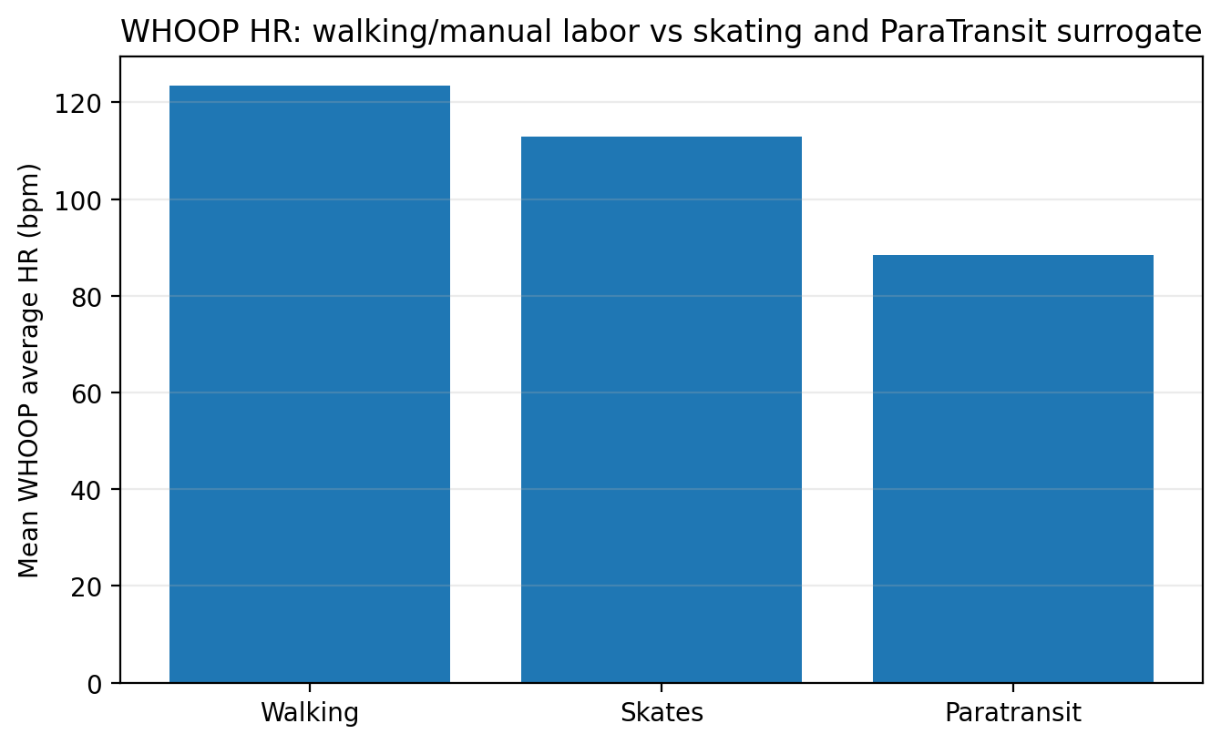
Figure 1 Walking/manual-labor (feet) events show higher mean average HR than skating (miles), while ParaTransit surrogate events provide longitudinal context for passive transportation burden. Vehicle-specific ParaTransit burden is addressed primarily through Kubios/Polar H10 accelerometer evidence, videos, and declaration testimony.
B. Strava functional-mobility context
Category | Records | Total miles | Mean miles | Median miles | Max miles | Total hours | Mean speed m/s
walking | 8 | 2.94 | 0.37 | 0.00 | 1.83 | 6.71 | 0.15
skates | 920 | 16225.25 | 17.64 | 18.26 | 117.75 | 1553.61 | 3.03

Strava finding: Skating records show 16225.25 total miles and a mean session distance of 17.64 miles, while walking records show 2.94 total miles and a mean session distance of 0.37 miles. This supports functional mobility via skating and limited walking tolerance.
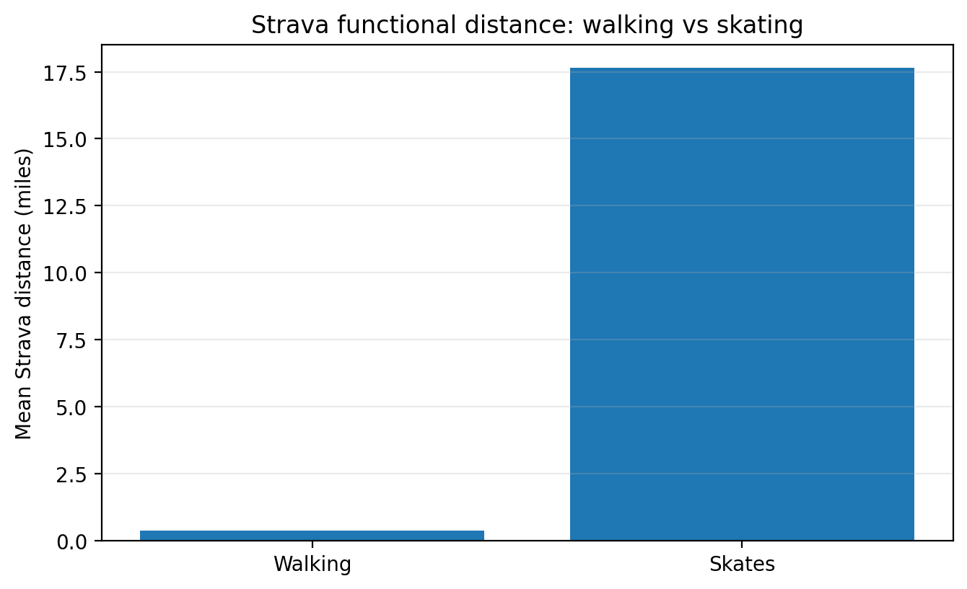
Figure 2 Walking records averaged approximately 0.37 miles, while skating records averaged approximately 17.64 miles, showing that skating provides substantially greater functional mobility than pain-limited walking.
C. Kubios/Polar H10 HRV+ and accelerometer evidence
Group | Records | RRI HR | Vertical mean | Vertical RMS | Movement std | Peaks/min | Peak-to-peak | Vertical/RRI CSS
Walking | 3 | 70.55 | 99.86 | 131.77 | 127.07 | 29.06 | 1153.00 | 0.77
Mall/PT controlled skating | 11 | 84.53 | 65.51 | 87.70 | 83.67 | 27.76 | 1463.36 | 0.97

Kubios finding: Walking produced 1.52x greater vertical mean load, 1.50x greater vertical RMS, and 1.52x greater movement instability than Mall/PT controlled skating in the latest Appendix A notebook. The walking test was only several hundred feet; the mall-skating comparator included approximately two miles of controlled mobility.
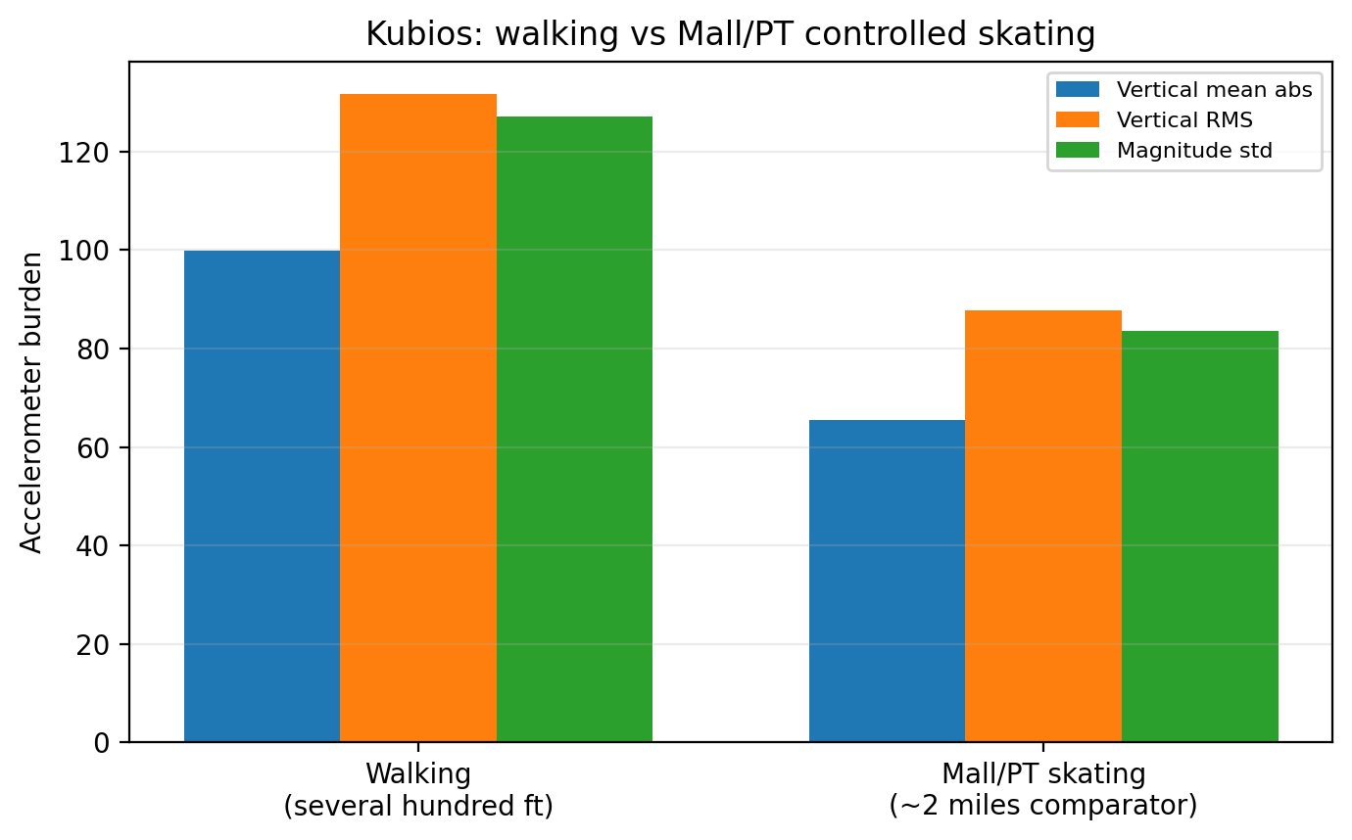
Figure 3 Walking over several hundred feet produced higher vertical mean, vertical RMS, and movement variability than approximately two miles of controlled Mall/PT skating, supporting skates as a lower-burden non-traditional mobility aid. Values are relative proxy comparisons, not exact anatomical force measurements.
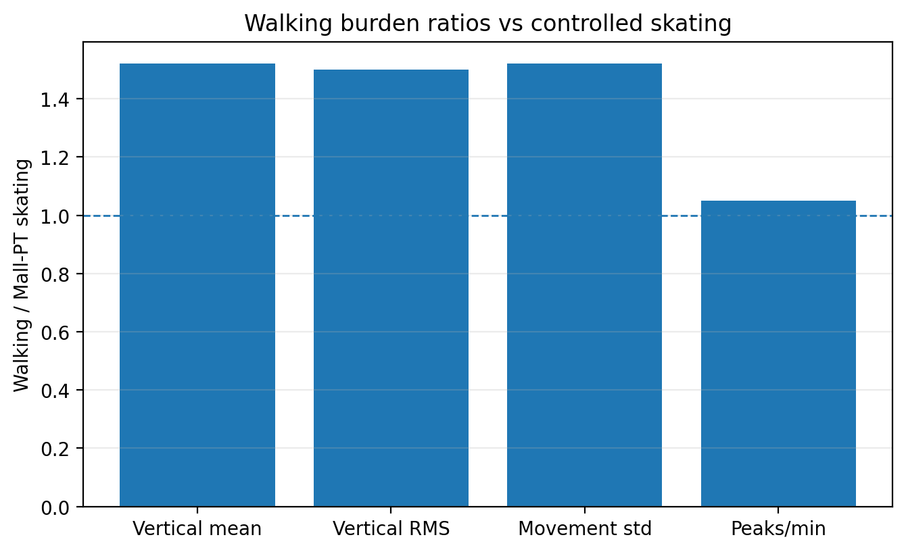
Figure 4 Accelerometer-derived ratios show that walking produced greater relative burden than controlled Mall/PT skating: approximately 1.52x vertical mean, 1.50x vertical RMS, 1.52x movement variability, and 1.05x peaks/min. The dashed line marks parity with controlled skating. Values are relative proxy comparisons using the same processing pipeline, not exact anatomical force measurements.
Legal representation for Section II: Appellant’s walking test covered only several hundred feet, while controlled Mall/PT skating covered substantially greater functional distance, including approximately two miles in the mall-skating comparator. Despite the far shorter walking exposure, walking produced materially greater vertical-impact proxy burden and movement instability than controlled skating. This corroborates Appellant’s 2005 doctor note and Mahar biomechanics support. It also supports recognition of inline skates as a lower-vertical-burden non-traditional mobility aid, rather than recreation or preference.

III. Comparator 2: ParaTransit bus/van vs ParaTransit sedan
Purpose: This section evaluates whether ParaTransit vehicle type changes the passive mechanical burden imposed on Appellant during seated transportation. The critical comparison is bus/cutaway and van versus sedan/taxi-type transport.
Accommodation history: Appellant has relayed that from approximately 2007 to 2025, taxi/sedan service was provided and functioned as a reasonable accommodation, except when shared rides or pickups of other passengers extended the ride beyond approximately 45 minutes and caused undue stress. Appellant further notes that current ParaTransit sedans often do not provide a usable front passenger seat because a radio or equipment occupies that space, making back-seat entry and exit very difficult due to disability.
A. WHOOP physiological context
Category | Records | Mean avg HR | Median avg HR | Highest avg HR | Highest max HR | Mean HRV | Mean strain
paratransit | 112 | 88.38 | 87.00 | 134.00 | 171.00 | 35.33 | 3.76
walking | 33 | 123.39 | 129.00 | 158.00 | 195.00 | 38.47 | 9.75
skates | 596 | 112.97 | 113.00 | 143.00 | 197.00 | 36.05 | 12.61

WHOOP note: The ParaTransit WHOOP group in this corpus is largely labeled as Horseback Riding or vehicle surrogate. It provides general physiological context but does not distinguish bus, van, and sedan at the same precision as Kubios. The label scheme is functional rather than clinical: Manual Labor marks walking/manual-labor events; Horseback Riding marks painful passive ParaTransit rides; Wheelchair marks forced skate trips during the license-suspension/no-public-transportation period; Motorcycle marks motorcycle rides used as physical therapy/tolerated transport; and Commuting marks taxi/sedan service once it was separated from Horseback Riding ParaTransit rides. Therefore, the vehicle-type argument should rely primarily on Kubios accelerometer evidence, supported by videos and declaration testimony.
Strava note: Strava does not provide a clean bus/van/sedan ParaTransit comparator in this corpus. Its primary legal value here is to show functional skating mobility and limited walking tolerance. For ParaTransit vehicle-type burden, use Kubios plus video evidence from October 24, 2025 and November 1, 2025.
B. Kubios bus/van/sedan comparison
Vehicle | Records | RRI HR | Vertical mean | Vertical RMS | Movement std | Peaks/min | Peak abs | Peak-to-peak
ParaTransit bus/cutaway | 3 | 90.29 | 114.56 | 178.67 | 121.86 | 31.57 | 2717.68 | 4750.00
ParaTransit van | 2 | 110.61 | 115.70 | 181.08 | 96.65 | 25.63 | 2813.89 | 5022.50
ParaTransit sedan | 3 | 103.68 | 74.77 | 119.48 | 65.29 | 21.54 | 1954.90 | 2883.00

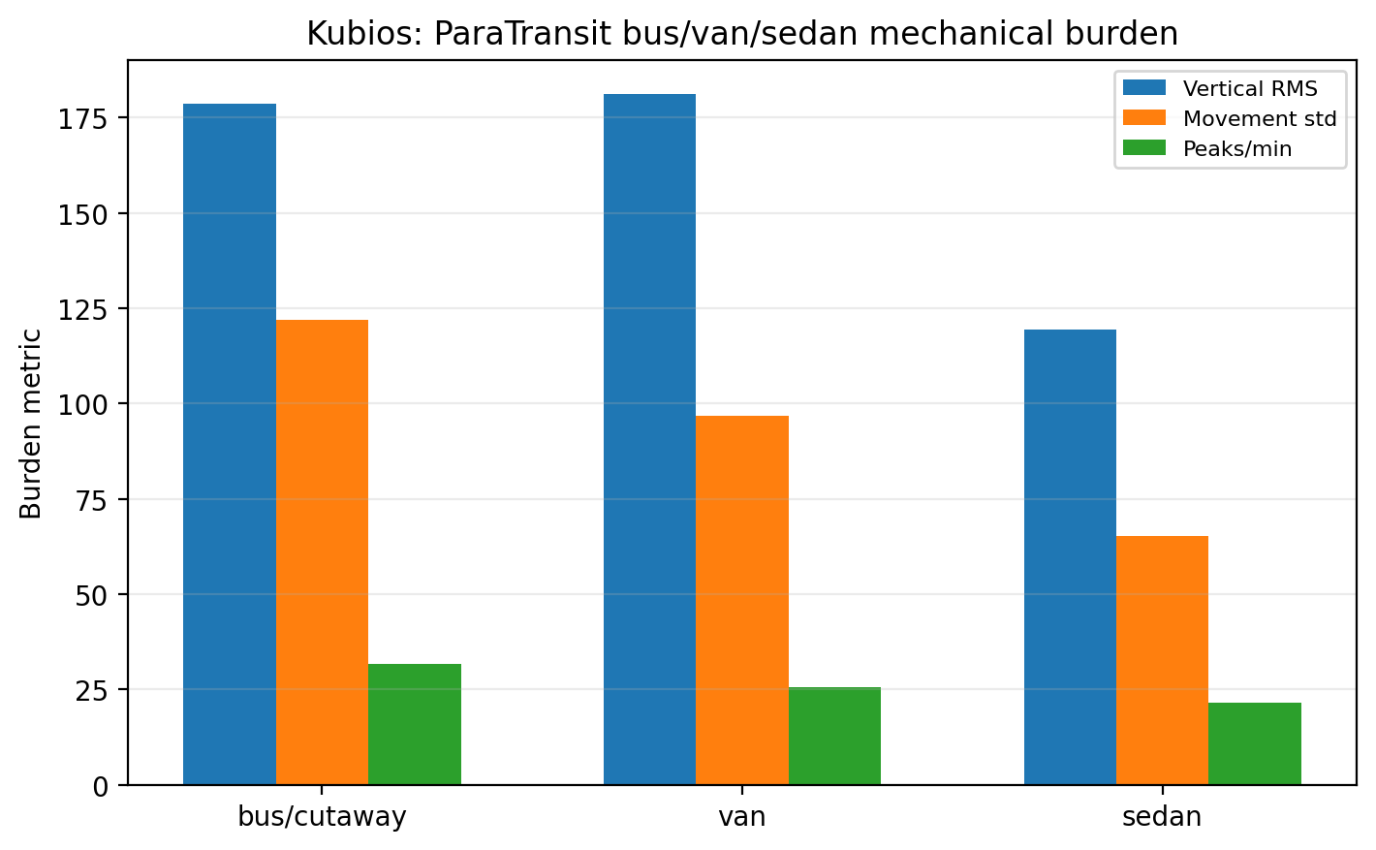
Figure 5 Kubios/Polar H10 accelerometer-derived metrics show higher passive movement burden during ParaTransit bus/cutaway and van rides than sedan rides, especially for vertical RMS and movement variability. These values are relative movement-burden proxies using the same processing method and should be read with the ParaTransit videos, declaration testimony, and medical/biomechanics record.
C. Vehicle burden ratios relative to sedan
Vehicle | Metric | Ratio vs sedan
bus/cutaway | RRI HR | 0.87
bus/cutaway | Vertical mean | 1.53
bus/cutaway | Vertical RMS | 1.50
bus/cutaway | Movement std | 1.87
bus/cutaway | Peaks/min | 1.47
bus/cutaway | Peak abs | 1.39
bus/cutaway | Peak-to-peak | 1.65
van | RRI HR | 1.07
van | Vertical mean | 1.55
van | Vertical RMS | 1.52
van | Movement std | 1.48
van | Peaks/min | 1.19
van | Peak abs | 1.44
van | Peak-to-peak | 1.74

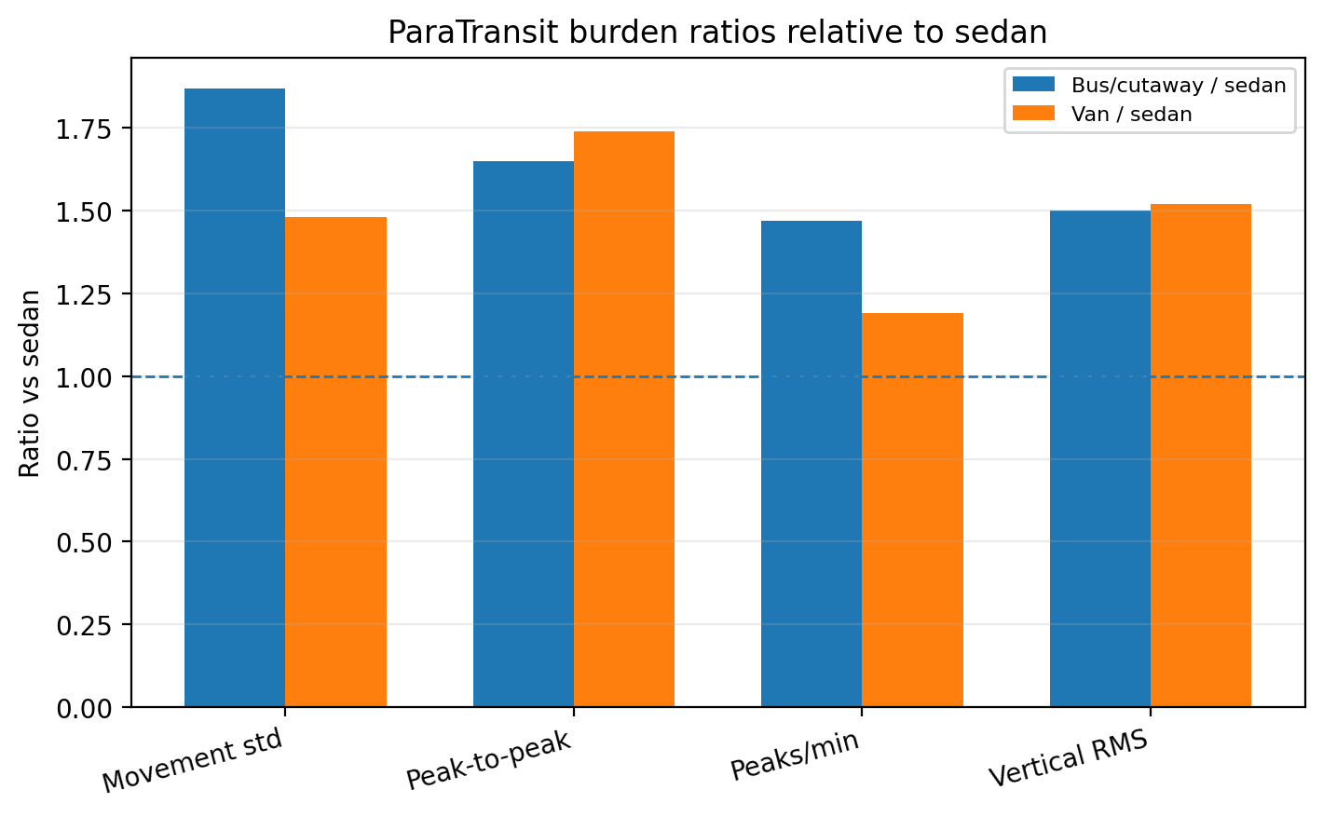
Figure 6 Relative to sedan transport, ParaTransit bus/cutaway and van rides produced higher accelerometer-derived burden across multiple passive-transport metrics. Bus/cutaway showed approximately 1.87x movement variability, 1.65x peak-to-peak burden, 1.47x peaks/min, and 1.50x vertical RMS compared with sedan; van showed approximately 1.74x peak-to-peak burden and 1.52x vertical RMS compared with sedan. The dashed line marks parity with sedan transport. Values are relative movement-burden proxies using the same processing pipeline, not exact anatomical force measurements.
Legal representation for Section III: ParaTransit bus/cutaway and van rides should be evaluated as passive mechanical stressors, not as ordinary seated travel. The data shows higher vertical and movement burden in bus/van rides than sedan rides. This is consistent with Appellant’s individualized medical and biomechanics record, including pelvic/SI limitations and lower-impact skate-based mobility support. A direct sedan-based, route-limited accommodation is therefore medically and biomechanically grounded. The accommodation should also include practical seat access: where a sedan’s front passenger seat is unavailable because of radio equipment, and back-seat entry or restricted back-seat posture is painful, the provider must supply a medically tolerable configuration that does not force painful entry, exit, restricted pelvic posture, or prolonged ride duration.

IV. Proposed legal argument language
Mobility-aid recognition: Appellant's inline skates are used as a non-traditional mobility aid because they convert painful, vertically loaded walking into lower-vertical-burden horizontal mobility. The current wearable data corroborates disability facts supported by record exhibits: the 2005 doctor note with Mahar biomechanics support, the 2007 DOT-FTA agency determination, the 2022 DMV authorization evidence for driving/riding with inline skates as prostheses, and current incident-specific wearable/biomechanical evidence.
Reasonable accommodation: The requested accommodation is not preferential treatment. It is a modification that mitigates disability-related burden. Controlled skating permits substantially greater function than walking, and sedan-based ParaTransit imposes materially less passive mechanical burden than bus/cutaway or van transport.
ParaTransit duration: From approximately 2007 through 2025, taxi/sedan service was generally sufficient as a lower-burden accommodation. It became inadequate when shared rides and passenger pickups caused trips to exceed approximately 45 minutes, increasing pain, stress, and cumulative exposure; and it worsened when vehicle assignment shifted toward bus/cutaway and van transport. The requested accommodation should therefore include sedan/direct-route service, rail-equivalent service, or route limits that prevent medically harmful ride duration and waiting exposure.
Seat access: A sedan is not automatically accessible if Appellant is forced into the back seat despite pelvic/SI limitations. If the front passenger seat is unavailable due to radio or other equipment, the provider must provide a configuration that allows safe, practical entry, exit, and pelvic movement without forcing painful body mechanics or restricted posture.
Evidentiary caution: Appellant does not claim that WHOOP, Strava, or Kubios alone proves pain. Appellant offers the wearable data as objective corroboration of a consistent longitudinal record: documented difficulty walking, individualized medical/biomechanics support, federal transportation-agency recognition, DMV authorization, demonstrated skating function, and passive ParaTransit burden.

V. Limitations and reliability notes
- Kubios bus/van/sedan sample sizes are small: bus/cutaway n=3, van n=2, sedan n=3. Present them as corroborative evidence aligned with videos, declaration testimony, and medical history.
- Use RRI-derived heart rate and accelerometer metrics. Avoid relying on raw ECG approximate HR values if artifacts are present.
- FNS/SNS should remain evidence of functional mobility and endurance, not the primary comparator for basic walking. The proper comparator is walking versus Mall/PT controlled skating. Inline skates should be referred to in the filing as a non-traditional mobility aid, while ordinary shorthand such as 'skating' may be used when describing activity data categories.
- Strava is strongest for functional route/distance evidence. It is not a bus/van/sedan comparator in this corpus.

