YE2A TO DX ENTITY

ALL BAND 24 HOURS PREDICTIONS (SHORT & LONG PATH)

ALASKA KL1
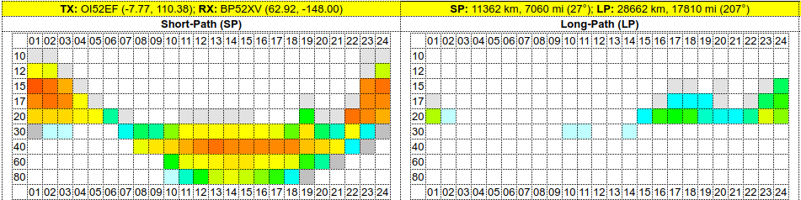

ARGENTINA LU
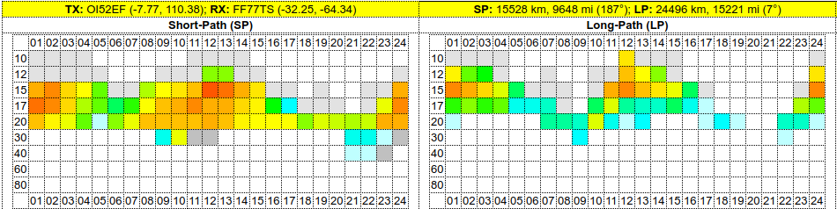

ASIATIC RUSSIA UA0
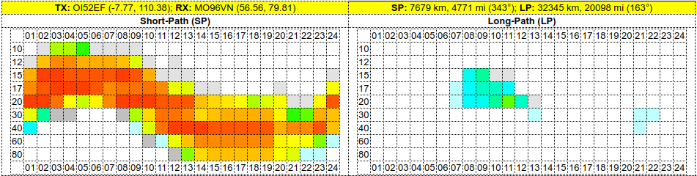

BRAZIL PY
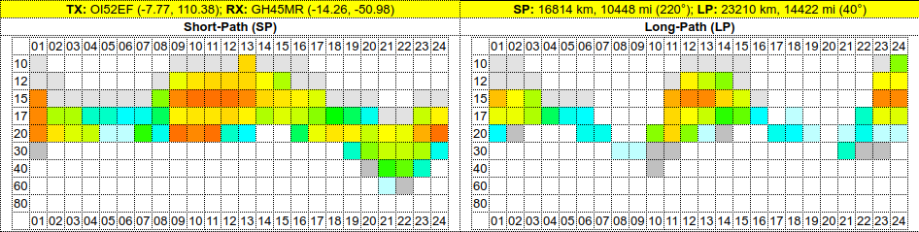

CANADA (EAST)
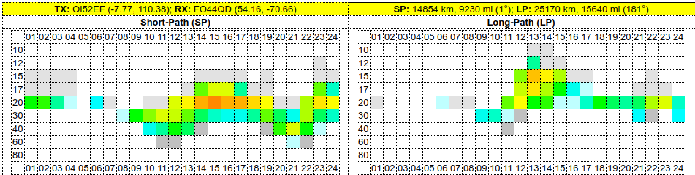
CUBA CM
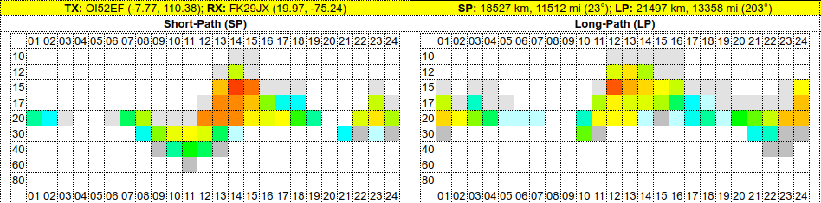

CURACAO PJ2
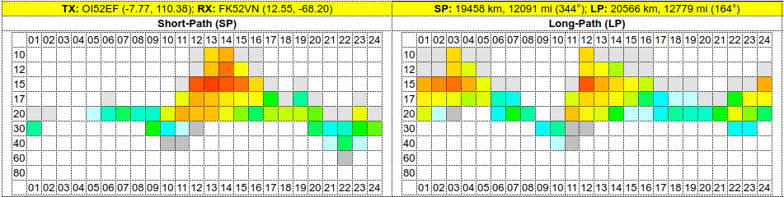

CENTRAL AFRICA TL8
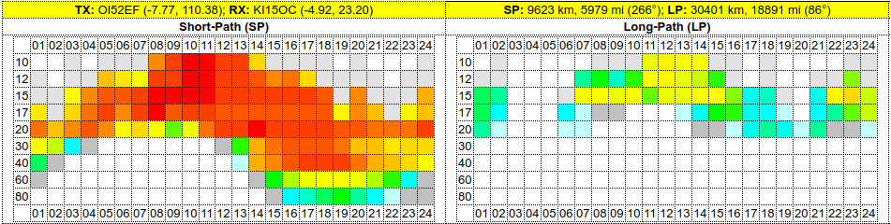

EUROPE
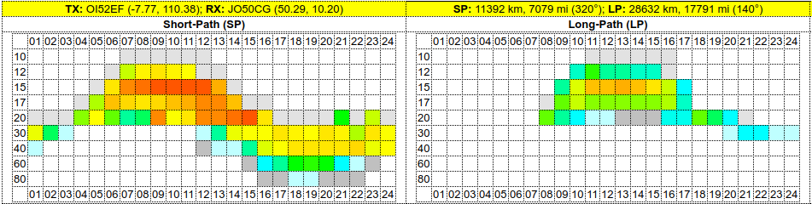
ISRAEL 4X
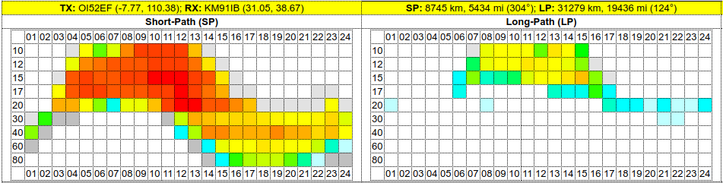

JAPAN JA
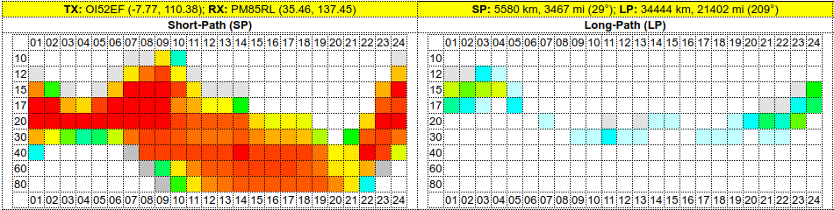
TUNISIA 3V
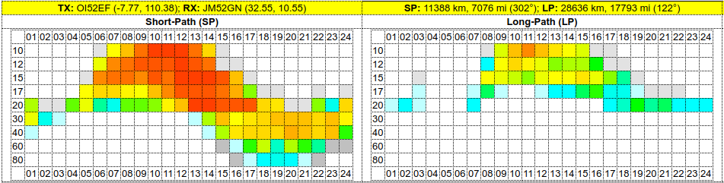

HAWAII KH6
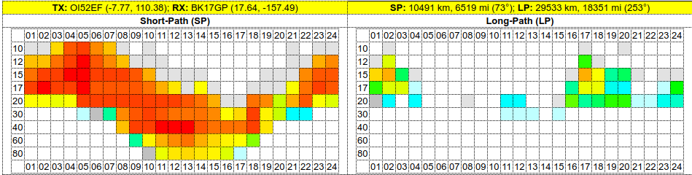
FINLAND OH1
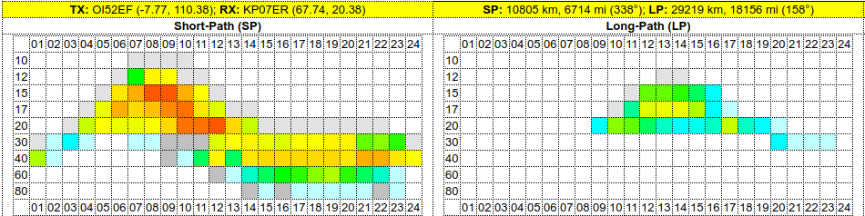

CANARY ISLAND EA8
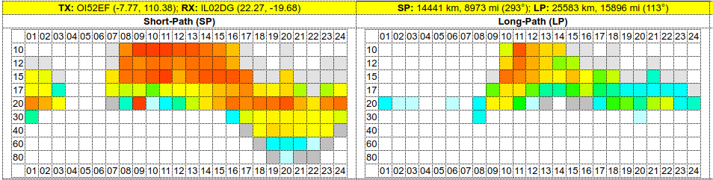

U.S. (EAST COAST)
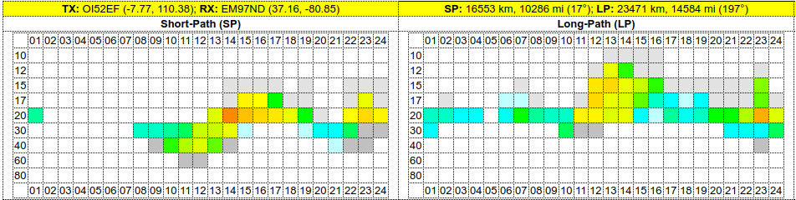

U.S. (WEST COAST)
