YE2A COVERAGE MAP

10 m Band (23 UTC – 17 UTC)

23 UTC
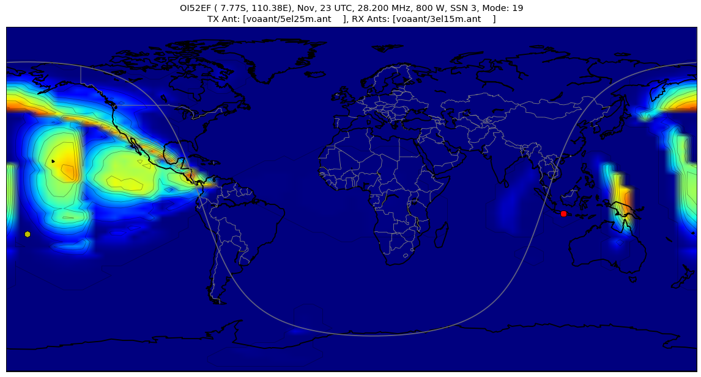

0 UTC
