Fruit Fly Assignment

***Introduction***

***Methods***

*Important characteristics of Fruit Fly Outbreaks*

*Ceratitis capitata fictus*

4 days egg, 15 days larvae, 13 days pupae, 20 days adult, lays 2 eggs per day

Include here the five high risk businesses

*Model Structure* *– Fruit Fly Outbreaks*

A spatially explicit model was developed to simulate potential outbreaks of fruit fly and test the efficacy of surveillance methods and FF trap variety in Fruitopia, Western Australia (-31.908, 115.818) (Figure 1). Fruitopia supports a population of 1532, most of which (78.9%) are employed by the MangoMangoTM orchard located in the north-west of the town (fake citation). The model reproduces Fruitopia’s 10,000 ha footprint in a 1000:1000 pixel square (1 pixel = 100 m2) hereafter referred to as the ‘map’. The map includes the locations of each FF trap, fruit tree, major thoroughfare (Main Street, Principal Avenue), storefront and MangoMangoTM orchard.

Outbreaks of FF were simulated by modelling population growth within each pixel until detection by a FF trap. The model performed each simulation according to the following specifications: Fruit tree location, distance between fruit trees, FF population growth, FF dispersal probability, FF introduction risk relative to map landmarks, FF trap location and FF trap chemoattractant strength. Three FF trap strengths were tested by the FF Outbreaks model; Lure 5, Lure 20, and Lure 50 across nine different surveillance strategies (Table 1). The current surveillance method used by the Shire of Fruitopia is the ‘standard’ grid pattern of 100 Lure 20 traps positioned at 1 km intervals (Figure 2).

*Data Analysis*

The efficacy of each alternative surveillance method- fixed factor with nine levels, and FF trap variety- fixed factor with 3 levels, were compared to the current method according to the number of days taken from infestation to detection (time), and the number of trees infested (no. trees) in each simulation. All data analysis was performed in R studio using the R language (Posit team 2023; R Core Team 2023). The distribution of each response variable (time; no. trees) was visualized using the qqPlot function from the *car* package (Fox and Weisberg 2019) and non-normality was determined. To test for difference between surveilance methods a Kruskal-Wallis test was performed between each response variable (time, no. trees) and surveillance method for each level of FF trap strength. The Kruskal-Wallis test performs an analysis of variance by rank and is appropriate when non-normality has been determined. A Kolmogorov-Smirnov test (K-S test) was performed to compare each surveillance method to the ‘standard’ grid method in use for each level of FF trap strength. Pairwise comparisons were performed using pairwise.wilcox.test() with a BH correction. Significance level was set to α0.05 for all analyses.

***Results***

Surveillance method designed by ‘Expert 2’ was the fastest to detect an outbreak (K-W test *p* < 0.001), resulted in fewer infested fruit trees (K-W test *p* < 0.001) and performed better than the current Standard Grid method in both regards across all three levels of FF trap strength (K-S test *p* < 0.001) (Figures 3-5). The Standard Grid method performed moderately well amongst the suite of alternatives, and significantly better than the least effective strategy ‘Inefficient’ in both time to detection of outbreak and number of infested trees across all three levels of FF trap strength (K-W test (Time; No. Trees) *p* < 0.001; K-S Test *p* < 0.001).

Lure 50 was the most efficient FF trap strength, resulting in a significant reduction in time to outbreak detection (*p* < 0.001) and number of trees infested during an outbreak (*p* < 0.001; Figures 6-7). Further, 90% and 99% of outbreaks were detected by days 77 and 134, which was 14 and 26 days earlier than Lure 20, the current FF trap strength in use by the Shire of Fruitopia. Lure 5 performed considerably worse in both time to detection (*p* < 0.001) and number of trees infested (*p* < 0.001), with 90% of outbreaks detected by day 145 and 99% by day 233.

***Figures***

Figure 1. Fruitopia represented as a 1000 x 1000 pixel map within the *Fruit Fly Outbreak* simulation model. Colours represent ….

Figure 2. Standard Grid pattern currently in use by the Shire of Fruitopia in their FF surveillance program

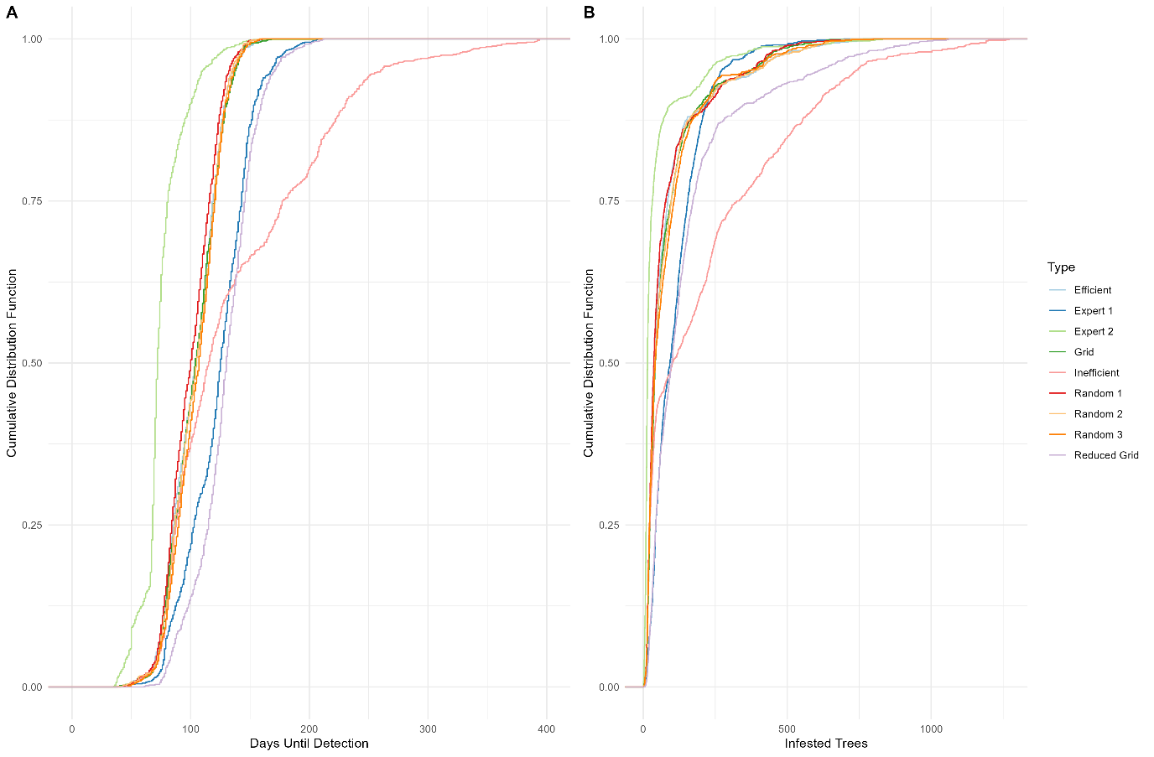

Figure 3:

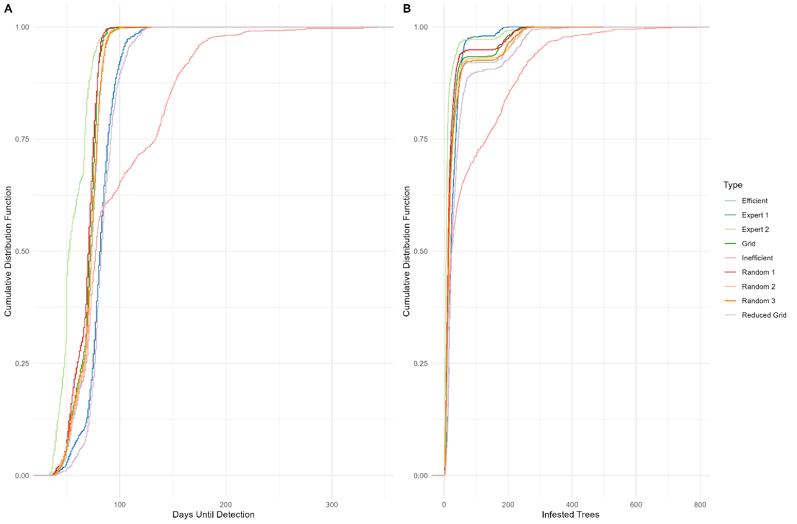

Figure 4.

Figure 5.

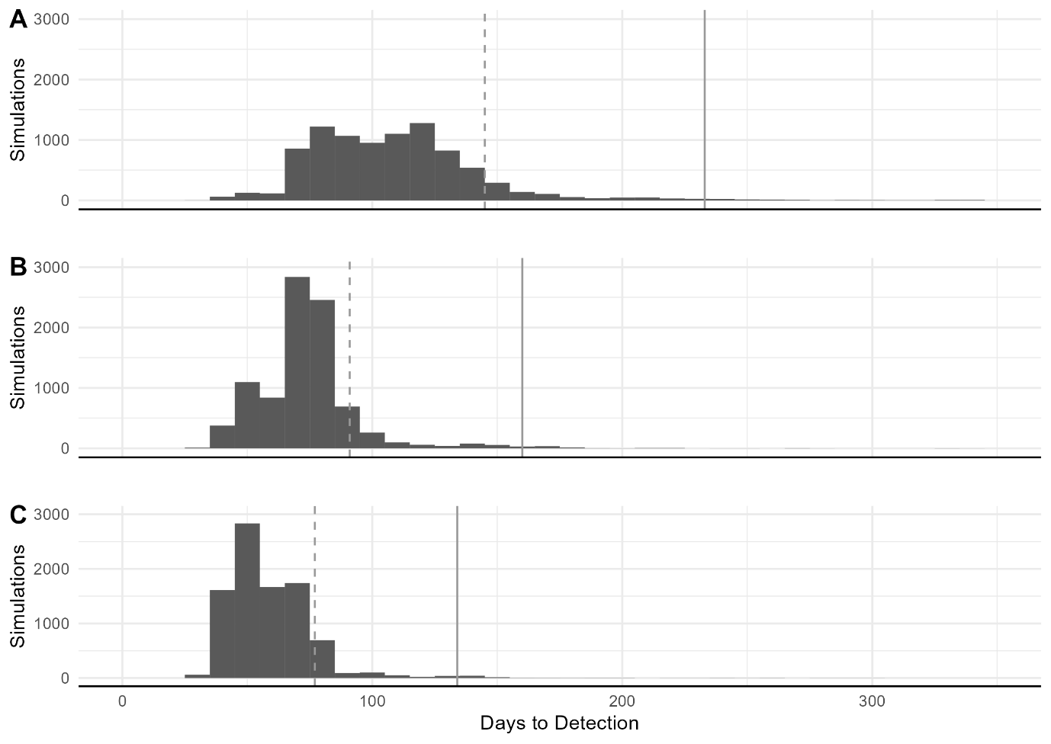

Figure 6.

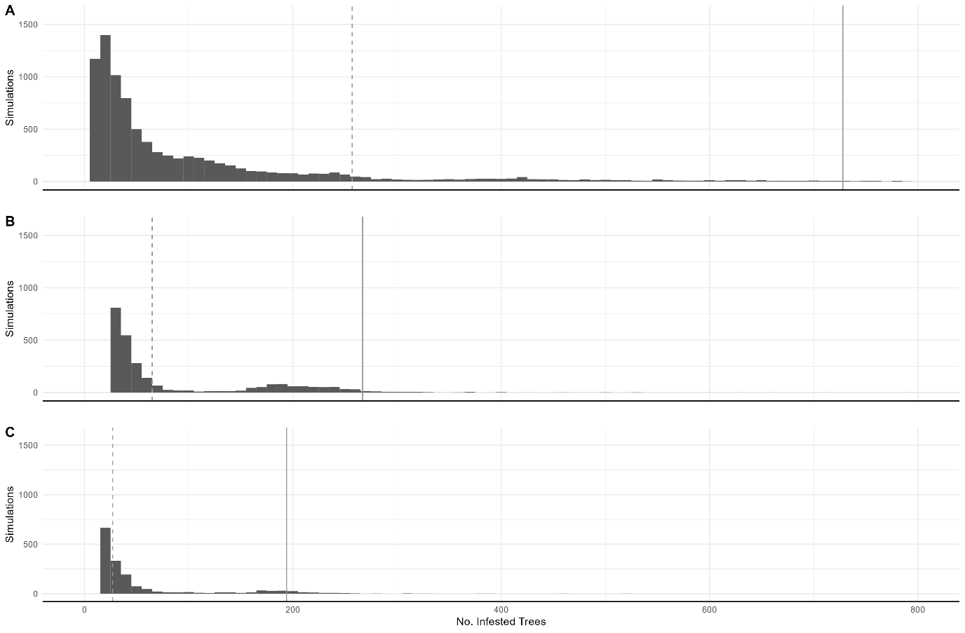

Figure 7.

***References***

Fox, John, and Sanford Weisberg. 2019. *An R Companion to Applied Regression*. Third. Thousand Oaks CA: Sage.

Posit team. 2023. *RStudio: Integrated Development Environment for R*. Boston, MA: Posit Software, PBC. http://www.posit.co/.

R Core Team. 2023. *R: A Language and Environment for Statistical Computing* (version 4.3.1). Vienna, Austria: R Foundation for Statistical Computing. https://www.R-project.org/.