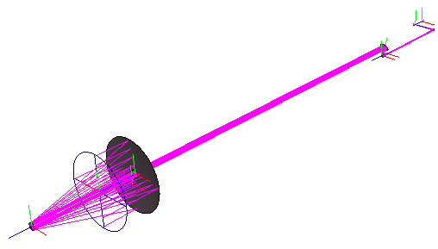

Secondary

Main Condenser Optics

(Primary)

Analysis Plane: (x,y) Grid

0.1 m

Feed Horn

3 m OPL (for hub optics)

Baseline (10 - 50 m)

Hub Condenser Optics

Feed Horn Details

Type: Smooth walled horn

Flare Length: 10 mm

Aperture Radius: 0.13 mm

Modes Excited: TE11 Only (single-moded)

File Name Format

feed-location_feed-type_baseline(m)_wavelength(μm)

e.g.

"on_axis_horn_bas30_wav400.dat"

Corresponds to a smooth-walled horn for an on-axis pixel, propagating a 400 μm signal over a 30 m baseline.

Beam Data

The fields are propagated from the horn, through the hub optics, across the baseline, and then through the main telescope.

The predicted beam is analysed at a distance of 0.1 m in front of the Primary Mirror.

Of course the far-field beams on the sky can also be calculated if needed.