FISICA Data and Optics Design Document

Background

Band 4 (GRASP)

In order to generate data to feed into the instrument simulator PyFIInS, where data for all four frequency bands is needed, a number of modelling approaches was required. For the longest wavelengths (band 4) the commercially available software GRASP was used. GRASP is a PO (physical optics) package that is capable of producing full vector electric field data at any point or plane within the optical system, or in the near or far-field of the primary mirror. GRASP also includes diffraction affects, meaning that it should yield an accurate solution even at very long wavelengths where diffraction is dominant. However, the computational technique employed by GRASP (where the number of sample points (*N*) grows with increasing frequency (*f*) as $N∝f^{2}$), means that for such a large primary mirror (*r* = 1m), where large is with respect to the comparison to wavelength, the higher frequency bands become very difficult to model without the use of super computers. Band 4 (200 - 400 µm) was modelled using GRASP on a moderately powerful PC, but more than a full day of computation was required to yield a solution accurate to -60 dB at 200 µm.

Band 1 (Zemax)

On the other extreme end, where wavelength is very small compared to the optics, ZEMAX ray tracing analysis was used for creating the simulated data for PyFIInS. Ray tracing is a relatively efficient simulation technique, however it does not account for diffraction, and scalar fields (or more precisely irradiance maps) are the end result, where features such as cross-polar fields are clearly not available. ZEMAX does in fact have a PO option, but again the problem of long computation times becomes problematic at the shorter wavelengths. Thus, ZEMAX's ray tracing tool was used to model the highest frequency band, Band 1, which covers wavelengths from 25 - 50 µm, and where diffraction effects are not expected to be significant.

Band 2 and Band 3 (GBM Analysis)

For the intermediate frequencies (Band 2: 50 - 100 µm, and Band 3: 100 - 200 µm) GBM (Gaussian beam mode) analysis was used for simulating the system. GBM analysis is a powerful yet efficient simulation technique. It is based on decomposing a field in terms of a set of modes, where the modes are solutions to the paraxial Helmholtz equation for Maxwell's equations. The decomposition is carried out at a point or plane where the field is well defined, for example across a uniformly illuminated mirror, or at the aperture of an EM feed horn. The modes can then be independently propagated through the optical system, where ABCD matrices (which represent the optical elements) can be used to operate on the complex beam parameter of the mode set. The end result from this approach is scalar field data across the plane of interest, but where all affects arising from diffraction are included in the propagation, thus producing an accurate description of, say, a beam from a corrugated horn propagated through a FISICA-like system, where cross-polar levels will be very low anyway.

Any well defined field can be decomposed in terms of some basis set of modes. In cylindrical polar coordinates the field can then be redefined as a sum of these modes, where each mode is weighted by its corresponding coefficient, as follows:

$$E(r,z)=\sum_{n=0}^{∞}{A_{n}φ_{n}\left(r,z;W\left(z\right),R\left(z\right)\right)}$$

$$where A_{n}=\iint{E\left(r^{'},z_{0}\right)[}{φ_{n}\left(r',z_{0};W\left(z_{0}\right),R\left(z_{0}\right)\right)]}^{*}2πr'dr'$$

The equation for the field of a rotationally symmetric Laguerre-Gaussian beam mode travelling in the *z* direction has the following form:

$$φ_{n}\left(r,z\right)=L_{n}\left[\frac{2r^{2}}{W{\left(z\right)}^{2}}\right]Exp\left[-\frac{r^{2}}{{ W\left(z\right)}^{2}}\right]Exp\left[-jk\left(z+ \frac{r^{2}}{2R\left(z\right)}\right)+j\left(\tan^{-1}\left(\frac{λz}{πW_{0}^{2}}\right)\right)\right]$$

where $L_{n}=\frac{e^{r}}{n! }\frac{d^{n}}{dr^{n}}\left(e^{-r}r^{n}\right)$ are the Laguerre polynomials.

The mode coefficients are calculated by performing overlap integrals for each Gaussian mode and the field to be propagated (horn aperture field, uniformly illuminated mirror, etc.). For a uniformly illuminated mirror of radius *a*, since the field is just unity across the mirror surface and zero elsewhere, we have:

$$A_{n}=\sqrt{\frac{2}{π{ W}_{0}^{2}}}\int_{0}^{a}{L_{n}\left[2\frac{r^{2}}{{W_{0}}^{2}}\right]Exp[-\frac{r^{2}}{{ W_{0}}^{2}} ]2π r}dr$$

where it was assumed that the beam waist was at the location of mirror, and thus *W*(z) = *W*0, and , and *z* = 0.

For an ideal corrugated Gaussian horn, since the field across the horn aperture surface can be approximated by a Bessel function of order zero, and zero elsewhere, we have:

$$B_{n}=\frac{4}{{ W}_{0}^{2}}\int_{0}^{a}{J_{0}\left[\frac{2.405r}{a}\right]L_{n}\left[2\frac{r^{2}}{{W_{0}}^{2}}\right]Exp[-\frac{r^{2}}{{ W_{0}}^{2}} ] r}dr$$

Initial Analysis (All 4 Bands)

First, GBM analysis was used to propagate beams from the uniformly illuminated primary mirror (M1) through the two sets of condensing optics (on-axis light collector and off-axis hub condenser), and over a further 3 m to allow for propagation through the hub optics (beam splitters, dichroics, FTS, etc.). This was carried out for all four frequency bands in order to determine the optimum size and shape of the final focussing mirror, where the centre of each band was chosen for the design at the intermediary baseline of 30 m. Table 1 displays the information on the beams at this plane for the start, middle, and end of each band.

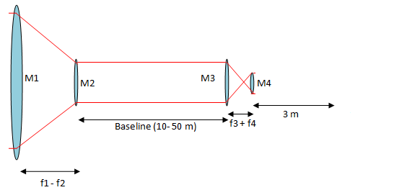

Analysis of

Beam for design of M5

Direction of Propagation

Plane Wave Illumination on M1

|  |  |  |  |  |  |  |  |  |  |
| --- | --- | --- | --- | --- | --- | --- | --- | --- | --- |
| Band | λmin [μm] | *w(*λmin)  [m] | *R(*λmin)  [m] | λcentre [μm] | *w(*λcentre) [m] | *R(*λcentre)  [m] | λmax [μm] | *w(*λmax)  [m] | *R(*λmax)  [m] |
| Band 1 | 25 | 0.019 | 8.120 | 37.5 | 0.020 | 8.800 | 50 | 0.022 | 6.840 |
| Band 2 | 50 | 0.022 | 6.840 | 75 | 0.017 | 5.750 | 100 | 0.016 | 5.150 |
| Band 3 | 100 | 0.016 | 5.150 | 150 | 0.021 | 5.450 | 200 | 0.0195 | 5.250 |
| Band 4 | 200 | 0.0195 | 5.250 | 300 | 0.0350 | 5.500 | 400 | 0.0410 | 7.450 |

Table 1: Beam parameters of the best fit Gaussian beam at the plane of the final hub mirror (5).

Band 4: 200 – 400 µm



*d* = 150 mm

Band 4 final focussing mirror with *d* = 150 mm will capture:

95.51% of beam at λ = 200 µm (*d* = 324 mm for 99% coupling)

92.53% of beam at λ = 300 µm (*d* = 482 mm for 99% coupling)

89.46% of beam at λ = 400 µm (*d* = 640 mm for 99% coupling)

Band 3: 100 – 200 µm

Band 3 final focussing mirror with *d* = 100 mm will capture:

96.68% of beam at λ = 100 µm (*d* = 170 mm for 99% coupling)

94.45% of beam at λ = 150 µm (*d* = 246 mm for 99% coupling)

91.80% of beam at λ = 200 µm (*d* = 324 mm for 99% coupling)

*d* = 100 mm

Band 2: 50 – 100 µm

Band 2 final focussing mirror with *d* = 80 mm will capture:

98.34% of beam at λ = 50 µm (*d* = 95 mm for 99% coupling)

97.72% of beam at λ = 75 µm (*d* = 136 mm for 99% coupling)

94.87% of beam at λ = 100 µm (*d* = 170 mm for 99% coupling)

*d* = 80 mm



*d* = 80 mm

Band 1 final focussing mirror with *d* = 80 mm will capture:

99.60% of beam at λ = 25 µm (*d* = 66 mm for 99% coupling)

98.99% of beam at λ = 37.5 µm (*d* = 81 mm for 99% coupling)

98.34% of beam at λ = 50 µm (*d* = 95 mm for 99% coupling)

Data Calculations (All 4 Bands)

Once the final mirror was added to the models the simulations were started, where this time the field from the detector was propagated out through the optics, and the predicted field across a plane 0.1 m from the primary mirror (M1) was recorded and saved as a data file for PyFIInS. This was done for the start, middle, and end of frequency of each band, and for three interferometric baselines of 10, 30, and 50 m.

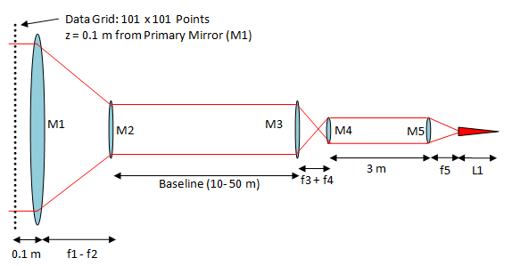

Direction of Propagation