How to run project

Mục lục

1 Run project on local 1

1.1 Change environment variable 1

1.2 Change appsettings 1

1.3 Create database 2

2 Additional configs for deployment 6

2.1 Generate new keys for RSA and AES 6

2.2 Cors 7

2.3 CustomClaimTypes 7

2.4 Update error message 8

# Run project on local

## Change environment variable

* Open **launchSettings.json** file.

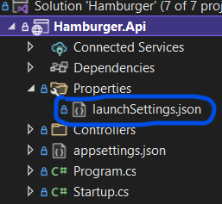

* Under **profiles.Development**.

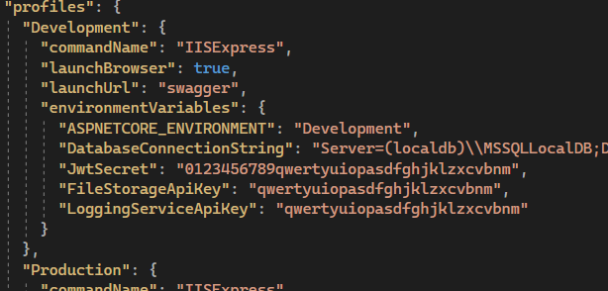

* Update **DatabaseConnectionString** to your SQLServer connection string or leave is as default.
* Update **JwtSecret** as your desire or you can leave it.
* If you update **FileStorageApiKey** or **LoggingServiceApiKey**, then you also have to update corresponding Api Key in [**Logging Project**](https://github.com/handoiditu1508/mongodb-logging-api) and [**File Server Project**](https://github.com/handoiditu1508/file-server).

## Change appsettings

* Open appsettings.Development.json file.

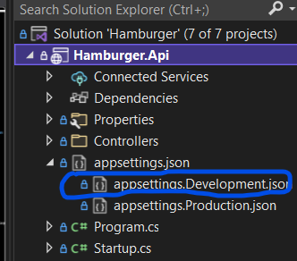

* Update values:

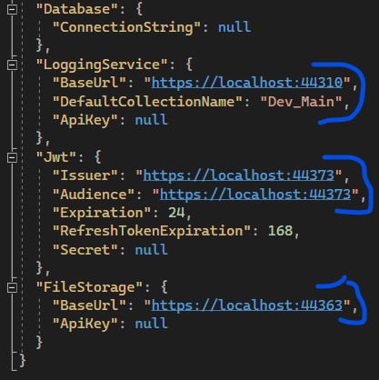

* Normally just leave these values as they are, unless you change the url of these API.
* LoggingService.BaseUrl: [handoiditu1508/mongodb-logging-api (github.com)](https://github.com/handoiditu1508/mongodb-logging-api)
* Jwt.Issuer, Jwt.Audience (current project): [handoiditu1508/be-boilerplate-2 (github.com)](https://github.com/handoiditu1508/be-boilerplate-2)
* FileStorage.BaseUrl: [handoiditu1508/file-server (github.com)](https://github.com/handoiditu1508/file-server)

## Create database

* Open Startup.cs file.

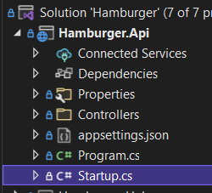

* At this line.

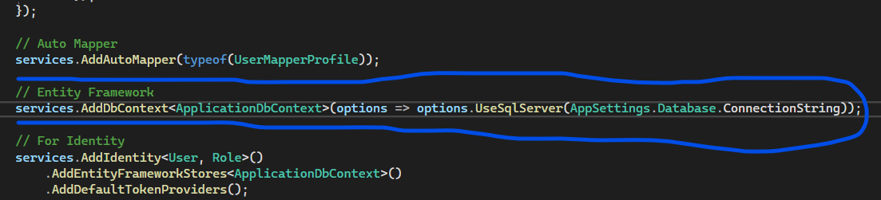

* Copy **DatabaseConnectionString** at the previous step and parse it here (temporarily).

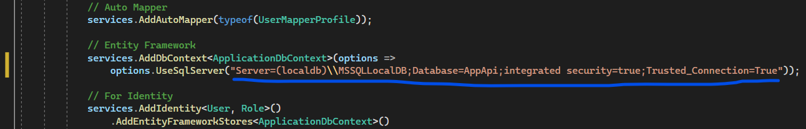

* Right-click on the **Hamburger.Api** project.

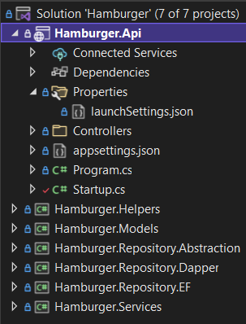

* Choose **Set as Startup Project**.

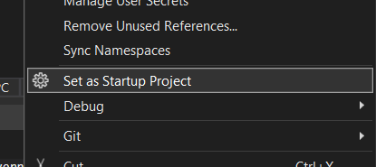

* Open **package manager console**.

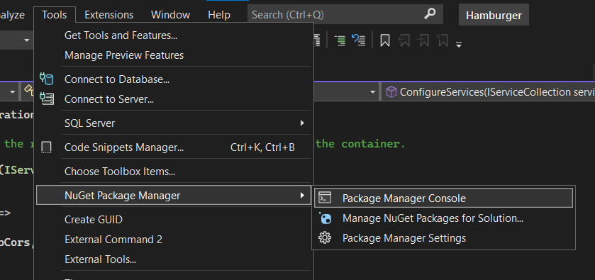

* Select project **Hamburger.Repository.EF** as Default.

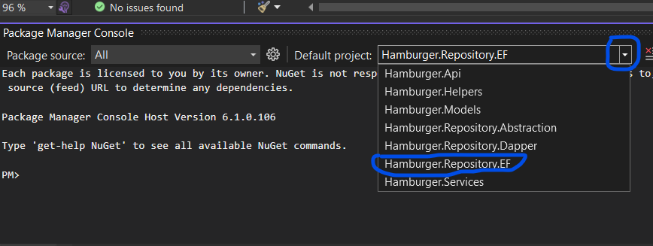

* Run **update-database** command.

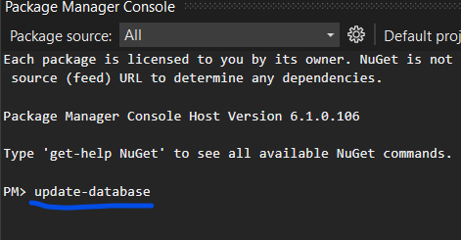

# Additional configs for deployment

## Generate new keys for RSA and AES

* Open CipherHelper.cs file.

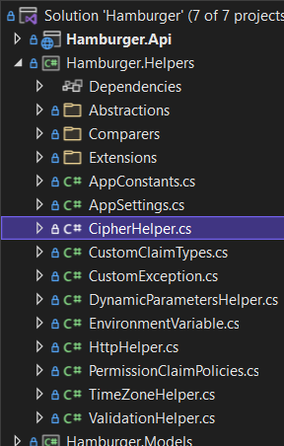

* Change AES key here.

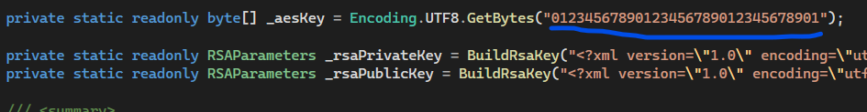

* To Change RSA keys.

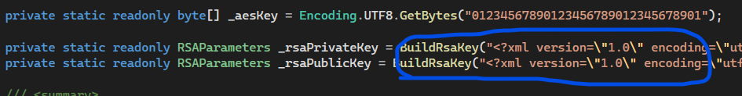

* Run this function in a console project to generate new keys pair.

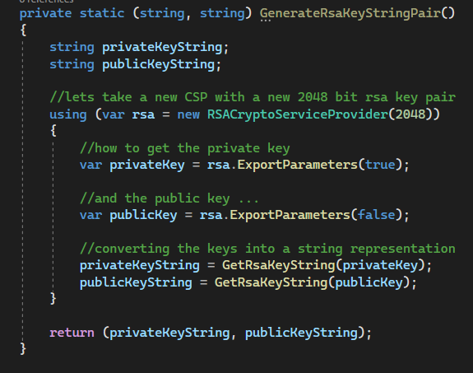

* Copy new keys pair to RSA keys.

## Cors

* Optionally you can add Cors to restrict Web App.

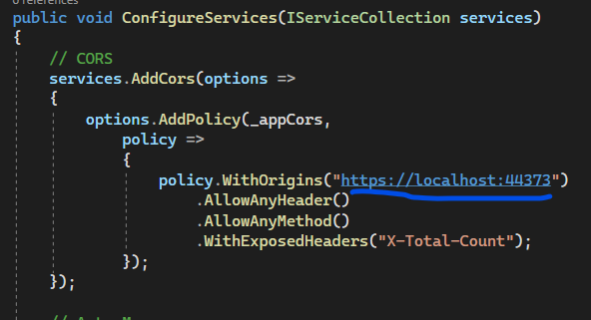

## CustomClaimTypes

* Open **CustomClaimTypes.cs**.

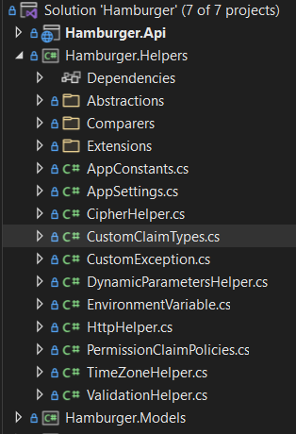

* Update **example.org** to your domain.

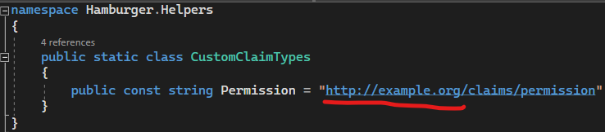

## Update error message

* In CustomException.cs file.

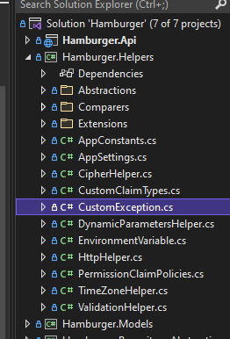

* Update error message to your language.

