How to run project

Mục lục

1 Run project on local 1

1.1 Change environment variable 1

2 Additional configs for deployment 1

2.1 Cors 1

2.2 White Listing 2

# Run project on local

## Change environment variable

* Open **launchSettings.json** file.

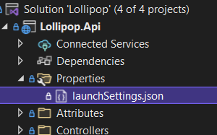

* Under **profiles.Development**.

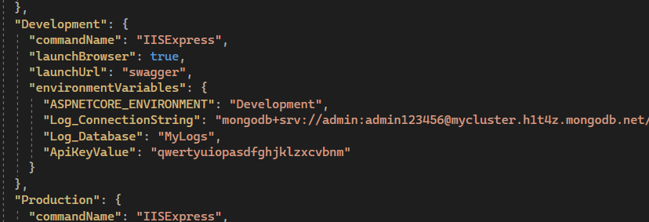

* Update **Log_ConnectionString** to your MongoDB connection string.
* **Log_Database** is the name of the database that contains logs.
* If you update **ApiKeyValue**, then you also have to update corresponding Api Key in [**BE Boilerplate Project**](https://github.com/handoiditu1508/be-boilerplate-2).

# Additional configs for deployment

## Cors

* Optionally you can add Cors to restrict Web App.

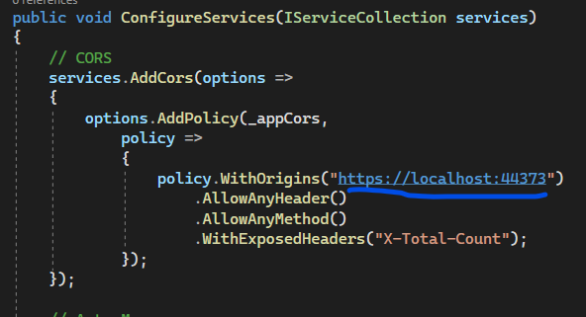

## White Listing

* Add IP Address of the deployed [BE Boilerplate Project](https://github.com/handoiditu1508/be-boilerplate-2) to **SafeList** in **AppSettings.json**.

