How to run project

Mục lục

1 Run project on local 1

1.1 Change environment variable 1

1.2 Change appsettings 1

2 Additional configs for deployment 2

2.1 Cors 2

2.2 White Listing 3

# Run project on local

## Change environment variable

* Open **launchSettings.json** file.

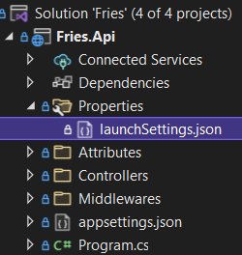

* Under **profiles.Development**.

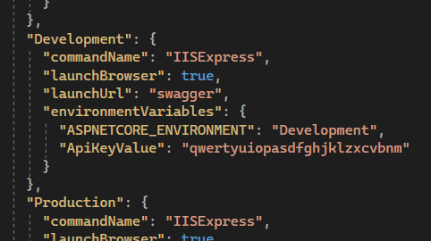

* If you update **ApiKeyValue**, then you also have to update corresponding Api Key in [**BE Boilerplate Project**](https://github.com/handoiditu1508/be-boilerplate-2).

## Change appsettings

* Open appsettings.Development.json file.

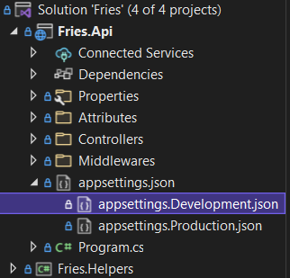

* Update values:

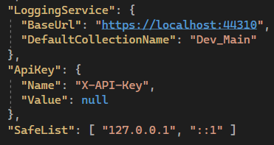

* Normally just leave these values as they are, unless you change the url of the Logging API.
* LoggingService.BaseUrl: [handoiditu1508/mongodb-logging-api (github.com)](https://github.com/handoiditu1508/mongodb-logging-api)

# Additional configs for deployment

## Cors

* Optionally you can add Cors to restrict Web App.

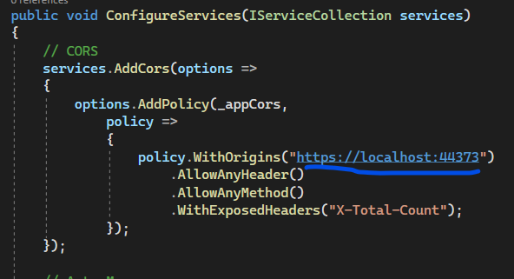

## White Listing

* Add IP Address of the deployed [BE Boilerplate Project](https://github.com/handoiditu1508/be-boilerplate-2) to **SafeList** in **AppSettings.json**.

