HitecApp Safety
Mobile Surveyor User Manual
PT Safety Indonesia Utama · ATEX Assessment & Compliance Services
📋 Purpose of this Manual
This user guide provides simple, step-by-step instructions for on-site field surveyors using HitecApp on mobile phones. Learn how to pick or create projects, take field photos, dictate captions with voice, and sync live with your team.

🌟 First Step: Set Up Your Project
Important: You must choose or create a project before you can take photos. The camera buttons stay locked until a project is active.
Option A: Pick Existing Project  1. Tap the 'Select a project...' dropdown.  2. Tap your plant / inspection name.  👉 Done! Company, city, and existing photos load instantly. | Option B: Create New Project  1. Type Company name (e.g. PT Safety Indonesia Utama).  2. Type City (e.g. Jakarta).  3. Type your Project Name.  4. Tap the '+ Create' button.  👉 Done! Camera buttons unlock immediately.

Step 1: Log In & Session Security
Easy mobile login with automatic data protection
1. Open your mobile browser (Google Chrome on Android or Safari on iPhone).
2. Enter your registered Email and Password.
3. Tap the blue Log In button.
4. Your work is auto-saved continuously. If your phone loses battery or signal, all your photos and captions stay safely saved!

💡 Pro Tip
You will never lose work if you get disconnected. Simply log back in to continue where you left off.

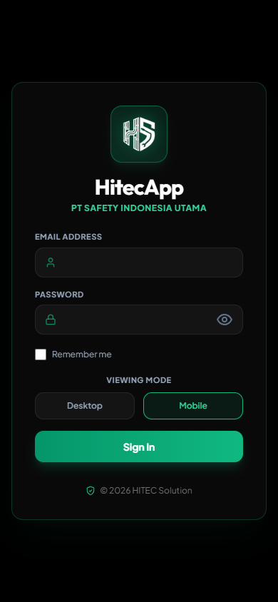
Figure: Mobile Screen for Step 1

Step 2: Single-Column Mobile View & Collapse Details
Designed for fast one-handed operation on site
1. On mobile phones, everything is arranged in one vertical column for quick scrolling.
2. Near the top, tap the 'Collapse Details ▲' button.
3. This hides the company and city boxes so you have full screen space to view your photo list!
4. Tap 'Expand Details ▼' anytime you need to see or change company details.

💡 Pro Tip
Always collapse the header when taking photos to maximize your field viewing area.

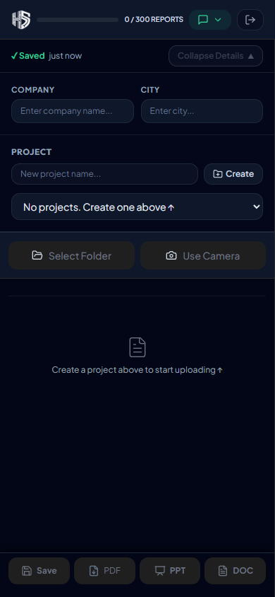
Figure: Mobile Screen for Step 2

Step 3: Take Photos in the Field
Direct camera capture with automatic image compression
1. Tap the large green '📷 Take Photo (Camera)' button.
2. Your phone camera opens. Snap your equipment, junction box, or hazard.
3. Tap 'Use Photo' or 'OK'.
4. The app automatically compresses the photo so it uploads in 1-2 seconds, even on weak 3G/4G cellular networks!

💡 Pro Tip
You can also tap 'Choose Files' to upload multiple photos at once from your phone gallery.

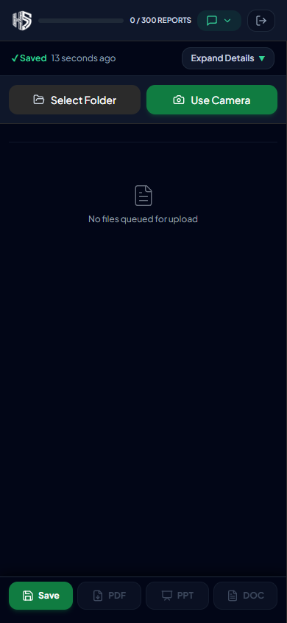
Figure: Mobile Screen for Step 3

Step 4: Speak Your Captions (Hold to Talk)
Hands-free voice dictation right next to each photo
1. Next to each photo thumbnail, find the square [🎙️ Mic] button.
2. Press and hold the Mic button with your thumb. The button turns RED (Rec).
3. Speak your ATEX observation clearly (e.g. 'Ex d IIB T4 Junction box with intact seal').
4. Release your thumb when done speaking. The app writes your caption automatically!
5. Green text = Photo has a caption ✅. Yellow text = Needs a caption ⚠️.

💡 Pro Tip
Hold the button the entire time you are speaking, and release only when you finish your sentence.

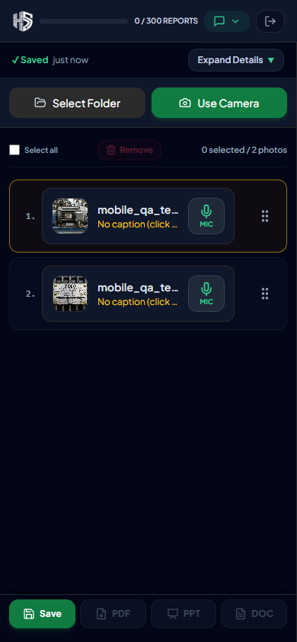
Figure: Mobile Screen for Step 4

Step 5: Tap to Type or Edit Captions
Expandable 5-row text box for quick adjustments
1. If you want to edit text or type manually, tap on the caption line below the filename.
2. A large 5-row text box expands immediately.
3. Type or edit your notes.
4. Tap the Green Checkmark ✅ to save your edit.
5. Tap the Red X ❌ to clear the text if needed.

💡 Pro Tip
Edits save instantly to the cloud so all teammates see the updated caption.

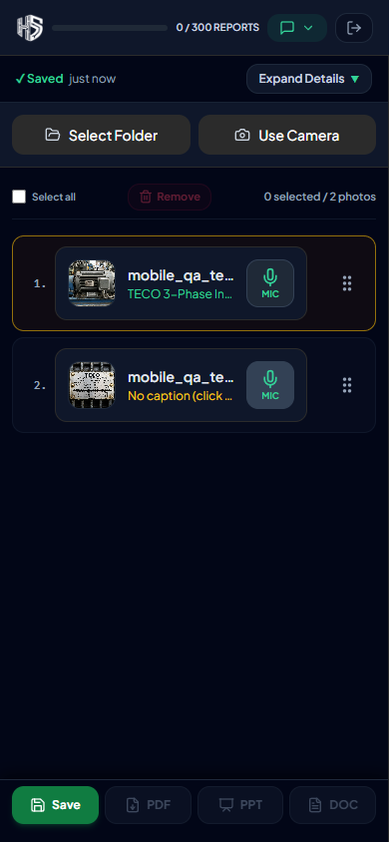
Figure: Mobile Screen for Step 5

Step 6: Reorder Photos (Touch & Drag)
Rearrange photo order for your final inspection report
1. Look at the right side of each photo row for the 6-dot grip handle (⠿).
2. Touch and hold the grip handle with your finger.
3. Slide your finger up or down to move the photo to its new position.
4. Lift your finger to drop. The row numbers (1., 2., 3...) renumber automatically!

💡 Pro Tip
Use drag-and-drop to group related equipment photos together before exporting.

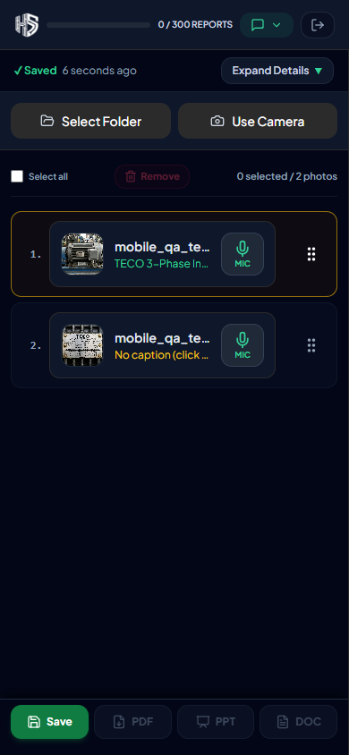
Figure: Mobile Screen for Step 6

Step 7: Lock Screen (View Mode) in the Field
Prevent accidental touches while walking around equipment
1. While walking through plant areas, tap 'Save' on the bottom action bar.
2. The screen switches to View Mode (all editing inputs are locked).
3. The button changes to 'Edit'.
4. When you are ready to take more photos or edit notes, tap 'Edit' to unlock!

💡 Pro Tip
View Mode is ideal when holding your phone while navigating stairways or ladders.

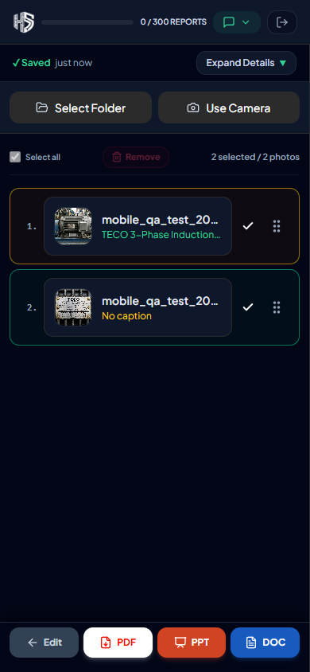
Figure: Mobile Screen for Step 7

Step 8: Export Reports & Live Team Sync
Generate instant documents or collaborate with up to 10 surveyors
1. Document Export: Tap Word (.docx), PowerPoint (.pptx), or PDF on the bottom toolbar to download your complete inspection document.
2. Team Sync: Up to 10 surveyors can work on the same plant project at the same time. Photos and captions sync live across all devices automatically!

💡 Pro Tip
Exported Word documents are fully formatted according to PT Safety Indonesia Utama engineering standards.

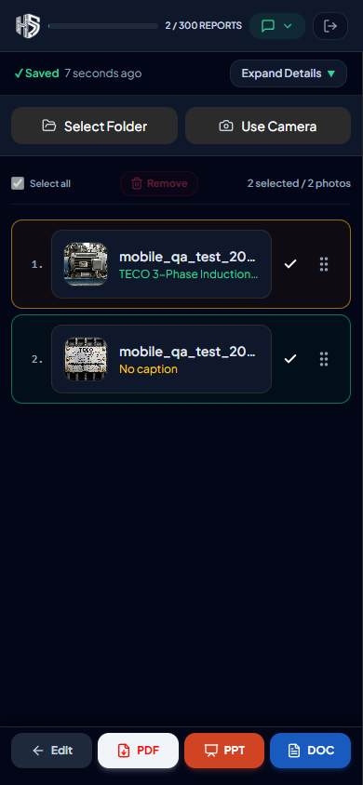
Figure: Mobile Screen for Step 8

