HitecApp Safety
Desktop Lead Assessor & Engineering Manual
PT Safety Indonesia Utama · ATEX Assessment & Compliance Services
📋 Purpose of this Desktop Manual
This comprehensive guide provides technical instructions for Lead Safety Assessors and Compliance Engineers using HitecApp on Desktop & Laptop workstations. Master the 2-column studio layout, review high-resolution equipment photos, draw colored annotations & doodles, apply ATEX/IEC 60079 standards, and export final client reports.

🌟 First Step: Set Up Your Project
Important: You must select an existing inspection or create a new project before uploading equipment photos or modifying captions.
Option A: Select Existing Project  1. Click the 'Select a project...' dropdown.  2. Choose your client plant project.  👉 All photos uploaded by field surveyors load instantly. | Option B: Create New Project  1. Enter Company Name (e.g. PT Safety Indonesia Utama).  2. Enter City Name (e.g. Jakarta).  3. Type New Project Name.  4. Click '+ Create'.  👉 Project is created and ready for batch uploads.

Step 1: Log In & Desktop Mode Selection
Secure engineer authentication with 1440px wide-screen workspace
1. Open Google Chrome, Microsoft Edge, or Firefox on your desktop or laptop.
2. Select 'Desktop' mode radio button on the login screen.
3. Enter your certified assessor credentials (Email & Password).
4. Click the blue 'Sign In' button. Your active session is protected with auto-save and device validation.

💡 Pro Tip
Selecting Desktop mode automatically activates the side-by-side 2-column studio layout optimized for widescreen monitors.


Figure: Desktop Workspace Screen for Step 1

Step 2: Desktop Two-Column Studio Overview
Left Photo Queue (35%) & Right Carousel Studio (65%) for maximum productivity
1. The desktop interface splits into two powerful functional panels:
2. Left Column (Photo Queue & Uploads): Displays your project selection, batch upload zone, photo count badges, and reorderable thumbnail queue.
3. Right Column (Carousel & Assessment Studio): Displays the high-resolution photo viewer, 5-row caption editor, and ATEX lead assessor observation fields.
4. Click any photo in the left queue to immediately open it in the right studio pane.

💡 Pro Tip
Use your keyboard Arrow Keys (Left / Right) to quickly flip through inspection photos in the Carousel Studio.

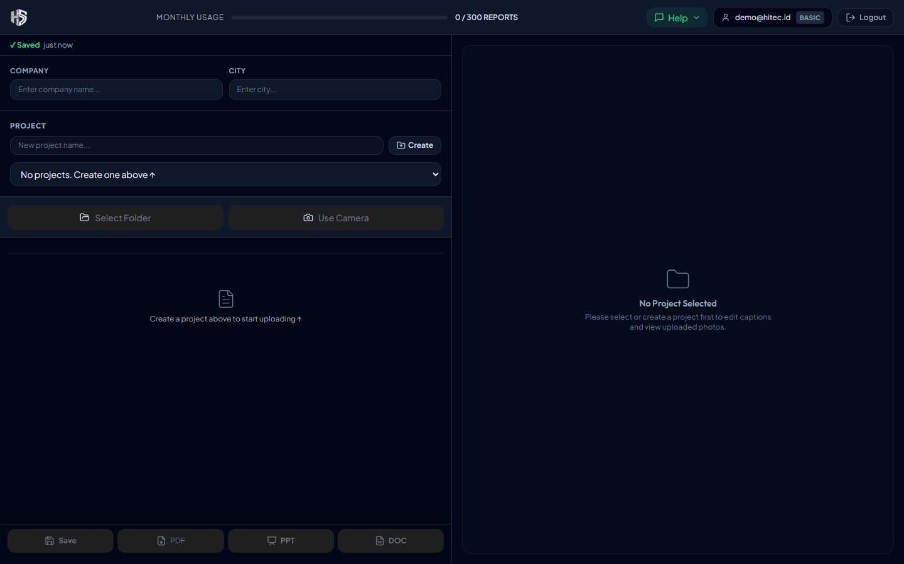
Figure: Desktop Workspace Screen for Step 2

Step 3: Batch Upload Equipment Photos & Folders
Upload single files or whole directories with instant WebP/JPEG compression
1. In the left panel Upload Zone, click 'Choose Files' or drag-and-drop multiple image files.
2. To ingest an entire plant survey folder at once, click the 'Upload Folder' button.
3. Photos are compressed on the fly to maximize network speed while retaining crystal-clear nameplate text.
4. Each photo appears in the queue with a status badge: Queued ➔ Uploading ➔ Done ✅.

💡 Pro Tip
You can upload up to 200 high-resolution equipment photos in a single batch without browser slowdown.

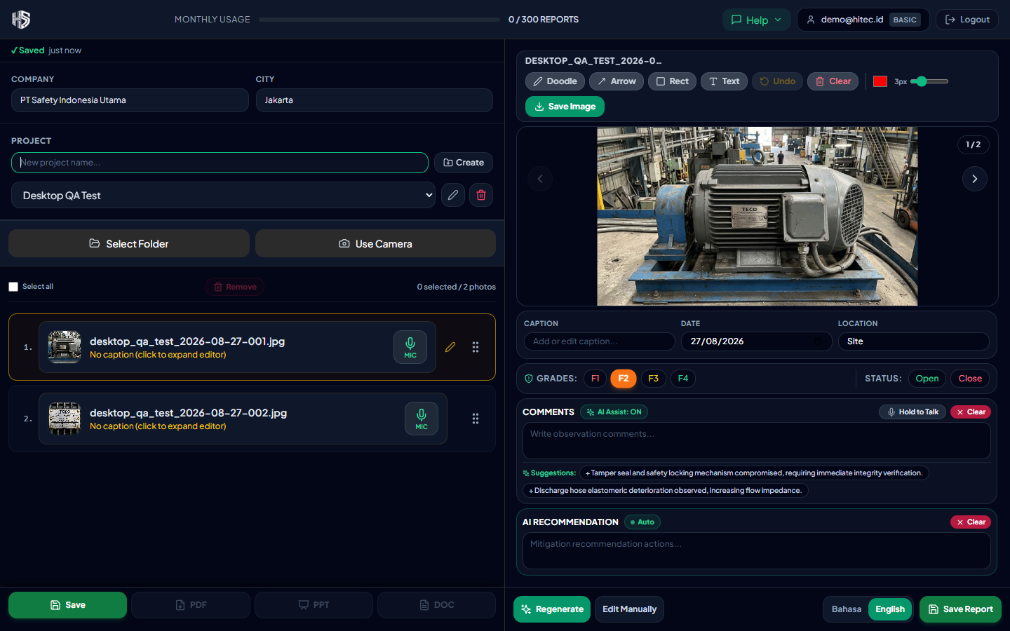
Figure: Desktop Workspace Screen for Step 3

Step 4: Dual-Panel Workspace & Focus Navigation
Seamlessly inspect equipment photos side-by-side with inspection data
1. As photos finish uploading, they display with sequential row numbers (1., 2., 3...).
2. The active photo is highlighted with an emerald border and synchronized in the Right Carousel Studio.
3. Status pills indicate whether a photo has a complete caption (Green ✅) or requires assessor review (Yellow ⚠️).
4. Click 'Collapse Details ▲' in the header to maximize vertical workspace.

💡 Pro Tip
Hover over any thumbnail in the left queue to preview the filename, size, and quick caption summary.

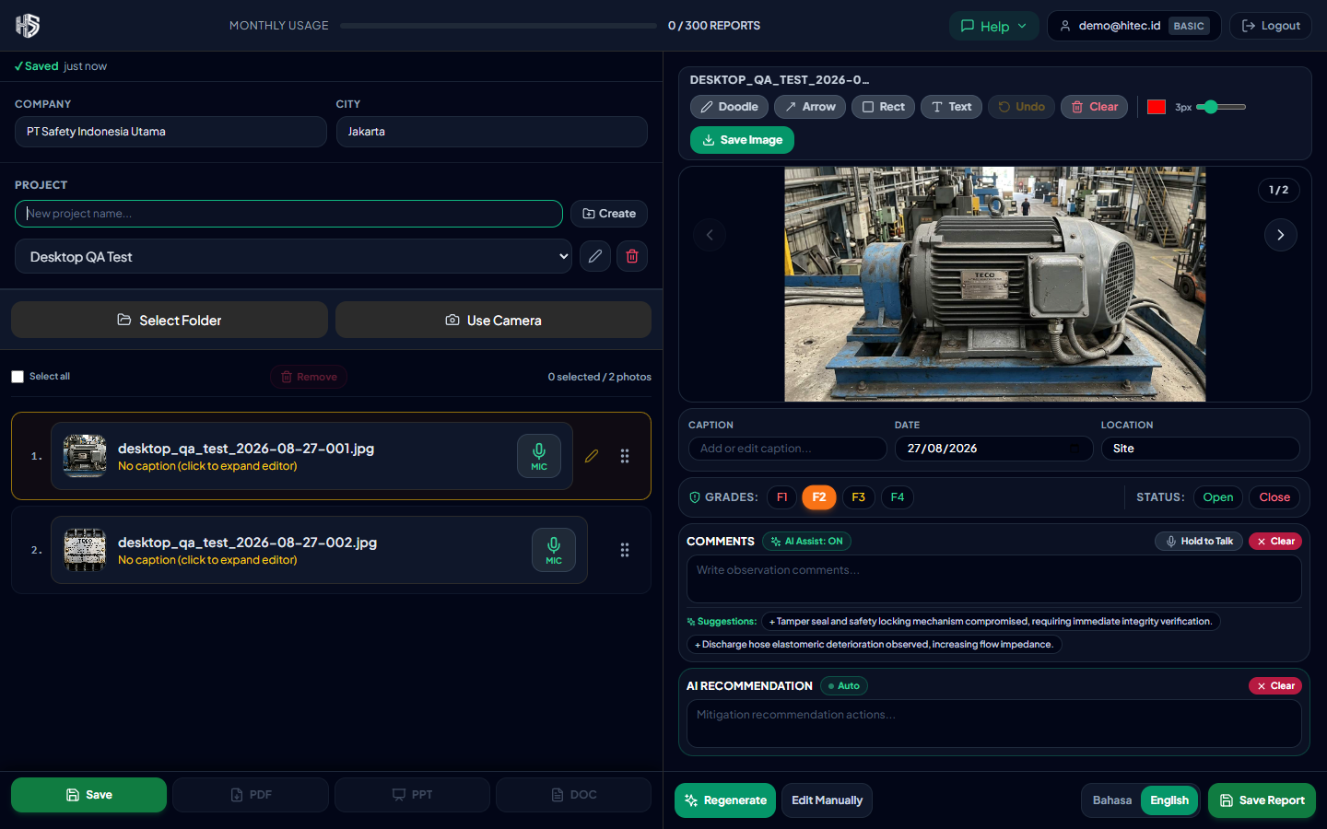
Figure: Desktop Workspace Screen for Step 4

Step 5: Visual Image Markup, Doodles & Color Selection
Highlight hazardous zones, earthing studs, and enclosures with customizable colors
1. Above the equipment photo, select from your engineering annotation tools: Rect (Rectangle), Arrow, Doodle (Free Draw), or Text.
2. Pick custom colors from the Color Picker palette (e.g. Red for Ex d junction box, Amber for Earthing terminals, Cyan for Cooling fins).
3. Adjust the Stroke Width slider (1px to 10px) to suit your report markup emphasis.
4. Click 'Save Image' to burn the annotations directly into the equipment photo for client inspection deliverables.

💡 Pro Tip
Use Red Rectangles to frame flameproof junction boxes and Amber Arrows to verify electrostatic bonding paths.

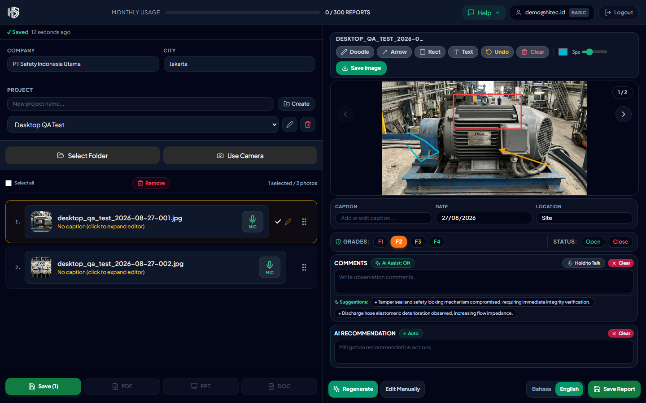
Figure: Desktop Workspace Screen for Step 5

Step 6: Technical Captioning & Equipment Identification
Precise nameplate specs, Zone classification, and tag numbering
1. Click inside the Caption field below the photo canvas.
2. Enter the equipment tag, manufacturer, rating, and Zone location (e.g. 'TECO 3-Phase Induction Motor 2.2kW, 220/380V, 50Hz, IP55 - Zone 1 HAC Assessment & Earthing Inspection').
3. Click outside the field or tap the checkmark to save. Captions sync to cloud storage in real time.

💡 Pro Tip
Always include equipment certification details (e.g. Ex d IIB T4, IP rating) in the caption for compliance audit readiness.

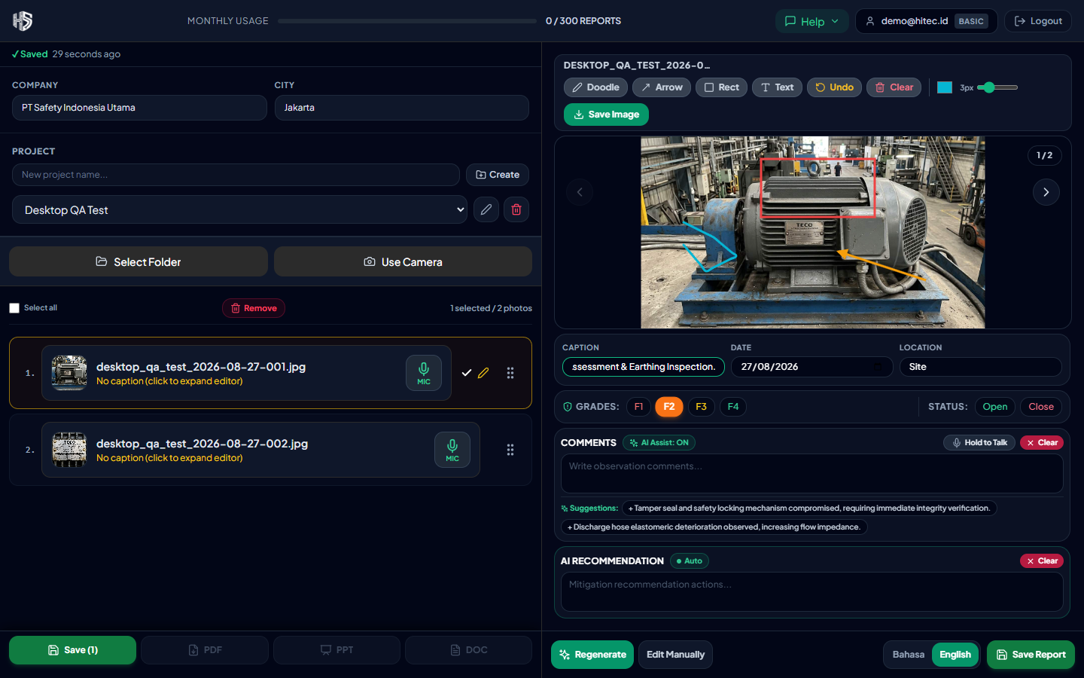
Figure: Desktop Workspace Screen for Step 6

Step 7: ATEX Assessor Observations & Risk Priority Grading
Comprehensive engineering assessment (IEC 60079 & EN 1127-1 compliance)
1. Document ignition risk observations and corrective recommendations in the dedicated engineering textfields.
2. Assign Risk Priority Grades (F1 Red = Immediate Hazard, F2 Orange = High Priority, F3 Yellow = Moderate, F4 Green = Minor / Conforming).
3. Toggle Latest Status between 'Open' (Action Required) and 'Close' (Mitigated).
4. Assessments are automatically linked to the specific equipment photo and included in the exported report.

💡 Pro Tip
Reference relevant European and International standards (e.g. IEC 60079-14 Section 9, EN 1127-1) directly in your recommendations.

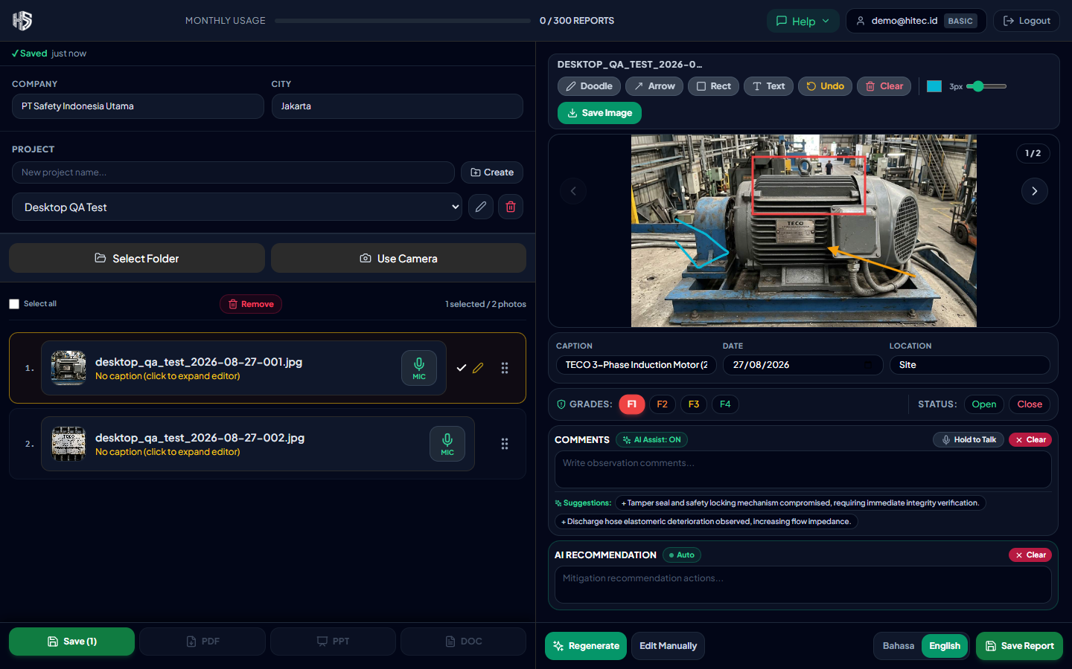
Figure: Desktop Workspace Screen for Step 7

Step 8: Drag-and-Drop Photo Sequence Management
Group inspection findings into logical plant report sequences
1. To change the order of photos in your final report, hover over the 6-dot grip handle (⠿) on the left queue row.
2. Click and drag the row up or down to its new target position.
3. Release your mouse. The entire queue renumbers automatically (1., 2., 3...).
4. The reordered sequence is instantly reflected in all generated PDF, PowerPoint, and Word documents.

💡 Pro Tip
Group photos by process area or equipment skid (e.g. Overview first, followed by Nameplate close-up and Terminal Box).

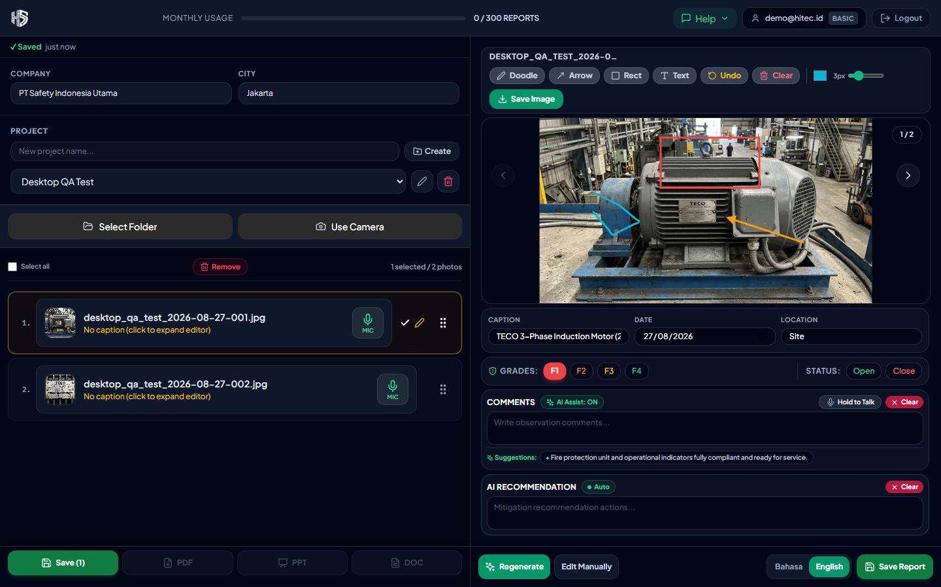
Figure: Desktop Workspace Screen for Step 8

Step 9: Save & View-Only Inspection Lock
Freeze review state and verify final findings before client delivery
1. When you finish captioning and assessing photos, click 'Save' on the bottom action bar.
2. The workspace transitions into View Mode (all editing inputs are locked to prevent inadvertent keystrokes).
3. The Save button converts into an 'Edit' toggle.
4. Click 'Edit' anytime you need to add more photos or revise engineering observations.

💡 Pro Tip
Switch to View Mode before presenting inspection findings in client review meetings to ensure data safety.

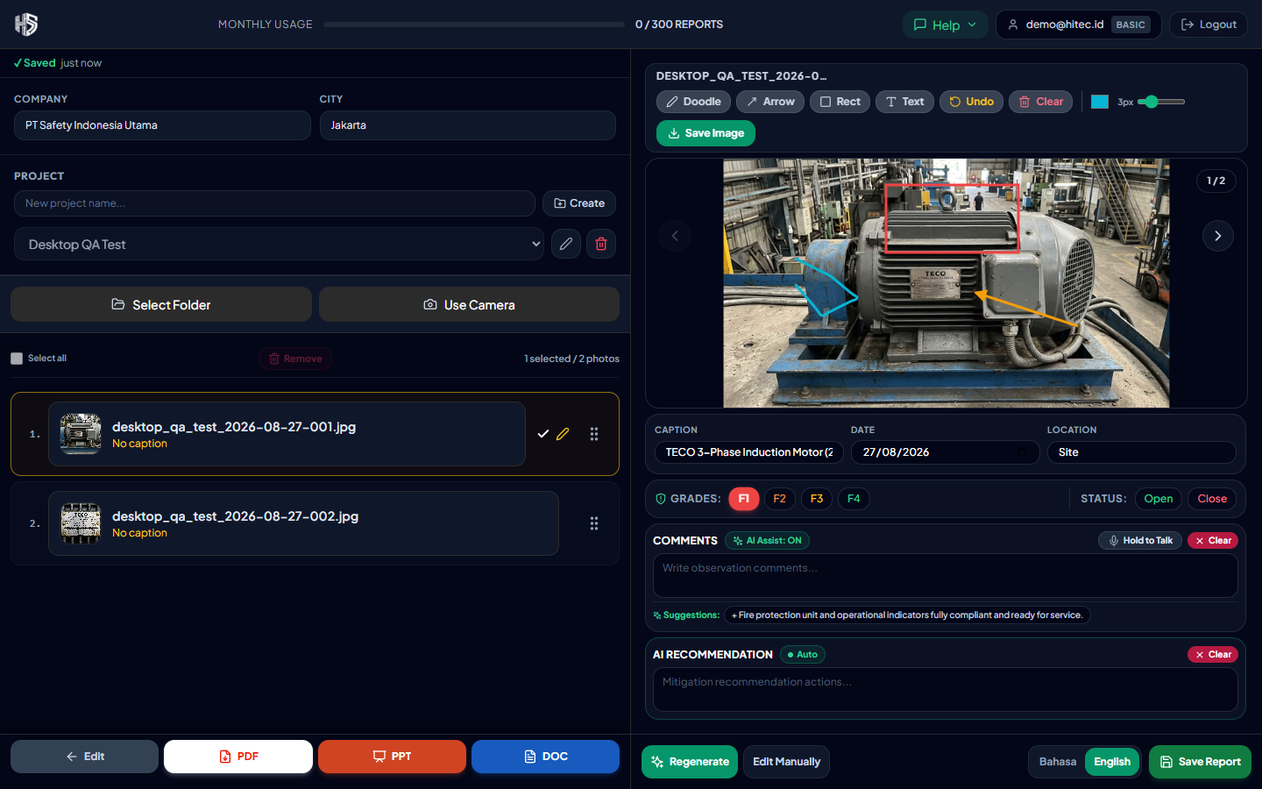
Figure: Desktop Workspace Screen for Step 9

Step 10: Multi-Format Report Generation (PDF, PPT, Word)
Export audit-ready ATEX deliverables in 1 click
1. From the bottom PublishBar, select your desired export format:
2. 📄 Word (.docx): Generates a fully formatted, high-contrast engineering document ready for official client submission.
3. 📊 PowerPoint (.pptx): Creates presentation slides with side-by-side equipment photos and bulleted assessor findings.
4. 📑 PDF (.pdf): Produces a clean, tamper-evident inspection report ideal for email distribution and archiving.
5. Exports download directly to your computer's Downloads folder within seconds.

💡 Pro Tip
Exported Word documents retain all formatting and typography rules (!font16) established by PT Safety Indonesia Utama.

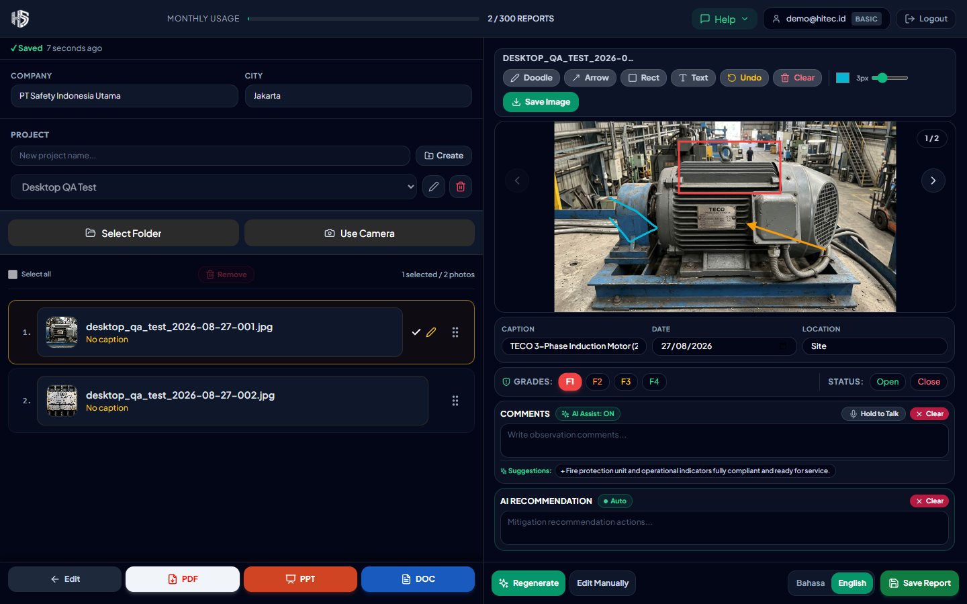
Figure: Desktop Workspace Screen for Step 10

