CIS130 Assignment 6 — Assembly Procedures, Loops, Arrays, and Conditionals Worksheet
Course: CIS 130
Assignment: Assignment 6 — Assembly Program 2
Student Name: Alejandro Pantoja-Zurita
Date: April 12th, 2026

Part 1 — Pseudocode or High-Level Equivalent
Write pseudocode OR Java/C++ code that represents the logic of your assembly program. Focus on the algorithm, not assembly syntax.
public class Main
{
public static void main(String[] args)
{
int[] temps = {43, 62, 58, 71, 39, 66, 74};
int threshhold = 60;
int warmDayCount = 0;
for (int i = 0; i < temps.length; i++){if (temps[i] > threshhold) {warmDayCount++;}}
System.out.println(warmDayCount);
}
}

Part 2 — Your MASM Assembly Code
Paste your full .asm file below. Every instruction in the .code section must include a descriptive comment.
; =========================================================================================
; AUTHOR: ALEJANDRO PANTOJA-ZURITA
; COLLEGE: DELAWARE TECHNICAL COMMUNITY COLLEGE
; COURSE: CIS 130: COMPUTER ORGANIZATION
; INSTRUCTOR: JIN AN
; DATE: APRIL 3, 2026
; PROJECT: ASSIGNMENT 5: ASSEMBLY PROGRAM 1
; NOTES: PROGRAM CREATED TO GET BETTER UNDERSTANDING OF ASSEMBLY PROGRAMMING.
; =========================================================================================

.386 ; Target CPU (32-bit CPU)

.model flat,stdcall

.stack 4096 ; Allocates stack space (4096 bytes) for program.

.data ; Variables are declared past this point

numbers dword 1, 2, 3, 4, 5, 6, 7, 8, 9, 10 ; numbers[] = [1, 2, 3, 4, 5, 6, 7, 8, 9, 10]
sum dword 0 ; variable to store the sum of the values in 'numbers' array. sum = 0.

ExitProcess proto,dwExitCode:dword

.code ; Instructions go past this point

main proc ; Main procedure (function) starts here.

mov ecx, lengthof numbers / 2 ; ecx (Extended Counter Register) = 5 -> LENGTHOF numbers (10) / 2 (# of loops).
; (Value decrements each loop till it gets to 0)

mov esi, 0 ; esi (Extended Source Index) = 0 -> keeps track of indexing while inside loop.
mov eax, 0 ; eax (Extended Acumulator Register) = 0 -> keeps track of the sum while inside loop.

L1: ; Loop created to get sum of array. L1 acts as the label to let program know where loop starts.

add eax, [numbers + esi * TYPE numbers] ; Add the value stored in numbers[index value] to eax. index = esi * TYPE numbers (4)
add esi, 2 ; Increment the value of esi to cycle through array. (esi += 2)

loop L1 ; Let program know to repeat loop again until ecx = 0. ecx automatically decrements each loop.

mov sum, eax ; Move the value stored inside eax to the sum in memory. sum = eax (sum of array.)

invoke ExitProcess,0 ; Tell Operating System to terminate the program.

main endp ; Main procedure (function) ends here.

end main ; Code for "linker", lets program know the entry point is the main procedure (function)

Part 3 — Screenshots
Screenshot 1 — Before calling your procedure (registers prepared)
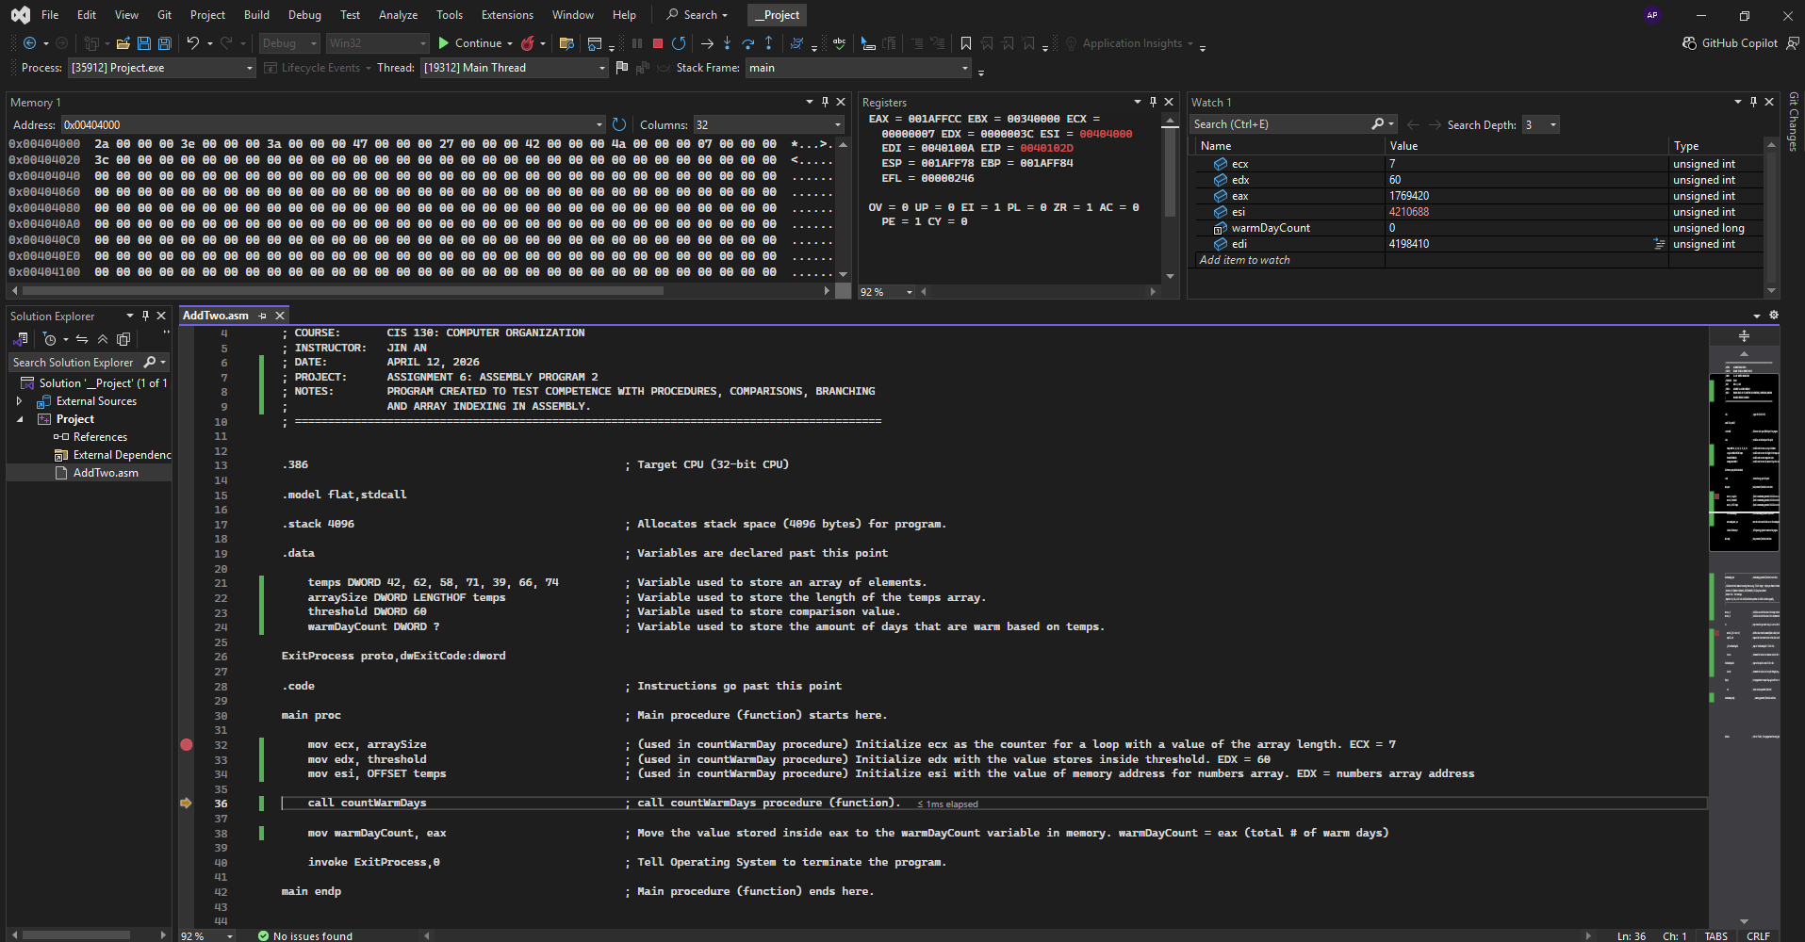
Screenshot 2 — Inside the procedure (loop + conditional check visible)
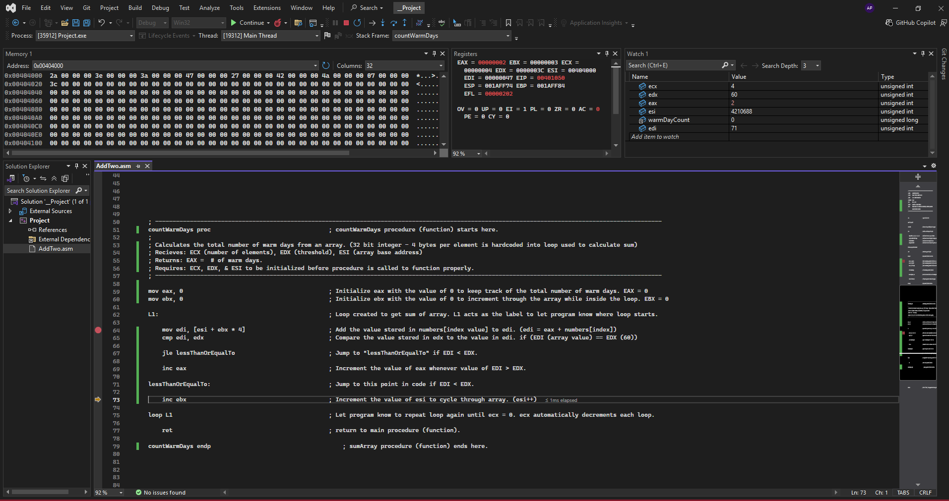
Screenshot 3 — After the procedure returns (final warm-day count stored)

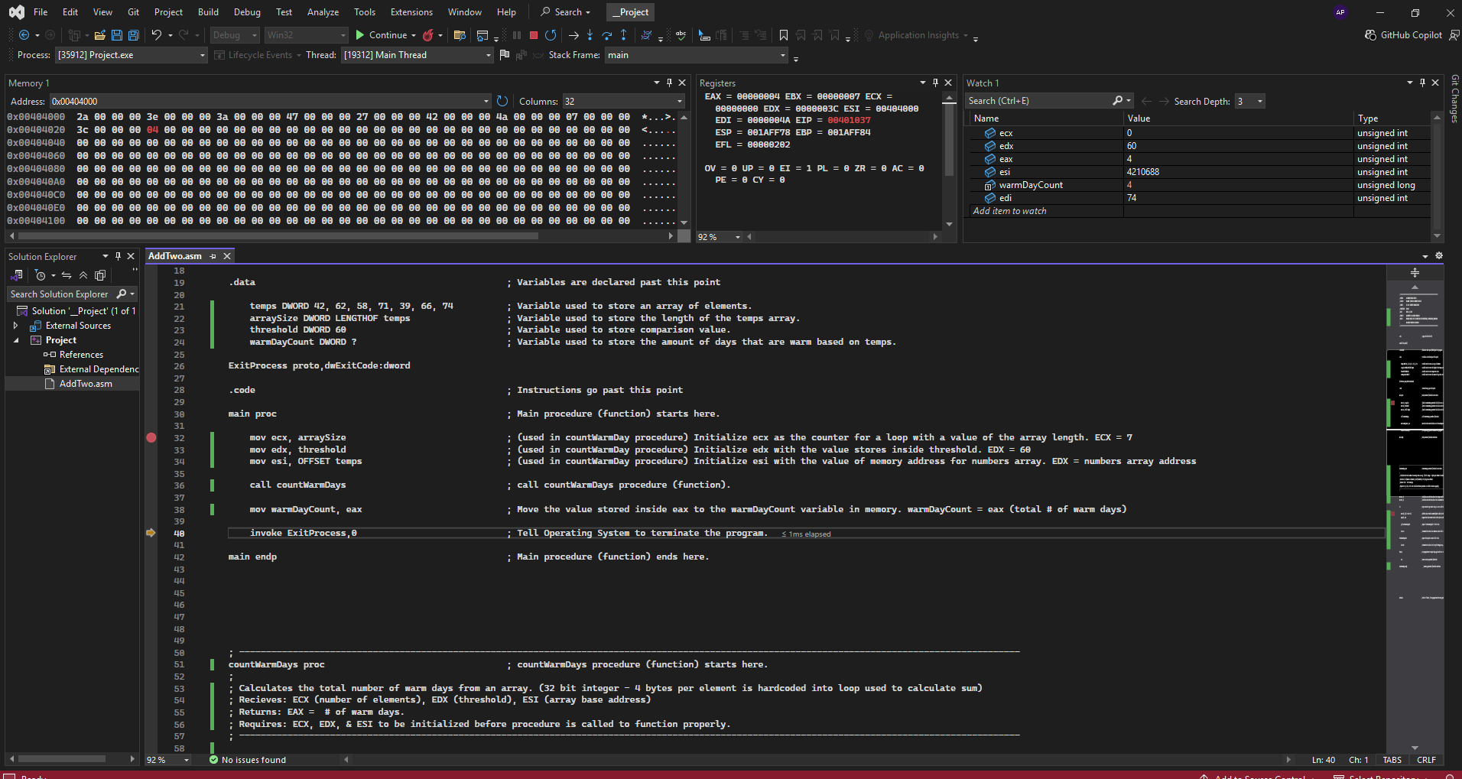Part 4 — Summary Questions
1. How did you pass parameters (array address, size, threshold) to your procedure?
I initially created variables to store the pieces of data before moving them into registers. An array for the different temperatures, a variable to store the threshold value. A variable to store the length of the temperature array. Lastly, I created a variable that would hold the number of warm days once the program was finished. I used registers ECX and EDX to hold the values for the length of the array and the threshold. For the address to the array I used ESI. These registers were used and were required to be correctly initialized for the procedure to function properly and calculate the total number of warm days.
2. Describe how your loop processes each temperature value.
I moved each value stored inside the array into register EDI while looping. Following this I would use the mov cmp or compare to compare the value EDI to EDX (threshold value). This would raise the Zero flag and overflow flag based on how the value in EDI compared to EDX. If the value in EDI was less than EDX I used jle to jump over the command inc eax. It would skip to the inc ebx command, which was used in the loop to cycle through the values inside the array. If the value in EDI was greater than EDX it would not skip over the line inc eax. EAX was used to keep track of the number of warm days while inside the procedure. It initially was set to 0 before the loop began.
3. Explain the conditional logic you used to determine whether a day is considered warm.
After comparing the Value in EDI to the value inside EDX (threshold) the zero flag or the overflow flag would be raised. This could be used in tandem with the jle (jump to if less than or equal to command). This way I could skip the line that would increment the value of eax (used to track the number of warm days). Instead it would proceed to the next loop.
4. Which registers were used for the array base address, loop counter, threshold, and running count?
ESI – used to store the array base address.
ECX – used to store the number of loops required to iterate through loop. (loop counter).
EDX – used to store the value of the threshold.
EAX – used to the store total number of warm days, higher than the value of EDX.
5. If the size of the array changed, what would you need to update in your code (if anything)? Explain.
Nothing would need to change aside the number of values inside the array. I made sure to store the loop counter value (ECX) with a value obtained from LENGTHOF temps rather than hardcode a value. This makes the code more modular since my program doesn’t require me to change code in multiple locations. This value is obtained in the .data section of my code. Afterward in the .code section the value obtained is moved into ECX, which is then used inside the procedure for the loop or iteration of the array.

Part 5 — Student Certification
By typing your name below, you certify that the work submitted in this worksheet represents your own effort and that all screenshots and code reflect your actual program execution.
Signature: _Alejandro Pantoja-Zurita__
Date: __04/12/26________________________

