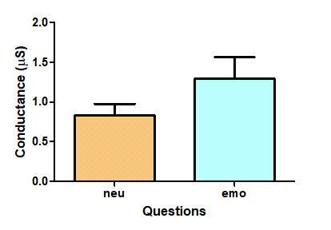
Aggregate electrodermal response to both neutral and emotional questions. The values plotted are the mean conductance (±SEM) for each group of questions. A paired t-test resulted in a p value of 0.0171 (p value is statistically significant since p ≤ 0.05).

Our collected data and statistical analysis thereof shows that there is a significant difference between the electrodermal response to neutral questions and emotional questions. When faced with neutral questions, the conductance of subjects’ skin measured a mean of 0.805μS. For emotional questions, the mean electrodermal skin conductance measure was 1.290μS. A paired t-test was run, and the calculated p value of 0.0171 shows a very strong significance in our hypothesis that neutral and emotional questions result in a measurable difference in the electrodermal skin response.
In summary, there is a measurable difference in the electrical conductance of our skin based on what kind of questions we are asked – either emotionally neutral or emotionally charged. These results should not be conflated with lie detection however. Even the galvanic skin response in conjunction with other physiological measurements is not a perfect measure of lie detection, such as with a polygraph test – it is disputed at best, which probably has to do with the subjective nature of “neutral” vs “emotional” with respect to lying.
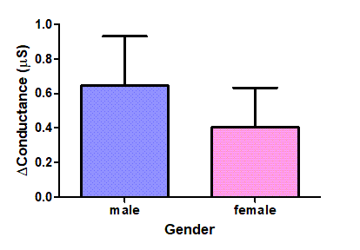
Aggregate change in electrodermal response by males and females. The values plotted are the mean difference in conductance between neutral and emotion questions (±SEM) for each gender. An unpaired t-test resulted in a p value of 0.5826 (p value is not statistically significant since p > 0.05).

The data we collected shows that the difference between male and female responses is insignificant. This data involved taking the change in skin conductance between emotional and neutral questions. In other words, for each participant, we took their individual mean emotional response, and then subtracted their individual mean neutral response. This data was compiled into two lists, based on gender. Our data showed that males had a mean change in conductance of 0.646μS, while the females had a mean change in conductance of 0.405μS, and an unpaired t-test p value of 0.5826 was not statistically significant.
In other words, the data was not conclusive in finding a distinction between male and female conductance changes. This surprised me, because I expected the opposite. I expected both a significant difference, and the mean difference for females to be higher than the mean difference for males. But I won’t argue with the data – our sample size wasn’t huge, but the p value being so high leads me to believe that my hypotheses are wrong. Really when you think about it, the utility in the scientific method is not that it can confirm our biases, but that it can help eliminate them.

