In VMWare, it is possible to set up permissions for a single UWEC credential, to a single VM. This is useful for assigning students a VM to use as a test environment.

With the proper permissions set up, students can get access to their virtual machines with ease.

Step 1

Go to <https://vcsa02.cs.uwec.edu/>. In order for this to work, the students must be connected to the school network. If the students would like to access their machines off campus, A VPN connection will suffice.

Step 2

Click on VSphere web Client (flash)

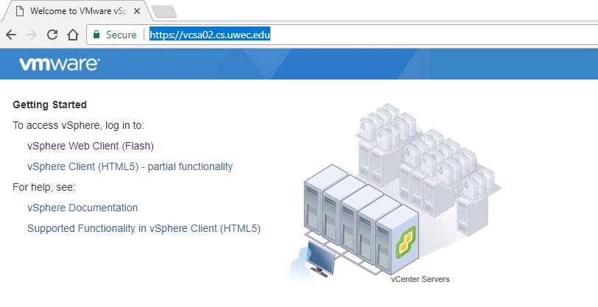

This will take you to the web client login page

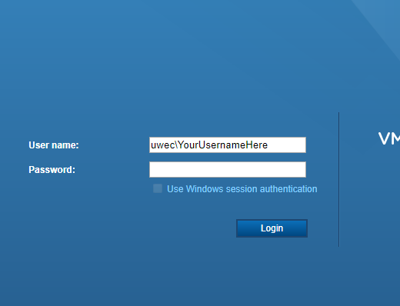

Log in with the domain\username format, using uwec as the domain. The password will be your standard uwec password.

Step 3

Once you log on, the screen will look like this

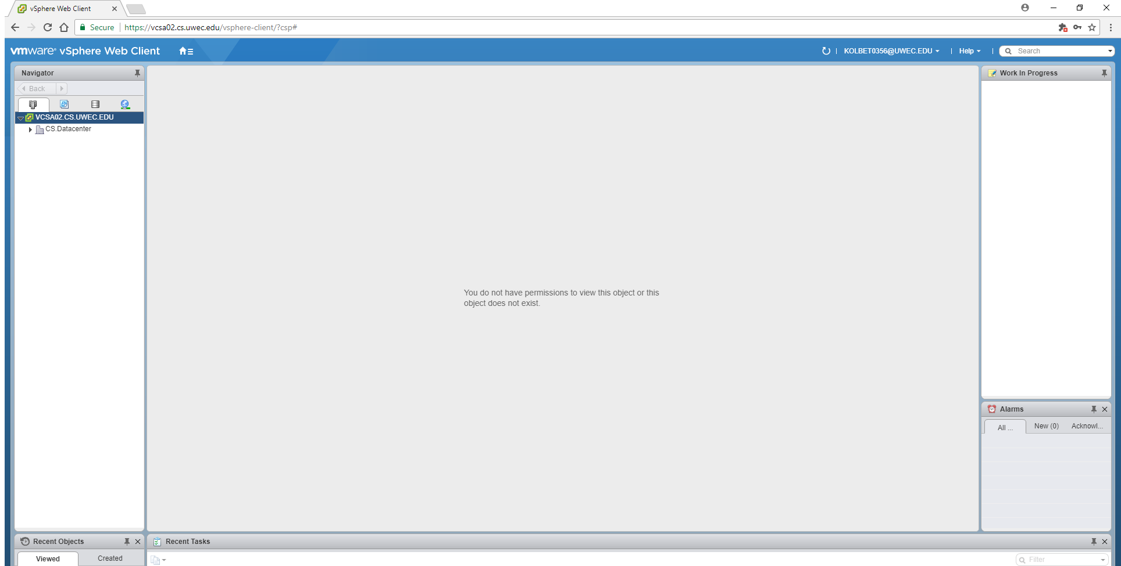

You will want to navigate using the arrows to the server the VM is hosted on. This will be easy because you won’t even be able to see a server if you don’t have any permissions on it.

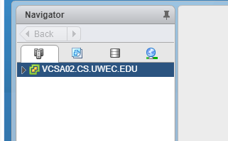

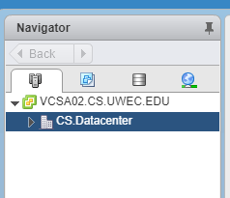

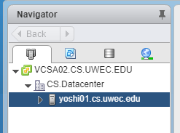

In the picture below, the selection highlighted in blue is the VM

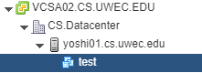

Any time you use a VM, you have to make sure it’s on. To do this, right click on the VM name, go to power, and click power on. You can turn it off this same way.

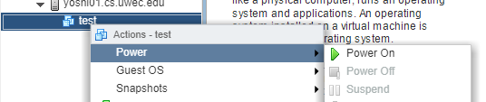

You’re finally ready to use your VM. To interact with the VM console, click open console

