现代软件开发技术实训实验报告
学号：161630315 姓名：于鹤

Python课程实验
源码GitHub地址：
- 创建项目
- 用pycharm创建一个Django项目，名称为homework。
- 新建app01。

- 实现功能
- 注册
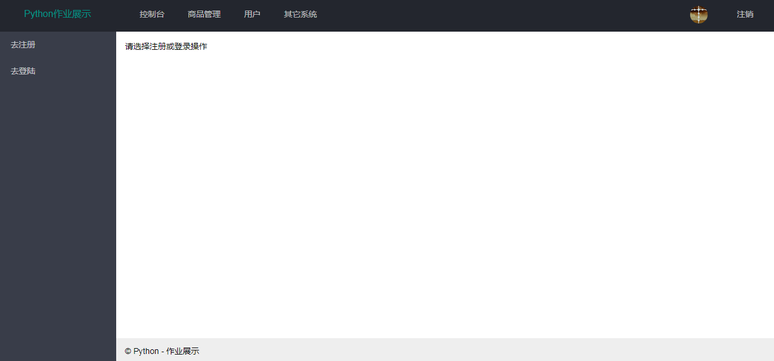
点击左侧去注册按钮，去实现注册功能
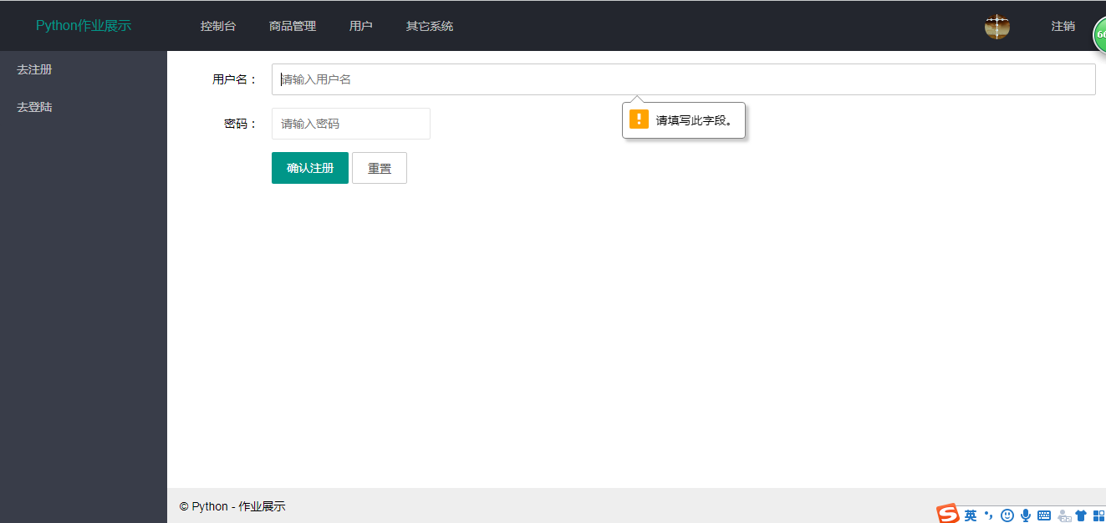
不能输入空字符
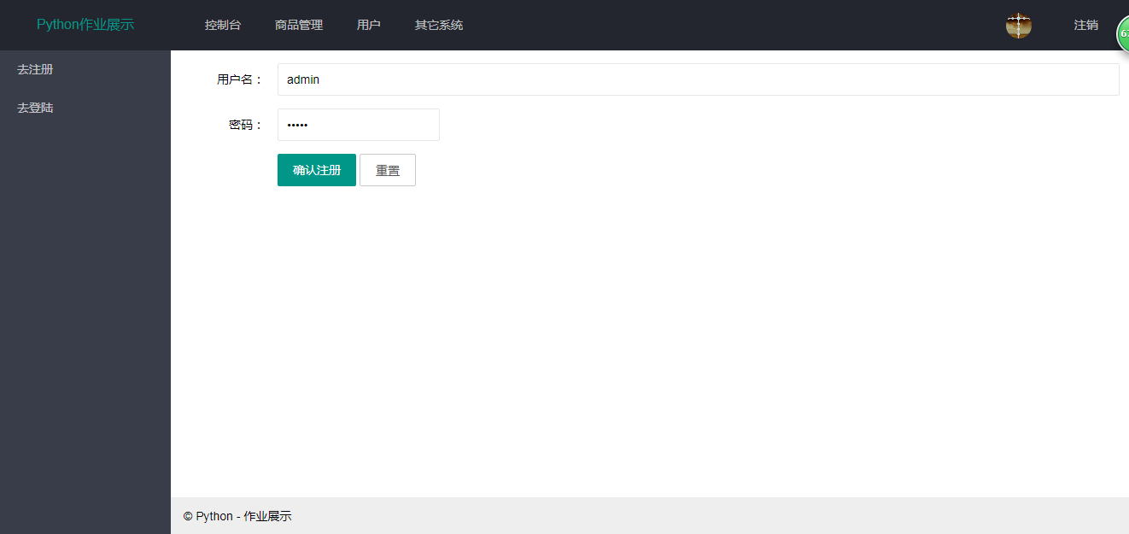
正常输入后实现注册
- 登录
点击控制台返回主页
点击左侧去登录按钮，实现登录功能
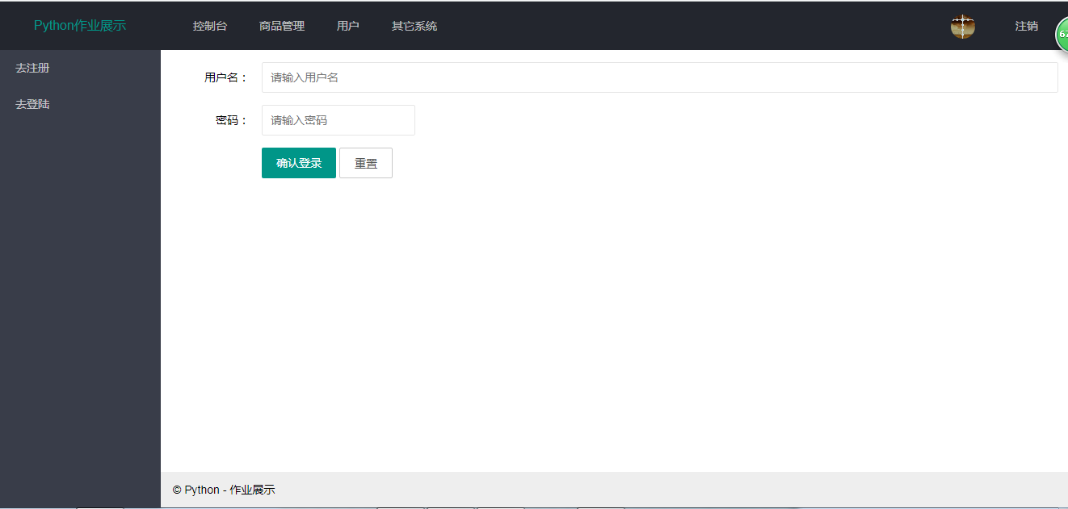
只输入用户名不输入密码会提示信息
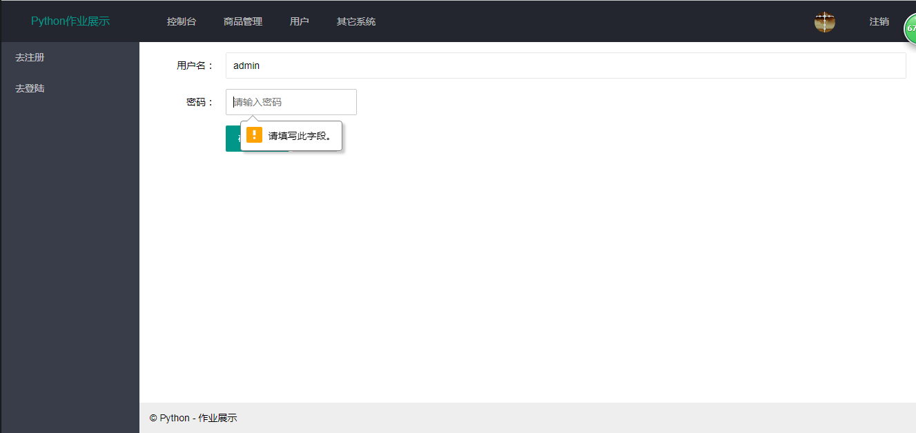
成功登陆后回跳到商品管理页面，并显示用户名
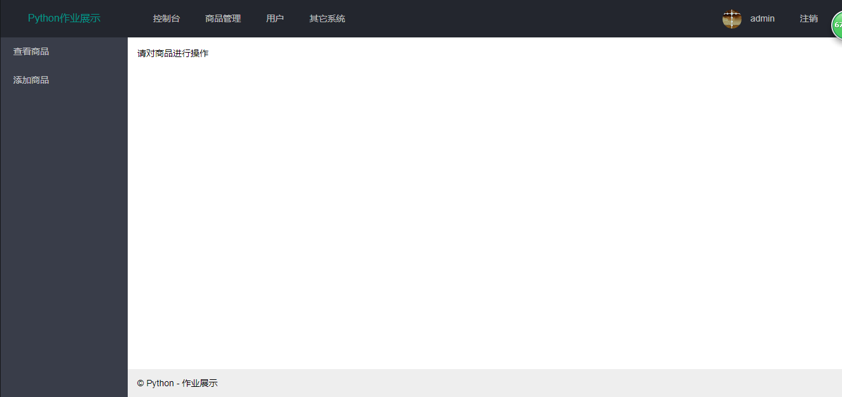
- 添加商品
点击左侧添加商品按钮
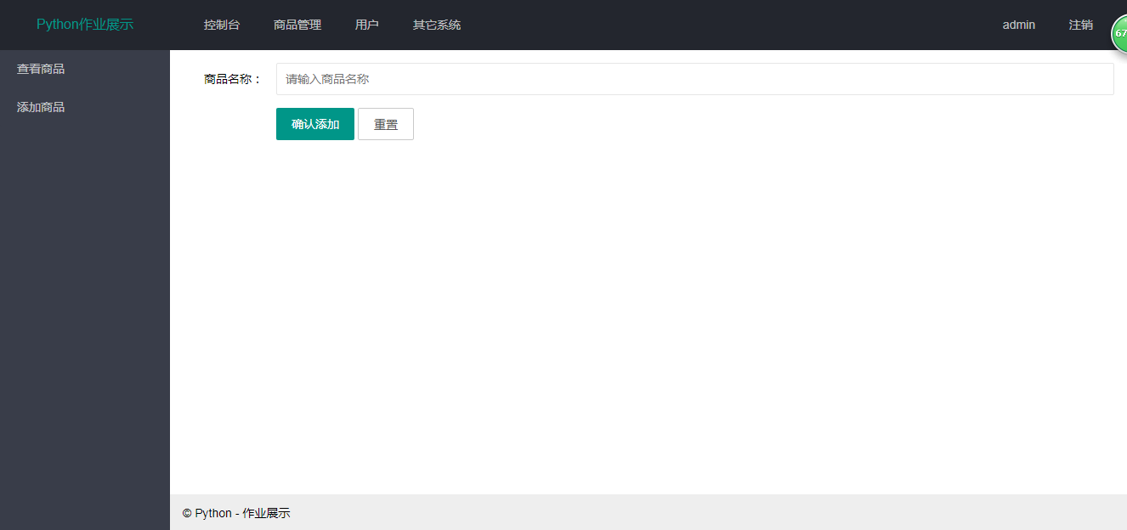
输入添加商品的名称，确认添加
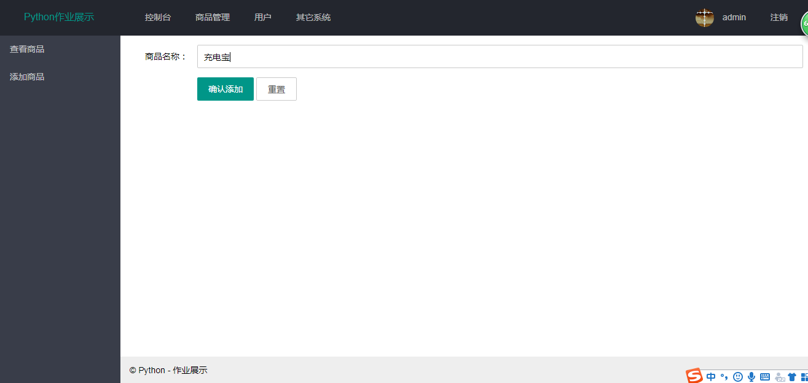
- 商品信息页面
点击左侧查看商品按钮进行商品查看
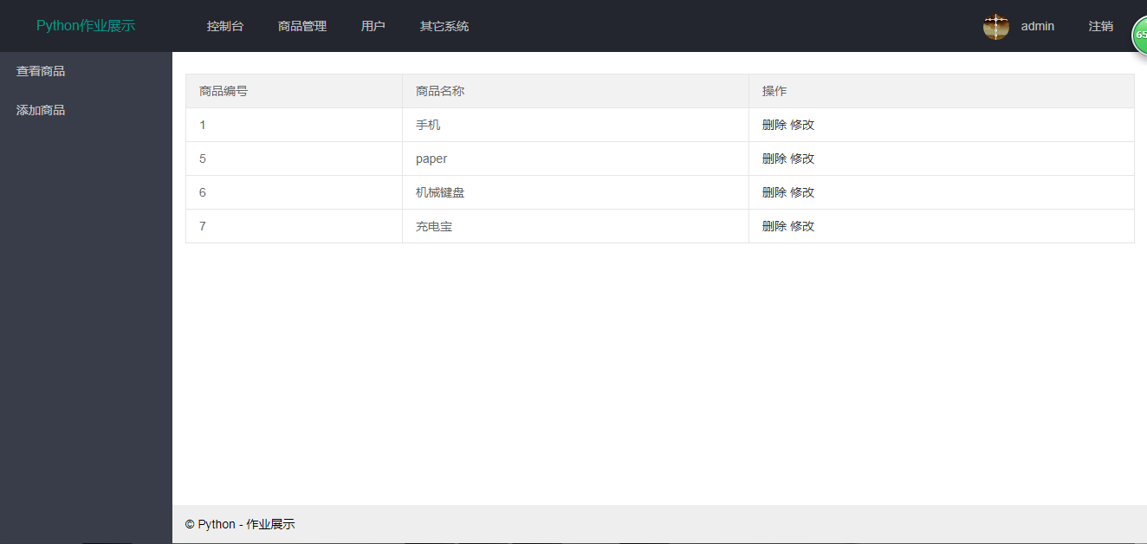
显示商品编号、商品名称和需要对商品进行的操作
- 删除商品
在商品信息页面点击删除
例，删除手机，删除后重新查看商品
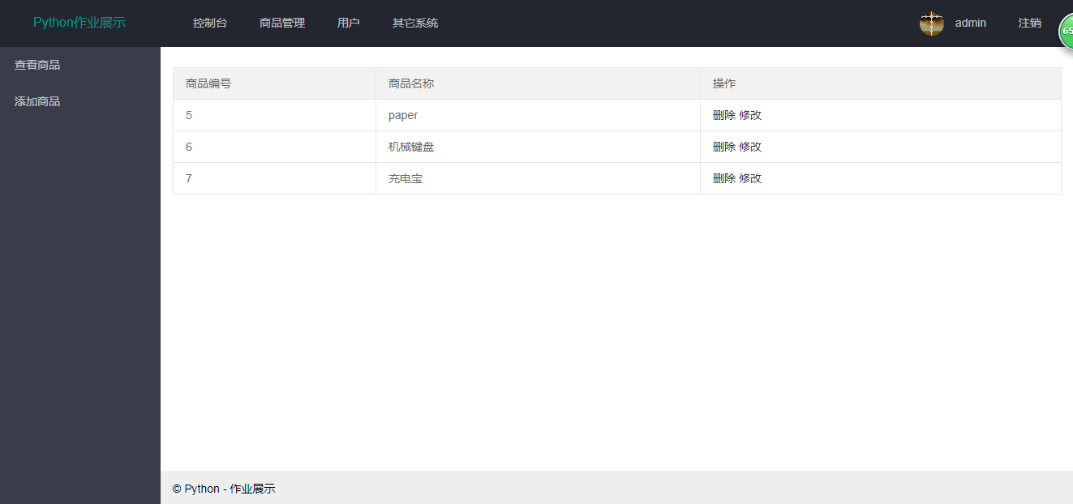
- 修改商品
在商品信息页面进行商品的修改
例，修改充电宝
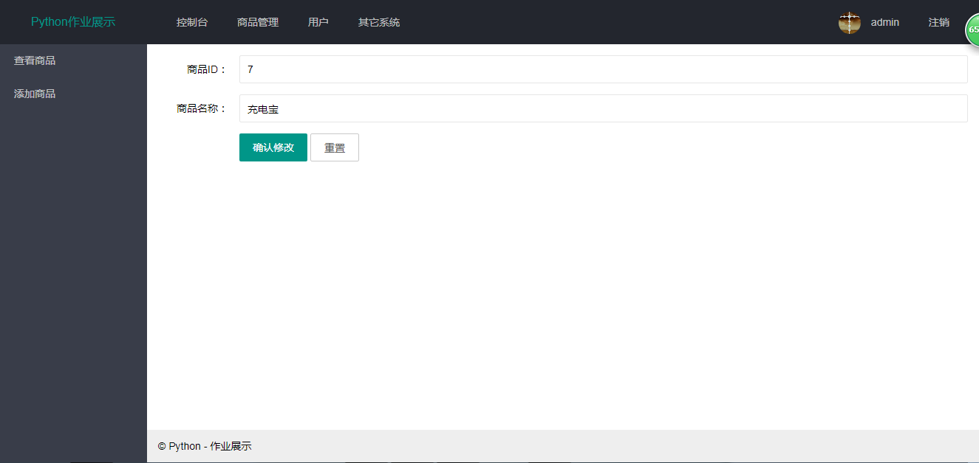
将充电宝修改为充电线
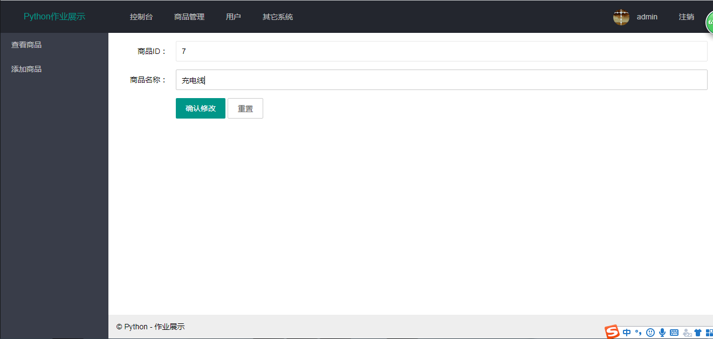
确认修改后重新查看商品信息
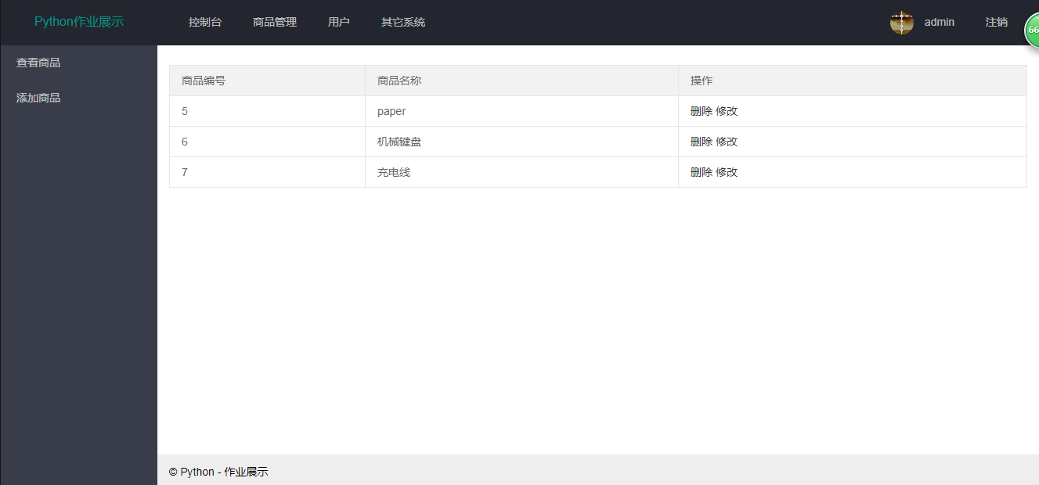
- 注销
点击注销，回到主页面，需要重新登陆
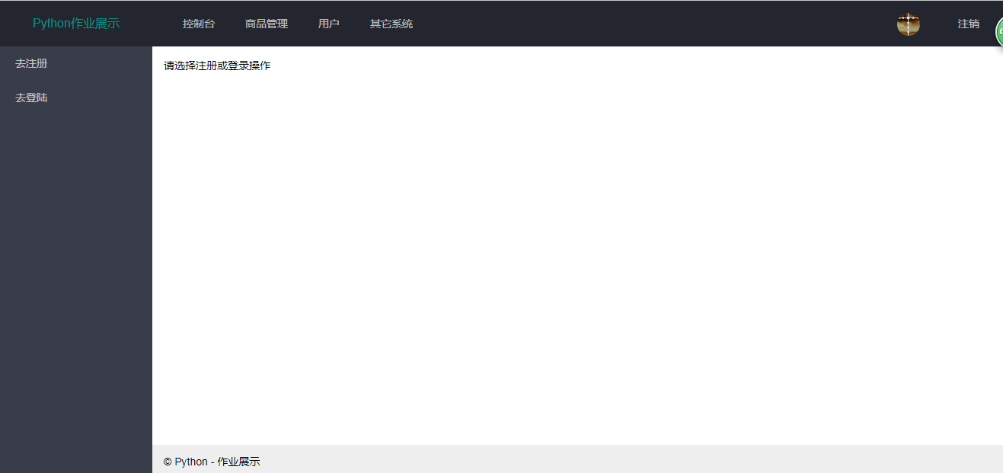

- 数据库
- 用户实体类
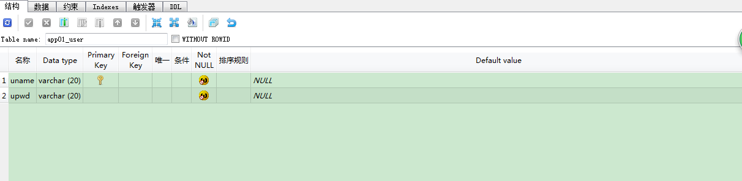
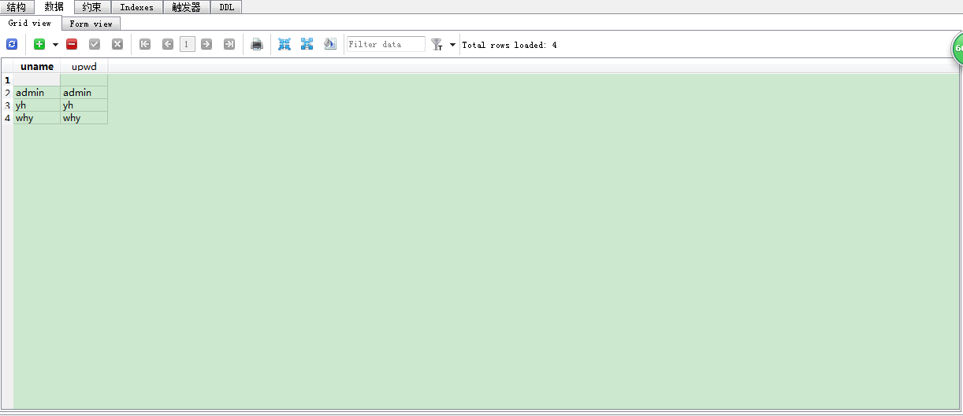
- 商品实体类
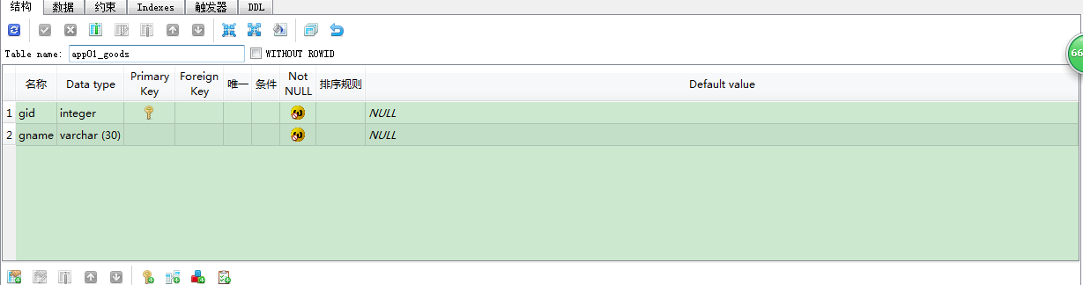
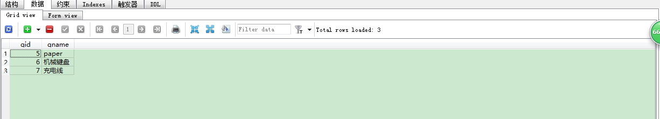

- 小结
实现了基本的操作，注册信息到数据库、检测输入框、登陆从数据库查询、保持登陆状态和注销等。熟悉了Django的MTV架构，urls、views和templates互相配合，以及添加models进行数据化。受益匪浅。

大数据实验：熟悉常用的HDFS操作

一、实验目的
•理解 HDFS 在 Hadoop 体系结构中的角色；
•熟练使用 HDFS 操作常用的 Shell 命令；
•熟悉 HDFS 操作常用的 Java API。

二、实验平台
•Windows7 + CentOS6.5
•Hadoop版本：2.7.3
•JDK版本：1.8
•Java IDE : Intellij IDEA

- 实验步骤
（一）编程实现以下功能，并利用 Hadoop 提供的 Shell 命令完成相同任务
1. 向 HDFS 中上传任意文本文件，如果指定的文件在 HDFS 中已经存在，则由用户
来指定是追加到原有文件末尾还是覆盖原有的文件。

Shell命令
已配置过PATH，直接使用hdfs dfs或者hadoop fs
vi text.txt (新建文件text.txt)
hdfs dfs -test -e text.txt //检查hdfs是否已存在该文件
echo $? //不存在显示1，存在显示0
hdfs dfs -copyFromLocal -f text.txt text.txt
hdfs dfs -test -e text.txt
echo $?

Java 代码
public class UploadFileJob {
private static boolean test(Configuration conf, String path) throws IOException {
FileSystem fs = FileSystem.get(conf);
return fs.exists(new Path(path));
}

private static final Map<String, UploadFile> UPLOAD = new HashMap<String, UploadFile>() {{
put("append", (conf, localFilePath, remoteFilePath) -> {
FileSystem fs = FileSystem.get(conf);
Path remotePath = new Path(remoteFilePath);
FileInputStream in = new FileInputStream(localFilePath);
FSDataOutputStream out = fs.append(remotePath);
byte[] data = new byte[1024];
int read = -1;
while ( (read = in.read(data)) > 0 ) {
out.write(data, 0, read);
}
out.close();
in.close();
fs.close();
});
put("overwrite", (conf, localFilePath, remoteFilePath) -> {
FileSystem fs = FileSystem.get(conf);
Path localPath = new Path(localFilePath);
Path remotePath = new Path(remoteFilePath);
fs.copyFromLocalFile(false, true, localPath, remotePath);
fs.close();
});
}};

public static void main(String[] args) {
Configuration conf = new Configuration();
conf.set("fs.default.name","hdfs://master:9000");
String localFilePath = "E://text.txt";
String remoteFilePath = "/user/hadoop/text.txt";
String choice = "append";
try {
Boolean fileExists = false;
if (UploadFileJob.test(conf, remoteFilePath)) {
fileExists = true;
System.out.println(remoteFilePath + " 已存在.");
UPLOAD.get(choice).upload(conf, localFilePath, remoteFilePath);
} else {
System.out.println(remoteFilePath + " 不存在.");
UPLOAD.get("overwrite").upload(conf, localFilePath, remoteFilePath);
}
System.out.println(localFilePath + " 已上传至 " + remoteFilePath);
} catch (Exception e) {
e.printStackTrace();
}
}
}
// 部分输出如下
...
/user/hadoop/text.txt 不存在.
E://text.txt 已上传至 /user/hadoop/text.txt
2.从 HDFS 中下载指定文件，如果本地文件与要下载的文件名称相同，则自动对下 载的文件重命名

Shell命令
if $(hdfs dfs -test -e file:///home/hadoop/text.txt);
then $(hdfs dfs -copyToLocal text.txt ./text2.txt);
else $(hdfs dfs -copyToLocal text.txt ./text.txt);
fi

Java代码
public class DownloadFileJob {
public static void copyToLocal(Configuration conf, String remoteFilePath, String
localFilePath) throws IOException {
FileSystem fs = FileSystem.get(conf);
Path remotePath = new Path(remoteFilePath);
File f = new File(localFilePath);
if (f.exists()) {
System.out.println(localFilePath + " 已存在.");
Integer i = 0;
while (true) {
f = new File(localFilePath + "_" + i.toString());
if (!f.exists()) {
localFilePath = localFilePath + "_" + i.toString();
break;
}
}
System.out.println("将重新命名为: " + localFilePath);
}
Path localPath = new Path(localFilePath);
fs.copyToLocalFile(remotePath, localPath);
fs.close();
}
public static void main(String[] args) {
Configuration conf = new Configuration();
conf.set("fs.default.name","hdfs://master:9000");
String localFilePath = "E://text.txt";
String remoteFilePath = "/user/hadoop/text.txt";
try {
DownloadFileJob.copyToLocal(conf, remoteFilePath, localFilePath);
System.out.println("下载完成");
} catch (Exception e) {
e.printStackTrace();
}
}
}
// 部分输出如下
...
E://text.txt 已存在.
将重新命名为: E://text.txt_0
下载完成
3. 将 HDFS 中指定文件的内容输出到终端中

shell命令
hdfs dfs -cat text.txt

Java代码
public class CatJob {
public static void cat(Configuration conf, String remoteFilePath) throws IOException {
FileSystem fs = FileSystem.get(conf);
Path remotePath = new Path(remoteFilePath);
FSDataInputStream in = fs.open(remotePath);
BufferedReader d = new BufferedReader(new InputStreamReader(in));
String line = null;
while ( (line = d.readLine()) != null ) {
System.out.println(line);
}
d.close();
in.close();
fs.close();
}
public static void main(String[] args) {
Configuration conf = new Configuration();
conf.set("fs.default.name","hdfs://master:9000");
String remoteFilePath = "/user/hadoop/text.txt";
try {
System.out.println("读取文件: " + remoteFilePath);
CatJob.cat(conf, remoteFilePath);
System.out.println("\n 读取完成");
} catch (Exception e) {
e.printStackTrace();
}
}
}
// 部分输出如下
读取文件: /user/hadoop/text.txt
...
hello world
读取完成
4. 显示 HDFS 中指定的文件的读写权限、大小、创建时间、路径等信息；

shell命令
hdfs dfs -ls -h text.txt

Java代码
public class InfoFileJob {
public static void ls(Configuration conf, String remoteFilePath) throws IOException {
FileSystem fs = FileSystem.get(conf);
Path remotePath = new Path(remoteFilePath);
FileStatus[] fileStatuses = fs.listStatus(remotePath);
for (FileStatus s : fileStatuses) {
System.out.println("路径: " + s.getPath().toString());
System.out.println("权限: " + s.getPermission().toString());
System.out.println("大小: " + s.getLen());
Long timeStamp = s.getModificationTime();
SimpleDateFormat format = new SimpleDateFormat("yyyy-MM-dd HH:mm:ss");
String date = format.format(timeStamp);
System.out.println("时间: " + date);
}
fs.close();
}
public static void main(String[] args) {
Configuration conf = new Configuration();
conf.set("fs.default.name","hdfs://master:9000");
String remoteFilePath = "/user/hadoop/text.txt";
try {
System.out.println("读取文件信息: " + remoteFilePath);
InfoFileJob.ls(conf, remoteFilePath);
System.out.println("\n 读取完成");
} catch (Exception e) {
e.printStackTrace();
}
}
}
// 部分输出如下
读取文件信息: /user/hadoop/text.txt
...
权限: rw-r--r--
大小: 11
读取完成
5. 给定 HDFS 中某一个目录，输出该目录下的所有文件的读写权限、大小、创建时 间、路径等信息，如果该文件是目录，则递归输出该目录下所有文件相关信息

终端命令测试
hdfs dfs -ls -R -h

Java代码
public class InfoDirectoryJob {
public static void lsDir(Configuration conf, String remoteDir) throws IOException {
FileSystem fs = FileSystem.get(conf);
Path dirPath = new Path(remoteDir);
RemoteIterator<LocatedFileStatus> remoteIterator = fs.listFiles(dirPath, true);
while (remoteIterator.hasNext()) {
FileStatus s = remoteIterator.next();
System.out.println("路径: " + s.getPath().toString());
System.out.println("权限: " + s.getPermission().toString());
System.out.println("大小: " + s.getLen());
Long timeStamp = s.getModificationTime();
SimpleDateFormat format = new SimpleDateFormat("yyyy-MM-dd HH:mm:ss");
String date = format.format(timeStamp);
System.out.println("时间: " + date);
System.out.println();
}
fs.close();
}
public static void main(String[] args) {
Configuration conf = new Configuration();
conf.set("fs.default.name","hdfs://master:9000");
String remoteDir = "/hello";
try {
System.out.println("(递归)读取目录下所有文件的信息: " + remoteDir);
InfoDirectoryJob.lsDir(conf, remoteDir);
System.out.println("读取完成");
} catch (Exception e) {
e.printStackTrace();
}
}
}
// 部分输出如下
(递归)读取目录下所有文件的信息: hello
...
路径: hdfs://master:9000/user/root/hello/son/text.txt
权限: rw-r--r--
大小: 24

...
读取完成
6. 提供一个 HDFS 内的文件的路径，对该文件进行创建和删除操作。如果文件所在 目录不存在，则自动创建目录；

shell命令
then $(hdfs dfs -touchz dir1/dir2/filename);^C
if $(hdfs dfs -test -d hello/son);
then $(hdfs dfs -touchz hello/son/test.txt);
else $(hdfs dfs -mkdir -p hello/son && hdfs dfs -touchz hello/son/test.txt);
fi
hdfs dfs -cat hello/son/test.txt
hdfs dfs -rm hello/son/test.txt
hdfs dfs -cat hello/son/test.txt

Java代码
public class DeleteFileJob {
public static boolean rm(Configuration conf, String remoteFilePath) throws IOException {
FileSystem fs = FileSystem.get(conf);
Path remotePath = new Path(remoteFilePath);
boolean result = fs.delete(remotePath, false);
fs.close();
return result;
}

public static void mkdir(Configuration conf, String remoteFilePath) throws IOException {
FileSystem fs = FileSystem.get(conf);
Path remotePath = new Path(remoteFilePath);
fs.mkdirs(remotePath);
fs.close();
}

public static void touchz(Configuration conf, String remoteFilePath) throws IOException {
FileSystem fs = FileSystem.get(conf);
Path remotePath = new Path(remoteFilePath);
fs.create(remotePath);
fs.close();
}

public static void main(String[] args) {
Configuration conf = new Configuration();
conf.set("fs.default.name","hdfs://master:9000");
String remoteFilePath = "/user/hadoop/input/text.txt";
String remoteDir = "/user/hadoop/input";
try {
if (UploadFileJob.test(conf, remoteFilePath) ) {
DeleteFileJob.rm(conf, remoteFilePath);
System.out.println("删除路径: " + remoteFilePath);
} else {
if ( !UploadFileJob.test(conf, remoteDir) ) {
DeleteFileJob.mkdir(conf, remoteDir);
System.out.println("创建文件夹: " + remoteDir);
}
DeleteFileJob.touchz(conf, remoteFilePath);
System.out.println("创建路径: " + remoteFilePath);
}
} catch (Exception e) {
e.printStackTrace();
}
}
}
// 部分输出入下
...
创建文件夹: /user/hadoop/input
...
创建路径: /user/hadoop/input/text.txt
7. 提供一个 HDFS 的目录的路径，对该目录进行创建和删除操作。创建目录时，如 果目录文件所在目录不存在， 则自动创建相应目录；删除目录时，由用户指定 当该目录不为空时是否还删除该目录

shell命令
hdfs dfs -rmdir dir/son
hdfs dfs -rm -R dir/son

Java代码
public class DeleteDirectoryJob {
public static boolean test(Configuration conf, String path) throws IOException {
FileSystem fs = FileSystem.get(conf);
return fs.exists(new Path(path));
}
public static boolean isDirEmpty(Configuration conf, String remoteDir) throws IOException {
FileSystem fs = FileSystem.get(conf);
Path dirPath = new Path(remoteDir);
RemoteIterator<LocatedFileStatus> remoteIterator = fs.listFiles(dirPath, true);
return !remoteIterator.hasNext();
}
public static boolean mkdir(Configuration conf, String remoteDir) throws IOException {
FileSystem fs = FileSystem.get(conf);
Path dirPath = new Path(remoteDir);
boolean result = fs.mkdirs(dirPath);
fs.close();
return result;
}
public static boolean rmDir(Configuration conf, String remoteDir) throws IOException {
FileSystem fs = FileSystem.get(conf);
Path dirPath = new Path(remoteDir);
boolean result = fs.delete(dirPath, true);
fs.close();
return result;
}
public static void main(String[] args) {
Configuration conf = new Configuration();
conf.set("fs.default.name","hdfs://master:9000");
String remoteDir = "/user/hadoop/input";
Boolean forceDelete = false;
try {
if ( !DeleteDirectoryJob.test(conf, remoteDir) ) {
DeleteDirectoryJob.mkdir(conf, remoteDir);
System.out.println("创建目录: " + remoteDir);
} else {
if ( DeleteDirectoryJob.isDirEmpty(conf, remoteDir) || forceDelete ) {
DeleteDirectoryJob.rmDir(conf, remoteDir);
System.out.println("删除目录: " + remoteDir);
} else {
System.out.println("目录不为空，不删除: " + remoteDir);
}
}
} catch (Exception e) {
e.printStackTrace();
}
}
}
// 部分输出如下
...
目录不为空，不删除: /user/hadoop/input
...
8. 向 HDFS中指定的文件追加内容，由用户指定内容追加到原有文件的开头或结尾

shell命令
hdfs dfs -appendToFile local.txt text.txt
hdfs dfs -get text.txt
cat text.txt >> local.txt
hdfs dfs -copyFromLocal -f text.txt text.txt

Java代码
public class AppendFileJob {
public static boolean test(Configuration conf, String path) throws IOException {
FileSystem fs = FileSystem.get(conf);
return fs.exists(new Path(path));
}
public static void appendContentToFile(Configuration conf, String content, String
remoteFilePath) throws IOException {
FileSystem fs = FileSystem.get(conf);
Path remotePath = new Path(remoteFilePath);
FSDataOutputStream out = fs.append(remotePath);
out.write(content.getBytes());
out.close();
fs.close();
}
public static void appendToFile(Configuration conf, String localFilePath, String
remoteFilePath) throws IOException {
FileSystem fs = FileSystem.get(conf);
Path remotePath = new Path(remoteFilePath);
FileInputStream in = new FileInputStream(localFilePath);
FSDataOutputStream out = fs.append(remotePath);
byte[] data = new byte[1024];
int read = -1;
while ( (read = in.read(data)) > 0 ) {
out.write(data, 0, read);
}
out.close();
in.close();
fs.close();
}
public static void moveToLocalFile(Configuration conf, String remoteFilePath, String
localFilePath) throws IOException {
FileSystem fs = FileSystem.get(conf);
Path remotePath = new Path(remoteFilePath);
Path localPath = new Path(localFilePath);
fs.moveToLocalFile(remotePath, localPath);
}
public static void touchz(Configuration conf, String remoteFilePath) throws IOException {
FileSystem fs = FileSystem.get(conf);
Path remotePath = new Path(remoteFilePath);
FSDataOutputStream outputStream = fs.create(remotePath);
outputStream.close();
fs.close();
}
public static void main(String[] args) {
Configuration conf = new Configuration();
conf.set("fs.default.name","hdfs://master:9000");
String remoteFilePath = "/user/hadoop/text.txt";
String content = "新追加的内容\n";
String choice = "after";
try {
if ( !AppendFileJob.test(conf, remoteFilePath) ) {
System.out.println("文件不存在: " + remoteFilePath);
} else {
if ( choice.equals("after") ) {
AppendFileJob.appendContentToFile(conf, content, remoteFilePath);
System.out.println("已追加内容到文件末尾" + remoteFilePath);
} else if ( choice.equals("before") ) {
String localTmpPath = "/user/hadoop/tmp.txt";
AppendFileJob.moveToLocalFile(conf, remoteFilePath, localTmpPath);
AppendFileJob.touchz(conf, remoteFilePath);
AppendFileJob.appendContentToFile(conf, content, remoteFilePath);
AppendFileJob.appendToFile(conf, localTmpPath, remoteFilePath);
System.out.println("已追加内容到文件开头: " + remoteFilePath);
}
}
} catch (Exception e) {
e.printStackTrace();
}
}
}
9.删除 HDFS 中指定的文件

shell命令
then $(hdfs dfs -touchz dir1/dir2/filename);^C
if $(hdfs dfs -test -d hello/son);
then $(hdfs dfs -touchz hello/son/test.txt);
else $(hdfs dfs -mkdir -p hello/son && hdfs dfs -touchz hello/son/test.txt);
fi
hdfs dfs -cat hello/son/test.txt
hdfs dfs -rm hello/son/test.txt
hdfs dfs -cat hello/son/test.txt

Java代码
public class DeleteFileJob {
public static boolean rm(Configuration conf, String remoteFilePath) throws IOException {
FileSystem fs = FileSystem.get(conf);
Path remotePath = new Path(remoteFilePath);
boolean result = fs.delete(remotePath, false);
fs.close();
return result;
}

public static void mkdir(Configuration conf, String remoteFilePath) throws IOException {
FileSystem fs = FileSystem.get(conf);
Path remotePath = new Path(remoteFilePath);
fs.mkdirs(remotePath);
fs.close();
}

public static void touchz(Configuration conf, String remoteFilePath) throws IOException {
FileSystem fs = FileSystem.get(conf);
Path remotePath = new Path(remoteFilePath);
fs.create(remotePath);
fs.close();
}

public static void main(String[] args) {
Configuration conf = new Configuration();
conf.set("fs.default.name","hdfs://master:9000");
String remoteFilePath = "/user/hadoop/input/text.txt";
String remoteDir = "/user/hadoop/input";
try {
if (UploadFileJob.test(conf, remoteFilePath) ) {
DeleteFileJob.rm(conf, remoteFilePath);
System.out.println("删除路径: " + remoteFilePath);
} else {
if ( !UploadFileJob.test(conf, remoteDir) ) {
DeleteFileJob.mkdir(conf, remoteDir);
System.out.println("创建文件夹: " + remoteDir);
}
DeleteFileJob.touchz(conf, remoteFilePath);
System.out.println("创建路径: " + remoteFilePath);
}
} catch (Exception e) {
e.printStackTrace();
}
}
}
// 部分输出入下
...
创建文件夹: /user/hadoop/input
...
创建路径: /user/hadoop/input/text.txt
10. 在 HDFS 中，将文件从源路径移动到目的路径。

shell命令
hdfs dfs -mv text.txt text2.txt

Java代码
public class MoveFileJob {
public static boolean mv(Configuration conf, String remoteFilePath, String
remoteToFilePath) throws IOException {
FileSystem fs = FileSystem.get(conf);
Path srcPath = new Path(remoteFilePath);
Path dstPath = new Path(remoteToFilePath);
boolean result = fs.rename(srcPath, dstPath);
fs.close();
return result;
}
public static void main(String[] args) {
Configuration conf = new Configuration();
conf.set("fs.default.name","hdfs://master:9000");
String remoteFilePath = "hdfs:///user/hadoop/text.txt";
String remoteToFilePath = "hdfs:///user/hadoop/new.txt";
try {
if ( MoveFileJob.mv(conf, remoteFilePath, remoteToFilePath) ) {
System.out.println(" 将 文 件 " + remoteFilePath + " 移 动 到 " +
remoteToFilePath);
} else {
System.out.println("操作失败(源文件不存在或移动失败)");
}
} catch (Exception e) {
e.printStackTrace();
}
}
}
// 部分输出如下
...
将 文 件 hdfs:///user/hadoop/text.txt 移 动 到 hdfs:///user/hadoop/new.txt
（二）编程实现一个类“MyFSDataInputStream” ，该类继承“org.apache.hadoop.fs.FSDataI nputStream” ，要求如下： 实现按行读取 HDFS 中指定文件的方法“readLine()” ，如果读到 文件末尾，则返回空，否则返回文件一行的文本。
Java代码
public class MyFSDataInputStream extends FSDataInputStream {
public MyFSDataInputStream(InputStream in) {
super(in);
}
public static String readline(BufferedReader br) throws IOException {
char[] data = new char[1024];
int read = -1;
int off = 0;
while ( (read = br.read(data, off, 1)) != -1 ) {
if (String.valueOf(data[off]).equals("\n") ) {
off += 1;
break;
}
off += 1;
}
if (off > 0) {
return String.valueOf(data);
} else {
return null;
}
}
public static void cat(Configuration conf, String remoteFilePath) throws IOException {
FileSystem fs = FileSystem.get(conf);
Path remotePath = new Path(remoteFilePath);
FSDataInputStream in = fs.open(remotePath);
BufferedReader br = new BufferedReader(new InputStreamReader(in));
String line = null;
while ( (line = MyFSDataInputStream.readline(br)) != null ) {
System.out.println(line);
}
br.close();
in.close();
fs.close();
}
public static void main(String[] args) {
Configuration conf = new Configuration();
conf.set("fs.default.name","hdfs://master:9000");
String remoteFilePath = "user/hadoop/text.txt";
try {
MyFSDataInputStream.cat(conf, remoteFilePath);
} catch (Exception e) {
e.printStackTrace();
}
}
}
...
hello world

hello world
...
- 查看 Java 帮助手册或其它资料，用“java.net.URL” 和“org.apache.hadoop.fs.FsURLSt reamHandlerFactory” 编程完成输出 HDFS 中指定文件的文本到终端中
Java代码
public class CopyFileJob {
static{
URL.setURLStreamHandlerFactory(new FsUrlStreamHandlerFactory());
}
public static void main(String[] args) throws Exception {
String remoteFilePath = "hdfs:master/user/hadoop/text.txt";
InputStream in = null;
try{
in = new URL(remoteFilePath).openStream();
IOUtils.copyBytes(in,System.out,4096,false);
} finally{
IOUtils.closeStream(in);
}
}
}

...
hello world
hello world
...
四、实验总结
熟悉使用hdfs的shell命令和Java API的调用，对hdfs有了更深入的了解。

