# Design

### Plasmids we use

As we focus on some typical types of signal pathways which make difference in Eukaryotes, especially in human, we have to find an expression system which can efficiently express Eukaryotes genes inside our saccharomycetes. By scanning previous studies, we find one kind of plasmid which has already been widely used in *P.pastoris* expression systems. It's pPIC9k (Scorer et al., 1994). Researchers have tried to clone multiple types of eukaryotes genes into this plasmid, such as myostatin propeptide (Du et al., 2015), recombinant human-source collagen (侯增淼 et al., 2019). In all these studies, this system has shown great maneuverability as well as high expression efficiency. Therefore, we decide to use it to express all proteins of the signal pathway.

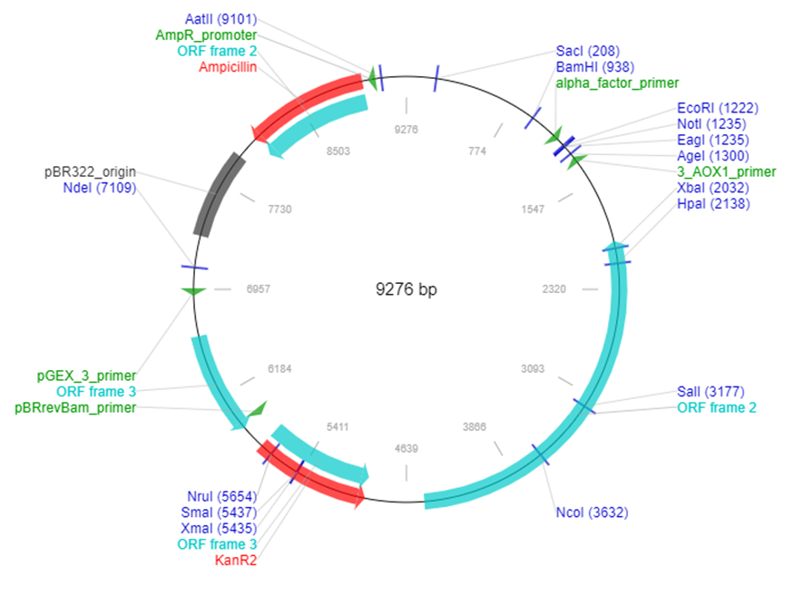

Figure 1. The plasmid profile of pPIC9k

Besides, our design also contains some prokaryotic genes to express. These genes play roles in the QS and intercellular communication parts. So we have to find ways to allow prokaryotic genes to be expressed stably inside *P.pastoris*. Therefore, we decide to use the most common shuffle plasmid, pCMV-HA. It has already been widely used to allow *E.coli* genes steadily expressed in yeast and there have already been much mature products in the market.

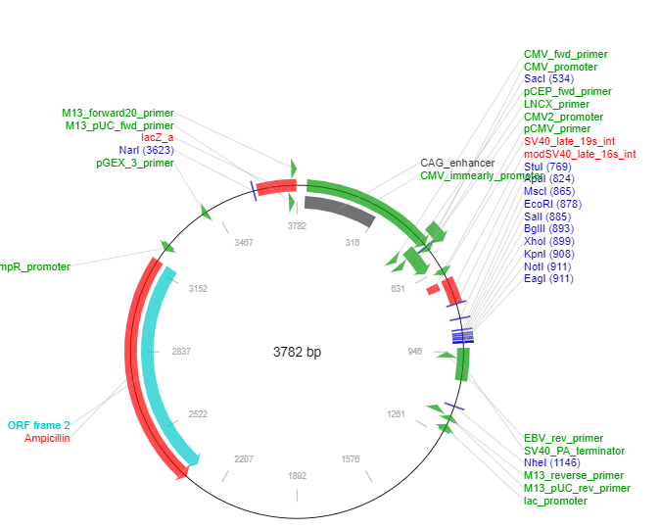

Figure 2. The plasmid profile of pCMV-HA

### Intercellular signaling

#### The secreting system

As We want to allow cells in the chamber be able to secret the proteins in the signal pathways and most signal pathways that we want to discover are common paths which typically expressed in eukaryotes.

To reach our goal, we want to allow cells in the chamber be able to secret the proteins in the signal pathways. Besides, as most signal pathways that we want to discover are common paths which typically expressed in eukaryotes, we have to choose a suitable way to get all the proteins be produced in a right space structure and well modified. Considering all these needs, we decide to choose *Pichia pastoris (P. pastoris)* , a kind of saccharomycetes, to produce the proteins that we need. This type of saccharomycetes has already shown great performance on keeping the secreting protein to stay in a right glycosylated modified state and folding level (Ahmad et al., 2014).

By transfecting protein-encoded plasmid into it, they gain the ability to synthesize the proteins that we need. Besides, in order to get cells in different chambers be able to communicate with each other, we construct a signal transmission system.

#### Intercellular communication

As the proteins in signal pathways are typically non-secreting proteins, we decide to use a transfer system to let it's information strength to be passed to the next level of chamber. We try to find possible communication method from some intercellular communication pathways and we finally decide to use AI-2 and CAI-I (Ng & Bassler, 2009). The reason why we use two types of signal pathways is that we don't want the signal molecules secreted by cells in adjacent chambers will interrupt with each other. So we let one level of chamber has the ability to get the signal from the prior level and secret a different signal molecule to the next.

As for AI-2 signal pathway, it's detected by sensor kinases CqsS (Schauder et al., 2001). When they combined with each other, it will trigger the pLuxU to express the protein (Chen et al., 2002). As for CAI-I signal pathway works similar to AI-2 signal pathway. It's detected by sensor kinase Lux-Q (Miller et al., 2002). By using specific transcriptional regulatory factors, we make it come true to let the signal transfer from the original signal pathway to an intercellular communication way.

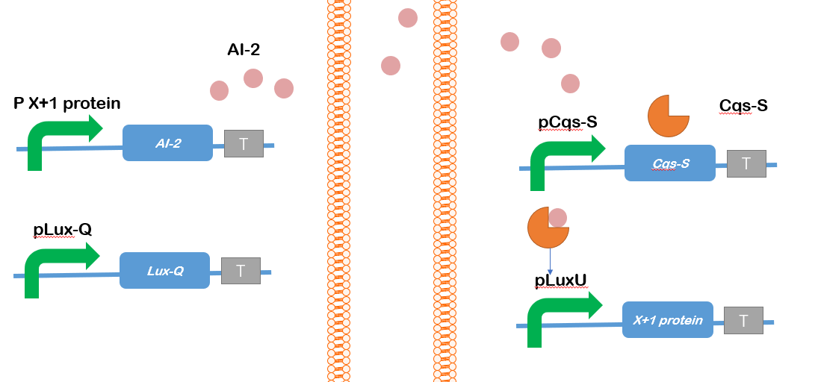

Figure 3. AI-2 pathway. Left: the first level chamber. Right: the next level chamber; X protein means the protein which is in the signal pathway that we want to simulate. X is expressed inside the present chamber. X+1 protein means the protein which on the next level of X protein in the signal pathway. X+1 protein is expressed inside the next chamber.

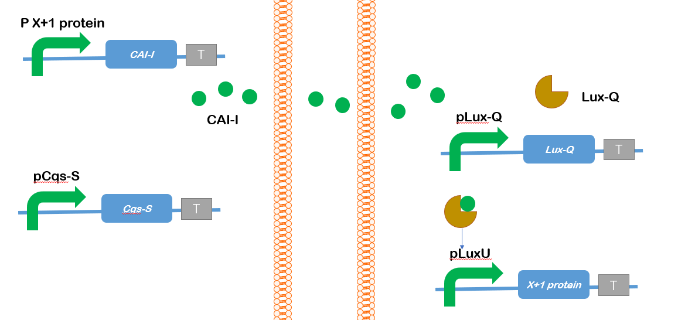

Figure 4. CAI-I pathway. Left: the first level chamber. Right: the next level chamber

### Integrated signaling pathway modules in each chamber

To enable the biologists to build intercellular synthetic biology circuits, we proposed an signaling pathway system. This is a toolkit includes a series of cells with integrated signaling pathway modules. Each cell has two or three layers that are used for information processing. These are input, hidden, and output layer (Fig. 1).

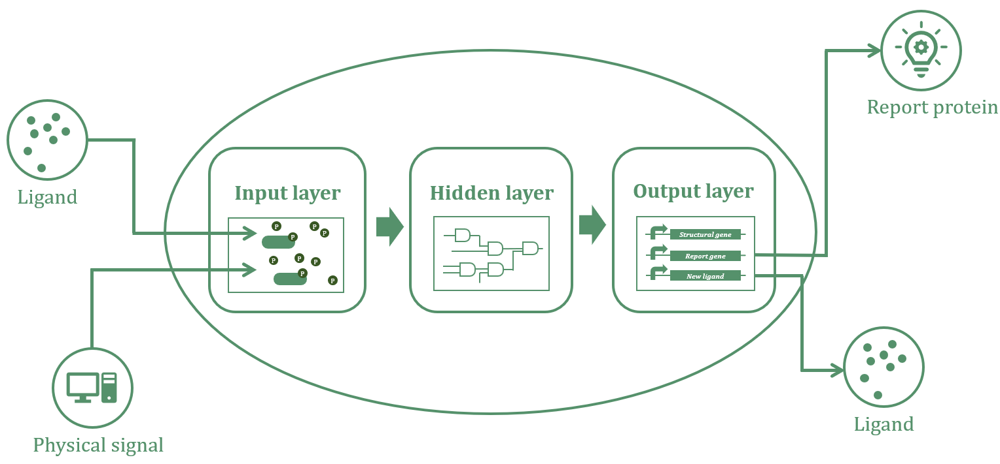

Figure 5. Construction of a signaling pathway system.

**Input layer**

The input layer enables a cell to sense the environmental signals using customized signal pathways. The signals can be autoinducers, antigens, and changes of the physical environment. Like a common signaling pathway, the input layer includes the receptors, kinases, transcription factors, and promotors. For example, Krawczyk et al. (Krawczyk et al., 2020) proposed an electrogenetic interface that used digital electronic input to program cellular behavior. They described a signal pathway with a voltage-gated channel CaV1,2 (receptor), NFAT (kinase), and PNFAT3 (promotor). Similarly, Aurand and March designed a biological sensor that can react to cytokine (Aurand & March, 2016). Some synthetic circuits can even react to UV (Ulm & Jenkins, 2015). These signal pathways can be reused in the input layer. Scientists can also introduce multiple signaling pathways to the input layer, which can make it possible to sense a variety of environmental signals.

**hidden layer (optional)**

In the hidden layer, we utilized protein-based logic gates proposed by Chen et al. (Chen et al., 2002) to process complex information from the input layer. These logic gates include AND, OR, and NOT gate, constructed by a series of heterodimeric molecules. For example, given hypothetical heterodimer pairs A: A’, B: B’ (here “:” denotes noncovalent interaction), a NOT gate can be constructed by A’, B’, and A’–B (here “–” denotes covalent interaction), where B’ is binding to a repressor. When the signal molecule A’–B occurs, a simple system A: A’ –B: B’ forms, which inhibits the gene expression (Fig. 2). Other logic gates are designed according to similar mechanisms. These logic gates can be used repetitively to construct complex information processing systems.

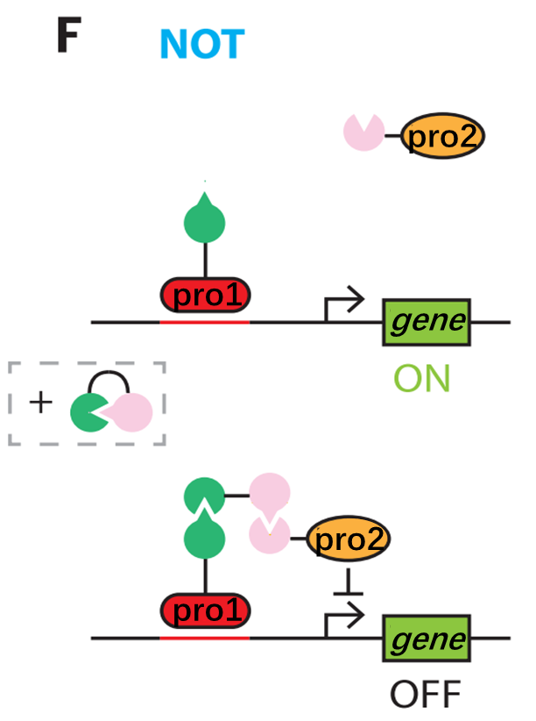

Figure 6. The design of NOT gate.

**Output layer**

This layer is used to customize cell behavior by using various structural and report genes. Genes that produces intercellular signal molecules should also be integrated into this layer in order to communicate the next cell.

### Chosen signaling pathways

We decide to use the specific interactions between ligands and receptors to trigger each signaling pathways. Here are three ligands we had chosen to triggering important signaling pathways for further research of HCC.

#### TGF-β

Receptor：TGFBR2

Downstream: TGFB1→Smads→RhoA

TGF-beta signaling is involved in the regulation of proliferation, differentiation and survival/or apoptosis of many cells, including glioma cells. TGF-beta acts via specific receptors activating multiple intracellular pathways resulting in phosphorylation of receptor-regulated Smad2/3 proteins that associate with the common mediator, Smad4. Such complex translocates to the nucleus, binds to DNA and regulates transcription of many genes. Furthermore, TGF-beta -activated kinase-1 (TAK1) is a component of TGF-beta signaling and activates mitogen-activated protein kinase cascades. Negative regulation of TGF-beta /Smad signaling may occur through the inhibitory Smad6/7. Increased expression of TGF-beta 1-3 correlates with a degree of malignancy of human gliomas. TGF-beta may contribute to tumor pathogenesis by direct support of tumor growth, self-renewal of glioma initiating stem cells and inhibiting of anti-tumor immunity. Inhibitors of TGF-beta signaling reduce viability and invasion of gliomas in animal models and show promises as novel, potential anti-tumor therapeutics.

TGF-beta superfamily of cytokines bind to receptors at the cell surface, and recruit two type I receptors and two type II receptors forming a tetrameric complex. Activated TGF-beta superfamily receptors induce a series of phosphorylation cascade, from receptor phosphorylation to subsequent phosphorylation and activation of downstream signal transducer R-Smads (receptor-activated Smads). Phosphorylated R-Smads form a heteroligomeric (often trimeric) complex with Smad4 (Co-Smad). The Smad complex is imported into the nucleus and regulates the expression of target genes by direct binding to the target gene promoter and/or through the interaction with transcriptional cofactors in a cell-type-specific manner.

https://www.sinobiological.com/pathways/tgf-beta-pathway

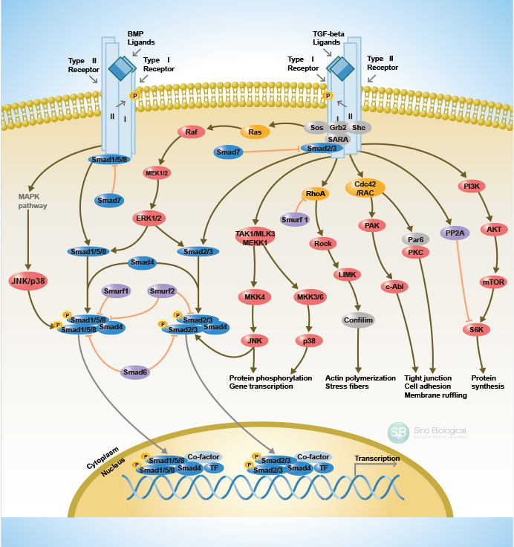

#### Wnt-β-catenin

Receptor：FZD-5

Downstream：DVL-1——β-catenin（CTNNB1）

Wnt pathways are involved in the control of gene expression, cell behavior, cell adhesion, and cell polarity. The Canonical (β-Catenin-Dependent) Wnt Signaling pathway is the best studied of the Wnt pathways and is highly conserved through evolution. In this pathway, Wnt signaling inhibits the degradation of β-catenin, which can regulate transcription of a number of genes. Wnt signaling is activated via ligation of Wnt proteins to their respective dimeric cell surface receptors composed of the seven transmembrane frizzled proteins and the LRP5/6. Upon ligation to their receptors, the cytoplasmic protein disheveled (Dvl) is recruited, phosphorylated and activated. Activation of Dvl induces the dissociation of GSK-3β from Axin and leads to the inhibition of GSK-3β. Next, the phosphorylation and degradation of β-catenin is inhibited as a result of the inactivation of the "destruction complex". Subsequently, stabilized β-catenin translocates into the nucleus leading to changes in different target gene expressions.

https://www.sinobiological.com/pathways/canonical-wnt-pathway

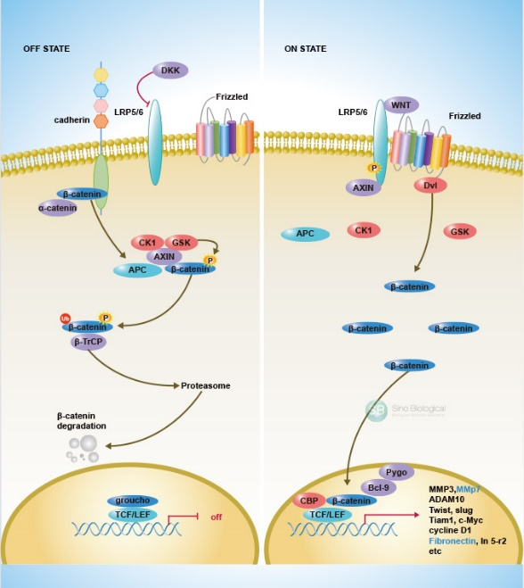

#### PI3K

Upon growth factor stimulation and subsequent activation of receptor tyrosine kinases (RTKs), class IA PI3Ks, consisting of p110α/p85, p110β/p85 and p110δ/p85, are recruited to the membrane via interaction of the p85 subunit to the activated receptors directly (e.g.PDGFR) or to adaptor proteins associated with the receptors (e.g. insulin receptor substrate 1, IRS1). The activated p110 catalytic subunit converts phosphatidylinositol-4,5-bisphosphate (PIP2) to phosphatidylinositol-3,4,5-triphosphate (PIP3) at the membrane, providing docking sites for signaling proteins with pleckstrin-homolog

y (PH) domains including the phosphoinositide-dependent kinase 1 (PDK1) and the Ser-Thr kinase AKT. The activated AKT elicits a broad spectrum of downstream signaling events. Class IB PI3K (p110γ/p101) can be activated directly by G-protein coupled receptors (GPCRs) through interacting with the Gβγ subunit of trimeric G proteins. The p110β and p110δ can also be activated by GPCRs. PTEN (phosphatase and tensin homologue) antagonizes the PI3K action by dephosphorylating PIP3.

Phosphatidylinositol-3 kinase (PI3K) is one of the most important regulatory proteins that is involved in different signaling pathways and controlling of key functions of the cell. The PI3K pathway is deregulated in the majority of human cancers. In sporadic tumors and in cancer cell lines, there are numerous other genetic and epigenetic changes that have been extensively documented by the human cancer genome project

<https://www.sinobiological.com/research/enzymes/phosphatidylinositol-3-kinase>

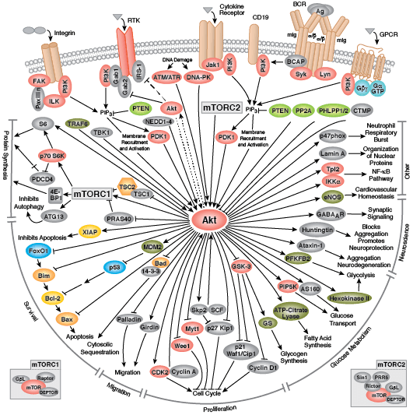

### Amount control

In most researches, scientists normally try to figure out the relationship between the variance and the pathway by testing the amount of the molecules of the signal pathway. However, as we try to use chambers in which dozens of cells are cultivated and secreting the proteins to simulate how the signal pathways carry on, the amount of the total cells may increase due to the cell division. Under such circumstance, the amount of the molecules will also show an increase. Therefore, we are not able to make a conclusion of the final results as we don't know whether the difference is caused by the variance we applied or the cell growth.

To solve this problem, we are triggered by the quorum sensing system in bacteria. By using QS system, we are able to control the amount of cells in one chamber to a fixed range.

We create a set of pathways which are able to sense the amount of the signal molecules in the surrounding environment. When the level reaches to a threshold value which indicate the cell amount increase, the suicide mechanism will be triggered and cytotoxic protein ccdB will be expressed, killing the cell. Therefore, the total amount of the cells in one chamber will be controlled. We firstly use C14-HSL/LuxI/VjbR/ccdB QS system to realize the design (Ball et al., 2017).

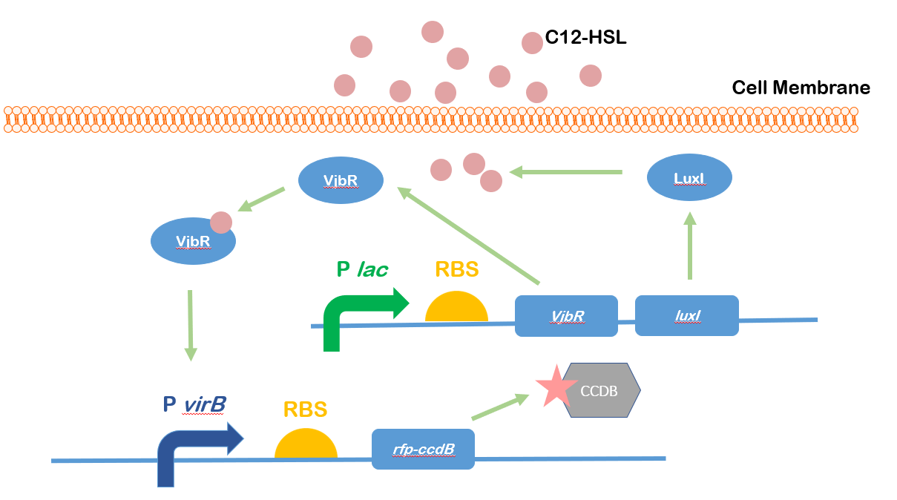

Figure 7. C14-HSL/LuxI/VjbR/ccdB system

Moreover, as the signal molecules are secreted into the surrounding environment, it's possible that the signal molecules will flow into the next chamber. So if only one type of system is used, the regular growth of cells in the next chamber will be interrupted. Therefore, we decide to use different signal molecules in two adjacent chambers. Here we find Swr QS system as another one to control the growth (Khajanchi et al., 2009).

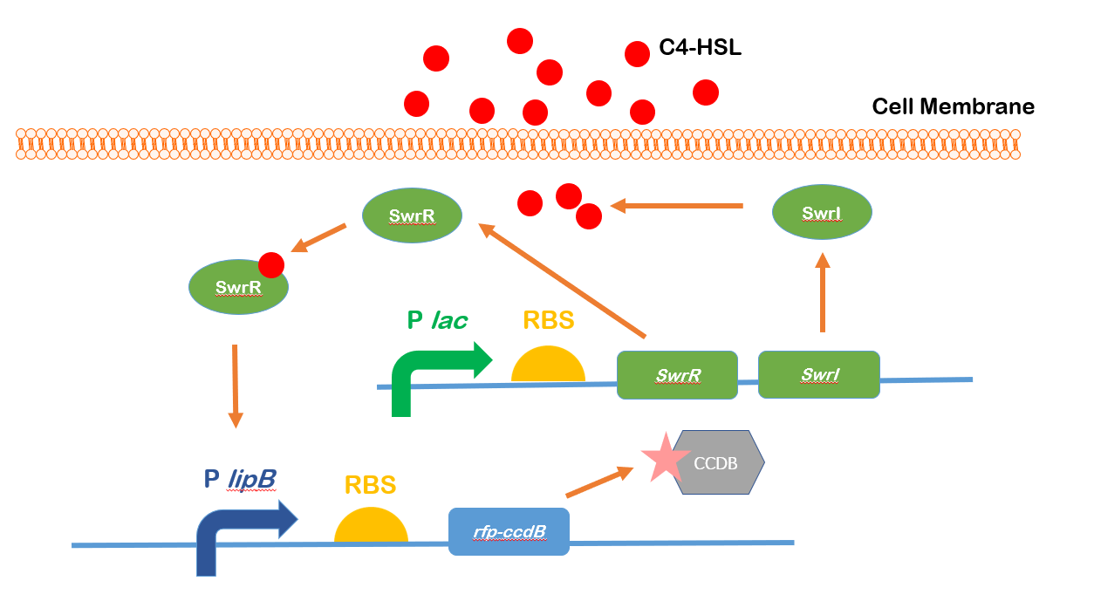

Figure 8. C4-HSL/SwrI/SwrR/ccdB system

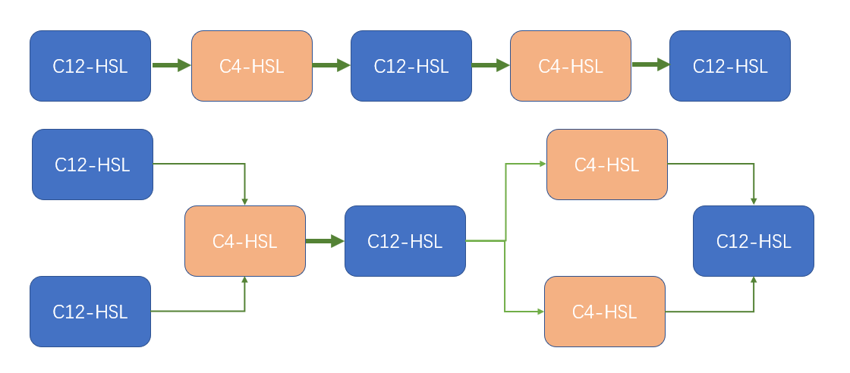

Figure 9. By changing the signal molecules, adjacent signal molecules will not interrupt with each other.

### Recording system

Our recording system includes a pair of nearly identical recording plasmids, R1 and R2, that differ only by 3 nucleotides in an EGFP gene that encodes enhanced green fluorescent protein. The EGFP gene in R1 expresses full-length fluorescent protein, whereas the EGFP gene in R2 contains a premature stop codon and cannot produce fluorescent protein (Fig. 10A)

The R1/R2 ratio serves as the information carrier that reflects the signal of interest in an analog mode. To convert the signal of interest into an R1/R2 ratio change, a Cas9-sgRNA pair induced by the stimulus cleaves plasmid R1 but not R2. The expression of the Cas9-sgRNA complex is controlled by the signal of interest and results in R1 depletion in the bacteria. (Tang & Liu, 2018)

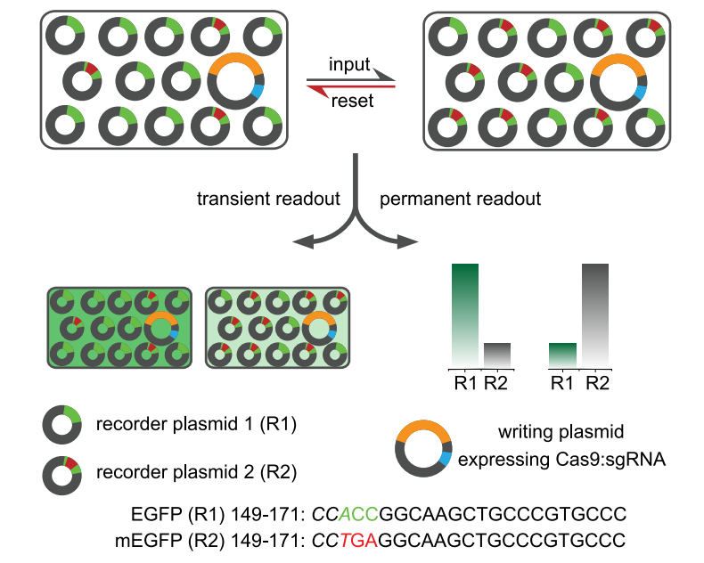

Figure 10.

Both R1 and R2 confer resistance to different antibiotics. Which means the memory system can be rewritten by adding specific antibiotics which adjust the ratio of R1:R2 to the default.

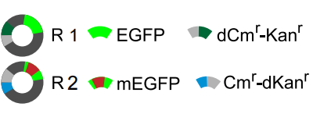

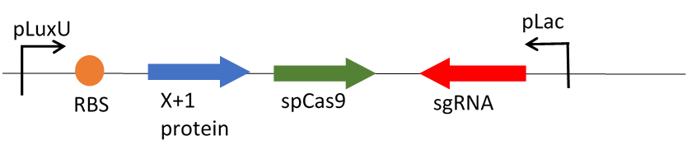



### Bibliography

Ahmad, M., Hirz, M., Pichler, H., & Schwab, H. (2014). Protein expression in Pichia pastoris: Recent achievements and perspectives for heterologous protein production. *Applied Microbiology and Biotechnology*, *98*(12), 5301–5317. https://doi.org/10.1007/s00253-014-5732-5

Aurand, T. C., & March, J. C. (2016). Development of a synthetic receptor protein for sensing inflammatory mediators interferon-γ and tumor necrosis factor-α. *Biotechnology and Bioengineering*, *113*(3), 492–500. https://doi.org/10.1002/bit.25832

Ball, A. S., Chaparian, R. R., & van Kessel, J. C. (2017). Quorum Sensing Gene Regulation by LuxR/HapR Master Regulators in Vibrios. *Journal of Bacteriology*, *199*(19). https://doi.org/10.1128/JB.00105-17

Chen, X., Schauder, S., Potier, N., Van Dorsselaer, A., Pelczer, I., Bassler, B. L., & Hughson, F. M. (2002). Structural identification of a bacterial quorum-sensing signal containing boron. *Nature*, *415*(6871), 545–549. https://doi.org/10.1038/415545a

Du, W., Xia, J., Zhang, Y., Liu, M. J., Li, H. B., Yan, X. M., Zhang, J. S., Li, N., Zhou, Z. Y., & Xie, W. Z. (2015). Expression of recombinant myostatin propeptide pPIC9K-Msp plasmid in Pichia pastoris. *Genetics and Molecular Research*, *14*(4), 18414–18420. https://doi.org/10.4238/2015.December.23.29

Khajanchi, B. K., Sha, J., Kozlova, E. V., Erova, T. E., Suarez, G., Sierra, J. C., Popov, V. L., Horneman, A. J., & Chopra, A. K. (2009). N-acylhomoserine lactones involved in quorum sensing control the type VI secretion system, biofilm formation, protease production, and in vivo virulence in a clinical isolate of Aeromonas hydrophila. *Microbiology (Reading, England)*, *155*(Pt 11), 3518–3531. https://doi.org/10.1099/mic.0.031575-0

Krawczyk, K., Xue, S., Buchmann, P., Charpin-El-Hamri, G., Saxena, P., Hussherr, M.-D., Shao, J., Ye, H., Xie, M., & Fussenegger, M. (2020). Electrogenetic cellular insulin release for real-time glycemic control in type 1 diabetic mice. *Science*, *368*(6494), 993–1001. https://doi.org/10.1126/science.aau7187

Miller, M. B., Skorupski, K., Lenz, D. H., Taylor, R. K., & Bassler, B. L. (2002). Parallel Quorum Sensing Systems Converge to Regulate Virulence in Vibrio cholerae. *Cell*, *110*(3), 303–314. https://doi.org/10.1016/S0092-8674(02)00829-2

Ng, W.-L., & Bassler, B. L. (2009). Bacterial Quorum-Sensing Network Architectures. *Annual Review of Genetics*, *43*(1), 197–222. https://doi.org/10.1146/annurev-genet-102108-134304

Schauder, S., Shokat, K., Surette, M. G., & Bassler, B. L. (2001). The LuxS family of bacterial autoinducers: Biosynthesis of a novel quorum-sensing signal molecule. *Molecular Microbiology*, *41*(2), 463–476. https://doi.org/10.1046/j.1365-2958.2001.02532.x

Scorer, C. A., Clare, J. J., McCombie, W. R., Romanos, M. A., & Sreekrishna, K. (1994). Rapid Selection Using G418 of High Copy Number Transformants of Pichia pastoris for High–level Foreign Gene Expression. *Bio/Technology*, *12*(2), 181–184. https://doi.org/10.1038/nbt0294-181

Tang, W., & Liu, D. R. (2018). Rewritable multi-event analog recording in bacterial and mammalian cells. *Science (New York, N.Y.)*, *360*(6385). https://doi.org/10.1126/science.aap8992

Ulm, R., & Jenkins, G. I. (2015). Q&A: How do plants sense and respond to UV-B radiation? *BMC Biology*, *13*(1), 45. https://doi.org/10.1186/s12915-015-0156-y

侯增淼, 李晓颖, 李敏, 杨金芳, 杨小琳, 赵金礼, Hou, Z., Li, X., Li, M., Yang, J., Yang, X., & Zhao, J. (2019). 重组人源性胶原蛋白的制备及表征. 生物工程学报, *35*(2), 319–326.