Computer Organization
指導教授：蔡宗漢
Final Project

電機3B Runa
電機3B Davi
電機3B Milo

- Single cycle implementation
  - 架構
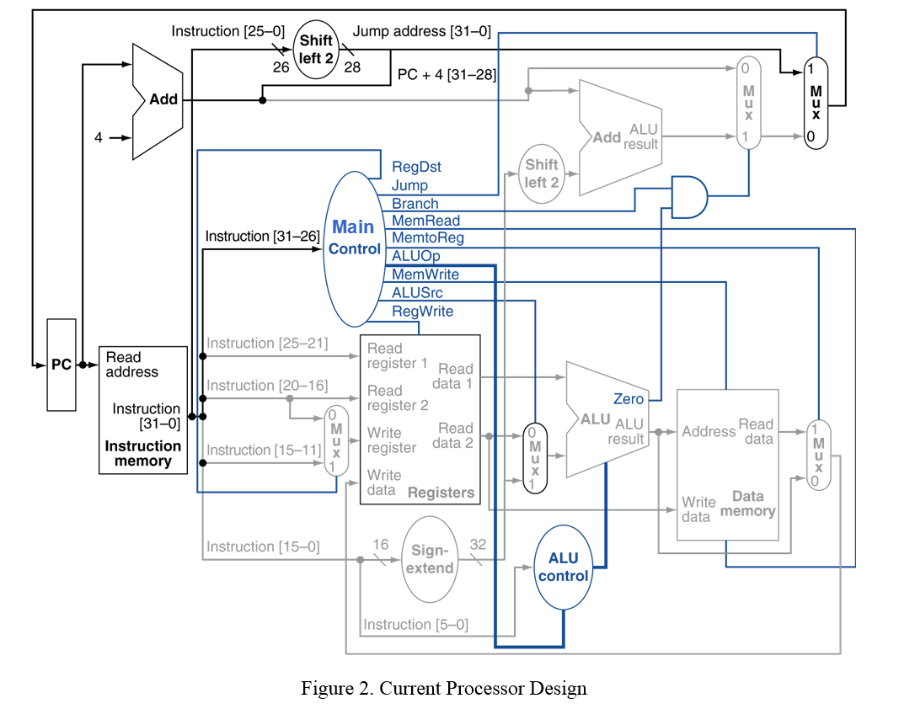
  - Block Diagram

  - 架構說明

