#A. Spiral Graph(II)

Description
- In this problem, the program will generate a spiral graph with numbers as shown in the following figure.
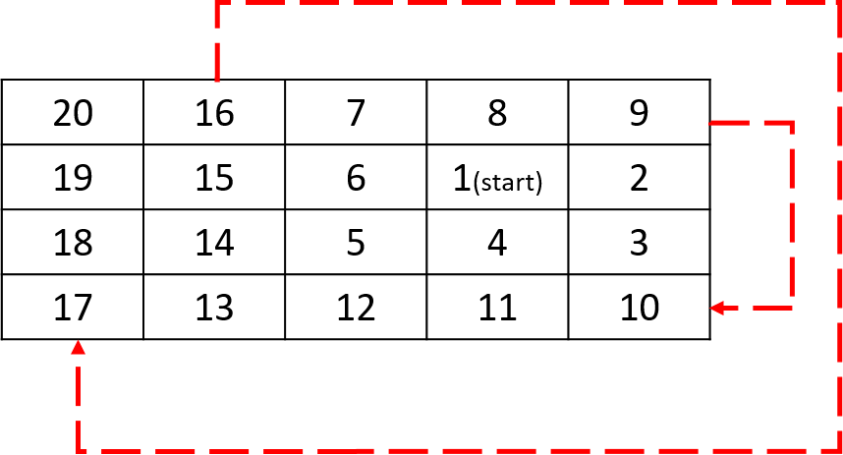
- First, the program will take two numbers to determine the width and length of the graph, and then take two numbers (x, y) to determine the start point in the graph. After that, your program should generate a spiral graph with an increasing number sequence from the start point. The number should travel by clockwise. When the program completes a full circular spin, next circular spin should larger than previous one. Whenever the program wants to turn direction, the program should always not visit the point have been visited. Notice that you have to consider the boundary of the graph in your program.
- The representation of each number needs to follow the last number. Ex. If the last number is the hundreds digit, each number must be presented in 3 digits, and the insufficient digits must be filled with 0.

Input
The range of the input:
3 <= width <= 31
3 <= length <= 31
0 <= x <= 30
0 <= y <= 30
Copy

Output
The program will output the corresponding spiral graph.

Samples

Sample Input 1
Width,Length
4 5
x,y
1 3
Copy

Sample Output 1
20 16 07 08 09
19 15 06 01 02
18 14 05 04 03
17 13 12 11 10
Copy

Sample Input 2
Width,Length
10 22
x,y
0 21
Copy

Sample Output 2
220 210 200 190 180 170 160 150 140 130 120 110 100 081 064 049 036 025 016 009 004 001
219 209 199 189 179 169 159 149 139 129 119 109 099 080 063 048 035 024 015 008 003 002
218 208 198 188 178 168 158 148 138 128 118 108 098 079 062 047 034 023 014 007 006 005
217 207 197 187 177 167 157 147 137 127 117 107 097 078 061 046 033 022 013 012 011 010
216 206 196 186 176 166 156 146 136 126 116 106 096 077 060 045 032 021 020 019 018 017
215 205 195 185 175 165 155 145 135 125 115 105 095 076 059 044 031 030 029 028 027 026
214 204 194 184 174 164 154 144 134 124 114 104 094 075 058 043 042 041 040 039 038 037
213 203 193 183 173 163 153 143 133 123 113 103 093 074 057 056 055 054 053 052 051 050
212 202 192 182 172 162 152 142 132 122 112 102 092 073 072 071 070 069 068 067 066 065
211 201 191 181 171 161 151 141 131 121 111 101 091 090 089 088 087 086 085 084 083 082

#B. Build a Tree

Description
- In this problem, you are asked to build a data structure, tree, with a given integer number series and print the tree in a specific order. The tree structure consists of nodes and edges, where nodes is represented by a circle and the edge is represented by a wire segment between circles. An example of a tree is as follows:
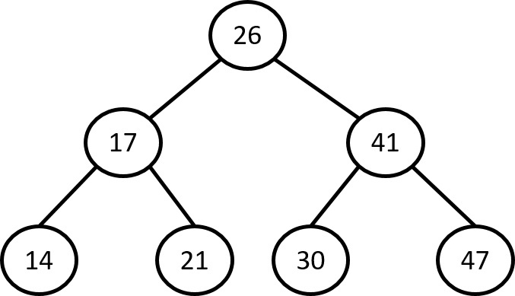
- To realize a tree in program, we will use struct to store information of each node as follows:
struct node
{
int num;
node *left = NULL;
node *right = NULL;
};
Copy
- To simplify the problem, we assume only 7 nodes are shown in the tree. Therefore, we can use a 7-element array to store the information of the tree where each element is an instance of the struct. In the beginning, you have to store the integer number from input into the array element one by one. The first number of the series will be the root node. Then, you have to build the tree with left and right pointer in the struct. The rules are as follows: the value of left node should be less than the value of current node, and the value of right node should be larger than the value of current node. For example, if the root's number is 7 and the node's number is 3, then you have to connect the node 3 with the left pointer of node 7 since 3 is smaller than 7. In contrast, if the root's number is 7 and the node's number is 10, then you have to connect the node 10 with the right pointer of node 7 since 10 is larger than 7. A full example is shown below:
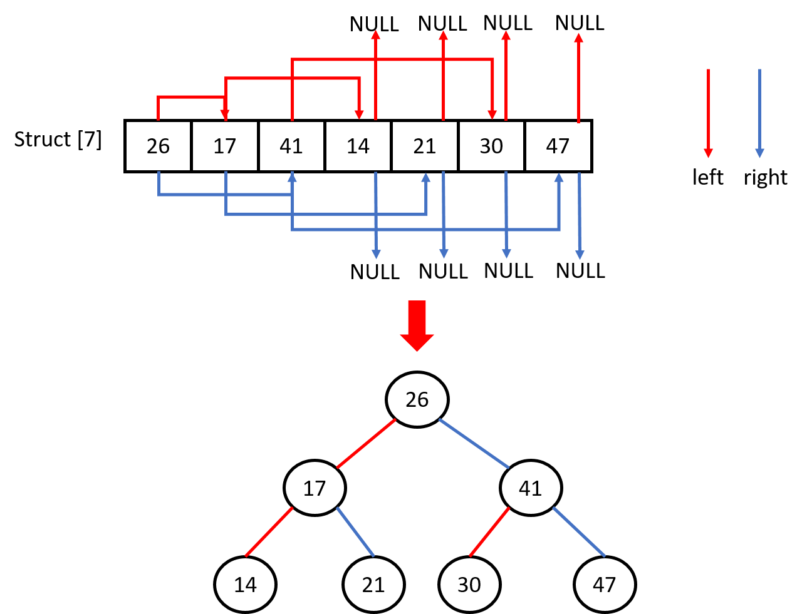
- After step 3, you can obtain a tree. Then you are asked to output the tree with the following order (the order is marked red)
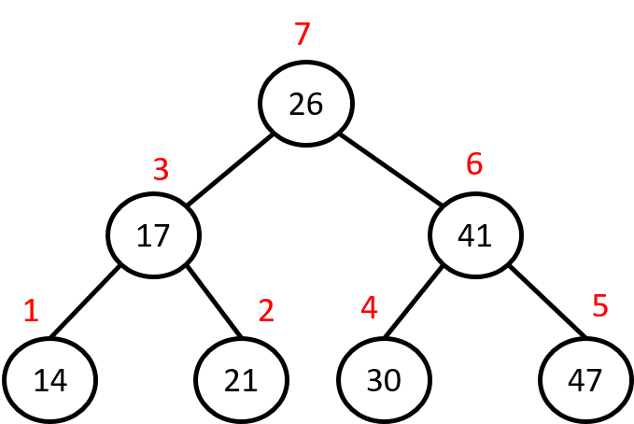

Input Constraints
series length = 7
-2^31 <= number in the series <= 2^31-1
Copy

Samples

Sample Input 1
26 17 41 14 21 30 47
Copy

Sample Output 1
14 21 17 30 47 41 26
Copy

Sample Input 2
1 2 3 4 5 6 7
Copy

Sample Output 2
7 6 5 4 3 2 1

#C. Buy and Sell Stock

Background
- In the modern day, stocks are regarded as good long-term investments. you may earn a lot of profit by buying and selling stocks appropriately. In this problem, you are asked to calculate the maximum profit of buying and selling a stock.


Description
- The program will firstly read a file which logs the price of the stock every day. Then you have to figure out the maximum profit by a serious of buying and selling procedure. The first line of the file is the name of the stock, and the second line tells you the prices of the stock at continuous days. An example of a file is shown below.
stock1
prices: 7 1 5 3 6 4(file只會有前兩行)
(where the price of the first day is 7, the price of the second day is 1, and so on.)
Copy
- A special rule is applied: On each day, you may decide to buy and/or sell the stock. You can only hold at most one share of the stock at any time. However, you can buy it then immediately sell it on the same day.
- The user will input the corresponding file name to get the stock price information. After that, the program will find and output the maximum profit the user can achieve. If the program can't find any profit, output 0.
- The range of the inputs are shown as follows: The number of elements in the prices series is [1, 312]. The range of each price is [0, 104].

Samples
File: stock1.txt
Maximum profit: 7

#D. Is Anagram?

Description
- An anagram is a word formed by rearranging the letters of a different word, typically using all the original letters exactly once. For example, the word triangle can be rearranged into integral.

Input
- Given two strings string1 and string2, you have to write a program to determine if string1 is an anagram of string2. Letters only contains a~z.

Output
- The program will output the compared result of two strings.

Samples

Sample Input 1
anagram naagrma
Copy

Sample Output 1
Yes! It's anagram.
Copy

Sample Input 2
rat cat
Copy

Sample Output 2
No! It is not anagram.

#E. Encryption System

Background
- Nowadays, more and more services have become online and more and more data, including personal information like ID number, credit card number and home address, are stored in the cloud edge instead of local edge. Even though it makes our daily life more convenient, it also causes the concern that the secrete data become unsafe and easy to get. Therefore, data security has gained more attention these days. By encrypting information, we can prevent your secrete data from being stolen by the unknown attacker.
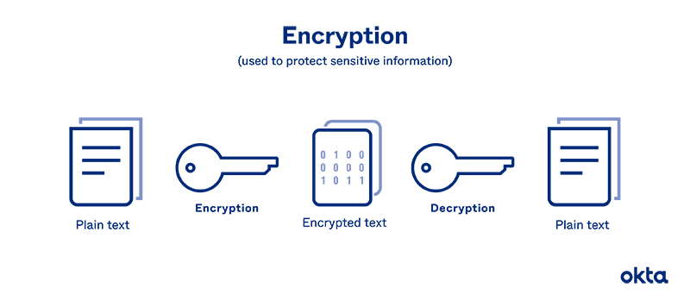

Description
- In this problem, you are asked to implement a simple encryption system. You have to follow the class which is defined below.
class encrypt
{
public:
encrypt(string);
void encryption();
void decryption();
void print_information();
private:
string information;
int key = 3;
};
Copy
- This class totally has two private elements, one constructor and three public class function. In every encryption, your system should follow the rules below.
  - You must encrypt each characters of information one by one.
  - If the character's order modulo 2 is 0, you need to encrypt the character by adding key^2.
  - If the character's order modulo 2 is 1, you need to encrypt the character by subtracting key.
- In the beginning, the system will ask user to select encryption or decryption. 1 is for encryption and 2 is for decryption. After that, the system will ask user to input the information which the user wants to encrypt/decrypt. Finally, the system will output the encrypted/decrypted information by using member function print_information().

Sample1
Welcome to encryption system!
Enter 1 to encrypt
Enter 2 to decrypt
1

Input information: Andy is a good teacher
Encrypted information: Jkmv f| j plxa qn^leno

Copy

Sample2
Welcome to encryption system!
Enter 1 to encrypt
Enter 2 to decrypt
2

Input information: Jkmv f| j plxa qn^leno
Decrypted information: Andy is a good teacher

#F. Average Score(II)

Description
- You are asked to write a program to calculate the average of N scores and find the failed one. This program will ask the user to enter N integers for the scores. The range of score is [0, 100]. After that, the program will print the average score with three decimal places. If there are score(s) less than 70 points, please display the word “fail:”, following by the order and the failed score(s) in the sequence.

Input Constraints
1 <= N <= 50
0 <= score <= 100
Copy

Output
- Your program will print the average score with N decimal places. If the average score is not an integer, round to second decimal place.

Samples

Sample Input 1
Please enter the scores of all students:
30
40
50
Copy

Sample Output 1
avg = 40
fail:
1: 30
2: 40
3: 50
Copy

Sample Input 2
Please enter the scores of all students:
20
40
60
70
Copy

Sample Output 2
avg = 47.5
fail:
1: 20
2: 40
3: 60

#G. NCU Theater Reservation System(VII)

Background
- Since we have already asked users to enter their phone number whenever they signed up an account, the manager wants this system to show all member's information including phone number. In this problem, you are asked to modify your show_member function that can print all member's phone number.
- The other features of the system are all as same as the system which had been explained in the lab courses.
- The output requirement is as follows:
  - Two space between “No.” and “Username”
  - Four space between “Username” and “Phone”
  - All names should align with U and all numbers should align with P

Description
- The dataflow of member system is as follows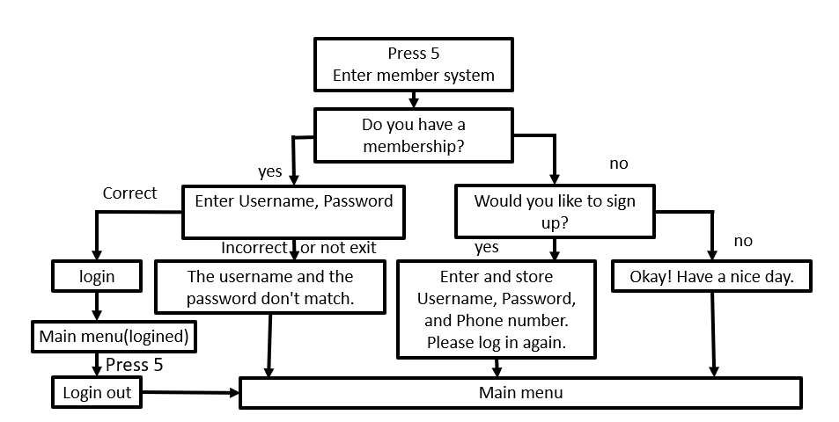
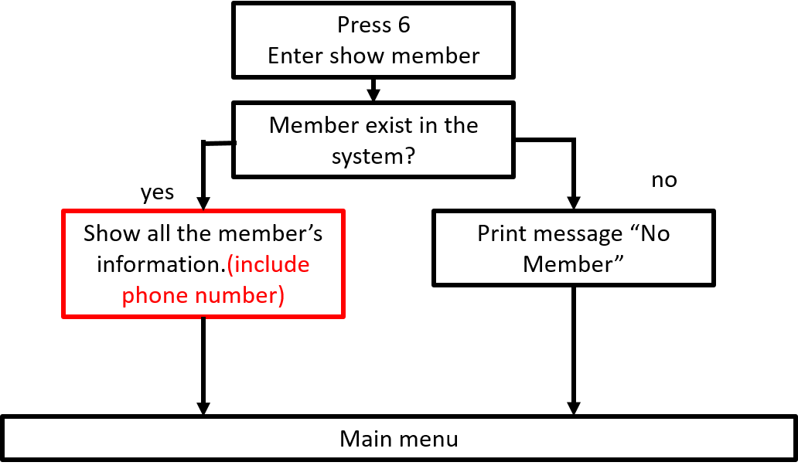

Samples
*** Welcome to NCU theater reservation system ***
Please type 1 to make a new reservation
Please type 2 to cancel an existing reservation
Please type 3 to show the all available seats
Please type 4 to show the status of all current seats
Please type 5 to member center
Please type 6 to show member
Please type 7 to load member information
Please type 8 to change member data
Please type 9 to find member data
Please type 10 to exit the system
Enter your selection Here: 7

***Load member information***
Please enter the member file name: member1.txt
The file member1.txt has been loaded...

*** Welcome to NCU theater reservation system ***
Please type 1 to make a new reservation
Please type 2 to cancel an existing reservation
Please type 3 to show the all available seats
Please type 4 to show the status of all current seats
Please type 5 to member center
Please type 6 to show member
Please type 7 to load member information
Please type 8 to change member data
Please type 9 to find member data
Please type 10 to exit the system
Enter your selection Here: 6

***NCU Theater Membership***
No. Username Phone
1. Andy 0975817468
2. Kevin 0912345678
3. Jinx 0812345678
4. Akali 0812345678
5. Jax 9032165498
6. Andy666 1234567890
7. hiAndyisme 6666666666
8. iamAndy 0987654321

*** Welcome to NCU theater reservation system ***
Please type 1 to make a new reservation
Please type 2 to cancel an existing reservation
Please type 3 to show the all available seats
Please type 4 to show the status of all current seats
Please type 5 to member center
Please type 6 to show member
Please type 7 to load member information
Please type 8 to change member data
Please type 9 to find member data
Please type 10 to exit the system
Enter your selection Here: 10

Thank you for using our system
Have a nice day~~

