-- current 2019-11-11

select * from ods.o_thread_lend_portfolio_plans_a where lendRequest_id=6529370

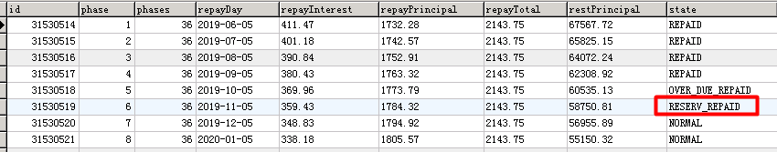

-- current 2019-11-11

select * from ods.o_thread_lend_portfolio_plans_a where lendRequest_id=6529370

