Running/Modifying the Mythic+ APL

[Optional] Insert M+ Player Profile (Here)
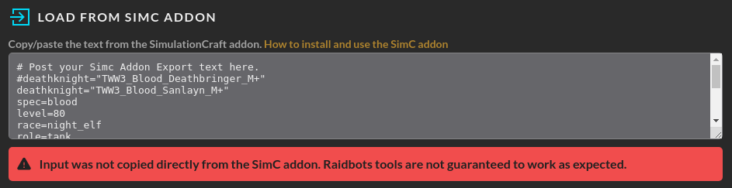

(Option 1) San’layn M+ Profile
# Post your Simc Addon Export text here.
deathknight="MID2_Blood_Sanlayn_M+"
spec=blood
level=90
race=night_elf
role=tank
position=front
talents=CoPAAAAAAAAAAAAAAAAAAAAAAwMzyMzMmZmxgZZmZmmZxMjZmBAAAAwgZmZmZMzMjBAzMzMzAAAYgBmxiGLbgsMgNAzYAAAmZghB
omnium_talents=rune_of_unleashed_fire/rune_of_selfmending/rune_of_lingering/rune_of_the_versatile_warrior/rune_of_overload

head=baleful_graveknights_casque,id=271474,ilevel=334,gem_id=240983,redirected_base_stats=239050
neck=aqirbane_reliquary,id=268265,ilevel=341,gem_id=240916/240916
shoulders=baleful_graveknights_gibbets,id=271472,ilevel=334
back=adherents_silken_shroud,id=239656,ilevel=331,embellishment=arcanoweave_lining,crafted_stats=40/36
chest=baleful_graveknights_breastplate,id=271477,ilevel=334,redirected_base_stats=251193,enchant=mark_of_the_worldsoul_2
wrists=spellbreakers_bracers,id=237834,ilevel=331,gem_id=240916,embellishment=arcanoweave_lining,crafted_stats=40/36
hands=baleful_graveknights_deathgrips,id=271475,ilevel=334,redirected_base_stats=251221
waist=sandscoured_greatbelt,id=159442,ilevel=334,gem_id=240916
legs=baleful_graveknights_greaves,id=271473,ilevel=334,redirected_base_stats=271878,enchant=forest_hunters_armor_kit_2
feet=poisonproof_stompers,id=273777,ilevel=334
finger1=jade_ophidian_band,id=162544,ilevel=334,gem_id=240916,enchant=silvermoons_tenacity_2
finger2=lightwardens_bind,id=251194,ilevel=334,gem_id=240916,enchant=silvermoons_tenacity_2
trinket1=keepers_seething_core,id=270165,ilevel=341
trinket2=twisted_horrors_tendril,id=281215,ilevel=341
main_hand=luselama_lights_justice,id=280799,ilevel=341,enchant=rune_of_sanguination

(Option 2) Deathbringer M+ Profile
# Post your Simc Addon Export text here.
deathknight="MID2_Blood_Deathbringer_M+"
spec=blood
level=90
race=night_elf
role=tank
position=front
talents=CoPAAAAAAAAAAAAAAAAAAAAAAwMzyMzMmxMzMMLjZmmZxMjZmBAAAAwgZmZmZMzMjBAzMzMzAAAMmtBGwSwywEYYBwMGAAMzAMYA
omnium_talents=rune_of_unleashed_fire/rune_of_selfmending/rune_of_lingering/rune_of_the_versatile_warrior/rune_of_overload

head=baleful_graveknights_casque,id=271474,ilevel=334,gem_id=240983,redirected_base_stats=239050
neck=aqirbane_reliquary,id=268265,ilevel=341,gem_id=240916/240916
shoulders=baleful_graveknights_gibbets,id=271472,ilevel=334
back=adherents_silken_shroud,id=239656,ilevel=331,embellishment=arcanoweave_lining,crafted_stats=40/36
chest=baleful_graveknights_breastplate,id=271477,ilevel=344,redirected_base_stats=251193,enchant=mark_of_the_worldsoul_2
wrists=spellbreakers_bracers,id=237834,ilevel=331,gem_id=240918,embellishment=arcanoweave_lining,crafted_stats=40/49
hands=baleful_graveknights_deathgrips,id=271475,ilevel=334,redirected_base_stats=251221
waist=sandscoured_greatbelt,id=159442,ilevel=334,gem_id=240918
legs=baleful_graveknights_greaves,id=271473,ilevel=344,redirected_base_stats=271878,enchant=forest_hunters_armor_kit_2
feet=scaleguards_stalwart_greatboots,id=193728,ilevel=334
finger1=jade_ophidian_band,id=162544,ilevel=334,gem_id=240916,enchant=silvermoons_tenacity_2
finger2=lightwardens_bind,id=251194,ilevel=334,gem_id=240918,enchant=silvermoons_tenacity_2
trinket1=keepers_seething_core,id=270165,ilevel=341
trinket2=twisted_horrors_tendril,id=281215,ilevel=341
main_hand=luselama_lights_justice,id=280799,ilevel=341,enchant=rune_of_sanguination

Change Simulation Options
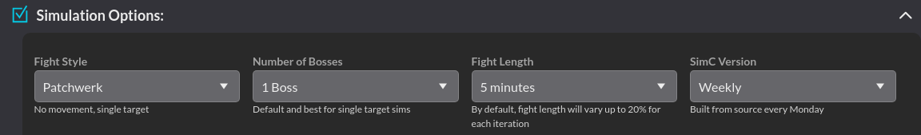

For the purposes of the M+ profile and APL, we are only adjusting Fight Length to 8 Minutes in this section. Even if we want to look at a different target count (which, for Mythic+, we often do), that will be done in another section. 8 Minutes is selected mainly to achieve a desirable Bloodlust uptime while also capturing Mythic+ as a long-duration continuous encounter to some degree (this is thought to be a more accurate representation than extremely short Fight Lengths that can severely overemphasize cooldown-based abilities).

Insert APL (Insert Here)
Mainly to achieve a desirable Bloodlust uptime while also capturing

Current M+ APL
# Default consumables
potion=lights_potential_2
flask=flask_of_thalassian_resistance_2
food=silvermoon_parade
augmentation=void_touched
temporary_enchant=main_hand:thalassian_phoenix_oil_2

# Executed before combat begins. Accepts non-harmful actions only.
actions.precombat=snapshot_stats
actions.precombat+=/deaths_caress

# Executed every time the actor is available.
actions=auto_attack
actions+=/use_items
actions+=/blood_fury
actions+=/berserking
actions+=/arcane_pulse,if=active_enemies>=2|rune<1&runic_power.deficit>60
actions+=/lights_judgment,if=(buff.unholy_strength.up|!death_knight.runeforge.fallen_crusader)
actions+=/ancestral_call
actions+=/fireblood
actions+=/bag_of_tricks
actions+=/potion,if=buff.dancing_rune_weapon.up
actions+=/vampiric_blood,if=!buff.vampiric_blood.up
actions+=/raise_dead

actions+=/death_strike,if=(target.time_to_die%%0.1)*10<=0.10
actions+=/dancing_rune_weapon
actions+=/marrowrend,if=!buff.bone_shield.up|buff.bone_shield.remains<3|buff.bone_shield.stack<=1
actions+=/marrowrend,if=(buff.exterminate.up)&(cooldown.dancing_rune_weapon.remains<3|buff.exterminate.remains<3)
actions+=/deaths_caress,if=(!buff.bone_shield.up|buff.bone_shield.remains<3|buff.bone_shield.stack<=1)
actions+=/blood_boil,if=dot.blood_plague.remains<3
actions+=/heart_strike,if=(buff.essence_of_the_blood_queen.remains<4&buff.essence_of_the_blood_queen.remains&(buff.gift_of_the_sanlayn.remains|buff.vampiric_strike.remains))
actions+=/death_strike,if=runic_power.deficit<20
actions+=/reapers_mark
actions+=/marrowrend,if=buff.bone_shield.stack<6
actions+=/marrowrend,if=(buff.exterminate.up)&((debuff.reapers_mark_debuff.up&(debuff.reapers_mark_debuff.remains<5|debuff.reapers_mark_debuff.stack>=20|buff.exterminate.stack>1))|fight_remains<10)
actions+=/deaths_caress,if=buff.bone_shield.stack<6
actions+=/any_dnd,if=talent.reapers_mark.enabled&!buff.death_and_decay.remains
actions+=/any_dnd,if=talent.vampiric_strike.enabled&((buff.crimson_scourge.remains)|(active_enemies>2&!buff.death_and_decay.remains))
actions+=/blood_boil,if=buff.boiling_point.up&!buff.boiling_point_echo.up
actions+=/heart_strike,if=talent.vampiric_strike.enabled|cooldown.reapers_mark.remains>2|rune>2|buff.dance_of_midnight_1.up
actions+=/consumption,empower_to=1
actions+=/blood_boil
actions+=/arcane_torrent,if=runic_power.deficit>20
actions+=/deaths_caress,if=buff.bone_shield.stack<11

Select SimC Expert Mode


This is going to be necessary for the next step.

Override Number of Enemies and Attack Behavior
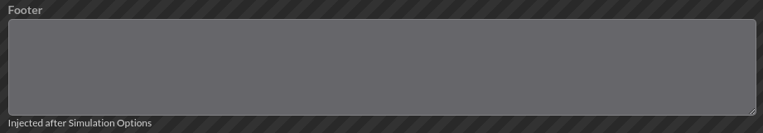

By Default, the enemy attack pattern is going to be based off of a raid boss. For an M+ evaluation we would rather the targets have a more consistent attack pattern. The damage enemies do is largely irrelevant outside of unique damage reflection effects (it does effect Blood Shield uptimes, to be fair, but that is not enough to put too much diligence into the damage they are dealing). What we largely care about as a result of these attacks is Bone Shield consumption rate. For multiple targets, the settings below will pseudo-desync their auto attacks. If you do not do this, at all, enemy attacks will always be perfectly synced and it will (A) cause Bone Shield consumption to be underestimated and (B) it will underestimate the extent to which increased parry reduces Bone Shield consumption since you would need to parry all of the sync’d auto attacks in one go to have any effect on the rate without any staggering.

(Option 1) Single Target
enemy=Razor_Sharp_Pillow
actions=auto_attack,damage=250000,range=100,attack_speed=2.0

(Option 2) Five Target
enemy=Razor_Sharp_Pillow
actions=auto_attack,damage=250000,range=100,attack_speed=1.333
enemy=Razor_Sharp_Pillow
actions=auto_attack,damage=250000,range=100,attack_speed=1.5
enemy=Razor_Sharp_Pillow
actions=auto_attack,damage=250000,range=100,attack_speed=2.0
enemy=Razor_Sharp_Pillow
actions=auto_attack,damage=250000,range=100,attack_speed=3.0
enemy=Razor_Sharp_Pillow
actions=auto_attack,damage=250000,range=100,attack_speed=4.0

