Running/Modifying the Raid APL

[Optional] Insert Raid Player Profile (Insert Here)
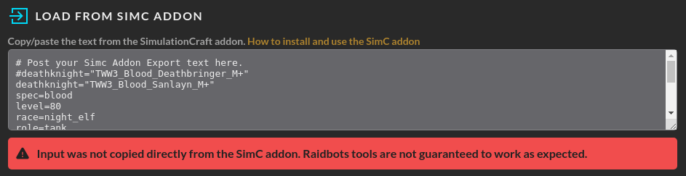

(Option 1) San’layn Raid Profile
# Post your Simc Addon Export text here.
deathknight="MID2_Death_Knight_Blood_San’layn"
spec=blood
level=90
race=troll
role=tank
position=front
talents=CoPAAAAAAAAAAAAAAAAAAAAAAwYWmZmxMmZmhZZmZmmZxMjxMAAAAAmZmZGmZGzMjZAgZmZGAAADMwMW0YZDklBsBYGzAAAmZwgB
omnium_talents=rune_of_unleashed_fire/rune_of_selfmending/rune_of_lingering/rune_of_masterful_cunning//rune_of_overload

head=baleful_graveknights_casque,id=271474,ilevel=334,gem_id=240983,redirected_base_stats=268229
neck=aqirbane_reliquary,id=268265,ilevel=344,gem_id=240914/240894
shoulders=baleful_graveknights_gibbets,id=271472,ilevel=334
back=silken_voodoo_drape,id=268253,ilevel=344
chest=baleful_graveknights_breastplate,id=271477,ilevel=344,redirected_base_stats=268222,enchant=mark_of_the_worldsoul_2
wrists=spellbreakers_bracers,id=237834,ilevel=331,gem_id=240916,embellishment=stabilizing_gemstone_bandolier,crafted_stats=40/36
hands=baleful_graveknights_deathgrips,id=271475,ilevel=334,redirected_base_stats=251214
waist=girdle_of_toxic_regret,id=268259,ilevel=344,gem_id=240918
legs=baleful_graveknights_greaves,id=271473,ilevel=344,redirected_base_stats=271878,enchant=forest_hunters_armor_kit_2
feet=entombed_cultists_sabatons,id=268245,ilevel=334
finger1=band_of_the_amani_warlord,id=273792,ilevel=334,gem_id=240910,enchant=eyes_of_the_eagle_2
finger2=masterwork_sindorei_band,id=240949,ilevel=331,gem_id=240894,enchant=eyes_of_the_eagle_2,embellishment=prismatic_focusing_iris,crafted_stats=40/36
trinket1=voracious_heart_of_ulatek,id=270175,ilevel=344
trinket2=zuljins_guillotine_technique,id=270173,ilevel=344
main_hand=mazeroa_warlords_fury,id=268213,ilevel=344,enchant=rune_of_sanguination

(Option 2) Deathbringer Raid Profile
# Post your Simc Addon Export text here.
deathknight=MID2_Death_Knight_Blood_Deathbringer
level=90
race=troll
role=tank
position=front
spec=blood
talents=CoPAAAAAAAAAAAAAAAAAAAAAAwYWGzMmZmZmhZbmZmmZxMjhxAAAAAmZmZGmZGzMjZAgZmZGAAgxsNwAWCWGmADLAmhZAAMzAMYA
omnium_talents=rune_of_unleashed_fire/rune_of_selfmending/rune_of_lingering/rune_of_the_versatile_warrior/rune_of_overload

head=baleful_graveknights_casque,id=271474,ilevel=334,gem_id=240983,redirected_base_stats=251126
neck=aqirbane_reliquary,id=268265,ilevel=344,gem_id=240894/240894
shoulders=baleful_graveknights_gibbets,id=271472,ilevel=334
back=silken_voodoo_drape,id=268253,ilevel=344
chest=baleful_graveknights_breastplate,id=271477,ilevel=344,redirected_base_stats=268222,enchant=mark_of_the_worldsoul_2
wrists=spellbreakers_bracers,id=237834,ilevel=331,gem_id=240894,embellishment=stabilizing_gemstone_bandolier,crafted_stats=40/49
hands=baleful_graveknights_deathgrips,id=271475,ilevel=334,redirected_base_stats=251214
waist=girdle_of_toxic_regret,id=268259,ilevel=344,gem_id=240918
legs=baleful_graveknights_greaves,id=271473,ilevel=344,redirected_base_stats=271878,enchant=forest_hunters_armor_kit_2
feet=entombed_cultists_sabatons,id=268245,ilevel=334
finger1=band_of_the_amani_warlord,id=273792,ilevel=334,gem_id=240894,enchant=eyes_of_the_eagle_2
finger2=masterwork_sindorei_band,id=240949,ilevel=331,gem_id=240894,enchant=eyes_of_the_eagle_2,embellishment=prismatic_focusing_iris,crafted_stats=40/49
trinket1=voracious_heart_of_ulatek,id=270175,ilevel=344
trinket2=zuljins_guillotine_technique,id=270173,ilevel=344
main_hand=mazeroa_warlords_fury,id=268213,ilevel=344,enchant=rune_of_sanguination

[Optional] Change Simulation Options
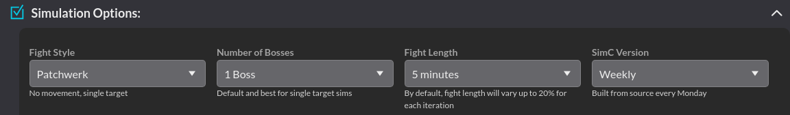

For the purposes of the raid profile and APL, this is where you would adjust the number of units if you wanted. You are certainly free to change fight length for individual checks, but if you are proposing any changes to the profile or APL they are currently going to be based on a 5 minute fight duration until you can convince the entire SimC community to use a different fight duration as a standard (good luck).

Insert APL (Insert Here)


Current Raid/Baseline APL
# Default consumables
potion=potion_of_recklessness_2
flask=flask_of_thalassian_resistance_2
food=silvermoon_parade
augmentation=void_touched
temporary_enchant=main_hand:thalassian_phoenix_oil_2

# Executed before combat begins. Accepts non-harmful actions only.
actions.precombat=snapshot_stats
actions.precombat+=/deaths_caress

# Executed every time the actor is available.
actions=auto_attack
actions+=/use_items
actions+=/use_item,name=voracious_heart_of_ulatek,use_off_gcd=1,if=cooldown.dancing_rune_weapon.remains>78|fight_remains<20
actions+=/use_item,name=blazebinders_hoof,use_off_gcd=1,if=cooldown.dancing_rune_weapon.remains>78|fight_remains<20|fight_remains>120
actions+=/use_item,name=vile_vial_of_volatile_venom,use_off_gcd=1,if=cooldown.dancing_rune_weapon.remains>78|fight_remains<20|fight_remains>120

actions+=/fireblood,if=fight_remains>120|cooldown.dancing_rune_weapon.remains>78|fight_remains<8
actions+=/blood_fury,if=fight_remains>120|cooldown.dancing_rune_weapon.remains>78|fight_remains<12
actions+=/berserking,if=cooldown.dancing_rune_weapon.remains>78|fight_remains<=15
actions+=/ancestral_call,if=fight_remains>120|cooldown.dancing_rune_weapon.remains>78|fight_remains<15
actions+=/potion,if=cooldown.dancing_rune_weapon.remains>78|fight_remains<=30
actions+=/vampiric_blood,if=!buff.vampiric_blood.up
actions+=/call_action_list,name=high_prio_actions
actions+=/run_action_list,name=deathbringer,if=hero_tree.deathbringer
actions+=/run_action_list,name=san_gift,if=hero_tree.sanlayn&buff.gift_of_the_sanlayn.up
actions+=/run_action_list,name=sanlayn,if=hero_tree.sanlayn

actions.high_prio_actions=raise_dead,use_off_gcd=1

actions.deathbringer=dancing_rune_weapon,if=(cooldown.reapers_mark.remains>0|rune<2)&buff.exterminate.stack<2&(fight_remains>gcd*2)
actions.deathbringer+=/death_strike,if=(runic_power.deficit<20|(runic_power.deficit<26&buff.dancing_rune_weapon.up))
actions.deathbringer+=/death_and_decay,if=!buff.death_and_decay.up
actions.deathbringer+=/reapers_mark
actions.deathbringer+=/marrowrend,if=buff.exterminate.up
actions.deathbringer+=/deaths_caress,if=(!buff.bone_shield.up|buff.bone_shield.remains<3|buff.bone_shield.stack<6)&rune<4
actions.deathbringer+=/marrowrend,if=!buff.bone_shield.up|buff.bone_shield.remains<3|buff.bone_shield.stack<6
actions.deathbringer+=/death_strike,if=buff.dancing_rune_weapon.up|fight_remains<10
actions.deathbringer+=/blood_boil,if=buff.boiling_point.up
actions.deathbringer+=/consumption,empower_to=1,if=!buff.dancing_rune_weapon.up
actions.deathbringer+=/heart_strike,if=(rune>=2|buff.dance_of_midnight_1.up)
actions.deathbringer+=/blood_boil
actions.deathbringer+=/death_strike
actions.deathbringer+=/heart_strike
actions.deathbringer+=/consumption,empower_to=1
actions.deathbringer+=/arcane_torrent,if=runic_power.deficit>20

actions.san_gift=heart_strike,if=buff.essence_of_the_blood_queen.remains<1.5&buff.essence_of_the_blood_queen.remains
actions.san_gift+=/death_strike,if=runic_power.deficit<36
actions.san_gift+=/any_dnd,if=buff.crimson_scourge.remains&!buff.visceral_strength.remains
actions.san_gift+=/heart_strike,if=buff.essence_of_the_blood_queen.stack<7
actions.san_gift+=/death_strike
actions.san_gift+=/blood_boil,if=buff.boiling_point.up
actions.san_gift+=/heart_strike
actions.san_gift+=/blood_boil

actions.sanlayn=dancing_rune_weapon,if=!buff.exterminate.up&!debuff.reapers_mark_debuff.up&(fight_remains>95|fight_remains<25|time>300)
actions.sanlayn+=/deaths_caress,if=!buff.bone_shield.up|buff.bone_shield.remains<1.5|buff.bone_shield.stack<=1
actions.sanlayn+=/heart_strike,if=(buff.essence_of_the_blood_queen.remains<1.5&buff.essence_of_the_blood_queen.remains&buff.vampiric_strike.remains&fight_remains>buff.essence_of_the_blood_queen.remains+10)
actions.sanlayn+=/death_strike,if=runic_power.deficit<20
actions.sanlayn+=/deaths_caress,if=buff.bone_shield.stack<6
actions.sanlayn+=/marrowrend,if=buff.bone_shield.stack<6
actions.sanlayn+=/any_dnd,if=buff.crimson_scourge.remains
actions.sanlayn+=/blood_boil,if=buff.boiling_point.up
actions.sanlayn+=/marrowrend,if=buff.blood_debt.stack=10
actions.sanlayn+=/heart_strike,if=buff.vampiric_strike.up
actions.sanlayn+=/death_strike,if=runic_power.deficit<40|fight_remains<10|(buff.essence_of_the_blood_queen.remains&buff.essence_of_the_blood_queen.remains<8)
actions.sanlayn+=/consumption,empower_to=1
actions.sanlayn+=/heart_strike,if=(rune>=2|buff.dance_of_midnight_1.up)
actions.sanlayn+=/blood_boil,if=runic_power.deficit<75
actions.sanlayn+=/heart_strike
actions.sanlayn+=/blood_boil
actions.sanlayn+=/death_strike

