The Software Development Life Cycle Group Project

User Interaction Design
Author(s) | Adrian Gawryszewski  James Barnett  Samuel Clements  Stoyko Veselinov Kodzhabashev
Configuration Reference
Last Update | 15/02/13
Version Number | 1.2
Document Status | Release
Department of Computer Science
Aberystwyth University
Aberystwyth
Ceredigion
SY23 3DB

Copyright © Aberystwyth University 2012-13
Table of Contents
1 INTRODUCTION 3
1.1 Purpose of this document 3
1.2 Scope 3
1.3 Objectives 3
2 DOCUMENT CONTENT 4
2.1 Account management 4
2.1.1 Register/Unregister 4
2.1.2 Login/Logoff 4
2.2 Offers 5
2.2.1 Friend Requests 5
2.2.2 Fight request 5
2.2.3 Breed 5
2.2.4 Trade 5
2.2.5 Notifications 6
2.2.6 Accept an offer 6
2.3 Other Views 7
2.3.1 Home Screen 7
2.3.2 View Friends Monsters 8
2.3.3 Profile View 8
2.3.4 Choose a monster 9
3 REFERENCES 9
4 DOCUMENT CHANGE HISTORY 9

INTRODUCTION

Purpose of this document
This document describes the user interaction design for the The Software Development Life Cycle Group Project.

Scope
This document covers the possible interactions a user may have with the end product.

Objectives
The objectives of this document are to:
- Describe all possible user interactions with the end product, without any reference to technical aspects of the product.----

DOCUMENT CONTENT

Account management
When a user starts playing the ‘Monster Mash’ game, they will first have to register and then login in order to start playing. The homepage for the game will display options for the user to provide an email and password to login, or a button to register.

Register/Unregister
The first step you need to make in order to play the game is to create an account. When you click on the “register” button, you will be taken to another page where you will be able to fill in your information, including an email and password. When this has been filled in, the user will be able to click a button at the bottom of the page to continue. A page will then be displayed telling the user if the action was successful or not.

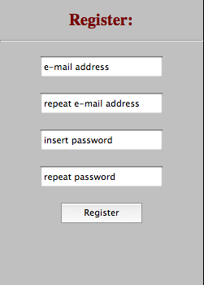

Users can remove their account with the “unregister” button placed on MyProfile site. Again, a page will then be displayed telling the user if the action was successful or not.

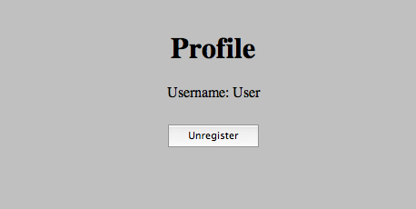

Login/Logoff

A login form will be displayed on the homepage. The user will need to enter the correct account details, and will then be taken to their account page. If the account details are incorrect, they will be returned to the home page and shown a message explaining this. Underneath the form will be an option to register.

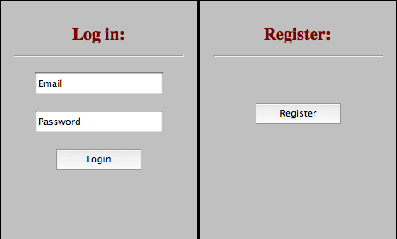

Once the user has logged into their account, they will be able to see a logoff button. Pressing it will immediately take them out of the game and back to the home page of the game.

Offers
There are several types of user interaction that can be described in terms of “offers”, where one user offers a request to another user, who then has the chance to either accept or reject the offer. There are four interactions that work this way:

Friend Requests
To send friend request to another player we need to insert friends name (email address) in a text box, placed below friends list and press “Add” button. After that a friend request will occur in a notifications panel.

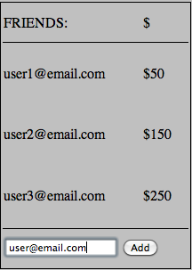

When click on friend request in notification panel you will be redirected to new window, where you will be able to accept or decline friends request.

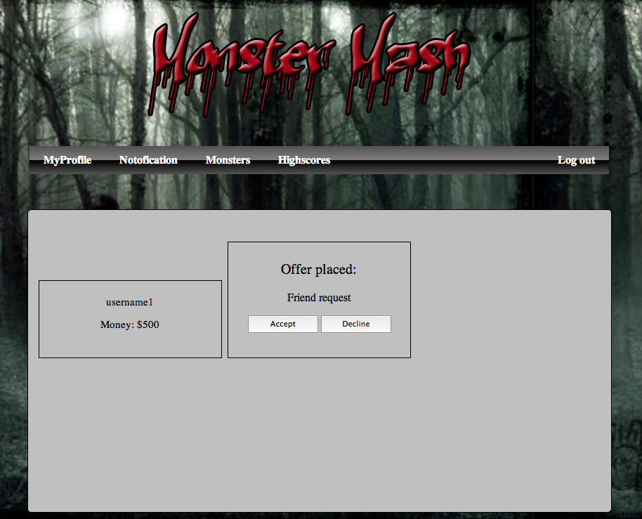
If offer is accepted a new friend occurs in your friend table. From now on you can send offers to this player.

Fight request
To sent a fight request to another player you have to press “fight” button placed under your friend name in friends table.
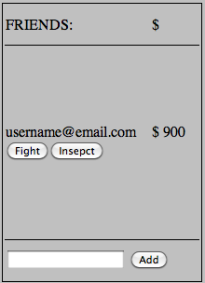

You will be redirected to another page, where you have to choose one monster from your and friend's farm and specify a prize.

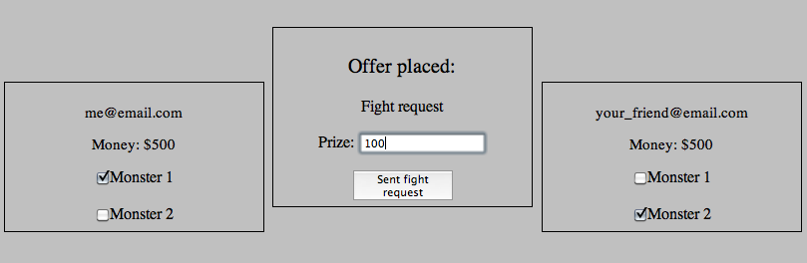

Your opponent has to accept your offer, otherwise any action won't be taken. If accepted monsters proceed to fight. After the fight a winner receives money reward. A report from a fight occurs on a notifications page.

As a result of any fight your monster can be injured or die. Injury may reduce the monsters attributes, and death will remove it from the owners list of owned monsters.

Breed

To send a breed request to your friends you need to go to your monster farm. Under every Monster record is placed a “Offer to breed” button.
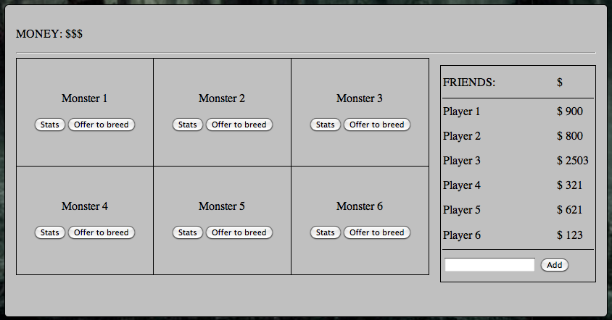

When you click it, you will be redirected to another page, where monster with stats are displayed and you will be asked to enter a price. Then you have to press a “Send breed offer” and it will be sent to every one from your friends list.
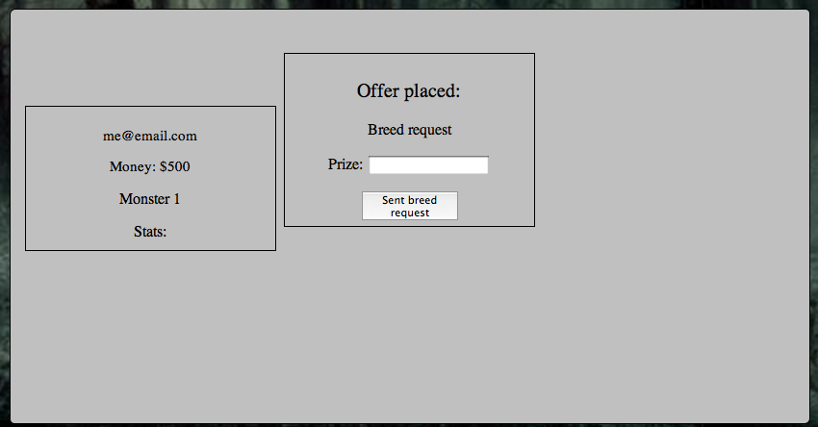

If anyone will accept your offer a person who accepted gets a new monster and other side gets a money reward. If offer is declined nothing happens. In both cases appropriate message occurs on a notification page.

Trade
This game allows the user to trade our monsters to other players. We might decide we want to sell one of our creatures in order to earn some extra money etc. To send a sell request we need to go to our monster farm and press the ”sell” button under the chosen monster.

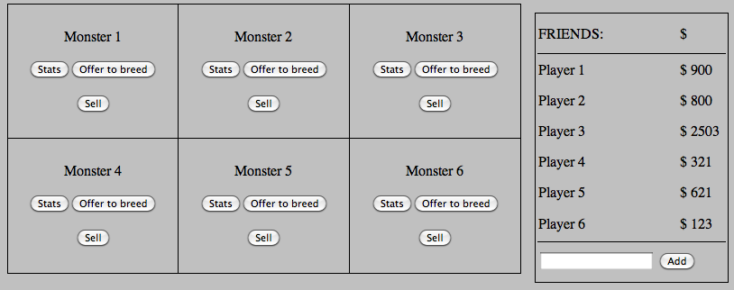
System redirects us to another page, where we decide how much we expect to earn on this transaction and press “sent sell request”. This will sent sell request to all players from our friends list.

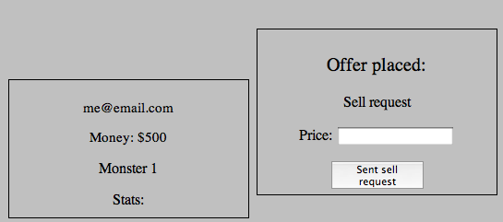
If offer is accepted, we get money and the other side receives a monster. If offer is declined nothing happens. In both cases an appropriate message occurs on our notification page.

Notifications

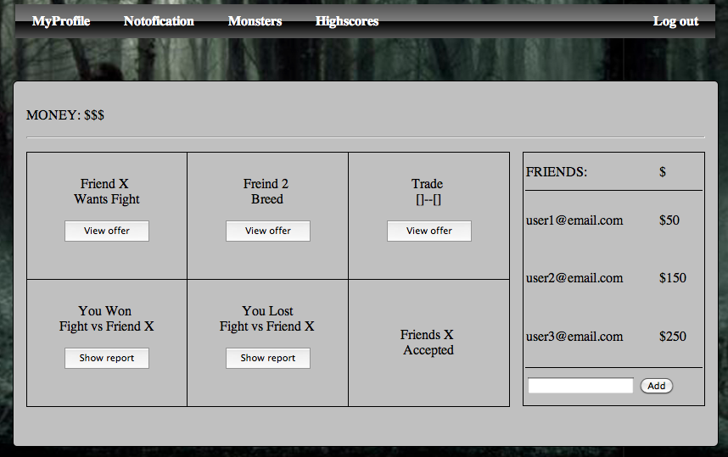
Once people have made offers to you, they will appear on the notifications page. Clicking on a “View offer” button will take the user to the 'Accept offer'. page.

We can also check reports from our last fights (won and lost) by clicking on the “Show report” button.

Accept an offer

A user can select an offer, which will then show this screen, displaying details of the offer to be accepted. The details will be based on whether the offer is a friend request, or a monster trade/breed/fight. Either the friends or the monsters involved will be shown on the left and right, as a small card containing their stats. In the centre will be buttons to accept and reject the offer.

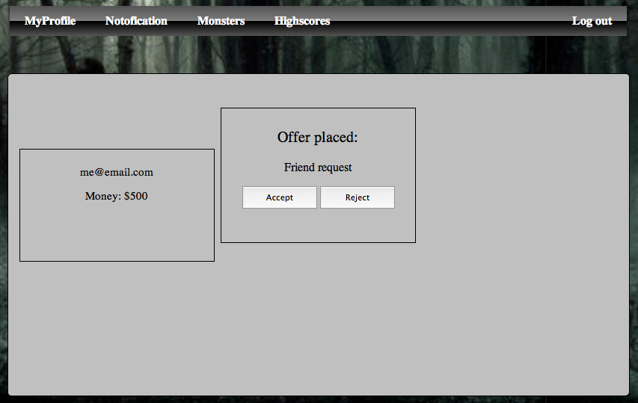

When the user continues, they will be taken back to the previous page and shown a message telling them that the offer has been accepted or rejected.

Other Views

Home Screen
After you successfully login to a system you will be directed to a My Farm page.

From the main home screen you can see a panel of your monsters, a list of your friends on the far right and an option to add friends. You can also logout using the logout button at the top right corner. The money you currently have is displayed at the top.
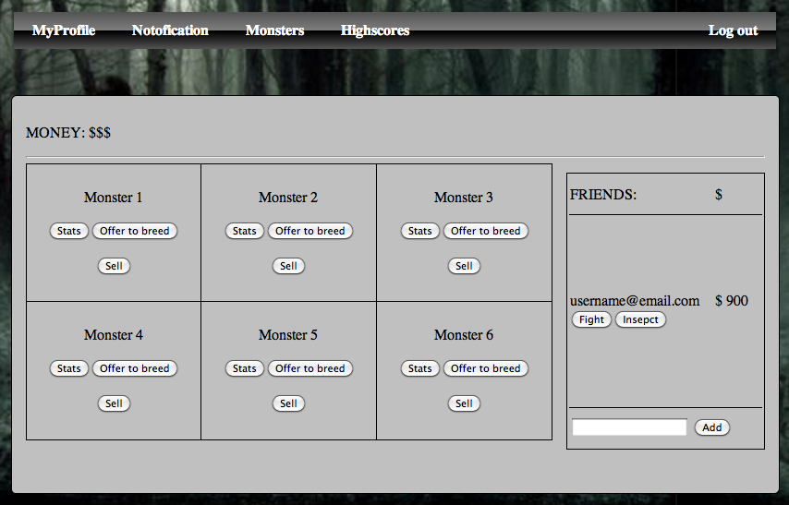

View Friends Monsters
You can inspect you friend's monster farm and check what monster he/she has simply by clicking on the “Inspect” button under your friend's name in a friend's list table.

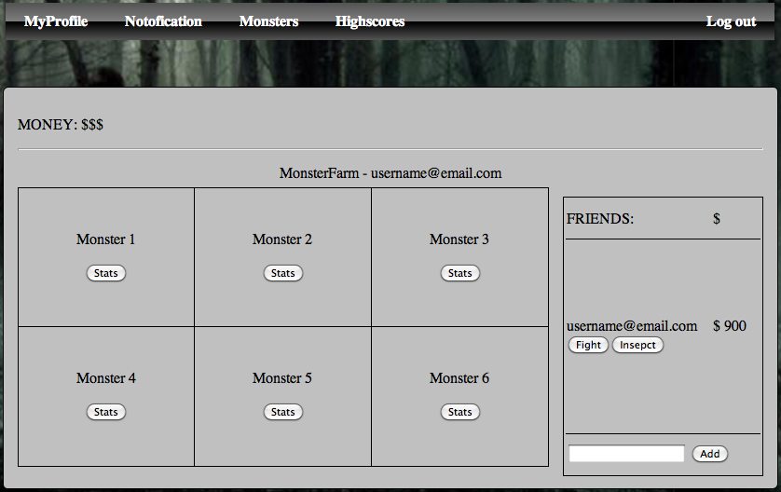

On this page will be a status bar that will tell you the username of your friend so you know you are on the right page. Below that you will see the main panel which will display the monsters that your friend has and the stats for each monster.

Profile View
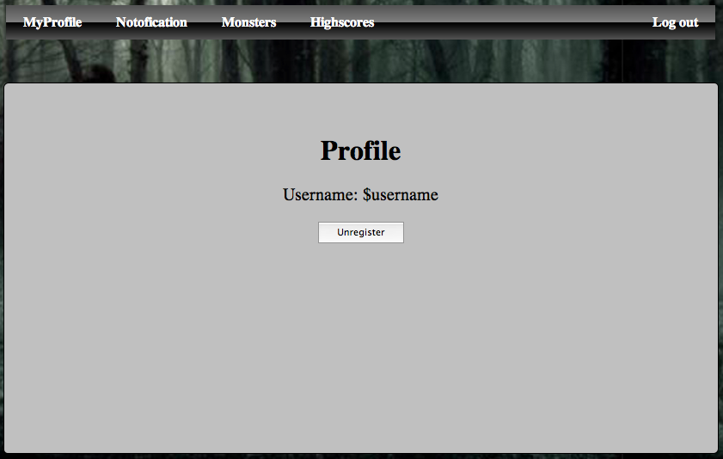
On this page you can see your username and a “Unregister” button. You can use it to remove your account. You can also logout using the logout button at the top right corner.

REFERENCES
This section is an automatic bibliography.

DOCUMENT CHANGE HISTORY
Version | CCF No. | Date | Sections changed | Changed by
1.1 | N/A | 31/10/12 | Corrected document to be inline with the General Documentation Standards | Samuel Clements
1.2 |  | 17/02/13 | All section updated/added print screens | Adrian Gawryszewski
1.3 |  | 18/02/13 | Spelling + grammar changes

