**WindowBuilder Pro – Google**

1. A plugin for Eclipse.

2. Uses WYSIWYG layout tools so no knowledge of Java is needed to build a GUI.

3. Someone will have to learn to use it quickly or as a group in a session and just bash it out.

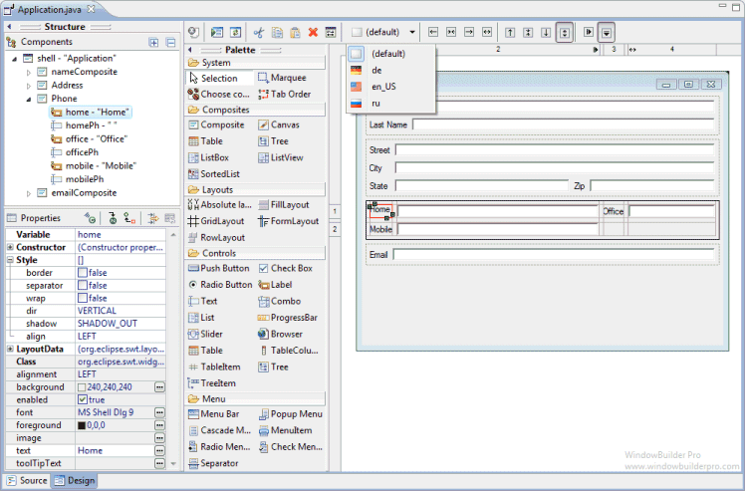

**App Sketcher – Free trial**

Create interactive prototypes quickly with HTML and JQuery UI components. No coding required.

Specify behaviour by adding dynamic content and actions.

WYSIWYG

Could use for part of the design depending on trial limitations

**Sketchflow – Commercial – Expression Studio Ultimate**

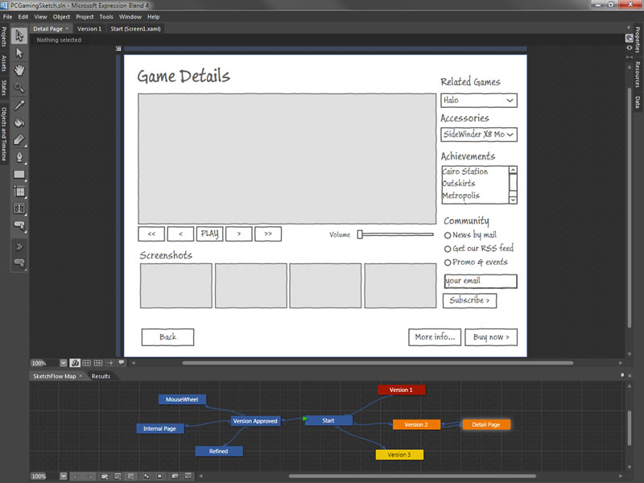

Would take learning and to be done very quickly.

**Prototyper - Free -** [**http://www.justinmind.com/prototyper/free-edition**](http://www.justinmind.com/prototyper/free-edition)

This is a GUI creator for mobile and web. Will download it and have a play around with it.

**QT Designer -** [**http://qt.digia.com/Product/Developer-Tools/**](http://qt.digia.com/Product/Developer-Tools/)

* C++ and JavaScript code editor
* Integrated UI designer
* Project and build management tools
* Support for desktop and mobile targets

Most people online on programming forums suggest doing sketches and scanning them as changes can be made later more easily and you should avoid making the design look professional and pretty in the early stages because if it doesn’t look ‘exactly’ as specified in the design it may anger the customer which could cause problems.

**List of others**

**http://c2.com/cgi/wiki?GuiPrototypingTools**