CS22310 – Hotel Booking website

Nathan Hand (nah14@aber.ac.uk)

1. Task analysis
This section of the document covers the first steps that I went through when thinking about the design of this website. It was important that I understand the different steps involved with the website in terms of who would use the website, how and finally why. With this in mind I identified 3 primary user-groups of the website which are as follows.
Traveller/ guest, this person is expected to be using the website in hopes of finding a hotel/ guest house to stay in.
Guest house/ Hotel, this person/ company is expected to use the website via offering their hotel into the database/ storage so that they might get more customers through the website as a reference.

Admin/ Customer services, this person/ people are expected to use the website to manage customer queries via the contact us page as well as manage the approval of newly registered users to the website.

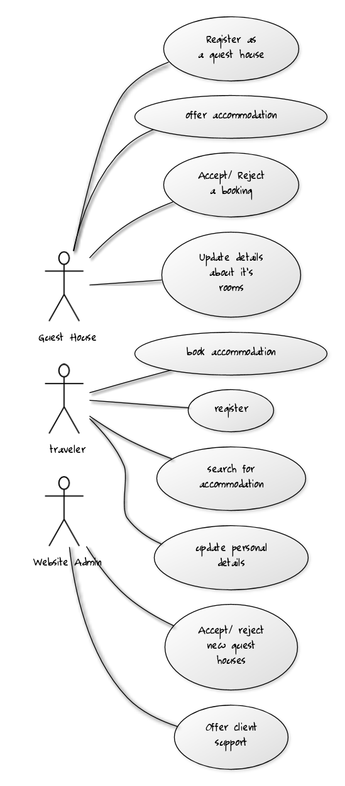
1.1 Use case diagram

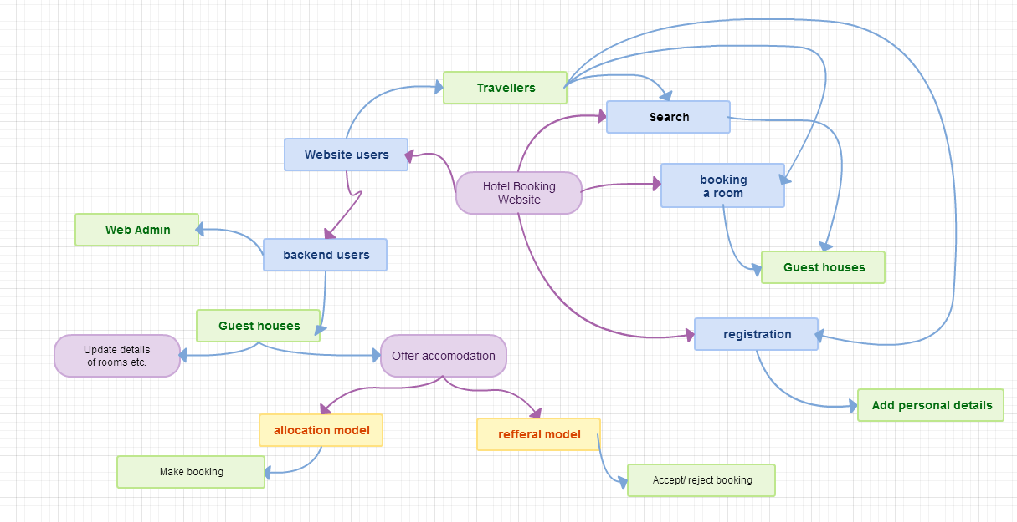
1.2 Rich picture

1.3 Data Flow Diagram
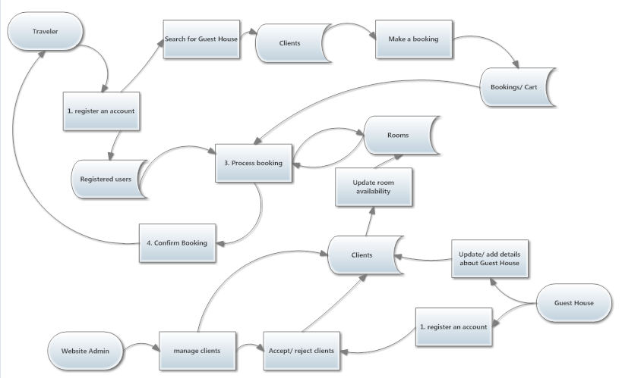

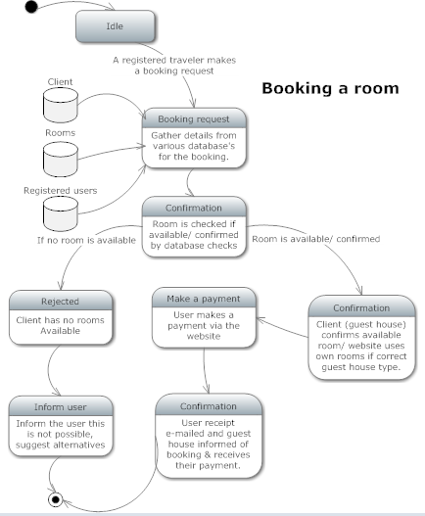
1.4 State transition diagram

2 High level design of interaction, naviagation, layouts etc.

The website has a number of functional requirements that are to be met by the design of the website, this will be shown off in more detail in the prototype but here I will discuss the functional requirements and how I intend to cover them.
FR1 Registration
A page via which new client establishments can apply for an account. This must be backed by
administrative access to authorisation of the application.

A registration can be made via the registration page for all clients, this will initially include basic information such as e-mail, username and password and then once logged in the user will be able to apply to become a client. The application to become a client will then be handled by an admin via the administrator back-end.

FR2 Description management
Client web access for entry and editing of material describing the establishment and its
accommodation.

A client once accepted will have access to a backend which allows for the addition and updating of details about its hotels and rooms available etc. This is all handled via PHP and is a database driven update.

FR3 Availability management
Client web access for updating room availability under the allocation model.CS22310 Assignment – Hotel Booking Service Requirements Specification

client web access is done via logging into the website, clients will be re-directed to a different login section then a regular traveller which will have special forms and functions for updating their hotels, descriptions etc. Hotels will also be able to E-mail in their requested changes via the e-mail used on the website when they registered.

FR4 Search
Entry of appropriate search criteria by the traveller and subsequent display of matches.

The primary function of the website in terms of making bookings is searching for those hotels and then making those bookings, therefore the first page that we come to includes a search bar directly in-front of us. There will also be an appropriate search bar at the top of every single page making it very easy for users to see and create a new search. Searching is a very important part of the website and should be available on every page that a traveller is expected to visit this is why It will be placed in my header at the top of the page easily viewable in the same place at each page location.

FR5 Cart facility
Recording of retrieved matches in a local list of possible accommodation. Management of the
cart contents.

Cart will be maintained via PHP session data and then later saved into the SQL database to allow for the data to be retrieved if the user access's their account from a different device or computer. The cart will be always viewable and a link posted on every page keeping decent consistency.

FR6 Customer detail collection
Collection of sufficient customer details to support booking.

Customer details will be taken/ updated before any payment can be made, this will be available via a “my account” section and will allow users to update their details at any time via the website.

FR7 Booking
Submission of cart items and management of the response, confirming rooms under the
allocation model and initiating requests to establishments under the referral model.

Confirmation of a room will be made via an e-mail sent to the traveller after the room is confirmed by the client. The client will have an automated e-mail with a uniquely crafted link sent to their client e-mail address as well as a contact phone number for phoning in confirmation. This would be sent directly to “front desk” staff which will be able to process the booking.

FR8 Registration management
Registration and management of travellers, supporting storage of user details and cart
contents.

The management of all users will be taken care of by various administrators that work for the website, all data is handled by a back-end system for the website. This will include pending applications to become a client for the website as well as management of all user accounts and their data giving the admin the ability to block accounts, reset passwords and do various maintenance for the users and clients If required via the client support system.

FR9 Client support
Introduction and description of client facilities and how to access them.

Client support will be offered via E-mail, once a client has been accepted into the website via an online admin an e-mail will be sent to the client detailing a tutorial on how to easily add and update their hotel information. As well as any useful information that they might require at the time, this client will also be added to a mailing list that will update/ be sent to the client when any new features are added to the website.

3. Prototype website

The prototype implementation of this website can be found at the following website address: http://users.aber.ac.uk/nah14/hci/index.php this prototype is developed in PHP which allows for consistency across all of the pages as well as easy implementation of functional requirements for when this website would go live.
Items such as a header and a footer are included on every page of the website to keep the design the same throughout and keep important features such as the search bar available to the user.
The website is a prototype and as such information seen is not expected to be relevant/ appropriate/ what is expected in the end user system. There are no functional requirements for the website as stated in the specification as such login, register and other features are not going to work if attempted this is intended.

4. Accessibility principles and guidelines

There are a number of principles that I thought about when designing and making the prototype for this assignment. The first of which is visibility, I wanted all of my words to be visible to the end user and easy to read by not making mistakes in similar coloured text on similar coloured text. All of my text is found with the easy to read black on white.
All font is easy to read using standard easy to read text as well as being seen at a decent size.
Next I decided that the user should be able to contact the website so I made a contact us form so that users can submit anything they liked to the website be it feedback or generally complaints etc.

The website might have international visitors looking to book a hotel for when they visit a country that the website is intended to operate in (currently assuming English and the united kingdom).

