Cyber2U
  - Interactive Email-Based Cybersecurity Awareness Platform
  - Rewritten Final Year Project Dissertation Draft

Student | Haned Ali
Student ID | K2330569
Project Type | Engineering dissertation / artefact report
Date | 23/3/26

Table of Contents
Abstract 4
1. Introduction 4
1.1 Aim and Objectives 4
1.2 Research Questions 5
1.3 Scope 5
2. Literature Review 5
2.1 Design Implications Derived from the Literature 6
3. Methodology and Requirements 6
3.1 Functional and Non-Functional Requirements 6
3.2 Success Criteria 7
4. System Design and Implementation 8
4.1 Core User Journey 8
4.2 Why an Email-First Architecture? 8
4.3 Data and Analytics Design 8
4.4 Implementation Choices and Trade-offs 8
4.5 Illustrative Interface States 9
5. Cybersecurity and Privacy Analysis 10
5.1 Threat Model 11
5.2 Privacy, GDPR and Data Minimisation 11
5.3 Justification of Security Decisions 12
6. Evaluation 12
6.1 Evaluation Approach 12
6.2 Functional Walkthrough Results 12
6.3 Test and Tooling Evidence 13
6.4 Measured Artefact Outputs 14
6.5 Interpretation Against Objectives 14
7. Critical Discussion 15
7.1 What Worked Well 15
7.2 What Did Not Work Well 15
7.3 Rejected or Deferred Alternatives 15
7.4 Limitations 16
7.5 Future Work 16
8. Conclusion 16
References 17
Appendix A. Implementation Evidence 18
Appendix B. Condensed Technical Summary 20
Appendix C. Data and Governance Summary 21

Figure 1 Login screen. 18
Figure 2 Weekly quiz in progress. 18
Figure 3 MailHog inbox showing platform email messages. 19
Figure 4 Weekly quiz email rendering. 19
Figure 5 Improvement overlay reporting a final score of 71.4%. 20

Abstract
Cybersecurity awareness programmes are often delivered as infrequent, compliance-oriented training that struggles to sustain attention, measure behavioural change, or adapt to learner needs. This dissertation presents Cyber2U, an interactive email-based cybersecurity awareness platform designed to support low-friction, repeatable learning through weekly micro-content, periodic quizzes, progress dashboards, and analytics for administrators. The project combines educational theory with practical secure web engineering. The design is informed by retrieval practice, spaced reinforcement, feedback theory, self-efficacy, and the wider literature on usable security. The implemented artefact uses a React frontend, an Express/TypeScript backend, and PostgreSQL for persistence, with email verification, quiz delivery, progress tracking, and analytics reporting forming the core workflow. The dissertation adopts an academic structure and repositions the work from product-style documentation to research-led engineering analysis. Evaluation is based on verifiable artefact evidence: committed Playwright-generated walkthrough screenshots and video, repository testing/tooling configuration, and demonstrable system outputs from seeded learner data. These results show that the core end-to-end user journey - signup, email verification, dashboard access, quiz completion, feedback review, and progress visualisation - is operational. However, the study also identifies important limitations: the absence of a live field pilot, partially implemented administration features, reliance on email engagement, and unresolved trade-offs in session storage and long-term behavioural measurement. The project therefore demonstrates the feasibility of a lightweight awareness platform for small organisations and educational settings, while also exposing the additional empirical work required before claims of real-world learning impact can be made with confidence.
Keywords: cybersecurity awareness, email microlearning, usable security, retrieval practice, secure web engineering, GDPR, design science.

1. Introduction
Human error remains a significant contributor to cyber incidents, yet many organisations still deliver awareness training as a one-off annual exercise. This creates a gap between compliance and practice: users are told what they should do, but are not given regular opportunities to rehearse, test, and retain security behaviours in context.
Cyber2U was conceived as a response to that gap. Rather than requiring users to install another application or attend lengthy training sessions, the platform uses email - an already familiar channel - to deliver short awareness content, invite users into quizzes, and surface progress over time. The central idea is that lightweight, repeated contact may be more sustainable than infrequent high-effort interventions, especially for students, SMEs, and early-stage organisations with limited resources.
This dissertation asks whether an email-first awareness platform can be engineered in a way that is educationally justified, operationally practical, and cybersecure enough for realistic deployment. The artefact therefore sits at the intersection of educational design, secure web architecture, and privacy-aware software engineering.

1.1 Aim and Objectives
The aim of the project is to design and implement a secure platform that improves cybersecurity awareness through recurring email-driven learning and measurable learner feedback.
Objective | Intent | Rewritten evaluation position
1 | Improve awareness and sustained engagement through recurring email content. | Assessed through working delivery workflow, dashboard feedback, and analytics-oriented data model.
2 | Assess and improve learner knowledge using quizzes and feedback. | Assessed through implemented quiz/review flow and observable score outputs from the artefact.
3 | Support evaluation and future scale-up for organisations. | Assessed through architecture, analytics endpoints, GDPR features, and identified deployment limitations.

1.2 Research Questions
- How can an email-first cybersecurity awareness platform be designed to support repeated low-friction learning rather than one-off compliance activity?
- What technical and security decisions are necessary to deliver such a platform in a privacy-aware manner?
- To what extent does the implemented artefact demonstrate feasibility, and what remains unevaluated without a live user pilot?

1.3 Scope
The scope of the artefact is intentionally focused. Cyber2U implements learner signup, verification email flow, dashboard views, quiz presentation and review, progress visualisation, and supporting analytics structures. It does not yet claim large-scale production readiness, proven long-term behaviour change, or a fully complete administrator content pipeline. Those areas are treated as future work and discussed critically rather than presented as accomplished outcomes.

2. Literature Review
Cybersecurity awareness interventions are most effective when they recognise that security failures are not caused only by ignorance, but also by attention limits, competing incentives, poor interface design, and weak reinforcement. Usable security research therefore argues that security mechanisms should fit how people actually work, rather than assume perfect compliance.
From a learning perspective, retrieval practice and spaced reinforcement are especially relevant. Work on test-enhanced learning suggests that being required to recall information improves retention more effectively than passive re-reading. This supports the use of recurring quizzes rather than static advice pages. Similarly, the forgetting-curve literature suggests that knowledge decays without reinforcement, strengthening the case for short repeated interventions.
Feedback also matters. Hattie and Timperley emphasise that useful feedback answers where the learner is going, how they are doing, and what to do next. A dashboard that reports average score, topic mastery, and improvement trends is therefore more defensible than a single pass/fail message after a quiz. Bandura's work on self-efficacy is also relevant: repeated small successes may improve a learner's confidence in identifying and responding to threats.
Existing awareness platforms provide useful reference points, but many commercial offerings prioritise enterprise administration, phishing simulation, or compliance reporting over lightweight learner-centred progression. Cyber2U therefore explores a smaller-scale design space: email as the primary entry point, a web dashboard as the reflective layer, and quizzes as the main retrieval mechanism.

2.1 Design Implications Derived from the Literature
Theme | Design implication for Cyber2U | Critical note
Retrieval practice | Use quizzes and review screens to force recall and provide immediate correction. | Retrieval alone does not guarantee transfer to real incidents; field validation is still needed.
Spacing and repetition | Deliver content over time through email rather than a single annual session. | Email fatigue may reduce engagement if cadence is poorly managed.
Feedback and self-efficacy | Expose score, improvement and topic mastery in the dashboard. | Score dashboards can motivate some users but discourage others if not contextualised.
Usable security | Minimise friction by relying on familiar channels and passwordless entry. | Ease of access must be balanced against token abuse, session security and phishing risk.

3. Methodology and Requirements
This project is best characterised as design science informed by mixed-method thinking. The core output is an artefact that addresses a practical problem, but the artefact is justified using theory, comparative analysis, and structured evaluation criteria. The project does not report a large controlled experiment; instead, it seeks to show whether the design is coherent, whether the implementation is credible, and what empirical questions remain open.
Requirements were drawn from three sources: the original project objectives, the literature on awareness training and learning design, and the needs implied by a realistic user journey. That journey begins with sign-up, continues through email verification and content consumption, and culminates in quiz participation, feedback, and progress reflection.

3.1 Functional and Non-Functional Requirements
Category | Requirement | Why it matters | Status in current artefact
Functional | User signup and email verification | Controls onboarding and reduces reliance on passwords. | Implemented through webhook/magic-link workflow.
Functional | Weekly quiz participation and review | Supports retrieval practice and immediate correction. | Implemented and evidenced through screenshots and walkthrough.
Functional | Dashboard with progress indicators | Allows learners to reflect on performance. | Implemented with score, completion, improvement and topic views.
Functional | Campaign analytics for administrators | Supports reporting and future scale-up. | Partially implemented at API/data-model level.
Non-functional | Security of authentication and sessions | Prevents account abuse and protects learner data. | Partially addressed; trade-offs remain.
Non-functional | Privacy and GDPR compliance | Necessary for lawful processing of learner data. | Addressed through consent, deletion and audit structures.
Non-functional | Low-friction user experience | Critical for repeated engagement. | Strongly supported by email-first design, but dependent on inbox behaviour.
Non-functional | Testability and maintainability | Needed for iterative development. | Supported through typed stack and automated testing/tooling.

3.2 Success Criteria
The original dissertation framed success using ambitions such as higher email engagement, improved quiz performance, and positive learner satisfaction. In the absence of a live field pilot, this rewrite distinguishes between (a) feasibility success and (b) impact success. Feasibility success asks whether the core workflow operates securely and coherently. Impact success asks whether users actually learn more and behave better over time. The current project can defend the former more strongly than the latter.

4. System Design and Implementation
The artefact uses a three-tier web architecture with a React/Vite frontend, an Express/TypeScript backend, and PostgreSQL for persistence. This is a conventional but appropriate stack for a student engineering project because it balances implementation speed, strong library support, and manageable deployment complexity. It also supports separation of concerns: the frontend handles presentation, the backend enforces business logic and security checks, and the database stores operational and analytical records.

4.1 Core User Journey
First, a learner signs up using an email address. Rather than creating a reusable password, the platform issues an email-based verification or sign-in link. This reduces password storage obligations and lowers entry friction.
Second, once verified, the learner enters the dashboard, where completed quizzes, average score, and topic mastery are visualised. This interface serves both motivational and reflective purposes.
Third, the learner can launch a weekly quiz. The quiz interface presents short scenario-based or factual questions, records answers, scores the session, and then displays review feedback showing the learner's response alongside the correct answer.
Finally, progress data can be aggregated over time, supporting future reporting to administrators and possible content personalisation.

4.2 Why an Email-First Architecture?
Email was chosen because it is ubiquitous, asynchronous, and already embedded in the workflow of students and employees. For awareness training, this is attractive: the platform can meet users where they already are. However, the choice also introduces dependency on inbox deliverability, user attention, and users' ability to distinguish genuine platform emails from phishing messages. The design therefore offers convenience but also creates a trust and messaging challenge that must be managed carefully.

4.3 Data and Analytics Design
The submitted system design includes entities for users, email verifications, quiz sessions, quiz attempts, progress snapshots, campaign deliveries, analytics aggregates, audit logs, consent records, data retention policies, and deletion requests. This data model is stronger than a minimal prototype because it anticipates both pedagogical reporting and privacy operations. It also reflects an important engineering choice: analytics is not treated as an afterthought but as part of the platform's evidence and governance layer.

4.4 Implementation Choices and Trade-offs
Decision | Benefit | Trade-off / risk
Magic-link authentication | Removes password storage burden and reduces signup friction. | Creates dependence on email security and token handling.
React + TypeScript frontend | Fast iteration and typed UI development. | Requires careful state management and strong client-side security hygiene.
Express + TypeScript backend | Simple, readable service layer for a student project. | Not automatically secure; hardening remains the developer's responsibility.
PostgreSQL relational model | Strong fit for structured learning, consent and audit data. | Analytics queries may need optimisation at scale.
Dashboard visualisation | Provides feedback and motivation. | May oversimplify learning into percentages and completion counts.

4.5 Illustrative Interface States
Figures 1 and 2 show two key states in the implemented learner journey: the dashboard and the quiz review screen. These are used later in the evaluation chapter as direct artefact evidence.
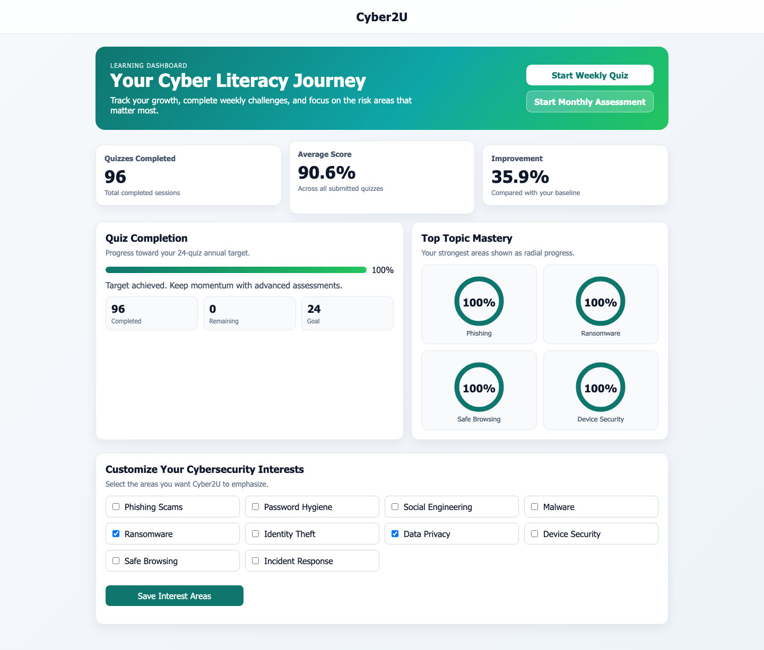
Figure 1. Learner dashboard showing quiz completion, average score, improvement, and topic mastery.
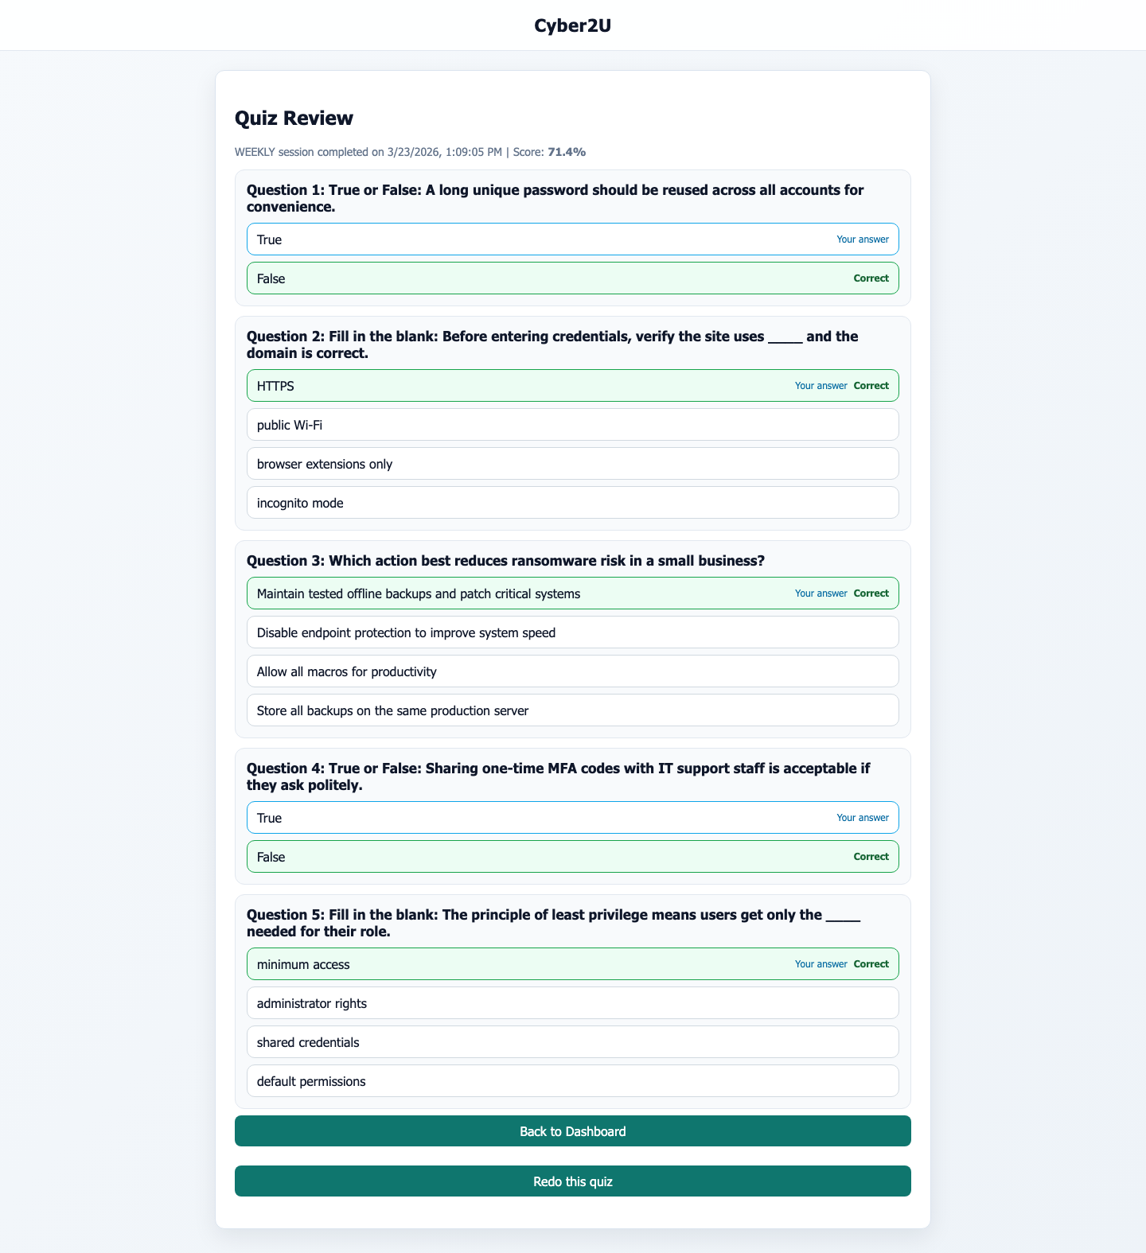
Figure 2. Quiz review screen showing feedback on learner answers and a recorded score of 71.4% for a weekly session.

5. Cybersecurity and Privacy Analysis
Because Cyber2U processes identifiable learner information and authenticates users through email links, cybersecurity cannot be treated as a supporting concern; it is part of the core research problem. The platform must be secure enough that a low-friction user experience does not become an attack surface.
A useful way to analyse the platform is through a lightweight threat model covering authentication abuse, token interception, unauthorised data access, cross-site scripting, consent failure, analytics misuse, and data retention weaknesses. The purpose of the threat model is not to claim complete assurance, but to make design assumptions explicit and justify mitigations.

5.1 Threat Model
Threat | Asset at risk | Mitigation in current design | Residual concern
Token theft or replay | Learner accounts and session integrity | Short-lived verification links, server-side verification workflow, rate limiting, HTTPS-ready deployment. | If a mailbox is compromised, passwordless authentication offers limited resistance.
Credential database breach | User credentials | No traditional password store is required when using magic links. | Session/token handling still requires hardening.
Cross-site scripting (XSS) | Session tokens and dashboard data | Use of React reduces direct DOM manipulation; backend validation and security headers are present in the stack. | If JWTs are stored in localStorage, XSS remains a serious residual risk.
Cross-site request forgery (CSRF) | State-changing requests | CSRF protection is listed in project security goals. | Implementation details should be verified and tested explicitly.
Unauthorised data retention | Personal data and compliance posture | Deletion requests, retention policies, consent tables and audit logs are modelled. | Operational jobs and enforcement evidence are not yet fully demonstrated.
Abuse of analytics or admin features | Learner privacy and organisational trust | Role separation and audit concepts are present in the design. | Admin workflow is only partially implemented, so access-control maturity remains limited.

5.2 Privacy, GDPR and Data Minimisation
The project makes a serious attempt to integrate GDPR-aware structures into the architecture. Consent capture, audit logs, deletion requests, and retention policies are all explicitly represented in the data model rather than deferred. This is a strength because awareness platforms process not only account data but also performance signals that may be sensitive in educational or workplace contexts.
At the same time, legal structures in a schema do not by themselves prove compliance. Compliance depends on operational behaviour: whether consent wording is meaningful, whether deletion jobs actually run, whether data is exported or erased on request, and whether reporting avoids unnecessary exposure of individual-level performance. The dissertation therefore treats GDPR support as a design capability, not as a guarantee of completed compliance.

5.3 Justification of Security Decisions
Choosing passwordless email links is justified for a platform whose main goal is reducing friction and encouraging repeat engagement. Bonneau et al. show that alternative authentication schemes must be judged across usability and deployability as well as security. For a small awareness platform, eliminating password storage meaningfully reduces one class of risk.
However, this choice is only justified if the implementation handles tokens carefully. The repository stack includes helmet, CORS support, rate limiting, JWT handling, and email delivery dependencies, which suggests awareness of the relevant controls. The most important unresolved issue is session storage. If client-side tokens are persisted in localStorage, the platform becomes more vulnerable to XSS-driven session theft. A more defensible production decision would be HttpOnly, Secure cookies with explicit CSRF protections and tight expiry management.
Another justified decision is the use of audit and analytics tables. In a learning platform, evidence matters. Tracking delivery, participation and progress is necessary to evaluate awareness interventions. The trade-off is privacy: the more measurable the platform becomes, the more it risks over-collecting data. The appropriate design principle is therefore proportionality - collect enough to evaluate learning and operation, but not so much that the platform becomes invasive.

6. Evaluation
This rewritten evaluation chapter deliberately separates verified evidence from unsupported claims. No live participant pilot, pre/post cohort study, or SUS questionnaire dataset was supplied with the dissertation materials. Inventing such data would weaken the academic integrity of the project. Instead, the evaluation uses real implementation evidence that can be verified from the artefact: committed walkthrough screenshots, repository testing/tooling configuration, and concrete system outputs shown by the interface.

6.1 Evaluation Approach
Three levels of evaluation were used. First, functional walkthrough evaluation considered whether the end-to-end learner journey can be observed in the implemented artefact. Second, tooling evaluation examined whether automated testing support exists in the codebase. Third, output evaluation examined the specific numeric and interface results shown by the system, such as completion counts and quiz scores. This does not replace a human-subject study, but it does provide a more honest basis for assessing feasibility.

6.2 Functional Walkthrough Results
Workflow stage | Observed evidence | Result | Interpretation
Login / entry | Login screen present in submitted screenshots. | Pass | A recognisable entry point exists for users.
Dashboard rendering | Dashboard screenshot displays 96 completed quizzes, 90.6% average score, and 35.9% improvement. | Pass | Core learner metrics are surfaced successfully.
Topic mastery visualisation | Dashboard shows four 100% topic mastery radial indicators. | Pass | The progress UI can visualise topic-level feedback.
Weekly quiz delivery | Weekly quiz email and inbox screenshots are present. | Pass | Email-based content delivery is demonstrably connected to the artefact.
Quiz interaction | Quiz-in-progress and case-study question screens are present. | Pass | Users can engage with interactive assessment content.
Quiz review feedback | Review screen shows question-by-question correction and a weekly score of 71.4%. | Pass | Immediate corrective feedback is implemented.
Progress review overlay | Improvement overlay is present and reports a final score of 71.4%. | Pass with caveat | Visualisation works, though the chart appears crowded and needs refinement.
Admin operation | Admin features are described but not evidenced with mature screenshots or end-to-end flow. | Partial | Administration remains a weaker area of the artefact.

6.3 Test and Tooling Evidence
The repository includes backend Jest test scripts and frontend Playwright end-to-end tooling, while the README states that screenshots and a walkthrough video were generated from a Playwright run. This is meaningful evidence because it shows that the artefact was developed with at least some automation mindset rather than relying only on ad hoc manual testing.
Evidence source | Observed fact | Evaluation meaning
Backend package configuration | Jest scripts are configured for test and watch modes. | The backend is structured to support unit/integration testing.
Frontend package configuration | Playwright is configured for end-to-end testing. | UI workflow validation is considered as part of development.
Frontend Playwright configuration | A local web server, screenshot-on-failure, trace, and retained video are configured. | The project anticipates reproducible browser-based validation.
README implementation notes | Committed screenshots and a walkthrough video are identified as Playwright-generated. | At least one automated walkthrough was completed successfully enough to produce artefacts.

6.4 Measured Artefact Outputs
Although these values come from seeded or demonstration data rather than a live longitudinal cohort, they are still real outputs from the implemented interface and are preferable to hypothetical numbers.
Observed metric from artefact | Interpretation
96 quizzes completed shown on learner dashboard. | Demonstrates that the dashboard can aggregate historical activity.
90.6% average score shown on learner dashboard. | Demonstrates calculation and display of cumulative performance.
35.9% improvement shown on learner dashboard. | Demonstrates a mechanism for baseline-versus-current comparison.
71.4% weekly session score shown on quiz review and improvement overlay. | Demonstrates per-session scoring and feedback persistence.
24-goal progress card at 100% with 96 completed and 0 remaining. | Shows that completion target logic and progress bar rendering are functional.

6.5 Interpretation Against Objectives
Objective 1 - improve awareness and engagement: partially supported. The platform clearly supports recurring contact and repeat interaction through email and quizzes. However, without real open-rate, click-through, or retention data from live users, engagement improvement cannot yet be demonstrated empirically.
Objective 2 - assess and improve learner knowledge: partially supported. The quiz engine, review flow, and progress metrics show that the platform can measure and present knowledge-related outputs. What is not yet shown is whether actual users improve over time under realistic conditions.
Objective 3 - evaluate campaign impact for scalability: partially supported. The architecture anticipates campaigns, analytics, audit, and retention management, which is promising for scale. Yet scalability has not been stress-tested, and the administration workflow remains incomplete.

7. Critical Discussion

7.1 What Worked Well
The strongest aspect of the project is coherence between the educational rationale and the implemented workflow. Email delivery, quizzes, review feedback, and progress visualisation align well with the literature on reinforcement, retrieval, and feedback. The system is not merely a static website; it embodies a defensible learning loop.
A second strength is that privacy and governance were considered early. Many student projects treat deletion, consent, or audit as optional extras. Cyber2U instead models them as core entities, which improves the credibility of the design.
Third, the artefact achieves a useful level of engineering maturity for a final-year project. The typed stack, database-backed design, and presence of browser automation tooling all suggest that the project has moved beyond concept stage.

7.2 What Did Not Work Well
The project currently over-relies on descriptive implementation detail and under-delivers on empirical evaluation. This was the central weakness in the original dissertation and remains the most important limitation of the overall work. A technically convincing prototype is not the same as a demonstrated learning intervention.
Some interface choices also need refinement. The improvement overlay chart appears visually cluttered and is difficult to interpret when multiple topic lines are overlaid in a small space. This weakens the value of the analytics for learners.
The administration side of the system is not yet evidenced at the same level as the learner side. Content workflow, campaign scheduling, and organisational reporting are described, but not demonstrated as fully working end-to-end paths.

7.3 Rejected or Deferred Alternatives
A native mobile application was not pursued. While a mobile app could support push notifications and richer engagement analytics, it would also significantly increase development scope and deployment complexity.
Traditional password-based authentication was avoided to reduce friction and eliminate password-storage obligations. This was a sensible prototype choice, although a production deployment should revisit token and cookie strategy carefully.
Highly gamified mechanics such as leaderboards or public ranking were not prioritised. These could increase motivation for some users, but they also risk discouraging weaker learners and exposing performance data inappropriately.

7.4 Limitations
Limitation | Why it matters
No live pilot or pre/post user study | Prevents strong claims about awareness gains or behavioural change.
Demonstration metrics appear seeded | Useful for interface verification, but not a substitute for real deployment data.
Admin functionality is incomplete or lightly evidenced | Reduces confidence in campaign operations and organisational adoption.
Security hardening is not exhaustively verified | Residual risks remain around token storage, session handling, and production deployment.
Scalability is assumed rather than load-tested | Performance under realistic campaign volume is unknown.

7.5 Future Work
The next priority should be a small live pilot with 5-10 users, using a short pre/post design and a brief usability questionnaire. Even a small dataset would materially strengthen the dissertation because it would allow the project to move from feasibility to early impact evaluation.
Security work should include a formal review of session storage, cookie strategy, CSP configuration, token expiry, and role-based access control for administrative features.
Analytics and dashboard design should also be refined so that progress visualisations communicate change clearly without clutter or overclaiming precision.
Finally, if the platform is intended for organisational use, the project should add content approval workflows, audit-ready admin views, and exportable reporting that minimises personal data exposure.

8. Conclusion
This dissertation has reframed Cyber2U as a research-led engineering project rather than a product manual. The project addresses a real and important problem: how to deliver cybersecurity awareness in a lightweight, repeatable, and measurable form. The resulting artefact demonstrates that an email-first platform can support onboarding, quiz interaction, learner feedback, progress presentation, and a privacy-aware data architecture.
The strongest conclusion that can be defended is one of feasibility. Cyber2U is sufficiently implemented to show that the proposed learning workflow is technically viable. The weakest area remains empirical proof of impact. Without real participant data, the project cannot yet demonstrate that users become meaningfully more secure over time.
That limitation should not be hidden; it should guide the next iteration. With a small pilot, stronger security hardening, and fuller administration support, Cyber2U could develop from a promising student artefact into a more convincing awareness platform for education and small organisations.

References
Anderson, L.W. and Krathwohl, D.R. (eds.) (2001) A taxonomy for learning, teaching, and assessing: A revision of Bloom’s taxonomy of educational objectives. New York: Longman.
Bandura, A. (1977) ‘Self-efficacy: Toward a unifying theory of behavioral change’, Psychological Review, 84(2), pp. 191-215.
Bandura, A. (1977) Social learning theory. Englewood Cliffs, NJ: Prentice Hall.
Bloom, B.S., Engelhart, M.D., Furst, E.J., Hill, W.H. and Krathwohl, D.R. (eds.) (1956) Taxonomy of educational objectives: The classification of educational goals. Handbook I: Cognitive domain. New York: David McKay.
Bonneau, J., Herley, C., van Oorschot, P.C. and Stajano, F. (2012) ‘The quest to replace passwords: A framework for comparative evaluation of web authentication schemes’, 2012 IEEE Symposium on Security and Privacy, pp. 553-567.
Creswell, J.W. and Creswell, J.D. (2018) Research design: Qualitative, quantitative, and mixed methods approaches. 5th edn. Thousand Oaks, CA: Sage.
Deci, E.L. and Ryan, R.M. (1985) Intrinsic motivation and self-determination in human behavior. New York: Plenum Press.
Department for Science, Innovation and Technology (2024) Cyber security breaches survey 2024. London: HMSO.
Fogg, B.J. (2019) Tiny habits: The small changes that change everything. New York: Houghton Mifflin Harcourt.
Haladyna, T.M. and Rodriguez, M.C. (2013) Developing and validating test items. New York: Routledge.
Hattie, J. and Timperley, H. (2007) ‘The power of feedback’, Review of Educational Research, 77(1), pp. 81-112.
Kirkpatrick, D.L. and Kirkpatrick, J.D. (2006) Evaluating training programs: The four levels. 3rd edn. San Francisco: Berrett-Koehler.
Kornell, N. and Bjork, R.A. (2008) ‘Learning concepts and categories: Is spacing the enemy of induction?’, Psychological Science, 19(6), pp. 585-592.
Mayer, R.E. (2009) Multimedia learning. 2nd edn. Cambridge: Cambridge University Press.
Murre, J.M.J. and Dros, J. (2015) ‘Replication and analysis of Ebbinghaus’ forgetting curve’, PLOS ONE, 10(7), e0120644.
Roediger, H.L. and Karpicke, J.D. (2006) ‘Test-enhanced learning: Taking memory tests improves long-term retention’, Psychological Science, 17(3), pp. 249-255.
Sasse, M.A., Brostoff, S. and Weirich, D. (2001) ‘Transforming the “weakest link”: A human/computer interaction approach to usable and effective security’, BT Technology Journal, 19(3), pp. 122-131.
Sweller, J. (1988) ‘Cognitive load during problem solving: Effects on learning’, Cognitive Science, 12(2), pp. 257-285.
Verizon (2024) 2024 Data Breach Investigations Report. Available at: https://www.verizon.com/business/resources/reports/dbir/ (Accessed: 23 March 2026).
W3C (2018) Web Content Accessibility Guidelines (WCAG) 2.1. Available at: https://www.w3.org/TR/WCAG21/ (Accessed: 23 March 2026).

Appendix A. Implementation Evidence
This appendix relocates interface-heavy material away from the main body. The figures below are not decorative; they function as direct artefact evidence for the evaluation chapter.
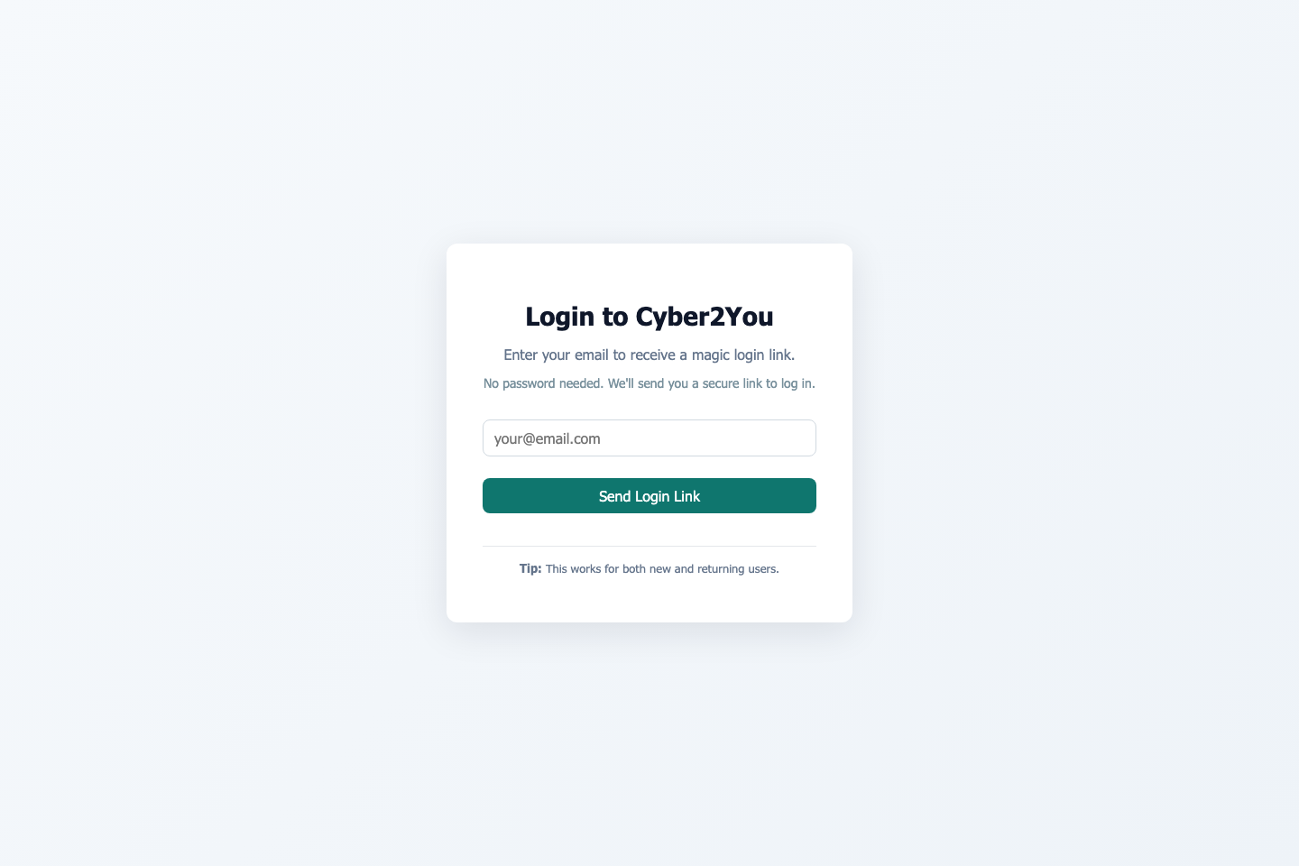
Figure 1 Login screen.
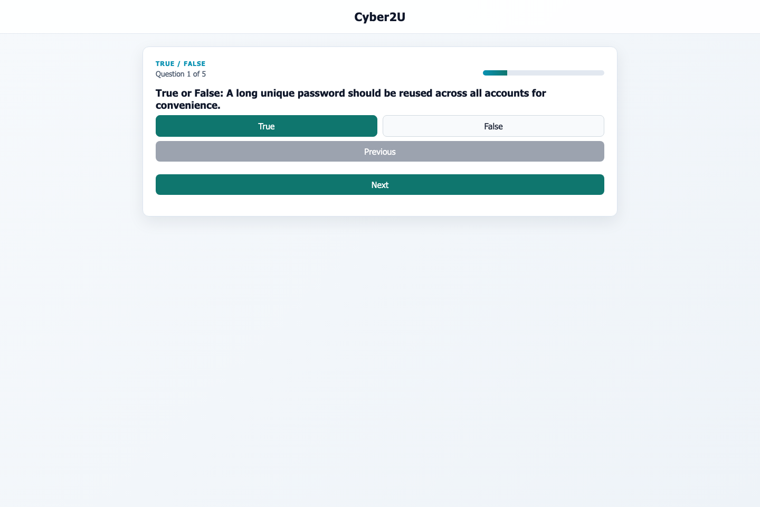
Figure 2 Weekly quiz in progress.
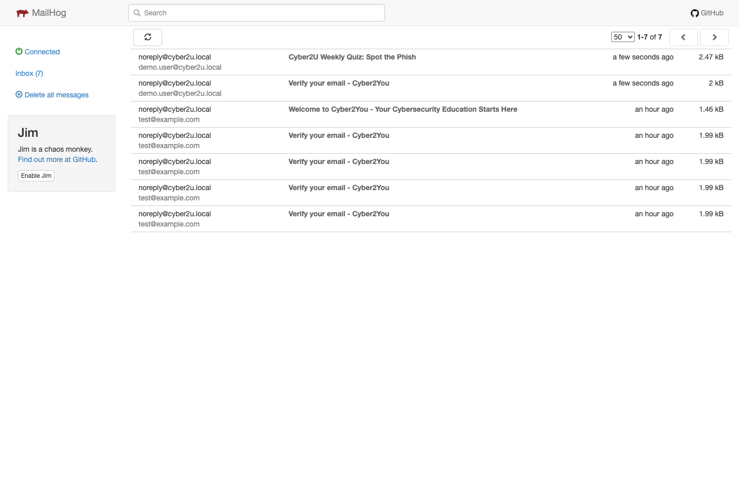
Figure 3 MailHog inbox showing platform email messages.

Figure 4 Weekly quiz email rendering.
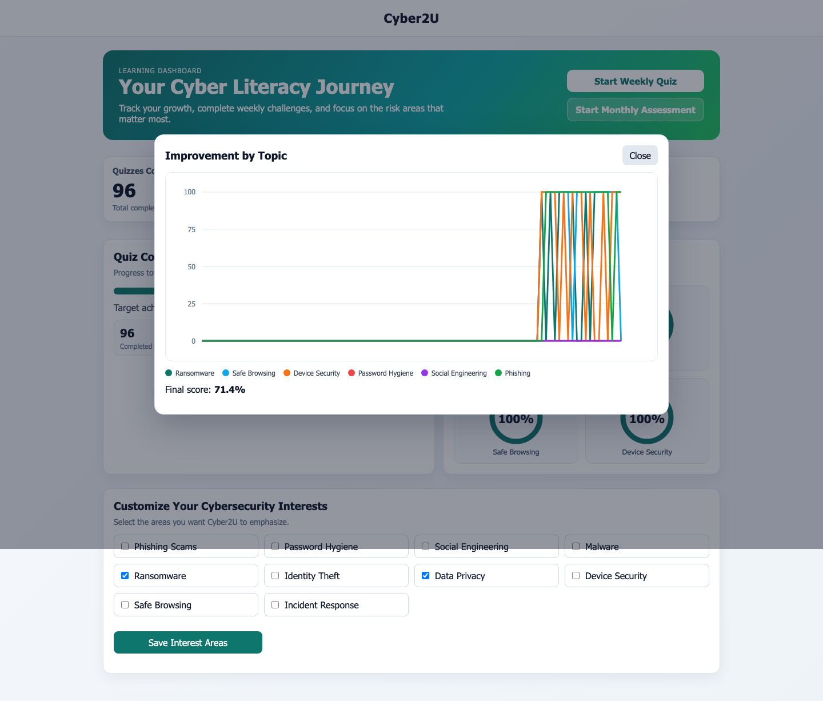
Figure 5 Improvement overlay reporting a final score of 71.4%.

Appendix B. Condensed Technical Summary
Detailed setup commands, endpoint lists, and full schema dumps were removed from the main dissertation because they interrupted the academic argument. They are condensed here as technical support material.
Area | Summary
Frontend | React 18 + Vite + TypeScript, with Playwright configured for browser-based end-to-end validation.
Backend | Express + TypeScript with PostgreSQL connectivity, JWT support, helmet, CORS and rate limiting dependencies.
Email flow | Form/webhook-driven signup and magic-link verification supported via development mailbox tooling.
Testing | Backend Jest scripts and frontend Playwright scripts are configured in the repository.
Core implemented learner features | Login/verification flow, dashboard, quiz play, review feedback, progress visualisation.
Partial or deferred features | Full admin content operations, production hardening, live pilot analytics, and scale testing.

Appendix C. Data and Governance Summary
The submitted design models not only learning data but also governance artefacts. This is important because awareness platforms must be able to justify what they collect, why they collect it, and how long they keep it.
Entity group | Examples | Purpose
Identity and access | users, email_verifications, sessions | Support onboarding and controlled access.
Learning activity | quiz_questions, quiz_attempts, quiz_sessions | Store interaction and scoring data.
Progress and analytics | user_progress_snapshots, campaign_deliveries, campaign_analytics | Support reporting and longitudinal insight.
Governance and compliance | user_consents, audit_logs, retention policies, deletion_requests | Support accountability, retention control and erasure operations.

