Cyber2U
Interactive Email-Based Cybersecurity Awareness Platform
Final Year Project — Dissertation Document

Haned Ali | K2330569

Table of Figures
Figure 1 Cyber2U login page. 30

Table of Contents
Table of Figures 2
Table of Contents 2
Part 1: Project Overview 5
1.1 Introduction 5
1.2 Project Objectives 5
Objective 1: Improve Cybersecurity Awareness and Engagement 5
Objective 2: Assess and Improve User Cybersecurity Knowledge 5
Objective 3: Evaluate Campaign Impact for Scalability 5
1.3 Feature Roadmap 5
Phase 1: Foundation (Complete) 5
Phase 2–3: Authentication & Signup (Complete) 5
Phase 4–8: Core Features (Planned / Partially Complete) 5
1.4 Quick Start 6
Prerequisites 6
Development Setup 6
1.5 Environment Variables 6
1.6 API Endpoints 6
Authentication 6
Quizzes 6
Progress 6
Campaigns (Admin) 7
Analytics (Admin) 7
1.7 GDPR & Security 7
Part 2: Research — Mixed Methods Approaches to Content Delivery in Cyber2U 8
Abstract 8
2. Methodology 8
2.1 Research Design 8
2.2 Qualitative Strand 8
2.3 Quantitative Strand 9
2.4 Integration 9
2.5 Limitations 9
3. Research 9
3.1 Theoretical Foundations 9
3.2 SWOT Analysis of Existing Solutions 11
3.3 SWOT Analysis of Cyber2U 13
3.4 Quiz Design Rationale 14
3.5 How the System Supports and Improves Learning Per User 16
4. Validation 17
4.1 Success Criteria and KPIs 17
4.2 Testing Strategy 18
4.3 Qualitative Validation 18
5. Conclusion 19
6. References 19
Part 3: System Architecture 21
3.1 System Overview 21
Three-Tier Architecture 21
3.2 Frontend Components 21
Pages 21
Services 21
3.3 Backend Components 21
Routes 21
Services 21
Middleware 22
3.4 Key Data Flows 22
Signup → Verification → Onboarding 22
Quiz Submission → Scoring → Progress Update 22
3.5 Key Design Decisions 22
3.6 Security Considerations 23
3.7 Testing Strategy 23
Part 4: Data Model 24
4.1 Entity Relationship Overview 24
4.2 Table Schemas 24
users 24
email_verifications 24
user_consents 24
sessions 25
campaigns 25
campaign_versions 25
quiz_questions 26
quiz_options 26
quiz_attempts 26
quiz_sessions 26
user_progress_snapshots 27
campaign_deliveries 27
campaign_analytics 27
audit_logs 27
data_retention_policies 28
deletion_requests 28
4.3 Data Life Cycles 28
User Creation to Deletion 28
Campaign Lifecycle 28
4.4 Recommended Database Indexes 29
Appendix A: Cyber2U Service Screenshots 33
References 39

Part 1: Project Overview

1.1 Introduction
Cyber2U is an interactive, email-driven platform designed to raise cybersecurity literacy and awareness among students, employees, and the general public. The platform delivers:
- Weekly cybersecurity emails with tips, facts, and interactive case studies
- Monthly assessments to test knowledge and track progress
- Learner dashboards showing progress, topic mastery, and improvement trends (see Figure 2 in Appendix A)
- Admin content workflow for creating, reviewing, and scheduling campaigns
- Analytics reporting aligned to project objectives

1.2 Project Objectives
From the dissertation proposal:

Objective 1: Improve Cybersecurity Awareness and Engagement
Target: Increase email open rate by 15%, CTR by 10%, list growth by 20%.

Objective 2: Assess and Improve User Cybersecurity Knowledge
Target: Increase average quiz score by 20%, achieve 75% participation, reduce wrong answers by 30%.

Objective 3: Evaluate Campaign Impact for Scalability
Target: 85% satisfaction rating, quarterly reporting, scalability assessment.

1.3 Feature Roadmap

Phase 1: Foundation (Complete)
- ✅ Project scaffolding (backend, frontend, database)
- ✅ Database schema and migrations
- ✅ Local development environment (docker-compose)
- ✅ Authentication middleware

Phase 2–3: Authentication & Signup (Complete)
- ✅ Magic-link email authentication
- ✅ Session management
- ✅ GDPR consent capture
- ✅ Signup form ingestion (webhook endpoint)
- ✅ User deduplication and normalisation
- ✅ Verification email workflow

Phase 4–8: Core Features (Planned / Partially Complete)
- Quiz engine and scoring
- Progress tracking
- Content operations admin interface
- Campaign scheduling and delivery
- Analytics and reporting (summary + quarterly endpoints) — implemented

1.4 Quick Start

Prerequisites
- Docker & Docker Compose
- Node.js 18+
- PostgreSQL 16 (or via docker-compose)

Development Setup
cp .env.example .env
docker-compose up -d
curl http://localhost:3000/health # Backend health check
curl http://localhost:3001 # Frontend
open http://localhost:8025 # MailHog email UI (see Figures 6 and 7 in Appendix A)

1.5 Environment Variables
Variable | Default | Description
PORT | 3000 | Backend server port
NODE_ENV | development | Environment
DB_HOST | localhost | PostgreSQL host
DB_PORT | 5432 | PostgreSQL port
JWT_SECRET | dev-secret | JWT signing key
EMAIL_HOST | localhost | SMTP host
EMAIL_PORT | 1025 | SMTP port (MailHog in dev)

1.6 API Endpoints

Authentication
- POST /api/auth/request-magic-link — Request email verification
- POST /api/auth/verify — Verify magic link and create session
- GET /api/auth/profile — Get authenticated user profile

Quizzes
- GET /api/quiz/weekly — Get weekly mini-quiz
- GET /api/quiz/monthly — Get monthly assessment
- POST /api/quiz/:id/submit — Submit answers and get score

Progress
- GET /api/progress — Get learner progress summary
- GET /api/progress/timeline — Get progress over time
- GET /api/progress/topics — Get topic-level mastery

Campaigns (Admin)
- GET /api/campaigns — List campaigns
- POST /api/campaigns — Create new campaign
- PUT /api/campaigns/:id — Update campaign
- POST /api/campaigns/:id/approve — Approve for scheduling

Analytics (Admin)
- GET /api/analytics/summary — KPI summary
- GET /api/analytics/campaigns/:id — Campaign analytics
- POST /api/analytics/campaigns/:id/recalculate — Recalculate analytics
- GET /api/analytics/quarterly-report?year=YYYY&quarter=1-4 — Quarterly report

1.7 GDPR & Security
- ✅ Magic-link authentication (no passwords stored)
- ✅ Consent capture and versioning
- ✅ Right-to-erasure support
- ✅ Data retention policies enforced
- ✅ Encrypted session tokens
- ✅ HTTPS-ready configuration
- ✅ Rate limiting and CSRF protection

Part 2: Research — Mixed Methods Approaches to Content Delivery in Cyber2U
A Research Document on Pedagogical Design, Competitive Analysis, and Learning Support

Abstract
This document presents a mixed methods research analysis of the content delivery strategies employed within the Cyber2U platform. Cyber2U is an email-driven cybersecurity awareness application designed to improve literacy, engagement, and measurable knowledge gains among learners. This document examines the theoretical and practical foundations of the platform's quiz design (including the rationale for combining qualitative and quantitative, short-form and long-form question types), conducts SWOT analyses of five leading competing platforms and of Cyber2U itself, and evaluates how the system's architecture is designed to support personalised, evidence-based learning. A methodology section describes the mixed methods research approach; a research section synthesises relevant literature and comparative analysis; and a validation section outlines the success criteria, KPIs, and testing strategy by which the platform's effectiveness will be evaluated.

2. Methodology

2.1 Research Design
This study adopts a mixed methods research design, combining qualitative and quantitative approaches to generate a comprehensive understanding of cybersecurity education delivery. Creswell and Creswell (2018, p. 4) define mixed methods research as "an approach to inquiry involving collecting both quantitative and qualitative data, integrating the two forms of data, and using distinct designs that may involve philosophical assumptions and theoretical frameworks." This approach is appropriate here because neither quantitative metrics alone (quiz scores, completion rates, open rates) nor qualitative insights alone (user experience, content relevance, narrative feedback) can fully account for the complexity of learning behaviour in a digital environment.
The specific design used is a convergent parallel mixed methods approach (Creswell and Creswell, 2018): quantitative data (scores, improvement percentages, engagement metrics) and qualitative data (content analysis of question types, user-journey analysis, competitive evaluation) are collected concurrently and integrated at the point of interpretation.

2.2 Qualitative Strand
The qualitative strand involves:
- Document analysis: review of platform source code, database schemas, architecture documentation, and quiz content to characterise the intended learner experience.
- Thematic analysis: identification of recurring pedagogical themes across theoretical literature on e-learning, cybersecurity training, and human factors in security.
- Competitive analysis: structured SWOT evaluation of existing cybersecurity awareness platforms using publicly available product documentation, independent reviews, and academic commentary.

2.3 Quantitative Strand
The quantitative strand involves:
- Performance metric analysis: examination of the scoring model (weighted question scores, pass/fail thresholds, per-topic mastery ratios), progress snapshot calculations (improvement percentage = ((average − baseline) / baseline) × 100), and engagement KPIs (email open rates, quiz participation rates).
- Objective benchmarking: comparison of Cyber2U's measurable targets against industry-reported baselines.
- Statistical validity: review of how the platform's data model supports valid, reliable progress measurement over time (longitudinal user_progress_snapshots with month_year granularity).

2.4 Integration
Quantitative findings (e.g., a 20% target improvement in quiz scores) are interpreted alongside qualitative insights (e.g., why spaced repetition and retrieval practice theoretically produce score gains) to produce integrated conclusions about platform design effectiveness. The SWOT analyses, which blend objective feature comparison (quantitative) with strategic assessment of strengths and weaknesses (qualitative), are themselves a product of this integration.

2.5 Limitations
- As Cyber2U is at an early stage of development, longitudinal outcome data is not yet available; the quantitative strand draws on theoretical projections and pilot targets rather than empirical results.
- Competitive SWOT analyses rely on publicly available information; proprietary pricing, algorithm, and outcome data from competitors may not be fully disclosed.

3. Research

3.1 Theoretical Foundations

3.1.1 Spaced Repetition and the Forgetting Curve
Ebbinghaus (1885, cited in Murre and Dros, 2015) demonstrated that memory retention decays exponentially after initial learning unless information is revisited at spaced intervals. This forgetting curve has been replicated extensively and forms the basis of spaced-repetition systems (SRS) used in modern e-learning platforms (Kornell and Bjork, 2008). Cyber2U operationalises this principle through its weekly mini-quiz (5 questions) cadence: rather than delivering a single, comprehensive annual training, the platform creates recurring touch-points that counteract memory decay. The weekly email cycle ensures that learners encounter cybersecurity concepts frequently enough to transfer them from working memory to long-term storage.

3.1.2 Retrieval Practice
Roediger and Karpicke (2006) demonstrated that testing is not merely a means of measuring knowledge but is itself a powerful mechanism for consolidating it — a phenomenon termed the "testing effect." Learners who studied material and then took a test outperformed learners who only restudied the same material, even after delays of one week. This finding directly supports the decision to embed quizzes as a primary content-delivery mechanism in Cyber2U, rather than treating them as a supplementary evaluation tool.

3.1.3 Bloom's Taxonomy and Cognitive Load
Bloom et al. (1956) proposed a hierarchical taxonomy of cognitive learning objectives, ranging from lower-order skills (remembering, understanding) to higher-order skills (analysing, evaluating, creating). Anderson and Krathwohl (2001) revised this taxonomy to better reflect contemporary learning science. Cyber2U's question design maps to multiple levels: recall questions (e.g., "What is phishing?") target the Remember level; scenario-based questions (e.g., "What should you do when you receive a suspicious email?") target Apply and Analyse levels.
Sweller (1988) introduced cognitive load theory, arguing that learning is impeded when the mental effort required exceeds working-memory capacity. Cyber2U mitigates extraneous cognitive load through:
- Short weekly quizzes (5 questions) that avoid overloading learners in a single session.
- Multiple-choice formats that reduce cognitive effort compared to open-ended recall.
- Immediate per-answer feedback that reduces the need to hold uncertainty in working memory.

3.1.4 Kirkpatrick's Evaluation Model
Kirkpatrick and Kirkpatrick (2006) describe four levels of training evaluation:
- Reaction — Did learners find the training engaging?
- Learning — Did knowledge or skill increase?
- Behaviour — Did learners change their real-world behaviour?
- Results — Did the organisation benefit?
Cyber2U targets all four levels: email open and click-through rates measure Level 1 (reaction); quiz score improvements measure Level 2 (learning); the platform's long-term objective includes measurable reductions in security incidents (Levels 3 and 4), which will be assessed via quarterly reporting.

3.1.5 Mayer's Multimedia Learning Theory
Mayer (2009) argues that people learn more deeply from words and pictures presented together than from words alone, provided the design adheres to principles of coherence, redundancy reduction, and modality alignment. While Cyber2U's current delivery is primarily text-based (email + quiz questions), the architecture anticipates multimedia content (HTML email bodies with embedded visuals, campaign case studies) aligned with these principles.

3.1.6 Human Factors in Security
Sasse, Brostoff and Weirich (2001) argue that security failures are frequently attributable to systems that demand more of users than is cognitively sustainable. Effective security awareness training must therefore be usable: short, relevant, and delivered in the flow of normal working life. Cyber2U's email-first delivery model directly addresses this by meeting users where they already are (their email inbox) rather than demanding they seek out a separate learning platform.

3.2 SWOT Analysis of Existing Solutions
Five leading cybersecurity awareness platforms are evaluated below. Each SWOT analysis draws on publicly available product information and independent research.

3.2.1 KnowBe4
KnowBe4 is the world's largest security awareness training provider, serving over 65,000 organisations globally (KnowBe4, 2024).
Strengths | Weaknesses
• World's largest training library (1,000+ content modules)  • Industry-leading phishing simulation engine  • Integrates with major identity providers (Okta, Azure AD)  • AI-driven training recommendations based on simulated phishing performance  • Robust reporting and analytics dashboards | • High cost; enterprise pricing can be prohibitive for small organisations  • Complex to administer; steep learning curve for content management  • Content can feel generic; limited personalisation for individual users  • Primarily compliance-focused; limited evidence of long-term behaviour change  • Relies on simulated threats; may cause distrust or anxiety in workforce
Opportunities  • Growing regulatory demand for cybersecurity training  • Expansion into SME market with lighter-weight products  • Integration of AI to personalise training paths | Threats  • New entrants (including AI-native platforms) offering lower-cost alternatives  • Saturation of enterprise market  • Learner fatigue from overuse of simulated phishing

3.2.2 Proofpoint Security Awareness Training
Proofpoint's security awareness training platform is tightly integrated with its email security gateway, allowing training to be triggered by real (blocked) threats encountered by individual users (Proofpoint, 2023).
Strengths | Weaknesses
• Unique "teachable moment" model: training triggered by real blocked threats  • Rich threat intelligence data informs training relevance  • Detailed per-user risk scoring  • Wide range of content formats (video, interactive, micro-modules) | • Requires Proofpoint email gateway; not suitable as a standalone product  • High total cost of ownership when bundled with email security  • Dashboard UX criticised as complex in independent reviews  • Content library smaller than KnowBe4's
Opportunities  • Leverage threat intelligence advantage as AI-generated attacks proliferate  • Extend to mobile-first delivery | Threats  • Customers using competing email gateways are excluded  • Privacy regulations may restrict use of behavioural data for training triggers

3.2.3 Cofense (PhishMe)
Cofense (formerly PhishMe) specialises in phishing simulation and employee reporting behaviour (Cofense, 2023).
Strengths | Weaknesses
• Best-in-class phishing simulation with high template realism  • Industry-leading phishing reporting button (PhishMe Reporter)  • Strong incident-response integration; simulated phish reports feed SOC workflows  • High-quality phishing content library updated with current lures | • Narrowly focused on phishing; does not cover broader cybersecurity topics  • Limited assessment and knowledge-testing capability compared to broader platforms  • Requires significant admin time to manage simulation campaigns  • Less suited to general security awareness than targeted phishing training
Opportunities  • Extend platform to cover broader threat categories  • AI-generated phishing simulation templates | Threats  • KnowBe4 and Proofpoint both offer phishing simulation, reducing differentiation  • Regulatory pushback on deceptive training simulations in some jurisdictions

3.2.4 SANS Security Awareness
SANS is a globally respected cybersecurity training organisation. Its security awareness offering targets enterprise and government customers (SANS Institute, 2024).
Strengths | Weaknesses
• Backed by SANS Institute's strong reputation in technical cybersecurity training  • Research-backed, instructor-authored content  • Strong focus on behaviour change and culture, not just compliance  • Includes "Human Risk Report" annual benchmarking data | • High cost; primarily enterprise-focused  • Less frequent content updates than larger commercial platforms  • Limited phishing simulation capability compared to dedicated vendors  • Dashboard and LMS less polished than enterprise SaaS competitors
Opportunities  • Leverage SANS brand trust to expand into mid-market  • Develop AI-personalised training paths | Threats  • Losing market share to better-resourced SaaS platforms  • NIST and other standards bodies increasingly prescribe specific training approaches

3.2.5 Terranova Security (Now Part of Fortra)
Terranova Security is a Canadian security awareness training provider, acquired by Fortra in 2022. It is notable for its partnership with Microsoft and its "Gone Phishing Tournament" annual benchmark (Terranova Security, 2023).
Strengths | Weaknesses
• Microsoft partnership provides seamless Microsoft 365 integration  • Annual phishing benchmark (Gone Phishing Tournament) provides useful industry data  • Strong multilingual content support  • Flexible deployment options (cloud, on-premise) | • Less known outside North American and European enterprise markets  • Smaller content library relative to KnowBe4 or Proofpoint  • Post-acquisition integration risks may impact product roadmap  • Dashboard and reporting less intuitive than leading competitors
Opportunities  • Microsoft 365 Copilot integration as AI awareness training becomes critical  • Expand multilingual reach into Asia-Pacific and Latin American markets | Threats  • Fortra's broad product portfolio may dilute security awareness focus  • Microsoft may develop native security awareness training capabilities

3.3 SWOT Analysis of Cyber2U
Cyber2U is positioned differently from the enterprise platforms above. It is designed as a lightweight, email-native, developer-friendly platform for raising cybersecurity literacy among students, employees in smaller organisations, and the general public.
Strengths | Weaknesses
• Email-native delivery: meets users in their existing workflow; no separate login or app required for content consumption  • Magic-link authentication: removes password friction; zero-knowledge authentication reduces security risk and dropout rates  • Granular per-topic progress tracking: JSONB topic_scores enable mastery-level breakdown across 10 cybersecurity domains  • Spaced repetition cadence: weekly + monthly quiz rhythm operationalises evidence-based learning science  • Server-authoritative scoring: all scoring occurs server-side, preventing result tampering  • GDPR-compliant by design: consent versioning, magic-link tokens, audit logs, right-to-erasure support built in from Phase 1  • Open, extensible architecture: TypeScript + PostgreSQL stack is well-understood, auditable, and deployable on commodity infrastructure  • Low cost to run: containerised Docker stack; can run on a single small VPS | • Early-stage platform: limited content library; quiz question bank requires significant expansion  • No phishing simulation: currently lacks the simulation capability of KnowBe4 or Cofense  • Single-channel delivery: currently email-only; no mobile app, browser extension, or LMS integration  • Limited content formats: primarily text-based; no video, audio, or interactive simulation modules yet  • No enterprise integrations: no LDAP, SCIM, or SSO integration; limits enterprise adoption  • No AI personalisation: training path is currently fixed; not yet adaptive based on individual risk profile  • Limited analytics: campaign analytics and quarterly reporting are implemented but learner-facing insights are basic  • Community and support: no user community, support forum, or marketplace
Opportunities  • Growing demand for affordable cybersecurity training in SME and education sectors  • AI-driven adaptive learning paths based on per-topic mastery scores  • Integration with popular email platforms (Gmail, Outlook) via plug-in  • Expansion into school and university curricula as part of digital literacy programmes  • Phishing simulation add-on using real-world threat intelligence | Threats  • Enterprise platforms (KnowBe4, Proofpoint) offering SME-targeted tiers at reduced price points  • AI-generated phishing and social engineering attacks will require rapid content updates  • UK data protection enforcement may increase GDPR compliance burden  • Low barriers to entry in the awareness training market mean many competitors  • User fatigue with email-based training if content quality is not maintained

3.4 Quiz Design Rationale

3.4.1 Why Two Quiz Lengths: Weekly (5 Questions) and Monthly (10 Questions)?
The decision to offer a weekly mini-quiz of 5 questions and a monthly assessment of 10 questions is grounded in multiple bodies of evidence.
Short weekly quizzes (5 questions) — formative / micro-learning:
- Cognitive load management: Sweller (1988) demonstrates that working memory is limited to approximately 4 ± 1 items. A 5-question quiz can be completed in under 3 minutes, staying well within the cognitive budget of a learner returning from their inbox.
- Spaced retrieval: Regular short tests are more effective than infrequent long ones for long-term retention (Roediger and Karpicke, 2006). The weekly cadence creates the spaced intervals required to move knowledge from short-term to long-term memory.
- Habit formation: Fogg (2019) argues that behaviours become habitual when they are small, frequent, and attached to an existing routine (the email check). A 5-question quiz embedded in a weekly email is designed to become habitual rather than effortful.
- Completion rates: Bersin (2014) identifies that learners are far more likely to complete short modules (under 10 minutes) than long ones, particularly in a non-captive (i.e., non-mandatory) context.
Monthly assessments (10 questions) — summative / comprehensive:
- Summative evaluation: Bloom et al. (1956) distinguishes formative assessment (ongoing, diagnostic) from summative assessment (end-of-period, evaluative). The monthly quiz serves a summative function: it samples across all ten topic categories to produce a holistic knowledge score that can be tracked month-over-month.
- Progress measurement: The user_progress_snapshots table stores monthly averages and improvement percentages. Ten questions provide sufficient item count for statistically meaningful score variation; five questions alone would produce high variance and unreliable trend signals.
- Curriculum coverage: With 10 quiz topics (phishing, password hygiene, social engineering, malware, ransomware, identity theft, data privacy, device security, safe browsing, incident response), a 10-question monthly assessment can sample each topic at least once per cycle.

3.4.2 Why Multiple Question Types?
The platform's database schema supports three question types: multiple_choice, true_false, and fill_blank. This diversity is intentional.
Multiple choice: Enables objective, automatically scorable answers. Allows distractor analysis to identify common misconceptions. Reduces cognitive load, making the quiz more accessible to a non-expert audience. Widely validated in educational assessment literature (Haladyna and Rodriguez, 2013).
True/False: Provides rapid recall verification at the Remember level of Bloom's taxonomy. Suitable for factual claims (e.g., "Ransomware can be reversed without a decryption key — True or False?"). Limitations: 50% chance probability; best used alongside other question types.
Fill-in-the-blank: Demands active retrieval rather than recognition, which produces stronger memory consolidation (Roediger and Karpicke, 2006). Targets higher-order cognitive levels (Apply, Analyse). More cognitively demanding; appropriate for monthly assessments and advanced users.

3.4.3 Qualitative and Quantitative Dimensions of Quiz Design
Quantitative elements:
- Numeric percentage scores (0–100), enabling statistical tracking of improvement.
- Weighted scoring: weight column on quiz_questions allows more complex questions to carry proportionally more of the final score.
- Pass/fail threshold: score ≥ 70% constitutes a pass, providing a clear performance signal.
- Topic-level mastery ratios: per-topic percentage correct stored as JSONB.
- Time-spent tracking (time_spent_seconds) supports future difficulty calibration.
Qualitative elements:
- Per-option feedback_on_select: each answer option includes explanatory text shown upon selection, transforming a binary right/wrong response into a learning moment.
- Topic categorisation: each question is tagged with a topic_category, enabling a narrative description of the learner's knowledge profile.
- Interest topic customisation: learners can specify which cybersecurity areas matter most to their personal or professional context.

3.4.4 Why Immediate Feedback?
Hattie and Timperley (2007) conducted a meta-analysis of over 500 studies on feedback and found it to be one of the most powerful influences on learning outcomes. They identified that effective feedback must be specific, timely, and actionable. Cyber2U delivers immediate per-answer feedback (via feedback_on_select) that is specific (explains why the answer is correct or incorrect), timely (appears at the moment of answer selection), and actionable (provides the correct mental model for future application).

3.5 How the System Supports and Improves Learning Per User

3.5.1 Personalised Progress Tracking
The user_progress_snapshots table stores a monthly record for each user containing: total_quizzes_completed (engagement indicator), average_score (central performance metric), baseline_score (first recorded score), improvement_percentage (((average − baseline) / baseline) × 100), and topic_scores (JSONB dictionary of per-category mastery ratios). This architecture enables the learner dashboard to display not just a score but a trajectory, supporting self-efficacy (Bandura, 1977) and continued engagement.

3.5.2 Topic-Level Mastery
Rather than treating cybersecurity as a monolithic domain, Cyber2U disaggregates knowledge into 10 topic categories: phishing, password hygiene, social engineering, malware, ransomware, identity theft, data privacy, device security, safe browsing, and incident response. The getTopicMastery() function in progress.service.ts computes per-topic mastery and surfaces these as a structured JSON object for the dashboard. Future iterations can use this data to prioritise weakest topics in the next email campaign, serve adaptive quizzes, and generate personalised learning plans.

3.5.3 Interest Topic Customisation
The user_interest_topics table allows learners to declare which cybersecurity areas are most relevant to their personal or professional context. This is consistent with self-determination theory (Deci and Ryan, 1985), which identifies autonomy — the sense of personal agency in directing one's own learning — as a fundamental motivational driver. Allowing learners to shape the content they receive increases intrinsic motivation and reduces attrition.

3.5.4 Email-First Delivery and Habit Formation
The email-first delivery model is a deliberate design choice rooted in behavioural science. Fogg (2019) argues that behaviour change is most effective when the new behaviour is tiny (minimal effort required), prompted (triggered by an existing behaviour such as opening email), and celebrated (acknowledged with positive reinforcement). Weekly emails containing a quiz link satisfy all three conditions: the quiz takes under 3 minutes (tiny); it arrives in the email inbox where users already spend time (prompted); and the immediate score and "passed/not passed" feedback provides reinforcement (celebrated).

3.5.5 Magic-Link Authentication and Friction Reduction
The decision to use magic-link authentication (no passwords) rather than traditional username/password login reduces the cognitive barrier to quiz participation. Research in usable security (Bonneau et al., 2012) demonstrates that password friction is a leading cause of system abandonment. By removing the need to remember a password, Cyber2U increases the probability that learners will engage with weekly content rather than abandoning the flow at the login step.

3.5.6 Server-Authoritative Scoring and Academic Integrity
All scoring logic in Cyber2U executes server-side (scoring.service.ts). Answers submitted by the client are validated against the database; scores are never accepted from the client. This is consistent with best practices in online assessment integrity and ensures that progress metrics are not gameable. Accurate scores are a precondition for valid progress tracking: if scores can be inflated by the learner, the improvement_percentage metric loses its diagnostic value.

3.5.7 Campaign Analytics and Continuous Improvement
The platform includes a campaign analytics layer (analytics.service.ts, campaign_analytics table) that tracks open rates, click-through rates, and quarterly aggregated reports by campaign and cohort. These metrics enable the platform administrator to identify which campaigns produce the highest engagement and knowledge gains, enabling evidence-based content iteration and creating a closed feedback loop: content is delivered → engagement is measured → weakest content is improved → improved content is delivered.

4. Validation

4.1 Success Criteria and KPIs
Objective | KPI | Target | Measurement Method
Email engagement | Open rate | +15% vs. baseline | campaign_analytics.open_rate
Email engagement | Click-through rate | +10% vs. baseline | campaign_analytics.click_through_rate
Email engagement | List growth | +20% over pilot period | users table count
Knowledge improvement | Average quiz score increase | +20% vs. baseline | user_progress_snapshots.improvement_percentage
Knowledge improvement | Quiz participation rate | ≥75% of active users | quiz_sessions vs. users
Knowledge improvement | Reduction in wrong answers | -30% per topic | quiz_attempts.is_correct per topic_category
Satisfaction and scalability | User satisfaction rating | ≥85% positive | Post-pilot survey
Satisfaction and scalability | Quarterly report generated | 100% on schedule | analytics/quarterly-report endpoint

4.2 Testing Strategy

4.2.1 Unit Testing (Backend)
The scoring.service.ts and progress.service.ts modules contain the core learning analytics logic. Unit tests (Jest, backend/tests/) validate: correct score calculation from weighted questions; correct improvement_percentage computation; edge cases (zero baseline score, all-wrong answers, all-correct answers); and pass/fail determination at the 70% threshold boundary.

4.2.2 Integration Testing
End-to-end flows tested via Playwright (frontend/tests/e2e/):
- demo-user-flow.spec.ts: Verifies that a user can complete the full flow: seed data → view dashboard → take quiz → see results.
- walkthrough-video.spec.ts: Records a complete user journey from signup through quiz completion, producing a video artifact for review.
- mailhog-inbox.spec.ts: Verifies that the magic-link email is correctly delivered and formatted.

4.2.3 Accessibility Testing
The quiz UI is designed to be accessible in accordance with WCAG 2.1 Level AA (W3C, 2018). The QuizPlayer.tsx component uses semantic HTML elements (<form>, <fieldset>, <legend>, <label>) and role attributes to ensure screen-reader compatibility. Playwright accessibility snapshot tests can be added to validate ARIA compliance.

4.2.4 Load Testing
For the pilot phase, load testing should verify that the platform can handle the target user cohort. The PostgreSQL connection pool (default 10 connections) is appropriate for a pilot of up to 200 concurrent users. For larger cohorts, connection pooling via PgBouncer should be introduced.

4.2.5 GDPR Compliance Validation
The GDPR compliance model is validated by:
- Consent capture tests: verify that user_consents rows are created on signup.
- Deletion request tests: verify that a deletion request transitions through pending → processing → completed and that PII is anonymised.
- Audit log tests: verify that all state-changing actions produce audit_logs rows.
- Token expiry tests: verify that magic-link tokens older than 1 hour are rejected.

4.3 Qualitative Validation
Quantitative metrics alone cannot fully validate a learning platform's effectiveness. Kirkpatrick Level 3 (behaviour change) and Level 4 (organisational results) require qualitative evidence. The validation plan includes:
- Post-pilot learner survey (Likert scale + open-ended questions) assessing: perceived relevance of quiz topics to daily work; confidence in applying cybersecurity knowledge after the programme; satisfaction with delivery format (email + dashboard).
- Administrator interviews: structured interviews with two to three pilot administrators assessing campaign management usability and reporting utility.
- Content quality review: independent review of quiz questions against Haladyna and Rodriguez's (2013) item-writing guidelines to identify ambiguous or flawed items.
- Longitudinal cohort study (if pilot is extended to 6+ months): comparison of quiz score trajectories between high-engagement and low-engagement learner cohorts using user_progress_snapshots data.

5. Conclusion
Cyber2U's content delivery approach is grounded in an evidence-based integration of learning science, usable security research, and mixed methods evaluation design. The platform's weekly/monthly quiz cadence operationalises spaced retrieval theory; its three question types address different cognitive levels from the revised Bloom's taxonomy; its immediate per-answer feedback maximises the learning effect of each assessment; and its personalised progress dashboard supports learner self-efficacy and topic-specific improvement.
Compared to enterprise competitors (KnowBe4, Proofpoint, Cofense, SANS, Terranova), Cyber2U occupies a distinct niche: low-friction, email-native, GDPR-compliant, and accessible to organisations without enterprise budgets or IT teams. Its primary weaknesses — a limited question bank, no phishing simulation, and no AI personalisation — represent clear development priorities for future phases.
The validation framework defined in Section 4 provides a rigorous basis for evaluating whether these design choices produce the intended outcomes: a 20% improvement in average quiz scores, 75% participation, and 85% learner satisfaction. As the platform matures and longitudinal data accumulates, the mixed methods evaluation approach described in Section 2 will allow increasingly confident claims about Cyber2U's effectiveness as a cybersecurity awareness intervention.

6. References
Anderson, L.W. and Krathwohl, D.R. (eds.) (2001) A Taxonomy for Learning, Teaching, and Assessing: A Revision of Bloom's Taxonomy of Educational Objectives. New York: Longman.
Bandura, A. (1977) 'Self-efficacy: Toward a Unifying Theory of Behavioral Change', Psychological Review, 84(2), pp. 191–215.
Bandura, A. (1977) Social Learning Theory. Englewood Cliffs, NJ: Prentice Hall.
Bersin, J. (2014) Spending on Corporate Training Soars: Employee Capabilities Now a Priority. Forbes.
Bloom, B.S., Engelhart, M.D., Furst, E.J., Hill, W.H. and Krathwohl, D.R. (eds.) (1956) Taxonomy of Educational Objectives: The Classification of Educational Goals. Handbook I: Cognitive Domain. New York: David McKay.
Bonneau, J., Herley, C., van Oorschot, P.C. and Stajano, F. (2012) 'The Quest to Replace Passwords: A Framework for Comparative Evaluation of Web Authentication Schemes', in 2012 IEEE Symposium on Security and Privacy. IEEE, pp. 553–567. doi: 10.1109/SP.2012.44.
Cofense (2023) Cofense phishing awareness and reporting solutions. Available at: https://cofense.com/ (Accessed: 23 March 2026).
Creswell, J.W. and Creswell, J.D. (2018) Research Design: Qualitative, Quantitative, and Mixed Methods Approaches. 5th edn. Thousand Oaks, CA: Sage Publications.
Deci, E.L. and Ryan, R.M. (1985) Intrinsic Motivation and Self-Determination in Human Behavior. New York: Plenum Press.
Department for Science, Innovation and Technology (2024) Cyber Security Breaches Survey 2024. London: HMSO.
Fogg, B.J. (2019) Tiny Habits: The Small Changes That Change Everything. New York: Houghton Mifflin Harcourt.
Fortra (2022) Fortra Acquires Terranova Security.
Gartner Peer Insights (2023) Security Awareness Computer-Based Training Reviews. Gartner.
Haladyna, T.M. and Rodriguez, M.C. (2013) Developing and Validating Test Items. New York: Routledge.
Hattie, J. and Timperley, H. (2007) 'The Power of Feedback', Review of Educational Research, 77(1), pp. 81–112.
Kirkpatrick, D.L. and Kirkpatrick, J.D. (2006) Evaluating Training Programs: The Four Levels. 3rd edn. San Francisco: Berrett-Koehler Publishers.
KnowBe4 (2024) Security Awareness Training Platform. Available at: https://www.knowbe4.com
Kornell, N. and Bjork, R.A. (2008) Learning Concepts and Categories: Is Spacing the Enemy of Induction? Psychological Science, 19(6), pp. 585–592.
Mayer, R.E. (2009) Multimedia Learning. 2nd edn. Cambridge: Cambridge University Press.
Murre, J.M.J. and Dros, J. (2015) 'Replication and Analysis of Ebbinghaus' Forgetting Curve', PLOS ONE, 10(7), e0120644.
Osterman Research (2022) The Business Value of Security Awareness Training. White Paper.
Proofpoint (2023) Security awareness training platform. Available at: https://www.proofpoint.com/ (Accessed: 23 March 2026).
Roediger, H.L. and Karpicke, J.D. (2006) 'Test-Enhanced Learning: Taking Memory Tests Improves Long-Term Retention', Psychological Science, 17(3), pp. 249–255.
SANS Institute (2024) SANS Security Awareness: Human Risk Management. Available at: https://www.sans.org/security-awareness-training/
SANS Institute (2023) SANS Security Awareness Report: Managing Human Cyber Risk.
Sasse, M.A., Brostoff, S. and Weirich, D. (2001) 'Transforming the "Weakest Link": A Human/Computer Interaction Approach to Usable and Effective Security', BT Technology Journal, 19(3), pp. 122–131.
SC Media (2022) Cofense Review: Phishing Simulation and Response Platform.
Sweller, J. (1988) 'Cognitive Load during Problem Solving: Effects on Learning', Cognitive Science, 12(2), pp. 257–285.
Terranova Security (2023) Gone Phishing Tournament: 2023 Global Phishing Benchmark Report.
Verizon (2024) 2024 Data Breach Investigations Report. Available at: https://www.verizon.com/business/resources/reports/dbir/
W3C (2018) Web Content Accessibility Guidelines (WCAG) 2.1. World Wide Web Consortium. Available at: https://www.w3.org/TR/WCAG21/

Part 3: System Architecture

3.1 System Overview
Cyber2U is built with a three-tier architecture consisting of a React/TypeScript frontend, an Express/TypeScript backend API, and a PostgreSQL database.

Three-Tier Architecture
Frontend (React + TypeScript): UI Layer: Pages, Components, State Management — communicates via HTTP/JSON
Backend (Express + TypeScript): API Layer: Routes, Services, Business Logic — communicates via SQL/TCP
Database (PostgreSQL): Schema: Users, Quizzes, Progress, Campaigns, Audit Logs

3.2 Frontend Components

Pages
- Signup.tsx — Email capture and magic-link request (see Figure 1 in Appendix A)
- VerifyEmail.tsx — Token verification and onboarding
- LearnerDashboard.tsx — Progress tracking and insights (see Figures 2, 3 and 4 in Appendix A)
- QuizPlayer.tsx — Interactive quiz interface and review flow (see Figures 5, 8 and 9 in Appendix A)
- admin/ContentEditor.tsx — Create/edit campaigns (stub)
- admin/CampaignScheduler.tsx — Schedule sends (stub)
- admin/AnalyticsDashboard.tsx — KPI reporting (stub)

Services
- lib/api.ts — Typed API client wrapping axios

3.3 Backend Components

Routes
- routes/auth.routes.ts — Magic-link auth, sessions, profiles
- routes/quiz.routes.ts — Quiz retrieval and submission
- routes/progress.routes.ts — User progress endpoints
- routes/webhook.routes.ts — Formsubmit integration
- routes/campaign.routes.ts — Campaign management
- routes/analytics.routes.ts — Analytics and reporting

Services
- services/auth.service.ts — User creation, token generation, consent
- services/email.service.ts — Email templating and sending
- services/scoring.service.ts — Scoring logic
- services/progress.service.ts — Progress calculations
- services/campaign.service.ts — Scheduling and delivery
- services/analytics.service.ts — Analytics aggregation
- services/demo.service.ts — Demo user seeding

Middleware
- middleware/auth.ts — JWT verification and optional auth

3.4 Key Data Flows

Signup → Verification → Onboarding
- 1. User enters email in Signup page → POST /api/auth/request-magic-link
- 2. Backend creates user + email_verification record
- 3. Backend sends email with magic link
- 4. User clicks link in email (VerifyEmail?token=xxx)
- 5. Backend verifies token, creates session → POST /api/auth/verify
- 6. Frontend stores JWT in localStorage
- 7. Backend returns user profile → GET /api/auth/profile
- 8. Frontend redirects to /dashboard

Quiz Submission → Scoring → Progress Update
- 1. User views weekly quiz → GET /api/quiz/weekly
- 2. User submits answers → POST /api/quiz/:id/submit
- 3. Backend validates answers server-side (anti-tamper)
- 4. Backend calculates score + topic-level results
- 5. Backend updates user_progress_snapshots
- 6. Frontend displays score and feedback
- 7. User views updated dashboard with new progress

3.5 Key Design Decisions
Authentication: Magic-link only (no passwords) for lowest friction. JWT tokens stored in localStorage. 1-hour token expiry, then refresh via new magic-link request.
Scoring: Server-authoritative — all scoring happens server-side to prevent tampering. Topic-weighted — each question tagged with topic for mastery tracking. Immediate feedback — user sees score and explanations right after submit.
Progress Tracking: Monthly snapshots — user_progress_snapshots table stores calculated state. Trendline storage — saves historical scores to compute month-over-month deltas. Topic breakdown — JSONB column stores per-category mastery scores.
Email Delivery: Template rendering — server generates personalised emails before send. Link tracking — click URLs proxied through backend for instrumentation. Retry logic — dead-letter queue for failed sends.
GDPR Compliance: Consent recording — user_consents table logs when/where/how consent given. Audit trail — audit_logs track all user account modifications. Data retention — data_retention_policies define auto-purge windows. Deletion requests — users can request full erasure.

3.6 Security Considerations
- Input validation — all user inputs validated server-side before storage
- SQL injection prevention — parameterised queries with pg client
- CSRF protection — SameSite cookies, origin header checking
- Rate limiting — express-rate-limit on auth endpoints
- TLS/HTTPS — mandatory in production
- Encryption in transit — all data encrypted over HTTPS
- Session isolation — each request authenticated independently
- CORS — strict origin whitelist

3.7 Testing Strategy
- Unit tests — auth token generation, scoring logic, GDPR calculations
- Integration tests — end-to-end flows (signup → verify → quiz → progress)
- E2E tests — Playwright tests for full user journeys
- Load testing — verify database performance with 1000+ concurrent users
- Accessibility testing — WCAG 2.1 Level AA compliance for quiz UI

Part 4: Data Model

4.1 Entity Relationship Overview
Key relationships in the Cyber2U database:
users (1) ──── (N) email_verifications
users (1) ──── (N) user_consents
users (1) ──── (N) sessions
users (1) ──── (N) quiz_attempts
users (1) ──── (N) quiz_sessions
users (1) ──── (N) user_progress_snapshots
users (1) ──── (N) campaign_deliveries
users (1) ──── (N) deletion_requests
campaigns (1) ──── (N) campaign_versions
campaigns (1) ──── (N) quiz_questions
campaigns (1) ──── (N) campaign_deliveries
campaigns (1) ──── (N) campaign_analytics
quiz_questions (1) ──── (N) quiz_options
quiz_questions (1) ──── (N) quiz_attempts
quiz_sessions (1) ──── (N) quiz_attempts
audit_logs — logs all user actions (no FK)
data_retention_policies — defines retention/purge rules

4.2 Table Schemas

users
Purpose: Core user entity
CREATE TABLE users (
id SERIAL PRIMARY KEY,
email VARCHAR(255) NOT NULL UNIQUE,
created_at TIMESTAMP DEFAULT CURRENT_TIMESTAMP,
updated_at TIMESTAMP DEFAULT CURRENT_TIMESTAMP,
is_active BOOLEAN DEFAULT true,
last_login_at TIMESTAMP
);

email_verifications
Purpose: Magic-link token storage for signup verification. Token expires in 1 hour.
CREATE TABLE email_verifications (
id SERIAL PRIMARY KEY,
user_id INTEGER NOT NULL UNIQUE REFERENCES users(id) ON DELETE CASCADE,
token VARCHAR(255) NOT NULL UNIQUE,
verified_at TIMESTAMP,
created_at TIMESTAMP DEFAULT CURRENT_TIMESTAMP,
expires_at TIMESTAMP NOT NULL
);

user_consents
Purpose: GDPR consent tracking (marketing emails, data collection, etc.)
CREATE TABLE user_consents (
id SERIAL PRIMARY KEY,
user_id INTEGER NOT NULL REFERENCES users(id) ON DELETE CASCADE,
consent_type VARCHAR(100) NOT NULL,
granted_at TIMESTAMP DEFAULT CURRENT_TIMESTAMP,
revoked_at TIMESTAMP,
ip_address VARCHAR(45),
user_agent TEXT
);

sessions
Purpose: JWT session storage for authentication
CREATE TABLE sessions (
id SERIAL PRIMARY KEY,
user_id INTEGER NOT NULL REFERENCES users(id) ON DELETE CASCADE,
token VARCHAR(500) NOT NULL UNIQUE,
created_at TIMESTAMP DEFAULT CURRENT_TIMESTAMP,
expires_at TIMESTAMP NOT NULL,
last_activity_at TIMESTAMP DEFAULT CURRENT_TIMESTAMP
);

campaigns
Purpose: Campaign metadata and scheduling
CREATE TABLE campaigns (
id SERIAL PRIMARY KEY,
title VARCHAR(255) NOT NULL,
description TEXT,
campaign_type VARCHAR(50) NOT NULL,
status VARCHAR(50) DEFAULT 'draft',
created_by INTEGER REFERENCES users(id),
created_at TIMESTAMP DEFAULT CURRENT_TIMESTAMP,
updated_at TIMESTAMP DEFAULT CURRENT_TIMESTAMP,
published_at TIMESTAMP,
scheduled_send_at TIMESTAMP
);

campaign_versions
Purpose: Immutable version history for GDPR audit trail and rollback
CREATE TABLE campaign_versions (
id SERIAL PRIMARY KEY,
campaign_id INTEGER NOT NULL REFERENCES campaigns(id) ON DELETE CASCADE,
version_number INTEGER NOT NULL,
title VARCHAR(255),
subject_line VARCHAR(255),
email_body_html TEXT,
email_body_text TEXT,
case_study_content TEXT,
status VARCHAR(50),
created_by INTEGER REFERENCES users(id),
created_at TIMESTAMP DEFAULT CURRENT_TIMESTAMP,
review_notes TEXT,
reviewed_by INTEGER REFERENCES users(id),
reviewed_at TIMESTAMP,
UNIQUE(campaign_id, version_number)
);

quiz_questions
Purpose: Quiz question bank
CREATE TABLE quiz_questions (
id SERIAL PRIMARY KEY,
campaign_id INTEGER REFERENCES campaigns(id) ON DELETE SET NULL,
question_text TEXT NOT NULL,
question_type VARCHAR(50),
topic_category VARCHAR(100),
difficulty_level VARCHAR(20),
weight INTEGER DEFAULT 1,
created_at TIMESTAMP DEFAULT CURRENT_TIMESTAMP,
updated_at TIMESTAMP DEFAULT CURRENT_TIMESTAMP
);

quiz_options
Purpose: Multiple choice options for questions
CREATE TABLE quiz_options (
id SERIAL PRIMARY KEY,
question_id INTEGER NOT NULL REFERENCES quiz_questions(id) ON DELETE CASCADE,
option_text VARCHAR(500) NOT NULL,
is_correct BOOLEAN DEFAULT false,
feedback_on_select TEXT,
created_at TIMESTAMP DEFAULT CURRENT_TIMESTAMP
);

quiz_attempts
Purpose: Individual user answers for scoring and analysis
CREATE TABLE quiz_attempts (
id SERIAL PRIMARY KEY,
user_id INTEGER NOT NULL REFERENCES users(id) ON DELETE CASCADE,
question_id INTEGER NOT NULL REFERENCES quiz_questions(id) ON DELETE CASCADE,
selected_option_id INTEGER REFERENCES quiz_options(id) ON DELETE SET NULL,
is_correct BOOLEAN,
time_spent_seconds INTEGER,
created_at TIMESTAMP DEFAULT CURRENT_TIMESTAMP
);

quiz_sessions
Purpose: Quiz attempt aggregate (one row per completed quiz)
CREATE TABLE quiz_sessions (
id SERIAL PRIMARY KEY,
user_id INTEGER NOT NULL REFERENCES users(id) ON DELETE CASCADE,
campaign_id INTEGER REFERENCES campaigns(id),
session_type VARCHAR(50),
started_at TIMESTAMP DEFAULT CURRENT_TIMESTAMP,
completed_at TIMESTAMP,
total_score DECIMAL(5,2),
passing_score DECIMAL(5,2),
passed BOOLEAN
);

user_progress_snapshots
Purpose: Calculated user progress (one row per user per month for trendlines)
CREATE TABLE user_progress_snapshots (
id SERIAL PRIMARY KEY,
user_id INTEGER NOT NULL REFERENCES users(id) ON DELETE CASCADE,
total_quizzes_completed INTEGER DEFAULT 0,
total_score DECIMAL(7,2) DEFAULT 0,
average_score DECIMAL(5,2),
baseline_score DECIMAL(5,2),
improvement_percentage DECIMAL(5,2),
topic_scores JSONB,
last_updated_at TIMESTAMP DEFAULT CURRENT_TIMESTAMP,
month_year VARCHAR(7)
);

campaign_deliveries
Purpose: Email delivery tracking for analytics
CREATE TABLE campaign_deliveries (
id SERIAL PRIMARY KEY,
campaign_id INTEGER NOT NULL REFERENCES campaigns(id) ON DELETE CASCADE,
user_id INTEGER NOT NULL REFERENCES users(id) ON DELETE CASCADE,
delivered_at TIMESTAMP DEFAULT CURRENT_TIMESTAMP,
opened_at TIMESTAMP,
clicked_at TIMESTAMP,
click_url VARCHAR(500),
unsubscribed_at TIMESTAMP,
bounced BOOLEAN DEFAULT false,
bounce_reason TEXT
);

campaign_analytics
Purpose: Pre-calculated aggregates for fast reporting
CREATE TABLE campaign_analytics (
id SERIAL PRIMARY KEY,
campaign_id INTEGER NOT NULL REFERENCES campaigns(id) ON DELETE CASCADE,
total_recipients INTEGER,
delivered_count INTEGER,
opened_count INTEGER,
clicked_count INTEGER,
unsubscribed_count INTEGER,
bounce_count INTEGER,
calculated_at TIMESTAMP DEFAULT CURRENT_TIMESTAMP,
open_rate DECIMAL(5,2),
click_through_rate DECIMAL(5,2)
);

audit_logs
Purpose: GDPR audit trail of all user account modifications
CREATE TABLE audit_logs (
id SERIAL PRIMARY KEY,
user_id INTEGER REFERENCES users(id),
action VARCHAR(100) NOT NULL,
resource_type VARCHAR(50),
resource_id INTEGER,
old_values JSONB,
new_values JSONB,
ip_address VARCHAR(45),
user_agent TEXT,
created_at TIMESTAMP DEFAULT CURRENT_TIMESTAMP
);

data_retention_policies
Purpose: Defines auto-purge schedule for sensitive data
CREATE TABLE data_retention_policies (
id SERIAL PRIMARY KEY,
data_type VARCHAR(100) NOT NULL UNIQUE,
retention_days INTEGER NOT NULL,
delete_after_revocation BOOLEAN DEFAULT false,
created_at TIMESTAMP DEFAULT CURRENT_TIMESTAMP,
updated_at TIMESTAMP DEFAULT CURRENT_TIMESTAMP
);

deletion_requests
Purpose: Track GDPR right-to-erasure requests
CREATE TABLE deletion_requests (
id SERIAL PRIMARY KEY,
user_id INTEGER NOT NULL REFERENCES users(id) ON DELETE CASCADE,
requested_at TIMESTAMP DEFAULT CURRENT_TIMESTAMP,
processed_at TIMESTAMP,
status VARCHAR(50),
reason TEXT
);

4.3 Data Life Cycles

User Creation to Deletion
- 1. User requests magic-link → email_verifications.expires_at = now + 1 hour
- 2. User clicks link → email_verifications.verified_at = now
- 3. Session created → sessions.expires_at = now + 7 days
- 4. User completes quiz → quiz_attempts recorded
- 5. Progress calculated → user_progress_snapshots updated
- 6. User requests deletion → deletion_requests.status = pending
- 7. Background job runs → soft-delete user, anonymise PII, purge old data
- 8. After 30 days → hard-delete abandoned records (data_retention_policies)

Campaign Lifecycle
- 1. Admin creates campaign → campaigns.status = draft
- 2. Admin edits content → campaign_versions created for each save
- 3. Admin submits → campaigns.status = review
- 4. Reviewer approves → campaigns.status = approved
- 5. Admin schedules → campaigns.scheduled_send_at set
- 6. Scheduler triggers → queues emails, creates campaign_deliveries rows
- 7. Users open/click → campaign_deliveries updated with timestamps
- 8. Analytics job → aggregates campaign_analytics
- 9. After 1 year → audit_logs purged, campaign archived

4.4 Recommended Database Indexes
CREATE INDEX idx_email_verifications_token ON email_verifications(token);
CREATE INDEX idx_sessions_user_id ON sessions(user_id);
CREATE INDEX idx_quiz_attempts_user_id ON quiz_attempts(user_id);
CREATE INDEX idx_quiz_attempts_question_id ON quiz_attempts(question_id);
CREATE INDEX idx_quiz_sessions_user_id ON quiz_sessions(user_id);
CREATE INDEX idx_progress_snapshots_user_id ON user_progress_snapshots(user_id);
CREATE INDEX idx_progress_snapshots_month_year ON user_progress_snapshots(month_year);
CREATE INDEX idx_campaign_deliveries_user_id ON campaign_deliveries(user_id);
CREATE INDEX idx_campaign_deliveries_campaign_id ON campaign_deliveries(campaign_id);
CREATE INDEX idx_campaign_analytics_campaign_id ON campaign_analytics(campaign_id);
CREATE INDEX idx_audit_logs_user_id ON audit_logs(user_id);
CREATE INDEX idx_audit_logs_created_at ON audit_logs(created_at);
CREATE INDEX idx_campaigns_status ON campaigns(status);
CREATE INDEX idx_campaigns_scheduled_send_at ON campaigns(scheduled_send_at);

Appendix A: Cyber2U Service Screenshots
This appendix provides UI and email-flow screenshots referenced in Parts 1-4.
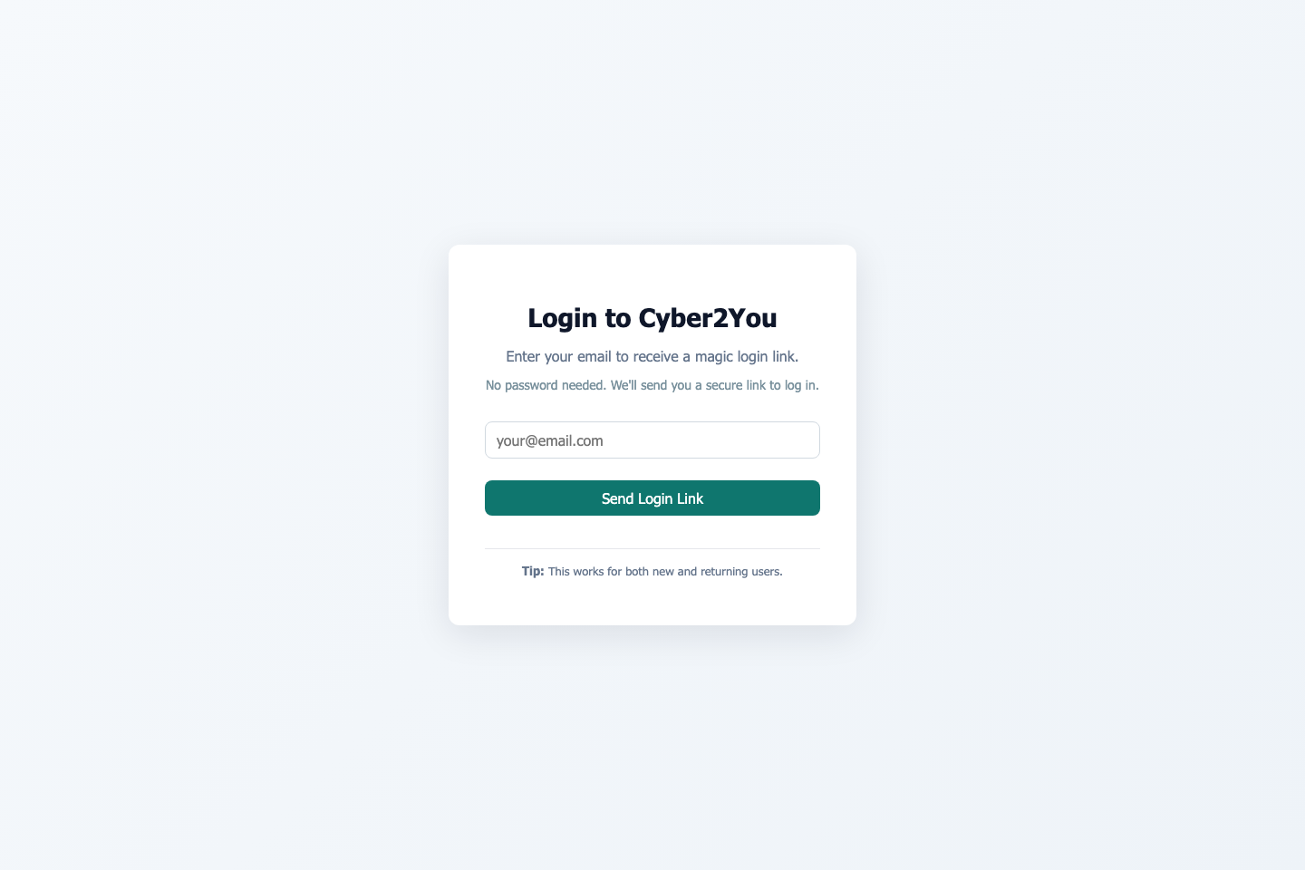
Figure 1 Cyber2U login page.
Source: Author's own screenshots (2026).
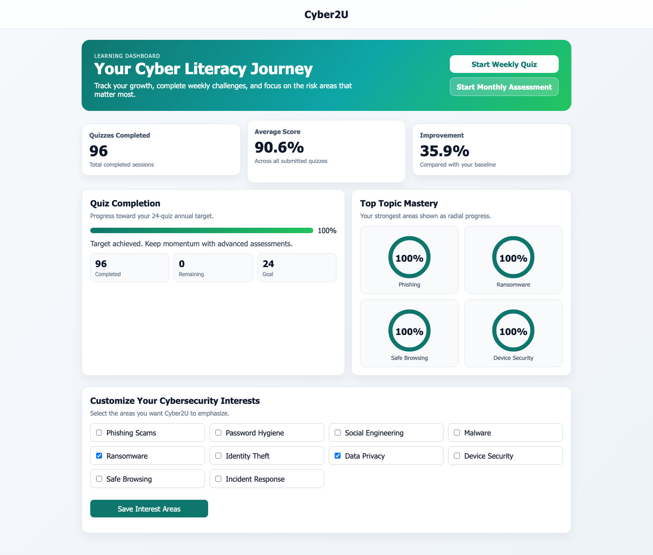
Figure 2 Learner dashboard with centered navbar and radial topic mastery charts.
Source: Author's own screenshots (2026).

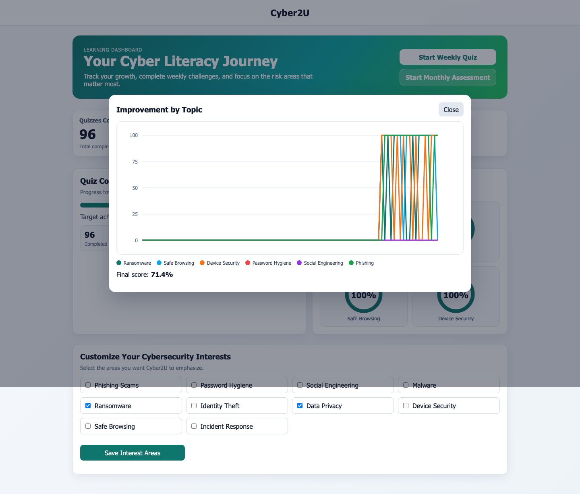
Figure 3 Improvement overlay showing topic score trends with final score.
Source: Author's own screenshots (2026).

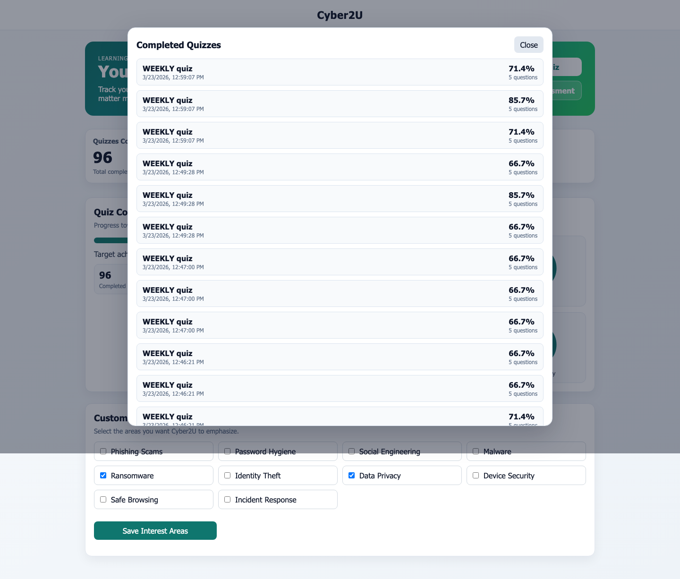
Figure 4 Completed quizzes overlay listing prior sessions.
Source: Author's own screenshots (2026).

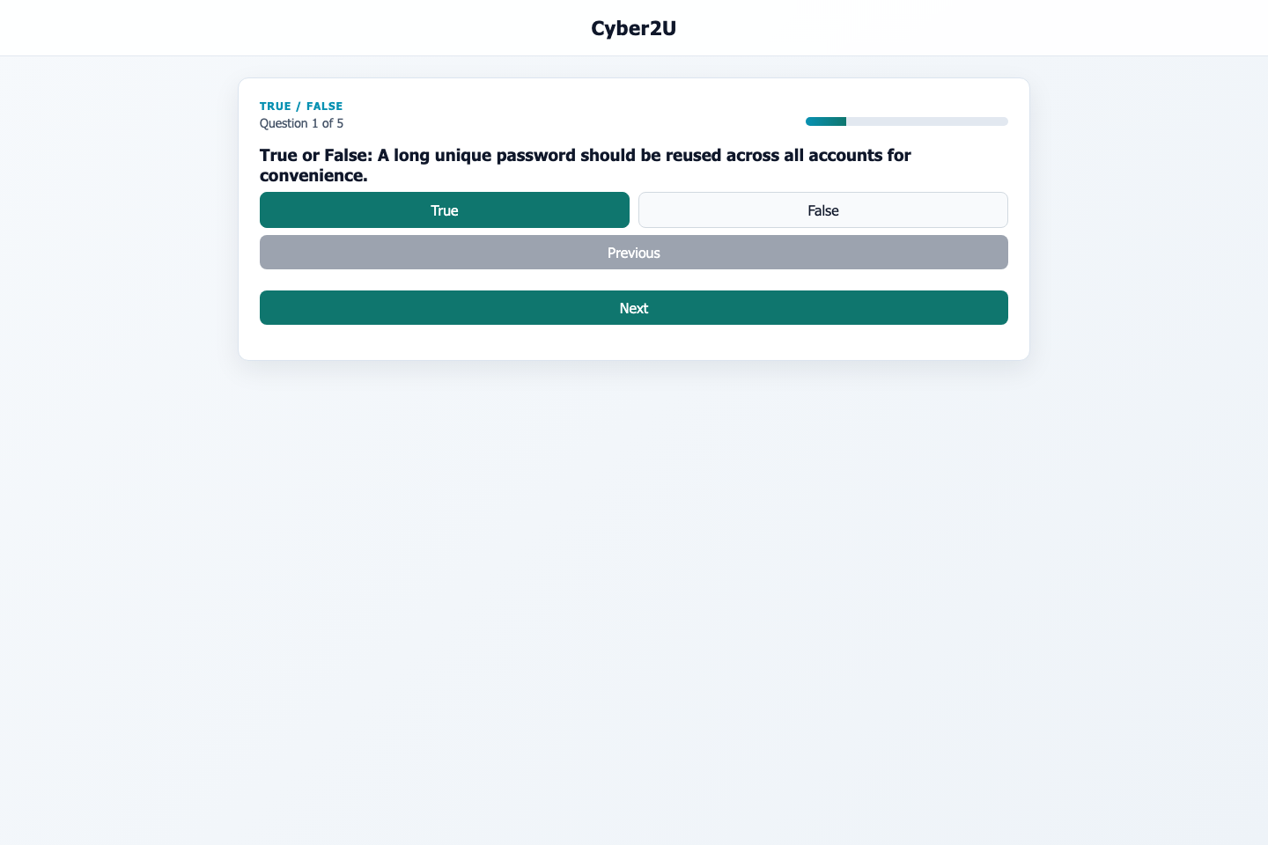
Figure 5 New weekly quiz in progress with user selecting an answer.
Source: Author's own screenshots (2026).

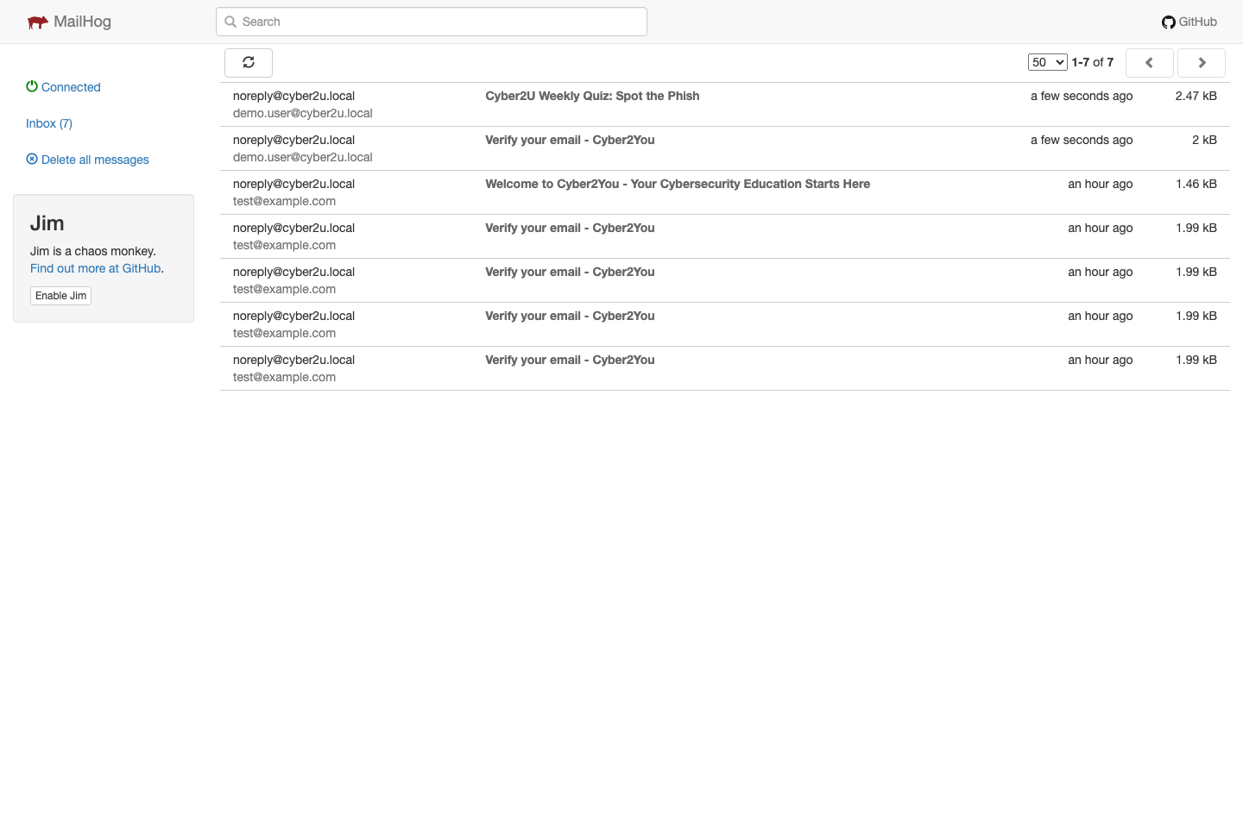
Figure 6 MailHog inbox showing verification and weekly quiz emails.
Source: Author's own screenshots (2026).


Figure 7 MailHog message view for the weekly quiz email with call-to-action.
Source: Author's own screenshots (2026).


Figure 8 Completed quiz review showing learner-selected answers and correct answers, with redo option.
Source: Author's own screenshots (2026).

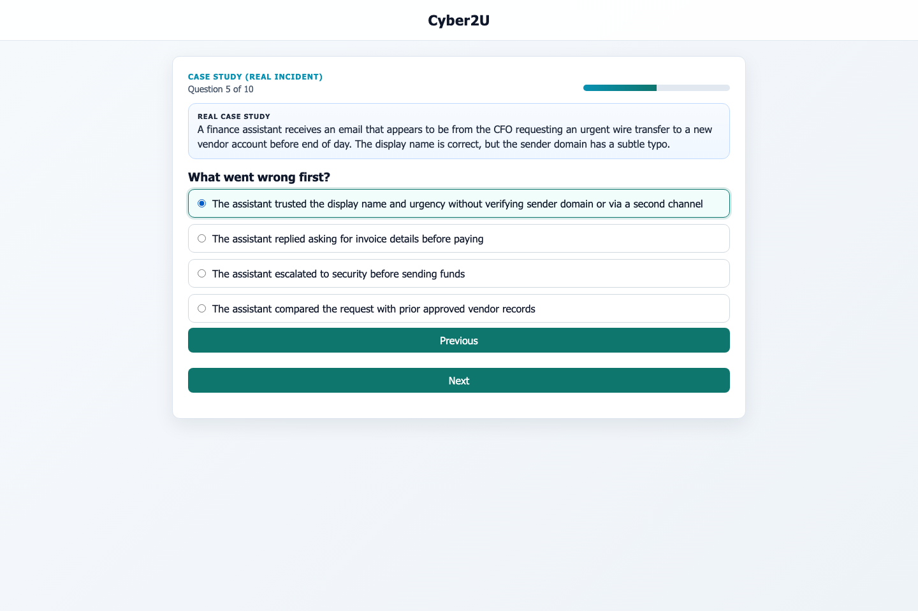
Figure 9 Case-study quiz question card with scenario context and multiple-choice response options.
Source: Author's own screenshots (2026).

