

Introduction Methodology Results
Conclusions Future Work
_{Appendi}x
Introduction Methodology Results Conclusions Future Work Appendix
Business Need: | Improving services and customers satisfy for Bacchanal Buffet.
Solution: | Using Yelp, Foursquare and Twitter data, Analyse Reviews, Customer’s Sentiment and provide suggestions.
Objectives: | • NLP Supervised Classification on Yelp Dataset • Sentiment Analysis on Yelp Dataset  • Scraping Foursquare Dataset and Building Sentiment Analysis • Getting Tweets about business and Building Sentiment Analysis. • Compare Results

3
Introduction Methodology Results Conclusions Future Work Appendix 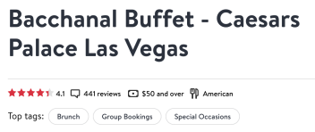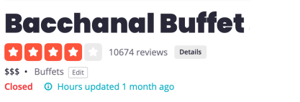
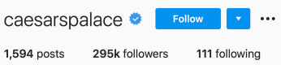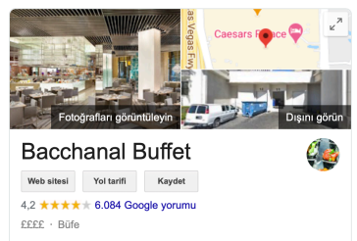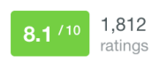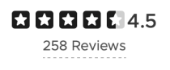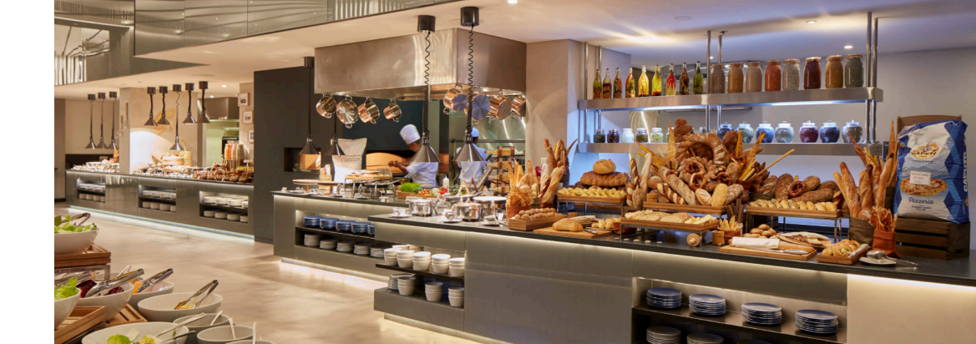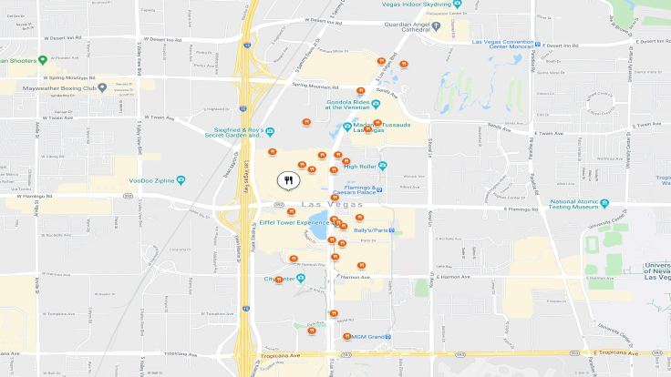4
Introduction Results Conclusions Future Work Appendix Methodology
Data Sources
• Json
• 209.393 business
• 1.968.703 users
• 8.021.122 reviews - 10.674
• Web Scraping
• 409 reviews
Data Acquire Manipulation
Tools
_{Modelling} NLP
Visualisation
• Nifi Get Twitter
5
Introduction Methodology Results Conclusions Future Work Appendix
Exploratory
Data Acquire Text Processing Modelling EvaluationData Analysis
6
Introduction Methodology Results Conclusions Future Work Appendix7
Introduction Methodology Results Conclusions Future Work Appendix8
Introduction Methodology Results Conclusions Future Work Appendix Text Processing
Adding Sentiment Features
1,2 —> Negative
3 —> Neutral
4,5 —> Positive
Removing Characters
numbers (1-9)
punctuation ()
new line (\n)
Convert Lower Case
Detecting Language
Removing non English (42 reviews)
Applying Stemming & Lemmatisation
9
Introduction Methodology Results Conclusions Future Work Appendix ModellingSplit dataset into X (feature) and y (target)
Split dataset into training and test sets
Methods
Count Vectorizer, 10374 rows x 15082 features
Count Vectorizer, Ngram,10374 rows x 244175 features
TF-IDF
TF-IDF, Ngram
Classifier
LogisticRegression(),
KNeighborsClassifier(),
DecisionTreeClassifier(),
RandomForestClassifier(),
AdaBoostClassifier(),
GradientBoostingClassifier(),
MultinomialNB(),
BernoulliNB()
10
10
Introduction Methodology Results Conclusions Future Work Appendix
11
11
Introduction Methodology Results Conclusions Future Work Appendix Sentiment Analysis - Text Processing
Removing Characters
numbers (1-9)
punctuation ()
new line (\n)
Convert Lower Case
Calculating Polarity, Subjectivity
TextBlob(text).sentiment
Calculating Pos, Neg, Neu, Compound
SentimentIntensityAnalyzer().polarity_scores()
12
12
Introduction Methodology Results Conclusions Future Work Appendix
WordCloud (5 Star) 4226 reviews
WordCloud (1 Star) 1051 reviews
13
13
Introduction Methodology Results Conclusions Future Work Appendix
WordCloud (Positive) Mean: 4.01
9167 reviews
WordCloud (Negative) Mean: 2.03
1167 reviews
14
14
Introduction Methodology Results Conclusions Future Work Appendix
Positive 2 words & 3 words Negative 2 words & 3 words
15
15
Introduction Methodology Results Conclusions Future Work Appendix
16
Introduction Methodology Results Conclusions Future Work Appendix
17
Introduction Methodology Results Conclusions Future Work Appendix
WordCloud (Positive) 262 reviews
WordCloud (Negative) 46 reviews
18
18
Introduction Methodology Results Conclusions Future Work Appendix ^{Positive 2 words & 3 words} Negative 2 words & 3 words
19
19
Introduction Methodology Results Conclusions Future Work Appendix
20
Introduction Methodology Results Conclusions Future Work Appendix
21
Introduction Methodology Results Conclusions Future Work Appendix
46.08 %
18.95 %34.97 %
22
Introduction Methodology Results Conclusions Future Work Appendix
Yelp  Supervised Cls  Positive Rate 66.06 | Yelp  Sentiment 88.37 | Foursquare Sentiment.  85.06 | Twitter  Sentiment  79.62
Negative Rate 18.93 | 11.25 | 14.94 | 16.28
Neutral Rate 15.01 | 0.39 | - | 4.1

23
Introduction Methodology Results Conclusions Future Work Appendix
• Waiting Long Time
• Expensive
• Salty
• Rude Waiter
• Restroom
• Customer services
• Food Poisoning
24
Introduction Methodology Results Conclusions Future Work Appendix
25

