Clothes House

Name: Haneen AL-Edinat

project Brief:

Each donation...New joy!

A project specialized in collecting and recycling surplus clothes and distributing them to the needy.

The idea here, where people can enter the site and make a donation request,

And the person who wants to take these donations can enter and choose among these donations and then

Communicate with him to deliver him to his home,

I wanted to start this project because there is no such website in Jordan

The idea was to make it easier for people to get their needs from these donations and prevent them

Embarrassment from going to associations and taking their needs.

In addition, I wanted to give this category an online shopping experience through their selection of items

The project is dedicated to collecting clothes for all age groups, children, men, and women,

When the user enters the site, he can browse the entire site without the need to log in or create an account, but when submitting

a donation request, the user must create an account and log in, and the same applies when the person who wants

to reserve some pieces enters the site must create an account and login

Where the site is entered and the donation request is submitted, and the donor is given time to receive the goods,

And upon entering the person who will take these goods,

A date will be set for receiving the pieces in a week.

List of technologies that are covered by the project:

- HTML

- CSS

- JavaScript

- Laravel

- MYSQL

Project information

Problem Statement:

In society, many people need some assistance and are working on registering through charities

And when going to receive this aid, it takes a lot of time and effort, in addition to embarrassment.

Solution Statement:

The solution was through the site, now you can enter and choose from clothes and you will reach your door.

REQUIREMENTS

Stakeholders: The stakeholders of my app are divided into two types:

1. User: Who can access the website and his functions are as follows:

-The user can send a donation request

-The user can reserve a piece of clothing

-The user can update his data

-The user can view his data

-The user can send contact us a request

-The user can search for clothes

2. The Admin: Who manage the clothes, users, categories, Contact us his functions are as follow:

-The Admin can add new cloth to the website.

-The Admin can edit the information of cloth.

-The Admin can delete a cloth.

-The Admin can add a new category to the website.

-The admin can edit the information of the category.

-The Admin can delete a category.

-The Admin can add a new user to the website.

-The Admin can edit the information of the user.

-The Admin can delete a user.

-The Admin can delete a contact information

Non-Functional Requirements:

- Availability: our application is available to users 24 hours a day,

there are.

-Usability: my web application is easy to use.

Performance: the system is well-programmed so that it doesn't use a lot

of system resource and it is fast.

- Security: in a web application, there is a login page for both the user and the

admin, I used middleware in Laravel to restrict who can access the admin pages

and make edits addition and deletion on it as well as I used Cross-site request forgeries (CSRF)

to protect your application from cross-site request forgeries (CSRF)

Attacks.

Project Expected output :

The web application is designed to be easy to use and

Donation and reservation of clothes by the beneficiary.

Database Design

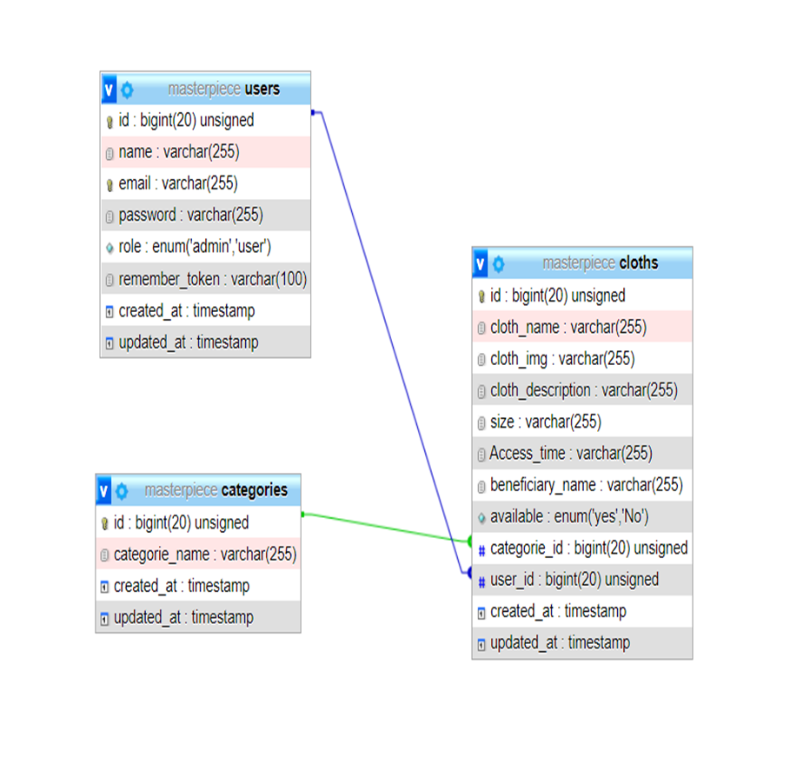

Use Case Diagram

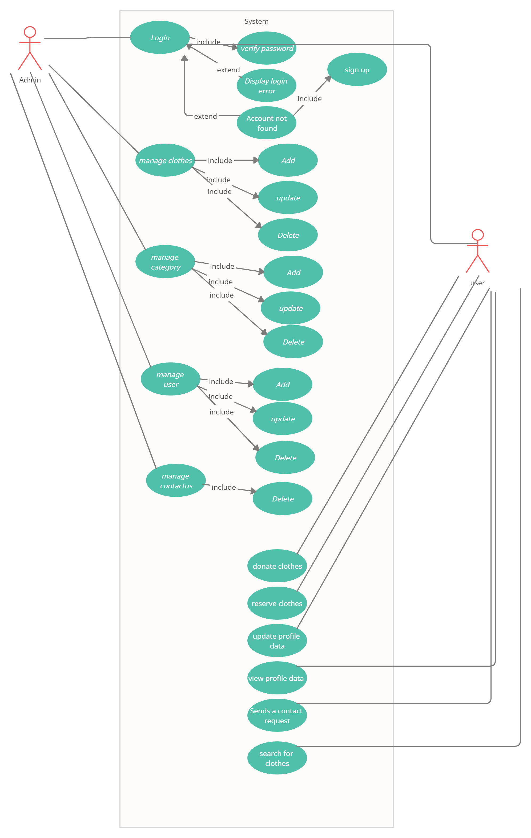

System wireframe

Landing page:

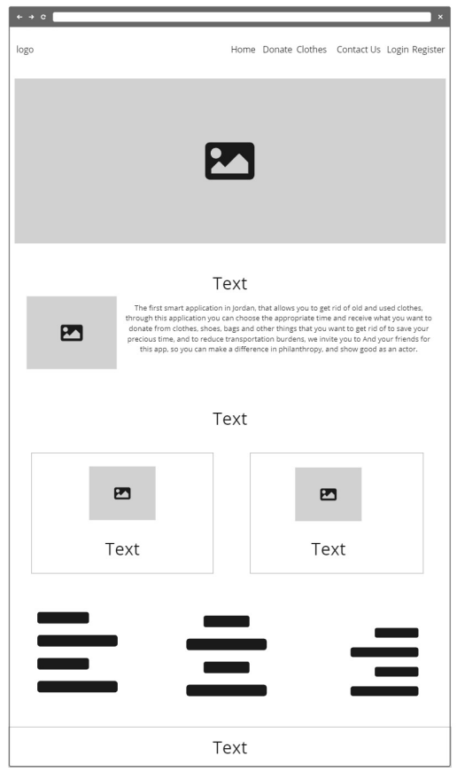

## Donors Form

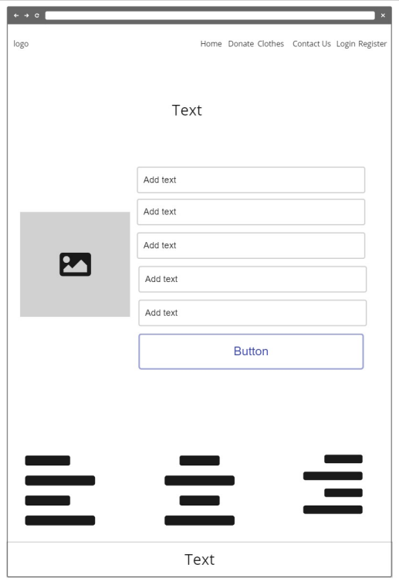

Clothes page:

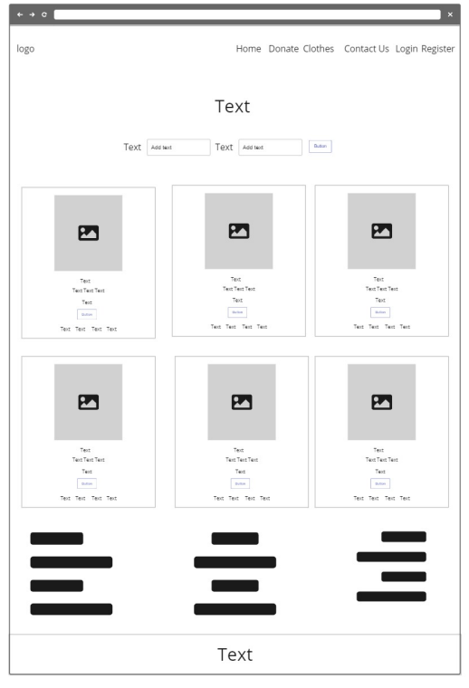

Contact Us page:

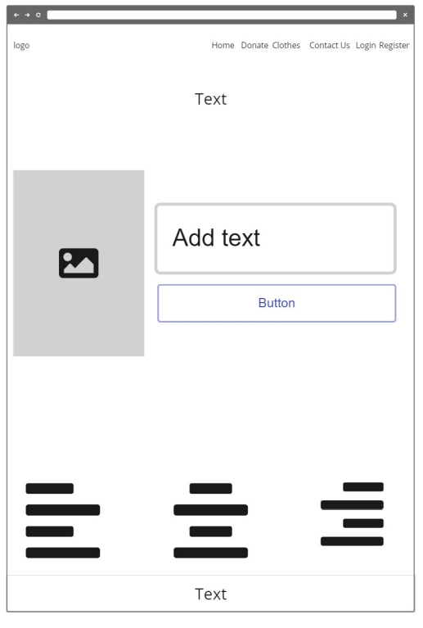

Login page:

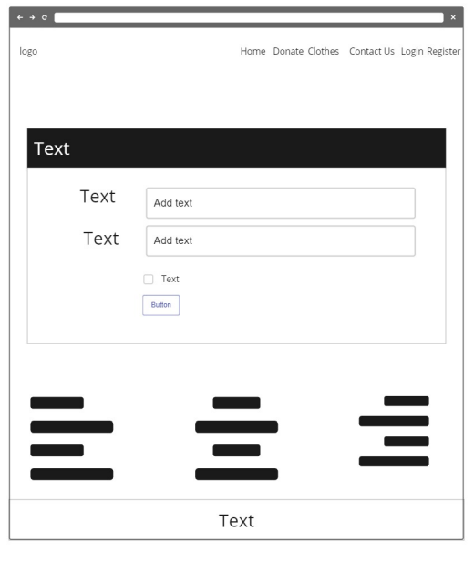

Register page:

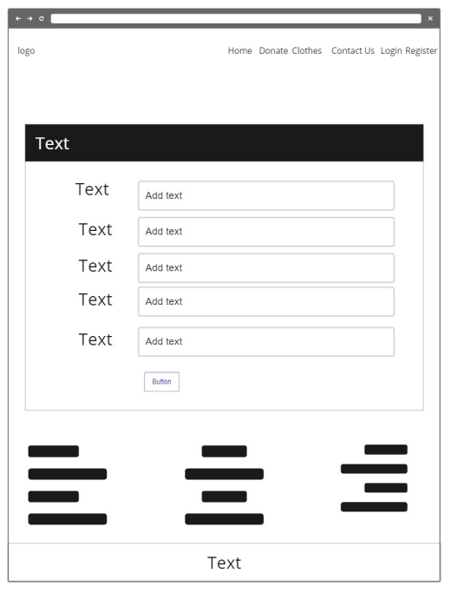

Profile page:

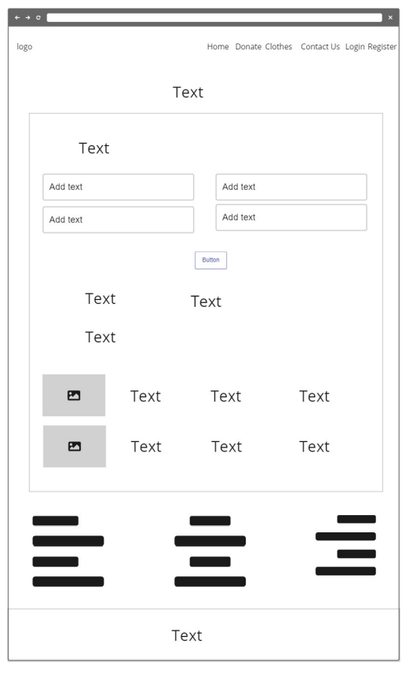

System mockup

Landing page:

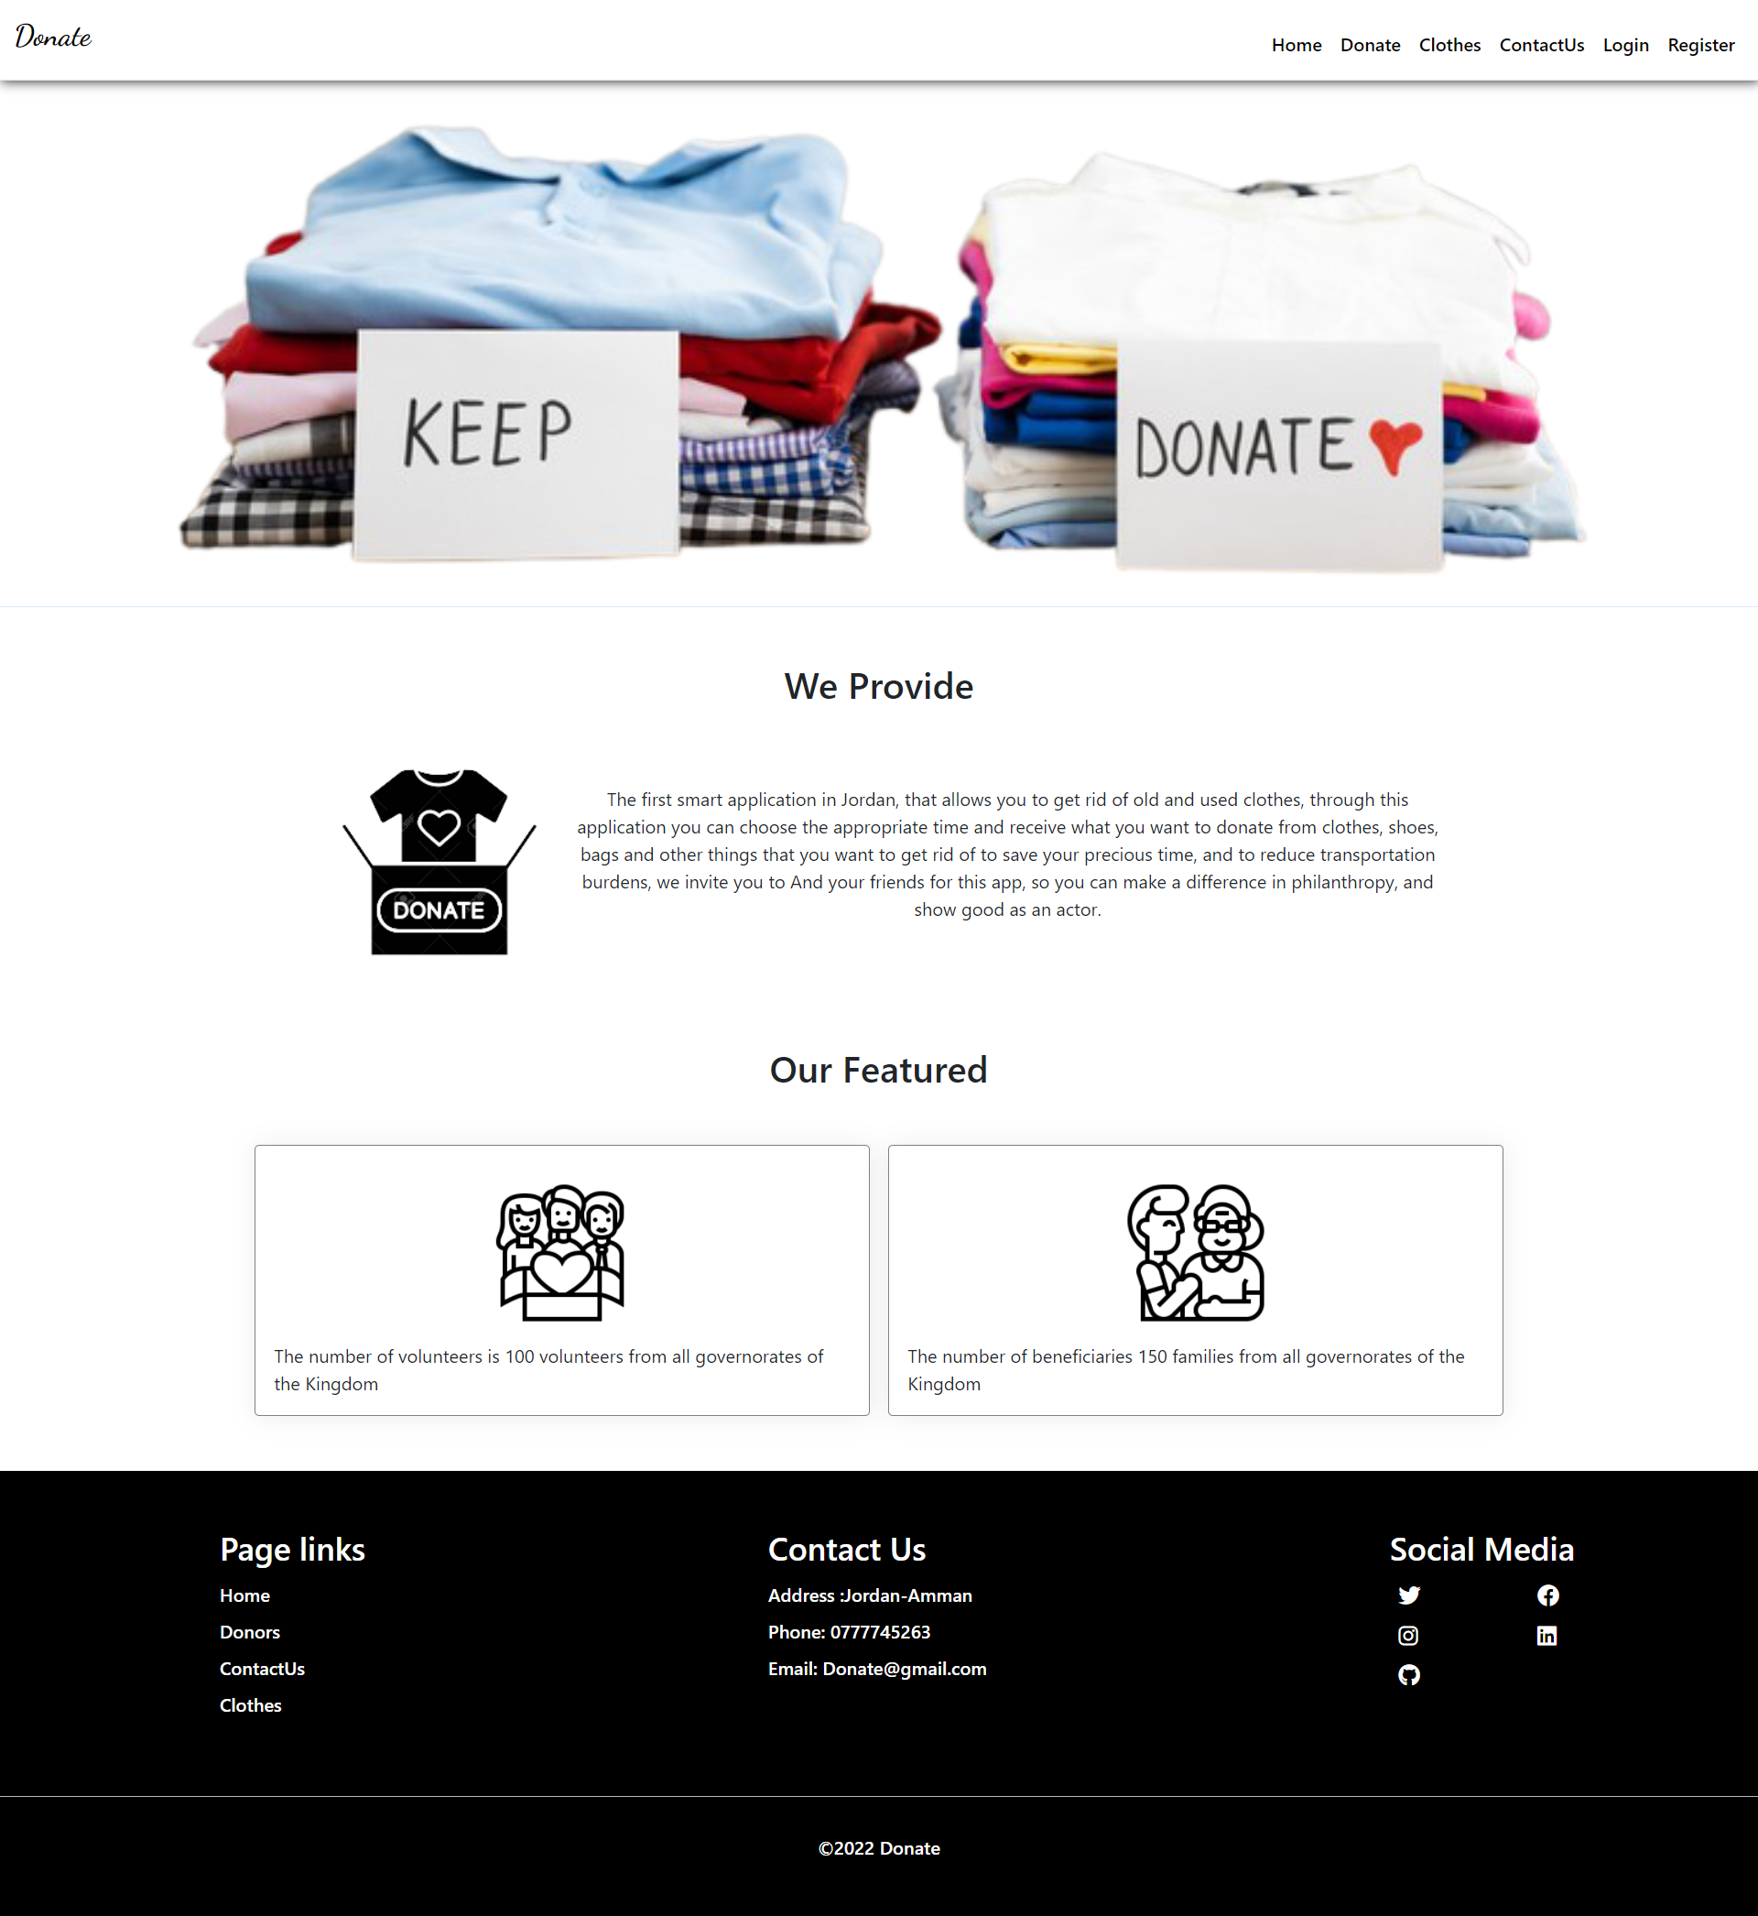

Donors Form:

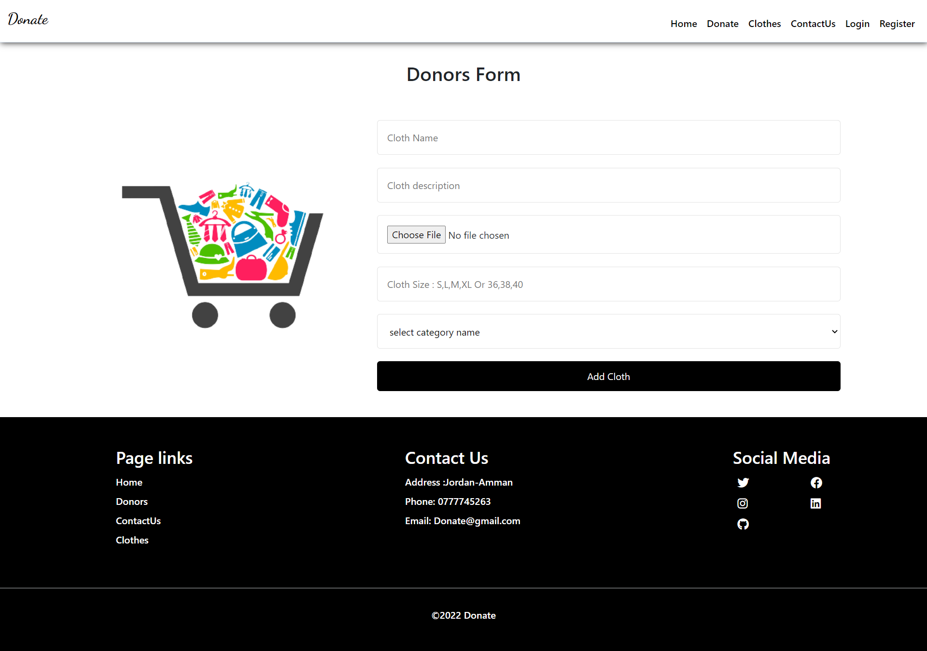

Clothes page:

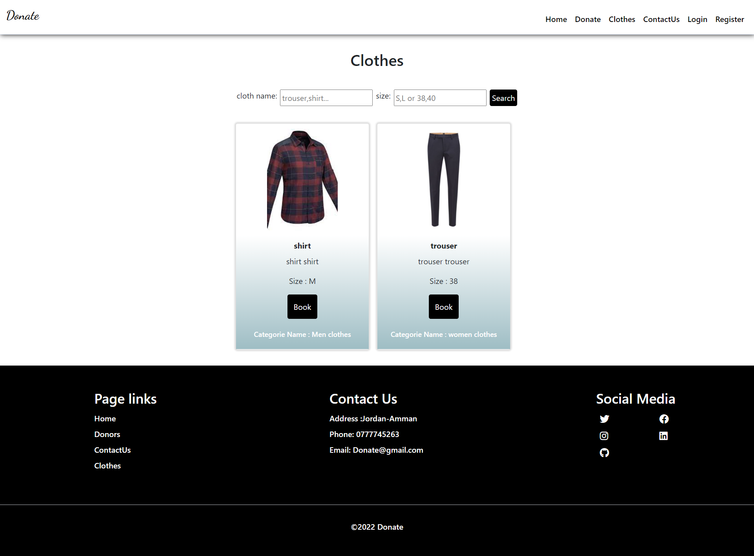

Contact Us page:

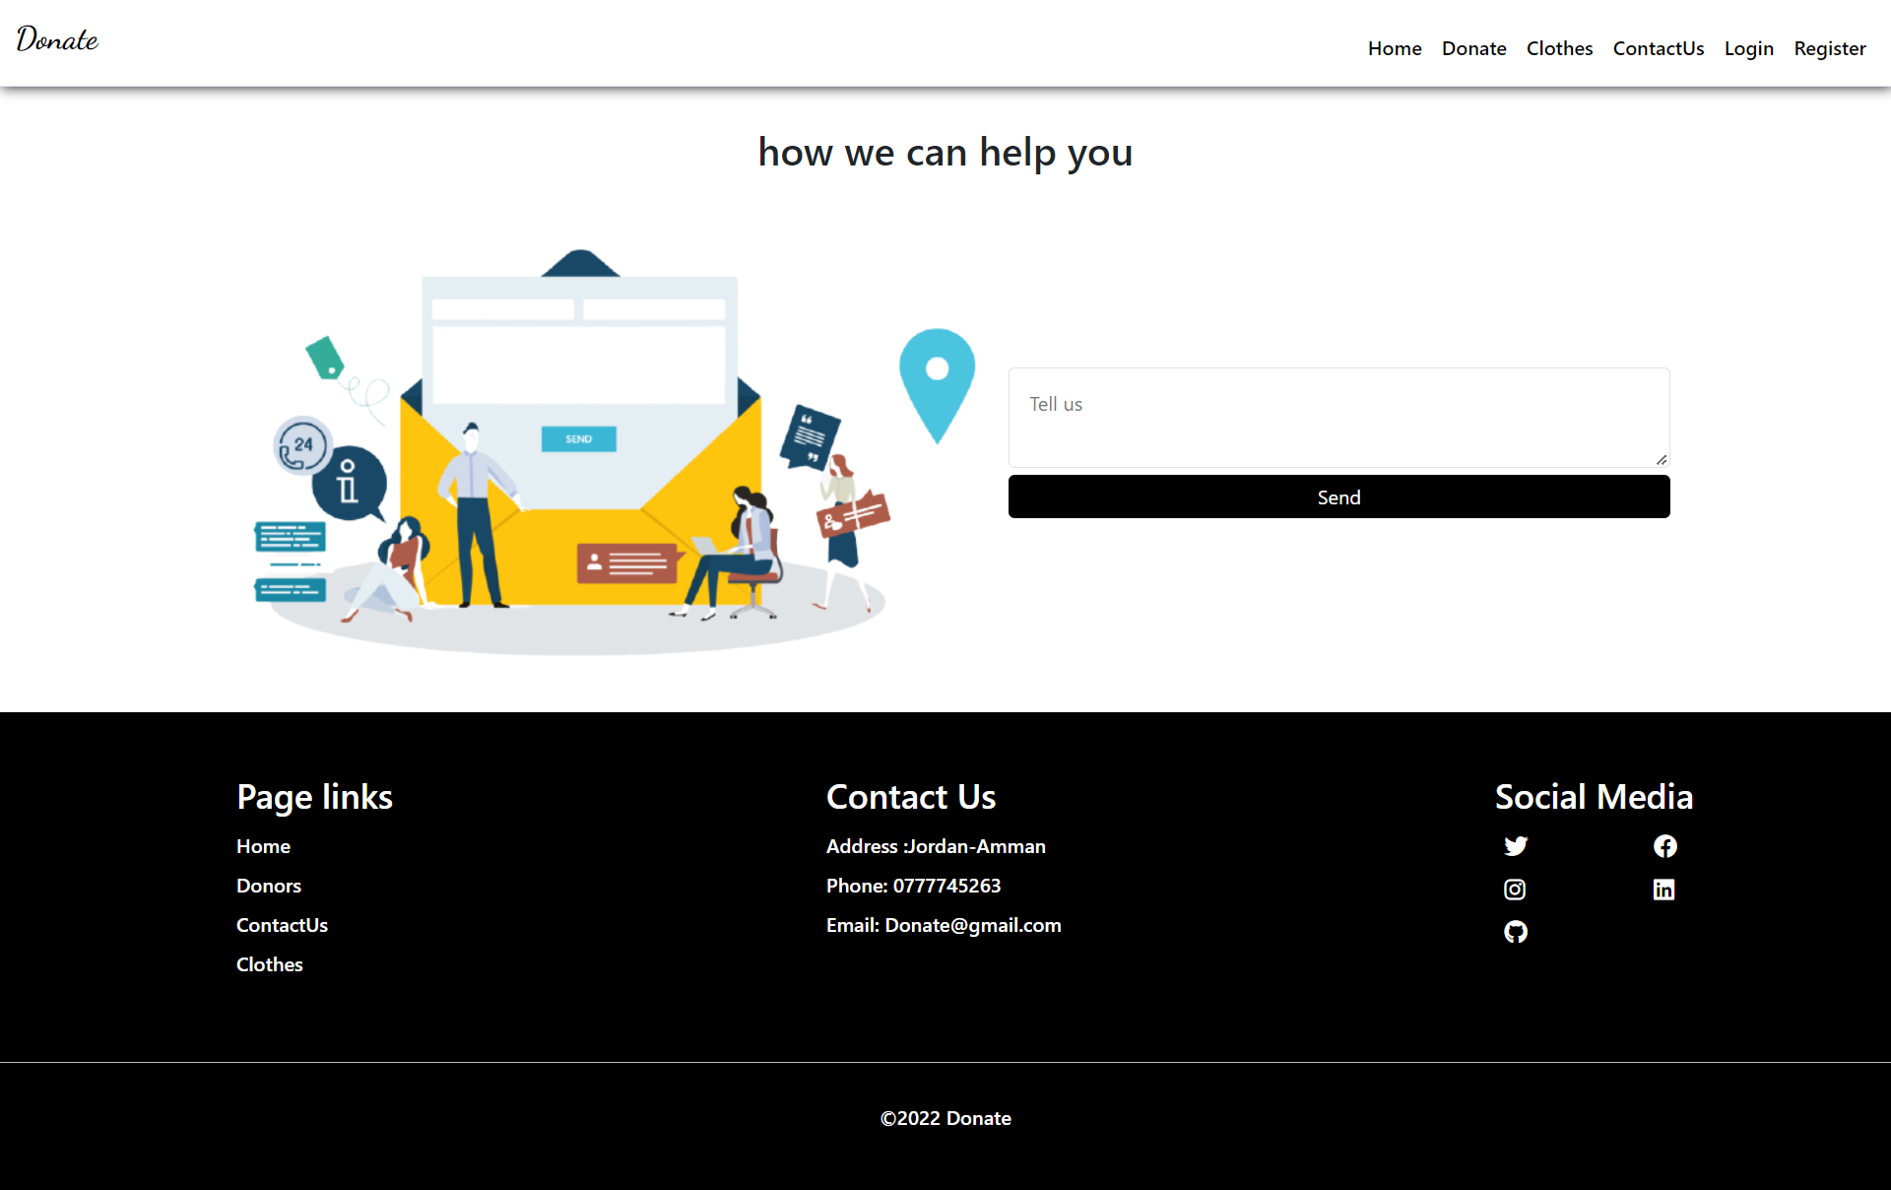

Login page:

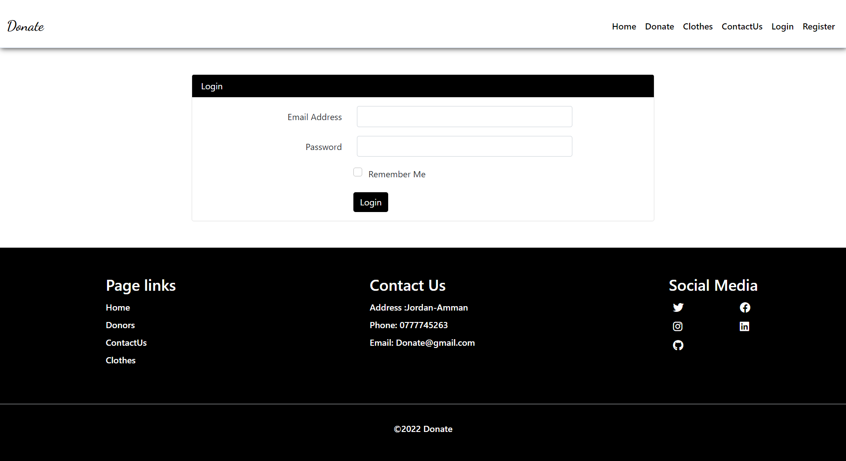

Register page:

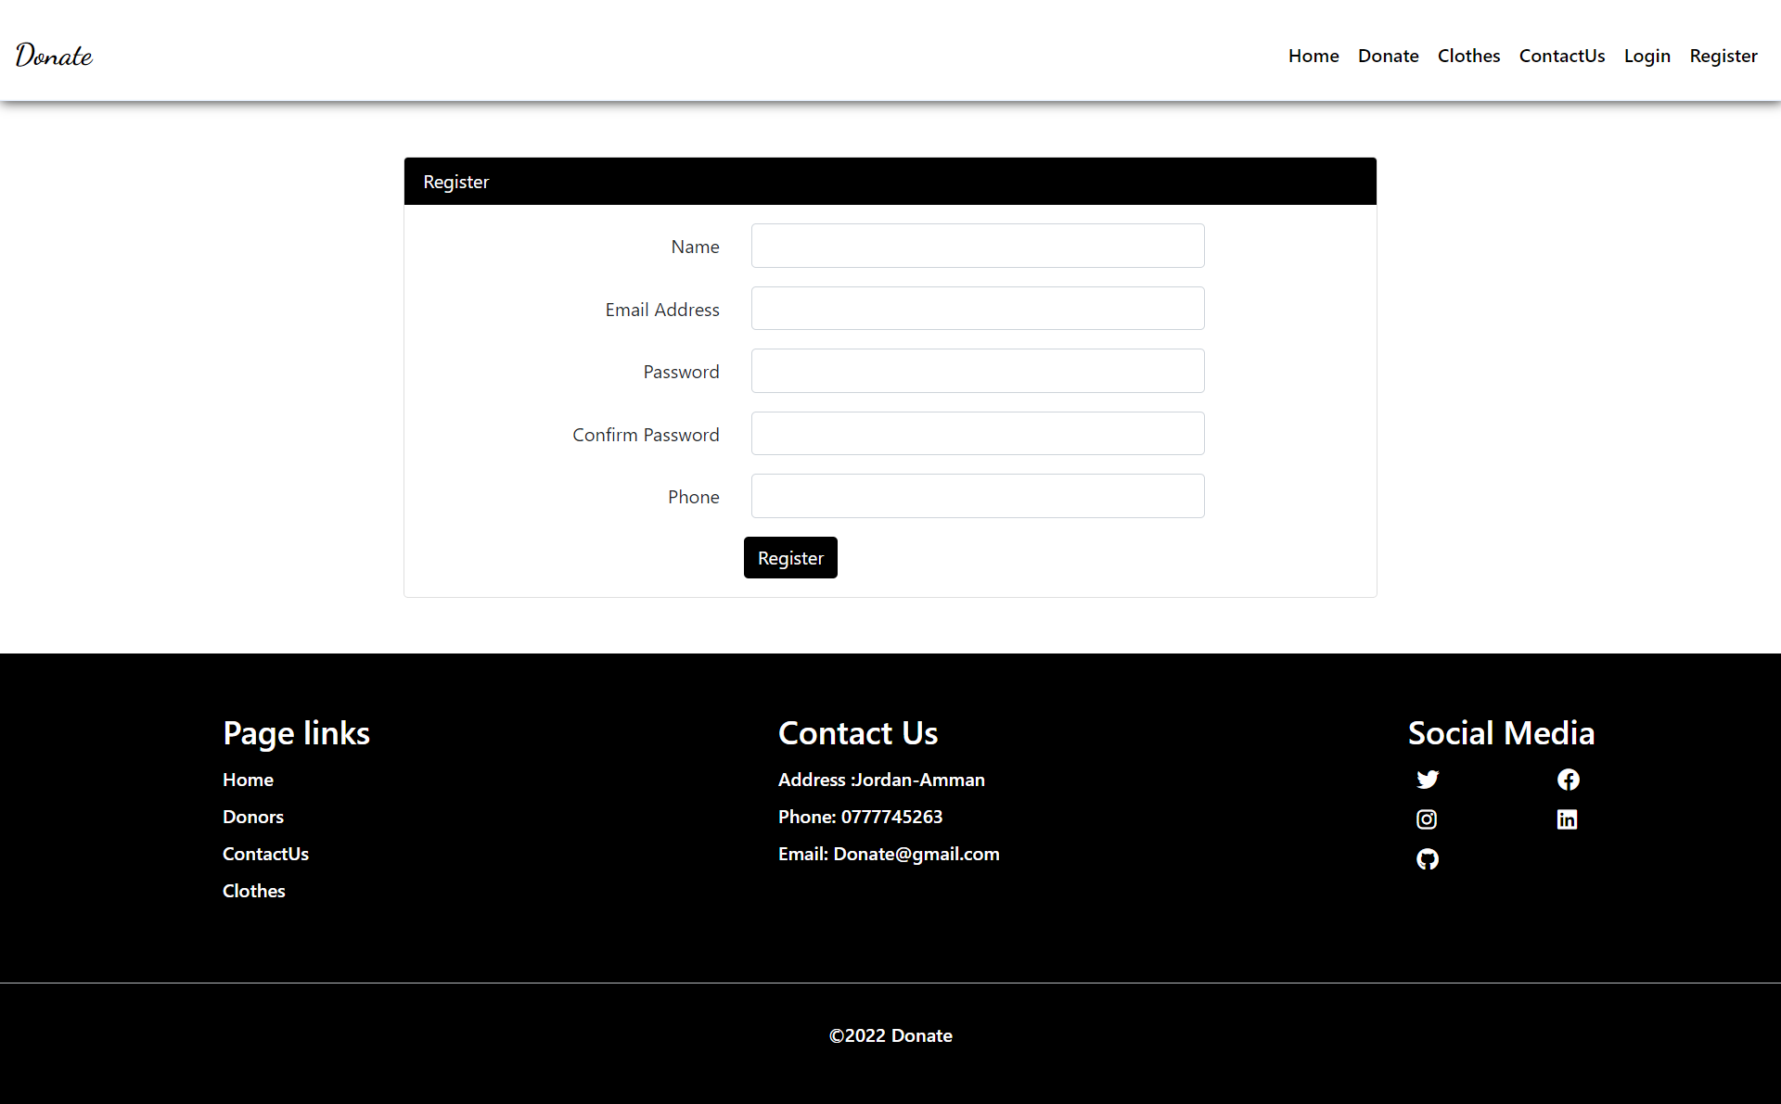

Profile page:

