Assignment 3 Project Plan:

Project Title: Project Management Tracker

Overview:

This CRUD based web application is a project management tracker that allows employees from “company ABC” to plan projects and deadlines on a virtually accessible planner. Employees will be able to make, edit, and delete projects and will have full access to a page that allows them to read entries made by all employees on the shared database. There will be a home page (landing page), projects page (mongo database), how-to page (helps show employees how to navigate the website, and lastly a help page (contact information and FAQ for tech support).

Objectives:

- Fully implement CRUD in the web application (include a delete confirmation page)
- Use mongoDB to store all inputs in a shared employee projects database
- Use bootstrap and and EJS template for efficiency and organization
- Include a new shared header/footer separate to example nav bar in class
- Protect mongoDB username/password using .env and .gitignore
- Deploy website on Render

Features:

- Read projects
- Add projects
- Edit projects
- Delete projects (with warning)

Diagram:

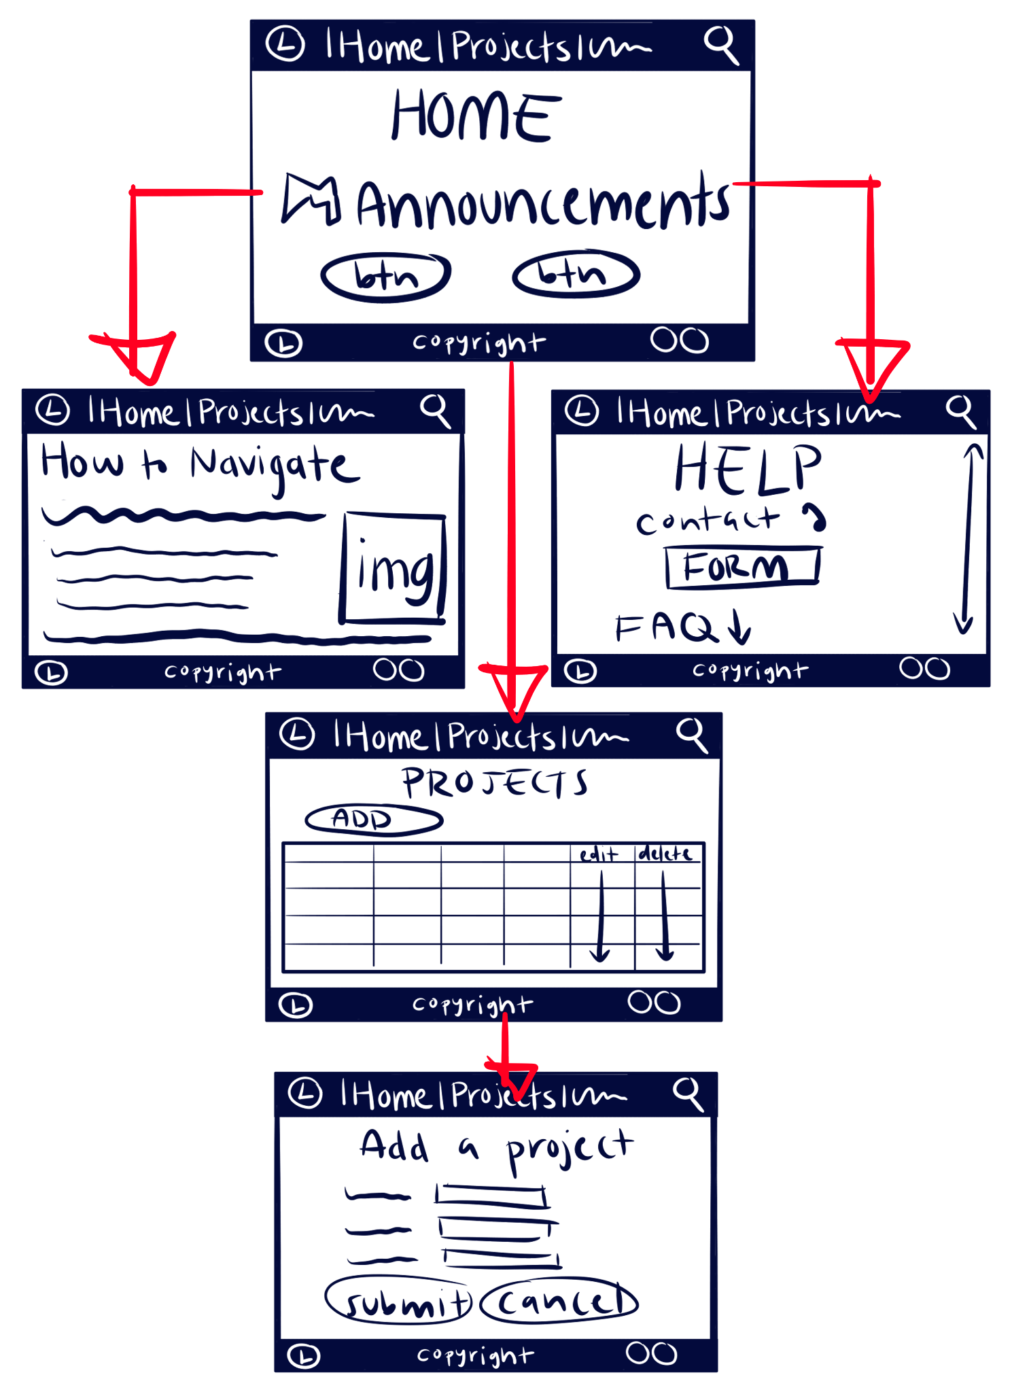
Projects Database Schema:

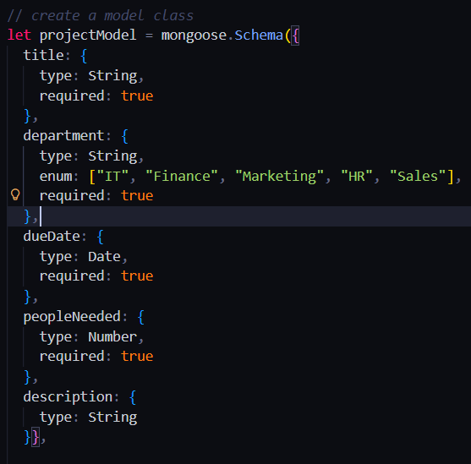

*for department, enum provides a list of allowed values, this will be further implemented in front end with a drop down component for department choices
*all are required, this prevents users from attempting to opt out of fields when adding or editing projects

