Use Case Diagram
Shows the interaction between the user and system components.
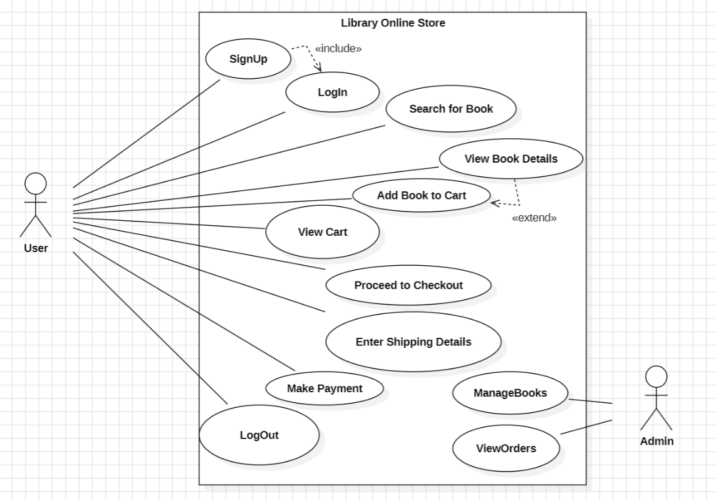
6.2 Sequence Diagram
Depicts the flow of events during sign-up, log-in, book search, view details, cart addition, checkout, and logout.
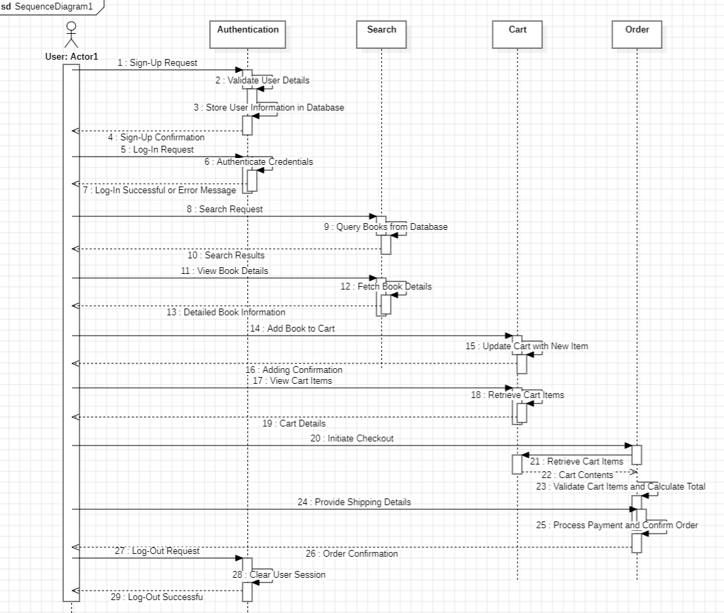

  - Class Diagram
