HBase Assignment
Beginner & Intermediate
Individual Practice Task

Overview

In this assignment you will build and query a product inventory system using HBase. You will work with a table called store that holds information about products across two column families.

Table Name | Column Families | Total Records
store | details, inventory | 5 products

Dataset — store Table

Column Family | Columns
details | name, brand, category
inventory | price, quantity, warehouse

Row Key | Name | Brand | Category | Price | Quantity | Warehouse
1 | laptop | dell | electronics | 1200 | 50 | A
2 | phone | samsung | electronics | 800 | 120 | A
3 | desk | ikea | furniture | 300 | 30 | B
4 | chair | ikea | furniture | 150 | 60 | B
5 | tablet | apple | electronics | 600 | 80 | A

Instructions

- Read each question carefully before writing your command.
- Write your HBase shell command(s) in the answer box below each question.
- Test every command in your HBase shell and verify the output before submitting.
- The dataset above is your only reference — do not use the emp or student tables.
Answers are provided at the end of this document. Do not look ahead until you have attempted all questions.

PART A — BEGINNER
Questions 1–6 cover table creation, inserting data, scanning, getting, and filtering.

Q1 Create the store table with two column families: details and inventory.
Your Answer:
create 'store', 'details', 'inventory'

Q2 Insert all 5 rows from the dataset above into the store table. Insert all columns for both column families.
Your Answer:
put 'store', 1, 'details:name', 'laptop'
put 'store', 2, 'details:name', 'phone'
put 'store', 3, 'details:name', 'desk'
put 'store', 4, 'details:name', 'chair'
put 'store', 5, 'details:name', 'tablet'

put 'store', 1, 'details:brand', 'dell'
put 'store', 2, 'details:brand', 'samsung'
put 'store', 3, 'details:brand', 'ikea'
put 'store', 4, 'details:brand', 'ikea'
put 'store', 5, 'details:brand', 'apple'

put 'store', 1, 'details:category', 'electronics'
put 'store', 2, 'details:category', 'electronics'
put 'store', 3, 'details:category', 'furniture'
put 'store', 4, 'details:category', 'furniture'
put 'store', 5, 'details:category', 'electronics'

put 'store', 1, 'inventory:price', '1200'
put 'store', 2, 'inventory:price', '800'
put 'store', 3, 'inventory:price', '300'
put 'store', 4, 'inventory:price', '150'
put 'store', 5, 'inventory:price', '600'

put 'store', 1, 'inventory:quantity', '50'
put 'store', 2, 'inventory:quantity', '120'
put 'store', 3, 'inventory:quantity', '30'
put 'store', 4, 'inventory:quantity', '60'
put 'store', 5, 'inventory:quantity', '80'

put 'store', 1, 'inventory:warehouse', 'A'
put 'store', 2, 'inventory:warehouse', 'A'
put 'store', 3, 'inventory:warehouse', 'B'
put 'store', 4, 'inventory:warehouse', 'B'
put 'store', 5, 'inventory:warehouse', 'A'

Q3 Scan the entire store table and confirm all 5 rows are present.
Your Answer:
scan 'store'
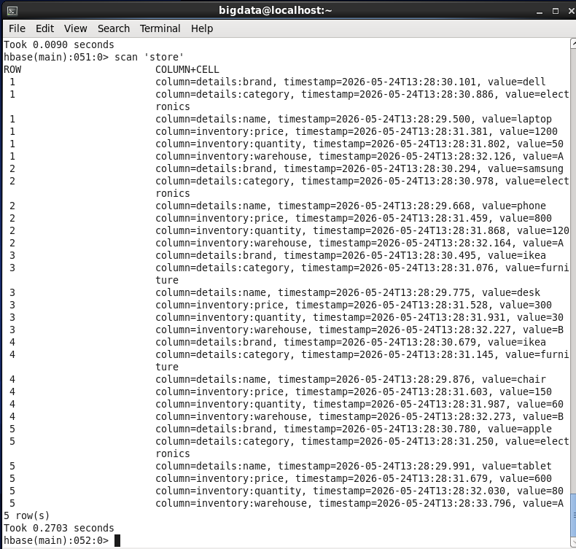

Q4 Retrieve all columns for the product with row key 3 (desk).
Your Answer:
get 'store', '3'
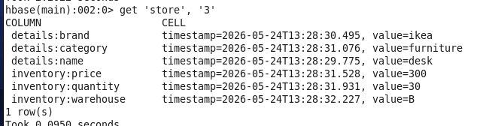

Q5 Retrieve only the inventory:price column for the product with row key 5 (tablet).
Your Answer:
get 'store', '5', {COLUMN => 'inventory:price'}
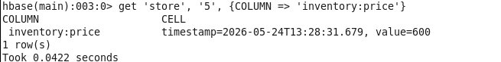

Q6 Use a ValueFilter scan to find all products with warehouse value A.
💡 Hint: Use the COLUMNS and FILTER options together in your scan.
Your Answer:
scan 'store', {
COLUMNS => 'inventory:warehouse',
FILTER => "ValueFilter(=,'binary:A')"
}
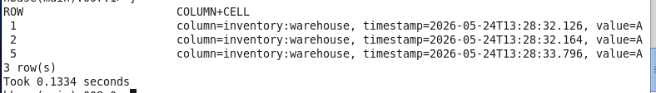

PART B — INTERMEDIATE
Questions 7–12 cover versioning, advanced filters, altering the table, and managing table lifecycle.

Q7 Enable versioning on the inventory column family to store up to 4 versions.
Your Answer:
alter 'store', NAME => 'inventory', VERSIONS => 4
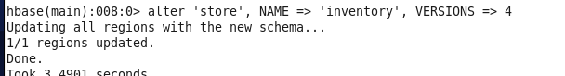

Q8 Update the inventory:quantity for the laptop (row 1) three times: first to 45, then to 40, then to 35. Then retrieve all stored versions of that cell.
💡 Hint: You need to alter versions first — make sure Q7 is done before this.
Your Answer:
put 'store', '1', 'inventory:quantity', '45'
put 'store', '1', 'inventory:quantity', '40'
put 'store', '1', 'inventory:quantity', '35'

get 'store', '1', {COLUMN => 'inventory:quantity', VERSIONS => 4}
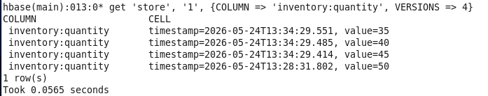

Q9 Use SingleColumnValueFilter to find all products in the furniture category.
Your Answer:
scan 'store', {
FILTER => "SingleColumnValueFilter('details','category',=,'binary:furniture')"
}
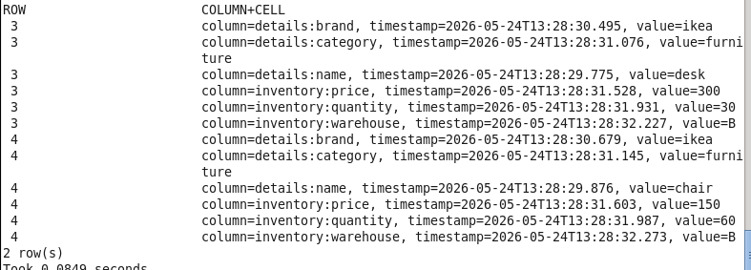

Q10 Use SingleColumnValueFilter to find all products stored in warehouse B.
Your Answer:
scan 'store', {
FILTER => "SingleColumnValueFilter('inventory','warehouse',=,'binary:B')"
}
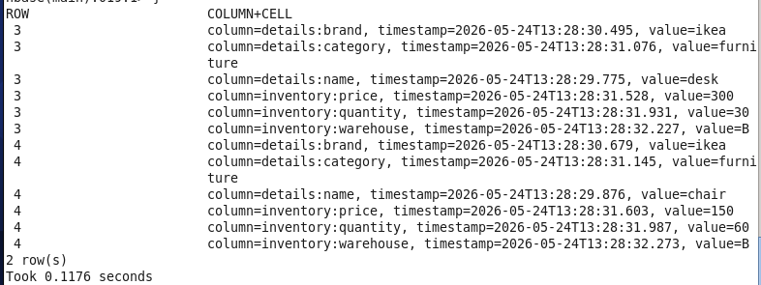

Q11 Add a new column family called supplier to the store table. Then insert supplier:country as egypt for row 1 and supplier:country as korea for row 2. Verify the schema updated correctly.
Your Answer:
alter 'store', NAME => 'supplier'

put 'store', '1', 'supplier:country', 'egypt'
put 'store', '2', 'supplier:country', 'korea'

describe 'store'
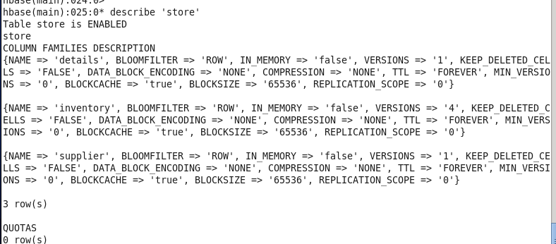

Q12 CHALLENGE 🏆 Write a single scan that returns only products that are in the electronics category AND stored in warehouse A.
💡 Hint: Look up FilterList with MUST_PASS_ALL to combine two SingleColumnValueFilter conditions.
Your Answer:
scan 'store', {
FILTER => "SingleColumnValueFilter('details','category',=,'binary:electronics') AND SingleColumnValueFilter('inventory','warehouse',=,'binary:A')"
}
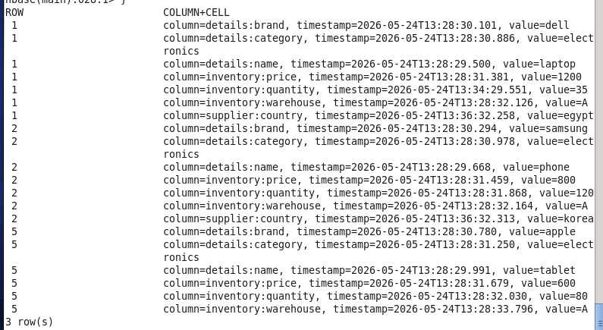

— End of Assignment —

