By: Haneen Alqennah 23120112

ML Assignment
Gallstone disease
Technical Report
Course: Machine Learning– Fall 2025/2026
Course instructor: Ala'a Alhabashna

Data Preparation and Description (Q1)

Data Description
The dataset is for Gallstone disease, and it's a common disease in the digestive system. The data has 38 features, like: age, height, weight, vitamin D, blood test results, and many medical tests. Also, it has 319 records, 161 of them are suffering and 158 are healthy. The target feature in the data is “Gallstone Status”, where 1 indicates that the presence of gallstone disease and 0 indicates a healthy individual.
The objective of this study is to develop a machine learning model that predicts whether the person is healthy or not using a set of 38 input features. The statement is binary classification, because we are classifying the individual as either a gallstone patient or a healthy control. The goal is to maximize predictive performance while identifying the most influential features associated with gallstone disease.
A successful prediction will help doctors diagnose the disease early which will reduce negative effects, and it will help to reduce the cost and time.

Data Preparation
I start to prepare the data to implement the models later.
There was not any null values or any object variable:
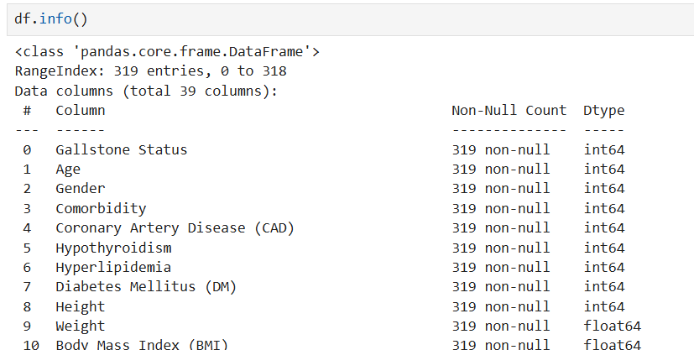
I have printed the data description to understand the dataset deeply:
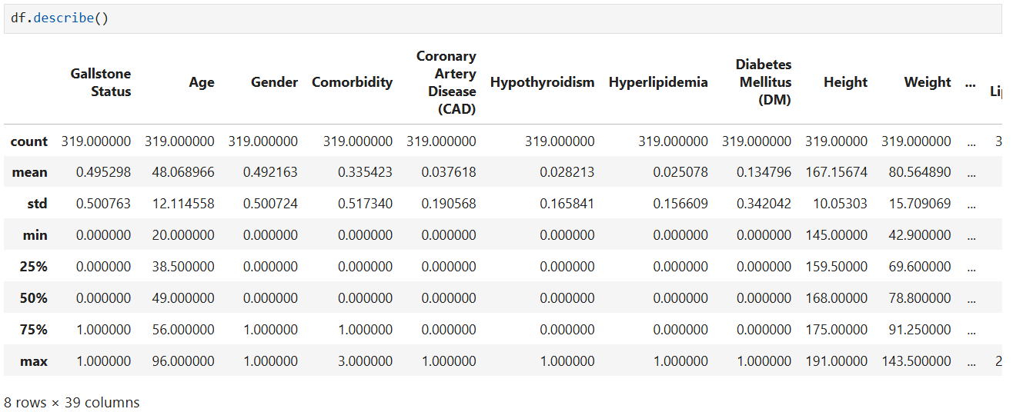
I have checked the duplicated and they ware zero:
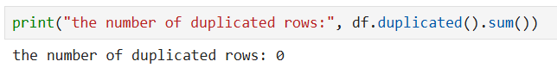
printing the co-relations between the variables:
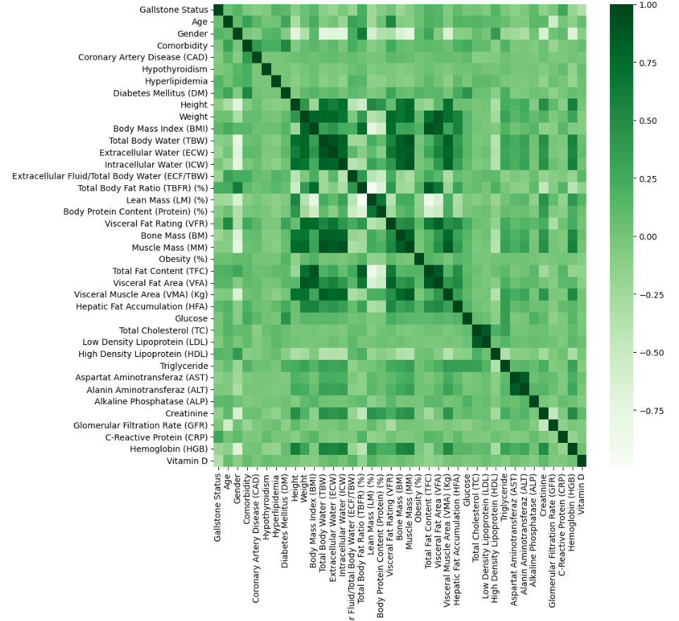
Next, I separated the data to input data (independent) and output data (dependent):
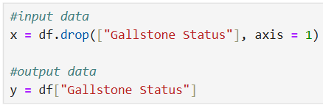
Then, split the data to training and testing sets (20% for testing and 80% for training):
Finally, Scaling the x_train and x_test (there are differences in the data and we will use sensitive models so we need to scale them):
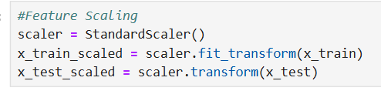

Model Implementation (Q2)
Now, we will implement and compare four machine learning algorithms for this problem.
This first code - Random Forest:
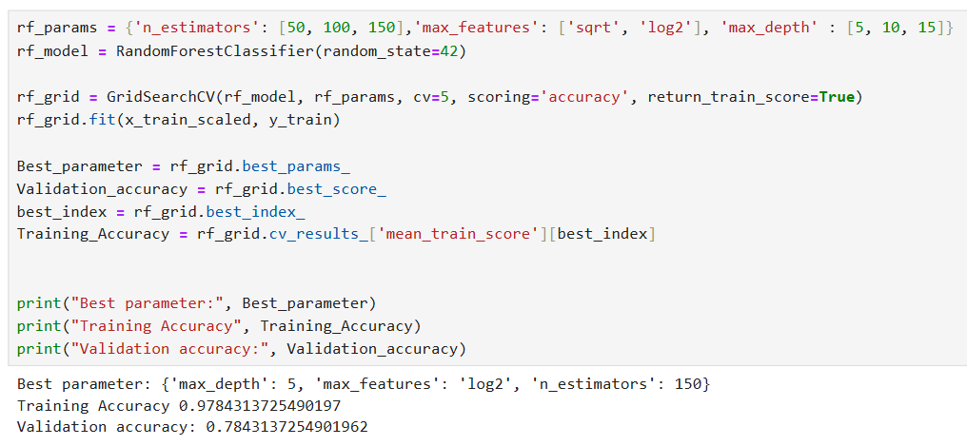

This second code - Gradient Boosting:
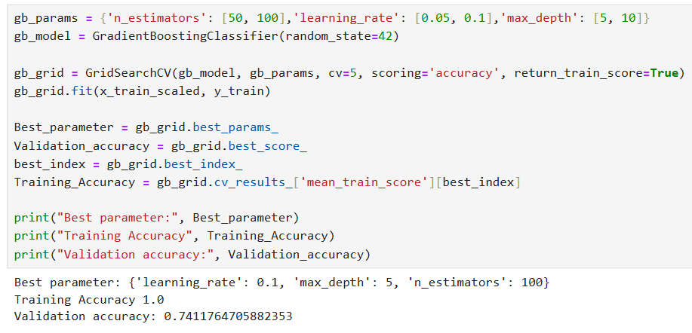
This third code - eXtreme Gradient Boosting (XDBoost):
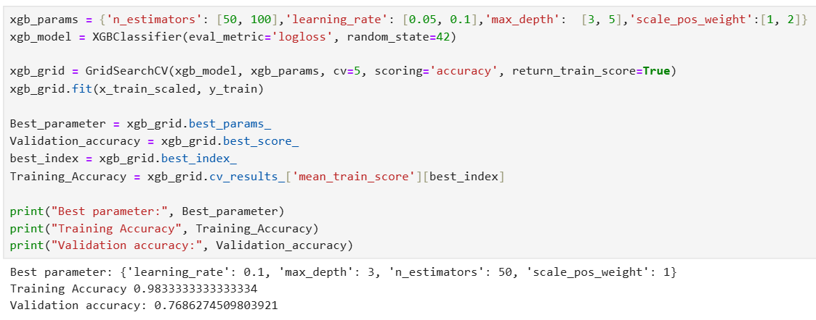

The fourth code - Support Vector Machine (SVM):
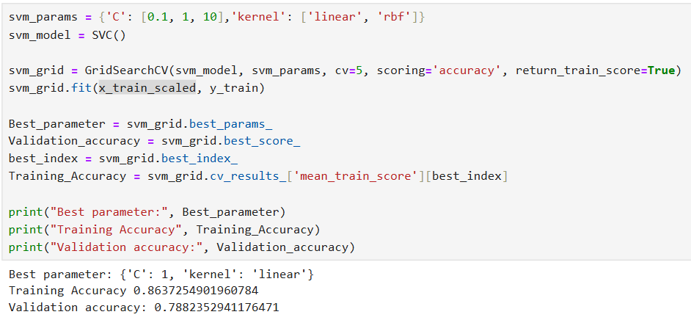

Algorithm | Hyperparameter | Description | Values considered
Random forest | n_estimators | The number of trees in the model | 50, 100, 150
 | max_features | The maximum number of features for each tree | 'sqrt', 'log2'
 | max_depth | The maximum depth of single tree | 5, 10, 15
Gradient Boosting | n_estimators | The number of the boosting stages that will be implemented. | 50, 100
 | learning_rate | Variable reduces the contribution of each tree | 0.05, 0.1
 | max_depth | The maximum depth of single tree | 5, 10
XGBoost | n_estimators | The number of the boosting stages that will be implemented. | 50, 100
 | learning_rate | Variable reduces the contribution of each tree | 0.05, 0.1
 | max_depth | The maximum depth of single tree | 3, 5
SVM | C | It is a variable that controls the balance to widen or narrow the margin and classify points correctly. | 0.1, 1, 10
 | kernel | The type of kernel used in the algorithm | 'linear', 'rbf'

Algorithm | Combination of hyperparameter values | Training performance | Validation performance
Random forest | 'max_depth': 5  'max_features': 'log2'  'n_estimators': 150 | 0.978 | 0.784
Gradient Boosting | 'learning_rate': 0.1, 'max_depth': 5, 'n_estimators': 100 | 1.0 | 0.741
XGBoost | 'Learning_rate': 0.1  'Max_depth': 3  'n_estimators': 50 | 0.983 | 0.768
SVM | 'C': 1  'kernel': 'linear' | 0.863 | 0.788

Grid search with cross validation was used for hyper parameter tuning in order to allow us to test and choose multiple parameters for each algorithm. Grid search with cross validation also guarantees that the chosen parameters will not be biassed towards any one train -test split, it makes sure the models are evaluated in a more generalized and reliable manner.
The Random forest, Gradient Boosting, and XGBoost may be overfitting due to the significant difference between the training scores and the validation scores, there is a very high training performance compared to the validation performance. The SVM has a realistic difference between the training and validation performance which indicates better generalization and balanced learning.

Model Testing and Evaluation (Q3)

Algorithm | Best combination of hyperparams | Test accuracy | Test precision | Test recall | f1 score
Random forest | 'max_depth': 5  'max_features': 'log2'  'n_estimators': 150 | 0.8125 | 0.8064 | 0.8064 | 0.8064
Gradient Boosting | 'learning_rate': 0.1, 'max_depth': 5, 'n_estimators': 100 | 0.8437 | 0.8888 | 0.7741 | 0.8275
XGBoost | 'Learning_rate': 0.1  'Max_depth': 3  'n_estimators': 50 | 0.8125 | 0.8275 | 0.7741 | 0.8
SVM | 'C': 1  'kernel': 'linear' | 0.7968 | 0.8461 | 0.7096 | 0.7719

To test the performance of each implemented model we used many evaluation metrics like accuracy, precision, recall, and F1 score. These metrics were chosen because the task is classification (binary problem: Diseased / healthy).
The accuracy provides an overall view on how much the model predicts correctly, the precision and recall give us more insights about the model behavior, while the F1 score balances precision and recall, providing a more evaluation when both metrics are important.
Based on the evaluation results the Random forest is the best model and the best one to use, because it achieved the best overall performance. Because it's a medical problem so the recall is the most important metric and it is the highest. Also, the f1 score and the accuracy are high and this is perfect.

Bias and Variance (Q4)
You can see in the previews tables the performance of each model. There are some models indicating a good fit, and some may underfitting or overfitting.
The model gets overfitted when the training performance is very high and the testing accuracy is much less, because the model has learned so much more than what we need it to learn, so when we give the model a new data it will not predict well, and this causes variance. While the overfitting is when the model did not train and learn enough, so the accuracy will be very low, and this will cause bias.
In our models, the SVM has balanced performance (good fit), the training performance was 0.863 while the testing accuracy was 0.7968, so they are close to each other (it is natural for the testing accuracy to be lower because it is predicting based on data it has never seen before).
The tree based models Random forest, Gradient Boosting, and XGBoost are close to overfitting especially the Gradient Boosting, because the training performances are so high (0.978, 1.0, 0.983) and this is a problem especially because the testing accuracy is not that much high (0.8125, 0.8437, 0.8125).
And there is no model underfit the data so this is perfect.
In conclusion, the three tree based algorithms are going underfitting, while the SVM model is the most reliable for this dataset because it is good fitting. Unlike what I say in the previews question that the random forest is the best one, we preferred to use the SVM model even if the testing accuracy is a little bit lower, because it did not overfit the training data. But we can use the random forest model if we need because its recall is highest.

Model effectiveness analysis (Q5)
To determine the most effective model we need to compare the testing accuracy for each one of the four algorithms.
The Random forest achieved 0.8125 similar to the XGBoosting, while the Gradient Boosting achieved the best score 0.8888, and the SVM got 0.7968. Although the three algorithms (Random forest, Gradient Boosting, and XGBoost) achieved higher accuracy and recall scores on the test set, they overfitted the data as we discussed in Q4, and the overfitting is risky in the medical problem.
On the other hand, the SVM shows the most effective solution for our problem, because it demonstrates a low generalization error with balanced values ​​in all metrics like accuracy 0.7968 and 0.8461 for precision. This ensures that the model is reliable for general use, rather than memorizing the data, even if the accuracy is not very high or perfect. In the medical environment, the best model is the model that makes mistakes consistently and with known rate. It's better than a fluctuating model that may fail completely with new patients.

Model effectiveness evaluation (Q6)

Effectiveness evaluation
To evaluate the effectiveness of the used algorithm, we analysed the test result using several evaluation metrics like accuracy, recall, precision, and f1 score. Each metric provides different information and insights about the model behavior and how much it is suitable for this classification medical problem.
The random forest gives the highest recall performance 0.8064 which indicates that it is highly able to correctly identify that the patients have gallstone disease. This result is expected, because the random forest does multiple decision trees and trains on different subsets of the data, which helps the model to capture the patterns, and this is very helpful in our cace because we are working on medical data. However, it gives a low precision score and appears to have a gap between training performance and testing performance, so that affects negatively on its performance and reduces its reliability when it's going to generalize.
The Gradient Boosting algorithm achieves the highest test accuracy 0.8437 and f1 score 0.8275, and this is expected given the nature of the algorithm, which builds trees sequentially and focuses on correcting previous errors, so this makes it more relevant to the task. However, it gives perfect training performance 1.0 and that indicates that the model is very sensitive to the training data so this creates overfitting. Although the test results are very high and this alone is a strong indicator. but because it's overfitting the data, in the long term it will be limited and not very accurate, unless we edit the data set.
XGBoost algorithm is going in the medial, it gives a low accuracy, recall, precision and f1 score but it is not the lowest. This is expected as XGBoost because it regularises the data which control the complexity. This reduces the overfitting and the complexity but on the other hand it may affect the performance as it is now. So, the XGBoost gives a middle ground between predictability and generalization stability.
Finally the SVM archives lowest test accuracy, but it gives the most consistent behavior in the train, validation and test steps. The low accuracy represents the margin of the model, which aims to find the most suitable boundaries for the model, while it is memorizing the individual samples. SVM with the Linear Kernel was able to demonstrate very successful performance in order to separate the relationship between the features and Gallstone Disease using linear separation. This means that the SVM is a very good and predictable model, especially when we are talking about high-risk medical areas, as there are no huge advantages in terms of accuracy but instead there is much higher importance for predictability and reliability.
In conclusion, while the Gradient Boosting gives the highest scores, it has a tendency toward overfitting which reduces its performance in the real ward deployment in the medical environments. On the other hand the SVM gives strong generalization and lower variance, which makes it a more suitable choice. Random Forest will be the best choice if we look at the recall function. Therefore, the choice of model should not be based solely on performance metrics, but should also be based on stability, generalizability, and suitability for medical use.

Explainable ML techniques
I had applied two explainable techniques to help users understand the final output. I used the Feature Importance with the random forest to identify the most influential features like CRP and Vitamin D. Also I used SHAP to explain individual predictions and show each variable increases or decreases the prediction outcome.
This explanation helps the doctors to understand the model decisions, so they become more confident in it and connect the model prediction with the medical knowledge. Although the other algorithms show high accuracy scores, the SVM model combined with explainable techniques provides a more reliable solution for real medical deployment.
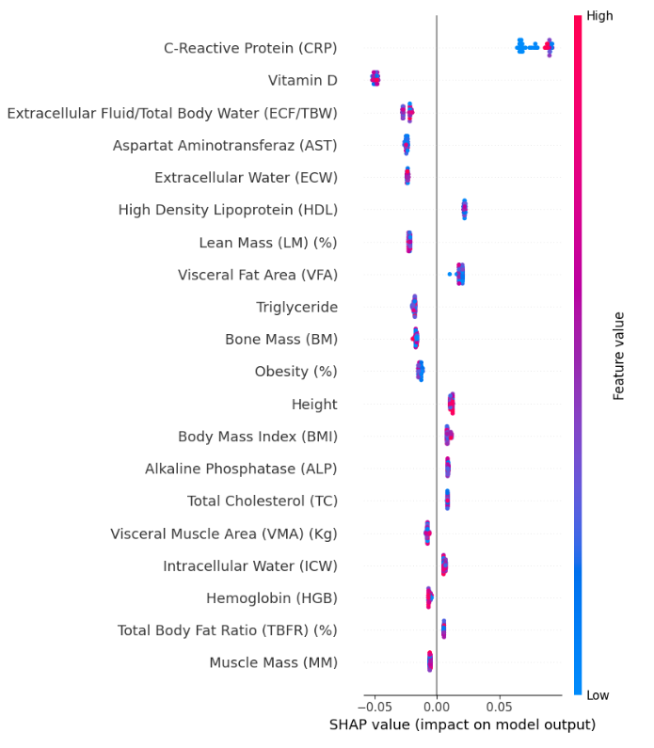
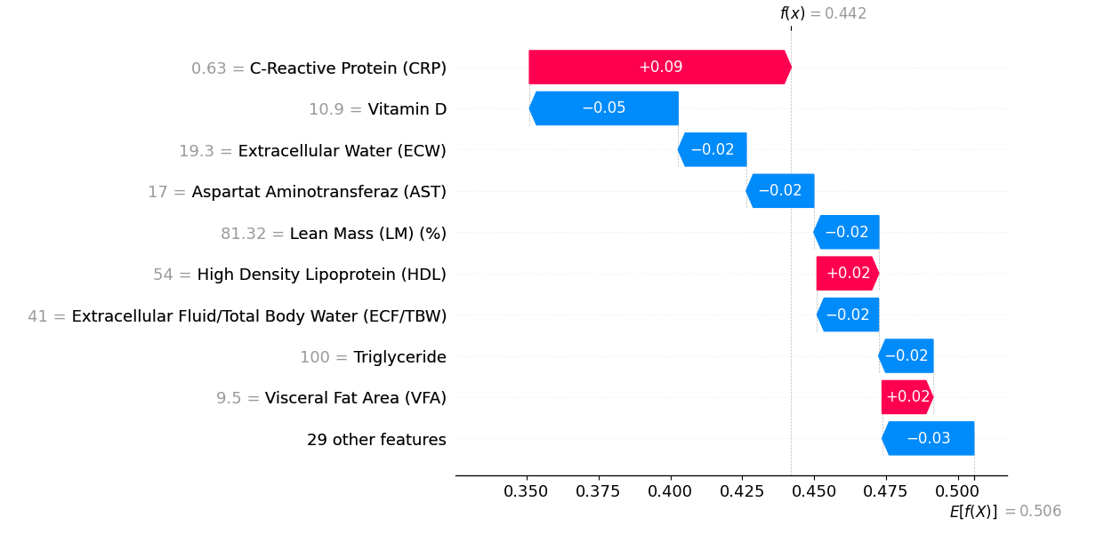
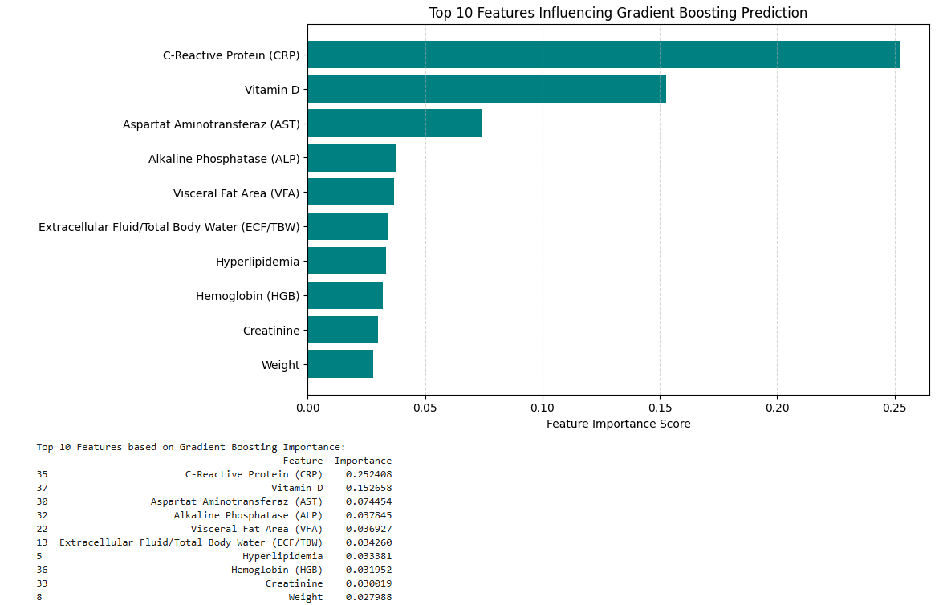

Critical evaluation and discussion (Q7)

References
I did not use any references, all of it from my notes in the lectures. :)

