Academy Machine – Ethical Hacking Project
This project demonstrates a complete ethical hacking workflow performed on the Academy vulnerable machine using Kali Linux. The project includes reconnaissance, enumeration, exploitation, and Remote Code Execution (RCE).

1. Reconnaissance and Target Identification
The Academy machine IP address was identified and connectivity between Kali Linux and the target machine was verified.
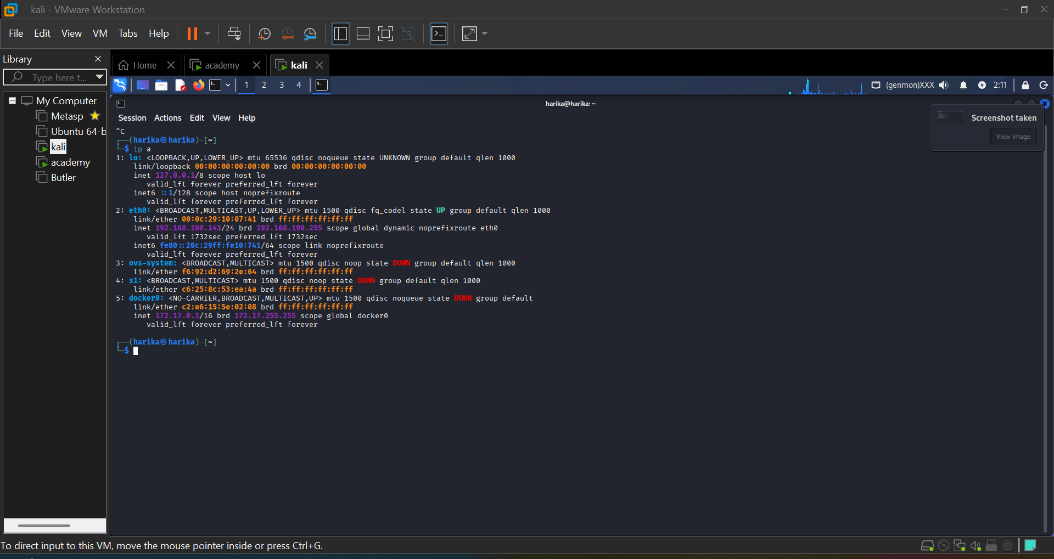
Figure 1: Kali Linux IP Address Verification

2. Port Scanning and Enumeration
Nmap was used to scan the Academy machine and identify open ports and running services. The scan revealed FTP, SSH, and HTTP services.
- Command Used:
- nmap -sV 192.168.190.147
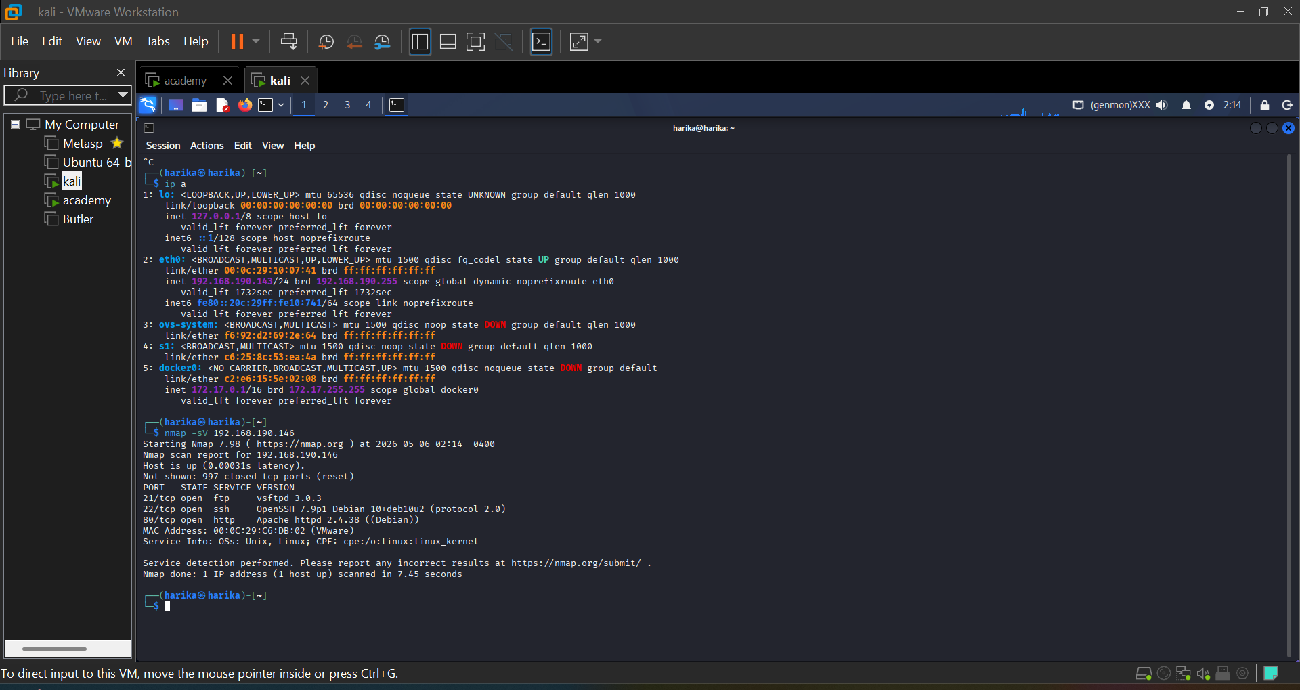
Figure 2: Nmap Scan Results

3. FTP Enumeration
The FTP service was accessed using anonymous login. Sensitive file note.txt was downloaded from the FTP server.
- Commands Used:
- ftp 192.168.190.147
- ls
- get note.txt
- cat note.txt
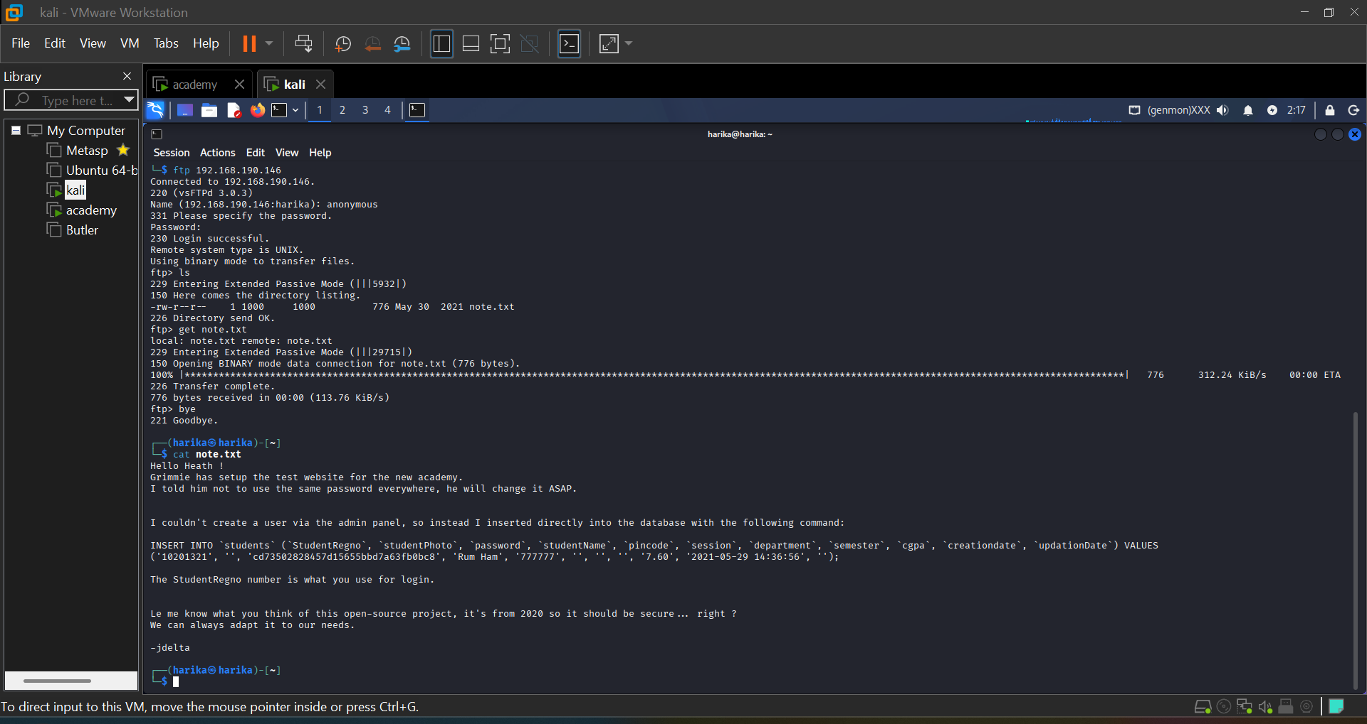
Figure 3: FTP Enumeration and note.txt Retrieval

4. Web Application Login
The extracted credentials were used to login into the Academy web application.
- Website:
- http://192.168.190.147/academy
- Credentials:
- Username: 10201321
- Password: student
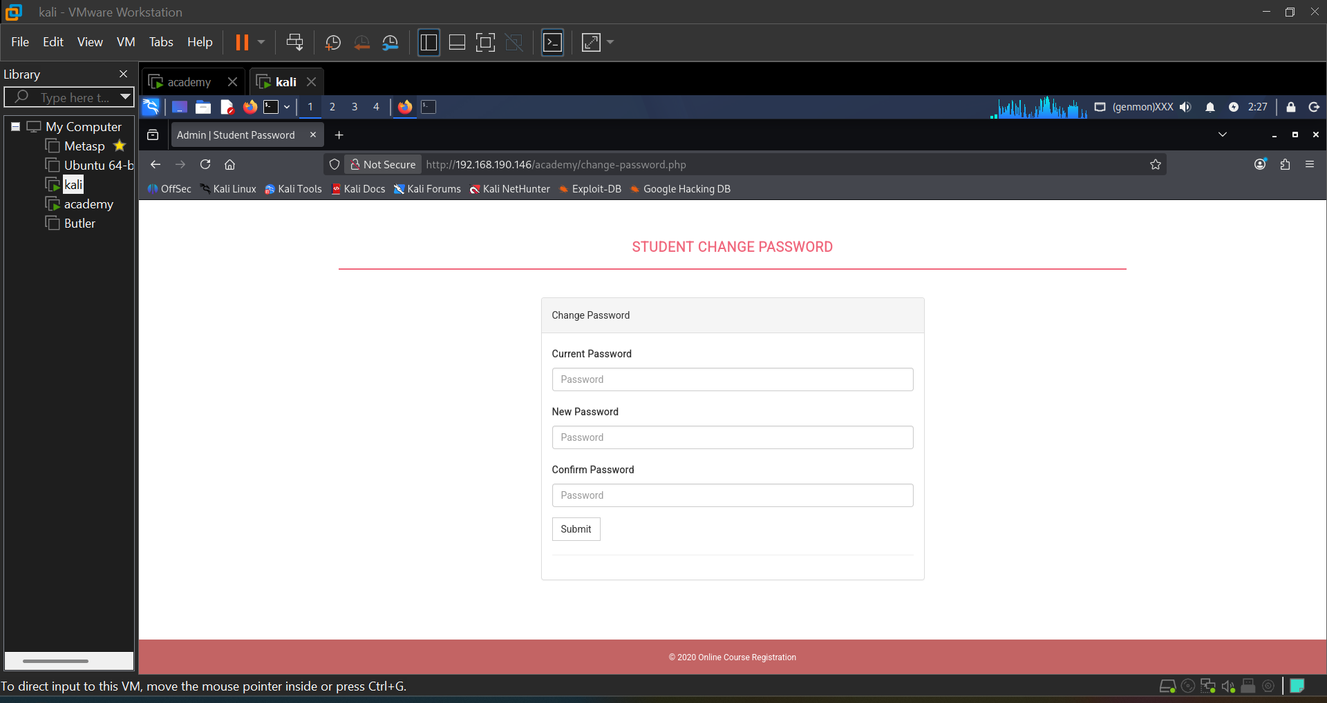
Figure 4: Successful Login into Academy Portal

5. File Upload Vulnerability
The My Profile section contained a file upload functionality. A PHP file was created and uploaded to test for file upload vulnerability.
- PHP Payload:
- <?php phpinfo(); ?>
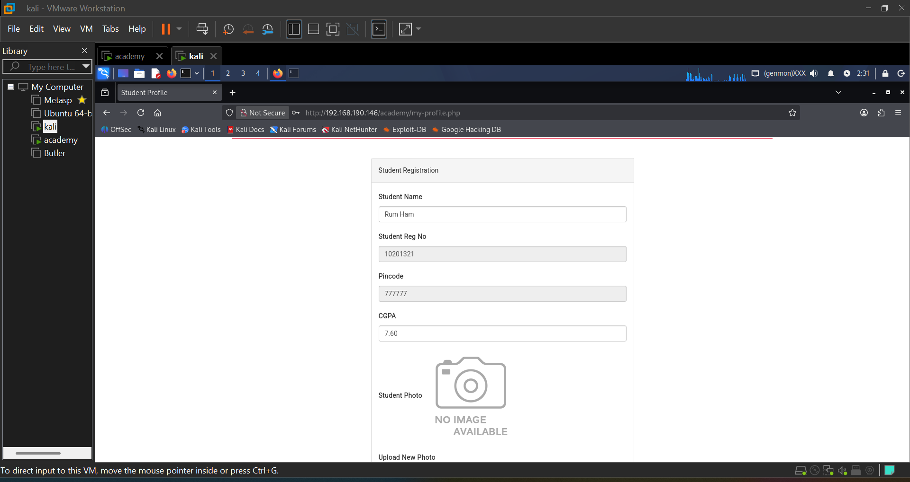
Figure 5: Vulnerable Upload Section
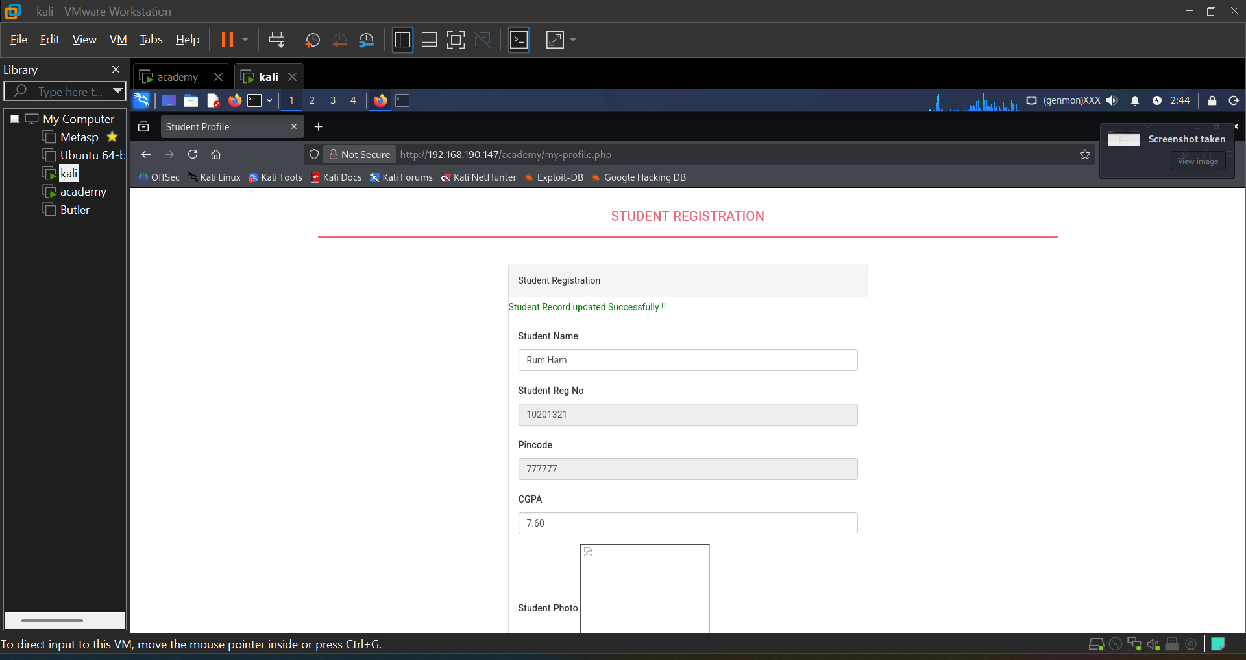
Figure 6: Successful PHP File Upload

6. Remote Code Execution (RCE)
The uploaded PHP file was executed from the upload directory, confirming Remote Code Execution vulnerability in the web application.
- Execution URL:
- http://192.168.190.147/academy/studentphoto/simple.php
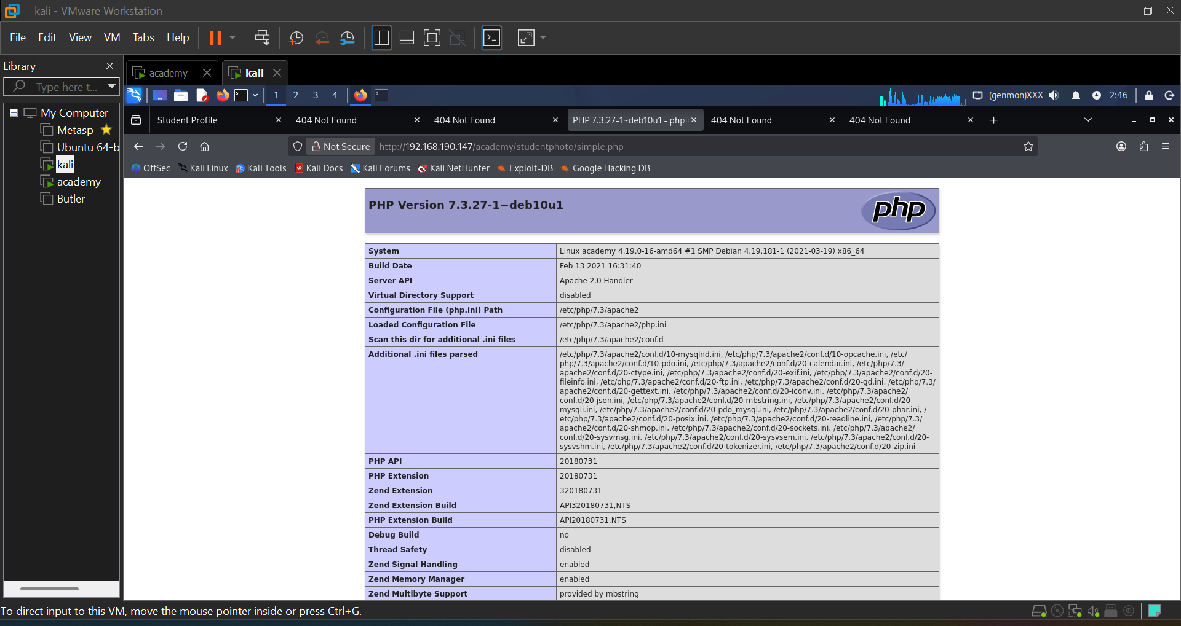
Figure 7: Remote Code Execution through Uploaded PHP File

Conclusion
The Academy machine project successfully demonstrated all major ethical hacking phases including reconnaissance, scanning, enumeration, exploitation, and Remote Code Execution. The project improved practical understanding of penetration testing and web application security vulnerabilities.

