# CT Storage

Hanel Prillian, Agung Prawoto

**What is CT Storage?**

CT Storage has made for help our community “ITC” to sharing a file each other or group. It’s same like dropbox how to work. This is using email to share with your friend has already registered. And also you can just create local folder, share folder, or public link for your file.

**Feature**

* Sharing Folder Including File
* Share Public File
* Create public link for file
* User management
* Extension Manager
* Space Management
* Notifications
* More…

**Ingredients**

* PHP > 5
* Bootstrap
* Jquery
* Font Awesome
* MYSQL

We mind to make it open source to development on future

please click this link:

<https://drive.google.com/drive/folders/0B9SObb_zLGGzMlNDTHRlbGNjclk?usp=sharing>

**Screenshot**

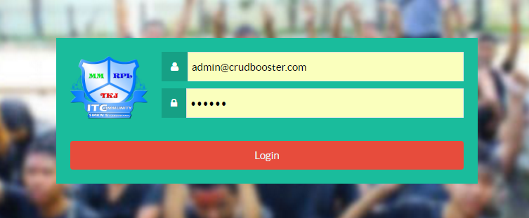

1. Login Page

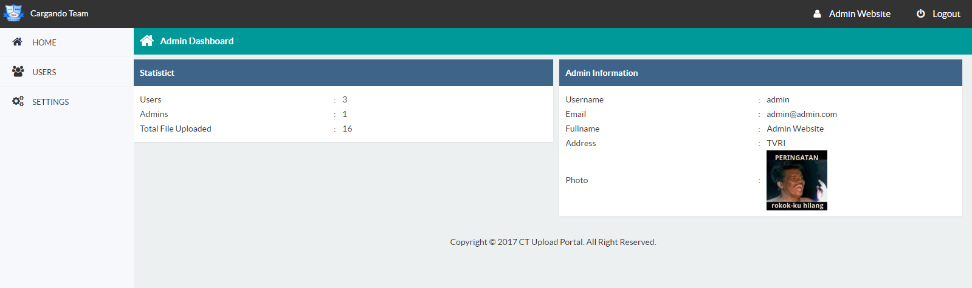

2. Admin Panel

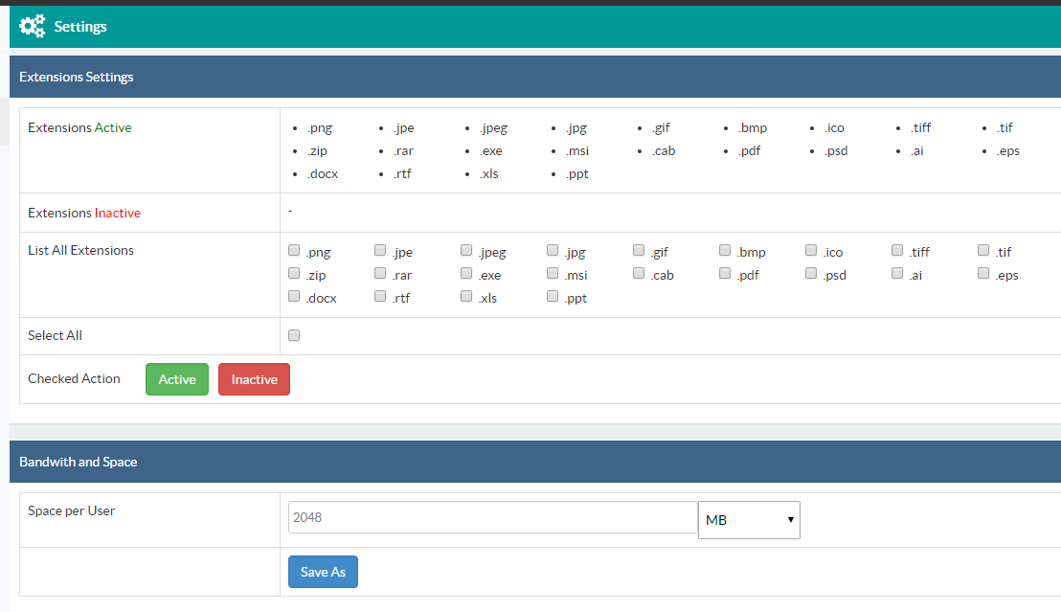

3. Settings

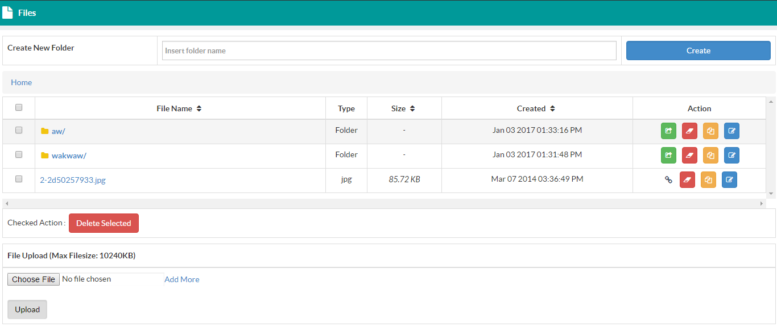

4. File Explorer

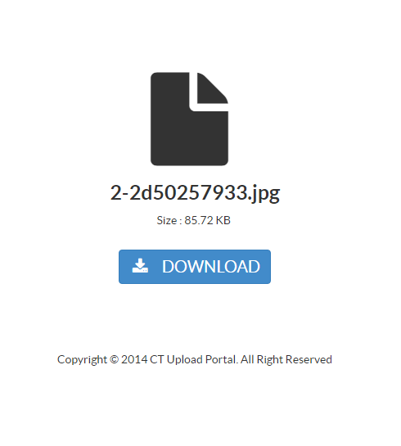

5. Public Link Example