

**Faculty of engineering - Shoubra**

**Benha University**

|  |  |  |  |
| --- | --- | --- | --- |
|  | Name | Edu mail | B.N |
| 1 | **حنين وائل السيد السيد العدل** | **Hanen195339@feng.bu.edu.eg** | **309** |

**TOBIC: cryptography**

* **Application Brief:**

This application talking about cryptography which used to protect our message and photo which we send to everyone, and there are types of cryptography like Symmetric Key Cryptography, Hash Functions, Asymmetric Key Cryptography, also cryptography has some Techniques and features like Confidentiality, Integrity, Non-repudiation, and Authentication.

The cryptography process has been used for a long time; cryptography is usually dated from about 2000 B.C., with the Egyptian practice of hieroglyphics. These consisted of complex pictograms, the full meaning of which was only known to an elite few. The first known use of a modern cipher was by Julius Caesar (100 B.C. to 44 B.C.)

* **Screen shots:**

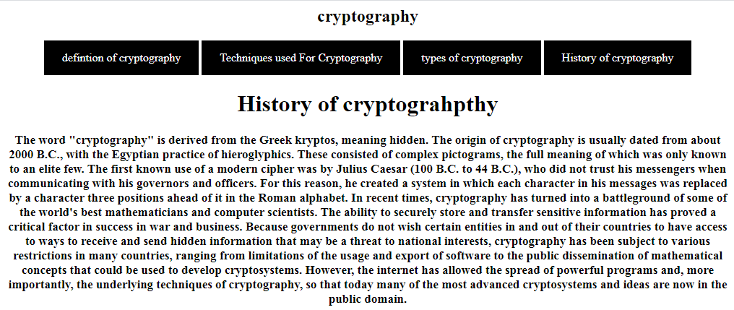

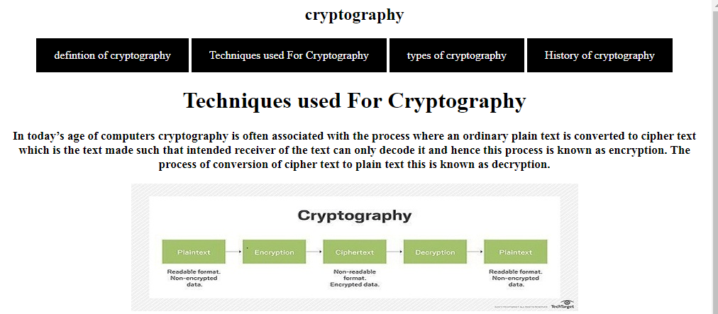

* **Source code:**

