**Introduction**

* Now a days people search for new places on Internet. They find out stories about that place, see pictures of that place and read reviews about that place. For example when a person wants to east something he/she search on internet like restaurants. They read reviews about that place and compare with other restaurants. Based on reviews and feedback they choose where to go for a good food and service.
* Saffron restaurant application is crafted for customer so that they can rate the food quality, Service, Variety in food, Money for value and write something about the overall experience at the restaurant.

**Scope**

* Saffron restaurant is an android application through which customer can leave a feedback and provide rating about food quality, service, and variety in food and rate money for value.
* Scope of this application is not limited to only just leaving a feedback. Customer, owner and manager of the restaurant also view feedbacks of other customer and based on that saffron restaurant can improve their service and hospitality.
* The database is hosted and managed online so that application is available all the time to the user.
* Application provides better and convenient usability along android mobile devices.

The designing and coding phase requires Eclipse Helios 3.6.2, Android SDK tools, ADT Plug-in- 16.0.1, Apache tomcat 7.0 and Dream Viewer.

The Application needs to be deployed android device. Application can be deployed on android API level 16. Internet access permission is provided in this application.

**Android**

*Definition:*

* A Smartphone and tablet operating system from the Open Handset Alliance Androids are the leading Smartphone, outselling every other brand by a huge majority. Based on Linux and Java, users download applications from Google's Play Store (formerly Android Market).
* Android quickly became a major competitor to Apple's iPhone, offering multitasking before Apple added it. Android phones feature touch screens, GPS, Wi-Fi, camera and 3G or 4G service. The phones initially had four physical buttons, but models began to migrate to touch screen only. Some Androids also include a physical slide-out keyboard.
* The first Android came out in 2008. By 2011, with over 100 models from three dozen handset manufacturers offered by all major cellular carriers, Android outsold every other smart phone.

Android is a platform designed for mobile devices that includes a customized Linux kernel, frameworks, libraries and commonly used applications. The Linux kernel manages the hardware and provides security, resource/file/process management, networking and drivers. A range of libraries sit on top of this kernel to provide functionality such as media playback, 2D/3D graphics, font rendering, data management, and web page rendering.

**Android and Java**

* Android is a bi-lingual platform. Developers have the choice of using either Java or   
  C/C++ as their primary programming language of choice. However, in practice most of   
  the applications are currently built in Java using the Eclipse IDE. The tooling,   
  documentation, and online community support is also built for programming in Java.
* Android developers made two critical changes to the Java environment to ensure that it works well on a mobile device. First, they opted to use the Dalvik virtual machine with optimizations for a mobile device rather than the Oracle/Sun Java Virtual Machine technology. Secondly, they rebuilt the standard library and have intentionally omitted many parts that are found in the Oracle/Sun Java. In a nutshell, they eliminated much of the bloat and provided a library/framework that runs smoothly even on an older generation mobile device — especially, for the UI and graphics library.

**Apache Tomcat Server**

* **Apache Tomcat** is an open source web server and servlet container developed by the Apache Software Foundation (ASF). Tomcat implements the Java Servlet and the Java Server Pages (JSP) specifications from Sun Microsystems, and provides a "pure Java" HTTP web server environment for Java code to run in. In the simplest configuration Tomcat runs in a single operating system process. The process runs a Java virtual machine (JVM). Every single HTTP request from a browser to Tomcat is processed in the Tomcat process in a separate thread.

**My SQL Database**

* MySQL is a relational database management system (RDBMS), and ships with no GUI tools to administer MySQL databases or manage data contained within the databases. Users may use the included command line tools, or use MySQL "front-ends", desktop software and web applications that create and manage MySQL databases, build database structures, back up data, inspect status, and work with data records. The official set of MySQL front-end tools, MySQL Workbench is actively developed by Oracle, and is freely available for use.
* We managed the data centrally for application and web site. For this we use MySQL. The database is common for both. Using MySQL provides following advantages.

*After installing the application:*

* After installing the application the first screen shown to user is represented below.
* If customer wants to leave a feedback he/she is prompted to first enters his/her name and email address of that customer. These two fields are required fields. Application won’t allow customer to enter into next step without entering name and email address.
* The feedback button here is for reading other customers feedback and experience.

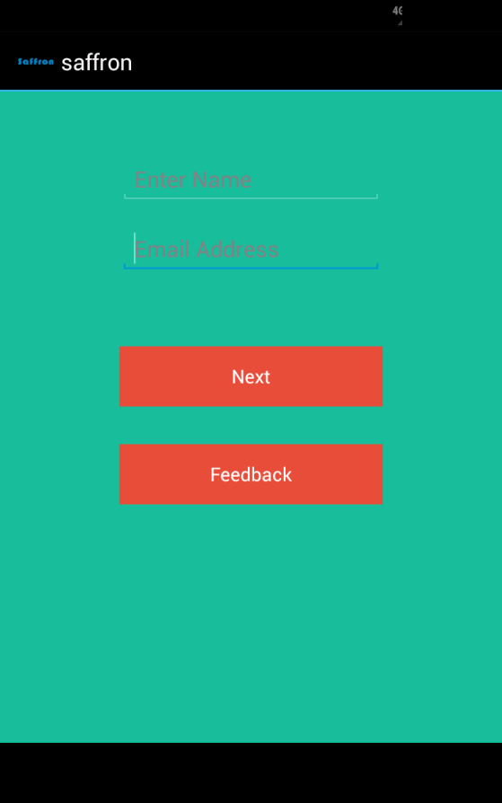

*Leaving a detailed review about restaurant:*

* After entering the name and email address of the customer, user is needs to rate some of the services like food quality, variety in food, service, and money for value and can leave a custom feedback about the restaurant.
* Rating is only based on three stars, 1 star = poor, 2 stars = moderate, 3 stars = excellent.

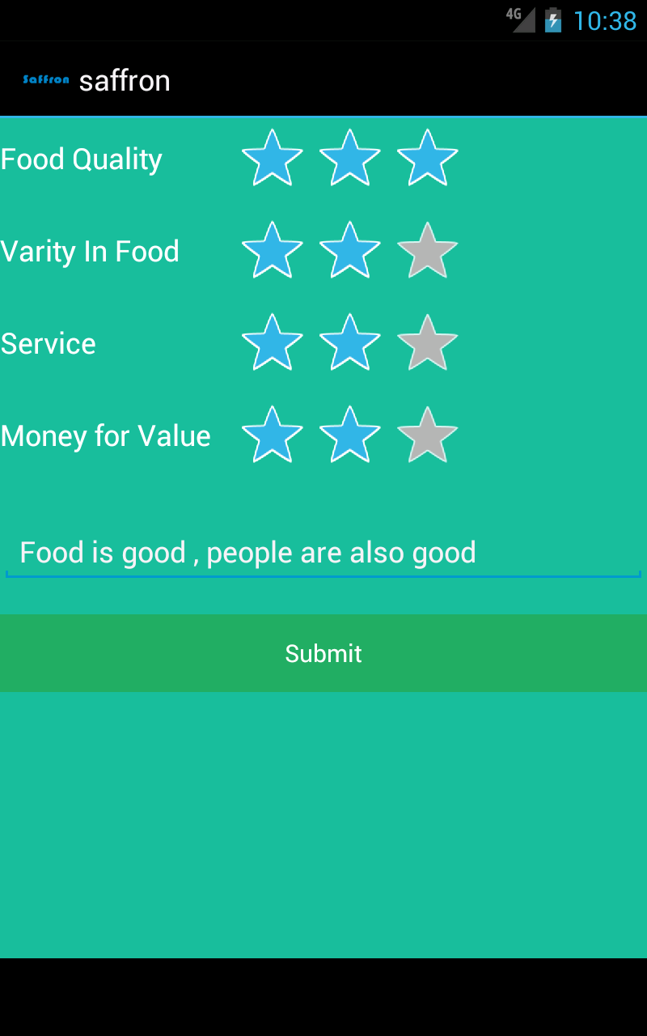

*When feedback is successfully posted:*

* When user information, rating and custom feedback message is posted successfully to the server it shows following message to the user.

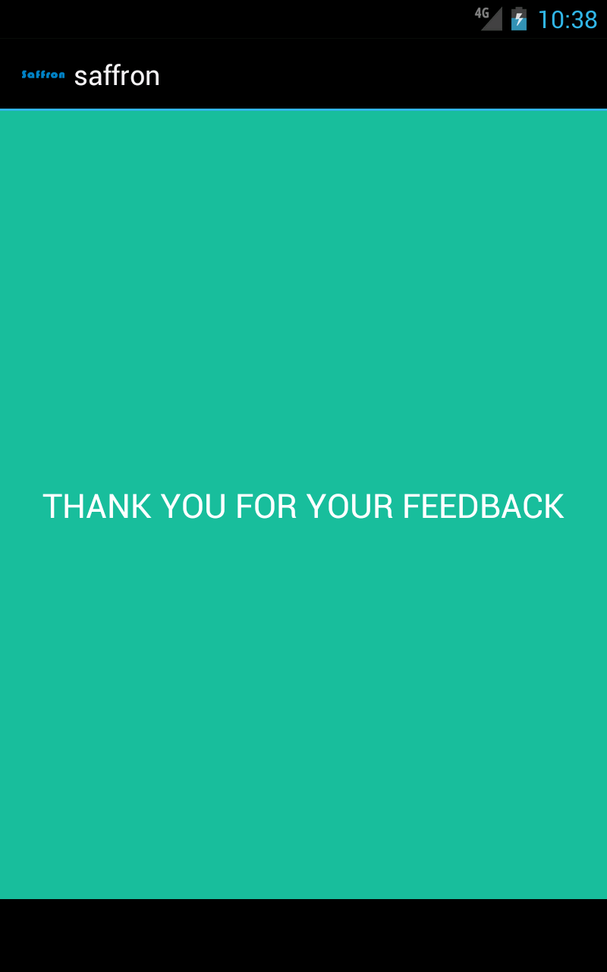

*Reading other customers feedbacks:*

* After clicking the feedback button on the main screen of the application it loads all the feedbacks from the database. A customized list view is prepared and it displayed only Customer name and Average rating leave by the previous customers.

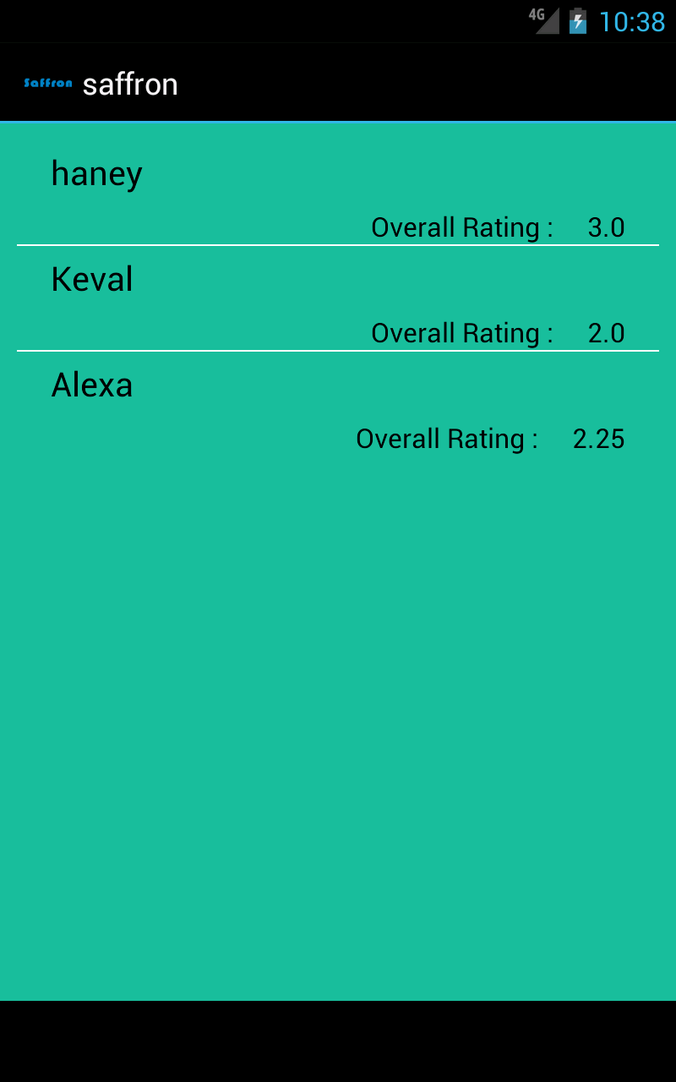

*Detailed review of previous customer about the restaurant:*

* Above custom list view is clickable. So when a customer, owner or manager of the restaurant wants to see detailed feedback of a customer posted previously can be seed by clicking on this list view.
* On this screen it shows customers name, email address, rating of food quality, service, variety in food, money for value and average rating. This rating is based on scale of 3. At last a feedback message is displayed.

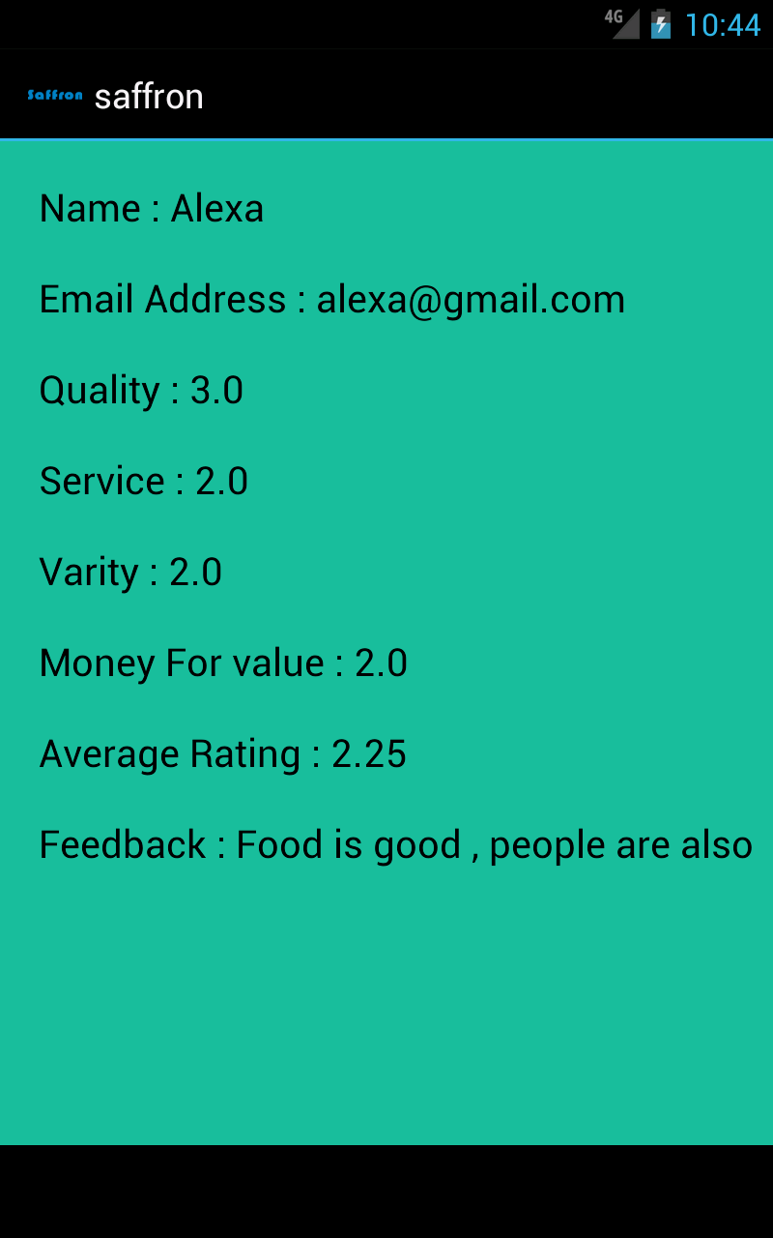

*Structured representation of the mySql database:*

* Database table saffron contains following columns in it: index, user_name, email_address, rat_quality, rat_varity, rat_service, rat_money_for_value and feedback.

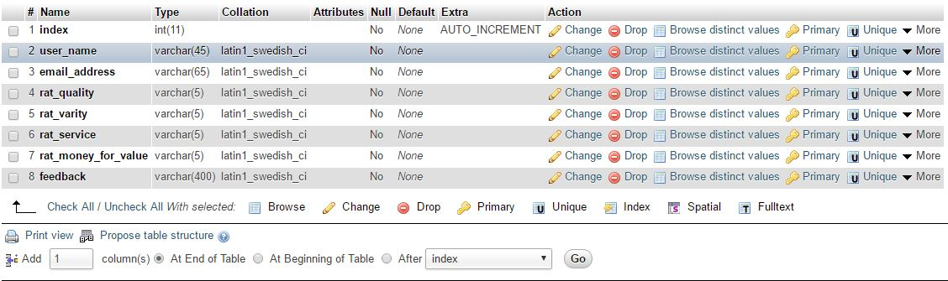

*Conclusion*

In nutshell, this application is designed for customer to leave review and feedback for the saffron restaurant. Main reason behind developing this application is for the owner and manager to know about the services and hospitality they provide to the customer is satisfactional or not. By reading every customer feedback restaurant owner and manager get to know where they need to improve their services for example, food, service, prices and so on.

ProgressDialog is used to create a dialog box when user hits the submit button in order to show user to wait for response.

http class is used to create a connection between android app to the web server.

Httppost variable is used to send data to the server in terms of post method.

Namevalue pair is used to attach data to the httppost variable.

Now to send data execute() method is used to send data to server.

A response is received from server when everything is done on sever side and an email is been send.

If something goes wrong then an error message is generated.

Server side:

Apache is used as a mailing server in this project.

On the server side we receive data from post method and store that data into variables.

Mail() method is used to send email to the user. Mail method arguments are receiver email address, subject and message.

When email is sent successfully to the user the mail method returns a true as a value and a message is send back to android application saying that email is successfully delivered to the manager.