# 参数化构建过程

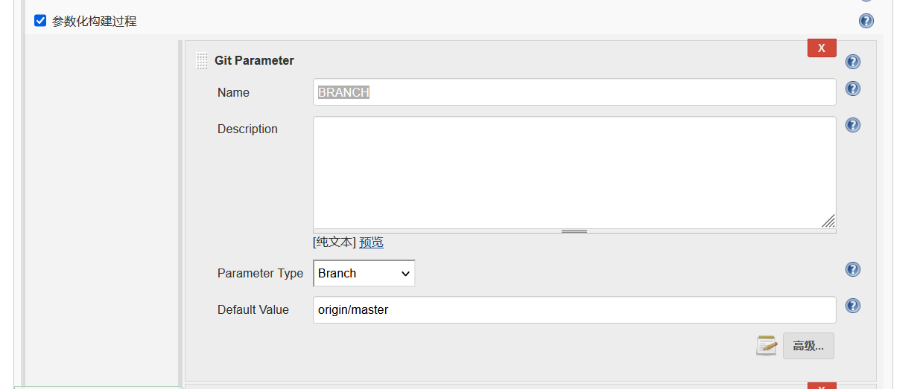

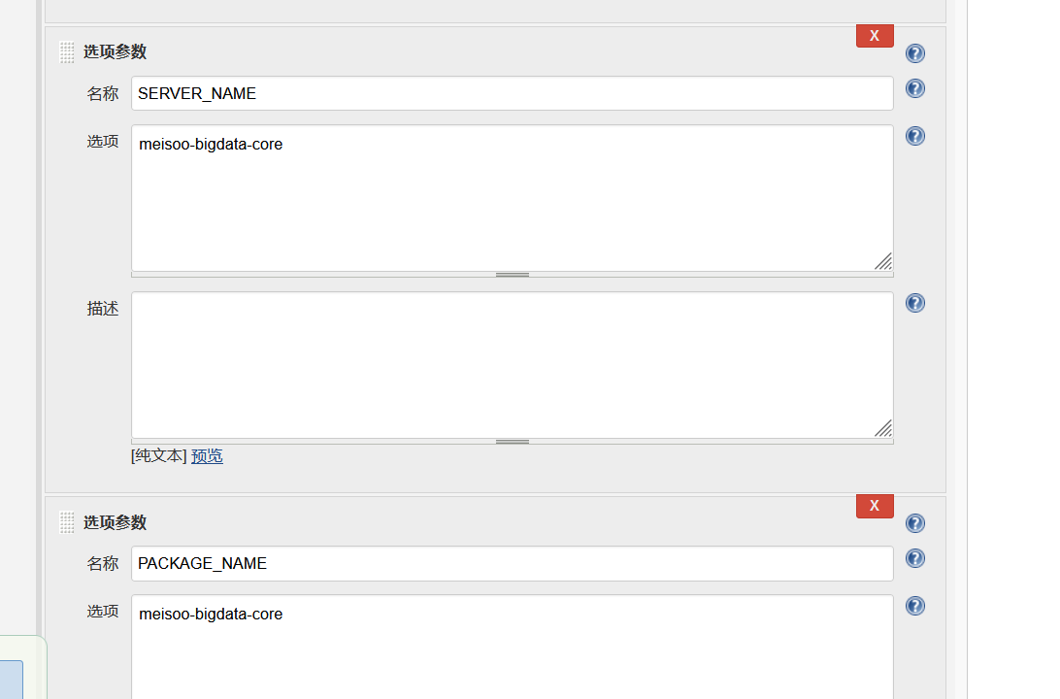

# 源码管理

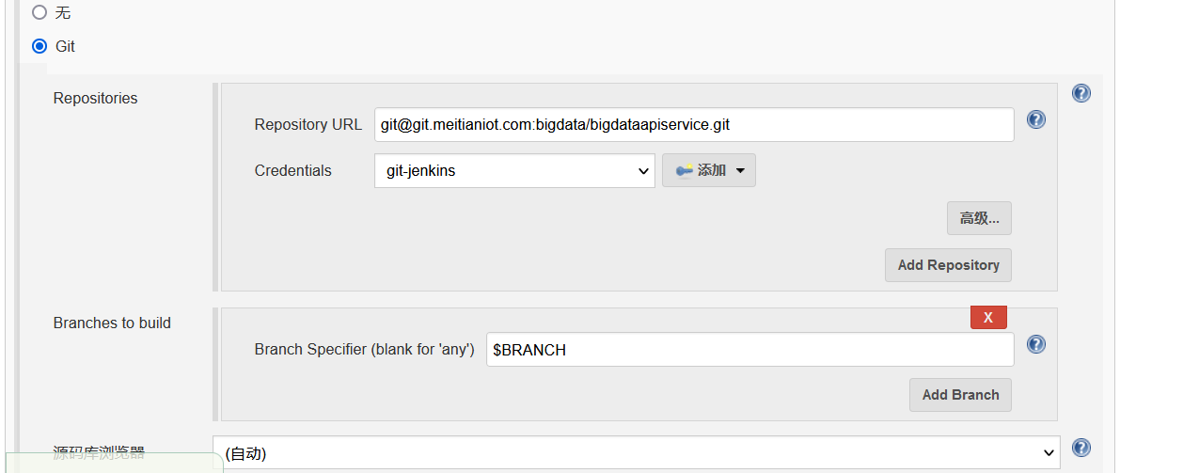

# 构建触发器

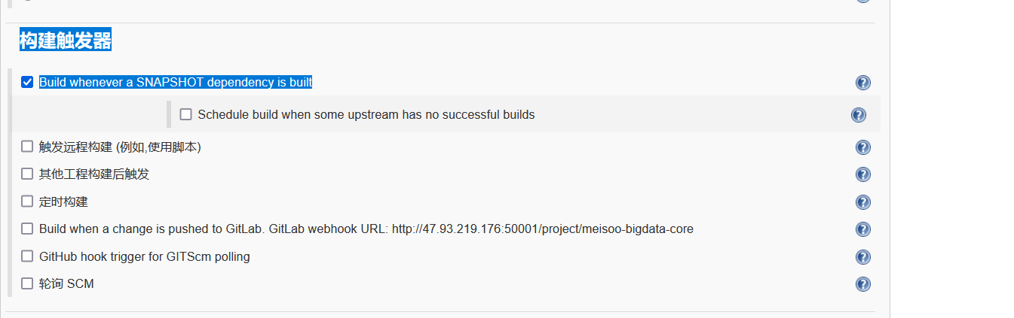

# 构建环境

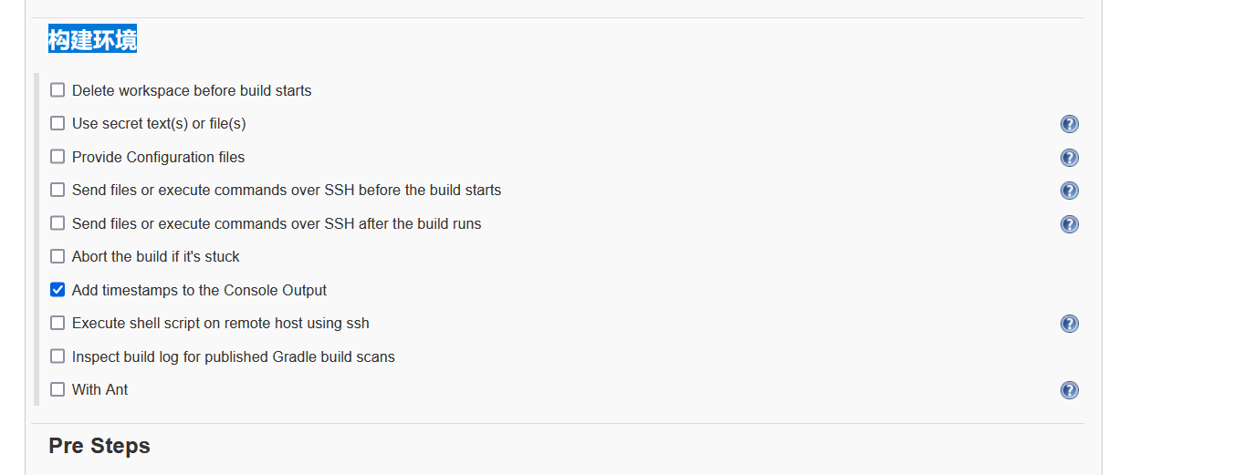

# Build

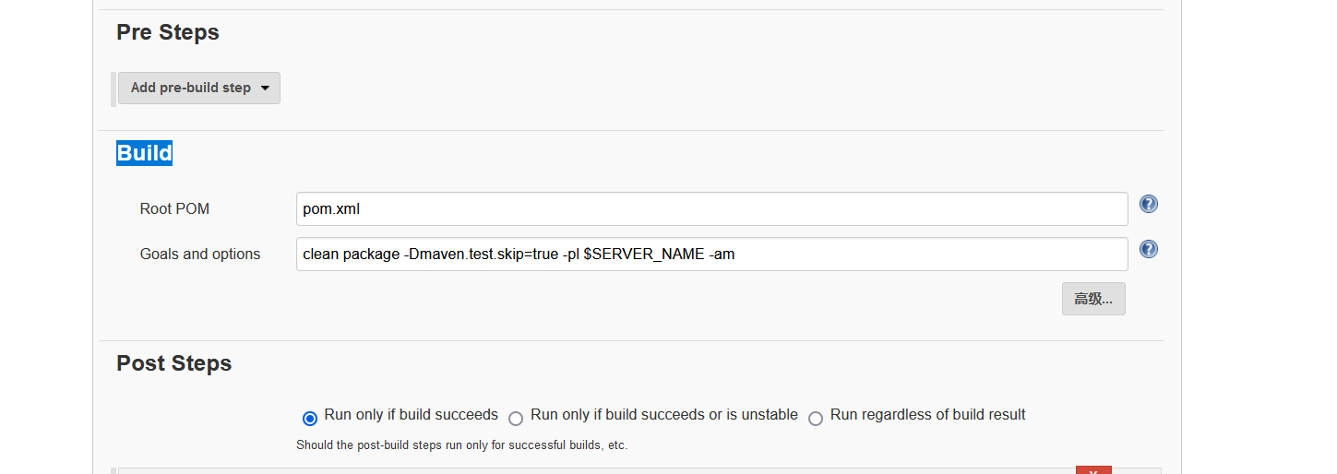

# Post Steps

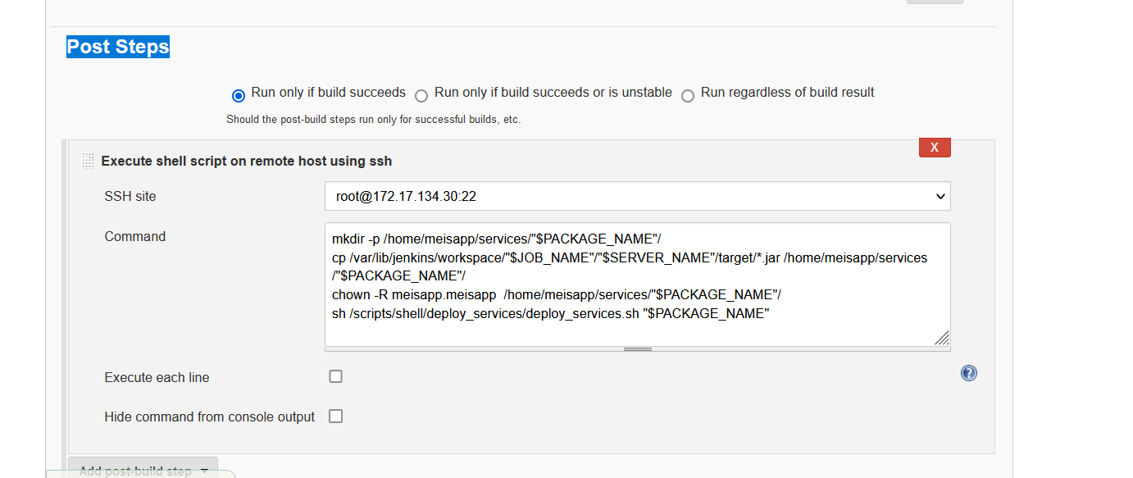

## 内容

mkdir -p /home/meisapp/services/"$PACKAGE_NAME"/

cp /var/lib/jenkins/workspace/"$JOB_NAME"/"$SERVER_NAME"/target/*.jar /home/meisapp/services/"$PACKAGE_NAME"/

chown -R meisapp.meisapp /home/meisapp/services/"$PACKAGE_NAME"/

sh /scripts/shell/deploy_services/deploy_services.sh "$PACKAGE_NAME"

## 详解

$JOB_NAME这个任务就是job

# deploy_services.sh

#!/bin/sh

service_name="$1"

deploy_service_dir=/home/meisapp/services

supervisor_file_dir=/etc/supervisord.d

deploy_script_dir=/scripts/shell/deploy_services

new_service_version=`ls "$deploy_service_dir"/"$service_name"/|egrep "$service_name.*.jar"|awk -F "_|.jar" '{print $2}'`

now_time=`date +%Y%m%d_%H%M%S`

function Usage(){

echo "Usage：sh $0 {service_name(服务名字)}"

}

function deploy_old_service(){

echo "老服务"

supervisorctl stop "$service_name"

old_service_version=`ls "$deploy_service_dir"/"$service_name"|egrep "^[0-9]"|grep -v bak`

mv "$deploy_service_dir"/"$service_name"/"$old_service_version"/ "$deploy_service_dir"/"$service_name"/"$old_service_version"_"$now_time"_bak

mkdir "$deploy_service_dir"/"$service_name"/"$new_service_version"

mv "$deploy_service_dir"/"$service_name"/"$service_name"_"$new_service_version".jar "$deploy_service_dir"/"$service_name"/"$new_service_version"

sed -i "s#"$old_service_version"#"$new_service_version"#g" /etc/supervisord.d/"$service_name".ini

chown -R meisapp.meisapp "$deploy_service_dir"/"$service_name"

if [[ "$old_service_version" == "$new_service_version" ]];then

supervisorctl restart "$service_name"

sleep 5

supervisorctl update "$service_name"

else

supervisorctl update "$service_name"

fi

service_status=`supervisorctl status "$service_name"|awk '{print $2}'`

if [[ "$service_status" == 'RUNNING' ]] || [[ "$service_status" == 'STARTING' ]];then

echo '服务更新完成'

else

echo '服务更新失败，详情查看服务日志' && exit 4

fi

}

function deploy_new_service(){

echo "新服务"

mkdir -p "$deploy_service_dir"/"$service_name"/"$new_service_version"

mv "$deploy_service_dir"/"$service_name"/"$service_name"_"$new_service_version".jar "$deploy_service_dir"/"$service_name"/"$new_service_version"

cat /"$deploy_script_dir"/supervisor_config_templay.ini >/etc/supervisord.d/"$service_name".ini

sed -i "s/test.jar/"$service_name"_"$new_service_version".jar/g" /etc/supervisord.d/"$service_name".ini

sed -i "s/test/"$service_name"/g" /etc/supervisord.d/"$service_name".ini

sed -i "s#service_version#"$new_service_version"#g" /etc/supervisord.d/"$service_name".ini

supervisorctl reread && supervisorctl add "$service_name"

chown -R meisapp.meisapp "$deploy_service_dir"/"$service_name"

supervisorctl start "$service_name"

service_status=`supervisorctl status "$service_name"|awk '{print $2}'`

if [[ "$service_status" == 'RUNNING' ]] || [[ "$service_status" == 'STARTING' ]];then

echo '服务更新完成'

else

echo '服务更新失败，详情查看服务日志' && exit 4

fi

}

function check_new_service(){

if [[ ! `ls "$deploy_service_dir"/"$service_name"|egrep "^[0-9]"` ]];then

deploy_new_service

else

deploy_old_service

fi

}

if [[ "$1" == '' ]];then

Usage

else

if [[ "$new_service_version" == '' ]];then

echo "jar包版本号不正确" && \

rm -f "$deploy_service_dir"/"$service_name"/"$service_name"_"$new_service_version".jar

exit 4

else

check_new_service

fi

fi