**AUGMENTED PAPER DESIGN WORKSHOP PACKET: PART I**

**Defining Augmented Paper**

Augmented paper: The synergistic combination of physical paper and computation

* Combining the affordances of physical paper and the unique functionalities of technology
* Motivation: There are limitations to both physical paper and computing devices. One method of addressing the limitations of both is by hybriding the two together.

**Defining Utility**

Utility: For our purposes, we can think of utility as a numerical measure of preference

* The concept was originally adopted from economics, and used to model the usefulness of a good or service
* Consider the following scenario: We are looking for a bike. We have bike A, bike B, and bike C. If we prefer bike A over all other options, we can say that bike A has the highest utility.
* Applied to HCI by Toomin, Kriplean, Portner, and Landay in 2011
  + Defined the utility function for human-computer interactions as

**Our Framework**

We defined the utility of augmented paper technologies as follows:

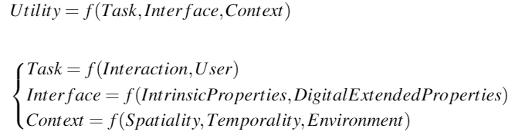

We distilled a total of 20 dimensions characterizing augmented paper. We organized the 20 dimensions using the structure defined above.

**Sunburst Visualization of Framework**

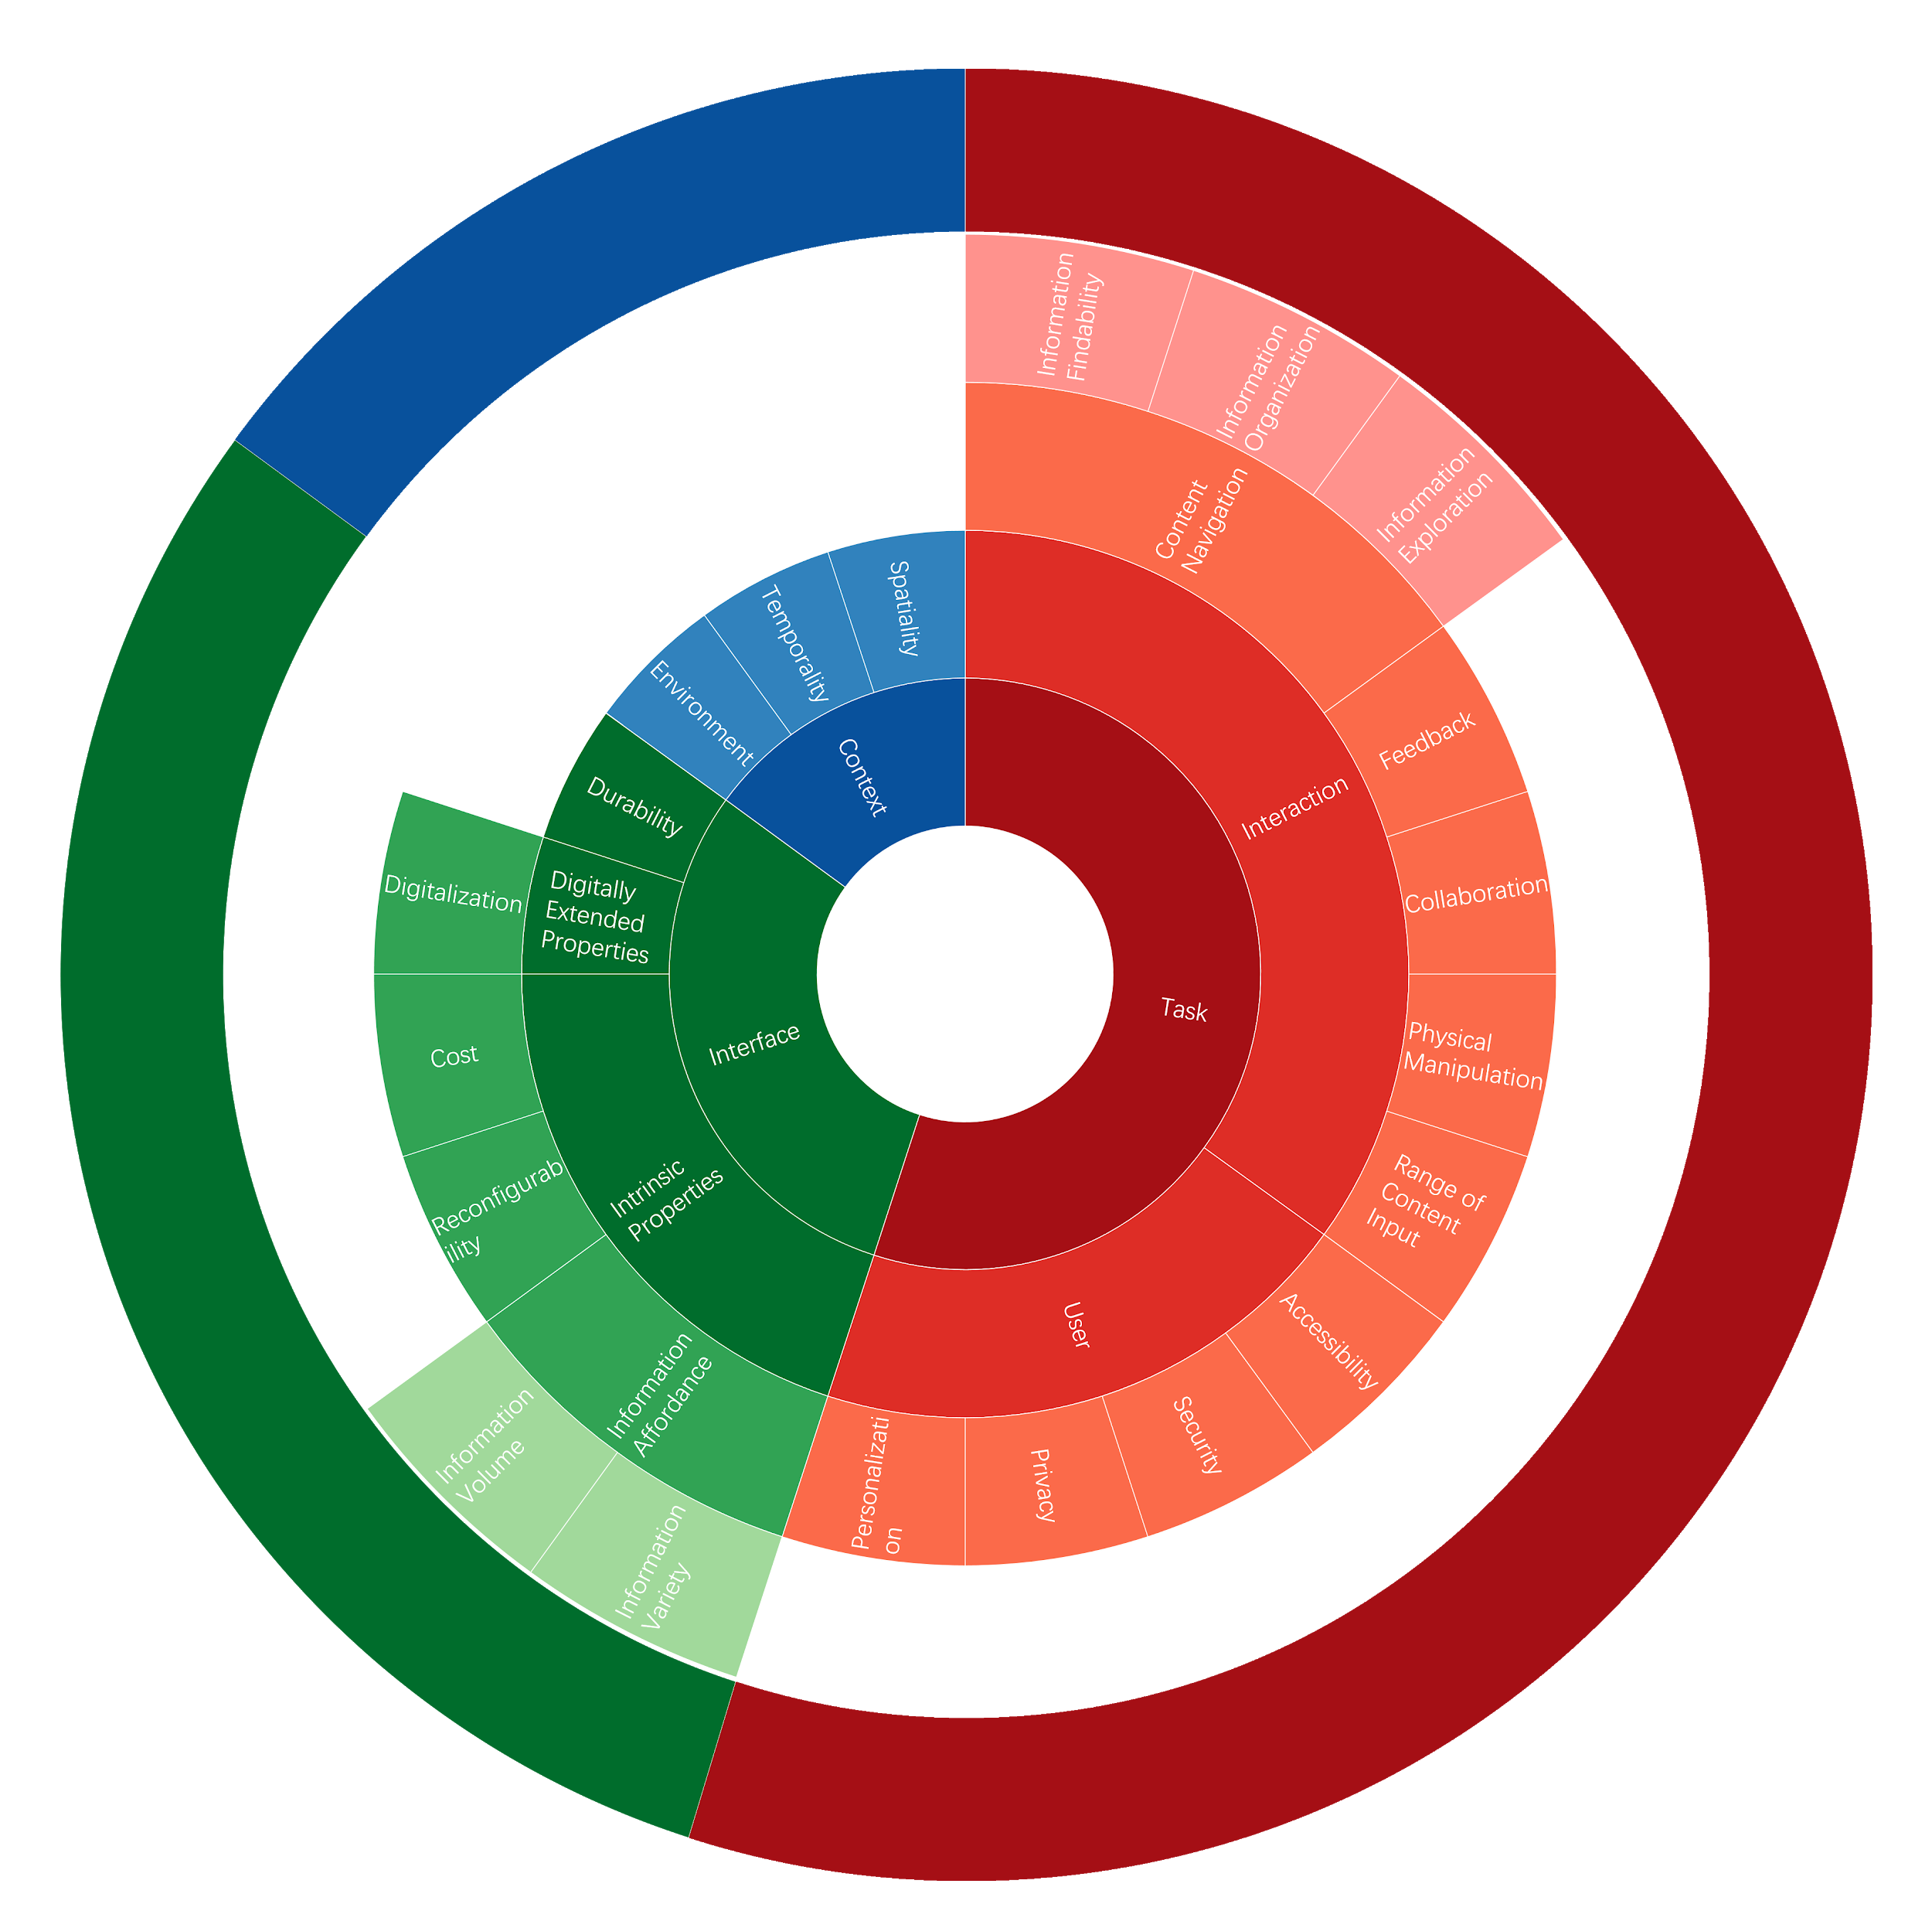

**Dimension Definitions**

|  |  |
| --- | --- |
| Range of Content Input | The number of ways to add information to a device or product |
| Information Exploration | The ability to view, examine, and understand the information presented |
| Information Organization | The ability to rearrange the information presented into an ordered format |
| Information Findability | The ability to find a specific piece of information |
| Physical Manipulation | The ability to interact with a physical product in a meaningful manner |
| Collaboration | The ability to use the same device or product with others to accomplish a task |
| Feedback | The ability to respond to user actions in a meaningful manner |
| Personalization | The ability to change part(s) of a product to match user preferences |
| Privacy | The ability to manage how much of your own personal information is revealed to others |
| Security | The ability to ensure safety from theft, damage, or misuse |
| Accessibility | The ability to accommodate different users with a wide variety of characteristics, backgrounds, physical or mental abilities, or needs |
| Cost | The amount that has to be paid or spent to buy or obtain something |
| Information Volume | The amount of information that a product can contain |
| Information Variety | The number of different formats of information that a product can display |
| Reconfigurability | The quality of being easy to change in shape |
| Durability | The quality of being lasting; can be used reliably for a long time |
| Digitalization | The ability to convert to a digital form |
| Spatiality | The quality of being associated with space or an arrangement (location, position, direction) in space |
| Temporality | The quality of being associated with time or an arrangement in time |
| Environment | The quality of being associated with the surroundings |

**AUGMENTED PAPER DESIGN WORKSHOP PACKET: PART II**

**Aster Graph Book**

You can use this page to record your idea.

To help you understand: the following attributes will be presented in abbreviation:

**Collab.** = Collaboration; **Phy. Man.** = Physical Manipulation;

**Inf. Fnd.** = Information Findability; **Inf. Org.** = Information Organization;

**Inf. Exp.** = Information Exploration; **Rng. Inp.** = Range of Content Input;

**Envmnt.** = Environment; **Tmpral.** = Temporality;

**Sptial.** = Spatiality; **Digtlz.** = Digitalization;

**Durabl.** = Durability; **Phy. Rcf.** = Physical Reconfigurability;

**Inf. Var.** = Information Variety; **Inf. Vol.** = Information Volume;

**Cost** = Cost; **Access.** = Accessibility; **Secrty.** = Security; **Prvicy.** = Privacy;

**Prsnal.** = Personalization; **Feedbk.** = Feedback;

**Aster Graph Sample**

Here, we demonstrate how to interpret our Aster plots. The Aster plot below was generated using arbitrary values. We included the following diagram purely for demonstration purposes.

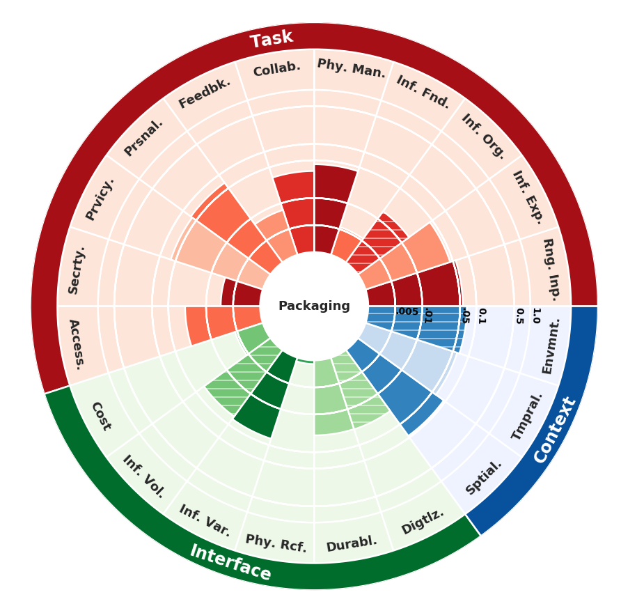

Bar Height: The height of each bar represents utility. This means that the **higher** the bar, the more users **preferred that product for that particular dimension**

Bar Color Shade: The color of each bar represents how important users think that dimension is for that particular product. **Darker** the bar, the **more important users perceive that attribute to be**

Line Texture: If the bar has stripes on it, it means that users **generally disagreed about the importance of that attribute** for a particular product

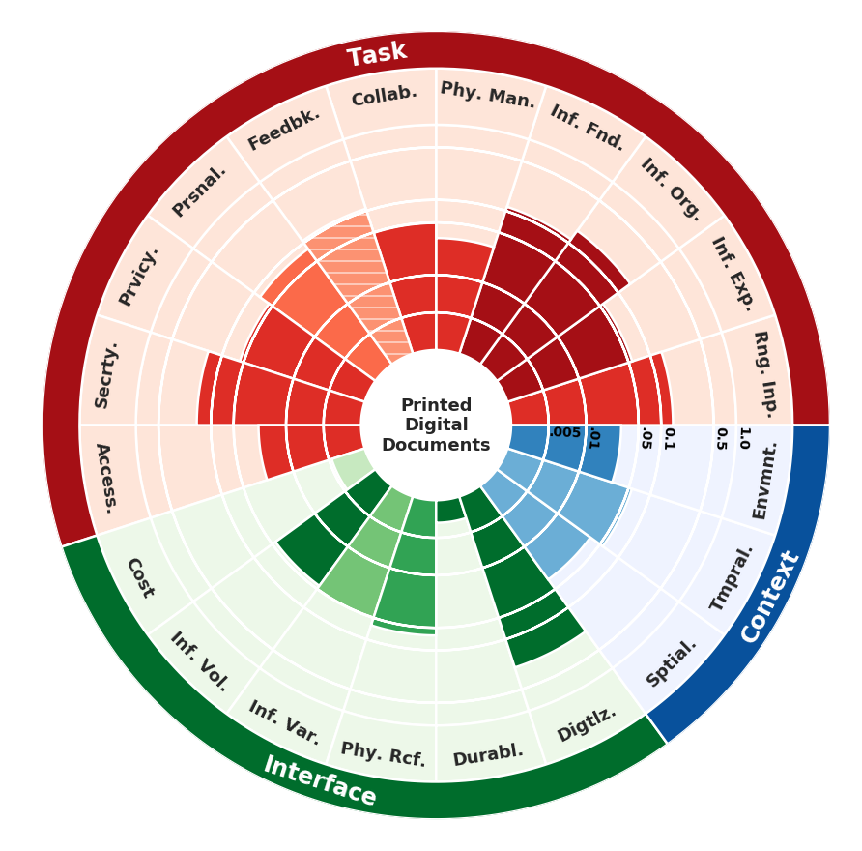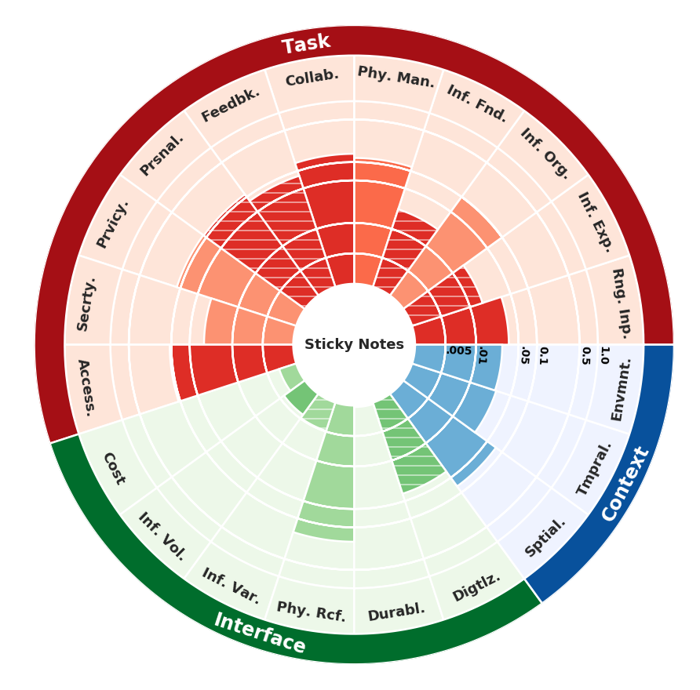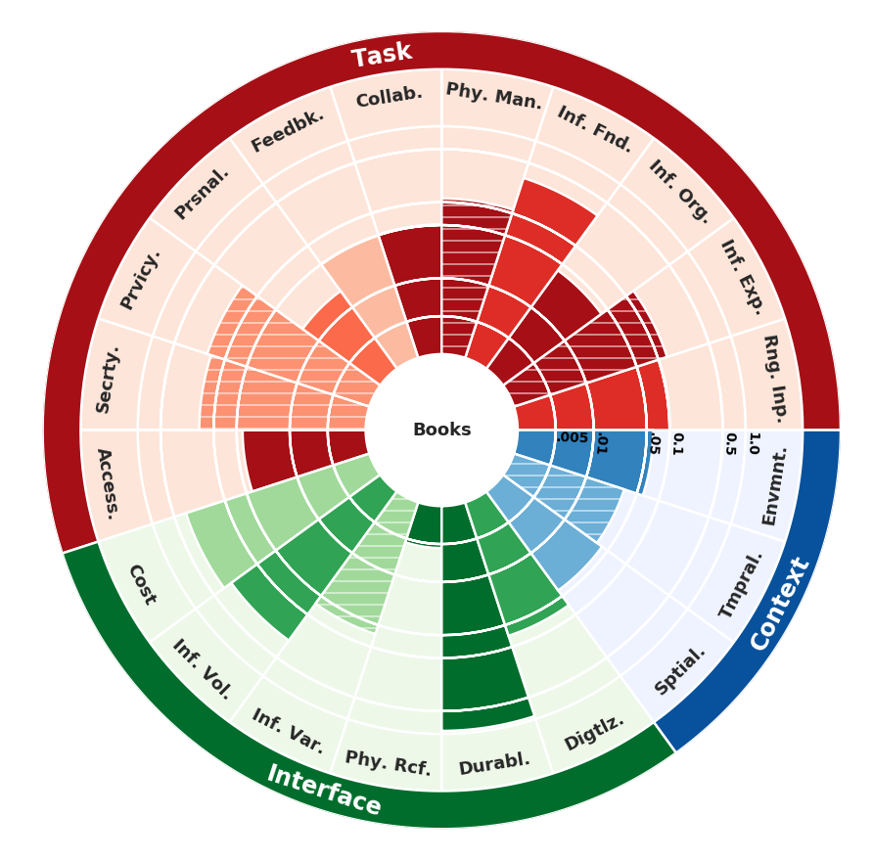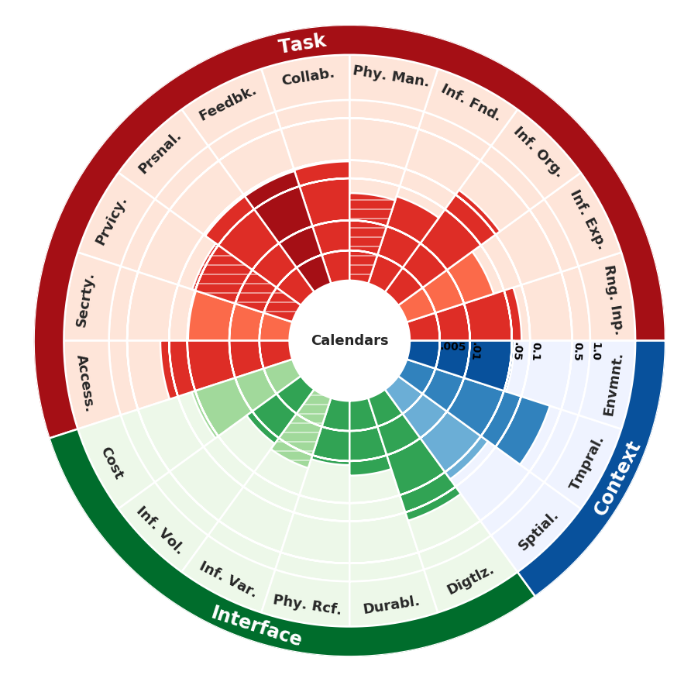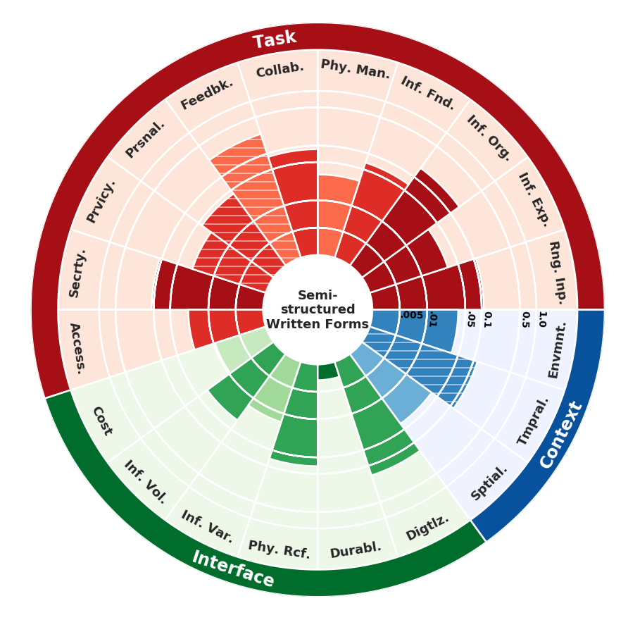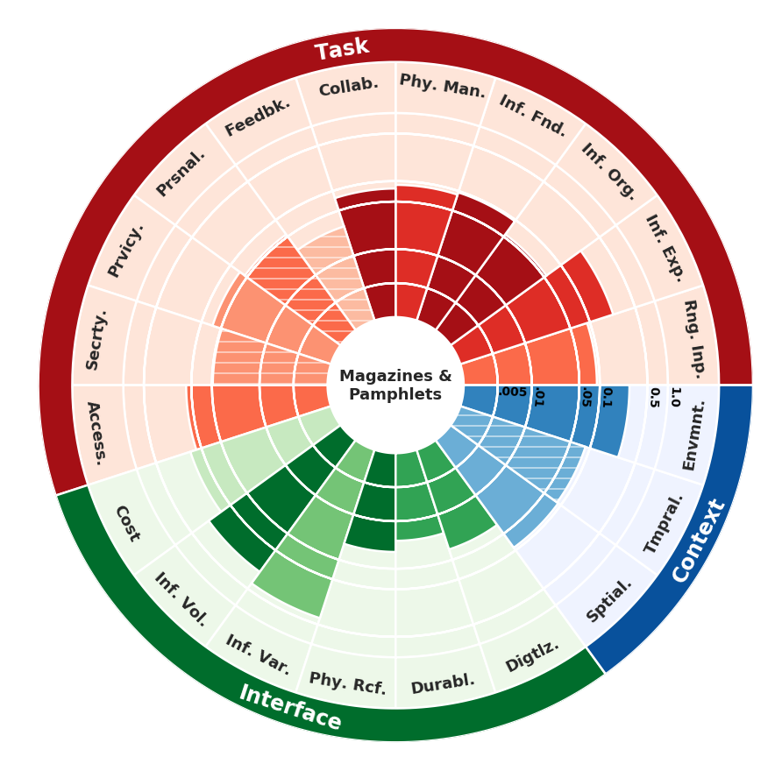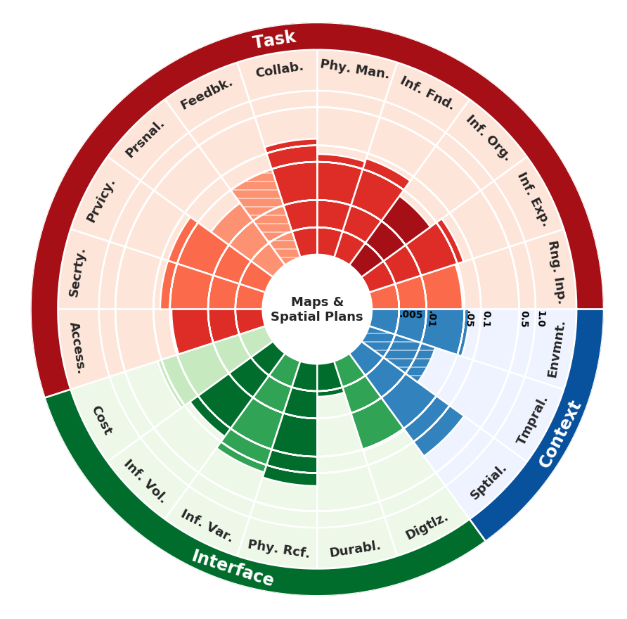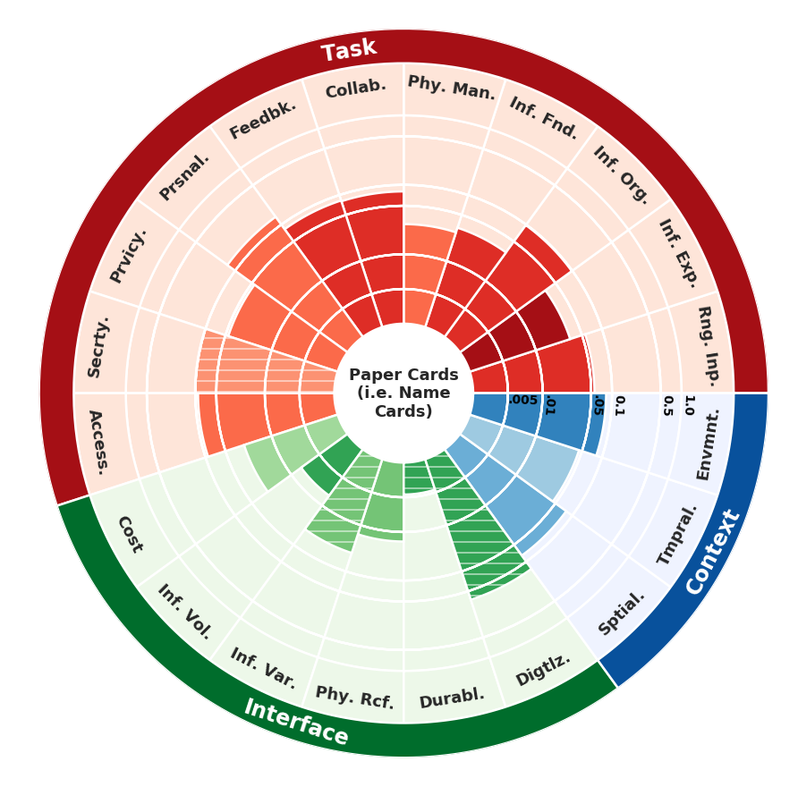

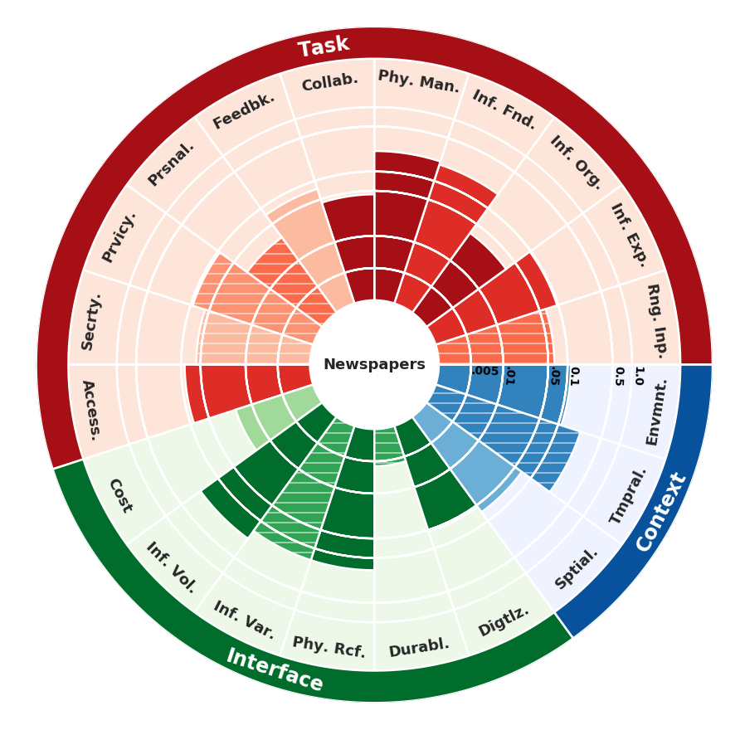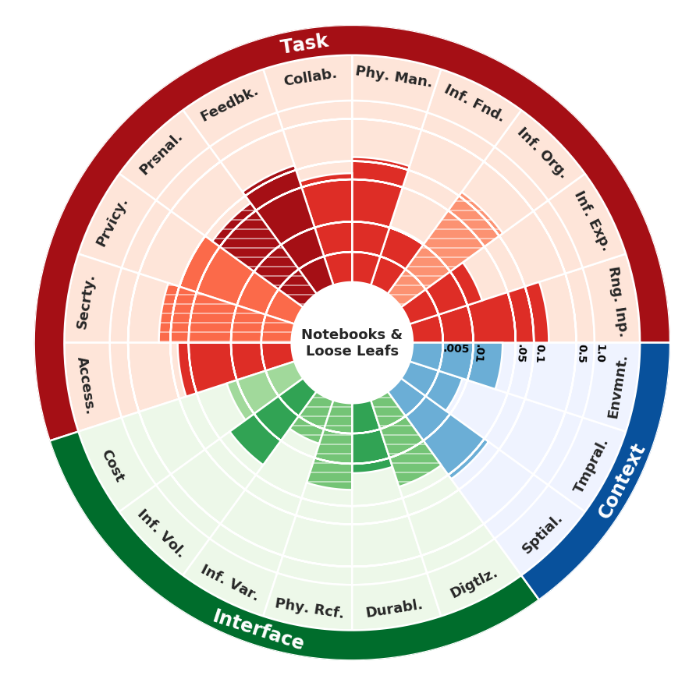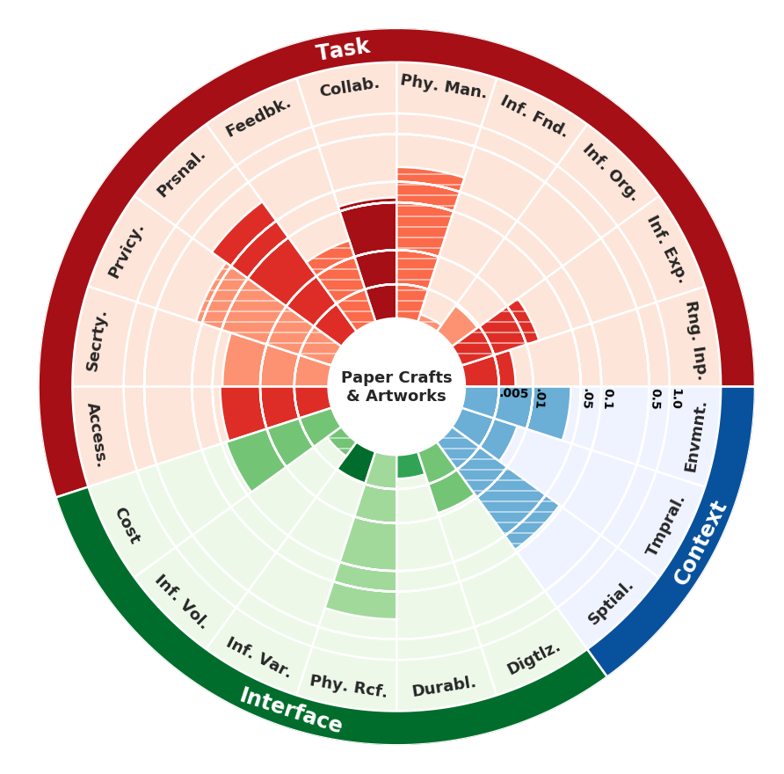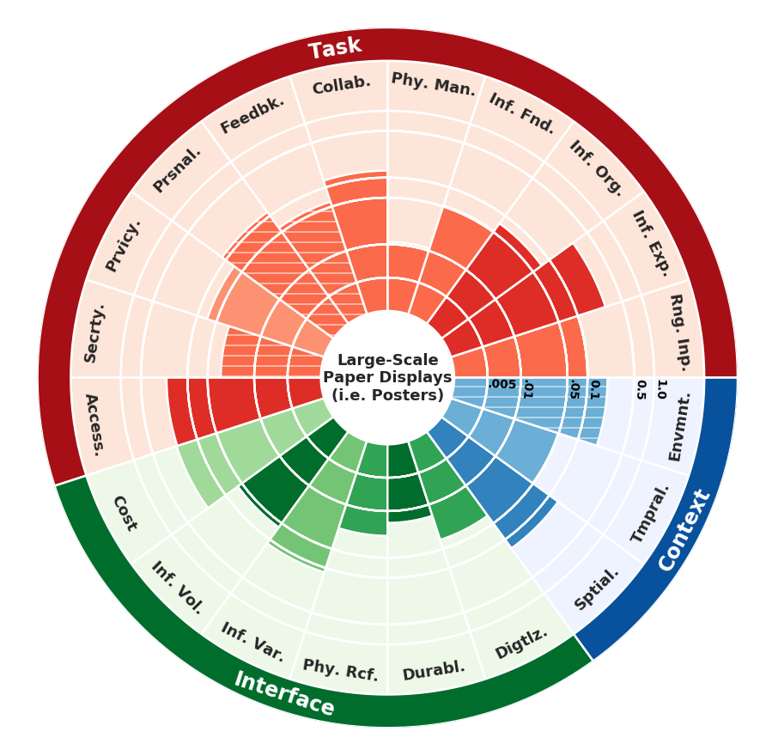

**Sketch Paper**

**Sketch Paper**

**Sketch Paper**