

NMIMS School of Law Bengaluru - Internship Details
Sl. No. | Name of the Law Firm/ NGO/ Court/ Organization/ Company | Date of the Internship (From – To) | Duration of Internship (in weeks) | Winter Internship / Summer Internship | Full Year Internship | Internship Certificate Provided (Yes/ No) | Faculty Sign | Remark Of School
1 | Advocate Jeevan Prakash, District Bar Association, Ranchi | 14 Jul 2022 – 14 Aug 2022 | 4 weeks | Summer Internship | No | Yes
2 | Jharkhand State Legal Services Authority (JHALSA) | 1 Jun 2023 – 30 Jun 2023 | 4 weeks | Summer Internship | No | Yes
3 | Grene Robotics (India) Private Limited | 1 Dec 2023 – 1 Feb 2024 | 9 weeks | Winter Internship | No | Yes
4 | Office of the Advocate General, Jharkhand High Court | 1 Dec 2024 – 30 Dec 2024 | 4 weeks | Winter Internship | No | Yes
5 | Fraudopedia Private Limited | 20 Jun 2025 – 20 Sep 2025 | 13 weeks | Summer Internship | No | Yes

DEAN | SEAL/STAMP
NMIMS School of Law | NMIMS School of Law



Internship, Moot Court, Trial/ Client Counselling/ Courtroom Observation Experience Diary

of
NMIMS School of Law
UNDER THE GUIDANCE OF
Career Guidance and Placement Cell
SUBMITTED TO –
School of Law, NMIMS Bengaluru
SUBMITTED BY –
Name: Chitraksh Mayank
Roll No.: i016
SAP ID: 81022100573
Course: BBA., LL.B. (Hons.) – Business Law
Year: V | Semester: X | Academic Year: 2025–2026

INDEX
SL NO. | PARTICULARS
1. | Weekly Reports of Internship 1 – Advocate Jeevan Prakash, District Bar Association, Ranchi
2. | Weekly Reports of Internship 2 – Jharkhand State Legal Services Authority (JHALSA), Ranchi
3. | Weekly Reports of Internship 3 – Grene Robotics (India) Private Limited, Hyderabad
4. | Weekly Reports of Internship 4 – Office of the Advocate General, Jharkhand High Court
5. | Weekly Reports of Internship 5 – Fraudopedia Private Limited
6. | Summary of All Internships
7. | Outcomes of the Internships (Learnings)
8. | Internship Certificates (All Five)
9. | Moot Court Experience Summary & Certificates
10. | Trial/Client Counselling/Courtroom Observation Summary
11. | Declaration and Acknowledgement

INTERNSHIP DIARY
INTERNSHIP NUMBER – 01
NAME OF THE NGO/COURT/ORGANIZATION/ FIRM/ CHAMBER OF INTERNSHIP –
Advocate Jeevan Prakash, District Bar Association, Ranchi
ADDRESS OF THE NGO/COURT/ORGANIZATION/ FIRM/ CHAMBER OF INTERNSHIP –
District Bar Association, Ranchi, Jharkhand
NAME OF THE SENIOR TO WHOM THE STUDENT IS REPORTING –
Advocate Jeevan Prakash (Enrolment No. JHA/0858/2007, Bar Council of Jharkhand)
AREA OF PRACTICE –
Civil and Criminal Litigation (District Court Level)
DURATION OF THE INTERNSHIP –
14th July 2022 – 14th August 2022 (4 Weeks)
NAME OF THE STUDENT – Chitraksh Mayank
SAP ID OF THE STUDENT – 81022100573
BATCH – 2021–2026
ROLL NO – i016
COURSE – BBA., LL.B. (Hons.) – Business Law

Signature of the Student Signature of the Program Chairperson

Date – 14th July 2022
Date: Week 1: 14th July 2022 – 20th July 2022
• AREA OF THE INTERNSHIP (LAWS DEALT WITH): Code of Civil Procedure, 1908 (CPC); Code of Criminal Procedure, 1973 (CrPC); Indian Penal Code, 1860 (IPC)
• TASK ASSIGNED: Orientation to the district court system; observation of Civil Court and Court of the Chief Judicial Magistrate (CJM) proceedings; review of pending case files for civil matters including suits for recovery of money, specific performance, and property disputes
• TASK COMPLETED: Attended orientation with Advocate Jeevan Prakash; observed court sessions in Civil Court and CJM Court; reviewed civil case files; familiarised with courtroom procedure, roles of the presiding officer and advocate, and the language and etiquette of district court advocacy
Date: Week 2: 21st July 2022 – 27th July 2022
• AREA OF THE INTERNSHIP (LAWS DEALT WITH): Code of Civil Procedure, 1908 (Order VII Rule 1, Order VIII Rule 3); Code of Criminal Procedure, 1973 (Sections 437, 439); Indian Penal Code, 1860 (Sections 406, 420)
• TASK ASSIGNED: Drafting of plaint under Order VII Rule 1 CPC for recovery of disputed loan amount; research on bail criteria under Sections 437 and 439 CrPC; drafting of bail application; observation of filing procedure at Civil Court registry
• TASK COMPLETED: Drafted plaint including statement of facts, legal grounds, prayer clause, and supporting documentation; observed filing procedure and court fees/stamp duty requirements; drafted bail application; attended hearings in criminal matters under Sections 406 and 420 IPC
Date: Week 3: 28th July 2022 – 3rd August 2022
• AREA OF THE INTERNSHIP (LAWS DEALT WITH): Code of Civil Procedure, 1908 (Order VIII Rule 3); Specific Relief Act, 1963; Negotiable Instruments Act, 1881 (Section 138); Code of Criminal Procedure, 1973
• TASK ASSIGNED: Drafting of written statement under Order VIII Rule 3 CPC; research on specific performance under Specific Relief Act; observation of criminal appeal before Sessions Court; drafting of legal notice under Section 138 NI Act
• TASK COMPLETED: Drafted written statement raising affirmative defences; identified Supreme Court and High Court judgements on specific performance; attended criminal appeal hearing; drafted legal notice in cheque dishonour matter under Section 138 NI Act
Date: Week 4: 4th August 2022 – 14th August 2022
• AREA OF THE INTERNSHIP (LAWS DEALT WITH): Code of Criminal Procedure, 1973 (Section 200); Code of Civil Procedure, 1908; Indian Penal Code, 1860
• TASK ASSIGNED: Drafting complaint petition under Section 200 CrPC; daily court accompaniment with supervising advocate; compilation of procedural notes and advocacy techniques
• TASK COMPLETED: Drafted portions of complaint petition under Section 200 CrPC; accompanied supervising advocate to courts daily; observed case management, adjournment proceedings, and list hearings; compiled comprehensive notes document and submitted reflective report

SUMMARY OF THE INTERNSHIP
The internship in the chambers of Advocate Jeevan Prakash at the District Bar Association, Ranchi (14th July 2022 – 14th August 2022) provided foundational exposure to civil and criminal litigation at the district court level. Over four weeks, the intern drafted plaints, written statements, bail applications, legal notices, and complaint petitions, and attended court hearings across civil and criminal matters. The experience established a thorough understanding of trial court procedure and the procedural discipline required in effective legal practice.

INTERNSHIP LEARNINGS
THINGS LEARNT:
Foundational understanding of trial court procedure under the CPC and CrPC; drafting of plaints, written statements, bail applications, legal notices, and complaint petitions; elements of criminal liability under Sections 406 and 420 IPC; bail criteria under Sections 437 and 439 CrPC; procedure for filing private complaints under Section 200 CrPC; court filing requirements including court fees and stamp duty; procedure for criminal appeals before the Sessions Court.
SKILLS ACQUIRED:
Legal drafting skills for court filings; legal research and case law identification; courtroom observation and advocacy etiquette; client interaction and instruction taking; case file organisation and management.
ANY OTHER REMARKS:
This internship, being the first in the academic programme, established the foundation for all subsequent practical legal work. It reinforced the importance of procedural law as the cornerstone of effective litigation practice.

INTERNSHIP CERTIFICATE – INTERNSHIP 01
Advocate Jeevan Prakash, District Bar Association, Ranchi
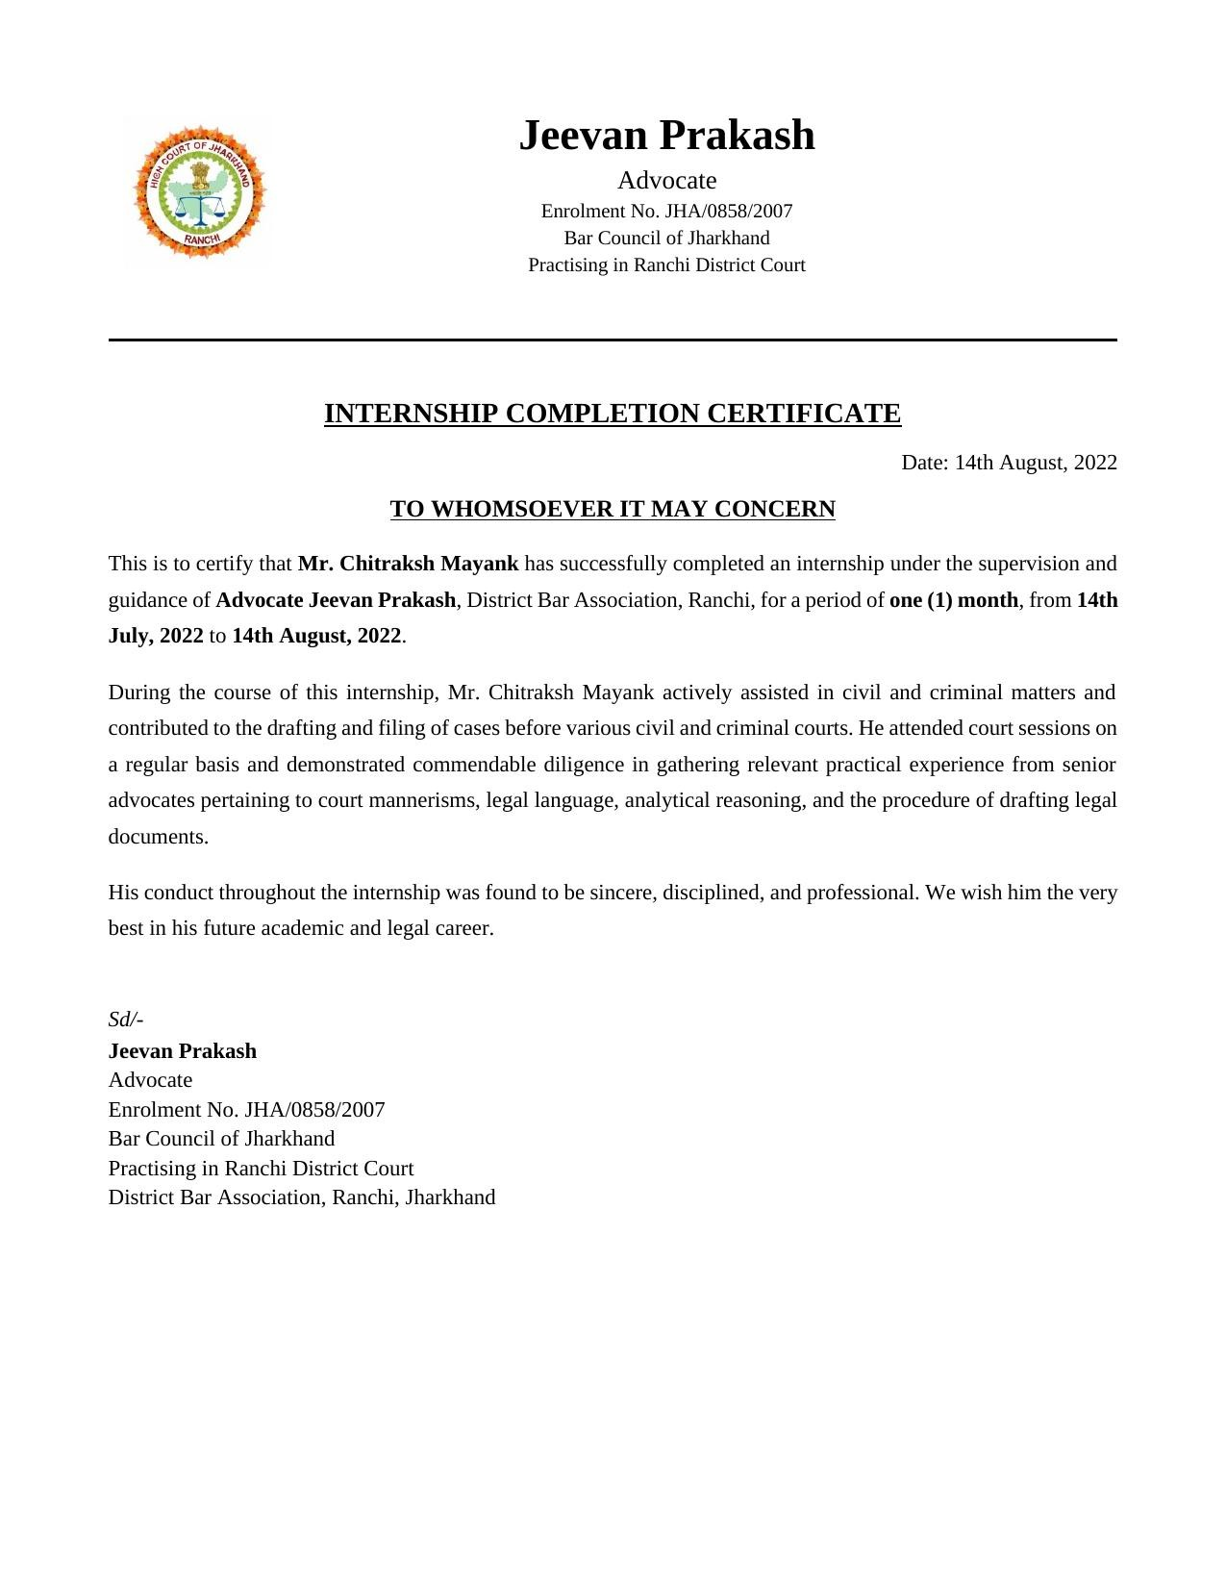

INTERNSHIP DIARY
INTERNSHIP NUMBER – 02
NAME OF THE NGO/COURT/ORGANIZATION/ FIRM/ CHAMBER OF INTERNSHIP –
Jharkhand State Legal Services Authority (JHALSA)
ADDRESS OF THE NGO/COURT/ORGANIZATION/ FIRM/ CHAMBER OF INTERNSHIP –
Nyaya Sadan, Near A.G. Office, Doranda, Ranchi – 834002, Jharkhand
NAME OF THE SENIOR TO WHOM THE STUDENT IS REPORTING –
Santosh Kumar, Member Secretary, JHALSA
AREA OF PRACTICE –
Alternative Dispute Resolution, Legal Aid, Lok Adalat Proceedings, Mediation
DURATION OF THE INTERNSHIP –
1st June 2023 – 30th June 2023 (4 Weeks)
NAME OF THE STUDENT – Chitraksh Mayank
SAP ID OF THE STUDENT – 81022100573
BATCH – 2021–2026
ROLL NO – i016
COURSE – BBA., LL.B. (Hons.) – Business Law

Signature of the Student Signature of the Program Chairperson

Date – 1st June 2023
Date: Week 1: 1st June 2023 – 7th June 2023
• AREA OF THE INTERNSHIP (LAWS DEALT WITH): Legal Services Authorities Act, 1987 (Sections 19–22); Constitution of India (Articles 21, 39A); Motor Vehicles Act; Negotiable Instruments Act, 1881 (Section 138)
• TASK ASSIGNED: Orientation to JHALSA mandate and structure; observation of initial mediation sessions involving family law and property disputes; assistance in preparing case summaries for Lok Adalat
• TASK COMPLETED: Attended orientation on the Legal Services Authorities Act, 1987 and the role of Lok Adalats and Mediation Centres; observed mediation sessions; familiarised with mediator role, confidentiality principles, and procedural framework; assisted para-legal volunteers in preparing Lok Adalat case summaries
Date: Week 2: 8th June 2023 – 14th June 2023
• AREA OF THE INTERNSHIP (LAWS DEALT WITH): Legal Services Authorities Act, 1987 (Section 21); Negotiable Instruments Act, 1881 (Section 138); Motor Vehicles Act
• TASK ASSIGNED: Attendance at Lok Adalat sittings across multiple dispute categories; assistance in drafting conciliation agreements and settlement deeds; study of ethical framework governing mediation
• TASK COMPLETED: Attended Lok Adalat sittings covering motor accident claims, electricity bill disputes, cheque dishonour matters, and labour disputes; assisted in drafting conciliation agreements and settlement deeds reduced to Lok Adalat awards under Section 21 of the Legal Services Authorities Act, 1987; collaborated with senior mediators on principles of impartiality and informed consent
Date: Week 3: 15th June 2023 – 21st June 2023
• AREA OF THE INTERNSHIP (LAWS DEALT WITH): Legal Services Authorities Act, 1987; Constitution of India (Articles 21, 39A); NALSA Guidelines
• TASK ASSIGNED: Supervised jail visit and preparation of report; group assignment on efficacy of Lok Adalats; organisation of legal awareness camp for the public
• TASK COMPLETED: Conducted supervised visit to local jail and prepared detailed report on legal aid services for undertrial prisoners; engaged in group assignment analysing Lok Adalat efficacy; assisted in organising legal awareness camp covering fundamental rights, legal aid entitlements, and consumer forum procedures
Date: Week 4: 22nd June 2023 – 30th June 2023
• AREA OF THE INTERNSHIP (LAWS DEALT WITH): Legal Services Authorities Act, 1987; Mediation Act, 2023; Alternative Dispute Resolution principles
• TASK ASSIGNED: Individual case-study assignments on ADR outcomes; observation of para-legal volunteer training session organised by JHALSA; preparation of comprehensive internship summary report
• TASK COMPLETED: Participated in individual case-study assignments developing analytical skills in identifying appropriate dispute resolution pathways; attended JHALSA training session for para-legal volunteers; prepared and submitted comprehensive internship summary report to the supervising authority

SUMMARY OF THE INTERNSHIP
The internship at the Jharkhand State Legal Services Authority (JHALSA), Ranchi (1st June 2023 – 30th June 2023) provided meaningful exposure to the access-to-justice infrastructure of the Indian legal system. Over four weeks, the intern attended Lok Adalat sittings, observed mediation sessions, conducted a supervised jail visit, and assisted in organising a legal awareness camp. The experience deepened appreciation for alternative dispute resolution, the constitutional commitment to free legal aid under Article 39A, and the role of community-based legal services in extending justice to underserved populations.

INTERNSHIP LEARNINGS
THINGS LEARNT:
Operation of Lok Adalats and their legal status under Section 21 of the Legal Services Authorities Act, 1987; principles of mediation including party autonomy, confidentiality, and facilitative neutrality; conditions of undertrial prisoners and legal aid services under NALSA guidelines; legal awareness topics including fundamental rights and consumer forum procedures; ADR pathway analysis.
SKILLS ACQUIRED:
Drafting of conciliation agreements and settlement deeds; case summary preparation for Lok Adalat; analytical skills in identifying appropriate dispute resolution mechanisms; community engagement and legal awareness communication; report writing and documentation.
ANY OTHER REMARKS:
The internship provided deep appreciation for the constitutional and statutory framework of access to justice in India, particularly for economically and socially disadvantaged sections. The experience of working alongside para-legal volunteers and senior mediators highlighted the indispensable role of community-based legal services.

INTERNSHIP CERTIFICATE – INTERNSHIP 02
Jharkhand State Legal Services Authority (JHALSA), Ranchi
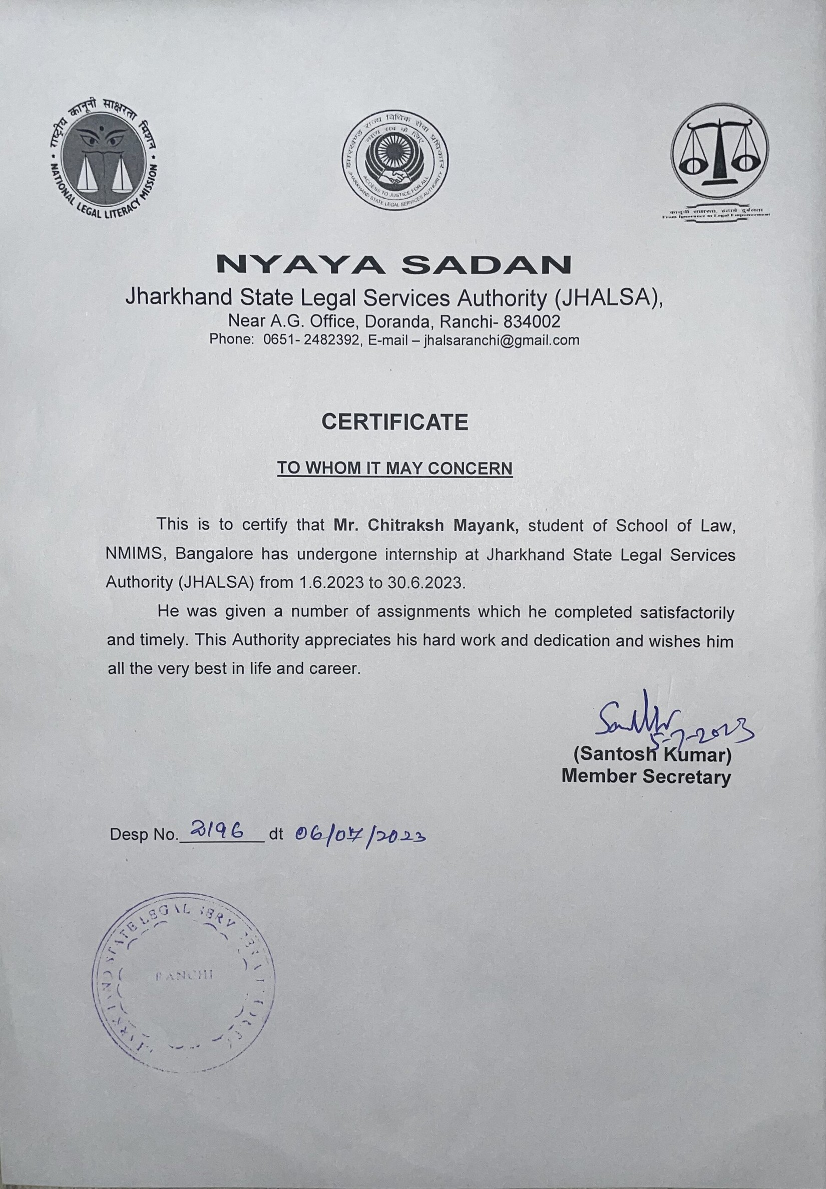

INTERNSHIP DIARY
INTERNSHIP NUMBER – 03
NAME OF THE NGO/COURT/ORGANIZATION/ FIRM/ CHAMBER OF INTERNSHIP –
Grene Robotics (India) Private Limited
ADDRESS OF THE NGO/COURT/ORGANIZATION/ FIRM/ CHAMBER OF INTERNSHIP –
Plot No. 437, Road No. 20, Jubilee Hills, Hyderabad – 500033, Telangana, India
NAME OF THE SENIOR TO WHOM THE STUDENT IS REPORTING –
Dr. Gaurav Sharma, PhD, Chief Legal Officer, Grene Robotics Private Limited
AREA OF PRACTICE –
Corporate Law, Transactional Drafting, Company Law, SEBI Regulations, Intellectual Property
DURATION OF THE INTERNSHIP –
1st December 2023 – 1st February 2024 (9 Weeks)
NAME OF THE STUDENT – Chitraksh Mayank
SAP ID OF THE STUDENT – 81022100573
BATCH – 2021–2026
ROLL NO – i016
COURSE – BBA., LL.B. (Hons.) – Business Law

Signature of the Student Signature of the Program Chairperson

Date – 1st December 2023
Date: Weeks 1–3: 1st December 2023 – 22nd December 2023
• AREA OF THE INTERNSHIP (LAWS DEALT WITH): Companies Act, 2013 (Sections 149, 153A, 14, 18); SEBI ICDR Regulations, 2018; FDI Policy; MCA Circulars
• TASK ASSIGNED: Review and analysis of existing corporate governance documentation for gaps; commencement of Share Subscription Agreement drafting; research on director appointment requirements under Companies Act; research on FOCC IPO requirements
• TASK COMPLETED: Reviewed and analysed company corporate governance documentation identifying compliance gaps under the Companies Act, 2013; commenced drafting Share Subscription Agreement defining rights, obligations, representations, warranties, and conditions for new investors; researched requirements for appointment of additional and executive directors; researched legal requirements for Foreign Owned or Controlled Companies (FOCC) seeking to undertake an IPO under SEBI ICDR Regulations and FDI policy
Date: Weeks 4–6: 23rd December 2023 – 12th January 2024
• AREA OF THE INTERNSHIP (LAWS DEALT WITH): Companies Act, 2013; SEBI ICDR Regulations, 2018; Contract Law; Intellectual Property Law
• TASK ASSIGNED: Drafting of Shareholders Agreement (SHA) covering share transfer restrictions, pre-emption rights, drag-along/tag-along provisions, anti-dilution protections, and governance rights; drafting of Strategic Partnership Deed; research on IPO legal prerequisites; comparative research note on SHA vs. Articles of Association
• TASK COMPLETED: Drafted comprehensive Shareholders Agreement; drafted Strategic Partnership Deed governing proposed collaboration with a defence technology partner including confidentiality, IP ownership, and liability allocation; researched legal prerequisites and regulatory conditions for IPO including lock-in requirements and promoter disclosure obligations under SEBI regulations; prepared comparative research note on SHA vs. Articles of Association
Date: Weeks 7–9: 13th January 2024 – 1st February 2024
• AREA OF THE INTERNSHIP (LAWS DEALT WITH): Companies Act, 2013 (Sections 14, 18); Contract Law; Intellectual Property Assignment; Insolvency and Bankruptcy Code, 2016
• TASK ASSIGNED: Drafting of Cancellation Deed for termination of prior contractual arrangement; drafting of Co-founder Agreement with equity, vesting, and IP clauses; review and finalisation of all instruments in consultation with supervising legal team; preparation of internal reference note on private-to-public company conversion
• TASK COMPLETED: Drafted Cancellation Deed recording formal termination of prior contractual arrangement; drafted Co-founder Agreement defining equity allocation, vesting schedule, exit provisions, non-compete/non-solicitation covenants, and IP assignment provisions; reviewed and finalised all drafted instruments incorporating revisions; prepared internal legal reference note on process for converting a private limited company to a public limited company under the Companies Act, 2013

SUMMARY OF THE INTERNSHIP
The internship at Grene Robotics (India) Private Limited, Hyderabad (1st December 2023 – 1st February 2024) provided a rigorous introduction to corporate transactional law in a high-growth, technology-driven start-up environment. Over nine weeks, the intern drafted a Share Subscription Agreement, Shareholders Agreement, Strategic Partnership Deed, Cancellation Deed, and Co-founder Agreement, and conducted substantial research on IPO prerequisites, director appointment requirements, and FOCC regulations. The experience consolidated understanding of corporate governance, contractual drafting, and transactional law in the defence technology sector.

INTERNSHIP LEARNINGS
THINGS LEARNT:
Corporate governance structures in venture capital and start-up contexts; allocation of economic and governance rights between founders, investors, and the company; director appointment requirements under the Companies Act, 2013; legal prerequisites for IPO including SEBI ICDR Regulations; formalising intra-founder relationships through Co-founder Agreements covering equity vesting and IP ownership; regulatory considerations in the defence technology sector including foreign investment restrictions.
SKILLS ACQUIRED:
Transactional legal drafting of shareholders agreements, subscription agreements, partnership deeds, and co-founder agreements; corporate governance review and gap analysis; regulatory research under the Companies Act, 2013 and SEBI regulations; document review and revision in consultation with senior legal team.
ANY OTHER REMARKS:
The opportunity to draft foundational legal instruments for a company operating at the cutting edge of Indian defence technology demonstrated the direct impact that well-drafted legal instruments have on a company's governance, fundraising, and long-term viability.

INTERNSHIP CERTIFICATE – INTERNSHIP 03
Grene Robotics (India) Private Limited, Hyderabad
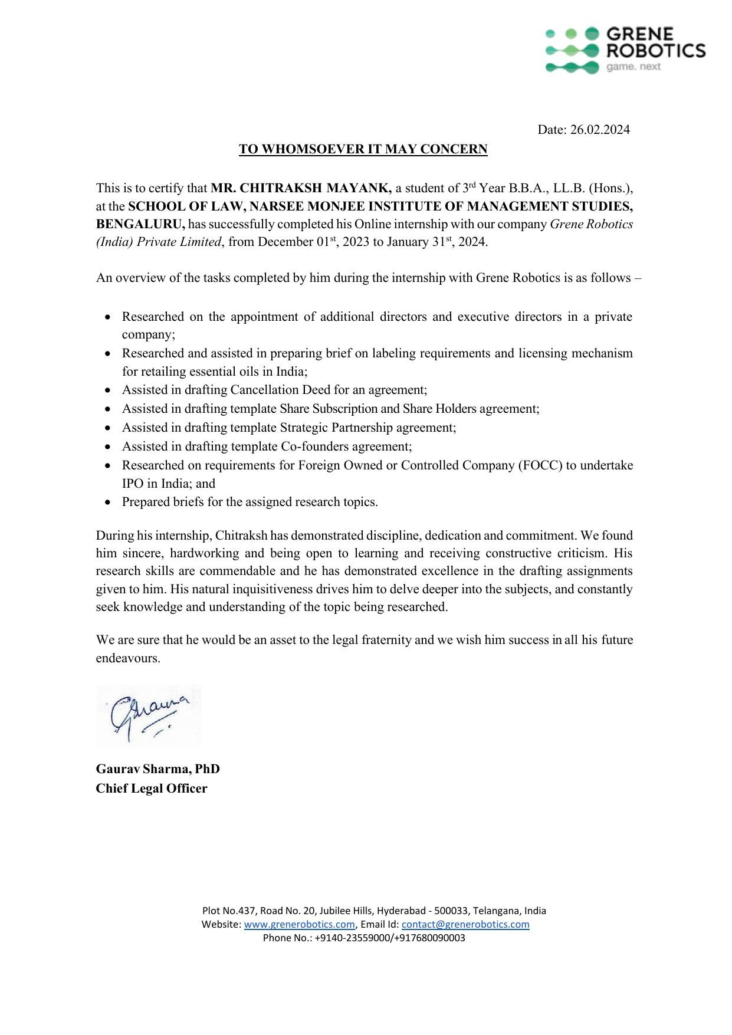

INTERNSHIP DIARY
INTERNSHIP NUMBER – 04
NAME OF THE NGO/COURT/ORGANIZATION/ FIRM/ CHAMBER OF INTERNSHIP –
Office of the Advocate General, Jharkhand High Court
ADDRESS OF THE NGO/COURT/ORGANIZATION/ FIRM/ CHAMBER OF INTERNSHIP –
Jharkhand High Court Campus, Dhurwa, Ranchi – 834004, Jharkhand
NAME OF THE SENIOR TO WHOM THE STUDENT IS REPORTING –
Rajiv Ranjan, Senior Advocate & Advocate General, Jharkhand
AREA OF PRACTICE –
Constitutional Law, Public Law Litigation, Civil Law, Criminal Law, Service Law
DURATION OF THE INTERNSHIP –
1st December 2024 – 30th December 2024 (4 Weeks)
NAME OF THE STUDENT – Chitraksh Mayank
SAP ID OF THE STUDENT – 81022100573
BATCH – 2021–2026
ROLL NO – i016
COURSE – BBA., LL.B. (Hons.) – Business Law

Signature of the Student Signature of the Program Chairperson

Date – 1st December 2024
Date: Week 1: 1st December 2024 – 7th December 2024
• AREA OF THE INTERNSHIP (LAWS DEALT WITH): Constitution of India (Articles 165, 226, 227, 300A); Code of Civil Procedure, 1908; Code of Criminal Procedure, 1973; Supreme Court precedents on constitutional law
• TASK ASSIGNED: Legal research on constitutional matters pending before the Jharkhand High Court; organisation and indexing of case files for writ petitions and civil matters; attendance at chamber discussions with supervising advocate; observation of High Court proceedings
• TASK COMPLETED: Conducted detailed legal research on constitutional matters including Supreme Court precedents and applicable statutory provisions; assisted in organising and indexing case files for pending writ petitions ensuring accuracy of pleadings; attended chamber discussions understanding procedural posture and legal strategy; observed High Court proceedings familiarising with courtroom protocol, judicial temperament, and advocacy etiquette
Date: Week 2: 8th December 2024 – 14th December 2024
• AREA OF THE INTERNSHIP (LAWS DEALT WITH): Constitution of India (Articles 226, 227, 300A); Code of Civil Procedure, 1908; Service Law; Land Acquisition Legislation
• TASK ASSIGNED: Assistance in drafting counter-affidavit on behalf of State Government in service matter; research on procedural requirements for writ proceedings; attendance at client consultations with government departments; observation of oral arguments in land acquisition writ petition
• TASK COMPLETED: Assisted in drafting counter-affidavit filed on behalf of the State Government in a service matter involving a dismissed government employee; researched procedural requirements for filing written statements and counter-affidavits in writ proceedings; attended client consultations and assisted in documenting client instructions; observed oral arguments in writ petition challenging a government land acquisition order under Article 226
Date: Week 3: 15th December 2024 – 21st December 2024
• AREA OF THE INTERNSHIP (LAWS DEALT WITH): Constitution of India (Articles 226, 227); Code of Criminal Procedure, 1973; Contempt of Courts Act, 1971; Constitutional Reservation Policy
• TASK ASSIGNED: Drafting portions of petition under Article 227; research on supervisory jurisdiction and judicial review; assistance in compiling criminal appeal arguments; preparation of response to show-cause notice in contempt matter
• TASK COMPLETED: Drafted portions of petition under Article 227 relating to a subordinate court's exercise of revisional jurisdiction; researched Supreme Court and Jharkhand High Court precedents on supervisory jurisdiction and judicial review; assisted in compiling legal arguments for criminal appeal including applicable CrPC provisions; participated in preparing response to show-cause notice in contempt matter under the Contempt of Courts Act, 1971
Date: Week 4: 22nd December 2024 – 30th December 2024
• AREA OF THE INTERNSHIP (LAWS DEALT WITH): Indian Penal Code, 1860 (Sections 406, 420); Constitution of India – Reservation Policy; Environmental Law; Public Trust Doctrine
• TASK ASSIGNED: Compilation of research memorandum on Sections 406 and 420 IPC in context of commercial disputes; attendance at final hearing in constitutional matter on reservation policy; assistance in preparing brief for environmental writ petition; organisation of all case files
• TASK COMPLETED: Compiled research memorandum on Sections 406 and 420 IPC analysing mens rea requirements and distinguishing civil breach from criminal liability; attended final hearing in constitutional matter concerning reservation policy and the 50% ceiling rule; assisted in preparing final brief on pending environmental writ petition researching principles of environmental law and doctrine of public trust; organised all case files before conclusion of internship

SUMMARY OF THE INTERNSHIP
The internship at the Office of the Advocate General for Jharkhand High Court (1st December 2024 – 30th December 2024) was an invaluable formative experience in constitutional and public law practice. Over four weeks, the intern conducted legal research on constitutional matters, drafted counter-affidavits and petitions under Articles 226 and 227, compiled research memoranda on IPC provisions, and regularly observed High Court proceedings including writ petitions, criminal appeals, and contempt matters. The experience provided direct exposure to the functioning of a premier constitutional law office and the demands of High Court litigation at a professional standard.

INTERNSHIP LEARNINGS
THINGS LEARNT:
Functioning of a constitutional law office and the role of the Advocate General under Article 165; supervisory jurisdiction of High Courts under Articles 226 and 227; legal drafting of counter-affidavits and petitions at professional standard; mens rea under Sections 406 and 420 IPC and distinction between civil and criminal liability; principles of environmental law and the doctrine of public trust; legal standard for contempt under the Contempt of Courts Act, 1971; client interaction with government officials in a legal advisory context.
SKILLS ACQUIRED:
High Court legal research and precedent identification; drafting of constitutional court pleadings and memoranda; courtroom observation at High Court level; client consultation and instruction documentation; case file organisation at High Court standard.
ANY OTHER REMARKS:
This internship represented the culmination of the academic programme's practical training, providing the highest level of exposure to constitutional and public law practice. The experience has substantially enhanced preparation for a career in litigation and legal consultancy.

INTERNSHIP CERTIFICATE – INTERNSHIP 04
Office of the Advocate General, Jharkhand High Court
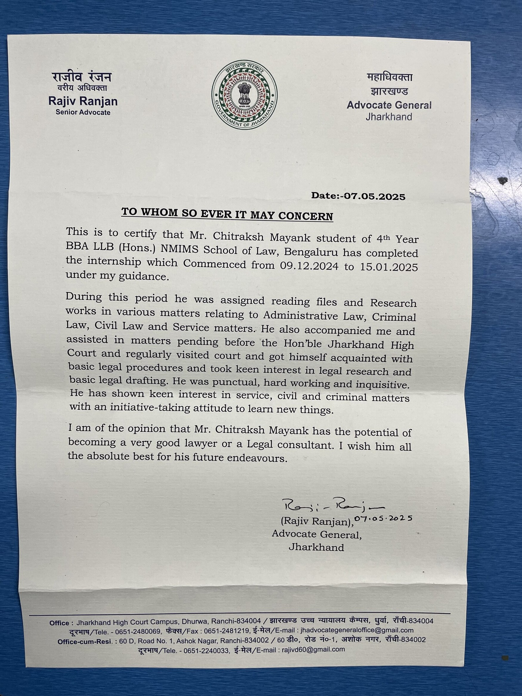

INTERNSHIP DIARY
INTERNSHIP NUMBER – 05
NAME OF THE NGO/COURT/ORGANIZATION/ FIRM/ CHAMBER OF INTERNSHIP –
Fraudopedia Private Limited
ADDRESS OF THE NGO/COURT/ORGANIZATION/ FIRM/ CHAMBER OF INTERNSHIP –
Fraudopedia Private Limited, India (Remote Mode)
NAME OF THE SENIOR TO WHOM THE STUDENT IS REPORTING –
Ms. Vidya Rajarao, Founder & CEO, Fraudopedia Private Limited
AREA OF PRACTICE –
Financial Fraud Research, Securities Regulation Analysis, Forensic Data Research, Application of Artificial Intelligence in Legal Research
DURATION OF THE INTERNSHIP –
20th June 2025 – 20th September 2025 (13 Weeks)
NAME OF THE STUDENT – Chitraksh Mayank
SAP ID OF THE STUDENT – 81022100573
BATCH – 2021–2026
ROLL NO – i016
COURSE – BBA., LL.B. (Hons.) – Business Law

Signature of the Student Signature of the Program Chairperson

Date – 20th June 2025
Date: Weeks 1–3: 20th June 2025 – 10th July 2025
• AREA OF THE INTERNSHIP (LAWS DEALT WITH): U.S. Securities Exchange Act, 1934; Sarbanes-Oxley Act, 2002; SEC Accounting and Auditing Enforcement Releases (AAER) framework; Indian Companies Act, 2013 (Sections 143, 447); SEBI (Prohibition of Fraudulent and Unfair Trade Practices) Regulations, 2003
• TASK ASSIGNED: Orientation to the research mandate of Fraudopedia; study of the SEC enforcement framework and the structure and content of Accounting and Auditing Enforcement Releases (AAERs); review of comparable Indian regulatory enforcement regimes under SEBI and the Companies Act, 2013; preparation of a research design note for extraction of AAER data from 1997 onwards
• TASK COMPLETED: Attended orientation with the Founder & CEO and the research team; completed in-depth study of the SEC's enforcement architecture under the Securities Exchange Act, 1934 and the Sarbanes-Oxley Act, 2002; mapped the AAER classification system used by the SEC Division of Enforcement; prepared a comparative note on SEC AAER enforcement vis-à-vis SEBI's fraud enforcement mechanisms under the PFUTP Regulations, 2003 and Sections 143 and 447 of the Companies Act, 2013; finalised the research design and taxonomy for systematic extraction of AAER data
Date: Weeks 4–6: 11th July 2025 – 31st July 2025
• AREA OF THE INTERNSHIP (LAWS DEALT WITH): U.S. Securities Exchange Act, 1934 (Sections 10(b), 13, 15); SEC Rule 10b-5; Generally Accepted Accounting Principles (GAAP); Public Company Accounting Oversight Board (PCAOB) standards
• TASK ASSIGNED: Extraction of SEC AAER data from 1997 to 2008 covering financial reporting fraud cases, audit failures, and enforcement actions; categorisation of extracted data by fraud scheme typology (revenue recognition, expense manipulation, asset overstatement, disclosure violations, and insider trading); preparation of structured dataset capturing respondent, allegations, charged provisions, and disposition
• TASK COMPLETED: Systematically extracted and catalogued SEC AAER records from 1997 through 2008; classified each AAER under standardised fraud scheme typologies including premature revenue recognition, improper capitalisation of expenses, fictitious sales, accounting reserve manipulation, and failure to disclose related party transactions; compiled structured dataset recording respondents, statutory provisions charged under Rule 10b-5 and Section 13 of the Exchange Act, 1934, enforcement actions (cease-and-desist orders, disgorgement, civil penalties, officer-and-director bars), and case dispositions; documented methodology and source verification for each entry
Date: Weeks 7–9: 1st August 2025 – 21st August 2025
• AREA OF THE INTERNSHIP (LAWS DEALT WITH): Sarbanes-Oxley Act, 2002 (Sections 302, 404, 906); Dodd-Frank Wall Street Reform and Consumer Protection Act, 2010; SEC Whistleblower Program; U.S. Foreign Corrupt Practices Act, 1977 (FCPA)
• TASK ASSIGNED: Continuation of AAER data extraction from 2009 to 2018 with focus on post-Sarbanes-Oxley enforcement trends; application of AI-assisted tools to analyse the extracted data for patterns in fraud typology, industry concentration, and enforcement outcomes; preparation of analytical memoranda synthesising findings across the covered period
• TASK COMPLETED: Extracted and structured AAER records from 2009 to 2018 capturing cases arising under Sarbanes-Oxley certifications, Dodd-Frank whistleblower incentives, and FCPA enforcement; applied AI tools including large language models and structured text extraction pipelines to normalise narrative AAER text into defined analytical parameters; generated analytical memoranda identifying recurring fraud patterns, industry clusters (notably financial services, healthcare, and technology), escalation in SEC monetary penalties over time, and the increasing role of whistleblower tips; prepared trend-analysis write-up on the evolution of SEC enforcement priorities in the post-Sarbanes-Oxley era
Date: Weeks 10–13: 22nd August 2025 – 20th September 2025
• AREA OF THE INTERNSHIP (LAWS DEALT WITH): SEC AAER framework (2019–2025); U.S. Generally Accepted Auditing Standards; Indian Forensic Audit framework under RBI and NFRA; comparative fraud enforcement principles
• TASK ASSIGNED: Completion of AAER data extraction for 2019 to 2025; finalisation of AI-driven analytical dashboards summarising fraud schemes, enforcement actions, and resolutions with the SEC; drafting of consolidated research report; preparation of a comparative summary linking SEC enforcement learnings to Indian forensic audit and fraud-examination practice
• TASK COMPLETED: Completed extraction of AAER records from 2019 through 2025 across the entire SEC Division of Enforcement output within the research scope; finalised AI-driven analytical outputs summarising salient aspects of each AAER including fraud scheme, statutory provisions invoked, nature and quantum of enforcement action, and final resolution with the SEC; drafted the consolidated research report encompassing the full 1997–2025 dataset, with visualisations of fraud typology trends, sectoral concentration, and penalty escalation; prepared a comparative summary mapping SEC enforcement methodology onto the Indian forensic audit and fraud-examination framework under NFRA and RBI; delivered final report to the Founder & CEO and obtained sign-off

SUMMARY OF THE INTERNSHIP
The internship at Fraudopedia Private Limited (20th June 2025 – 20th September 2025) provided sustained and intellectually demanding exposure to fraud examination, securities regulation, and the application of Artificial Intelligence to large-scale legal research. Over thirteen weeks, the intern systematically extracted SEC Accounting and Auditing Enforcement Release (AAER) data from 1997 through 2025, classified each entry by fraud scheme typology, and applied AI-assisted analytical tools to synthesise salient aspects of fraud schemes, enforcement actions, and resolutions with the SEC. The engagement culminated in a consolidated research report with comparative mapping onto the Indian forensic audit framework, and represented the most technology-intensive legal research undertaken during the course of the academic programme.

INTERNSHIP LEARNINGS
THINGS LEARNT:
Architecture of the SEC enforcement regime under the Securities Exchange Act, 1934 and the Sarbanes-Oxley Act, 2002; classification of financial reporting fraud schemes including revenue recognition, expense capitalisation, reserve manipulation, and related-party non-disclosure; evolution of SEC enforcement priorities in the post-Sarbanes-Oxley and post-Dodd-Frank periods; mechanics of the SEC Whistleblower Program and the Foreign Corrupt Practices Act, 1977; comparative understanding of SEBI's PFUTP Regulations, 2003 and Sections 143 and 447 of the Indian Companies Act, 2013; application of Artificial Intelligence and large language models to structured legal research and enforcement data analysis.
SKILLS ACQUIRED:
Forensic research and data extraction from regulatory databases spanning nearly three decades; design and application of classification taxonomies for fraud schemes; use of AI tools and large language models to extract structured signal from unstructured legal and regulatory text; quantitative and qualitative trend analysis of enforcement data; drafting of consolidated research reports and analytical dashboards for executive review; comparative regulatory analysis across U.S. and Indian fraud enforcement frameworks.
ANY OTHER REMARKS:
The internship at Fraudopedia represented a distinctive fusion of legal research, securities regulation, and Artificial Intelligence, and significantly advanced the intern's preparation for a technology-forward legal career at the intersection of regulatory compliance, forensic investigation, and applied AI. The mentorship of the Founder & CEO provided direct exposure to the strategic priorities of a fraud-examination practice operating at the frontier of the discipline.

INTERNSHIP CERTIFICATE – INTERNSHIP 05
Fraudopedia Private Limited
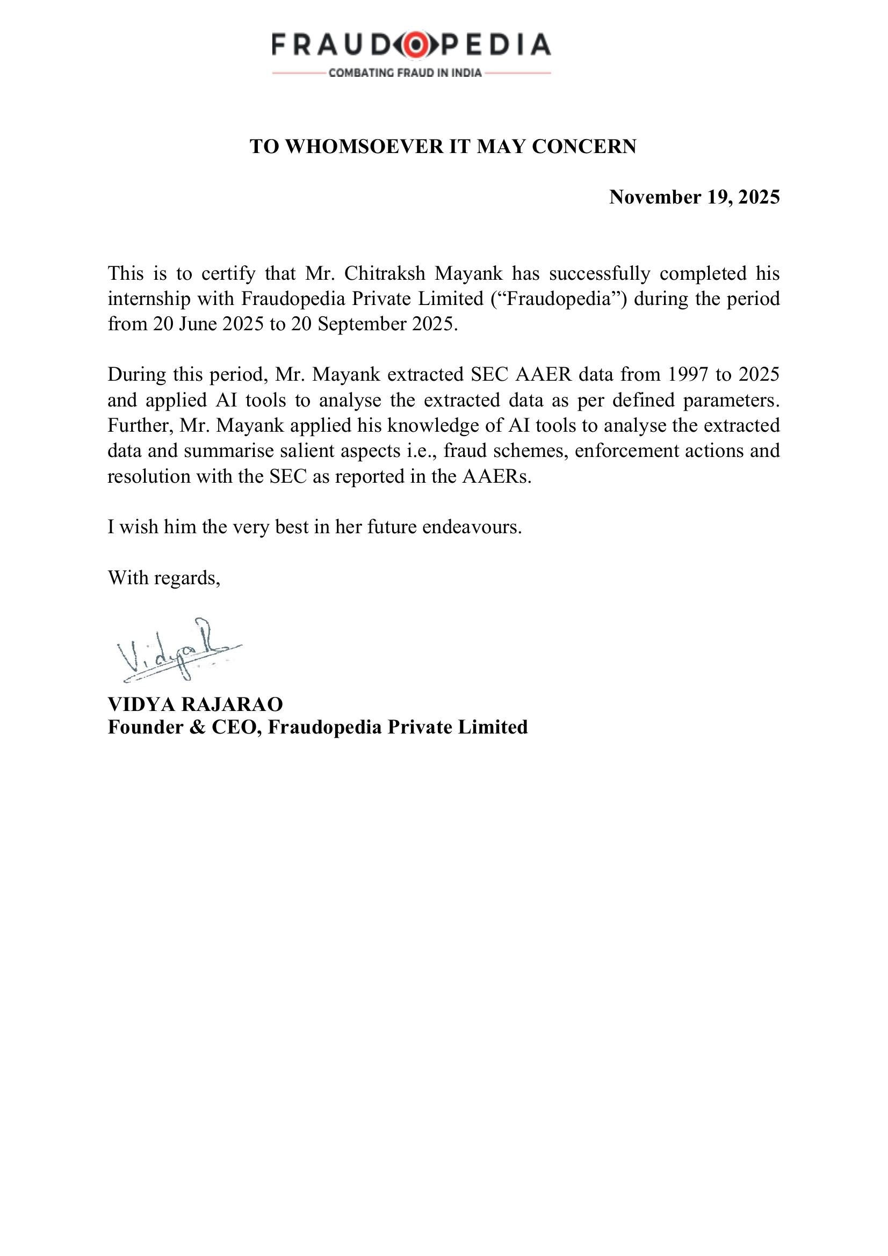

MOOT COURT EXPERIENCE SUMMARY & CERTIFICATES
Note: The following records participation in competitive academic activities undertaken during the BBA., LL.B. (Hons.) programme (2021–2026) at SVKM's NMIMS, School of Law, Bengaluru.
JIGYASA 2.0 National Model United Nations Competition (September 2023):
Special Mention award received while representing the Kingdom of the Netherlands in the UNDDC Committee at JIGYASA 2.0, conducted by JAIN (Deemed-to-be University), Bengaluru. This competition involved extensive research, drafting of position papers, and oral advocacy/negotiation skills in an international forum setting.
CSR Clash Competition – SYGNITE Inter-College Fest (28th February 2025):
Winner of the CSR Clash Competition held at Symbiosis Centre for Management Studies, Bengaluru (SCMS-B) as part of the SYGNITE 2025 Inter-College Fest. This competition tested analytical reasoning, argumentation, and presentation of legal and policy positions before a panel of judges.
NMIMS Research Embedded Learning Poster Symposium (16th March 2024):
Participated in the 1st Poster Symposium on Research Embedded Learning held at Mukesh Patel Auditorium, NMIMS, Mumbai, presenting original research work to faculty and peers.
[Competition Certificates attached as Annexure]

TRIAL ADVOCACY / CLIENT COUNSELLING / COURTROOM OBSERVATION SUMMARY
Trial Advocacy and Courtroom Observations
Office of the Advocate General, Jharkhand High Court (December 2024):
Regularly observed court proceedings and attended oral hearings across a range of constitutional, civil, and criminal matters. Key observations included hearings on writ petitions under Articles 226 and 227 of the Constitution of India, a criminal appeal involving questions of admissibility of evidence, and a contempt matter involving compliance with a court order by a public authority. Assisted the supervising advocate in preparation of arguments and observed how experienced advocates navigate judicial scrutiny and respond to the court's queries in real time.
Advocate Jeevan Prakash, District Bar Association, Ranchi (July–August 2022):
Attended district court hearings across civil and criminal matters, observing the conduct of trials at first instance including examination of witnesses, framing of charges, and disposal of interlocutory applications before the Civil Court and the Court of the Chief Judicial Magistrate. Observed examination-in-chief and cross-examination of witnesses and the procedural architecture of civil and criminal trials under the CPC and CrPC.
Client Counselling
Office of the Advocate General, Jharkhand High Court (December 2024):
Participated in client consultations with government officials and departments seeking legal advice on pending matters. The consultations provided exposure to the process of eliciting factual instructions from clients, identifying the legal issues arising from those facts, and communicating legal advice in a manner accessible to non-legal professionals.
Jharkhand State Legal Services Authority – JHALSA (June 2023):
Attended mediation sessions and Lok Adalat hearings involving a range of civil and family disputes. These sessions provided practical exposure to alternative dispute resolution mechanisms and the client counselling skills required to assist litigants in understanding and participating constructively in mediated proceedings.
Fraudopedia Private Limited (June 2025 – September 2025):
Engaged in structured legal research and enforcement-case analysis over thirteen weeks involving the SEC Accounting and Auditing Enforcement Releases (AAERs) spanning 1997 to 2025. Applied AI-assisted tools to extract and synthesise salient aspects of fraud schemes, enforcement actions, and resolutions with the SEC, and prepared a consolidated research report with comparative mapping onto the Indian forensic audit framework.

DECLARATION AND ACKNOWLEDGEMENT
Date: April 2026
I, Chitraksh Mayank, the undersigned student of School of Law, NMIMS, Bengaluru, do hereby declare that the information provided in this document is true and the things reported are learnt by me during my internships at various organizations under the guidance of Advocate Jeevan Prakash (District Bar Association, Ranchi), Santosh Kumar, Member Secretary (Jharkhand State Legal Services Authority), Dr. Gaurav Sharma, Chief Legal Officer (Grene Robotics Private Limited), Rajiv Ranjan, Advocate General (Office of the Advocate General, Jharkhand High Court), and Vidya Rajarao, Founder & CEO (Fraudopedia Private Limited).
I do hereby acknowledge the assistance provided by all the above-mentioned internship supervisors in completing the respective internships and I also thank the Dean and all the staff for their cooperation and guidance throughout the BBA., LL.B. (Hons.) programme (2021–2026) at SVKM's NMIMS, School of Law, Bengaluru.

_________________________ _________________________
Signature of the Student Verified By
Name: Chitraksh Mayank Name of the Faculty Guide:
Roll No.: i016 | SAP ID: 81022100573

